一、服务最小安装（WIKI所必需的服务）：
test@debian:~/$：apt-get install mysql-dev apache2 php5 php5-mysql mysql-server
注意：请在进行系统时登录用户为非root账号，防止被直接利用root权限进行破坏性操作；

二、对mediawiki安装包进行数字签名的验证：
数字签名：保证信息传输的完整性、发送者的身份认证、防止交易中的抵赖发生；
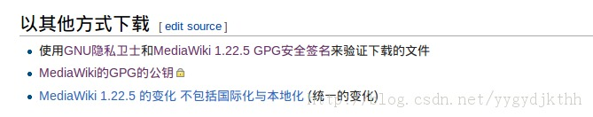
以我下载的mediawiki-1.22.5.tar.gz包为例：
得到MediaWiki 1.22.5 GPG安全签名文件：mediawiki-1.22.5.tar.gz.sig
能过上图的 MediaWiki的GPG的公钥 得到pubkey文件，并保存到文件mediawiki_pubkey.txt中；

导入公钥到当前系统中：
fuckids@debian-IDS:~/wiki$ gpg --import mediawiki_pubkey.txt
gpg: /home/fuckids/.gnupg/trustdb.gpg: trustdb created
gpg: key 7F901A30: public key "Mark A. Hershberger <mah@everybody.org>" imported
gpg: Total number processed: 1
gpg: imported: 1 (RSA: 1)
gpg: no ultimately trusted keys found
//列出当前的公钥，检查 是否导入 成功
fuckids@debian-IDS:~/wiki$ gpg -k
/home/fuckids/.gnupg/pubring.gpg
--------------------------------
pub 2048R/7F901A30 2009-07-01 [expires: 2019-06-29]
uid Mark A. Hershberger <mah@everybody.org>
sub 2048R/84896BEA 2009-07-01 [expires: 2019-06-29]

//使用签名文件对下载的文件进行验证：
fuckids@debian-IDS:~/wiki$ gpg --verify mediawiki-1.22.5.tar.gz.sig mediawiki-1.22.5.tar.gz
gpg: Signature made Fri 28 Mar 2014 08:21:11 AM CST using RSA key ID 7F901A30
gpg: Good signature from "Mark A. Hershberger <mah@everybody.org>"
gpg: WARNING: This key is not certified with a trusted signature!
gpg: There is no indication that the signature belongs to the owner.
Primary key fingerprint: 3CEF 8262 806D 3F0B 6BA1 DBDD 7956 EE47 7F90 1A30
其中 gpg: Good signature from "Mark A. Hershberger <mah@everybody.org>" 这一行表示签名文件是正确的，表示下载的包并没有被中间修改过；

三、mysql安全加固：
1、执行mysql安全加固程序：
test@debian:~/$： /usr/bin/mysql_secure_installation
此程序主要完成以下几个功能：
（1）、为root用户设置密码；
（2）、删除匿名账号；
（3）、取消root用户远程登录；
（4）、删除test库和对test库的访问权限；
（5）、刷新授权表使修改生效；
通过这几项加固设置能够提高mysql库的安全性。
执行例子：（注意：其中//开头的行是人为添加的注释）
test@debian:~/$:~/Autosnort - Debian$ /usr/bin/mysql_secure_installation
NOTE: RUNNING ALL PARTS OF THIS SCRIPT IS RECOMMENDED FOR ALL MySQL
SERVERS IN PRODUCTION USE! PLEASE READ EACH STEP CAREFULLY!
In order to log into MySQL to secure it, we'll need the current
password for the root user. If you've just installed MySQL, and
you haven't set the root password yet, the password will be blank,
so you should just press enter here.
Enter current password for root (enter for none):
OK, successfully used password, moving on...
Setting the root password ensures that nobody can log into the MySQL
root user without the proper authorisation.
You already have a root password set, so you can safely answer 'n'.
//为root用户设置密码；
Change the root password? [Y/n] n
... skipping.
By default, a MySQL installation has an anonymous user, allowing anyone
to log into MySQL without having to have a user account created for
them. This is intended only for testing, and to make the installation
go a bit smoother. You should remove them before moving into a
production environment.
//删除匿名账号；
Remove anonymous users? [Y/n] y
... Success!
Normally, root should only be allowed to connect from 'localhost'. This
ensures that someone cannot guess at the root password from the network.
//取消root用户远程登录；
Disallow root login remotely? [Y/n] n
... skipping.
By default, MySQL comes with a database named 'test' that anyone can
access. This is also intended only for testing, and should be removed
before moving into a production environment.
//删除test库和对test库的访问权限；
Remove test database and access to it? [Y/n] y
- Dropping test database...
ERROR 1008 (HY000) at line 1: Can't drop database 'test'; database doesn't exist
... Failed! Not critical, keep moving...
- Removing privileges on test database...
... Success!
Reloading the privilege tables will ensure that all changes made so far
will take effect immediately.
//刷新授权表使修改生效；
Reload privilege tables now? [Y/n] n
... skipping.
Cleaning up...
All done! If you've completed all of the above steps, your MySQL
installation should now be secure.
Thanks for using MySQL!

2、创建wiki数据库，创建专用于wiki访问数据库的用户并分配给此用户只能本地访问wiki数据库的权限；创建专用于wiki访问数据库的原因是尽量少用root账号进行库的操作，防止权限的过大化；
进行数据库命令为：
mysql -u root -p
输入root密码后登入如下：
mysql>
（1）、创建wiki数据库；
mysql> create database zlsl_wiki;
（2）、创建专用于wiki访问的数据库用户，'wiki_user'@'localhost'表示用户名为wiki_user，且此用户只能够在本地登录， 防止被远程访问利用，登录密码为：fucksec2013；
mysql> CREATE USER 'wiki_user'@'localhost' IDENTIFIED BY 'fucksec2013';
Query OK, 0 rows affected (0.00 sec)
（3）、grant命令的格式：grant 执行动作 on 数据库.* to 用户名@登录主机 identified by "密码" ，以下完成的功能则为用户wiki_user只能本地登录且只能对wiki数据库zlsl_wiki进行所有操作；
mysql> GRANT ALL ON zlsl_wiki.* TO 'wiki_user'@'localhost' IDENTIFIED BY 'fucksec2013';
Query OK, 0 rows affected (0.00 sec)
mysql> exit

重启数据库服务：
/etc/init.d/mysql restart

四、安装mediawiki:
解压mediawiki-1.22.5.tar.gz：
fuckids@debian-IDS $ su
fuckids@debian-IDS $ tar zxvf mediawiki-1.22.5.tar.gz
移动mediawiki目录到apache web服务器目录下：
fuckids@debian-IDS $ mv mediawiki-1.22.5 /var/www/mediawiki
然后在浏览器中输入：
http://127.0.0.1/mediawiki/index.php
配置mediawiki的安装过程：
wiki使用的数据库名为创建的数据库的名称，用户名及密码和前面创建的用户名密码一致；
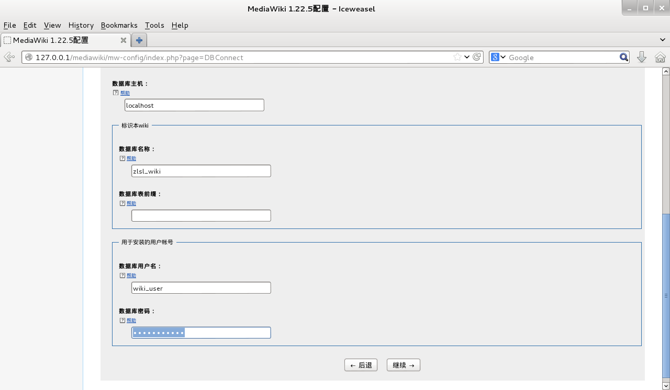
如果上一图中的用于安装的用户帐号和数据库访问的用户不一致时，在下图这个步骤中的数据库用户名和密码处填写相应的用户名/密码；
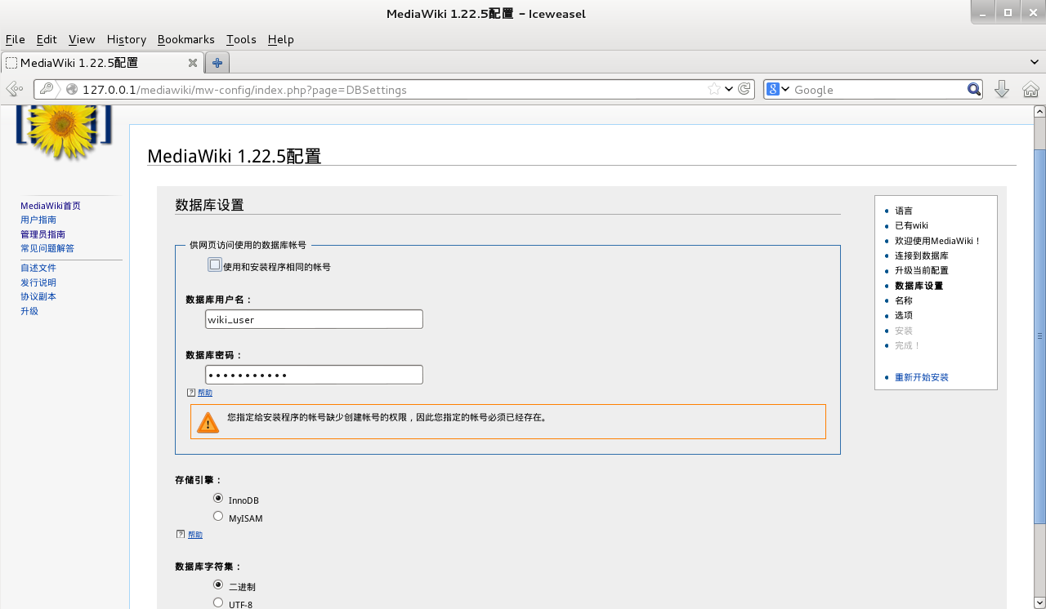
如果用于安装的用户帐号和数据库访问的用户一致时，在下图中直接勾选 使用和安装程序相同的帐号；

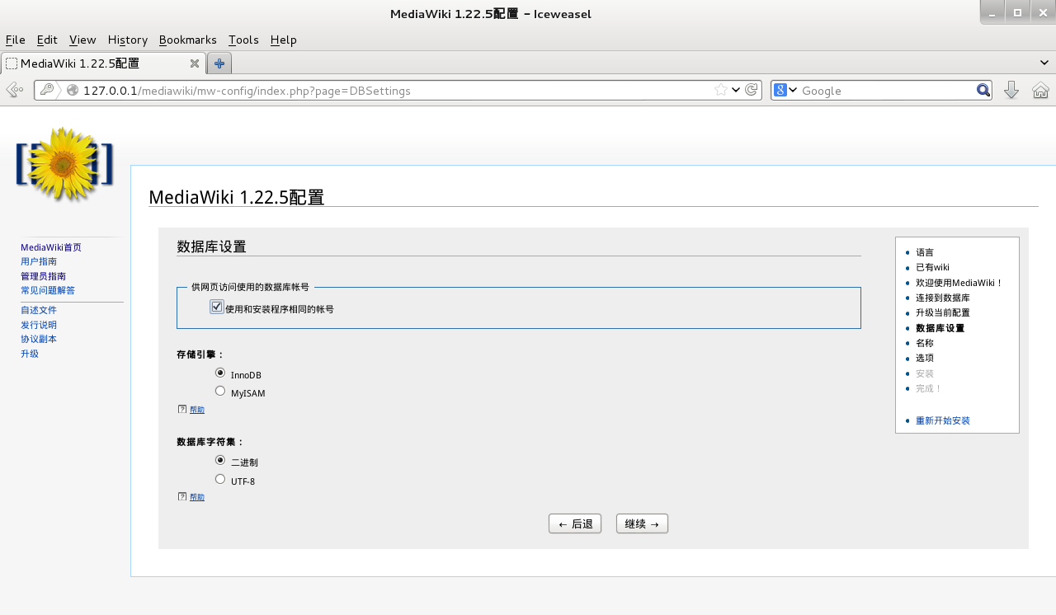

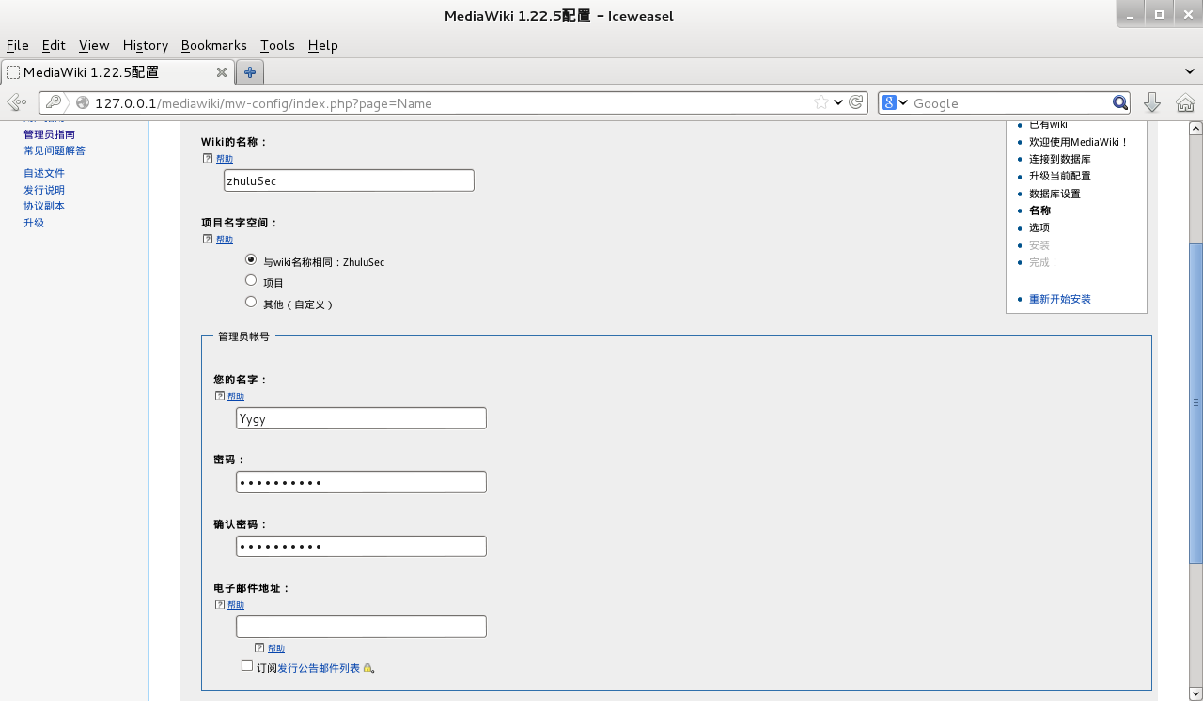

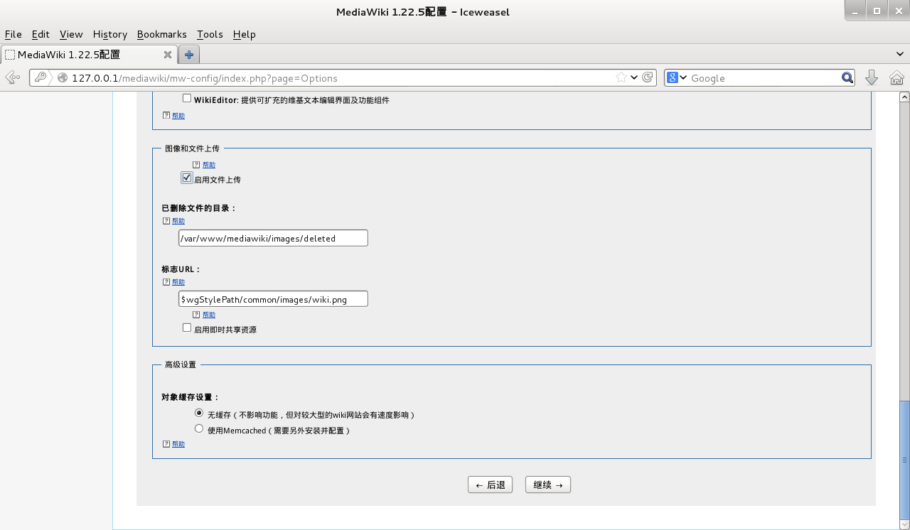

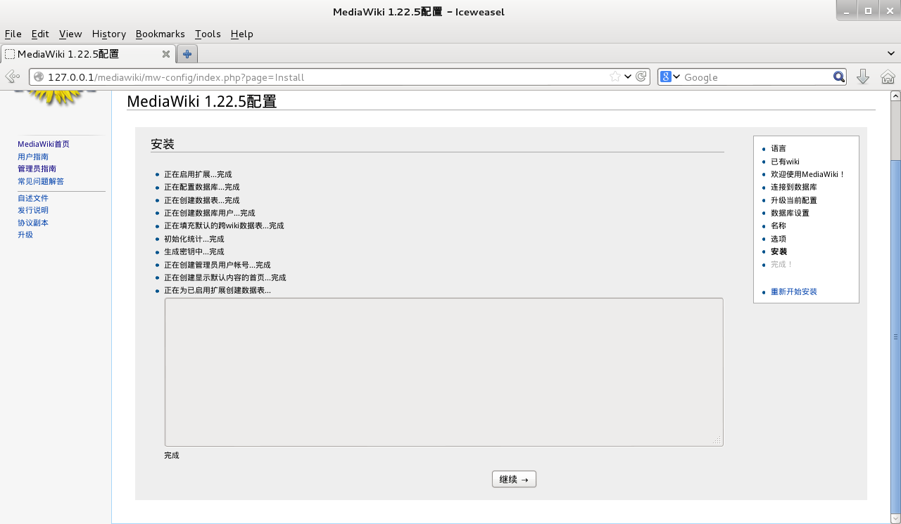

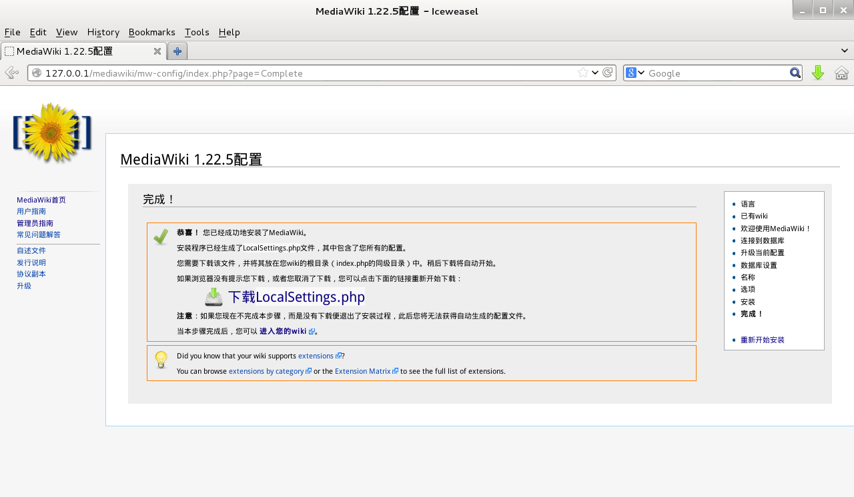
将生成的配置文件LocalSettings.php下载保存到/var/www/mediawiki目录下，此时再次输入以上网址若可以进行wiki的访问，则表示wiki安装成功；

五、php安全加固：
//php harden fuc
ref:
http://www.waitalone.cn/php-web-security-for-linux.html
http://www.itokit.com/2012/1006/74782.html

//change file php.ini of debian os
/etc/php5/apache2/php.ini

1、改变wiki文件目录和文件属性，禁止写入，在wiki根目录下执行：
find -type f -name \*.php -exec chmod 444 {} \;
find -type d -exec chmod 555 {} \;
2、修改php配置文件/etc/php5/apache2/php.ini：
vim /etc/php5/apache2/php.ini
设置：
//设置模式为安全模式，此值直接影响disable_functions的命令是否生效；
[SQL]
; http://php.net/sql.safe-mode
sql.safe_mode = On //设置了后会有问题？？？需要再测试
//禁用不安全的函数
disable_functions = system, show_source, symlink, exec, dl, shell_exec, passthru, phpinfo, escapeshellarg, escapeshellcmd

//避免暴露php信息
expose_php = Off
//关闭错误信息提示
display_errors = Off
//不允许调用dl
enable_dl = Off
//避免远程调用文件
allow_url_include = Off

六、apache加固：
生成数字证书进行双向认证进行https控制访问：
生成密钥和证书方法：ret:http://citypw.blogspot.tw/2013/11/how-to-set-up-apache2-with-ssltls.html

Generate CA certificates:
--------------------------------------------------------------------------------
root@d6-test:/opt/ssl# cp /usr/lib/ssl/misc/CA.sh .
root@d6-test:/opt/ssl# ./CA.sh -newca
CA certificate filename (or enter to create)
Making CA certificate ...
Generating a 2048 bit RSA private key
..................................+++
..............................................+++
writing new private key to './demoCA/private/./cakey.pem'
.............................................
.............................................
Country Name (2 letter code) [AU]:CN
State or Province Name (full name) [Some-State]:Shanghai
Locality Name (eg, city) []:Shanghai
Organization Name (eg, company) [Internet Widgits Pty Ltd]:MOT
Organizational Unit Name (eg, section) []:MOT
Common Name (e.g. server FQDN or YOUR name) []:hardened-shit
Email Address []:info@hardened-shit.com
Please enter the following 'extra' attributes
to be sent with your certificate request
A challenge password []:
An optional company name []:
Using configuration from /usr/lib/ssl/openssl.cnf
Enter pass phrase for ./demoCA/private/./cakey.pem:
Check that the request matches the signature
Signature ok
Certificate Details:
Serial Number:
c0:81:0e:bc:52:d0:19:5a
Validity
Not Before: Nov 19 02:08:14 2013 GMT
Not After : Nov 18 02:08:14 2016 GMT
Subject:
countryName = CN
stateOrProvinceName = Shanghai
organizationName = MOT
organizationalUnitName = MOT
commonName = hardened-shit
emailAddress = info@hardened-shit.com
X509v3 extensions:
X509v3 Subject Key Identifier:
D5:38:4C:2F:FE:CF:E5:19:E9:AC:C5:03:6E:81:6A:D9:15:8F:A8:63
X509v3 Authority Key Identifier:
keyid:D5:38:4C:2F:FE:CF:E5:19:E9:AC:C5:03:6E:81:6A:D9:15:8F:A8:63
X509v3 Basic Constraints:
CA:TRUE
Certificate is to be certified until Nov 18 02:08:14 2016 GMT (1095 days)
Write out database with 1 new entries
Data Base Updated
--------------------------------------------------------------------------------
Copy intermediate key and certificate:
--------------------------------------------------------------------------------
root@d6-test:/opt/ssl# cp demoCA/private/cakey.pem ca.key
root@d6-test:/opt/ssl#
root@d6-test:/opt/ssl# cp demoCA/cacert.pem ca.crt
--------------------------------------------------------------------------------
Generate server key:
--------------------------------------------------------------------------------
root@d6-test:/opt/ssl# openssl genrsa -des3 -out server.key 2048
Generating RSA private key, 2048 bit long modulus
...+++
.................+++
e is 65537 (0x10001)
Enter pass phrase for server.key:
Verifying - Enter pass phrase for server.key:
--------------------------------------------------------------------------------
Generate server CSR(Certificate Signing Request) with server key:
--------------------------------------------------------------------------------
root@d6-test:/opt/ssl# openssl req -new -key server.key -out server.csr
...........................................
........................................
-----
Country Name (2 letter code) [AU]:CN
State or Province Name (full name) [Some-State]:Shanghai
Locality Name (eg, city) []:Shanghai
Organization Name (eg, company) [Internet Widgits Pty Ltd]:MOT
Organizational Unit Name (eg, section) []:MOT
Common Name (e.g. server FQDN or YOUR name) []:hardened-shit
Email Address []:info@hardened-shit.com
Please enter the following 'extra' attributes
to be sent with your certificate request
A challenge password []:
An optional company name []:
--------------------------------------------------------------------------------
Genrate server certificate:
--------------------------------------------------------------------------------
root@d6-test:/opt/ssl# openssl req -x509 -days 2048 -key server.key -in server.csr > server.crt
Enter pass phrase for server.key
--------------------------------------------------------------------------------
You can check out the cert or verify it:
openssl x509 -noout -text -in server.crt
openssl verify -CAfile ca.crt server.crt
Generate client's key:
--------------------------------------------------------------------------------
root@d6-test:/opt/ssl# openssl genrsa -des3 -out client.key 2048
Generating RSA private key, 2048 bit long modulus
..........................................................................................................................................+++
........+++
e is 65537 (0x10001)
Enter pass phrase for client.key:
Verifying - Enter pass phrase for client.key:
--------------------------------------------------------------------------------
Client's CSR:
--------------------------------------------------------------------------------
root@d6-test:/opt/ssl# openssl req -new -key client.key -out client.csr
.......................................................
..............................................
-----
Country Name (2 letter code) [AU]:CN
State or Province Name (full name) [Some-State]:Shanghai
Locality Name (eg, city) []:Shanghai
Organization Name (eg, company) [Internet Widgits Pty Ltd]:MOT
Organizational Unit Name (eg, section) []:MOT
Common Name (e.g. server FQDN or YOUR name) []:hardened-shit
Email Address []:info@hardened-info.com
Please enter the following 'extra' attributes
to be sent with your certificate request
A challenge password []:
An optional company name []:
Generate client's certificate with CA certificate's signature:
root@d6-test:/opt/ssl# openssl ca -in client.csr -out client.crt
Using configuration from /usr/lib/ssl/openssl.cnf
Enter pass phrase for ./demoCA/private/cakey.pem:
Check that the request matches the signature
Signature ok
Certificate Details:
Serial Number:
c0:81:0e:bc:52:d0:19:5c
Validity
Not Before: Nov 19 02:28:13 2013 GMT
Not After : Nov 19 02:28:13 2014 GMT
Subject:
countryName = CN
stateOrProvinceName = Shanghai
organizationName = MOT
organizationalUnitName = MOT
commonName = hardened-shit
emailAddress = info@hardened-info.com
X509v3 extensions:
X509v3 Basic Constraints:
CA:FALSE
Netscape Comment:
OpenSSL Generated Certificate
X509v3 Subject Key Identifier:
A6:A5:D7:7C:C7:A8:C3:24:C7:90:14:76:84:15:43:D0:2C:0C:31:66
X509v3 Authority Key Identifier:
keyid:D5:38:4C:2F:FE:CF:E5:19:E9:AC:C5:03:6E:81:6A:D9:15:8F:A8:63
Certificate is to be certified until Nov 19 02:28:13 2014 GMT (365 days)
Sign the certificate? [y/n]:y
1 out of 1 certificate requests certified, commit? [y/n]y
Write out database with 1 new entries
Data Base Updated
--------------------------------------------------------------------------------
Convert to pkcs12 format, which can be identified by firefox:
--------------------------------------------------------------------------------
root@d6-test:/opt/ssl# openssl pkcs12 -export -clcerts -in client.crt -inkey client.key -out client.pfx
Enter pass phrase for client.key:
Enter Export Password:
Verifying - Enter Export Password:
--------------------------------------------------------------------------------
Enable SSL/TLS support in Apache2:
--------------------------------------------------------------------------------
root@hardened-shit:/opt# mv ssl /etc/ssl/hardened-shit
root@hardened-shit:/etc/apache2# a2ensite default-ssl
Enabling site default-ssl.
To activate the new configuration, you need to run:
service apache2 reload
root@hardened-shit:/etc/apache2# a2enmod ssl
Module ssl already enabled
//change file /etc/apache2/sites-enabled/default-ssl
SSLCertificateFile /etc/ssl/hardened-shit/server.crt
SSLCertificateKeyFile /etc/ssl/hardened-shit/server.key

SSLCertificateChainFile /etc/ssl/hardened-shit/ca.crt

SSLCACertificatePath /etc/ssl/hardened-shit/
SSLCACertificateFile /etc/ssl/hardened-shit/ca.crt

#SSLVerifyClient optional

SSLVerifyClient require
SSLVerifyDepth 10

//修改文件 /etc/apache2/ports.conf 以禁用http:80端口；
#NameVirtualHost *:80
#Listen 80

//若需要修改最大连接数等，修改文件 /etc/apache2/apache2.conf
StartServers 5
MinSpareServers 5
MaxSpareServers 10
MaxClients 150
MaxRequestsPerChild 0

注意：
以上配置完成后，需要进行服务的重启：
service apache2 restart
此时要输入服务端私钥的保护密码；

//复制客户端证书及CA证书并在需要对wiki进行访问的设备上的浏览器端进行导入这两个证书；
cp /etc/ssl/hardened-shit/client.pfx /media/Ubuntu\ prec/
cp /etc/ssl/hardened-shit/ca.crt /media/Ubuntu\ prec/

修改/var/www/Localsettings.php文件，若是80端口开放的话则下面的为http，若是开放的是443端口的话，那么下面的http就要修改为https。否则页面的布局和格式将出现问题；
## The protocol and server name to use in fully-qualified URLs
#$wgServer = "http://127.0.0.1";
$wgServer = "http://111.111.111.120";

//set uploadfile
chmod -R 777 images/
//added this set to Localsettings.php
$wgUploadPath="/var/www/mediawiki/images";

3、删除在错误页面中显示服务器信息的功能：

Disallow server to print out any Linux and Apache information on error pages.

Change the following lines at /etc/apache2/conf.d/security
sudo nano /etc/apache2/conf.d/security

Change the following lines as following:
ServerToken Prod
ServerSignature Off

4、抗DOS、DDOS Module安装：
In order to avoid HTTTP DoS, DDoS, install the mod_evasive module.
http://www.ansoncheunghk.info/article/two-important-modules-secure-your-apache#mod_evasive
apt-get install libapache2-mod-evasive
sudo mkdir /var/log/mod_evasive

sudo chown www-data:www-data /var/log/mod_evasive/

cd /etc/apache2/mods-available/
vim mod-evasive.conf
In order to add custom configuration, we need to create mod-evasive.conf file in /etc/apache2/mods-available folder.

<ifmodule mod_evasive20.c>

DOSHashTableSize 3097

DOSPageCount 2

DOSSiteCount 50

DOSPageInterval 1

DOSSiteInterval 1

DOSBlockingPeriod 3600

DOSLogDir /var/log/mod_evasive

DOSEmailNotify info@yourdomain.com

DOSWhitelist 127.0.0.1

</ifmodule>

To let you understand the meaning of each parameter, here are description of each parameter:

DOSHashTableSize: Size of the hash table used to store the IPs.

DOSPageCount: Number of pages allowed per DOSPageInterval.

DOSPageInterval: Time in seconds used by DOSPageCount.

DOSSiteCount: Number of objects allowed per DOSSiteInterval.

DOSSiteInterval: Time in seconds used by DOSSiteCount.

DOSBlockingPeriod: Time in seconds that IPs will be banned. If an IP tries to access the server within this period, the count will be restarted.

DOSLogDir: Optional. Directory to store the logs. If not specified, /tmp will be used.

DOSEmailNotify: Optional. Mail where notifications will be sent.

DOSWhitelist: Optional. List of IPs which won't be blocked.

Once you understand it, now you can changes the value to optimize for your server.

In order to activate the module, we have to inform Apache to enable mod_evasive. To activate the changes, we need to restart the Apache as well.

sudo a2enmod mod-evasive

sudo /etc/init.d/apache2 restart

Okay, mod_evasive module can guard again DoS or DDoS attack now. How are we going to secure Apache again SQL injection or Code Injection attack??? Other than, providing proper input validation or input filtering. We can install mod_security module to act as the first level web application security.

5、WAF—mod-security install:
apt-get install libapache-mod-security
download and install the latest OWASP ModSecurity Core Rule Set from the project website. Click here for more information.
https://github.com/SpiderLabs/owasp-modsecurity-crs

tar -zxvf SpiderLabs-owasp-modsecurity-crs.tar.gz
mkdir /etc/apache2/mods-security/rules/
cp -R SpiderLabs-owasp-modsecurity-crs-*/* /etc/apache2/mods-security/rules/
cd /etc/apache2/mods-security/rules/
mv modsecurity_crs_10_setup.conf.example modsecurity_crs_10_setup.conf

modify modsecurity_crs_10_setup.conf:
vi /etc/apache2/mod_security/modsecurity_crs_10_setup.conf

Add the following line to the end of the file and save :

SecDataDir /var/www

change follow file:

vim /etc/apache2/mods-security/mod-security.conf

< ifmodule mod_security2.c>
LoadFile /usr/lib/libxml2.so
Include /etc/apache2/mods-security/rules/*.conf
Include /etc/apache2/mods-security/rules/activated_rules/*.conf
Include /etc/apache2/mods-security/rules/experimental_rules/*.conf
Include /etc/apache2/mods-security/rules/base_rules/*.conf
Include /etc/apache2/mods-security/rules/slr_rules/*.conf
Include /etc/apache2/mods-security/rules/optional_rules/*.conf

# Turn the filtering engine On or Off

SecFilterEngine On

# Make sure that URL encoding is valid

SecFilterCheckURLEncoding On

# Unicode encoding check

SecFilterCheckUnicodeEncoding Off

# Only allow bytes from this range

SecFilterForceByteRange 0 255

# Only log suspicious requests

SecAuditEngine RelevantOnly

# The name of the audit log file

SecAuditLog /var/log/apache2/audit_log

# Debug level set to a minimum

SecFilterDebugLog /var/log/apache2/modsec_debug_log

SecFilterDebugLevel 0

# Should mod_security inspect POST payloads

SecFilterScanPOST On

# By default log and deny suspicious requests

# with HTTP status 500

SecFilterDefaultAction "deny,log,status:500"

</IfModule>

#enable security mod
a2enmod mod-security
#restart apache2 server
service apache2 restart

Check if everything is working.

Open the Terminal Window and enter :

tail -f /var/log/apache2/error_log

The output should look something like this :

[Wed Apr 09 02:47:29 2014] [notice] ModSecurity for Apache/2.6.6 (http://www.modsecurity.org/) configured.
[Wed Apr 09 02:47:29 2014] [notice] ModSecurity: APR compiled version="1.4.6"; loaded version="1.4.6"
[Wed Apr 09 02:47:29 2014] [notice] ModSecurity: PCRE compiled version="8.30"; loaded version="8.30 2012-02-04"

