ANALYSTLAB AFRICA
Experience Lab Internship Programme
Initial HealthConnect Analytics Report
Week 5: Data Analytics Track
Field | Detail
Project | HealthConnect Clinic Experience Lab
Track | Data Analytics
Week | Week 5 – Exploratory Analysis, KPI Development & Business Insights
Dataset | HealthConnect_Appointment_Data.csv (5,000 records, 18 variables)
Tools | Microsoft Excel, Power BI
Prepared by | Samson Oluwatimilehin Arawande

1. Week 4 → Week 5 Transition
This section briefly reviews the Week 4 foundation before moving into Week 5's practical work, as required by the assignment brief.

The problem defined in Week 4
Understanding the HealthConnect appointment dataset well enough to identify which factors are most associated with patient no-shows, and defining a small set of business questions and KPIs to guide deeper analysis in later weeks.

Week 4 proposed approach
Complete a data quality assessment, define 6 business questions, shortlist 5 KPIs justified against those questions, then move into KPI calculation and visualization in Week 5 using Excel and Power BI.

Relevant resources
HealthConnect_Appointment_Data.csv (5,000 records, 18 variables) and HealthConnect_Data_Dictionary.xlsx.

Key assumptions/limitations carried from Week 4
The dataset represents a single clinic or a combined view across locations (no site identifier present); booking and appointment dates are generated relative to a fixed synthetic reference point rather than real calendar time; the dataset is fictional, so findings illustrate realistic dynamics rather than confirming real-world outcomes.

What was proposed for Week 5
Calculate the five shortlisted KPIs, apply a documented treatment decision for missing values, and build initial visualizations in Excel before migrating into a Power BI dashboard.

Correction carried forward from Week 4
During Week 5 data preparation, the Week 4 assumption that reminder_channel had ~1,366 missing values was found to be incorrect. Manual inspection in Power Query confirmed these records hold a valid “None” category (used consistently wherever reminder_sent = “No”), not missing data. This is documented here rather than silently corrected, since it affects how the Week 4 data quality assessment should now be read.

2. Cross-Track Collaboration
HealthConnect is a shared, multidisciplinary project. This section documents one meaningful interaction point with another track, as required by the brief.

Track interacted with
Data Science.

Information/output exchanged
The confirmed KPI results — in particular, that booking lead time and previous no-show history are the two strongest predictors of no-shows (a ~40-point and ~24-point spread respectively, versus under 6 points for day, time, age, gender, and appointment type) — were identified as a candidate, data-backed feature shortlist for the Data Science track's Week 5 feature engineering work.

Why it was relevant
The Data Science Track’s Week 5 focus is data preparation, feature engineering, and baseline model development for a no-show prediction model. The Data Analytics findings give that track an evidence-based starting point for feature selection — prioritizing lead time, prior no-show count, and distance as candidate features — rather than needing to rediscover which variables matter through their own exploratory pass.

What changed or improved as a result
This narrows the Data Science track's candidate feature list to the confirmed strongest signals, and flags two data-quality points so they are not rediscovered independently: reminder_channel is a valid 4-category field (not missing data), and the previous_no_shows = 4 and 5 bands rest on very small samples (n=12 and n=3) and should be treated cautiously in any model that uses this feature.

3. Data Preparation Summary
Data preparation was carried out in Power Query (Power BI) ahead of any analysis, with full-dataset column profiling enabled (rather than the default 1,000-row sample) to ensure every check reflects all 5,000 records.

3.1 Data Types
- booking_date and appointment_date was confirmed/converted to proper Date type.
- age, booking_lead_days, previous_appointments, previous_no_shows, distance_to_clinic_km, and waiting_time_minutes are correctly typed as numeric fields.
- All remaining fields (gender, appointment_type, appointment_day, appointment_time, reminder_sent, reminder_channel, appointment_outcome, age_group) are correctly typed as text.

3.2 Duplicates
- appointment_id: 5,000 distinct and 5,000 unique values — zero duplicates.
- Zero fully duplicated rows.

3.3 Missing Values
Variable | Missing | % Missing | Note
distance_to_clinic_km | 90 | 1.8% | Genuine gap, unrecorded at booking.
waiting_time_minutes | 60 | 1.2% | Genuine gap, likely not captured for all visits.
Note: reminder_channel was initially flagged as missing by automated profiling (1,366 blank-looking records), but manual inspection confirmed these are not missing values — they are a genuine fourth category, “None,” used consistently wherever reminder_sent = “No.” The field is fully populated with four valid categories: SMS (2,000), None (1,366), WhatsApp (1,101), and Email (533). This distinction matters: automated null-detection tools can mislabel a legitimate text category as missing, and it is worth a manual check before finalizing a data quality assessment.

3.4 Logical Consistency Checks
- previous_no_shows never exceeds previous_appointments (0 violations).
- No appointment_date occurs before its booking_date (0 violations).
- No negative values in booking_lead_days, distance_to_clinic_km, or waiting_time_minutes.
- age_group bands align perfectly with underlying age values (0 mismatches).
- reminder_sent and reminder_channel is perfectly consistent (No ↔ None, Yes ↔ an actual channel), with zero contradictions.
- All categorical fields contain only expected values — no typos or stray categories.

3.5 Overall Assessment
The dataset is clean and reliable: no duplicates, no logical contradictions, and true missingness limited to two fields at under 2% each. One structural observation worth noting for later analysis: appointment_day includes meaningful volumes on both Saturday and Sunday, indicating the clinic operates seven days a week.

4. Exploratory Data Analysis
No-show rate (appointment_outcome = “No-Show”) was investigated across every relationship listed in the assignment brief: appointment characteristics, patient characteristics, appointment history, reminders, waiting time, distance, and cancellations. All figures below are calculated in Power BI using a No-Show Rate measure (No-Show Count ÷ Total Appointments), filtered to 2025 — the only complete calendar year in the dataset (2026 data covers January–June only and was excluded from trend analysis to avoid a misleading partial-year comparison).

4.1 Strong Predictors

Booking Lead Time
No-show rate rises steadily and consistently as lead time increases: 27.81% (0–7 days) → 33.55% (8–14) → 43.21% (15–30) → 53.82% (31–45) → 67.69% (46–60 days). This is the single strongest, cleanest relationship in the dataset — a roughly 40-point spread with solid sample sizes throughout (n=602–1,333 per band).

Previous No-Show History
No-show rate climbs from 43.51% (0 prior no-shows) to 67.95% (3 prior no-shows) across sample sizes large enough to trust (n=78–2,921). The 4 and 5-prior-no-show bands (66.67% and 100%) should be treated cautiously, as they rest on only 12 and 3 records respectively.

Distance to Clinic
A real but gentler gradient: 46.45% (0–5km) → 46.51% (5–10km) → 48.50% (10–15km) → 51.40% (15–20km) → 57.76% (20+km), an ~11-point spread. The 90 records with missing distance sit at 52.22% — close to the dataset average, suggesting the missing values are not concentrated among an unusual subgroup.

4.2 Moderate / Actionable Factor

Reminders
Sending any reminder reduces no-show rate from 51.39% to 47.36% (~4-point gap). By channel, SMS is clearly most effective (45.75%), ahead of Email (48.41%) and WhatsApp (49.77%), with no reminder at all performing worst (51.39%). This is a smaller effect than lead time or history, but it is the one factor the clinic can directly control operationally.

4.3 Weak Factors (No Meaningful Variation)
Five factors were investigated and each showed a spread under 6 percentage points — far weaker than lead time, history, or distance:
- Appointment type: 46.64% (General Consultation) to 51.23% (Follow-up) — ~4.6pt spread.
- Appointment time: 48.14% (Morning) to 49.78% (Evening) — ~1.6pt spread, essentially flat.
- Day of week: 44.99%–51.53% across all seven days — no clear weekday/weekend pattern.
- Age group: 45.12% (65+) to 50.75% (55-64) — mild tendency for older patients to attend more reliably, but weak overall (~5.6pt spread).
- Gender: Male 48.71% ≈ Female 48.43%, with “Prefer not to say” at 43.52% on a small sample (n=108).

4.4 Waiting Time
Average waiting time (from prior visits) is essentially flat across outcomes: Attended 24.36 minutes, No-Show 24.33 minutes, Cancelled 23.21 minutes. There is no meaningful relationship between how long a patient previously waited and whether they attend, cancel, or no-show their next appointment.

4.5 Cancellations
Cancellations (5.26% of all appointments) behave differently from no-shows and were analyzed separately rather than being grouped with either outcome. Cancellation rate is highest at the shortest lead times — 6.45% (0–7 days) versus 4.63% (15–30 days, the lowest point) — the opposite direction from the no-show pattern, which peaks at long lead times. This suggests cancellations and no-shows are different patient behaviors with different underlying causes, not two symptoms of the same problem.

5. KPI Calculations
Five KPIs were selected from the Week 4 shortlist, calculated in Power BI using DAX measures, and interpreted against their linked business question.
KPI | Definition | Result | Interpretation
Overall No-Show Rate  (BQ1) | Share of all appointments resulting in a no-show | 48.46%  (all data)  48.42%  (2025 only) | Nearly 1 in 2 appointments is missed — a substantial, clinic-wide operational problem.
No-Show Rate by Lead-Time Band  (BQ2) | No-show rate segmented by days between booking and appointment | 27.81% → 67.69%  across 5 bands | Strongest driver in the dataset; risk more than doubles from shortest to longest lead time.
Repeat No-Show Rate  (BQ3) | No-show rate segmented by count of prior no-shows | 43.51% → 67.95%  (0 to 3 prior) | Reliable early-warning signal; each additional prior no-show raises risk substantially.
Reminder Effectiveness Rate  (BQ5) | No-show rate by whether/which reminder channel was used | SMS 45.75% (best)  vs None 51.39% | Clinic's most directly actionable lever; SMS outperforms other channels.
No-Show Rate by Distance Band  (BQ4) | No-show rate segmented by distance to clinic | 46.45% → 57.76%  across 5 bands | Real but secondary effect — a gentler gradient than lead time or history.

6. Visualizations / Dashboard
A two-page interactive Power BI dashboard was built to support this analysis. Page 1 presents the confirmed KPI drivers; Page 2 documents the factors investigated for Business Question 6 (timing and demographics) that showed no meaningful variation — included deliberately, as a negative finding is still a finding.
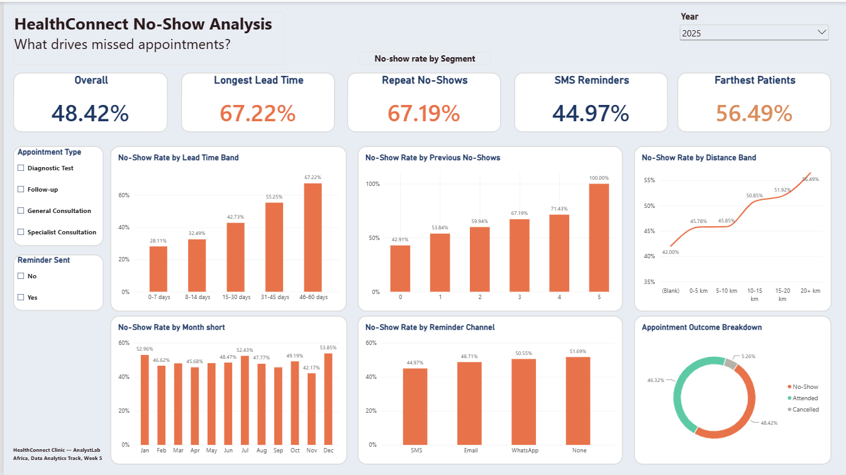
Figure 1. HealthConnect No-Show Analysis — Page 1: KPI drivers (lead time, history, distance, reminders, monthly trend, outcome breakdown).
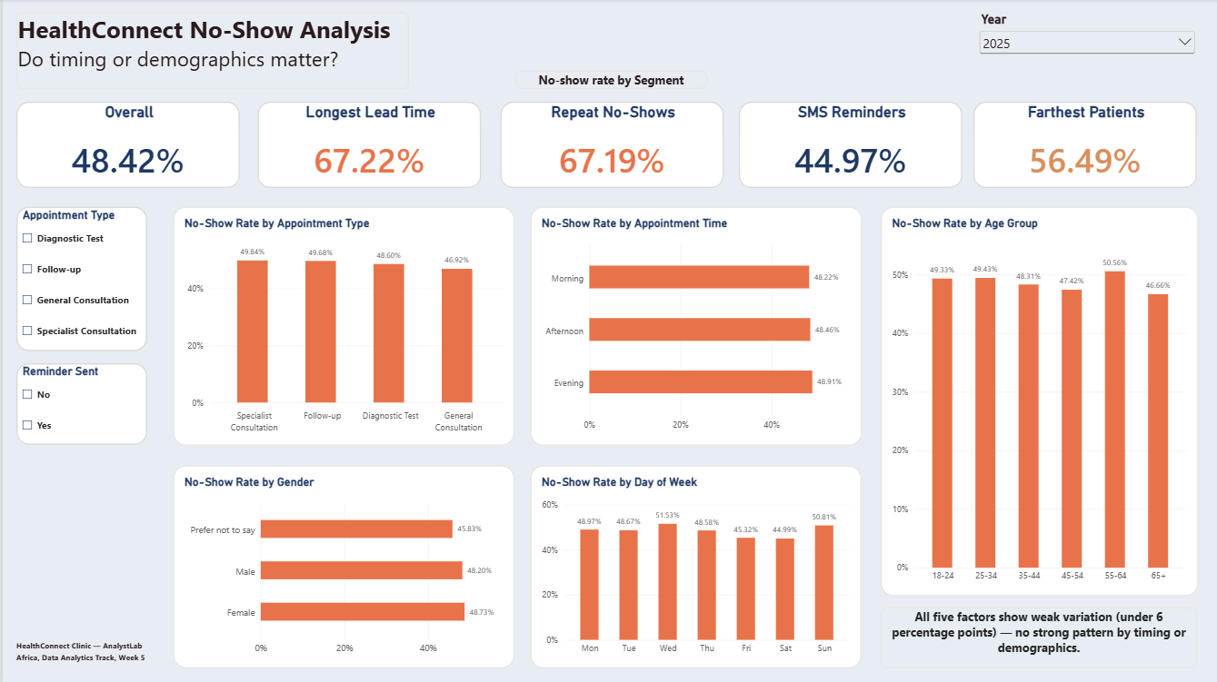
Figure 2. HealthConnect No-Show Analysis — Page 2: BQ6 supporting analysis (appointment type, time, day of week, age group, gender).
Design notes: Y-axis minimums on the two-line charts (Distance Band, Appointment Month) were set to 35% rather than 0%, since no-show rates in this dataset never approach the lower end of a 0–100% scale — a 0% floor would flatten the visible pattern almost to invisibility, while an uncapped auto-scale would exaggerate it. 35% keeps the genuine trend readable without either distortion. The Year slicer defaults to 2025, since 2026 data is a partial year (January–June) that would distort the monthly trend view if blended in.

7. Key Findings
Six business insights were drawn from the analysis, each with a direct implication for HealthConnect Clinic.

Insight 1: Booking lead time is the single strongest driver of no-shows.
No-show rate climbs from 27.8% to 67.7% as lead time increases from 0–7 days to 46–60 days — more than doubling. Implication: long-lead-time bookings deserve a distinct, more assertive follow-up strategy, not the same single reminder given to near-term bookings.

Insight 2: A patient's own no-show history predicts future behavior.
No-show rate rises from 43.5% (no prior no-shows) to 68% (3 prior no-shows), consistently across large samples. Implication: a simple “attendance risk” flag on repeat no-show patients could trigger higher-touch outreach (e.g., a phone call) ahead of their next visit.

Insight 3: Reminders help, and SMS is clearly the best channel — but the effect is modest.
Any reminder drops no-show rate by ~4 points (51.4% → 47.4%); SMS specifically outperforms WhatsApp and Email. Implication: reminders are the clinic's most directly controllable lever — shifting to SMS-first, especially for high-risk bookings, is low-cost and immediately actionable.

Insight 4: Distance has a real but secondary effect on attendance.
No-show rate rises from ~46.5% (under 10km) to 57.8% (20+km) — genuine, but a gentler gradient than lead time or history. Implication: telehealth or remote options for lower-acuity appointment types could reduce the travel burden for the clinic's most distant patients.

Insight 5: Cancellations and no-shows are different behaviors, not the same problem.
Cancellation rate peaks at short lead times (6.45% at 0–7 days) — the opposite pattern from no-shows, which peak at long lead times. Implication: a single “reduce missed appointments” strategy is too blunt; cancellations and no-shows likely need separate interventions.

Insight 6: Day of week, time of day, age, gender, and appointment type do not meaningfully predict attendance.
All five factors show under a 6-point spread — far weaker than lead time (40pt), history (24pt), or distance (11pt). Implication: the clinic should not invest in demographic- or time-slot-targeted interventions; the real risk factors are behavioral and logistical, not who the patient is or when they are booked.

8. Business Recommendations
- Introduce a second, more assertive confirmation touchpoint (e.g., a phone call or a second reminder) for appointments booked 30+ days in advance, rather than relying on a single reminder close to the date.
- Establish an internal “attendance risk” flag for patients with 2 or more prior no-shows, triggering personalized outreach ahead of their next booking.
- Set SMS as the default reminder channel clinic-wide, reserving Email/WhatsApp for patients without a valid mobile number, and priorities SMS specifically for bookings flagged as high-risk under recommendations 1 and 2.
- Pilot telehealth or remote consultation options for lower-acuity appointment types (e.g., Follow-up) for patients living 20+ km from the clinic.
- Build two distinct intervention tracks — proactive rebooking support for short-notice cancellations, and longer-term reminder/history-based support for no-show-prone patients — rather than one undifferentiated “reduce missed appointments” initiative.
- Deprioritize demographic- or time-slot-targeted interventions (age, gender, day, time, appointment type); resources are better spent on the three confirmed drivers — lead time, history, and distance.

9. Limitations
- The dataset is fictional and synthetic; patterns identified are illustrative of realistic dynamics but should not be read as confirmed findings about a real patient population.
- All relationships reported are correlational, not causal. In particular, the reminder effectiveness figures are observational: patients who receive and respond to reminders may differ in other ways (e.g., providing accurate contact details) from those who do not, so the SMS effect may be partly confounded rather than purely causal.
- Sample sizes at the extremes of previous_no_shows (4 and 5 prior no-shows, n=12 and n=3) are too small to draw firm conclusions — those two data points should be treated as indicative only.
- distance_to_clinic_km (90 records) and waiting_time_minutes (60 records) have small pockets of missing data; a formal treatment decision (imputation vs. exclusion) has not yet been finalized.
- The monthly trend analysis is restricted to 2025 only, since 2026 data covers just six months; this was a deliberate scope decision to avoid a misleading partial-year comparison, but it means the analysis cannot yet speak to whether patterns are stable year-over-year.
- Y-axis minimums on two-line charts (Distance Band, Appointment Month) were set to 35% rather than 0% for readability; this is a considered design choice but means those two charts should not be read at a glance without checking the axis labels.
- This is a cross-sectional analysis of a fixed dataset, not a longitudinal study — it cannot show whether an individual patient's risk changes over time or in response to an intervention.

10. Assumptions, Limitations, Risks & Dependencies — Update
This section reviews the Week 4 list and documents what remains relevant, what has been resolved, what has changed, and what is newly discovered.
Item | Week 4 Status | Week 5 Update
reminder_channel appears to have missing values | Assumed missing (~27%) | Corrected: confirmed a valid “None” category, not missing data — exactly matches reminder_sent = “No”
Missing values in distance_to_clinic_km / waiting_time_minutes need a treatment decision | Flagged, undecided | Resolved for dashboard purposes: displayed as an explicit “(Blank)” category rather than imputed, since the blank group's no-show rate (52.2%) sits close to the overall average and is not an outlier
Scope risk — business questions could expand beyond what's manageable | Identified risk | Resolved: stayed within the 6 confirmed business questions and 5 shortlisted KPIs throughout Week 5
Interpretation risk — relationships are descriptive, not tested | Identified risk | Still relevant — explicitly restated in Section 9 (Limitations); all findings remain correlational, not causal
Consistency risk — cross-track cleaning decisions not shared | Identified risk | Partially addressed via Section 2 (Cross-Track Collaboration), which shares the reminder_channel correction and small-sample caution with the Data Science track
Dataset is fictional/synthetic | Limitation | Still relevant, unchanged

New issue discovered in Week 5
No timestamp exists for when a reminder was sent relative to the appointment date — only whether one was sent. This limits how precisely reminder timing could be optimized in a future stage (e.g. testing whether a reminder sent 1 day out performs differently from one sent 7 days out).

Potential impact
The reminder_channel correction changes how the Week 4 data quality assessment should be read, and the small-sample caution at previous_no_shows 4–5 should inform how confidently that segment is used in any future predictive model.

How addressed
Both points are carried forward into this report's Limitations (Section 9) and Cross-Track Collaboration (Section 2) sections, so they inform Week 6 planning rather than being rediscovered later.

11. Week 5 Project Summary

What was planned for Week 5?
Complete data preparation, exploratory data analysis, KPI calculation, and an initial dashboard, then produce 5+ business insights — building directly on the Week 4 shortlist of business questions and KPIs.

What was actually completed
All of the above, plus two extensions beyond the brief's minimum: waiting time and cancellations were analyzed as their own dimensions (not just folded into the no-show comparison), and a genuine data-quality correction was made and documented (reminder_channel). A two-page interactive Power BI dashboard was built, including a Year filter, a formal KPI card row, and a dedicated second page documenting the weak/non-findings for Business Question 6.

Key findings or development outcomes
Booking lead time and previous no-show history are the two strongest, most reliable predictors of no-shows; distance and reminders have real but smaller effects; day, time, age, gender, and appointment type show no meaningful variation; cancellations behave in the opposite direction from no-shows across lead time, indicating they are different patient behaviors rather than the same problem.

Major challenges encountered
- A circular dependency error when sorting appointment_day by a DAX calculated sort column — resolved by rebuilding the sort column as a Power Query (M) column instead, which sidesteps the DAX dependency checker.
- Balancing chart honesty against readability on two-line charts (Distance Band, Appointment Month) — resolved by setting the Y-axis minimum to 35% rather than 0% or a fully auto-scaled range, and documenting that trade-off explicitly.
- The 2025/2026 partial-year issue in the monthly trend chart — resolved by defaulting the Year filter to 2025 only, the one complete year in the dataset.

Important decisions made and why
reminder_channel was reclassified as not-missing based on a manual Power Query check, since automated null-detection had misread a valid “None” text category as blank. The Year filter defaults to 2025 to avoid blending a complete year with a partial one. Y-axis minimums were set to 35% (not 0%) on two charts as a documented middle ground between visual honesty and pattern readability.

Changes to the Week 4 approach
No changes to the planned approach itself — all 5 shortlisted KPIs and all 6 business questions were carried through as originally defined. The one substantive change was factual: the reminder_channel missing-data assessment, corrected as described above.

Cross-track collaboration completed
Yes — see Section 2. Shared the confirmed strongest predictors (lead time, prior no-show history, distance) as a candidate feature shortlist for the Data Science track, along with the reminder_channel correction and a small-sample caution.

Remaining work
- Formalize the missing-value treatment decision for distance_to_clinic_km and waiting_time_minutes beyond the dashboard's “(Blank)” display category.
- Explore whether booking lead time and prior no-show history compound each other (an interaction effect) rather than acting independently — flagged as a good next step but not yet built.
- Refine business recommendations with clinic stakeholder input, where applicable.

Proposed focus for Week 6
Investigate the lead-time × prior-no-show interaction as a potential 7th insight; refine the dashboard based on any feedback received; and begin shaping the business recommendations into a more concrete, prioritized rollout plan for HealthConnect Clinic.

