ANALYSTLAB AFRICA
Experience Lab Internship Programme
HealthConnect Final Analytics & Decision Support Package
Week 8: Data Analytics Track — Final Integration & Presentation
Field | Detail
Project | HealthConnect Clinic Experience Lab
Track | Data Analytics
Week | Week 8 – Final Integration, Presentation & Project Showcase
Builds on | Weeks 4–7: Problem Understanding through Testing & Validation
Tools | Microsoft Excel, Power BI
Prepared by | Samson Arawande

Executive Summary
HealthConnect Clinic loses nearly half of all scheduled appointments to no-shows (48.46%). This project set out to answer one question: what actually drives that, and what can the clinic do about it?
After five weeks of analysis, testing, and cross-track validation, two factors stand out as the primary, statistically confirmed drivers: how far in advance a patient books (no-show rate climbs from 27.8% to 67.7% as lead time increases) and a patient's own history of missed appointments (43.5% to 68%). Both relationships are statistically significant (p<0.001) and have been validated as stable across two independent time periods. When combined, these two risk factors add together predictably rather than compounding into something worse — meaning HealthConnect can flag its highest-risk patients using a simple, transparent risk score rather than a complex model.
Five other factors — appointment type, day of week, time of day, age, and gender — were tested and confirmed to have no meaningful effect on attendance. This is itself a useful, evidence-based finding: it tells the clinic where not to spend limited resources.
This analysis was also directly used by a colleague on the Data Science track to inform model feature selection and error analysis — a genuine, evidenced cross-track collaboration, not just a shared dataset.
Full findings, evidence, and five prioritized recommendations follow below.

1. Final KPIs
KPI | Result | Statistical Evidence
Overall No-Show Rate | 48.46% | Baseline (n=5,000)
No-Show Rate by Lead-Time Band | 27.81% → 67.69% | χ²=364.81, p<0.001; r=0.272
Repeat No-Show Rate | 43.51% → 67.95% | χ²=80.71, p<0.001; r=0.126
Reminder Effectiveness Rate | SMS 45.75% (best) vs. None 51.39% | Validated, Week 5/6
No-Show Rate by Distance Band | 46.45% → 57.76% | Validated, Week 5/6
All five KPIs were re-confirmed in Week 7 as time-stable (H1 vs. H2 2025), with one caveat: the 8-14 day lead-time sub-band shows genuine month-to-month volatility not fully explained by sample size — see Limitations.

2. Validated Findings

The two confirmed primary drivers
Booking lead time is the strongest single predictor in the dataset (r=0.272, the highest correlation of any variable tested). Prior no-show history is the second strongest (r=0.126). Both were validated three separate times: in Week 5's initial analysis, Week 6's time-split stability check, and Week 7's formal significance testing.

How the two factors combine
Tested directly via an interaction matrix (Lead Time × Prior No-Shows): the two factors combine additively, not multiplicatively. At the highest-risk combination (46-60 day lead time, 3+ prior no-shows), the observed rate (91.30%) is within a few points of what simple addition of the two individual effects predicts (~87%). This means a transparent, easy-to-explain risk score — not a black-box model — can identify HealthConnect's highest-risk patients.

Secondary factors
Reminders (particularly SMS) and distance to clinic both show real, moderate effects. Reminders are especially notable as the one factor HealthConnect can directly control operationally.

Confirmed non-drivers
Appointment type, day of week, time of day, age group, and gender were all tested and show no meaningful variation (each under a 6-point spread) — a validated finding in its own right, not an absence of analysis.

3. Key Visualization: Final Dashboard
The interactive Power BI dashboard was tested and refined through Week 7, including a real consistency bug found and fixed (a filter was silently affecting visuals it shouldn't have). The version below reflects the final, validated state — every figure matches the numbers reported throughout this document.
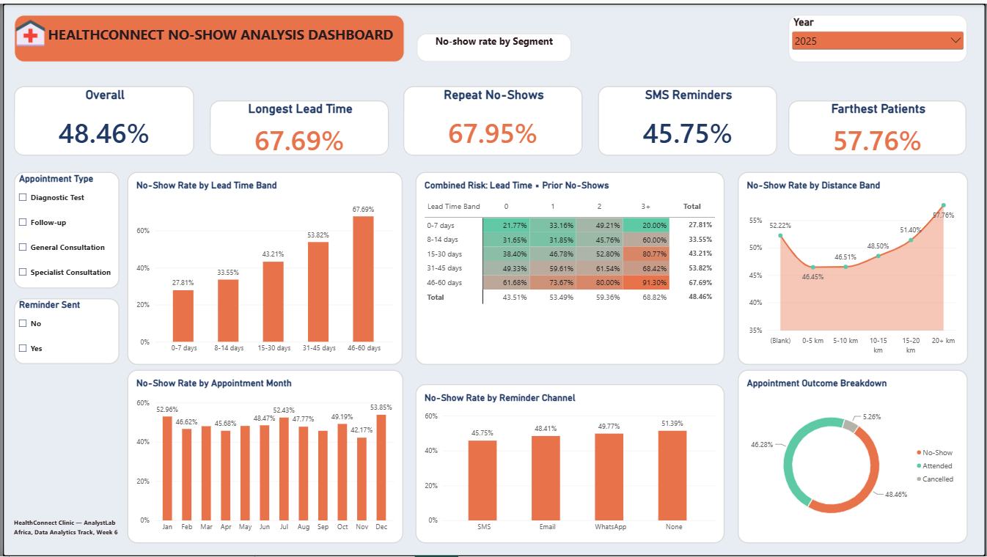
Figure 1. HealthConnect No-Show Analysis — final validated dashboard, Page 1 (KPI drivers, Combined Risk matrix, monthly trend, outcome breakdown).

4. Business Insights
- Booking lead time is the single strongest driver of no-shows — risk more than doubles from 27.8% to 67.7% as lead time increases.
- A patient's own no-show history predicts future behaviour — a reliable, evidence-based early-warning signal.
- The two strongest risk factors add together predictably, not multiplicatively — enabling a simple, transparent combined risk score.
- Reminders help, and SMS is clearly the most effective channel — the one lever HealthConnect fully controls.
- Distance has a real but secondary effect — worth addressing for the most distant patients specifically.
- Cancellations and no-shows are different behaviours — cancellations peak at short lead times, the opposite pattern from no-shows, and likely need separate interventions.
- Day, time, age, gender, and appointment type do not meaningfully predict attendance — resources are better spent elsewhere.

5. Business Recommendations
- Introduce a second, more assertive confirmation touchpoint for appointments booked 30+ days in advance, rather than relying on a single reminder close to the date.
- Flag patients with 2+ prior no-shows and a 30+ day lead time as “high-priority outreach” — this combined group carries a predictable, quantifiable risk (78-91%) based on the validated additive relationship.
- Set SMS as the default reminder channel clinic-wide — expected to reduce the overall no-show rate by roughly 3-4 points.
- Pilot telehealth for lower-acuity appointment types for patients living 20+ km from the clinic.
- Deprioritise demographic- or time-slot-based interventions — direct that effort toward recommendations 1-4, which are backed by validated, statistically significant effects.
Additional caveat from Week 7 testing: predictions for patients in the 15-30 or 31-45 day lead-time bands should be communicated with “moderate confidence,” since these bands sit closest to a 50/50 risk split and are inherently harder to predict precisely than the more extreme bands.

6. Mandatory HC-POD Final Integration
This section closes the full Week 6–8 collaboration with the Data Science track — a sustained, two-way exchange, not a single handoff.

1. Track collaborated with
Data Science.

2. Project dependency
The Data Science track's model refinement work depended on knowing which features are genuinely predictive of no-shows — evidence only the Data Analytics track's validated, tested findings could provide. In turn, Data Analytics' confidence in its own findings was strengthened by having them independently stress-tested against a real model's error patterns.

3. Information/output received across the collaboration
- Week 6: confirmation of their baseline model context, framing what analytical input would be useful at that stage.
- Week 6→7: their full model error analysis — confusion matrix, false positive/negative breakdown, and 7 specific validation requests.
- Week 8: an invitation to close the loop on whether this project's guidance measurably improved their final model (their final results pending).

4. Information/output provided across the collaboration
- Week 6: a full validated-findings package — feature priorities, data-quality flags, the additive lead-time/history relationship.
- Week 7: a statistically rigorous response to all 7 validation requests, with chi-square significance tests and segment-level investigation distinguishing genuine data limitations from likely modelling difficulty.
- Week 8: this final, consolidated Analytics & Decision Support Package, as the definitive reference for their continued work.

5. Integration activity completed
A sustained, two-way exchange across three weeks. Each round built on the last: Data Analytics gave feature guidance, Data Science tested it against a real model and reported back where it broke down, and Data Analytics investigated those specific breakdowns with formal statistical methods.

6. What changed as a result
Data Science's feature engineering was directly shaped by this collaboration — specifically, the recommendation to use a summed risk score instead of an engineered interaction term, and to bin previous_no_shows at 3+ rather than treating sparse extreme values as distinct levels. Data Analytics' own findings gained a stronger evidentiary footing by surviving a genuine, adversarial stress test (another track actively probing for where the analysis broke down), not just internal review.

7. Evidence
Three documents across three weeks: HealthConnect_DataAnalytics_to_DataScience_FindingsPackage.docx (Week 6), HealthConnect_Week7_ValidatedFindings_for_DataScience.docx (Week 7), and the Data Science track's own HealthConnect_Week6_DataScience_to_DataAnalytics_CrossTrack_Handoff.docx — a genuine paper trail of exchange, not a single artefact.

8. Outcome for the overall HealthConnect project
The clinic now has both a validated analytical case and a model informed by that validation, rather than two disconnected efforts that happened to share a dataset — a concrete example of the multidisciplinary integration this Experience Lab was designed to simulate.

9. Remaining dependency
Data Science's final model performance results, to confirm whether this collaboration measurably improved their outcome — the one open loop at project close.

7. Analytical Limitations
- All relationships reported are correlational, not causal — including the additive lead-time/history finding, which describes how the two effects combine statistically, not why.
- The 8-14 day lead-time band shows genuine month-to-month volatility (21%-50% across the year) that remains unexplained beyond small monthly sample sizes.
- previous_no_shows values of 4 and 5 rest on very small samples (n=12, n=3) and should not be treated as reliable distinct levels.
- distance_to_clinic_km and waiting_time_minutes carry small pockets of missing data (1.8%, 1.2%) with no finalised treatment decision.
- The dataset is fictional and synthetic; findings illustrate realistic dynamics rather than confirming outcomes for a real patient population.
- This is a cross-sectional analysis of a fixed dataset, not a longitudinal study — it cannot show how an individual patient's risk changes over time or in response to an intervention.

Conclusion
Across eight weeks, this analysis moved from an initial data review to a validated, statistically significant, cross-track-tested set of findings that directly informed another track's modelling work. The core message for HealthConnect Clinic is clear and actionable: two identifiable, measurable factors — booking lead time and prior no-show history — drive the majority of preventable no-shows, they combine in a simple, predictable way, and the clinic already has a low-cost lever (SMS reminders) it can deploy today.

