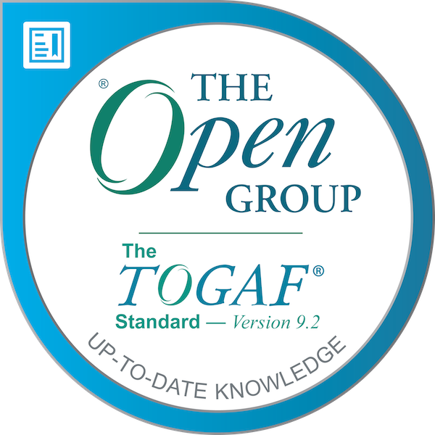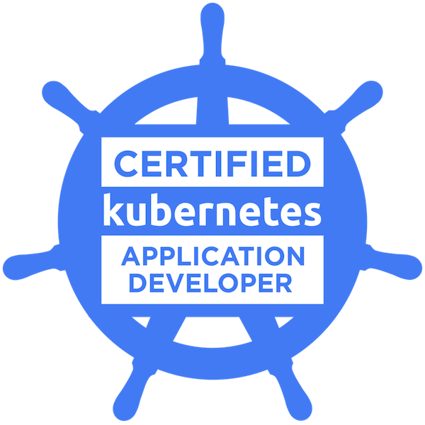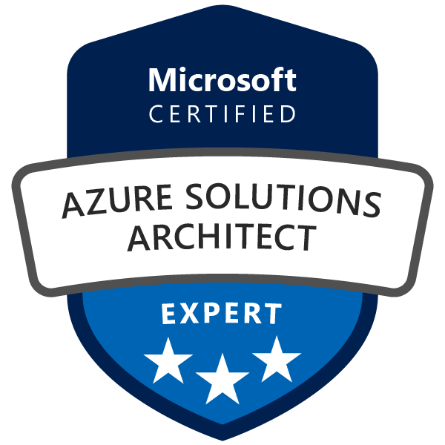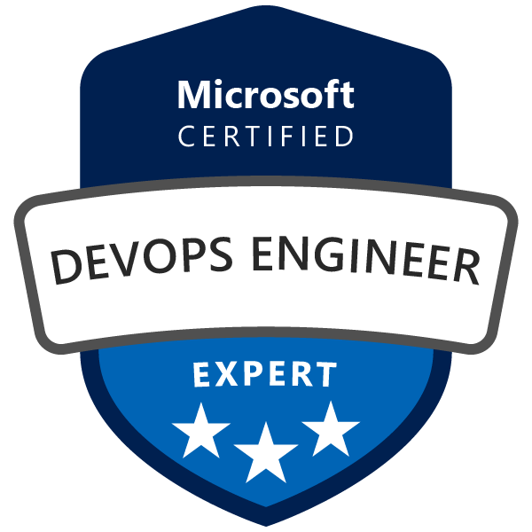

Mobile: 9986377040
E-Mail: debobrata.bose@gmail.com
LinkedIn: https://www.linkedin.com/in/debobratabose/
Badges: https://www.credly.com/users/debobrata-bose/badges

DEBOBRATA BOSE

Objective:
Seeking opportunity as a Senior Technical Manager, Senior Engineering Manager, Senior Cloud Architect role to commensurate my business, analytical and technical skills with a dynamic organization that would help me cultivate and nurture my skills with an opportunity to nurture talent and deliver.

Work Experience:
Total Work Experience | 17+ Years
Current Organization  Current Location | IBM  Bangalore

Career Summary:

- Seasoned technology professional, having over 17+ years of experience in Enterprise Architecture, Solutions Architecture, Cloud Migration & Solutions, Application Modernization, Digital Transformation, Devops and Client Relationship Management
- Architected responsive and scalable solutions leading to a cost saving of 150K USD annually. Provided solutions adhering to Well Architected Framework for cloud native application modernization and migration. Performed extensive Refactor and Rearchitect as part of migration strategy, in migrating clients’ infrastructure and workloads from On-Prem to Cloud and supporting multi-tenant architecture.
- Excellent interpersonal skills; ability to work successfully with teams across the organization, including Engineering, Program Management, Quality Assurance, and Senior Leadership
- Exceptional customer relationship skills including the ability to discover the true requirements underlying feature requests, recommend alternative technical and business approaches, and lead engineering efforts to meet aggressive timelines with optimal solutions
- Excellence in ensuring high-quality customer experience, enriching customer satisfaction while adhering to the work processes; championed effective communication and Agile thinking across the organizations, by implementing an efficient architectural blueprint upon the products/services
- Proficient in leading the project & implementation schedules, including monitoring, documenting & reporting the project status; established an architect function to ensure ample focus on on-going activities and quality improvements on an architectural level in the existing code base; structured the inception, maturation, and implementation of high-profile technology initiatives as per budget
- Rich experience in architecture, cloud consulting, requirements gathering, design, development and testing for Microsoft application stack with cloud provisioning in both public and private cloud. Expertise in multi cloud Azure, Openshift, AWS, GCP with skills on C#.NET, ASP.NET Core, EF Core, SQL Server, REST API, Web API, Docker, Kubernetes, Micro services, Git, Jira.
- Extensive knowledge in building cloud native container-based architecture and deployment leveraging orchestration services of various clouds on AKS, EKS and GKE.
- CI/CD Continuous Integration and Continuous Deployment using Azure Devops, GitLab. Knowledge on build, deployment and release management
- Demonstrated expertise in managing cloud costs and optimizing spending across multiple cloud platforms, including AWS, Azure9. Developed and implemented Cloud FinOps best practices, policies, and procedures to improve cloud financial management, budgeting, forecasting, and reporting.
- Experience in Architecting, Design and Development, Business analysis and consulting, requirements gathering, and testing for Microsoft application stack. Extensive experience in Techno-Functional role, Team Management, Client relationship management, and ability to work in a multi-vendor environment. Certified on Enterprise Architect framework like TOGAF 9.2.
- Expertise in API designing using Micro Services (CQRS, Event Sourcing, Async Messaging), DDD, Eventual Consistency, MVVM, MVC, SOLID.
- Azure Solution Architect Expert and Azure Devops Expert certified.
- Having 3 years of onshore client handling experience in UK (Edinburgh and London) and 1 year in Europe (Germany, Sweden, Poland)
- Good experience in working on Scaled Agile (SAFe) framework with Scrum, Kanban and Agile methodologies.
- Significant experience in AML ODD KYC and Oil and gas domain. Other domain experiences are in Engineering, Automation, Healthcare and ERP.
- Worked previously in following organizations: Danske Bank, Infosys, Capgemini, SAP Labs, NTT Data

Software Skills
Business Domain | AML Banking, Healthcare, ERP, Automation, Legal, Oil & Gas
Language, Dev. Tools and Technologies | C#.NET, .NET Core, Web API, Rest API, WPF, Silverlight, WCF, IIS, ASP.NET MVC 5.0, MOQ, XUnit, TDD, Visual Studio 2019/2017/2015/2012/2010, Visual Studio Code.
Design Patterns | DDD, Micro Services (CQRS, Event Sourcing, API Gateway, Async Messaging) MVVM, SOLID, Facade, Factory
Architecture Design & Frameworks | Draw.io, Gliffy, TOGAF
API tools | Swagger, Postman, SoapUI, Fiddler
Code Quality Tools | Sonarqube, Resharper
Frameworks | .NET Framework 4.5/4.0/3.5/3.0/2.0, .NET Core 3+ , ASP.NET MVC
Devops Tools | Azure Devops, GitLab
Database | SQL Server, Oracle, PostgreSQL, Entity Framework, EF Core
Source Controls | Git, TFS, Perforce, SVN
Agile Planning Tools | JIRA, Confluence, TFS, VSTS, Service Now (SNOW)
Cloud Azure | Azure -PaaS, IaaS, AKS, Azure Container, SQL AZURE, SQL MI, ASE, Application Gateway, Web App, App Service Plan, Virtual Network, ILB, Blob, Azure Functions, Azure DevOps CI/CD, Logic Apps, Backup & Disaster Recovery, Table, Queue, ACL, Load Balancers, CDN, Traffic Manager, PowerShell Script, Azure CLI, Azure DevOps, Azure Migrate , Cloud FinOps
Cloud AWS | AWS -PaaS, IaaS, EC2, S3, EBS, VPC, AWS Lambda, RDS, AWS Load balancer, AWS Application Gateway, AWS Glue, Kinesis, Athena
Cloud Openshift | Openshift PaaS (Pods, Config Maps, Replica Set, Deployment, Service account, Persistent Volumes, PVC, Policies, Secrets, Jobs etc.)
Containerization | Docker and Kubernetes. Terraform OSS

Honors and Awards
1 | Spot Felicitation Award in Danske IT, 2020
2 | BOB (Bright On Brilliance) Award for successful AWS Release and Deployment from LexisNexis, UK, 2017
3 | Project Star Award in Cap Gemini in August 2011.
4 | Special Achiever Award in 2010 in SAP Labs

Projects Undertaken:
Certifications
1 | TOGAF 9.2 Enterprise Architect Certified
1 | Azure Solution Architect Expert
2 | CKAD: Certified Kubernetes Application Developer
3 | AZ-400: Azure Devops Engineer Expert
4 | AZ-300 Microsoft Azure Architect Technologies
5 | AZ-301 Microsoft Azure Architect Design
6 | AZ-500: Microsoft Certified: Azure Security Engineer Associate
7 | AZ-400: Azure Devops Engineer Expert
8 | AZ-104 Microsoft Azure Administrator
9 | GitLab Associate Certified
10 | AWS Cloud Practitioner

1. Cyber Fraud Fusion Center – Fraud detection
Organization | IBM
Client | Barclays, UK
Role | Lead AWS Cloud Architect
Domain | Banking
Technicalities | AWS Glue, Kinesis, Athena, RDS, Data Sync, Lambda, S3, API Gateway
Team Size | 12
Agile Planning | Confluence
Duration | Jan 2022 – Present

Description:

Cloud Migration Architect for migration and modernizing Barclays application and infrastructure. Currently, Barclays holds 30+ banking internal application on premise. All these applications need to be migrated and modernized into AWS. These critical applications emit lots of real time as well batch data logs. There are 23 million log lines per hour generated by individual source system which are being processed and then feeds those data into Barclays E crime infrastructure spread across multiple data centers. Then end vision is to get analytics out of these big data logs and then run machine learning models to identify any threats or frauds on customer transactional data.

Roles and Responsibilities:
- Involved in implementing end to end architectural documentation. Current AS-IS architecture, Target To-BE architecture in AWS after migration, Estimating Cost for Real Time and Batch Data transfer into AWS.
- Design and create application and data ingestion architecture. As the source data is coming from on premise via real time as well as batch, ingesting this data via Kinesis Data Stream, Kinesis Firehose into S3 Raw buckets which is then fed into AWS Glue for Data preparedness and finally consumed via Athena to put the same into Sage maker for creating machine learning models and analytics report into Tableau and AWS Quick sight.
- Driving and leading the entire Agile teams for this migration initiative program and liaising with different stakeholders for creating a successful migration strategy.
- Identified and analyzed cost-saving opportunities, such as Reserved Instances, Spot Instances, and Rightsizing, resulting in significant reductions in cloud costs.
- Conducted regular cost reviews with stakeholders, including IT, finance, and business leaders, to ensure alignment with budgetary goals and objectives.
- Designed and delivered cloud cost dashboards and reports using tools such as Cloud Health, and AWS Cost Explorer to monitor and track cloud usage and spending.
- Collaborated with DevOps and engineering teams to implement cost-aware architecture, including tagging policies, resource allocation, and automation, to optimize cloud resource utilization and reduce waste. Led cloud cost optimization projects, including cloud migration, cloud-native application development, and infrastructure modernization initiatives.
- Maintained up-to-date knowledge of industry trends, emerging technologies, and best practices related to FinOps and cloud financial management.

2. SMC – ScriptMed Cloud Migration
Organization | IBM
Client | Inovalon, US
Role | Lead Solution Architect
Domain | Healthcare
Technicalities | ASP.NET Core, Microservices, EF Core, SQL Server, Web API, Postman, Docker, Azure Devops, Git, GCP, GKE, Kubernetes, PostgreSQL, Oracle
Team Size | 20
Agile Planning | VSTS
Duration | Nov 2021 – Dec 2022

Description:

Cloud Architect for hybrid cloud migration project responsible for migrating all ScriptMed Web applications and Micro-services from PCF orchestration model to Docker and Kubernetes hosted on Google Cloud Platform (GCP) cluster. It also involves migrating the document S3 storage from on-premises Minio to Google Cloud storage. Database and schema migration from Oracle to PostgresSQL hosted in GCP. The other different components involved as part of migration are Confluent Kakfa cluster, Redis server etc. As part of the migration factory, 9 web applications, 70 microservices and 1800 API needs to be migrated to GCP containerized GKE cluster with hybrid support in both on-prem and GCP cloud.
.
Roles and Responsibilities:
- Steering the team in doing the Discovery, Assessment, Survey as part of the migration strategy. Using PCF Discovery toolkit that explores, interrogates, and reviews the current dependencies of the PCF installation and its components. Using Move2Kub3 that uses source artifacts such as Docker Compose files or Cloud Foundry manifest files, and even source code, to generate Kubernetes deployment artifacts. Delivery Curator that supports various phases of Hyperscale Hybrid cloud migration projects. Ora2Pg for Oracle to PostgreSQL DB migration
- Guided to Re architect the code for microservices, data layer framework changes to support the hybrid cloud model for existing customers using on premise private PCF cloud and new customers on GCP hosted containerized GKE cluster
- Architected responsive scalable cloud native architecture leading to a costs savings on $150,000 annually in application modernization and migration
- Provided solutions and guidelines in adhering to Well Architected Framework for cloud native application modernization and migration. Performed extensive Refactor and Re architect as part of migration strategy, in migrating clients’ infrastructure and workloads from On-Premise to Cloud and supporting multi-tenant architecture
- Strong collaboration skill and experienced in working in a fast-paced multicultural agile environment coordinating with multiple teams located across geographies Actively involved in building the services team, hiring skilled practitioner, and mentoring of existing team members

3. AML ODD – Customer Onboarding
Organization | Danske IT
Client | Danske Bank, Nordic
Role | Solution Architect
Domain | AML Review ODD
Technicalities | ASP.NET Core, Microservices, EF Core, SQL Server, ELK Stack (Kibana), REST API, Postman, Docker, Azure Devops, Git, Jira, Openshift4, Kubernetes, Gliffy, Draw.io, Service Now (SNOW)
Team Size | 10
Agile Planning | Jira, Confluence
Duration | June 2019 – Nov 2021

Description:

Solution Architect responsible for handling AML (Anti Money Laundering) KYC and Customer Onboarding for Danske Bank customers across Nordic region. One pager is a case handling application designed to assist AML case handlers in review of cases for low, medium and high-risk customers. It has been designed to make the review process efficient and effective and help the AML advisor get all information about the case in one place.
.
Roles and Responsibilities:
- Solution architecting and designing microservice API design of different components. Architecting the backend component using microservices design patterns leveraging event sourcing and asynchronous messaging and deployment of docker images in OpenShift
- Conducted enterprise architecture workshop and trainings aligning with ADM (Architecture Development Method). Instrumental to be part of Architecture Review Board and follow the Architecture Compliance Review process and implementing Architecture Governance
- Fostered a culture of continuous integration & continuous delivery which reduced deployment time from 4 hours to 10 minutes leading to an improvement in the time to ship new feature releases by 26%
- Develop automation processes to enable teams to deploy, manage, configure, scale and monitor their applications using tooling or scripting reducing the time to get features in production by 80%
- Technical manager responsibility by managing multiple teams and squads from different functional areas.

4. SafeTag
Organization | Infosys
Client | Black & Veatch, US
Role | Architect
Domain | Engineering
Technicalities | Azure PaaS, ASP.NET Core, SQL Server, Application Insights, Web jobs, Webapp, SQL Azure, Azure Blob, Azure AD, Key Vault, Azure Auto Scaling, Redis Cache, CDN, Azure Functions, Logic Apps, API Apps, Web API
Team Size | 10
Agile Planning | VSTS
Duration | September 2012 – April 2019

Description:

Project and Solution Lead worked with multiple projects and clients across multiple domains in Energy, Oil and Gas, Engineering, Legal. Proficient in leading the project & implementation schedules, including monitoring, documenting & reporting the project status; established an architect function to ensure ample focus on on-going activities and quality improvements on an architectural level in the existing code base; structured the inception, maturation, and implementation of high-profile technology initiative as per budget

Roles and Responsibilities:
- Complete architecting and rebuild the customer application to move their application services and data as part of Azure PaaS deployment. Developed a high availability scalable application with increased traffic to 80%
- End to end Azure development, building and hosting web application on Azure web app. Build, design and architecture the project framework. Prepare Design & Architecture Document and Estimation
- Work together with product managers, business stakeholders and fellow engineers to design and implement solutions that were used by 50,000 customers globally
- Maintained tools for deployment, monitoring and operations which led to an improvement in application speed of 9%
- Acted as a subject-matter expert and developer advocate in migrating from SOA services to cloud native deployment. Owned all technical aspects of platform configuration and service orchestration
- Deployment using Azure DevOps and configuring CI/CD automated pipeline.
- Achieved Azure cloud cost savings and optimization targets, resulting in increased profitability, improved cash flow, and enhanced business agility for the organization

5. (ADT - MES Systems) – Component Development
Organization | Capgemini
Client | Volvo Trucks (VTOM)
Role | Team Lead
Domain | Automation – OTD MES
Technicalities | Microsoft Visual Studio .Net 4.0 Framework, C# 2010, WCF, Windows Service, Team Foundation Server 2010, Test-Driven-Development (TDD) , WMQ.NET, WMQ Client, Parallel Programming , PLINQ
Duration | July 2010 – September 2012

Description:
Senior consultant working for a Scandinavian Automation firm responsible for implementing MES (Manufacturing Execution System) for Order-To-Delivery system and further design and implementing Integration Component using WebSphere Message Queue with .NET API.

Roles and Responsibilities:
- Involved in working on Integration platform, integrating applications using IBM WMQ through .NET connectivity and even using IBM XMS.NET
- Implemented Message Listener Services using Windows Service. Involved in implementing different Integration patterns like Pub-Sub (Publish/Subscribe), Fire and Forget and Request-Reply on ‘Queues’ and ‘Topics’.
- Developed in-house tool from scratch on Microsoft WPF platform leveraging parallel programming with WCF services that interacts with SQL Server backend using Entity Framework with LINQ

6. SAP Business By Design
Organization | SAP Labs India Pvt. Ltd.
Role | Senior Developer
Domain | ERP
Technicalities | Microsoft Visual Studio .Net 3.5, C# 2008 WinForms, WPF, XML, Perforce, Expression Blend, Silverlight 2.0
Duration | August 2007 – June 2010

Description:

Build UI Designer as a design time tool for an SAP ERP BusinessByDesign suite, which establishes visual editing with drag drop (placing and rearranging containers and controls) and in-place text editing. It is used by colleagues from solution management for defining the UI layout and application development for binding the UI Model to backend data based on the existing controller objects.
Roles and Responsibilities:

- Design, Develop and build a SAP suite called BusinessByDesign for SME clientele of an Enterprise application
- Contributed innovative ideas to the team from both functional and technical perspective and registered a Patent for one of the ideas
- Major involvement was in building the UI using WPF and Silverlight from the functional specifications with C#.NET

7. HED & Admin-Rx FS System
Organization | NTT Data
Client | McKesson-HED, US – HealthCare
Role | Software Development Engineer
Domain | Healthcare
Technicalities | Microsoft Visual Studio .Net 2.0, C# WinForms, CoreJava-Eclipse(elementary), Oracle, Rational Clearcase, SQL Server 2000
Duration | October 2005 – August 2007

Description:
Build HED - Horizon Expert Documentation & Admin-Rx System is an advanced care documentation and assessment solution. This provides the clinical users with an adaptive clinical documentation model that is oriented to setting the individual patient’s characteristics.

Roles and Responsibilities:
- Involved in Front-end C# Coding and NUnit testing and performing Unit Test Plan.
- Onsite and Offshore coordination by holding conference calls with the Clients to discuss issues and providing resolutions.

Education
Degree/Examination | Institute/Board | Year of passing | Percentage/GPA
B-Tech – Computer Science and Engineering | West Bengal University of Technology | 2005 | 83.1%
ISC (10 + 2) | St. Joseph & Mary’s School | 2000 | 87.7%
ICSE (10) | St. Joseph & Mary’s School | 1998 | 74.6%

