**Using the button template:**

Duplicate the template button template:

Templates_objects/ob_button/ob_button_template

Files that will require modification are contained in both Step and Draw GUI

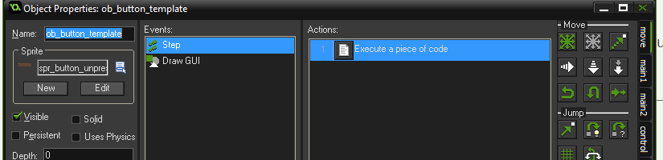

In the Step event script: Add the game code to be completed when the button is released here:

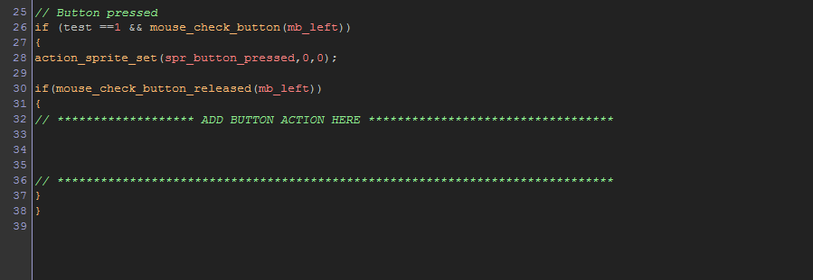

In the Draw event script: Add the text to appear on the button:

