**Auto Sales App**

**Introduction**

The objective of this project is to help the auto shop organize, document and track its car sales business. This will be implemented by Speeding up processes, simplifying the recording and access of information and insuring the ease of use.

The auto shop is currently using file cabinets to store inventory, customers and sales records. This resulted in a huge paper trail that made accessing information and conducting new business consume a great amount of time and space.

The proposed system will consist of a database and a GUI interface that will allow the user (Auto Shop) to enter or retrieve inventory, customers and accounts information as well as make payments. The database will approximately consist of around 50 customers. Each class will have at most 6 attributes and the database will generate a minimum of 20 reports a month.

The desktop runs windows 7, which is sufficient to run the system. On the other hand, the hardware needs to be upgraded to accommodate future enhancements and capabilities. Data transfer will be inserted manually and it will be housed in the MySQL server.

The GUI interface will be implemented using a swing and be comprised of simple tabs, buttons, text fields and check boxes.

**Requirements**

Table 1

|  |  |  |
| --- | --- | --- |
| Identifier | Priority | Requirement |
| REQ1 | 3 | The system must allow the user to insert, edit or delete an auto information. |
| REQ 2 | 2 | The system must allow the user to view an auto or all autos information. |
| REQ 3 | 3 | The system must allow the user insert, edit or delete a customer information. |
| REQ 4 | 1 | The system must allow the user to view a customer or all customers information. |
| REQ 5 | 3 | The system must allow the user to insert, edit or delete an account information. |
| REQ 6 | 1 | The system must allow the user to view an account or all accounts information. |
| REQ 7 | 2 | The system must allow the user to view account balance and make payments. |
| REQ 8 | 5 | The manager has full access to insert, edit or delete information. |

**User Stories**

Table 2

|  |  |
| --- | --- |
| 1 | Record, organize each customer’s information. |
| 2 | Allow easy and fast access to customers’ information. |
| 3 | Expedite and streamline every transaction. |
| 4 | Only the manager will have a complete access to input, edit and delete data. |
| 5 | Other employees will only be able to view data and process payments. |
| 7 | Handle at least 30 accounts. |

**Use Cases**

|  |  |  |
| --- | --- | --- |
| **Actor** | **Actor’s Goal** | **Use Case Name** |
| Manager | To insert an Auto | InsertAuto(UC-1) |
| Manager/Employees | To view an Auto | ViewAuto(UC-2) |
| Manager/Employee | To view all Autos | ViewAllAutos(UC-3) |
| Manager | To edit an Auto | EditAuto(UC-4) |
| Manager | To delete an Auto | DeleteAuto(UC-5) |
| Manager | To insert a Customer | InsertCust(UC-6) |
| Manager/Employees | To view a Customer | viewCust(UC-7) |
| Manager/Employees | To view all Customers | ViewAllCusts(UC-8) |
| Manager | To edit a Customer | EditCust(UC-9) |
| Manager | To delete a Customer | DeleteCust(UC-10) |
| Manager | To insert an Account | InsertAcc(UC-11) |
| Manager/Employees | To view an Account | ViewAcc(UC-12) |
| Manager/Employees | To view all Accounts | ViewAllAcc(UC-13) |
| Manager | To edit an Account | EditAcc(UC-14) |
| Manager | To delete an Account | DeleteAcc(UC-15) |
| Manager/Employees | To view a Balance | ViewABalance(UC-16) |
| Manager/Employees | To view All Balances | ViewAllBalance(UC-17 |
| Manager/Employees | To make a Payment | MakePayment(UC-18) |

**Traceability Matrix (Requirements-to-use cases)**

|  |  |  |  |  |  |  |  |  |  |  |  |  |  |  |  |  |  |  |  |
| --- | --- | --- | --- | --- | --- | --- | --- | --- | --- | --- | --- | --- | --- | --- | --- | --- | --- | --- | --- |
| **Req’t** | **PW** | UC  1 | UC  2 | UC  3 | UC  4 | UC  5 | UC  6 | UC  7 | UC  8 | UC  9 | UC10 | UC11 | UC12 | UC13 | UC14 | UC  15 | UC16 | UC  17 | UC  18 |
| REQ1 | 3 | X |  |  | X | X |  |  |  |  |  |  |  |  |  |  |  |  |  |
| REQ2 | 2 |  | X | X |  |  |  |  |  |  |  |  |  |  |  |  |  |  |  |
| REQ3 | 3 |  |  |  |  |  | X |  |  | X | X |  |  |  |  |  |  |  |  |
| REQ4 | 1 |  |  |  |  |  |  | X | X |  |  |  |  |  |  |  |  |  |  |
| REQ5 | 3 |  |  |  |  |  |  |  |  |  |  | X |  |  | X | X |  |  |  |
| REQ6 | 1 |  |  |  |  |  |  |  |  |  |  |  | X | X |  |  |  |  |  |
| REQ7 | 2 |  |  |  |  |  |  |  |  |  |  |  |  |  |  |  | X | X | X |
| REQ8 | 5 | X |  |  | X | X | X |  |  | X | X | X |  |  | X | X |  |  |  |
| Max PW | | 5 | 2 | 2 | 5 | 5 | 5 | 1 | 1 | 5 | 5 | 5 | 1 | 1 | 5 | 5 | 2 | 2 | 2 |
| Total PW | | 8 | 2 | 2 | 8 | 6 | 6 | 1 | 1 | 4 | 4 | 4 | 1 |  | 6 | 6 | 3 | 3 | 3 |

**Use Cases Class Diagram**

**Manager-Database**

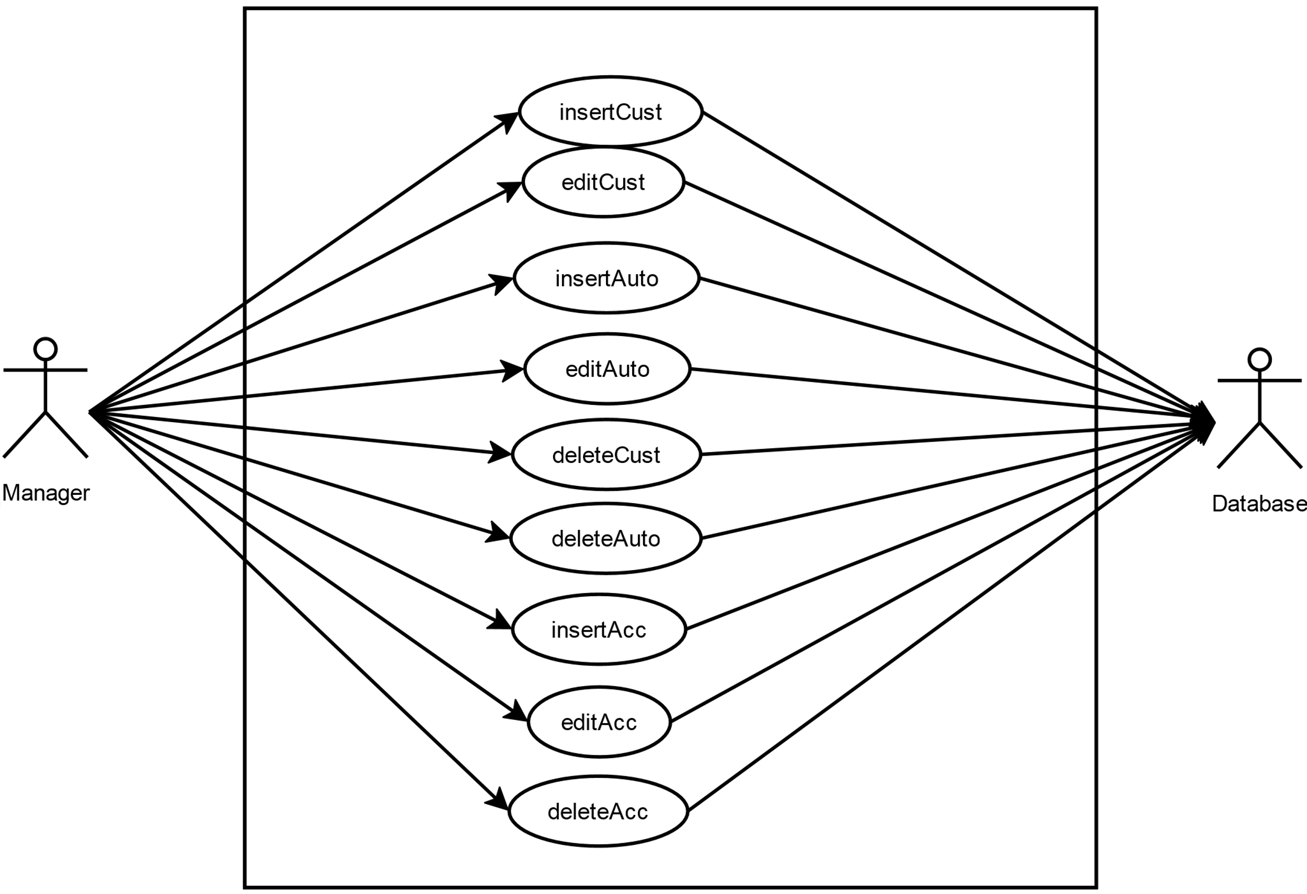

**Manager&Employee-Database**

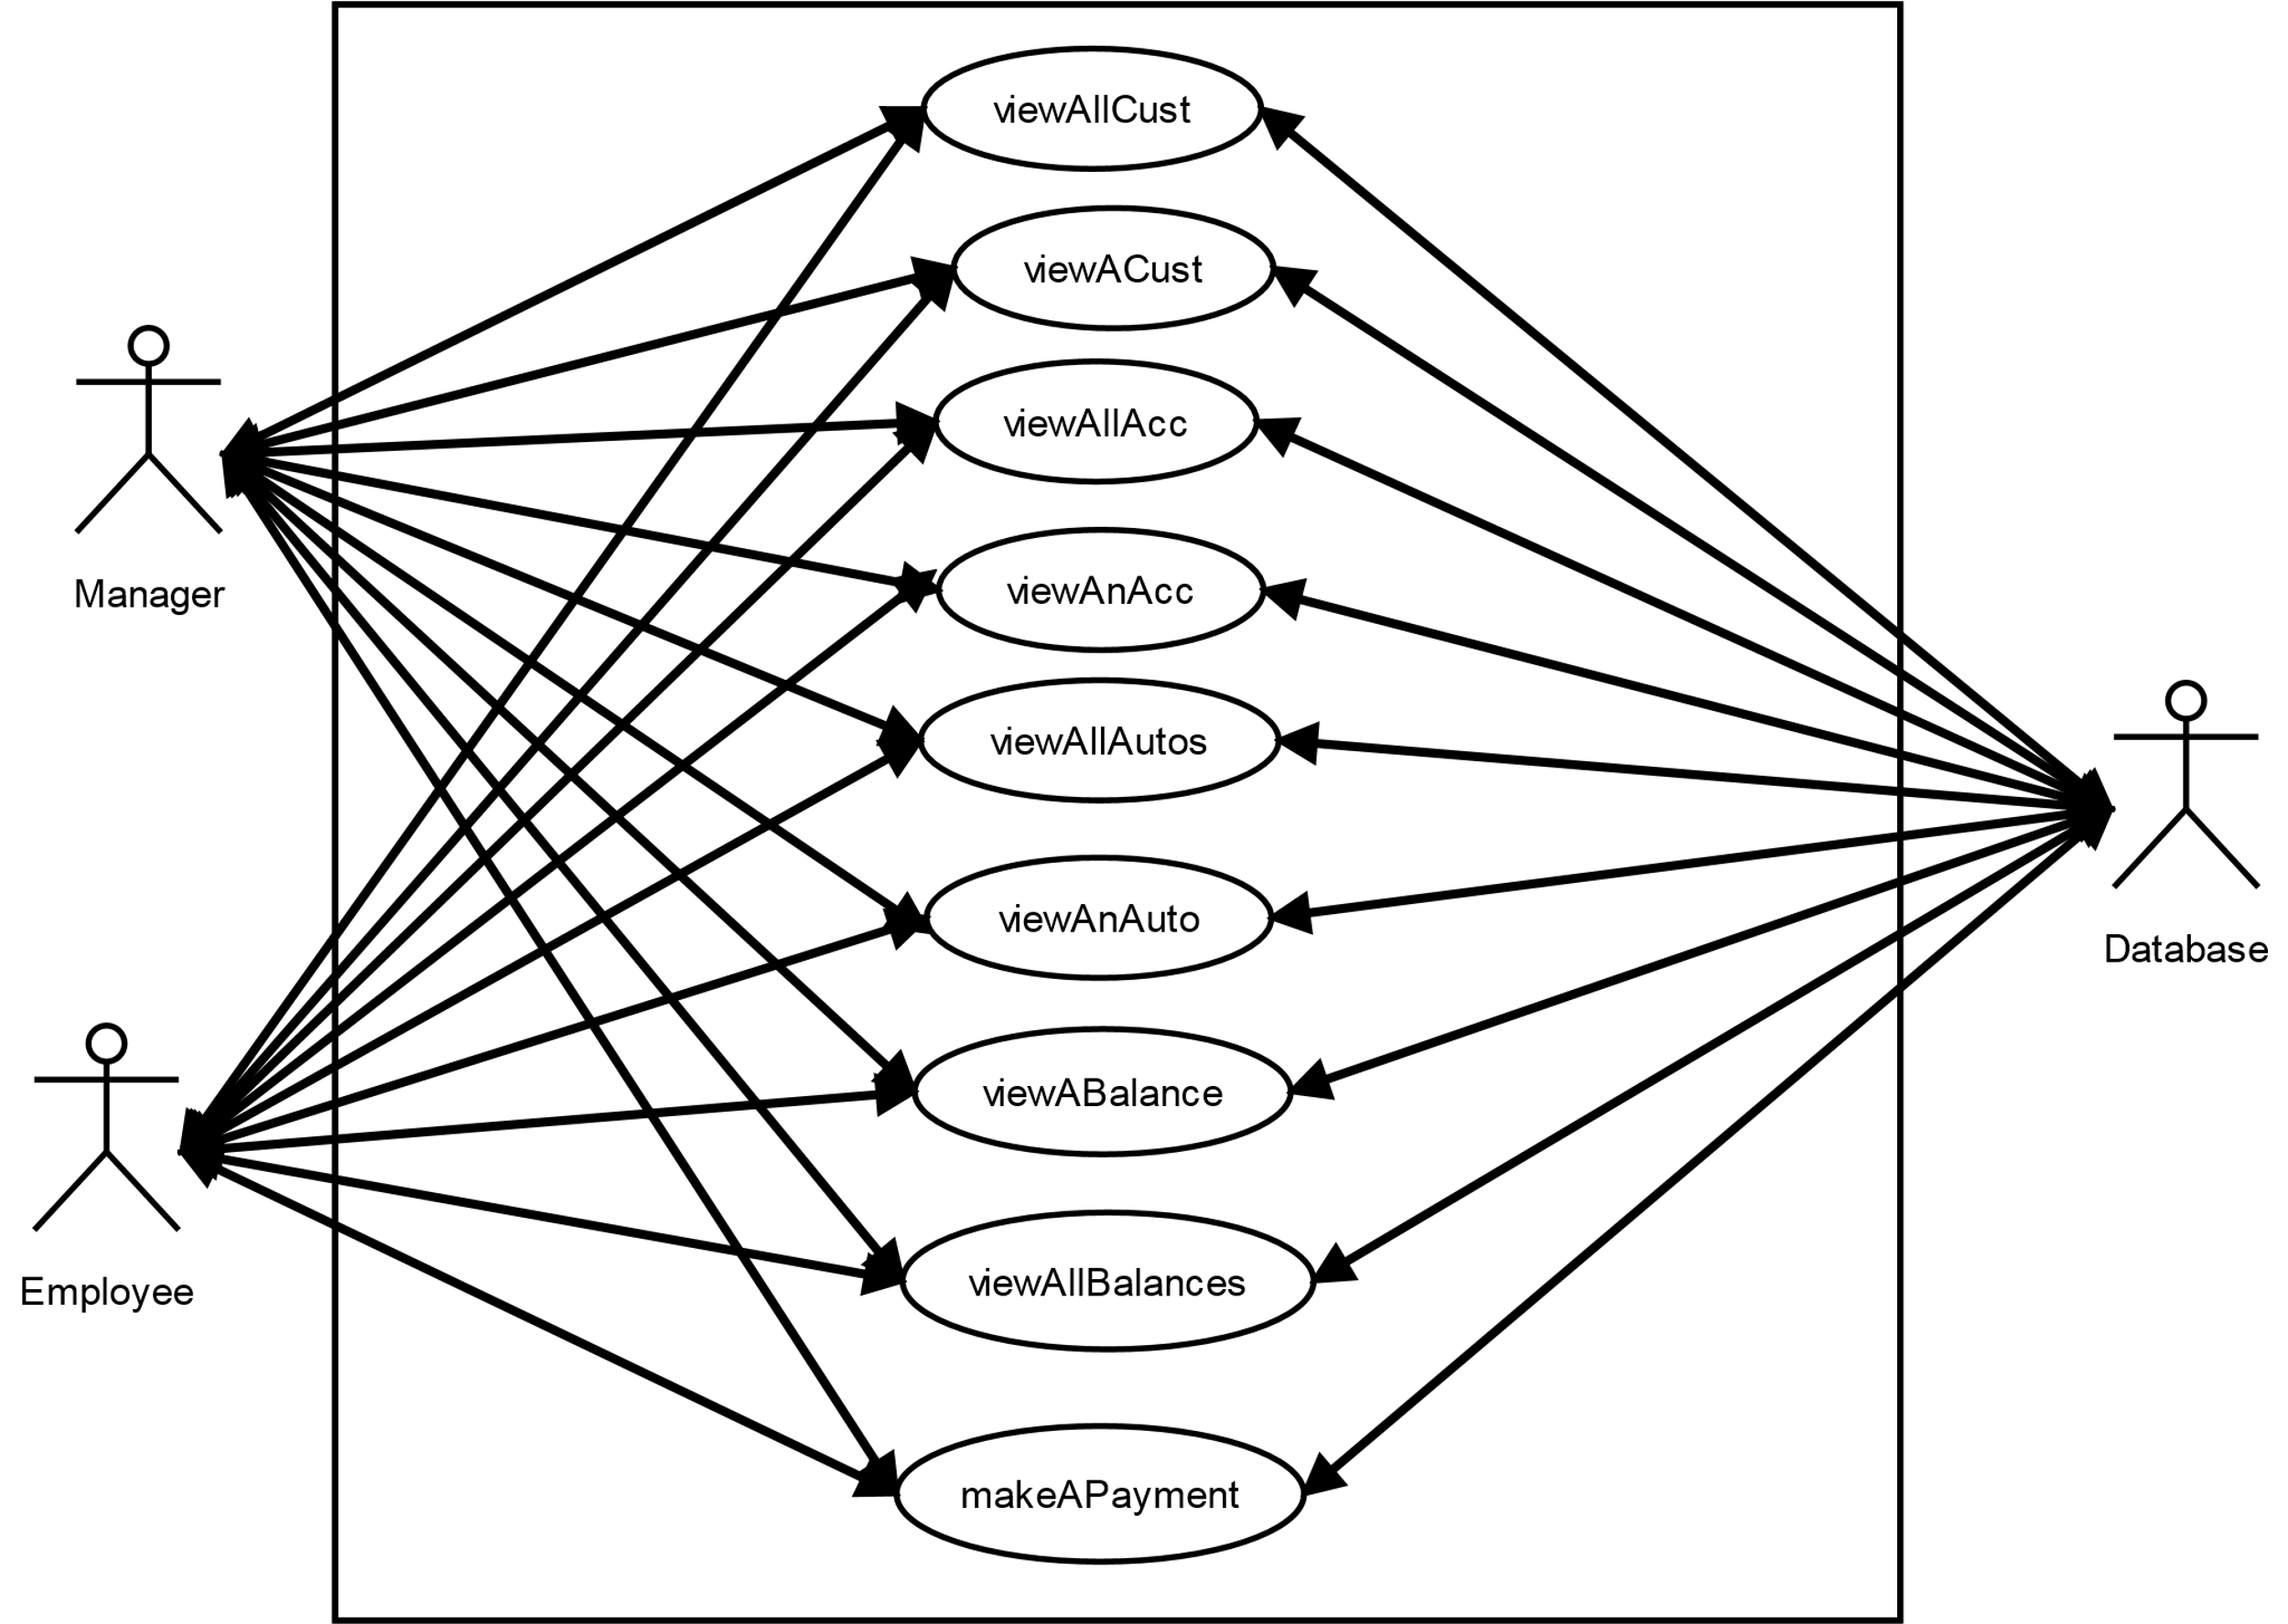

**AutoSales Class Diagram**

