Lucrare de laborator nr.2 Smson Nicoleta

1. set

2.WIN+R; cmd; CD C:\

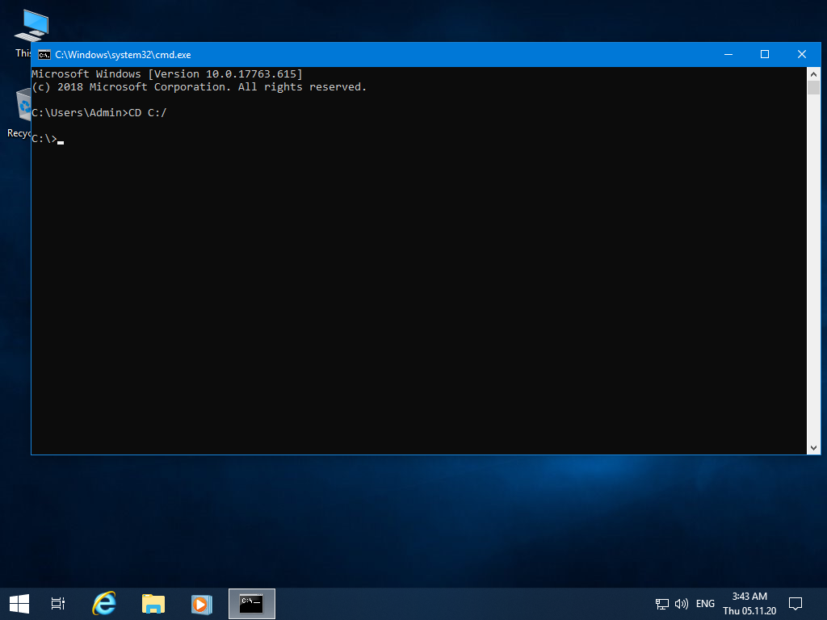

3. WIN+R; cmd; tree C:\ > raport.txt

4. WIN+R; cmd; DIR C:\O=D

5.WIN+R; cmd; tree/

6.WIN+R; cmd; mkdir VARIANTA I

7. WIN+R;cmd ;copy \*.xls D:\EXPORT\\*.xls

8.WIN+R;cmd; erase D:/test.txt

9. WIN+R;cmd; time/t

10. WIN+R;cmd; at

11. WIN+R;cmd;atrrib the O:\

12. WIN+R;cmd; time

13.

14.