**Whitewater Rafting Website Plan**

1. The image file you selected for the site logo.

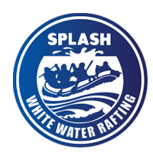

1. Write out the four (4) color labels (listed below) with the color codes you selected:
   * primary-color ___#003459 – Prussian Blue
   * secondary-color __#007EA7 - Cerulean
   * accent1-color  __#00A8E8 – Picton Blue
   * accent2-color __#00171F – Rich Black
   * additional-color #FFFFFF
2. Write out the two (2) font labels (listed below) and the names of the fonts you selected:
   * heading-font ___Merriweather____
   * text-font _____Roboto____________
3. Provide the URL link to your color palette that you designed in coolors.co  
   https://coolors.co/ffffff-00171f-003459-007ea7-00a8e8