Construction
- Dependence mapping for Constriction
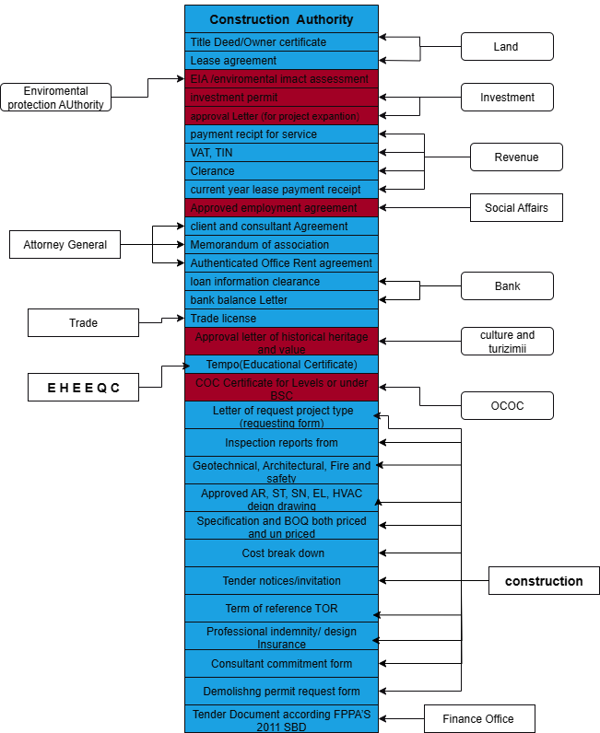

No | Sector exposed Data | Service | Developed system included service | Developed system not included service | System is not developed for service
1 | Land | Title deed/owner certificate
 |  | Lease Agreement
2 | Environmental Protection Authority | EIA(Environmental Impact Assesment)
3 | Investment | Investment permit
3 | Investment | Approve reason of renewal report (approved letter for modification or project type change)
4 | Revenue | Service payment receipt
4 | Revenue | VAT,TIN
4 | Revenue | Clearance
5 | Attorney | Approved employment agreement
5 | Attorney | client and consultant Agreement
5 | Attorney | memorandum of association
5 | Attorney | Authenticated Office Rent agreement
6 | Bank | Loan information clearance
6 | Bank | Bank balance Letter
7 | Trade | Trade license
8 | Culture And turizimii | historical heritage and value
9 | EHEEQC | Tempo (Educational Certificate)
10 | OCOC | COC Certificate
11 | Social Affairs | Unemployment support
12 | Construction | Letter of request project type (requesting form) can document Design site report
12 | Construction | Inspection reports from
12 | Construction | Geotechnical, Architectural, Fire and safety, Electro mechanical, Electrical Sanitary design, Structural design report
12 | Construction | Approved AR, ST, SN, EL, HVAC deign drawing
12 | Construction | Specification and BOQ both priced and un priced
12 | Construction | Cost break down
12 | Construction | Tender notices/invitation
12 | Construction | Term of reference TOR
12 | Construction | Professional indemnity/ design Insurance
12 | Construction | Consultant commitment form
12 | Construction | Demolishng permit request form -
12 | Construction | Consultant commitment form
13 | Finance | Tender Document according FPPA’S 2011 SBD

- From OCA Office
- Letter of request project type (requesting form)
can document Design site report
- Inspection reports from
- Geotechnical, Architectural, Fire and safety, Electro mechanical, Electrical Sanitary design, Structural design report
- Approved AR, ST, SN, EL, HVAC deign drawing
- Specification and BOQ both priced and un priced
- Cost break down
- Tender notices/invitation
- Term of reference TOR
- Professional indemnity/ design Insurance
- Consultant commitment form
- Tender Document according FPPA’S 2011 SBD
- Demolishng permit request form -
- From Vital Registration Office
- ID card
- From Land Office
- title deed /owner certificate
- Site plan
- Lease agreement
- From Environmental protection office
- EIA /environmental impact assessment
- From Oromia Investment and Industry office
- Investment permit
- Approve Reason of renewal report

- From Revenue Office
- invoice
- VAT
- TIN
- Confirmation of Turnover
- Current year lease payment receipt

- From Attorney General
- Approved employment agreement
- client and consultant Agreement
- memorandum of association
- Authenticated Office Rent agreement
- From Bank
- Loan information clearance
- Bank balance Letter
- From Trade office
- Trade licenses
- From culture and heritage office
- Approval latters of historical heritage and value
- From Educational instruction
- Tempo (Educational Certificate)
- From COC canter
- COC Certificate for Levels or under BSC

- Oromia Land Bureau
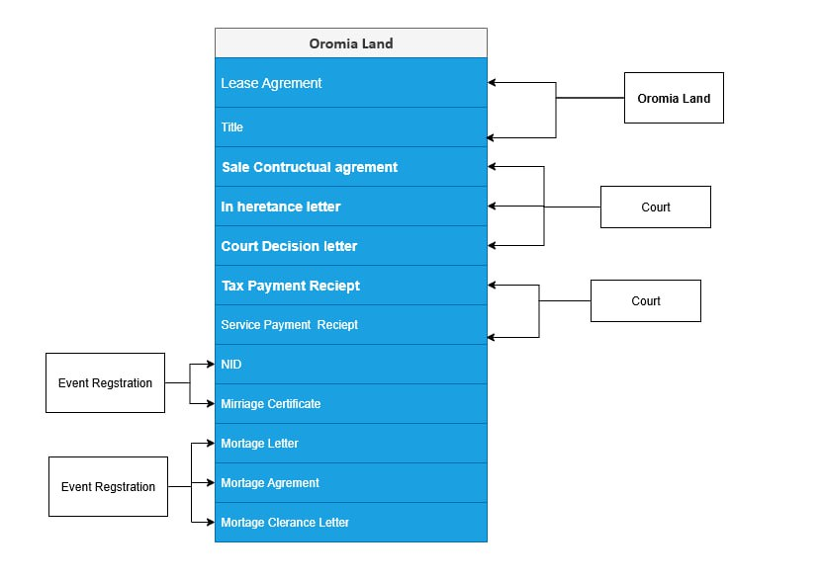

No | Sector exposed Data | Service | Developed system included service | Developed system not included service | System is not developed for service
1 | Oromia Land | Lease Agreement
1 | Oromia Land | Title
1 | Oromia Land | Sale Contract agreement
2 | Court | Inheritance Letter
2 | Court | Court Decision Letter
4 | Revenue Office | Tax payment receipt
4 | Revenue Office | Service payment receipt
5 | Event Registration | NID
5 | Event Registration | Marriage certificate
6 | Bank | Mortgage letter
6 | Bank | Mortgage Agreement
6 | Bank | Mortgage Clearance letter

- Oromia Land Office
  - Lease Agreement
  - Title
  - Sale Contract agreement

- Court
- Inheritance Letter
- Court Decision Letter
- Revenue Office
- Tax payment receipt
- Service payment receipt

- Event Registration
- NID
- Marriage certificate
- Bank
- Mortgage letter
- Mortgage Agreement
- Mortgage Clearance letter

- Oromia Trade Bureau
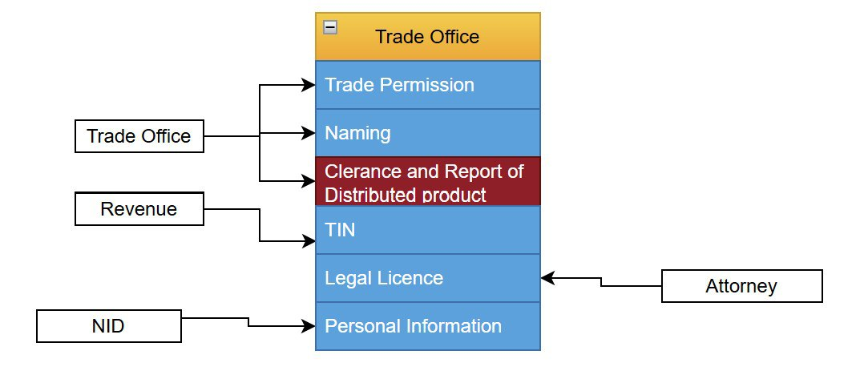

No | Sector exposed Data | Service | Developed system included service | Developed system not included service | System is not developed for service
1 | Trade | Trade Permission
1 | Trade | Naming
2 | Revenue | TIN
3 | Trade | Clerance and Report of Distributed Product
4 | Attorney | Legal Licence
5 | NID | Personel Information

- Dependence mapping From Trade Office
- Scanned Trade permission certificate, Naming Certificate.
- Dependence mapping From Revenue Office
- Tax Identification number (TIN),

- Dependence mapping From Agriculture Office
- The Report and Clearance of Distiributed Product sent from agriculture office.
- Dependence mapping From Attorney
- The Legal License where given from the Attorney office if the issue not about individual issue.
- Dependence mapping From NID
- The Personal Information fitched from the NID.

- Town(city)Water Supply Sewerage and Service Enterprises
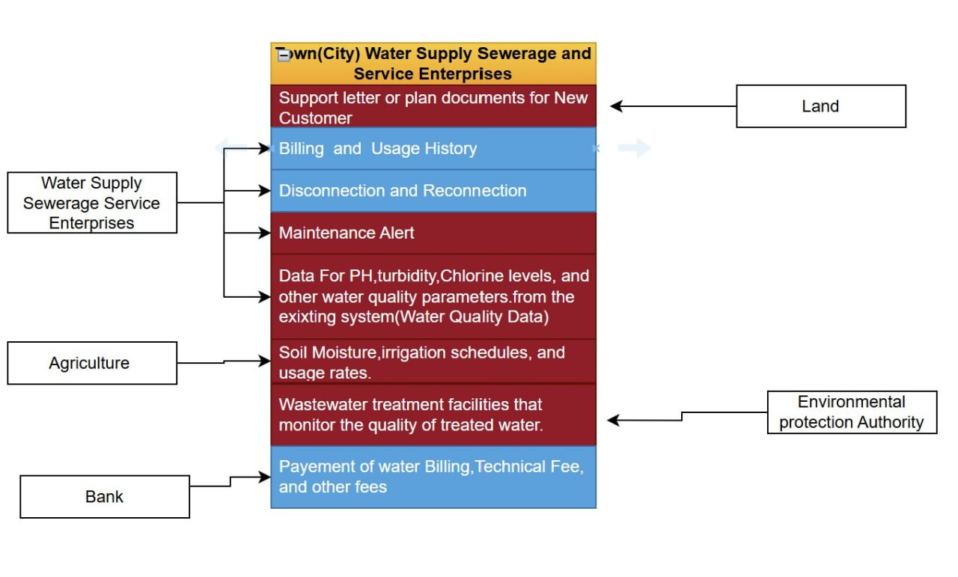

No | Sector exposed Data | Service | Developed system included service | Developed system not included service | System is not developed for service
1 | Land | Support letter or plan document for new customer
2 | Water Supply Sewerage Service Enterprises | Billing and Usage History
2 | Water Supply Sewerage Service Enterprises | Disconnection and Reconnection
2 | Water Supply Sewerage Service Enterprises | Maintenance Alert
2 | Water Supply Sewerage Service Enterprises | Data for PH,Turbidity,Chlorine levels, and other water quality parameters from the existing system(Water Quality Data)
3 | Agriculture | Soil moisture,irrigation schedule and usage rates.
4 | Enviromental Protection Authority | Wastewater treatment facilities that monitor the quality of treated water.
5 | Bank | Payment of water billing ,technical fee, and other fees.

Data Required | Office/Service Exposing Data | Service Endpoint Format | Description
Water Consumption Data | Water Supply Sewerage Service Enterprises (Adama Town) | GET /api/water-usage/{customer_id} | Real-time water consumption data from the Adama Water Utility System (WUMIS). Currently integrated with limited coverage.
Water Quality Data | Water Supply Sewerage Service Enterprises (Adama Town) | GET /api/water-quality/{location_id} | Monitors parameters like pH, turbidity, and chlorine levels. Data is available from the existing system for water quality analysis.
Water Flow Data | Water Supply Sewerage Service Enterprises (Adama Town) | GET /api/flow-rate/{pipeline_id} | Not yet developed. This feature needs to be created and integrated into the current system.
Billing and Usage History | Water Supply Sewerage Service Enterprises (Adama Town) | POST /api/billing/{customer_id}/generate-bill | Billing data, user account history based on consumption. Currently integrated with a bank in limited coverage for billing purposes.
Maintenance Alerts | Water Supply Sewerage Service Enterprises (Adama Town) | GET /api/maintenance-alerts/{system_id} | Alerts for pipeline repairs or upgrades. This feature is currently under development and is not yet integrated.
Demand Forecasting | Onestop Service | GET /api/water-demand/forecast/{region_id} | Forecasting tools for water demand are not yet developed, requiring new development for implementation.
Irrigation Water Data | Agriculture Bureau | GET /api/irrigation/{farm_id} | Data regarding irrigation systems, including soil moisture, irrigation schedules, and usage rates. Development needed to implement this.
Water Usage Optimization Data | Water Supply Sewerage Service Enterprises (Adama Town) | GET /api/efficiency/{region_id} | Data related to optimizing water usage efficiency for irrigation systems. Currently under development.
Water Availability Data | Oromia Water and Energy Bureau | GET /api/resource-availability/{region_id} | No centralized system exists for water resource availability; integration and system deployment are required.
Water Consumption Data (Industrial) | Oromia Water and Energy Bureau | GET /api/water-usage/{facility_id} | Data available for industrial consumption. Can be integrated from currently deployed systems for large-scale industries.
Wastewater Treatment Data | Environmental Protection Authority | GET /api/wastewater/{facility_id} | Data from wastewater treatment facilities that monitor the quality of treated water.
Water Quality Data (Environmental) | Ministry of Environment and Forests (MoEF) | GET /api/quality/{region_id} | Monitors water quality in rivers, lakes, and reservoirs for conservation purposes. Data essential for environmental health.
- Health office

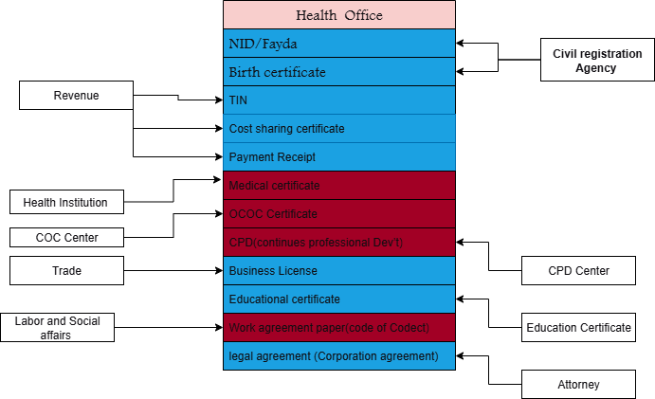

Health office
No | Sector exposed Data | Service | Developed system included service | Developed system not included service | System is not developed for service
 | Civil Registration Agency/Fayda | - NID/Fayda, Full Attachment Docs  - Birth certificate, Birth Certificate attachment Docs | ☑
 | Revenue Office | - TIN, TIN Certificate Scanned attachment | ☑
 | Revenue Office | - Cost sharing certificate, Scanned attachment (GET)  - Payment Receipt, Scanned attachment (GET) | ☑
 | Health Facilities | - Medical certificate, Scanned attachment |   ☑
 | CPD Centre | - CPD(continues professional Dev’t) , Scanned certificate attachment |  |  | ☑
 | Trade Office | - Business License, Scanned Business License attachment | ☑
 | COC Agency | - COC Certificate, scanned certificate attachment |  |  | ☑
 | Educational Institution | - Educational certificate, scanned certificate attachment | ☑
 | Labour and Social Affairs Office | - Work agreement paper(Code of conduct), scanned agreement attachment (GET) |  |  | ☑
 | Attorney Office | - Bylaws (Corporation agreement), scanned Corporation agreement attachment | ☑

Health office
  - Civil Registration Agency/Fayda
- NID/Fayda, Full Attachment Docs (GET)
- Birth certificate, Birth Certificate attachment Docs(GET)
  - Revenue Office
- TIN, TIN Certificate Scanned attachment (GET)
- Cost sharing certificate, Scanned attachment (GET)
- Payment Receipt, Scanned attachment (GET)
- Payroll report, Scanned attachment (GET)
  - Health Facilities
- Medical certificate, Scanned attachment (GET)
  - CPD Center
- CPD(continues professional Dev’t) , Scanned certificate attachment (GET)
  - Trade Office
- Business License, Scanned Business License attachment (GET)
  - COC Agency
- COC Certificate, scanned certificate attachment (GET)
  - Educational Institution
- Educational certificate, scanned certificate attachment (GET)
  - Labor and Social Affairs Office
- Work agreement paper(Code of conduct), scanned agreement attachment (GET)
  - Attorney Office
- Bylaws (Corporation agreement), scanned Corporation agreement attachment (GET)

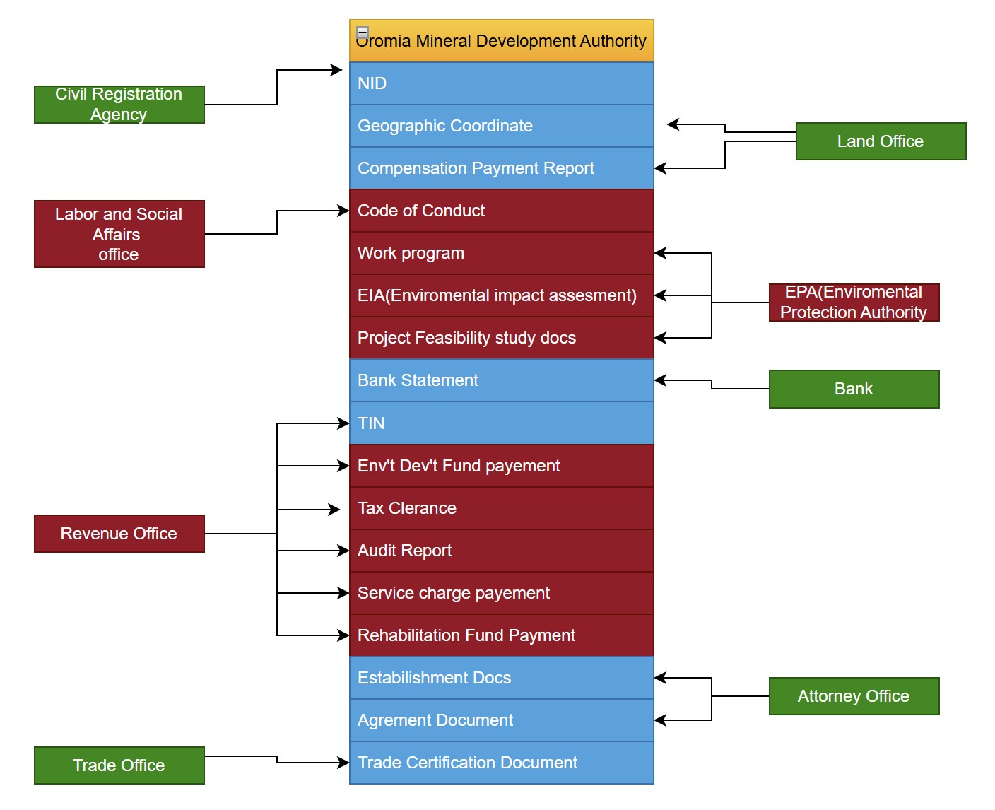
- Mineral Burea

Menial Development Authority
No | Sector exposed Data | Service | Developed system included service | Developed system not included service | System is not developed for service
 | Land Office | - Geographic coordinate, full doc attachment  - Compensation payment report, full doc attachment | ☑
 | EPA(Environmental Protection Authority) | - Work program, full doc attachment  - EIA(Environmental Impact Assessment ), full EIA doc attachment  - Project feasibility study document, Full doc attachment |  |  | ☑
 | Bank | - Bank statement, Statement attachment | ☑
 | Attorney Office | - Establishment document, Scanned attachment  - Agreement document , Scanned attachment | ☑
 | Civil Registration Agency /Fayda | - NID(Fayda),Full scanned information attachment | ☑
 | Labor and Social Affairs Office | - Code of conduct, Scanned doc. attachment |  |  | ☑
 | Revenue Office | - TIN, TIN Certificate Scanned attachment | ☑
 | Revenue Office | - Env’t Dev’t Fund payment, Scanned attachment  - Tax Clearance, Scanned attachment  - Audit Report, Full scanned information attachment  - Service Charge Payment , Scanned receipt attachment  - Re-habitation Fund Payment, Scanned receipt attachment |  |  | ☑
 | Trade Office | - Trade Registration certification, Scanned certificate attachment | ☑

  - Land Office
- Geographic coordinate, full doc attachment (GET)
- Compensation payment report, full doc attachment (GET)
  - EPA(Environmental Protection Authority)
- Work program, full doc attachment (GET)
- EIA(Environmental Impact Assessment ), full EIA doc attachment (GET)
- Project feasibility study document, Full doc attachment (GET)
  - Bank
- Bank statement, Statement attachment (GET)
  - Attorney Office
- Establishment document, Scanned attachment (GET)
- Agreement document , Scanned attachment (GET)
  - Civil Registration Agency /Fayda
- NID(Fayda),Full scanned information attachment(GET)
  - Labor and Social Affairs Office
- Code of conduct, Scanned doc. attachment (GET)
  - Revenue Office
- TIN, TIN Certificate Scanned attachment (GET)
- Env’t Dev’t Fund payment, Scanned attachment (GET)
- Tax Clearance, Scanned attachment (GET)
- Audit Report, Full scanned information attachment(GET)
- Service Charge Payment , Scanned receipt attachment (GET)
- Rehabitation Fund Payment, Scanned receipt attachment (GET)
  - Trade Office
- Trade Registration certification, Scanned certificate attachment (GET)

- Oromia Attorney
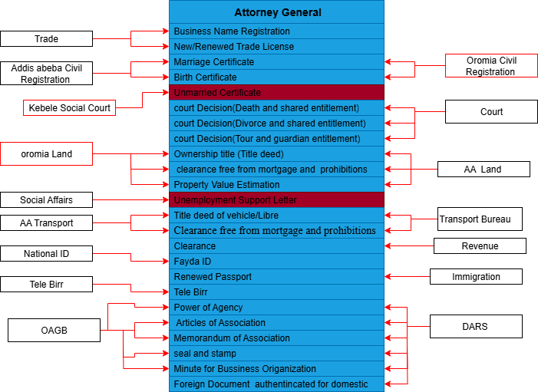

No | Sector exposed Data | Service | Developed system included service | Developed system not included service | System is not developed for service
1 | Trade | Business Name Registration
 |  | New/Renewed Trade License
2 | Civil Registration  AA and Oromia | Marriage Certificate
2 | Civil Registration  AA and Oromia | Birth Certificate
3 | Kebele Social Affair | Unmarried certificate
4 | Court | Court decision (Death and share entitlement
4 | Court | Court decision ( divorced spouse share entitlement )
4 | Court | Tour and guardian court decision
5 | Oromia and AA Land office | Ownership title (Title deed)
5 | Oromia and AA Land office | Property clearance free from any mortgage and prohibitions
5 | Oromia and AA Land office | Property Value Estimation
6 | Social and labor affair | Unemployment Support Letter
7 | Transport | Title deed of vehicle/Libre
7 | Transport | Clearance free from any mortgage and prohibitions
8 | Revenue | Clearance
9 | National ID | Fayda ID
10 | Immigration | Renewed Passport
 | Telle birr | Any payment
11 | OAGB and DARS | Seal and Stamp Samples
11 | OAGB and DARS | Power of Attorney
11 | OAGB and DARS | Articles of Association
11 | OAGB and DARS | Memorandum of Association
11 | OAGB and DARS | Minutes of trade Association

- Trade Office
- Business Name Registration Attachment (GET)
- New/Renewed Trade License Attachment (GET)
- Civil Registration
- Marriage Certificate Attachment (GET)
- Birth Certificate Attachment (GET)
- Kebele Social Court
- Unmarried Certificate Attachment (GET)
- Court
- Court decision regarding inheritance rights of the decedent in the case of Business organization share entitlement Attachment (GET)
- Court decision regarding the divorced spouse in the case of business organization share entitlement Attachment (GET)
- Tour and guardian court decision Attachment (GET)
- Land Office
- Ownership title (Title deed) Attachment (GET)
- Property clearance free from any mortgage and prohibitions Attachment (GET)
- Property Value Estimation Attachment (GET)
- Labor and Social Office
- Unemployment Support Letter Attachment (GET)
- Transport Office
- Title deed of vehicle/Libre Attachment (GET)
- Clearance free from any mortgage and prohibitions Attachment (GET)
- Revenue
- Clearance Attachment (GET)
- National ID
- Fayda ID
- Immigration
- Renewed Passport
- Payment
- Tele birr
- Federal Document Authentication and Registration
- Power of Agency issued by DARS Attachment (GET)
- Articles of Association Attachment (GET)
- Memorandum of Association Attachment (GET)
- Documents Authenticated abroad and authenticated by DARS for use within the country Attachment (GET)
- Meeting minutes of trade associations Attachment (GET)
- Addis Ababa civil Registration
- Birth certificate
- Marriage certificate
- Addis Ababa Land Bureau
- Ownership title (Title deed) Attachment (GET)
- Property clearance free from any mortgage and prohibitions Attachment (GET)
- Property Value Estimation Attachment (GET)
- Addis Ababa Trasport Bureau
- Title deed of vehicle/Libre Attachment (GET)
- Clearance free from any mortgage and prohibitions Attachment (GET)
- Oromia Attorney General Bureau
- Seal and Stamp Samples Attachment (GET)
- Power of Attorney issued at the OAGB Attachment (GET)
- Articles of Association Attachment (GET)
- Memorandum of Association Attachment (GET)
- Minutes of trade Association Attachment (GET)

8. Civil Registration
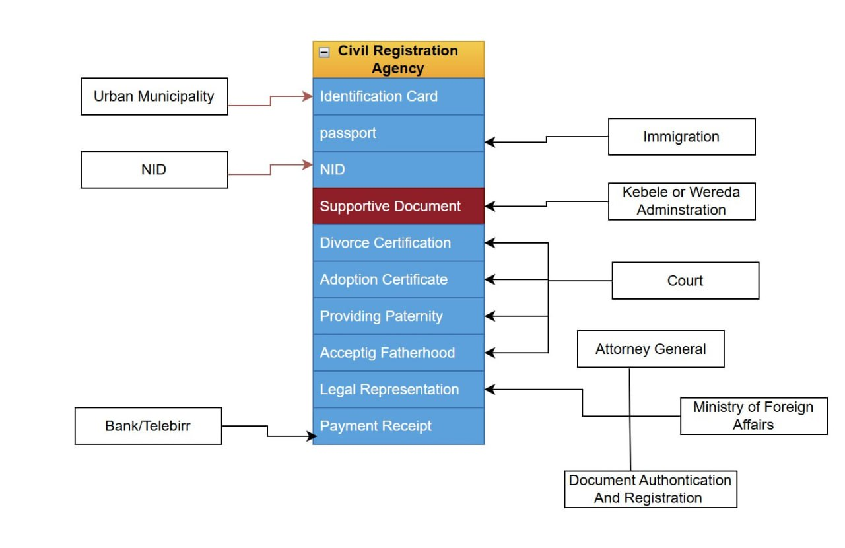
Service Mapping for Civil Registration Agency

No | Sector exposed Data | Service | Developed system included service | Developed system not included service | System is not developed for service
1 | Urban Municipality | Identification Card
 | Immigration | Password
2 | NID | NID
3 | Kebele or Wereda Administration | Supportive Document
4 | Court | Divorce Certification
5 | Court | Adoption Certification
 | Court | Providing paternity
 | Court | Accepting Fatherhood
 | Attorney | Legal Representation
 | Bank Or Tele Birr | Payement receipt

- From Immigration and Citizenship Services
- Passport: - Information of the person's Attachment (Get)
- From the National Identification Agency
- Faydsa: -Information of the person Attachment (Get)
- From Urban Municipality
- Identity card: - Information of the person Attachment (Get)
- From the Kebele or Woreda administration
- Letter of support: - Letter of support stating that the person is a village resident attachment (Get)
- From the court
- Divorce Certificate: - Information of the person Attachment (Get)
- Adoption Certificate: - Information of the person Attachment (Get)
- Proving paternity and: - Information of the person Attachment (Get)
- Accepting Fatherhood: - Information of the person Attachment (Get)
- From the Attorney General
- Legal representation: - Information of the person Attachment (Get)
- From the Ministry of Foreign Affairs
- Legal representation: - Information of the person Attachment (Get)
- From the Document Certification and Registration Service
- Legal representation: - Information of the person Attachment (Get)
- Tele birr/Bank
- Payment gateway for every payment receipt Attachment (Get)

9.Oromia Transport Agency
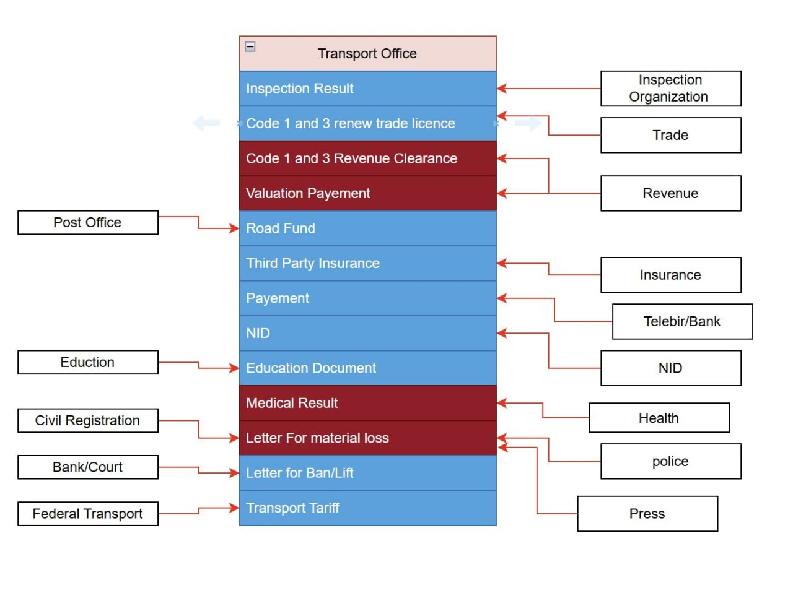

No | Sector exposed Data | Service | Developed system included service | Developed system not included service | System is not developed for service
1 | Inspection Organzation | Inspect the result
 | Trade | Code 1 and 3 renew trade service
 | Revenue | Code 1 and 3 Revenue clerance
 | Revenue | Valuation payement
 | Post Office | Road Fund
 | Insurance | Third party Insurance
 | Bank/Telebirr | Payement
 | NID | NID
 | Education | Education Document
 | Health | Medical Result
 | Event Registration | Letter For material loss
 | Police | Letter For material loss
 | Bress | Letter For material loss
 | Bank | Letter for Bank/lift
 | Federal Transport | Transport Tariff

- Revenue Bureau
- Revenue clearance for code 1 & 3 vehicles
- Tax payment clearance to change vehicle owner\
- Trade Bureau
- Renewed Trade License for code 1 & 3 vehicles
- Bollo Inspection Organization
- Passed inspection result for inspected vehicles
- Post Office
- To get a vehicle road fund clearance
- Insurance
- To know a vehicle thrid party assurance
- Telebirr/Bank
- Payment gateway for every payment
- National Id
- For every service that requests ID card
- Education Bureau
- For a new driving license
- Health Bureau
- To request a medical document for a new driving license or to renew a driving license
- Civil Registration
- To request a Marriage certificate for a vehicle owner change, etc.
- Police Commission
- To request a Letter for lost material
- Bank/Court
- To request a letter to Ban or Lift a ban
- Press(Gazette)
- To request a letter if the material loss is announced in the gazette
- Federal Transport
- To request a new transport tariff

10. Muniplacity
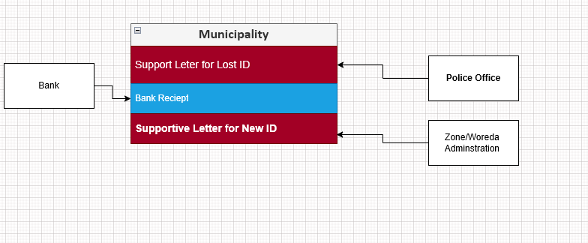
No | Sector exposed Data | Service | Developed system included service | Developed system not included service | System is not developed for service
1 | Polices Offices | Support Letter for Lost ID
2 | Bank | Bank Reciept
3 | Zone Woreda Admnistration | Support Letter for New ID

- Police office
- Support Latter for Lost ID
- Bank
- Bank Recipt
- Zone Woreda Administration
- Supportive Latter For New ID

11. Education Bureau
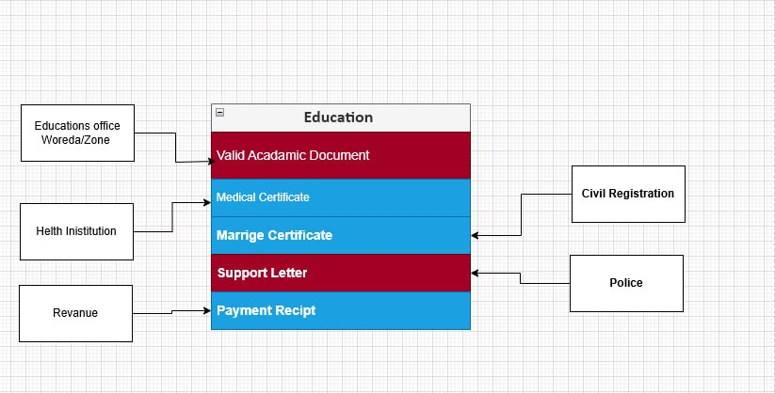

No | Sector exposed Data | Service | Developed system included service | Developed system not included service | System is not developed for service
1 | Woreda Administrative Education Office | Valid Academic Documents
2 | Health | Medical Certificate
3 | Vital Registration | Marriage Certifcate
4 | Police Office | Support Letter
5 | Bank | Payment Reciept

- Responsible Woreda/Town Administrative Education Office
- Valid Academic Documents
- Health
- Medical Certificate
- Revenue
- Payment Receipt
- Police Office
- Support Letter
- Vital Event
- Marriage Certificate

Oromia Devlopment Decplaced Community Egency
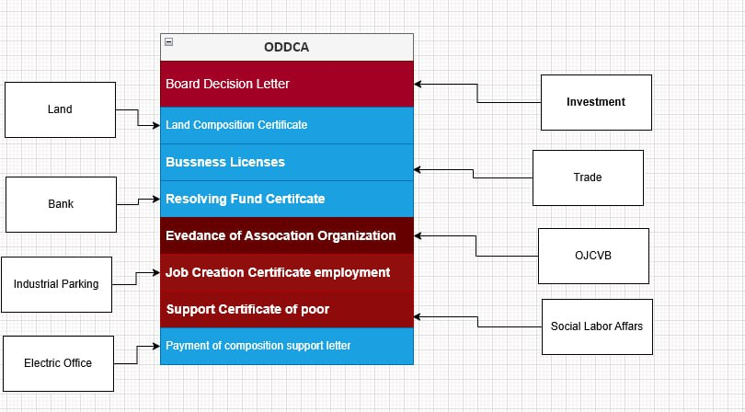

No | Sector exposed Data | Service | Developed system included service | Developed system not included service | System is not developed for service
1 | Investment | Certified of proof Owner Ship
2 | Land | Land Composition Certificated
3 | Zone Woreda Admnistration | Busness Licenses
4 | Bank | Resolving Fund Certificate
5 | OJCVB | Evedance of Assocation Organization
6 | Industrial Park | Job Creation Certificate employment
7 | Social Labor Affairs | Support Certificate of poor
8 | Electric Office | Payment Of Composition Support Letter

Job creation and vocational Bureau

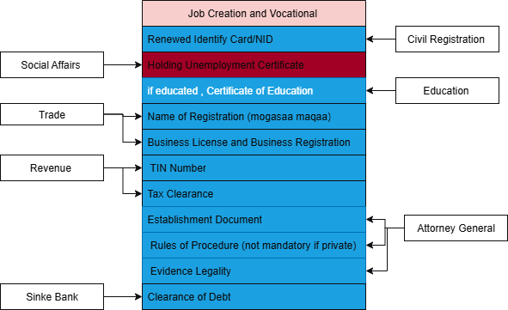

No | Sector exposed Data | Service | Developed system included service | Developed system not included service | System is not developed for service
1 | Civil registration | Renewed identity card/NID
2 | Social affairs | Holding Unemployment certificate
3 | Education | education, Certificate of Education
4 | Trade | Name of Registration (mogasaa maqaa)
4 | Trade | Business License and Business Registration
4 | Revenue | Tin Number
4 | Revenue | Tax Clearance
5 | Attorney | Establishment Document
5 | Attorney | Rules of Procedure (not mandatory if private)
5 | Attorney | Evidence Legality
6 | Industrial Park | Clearance of Debt
7 | Sinke | Clearance of Debt
- Civil Registration Agency / Fayda
- Renewed Identify Card/NID
- Social Affairs
- Holding Unemployment Certificate
- Education
- If education, Certificate of Education
- Trade
- Name of Registration (mogasaa maqaa)
- Business License and Business Registration
- Revenue
- TIN Number
- Tax Clearance
- Attorney Generals
- Establishment Document
- Rules of Procedure (not mandatory if private)
- Evidence Legality
- Sinqe Bank
- Clearance of Debt
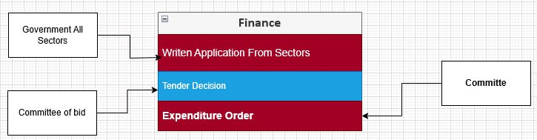
Finance

No | Sector exposed Data | Service | Developed system included service | Developed system not included service | System is not developed for service
1 | Governmental all sector | Write application from sectors
2 | Social affairs | Holding Unemployment certificate
3 | Education | education, Certificate of Education

- Government All Sector
- Writen application from sector
- Committee of bid
- Tender decision
- Committee
- Expenditure

