Oromia Science Technology

And

Information Communication Authority

**Durgo Application User Guide**

Prepared By: Dejene Kasa

May 5, 2020

**1.1** **Getting Started**

This document provides a step by step guide to use Durgo application. It is intended for use to all employees and staff in the Accountant and Cashbook Administration unit, who has entrusted with the control, custody and stewardship of public prop-erty. The user guide is prepared to be accessed in two forms, one is where you went to use this guide to perform a full activity based on functionality of the system and the second is that you went to have a general understanding of the system as pre-sented all navigational informations here in this guide.

Open the URL given to you by the system administrator in your web browser.



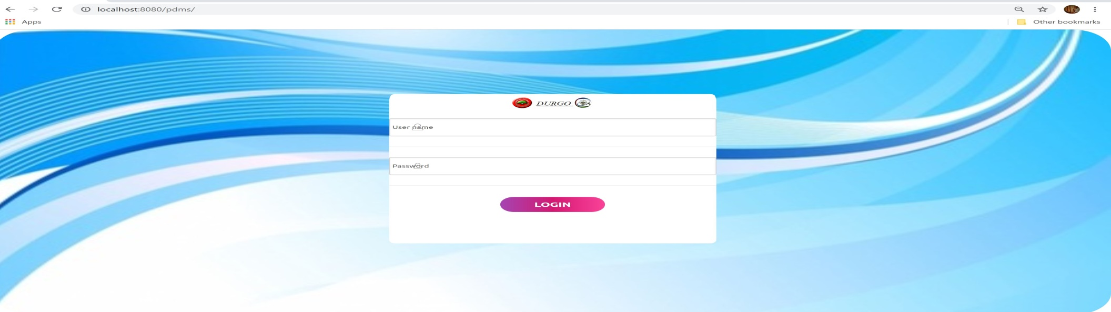

**username**

Login Form

Type in your username and password into the according fields. Hit the Login button or press <Enter> on your keyboard to authenticate.

**1.1.1** **General Overview of the User Interface**

Once authenticated, you are ready to perform certain activities by navigating through the links presented by the system. The screen of CMS is divided into three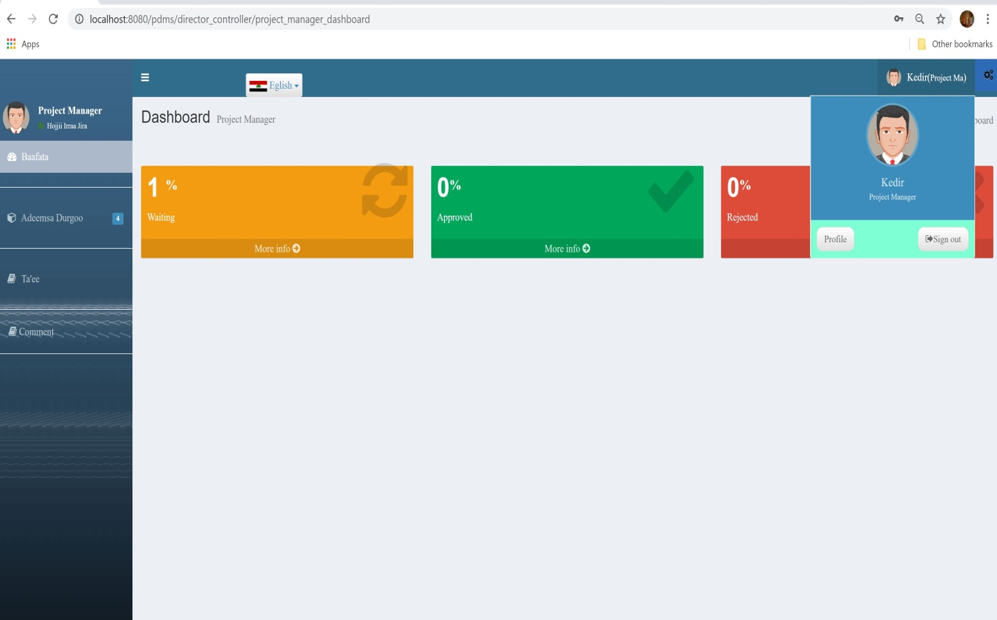

Request Form of Durgo management system

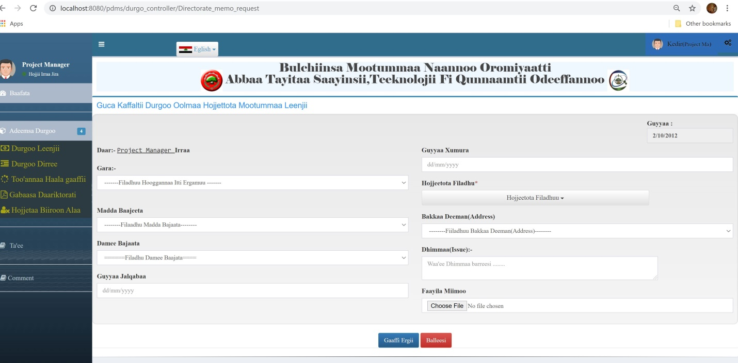

2.1 Directorate Dashboard

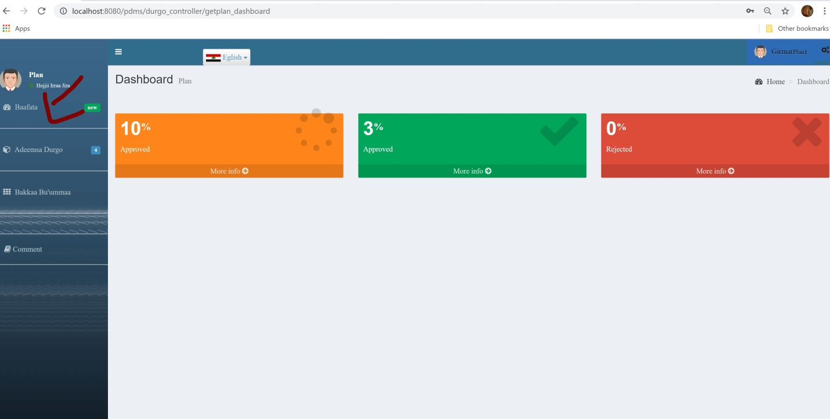

Plan dashboard

Registrar Office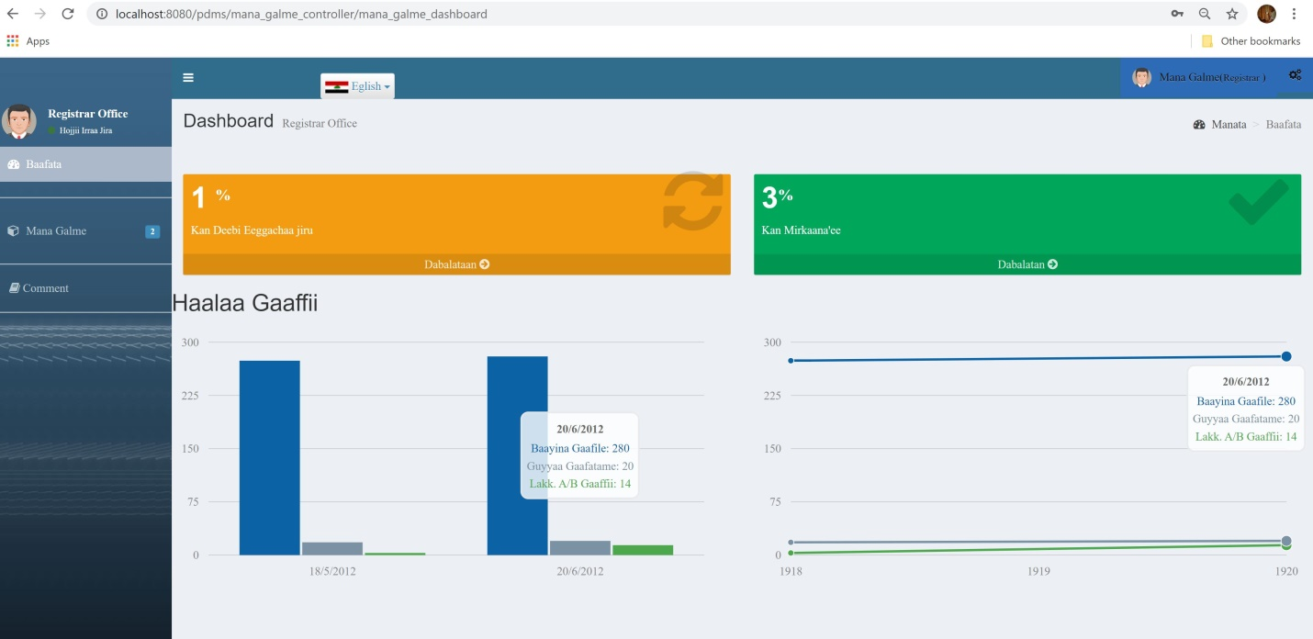

Registrar Office dashboard

Registrar Activity

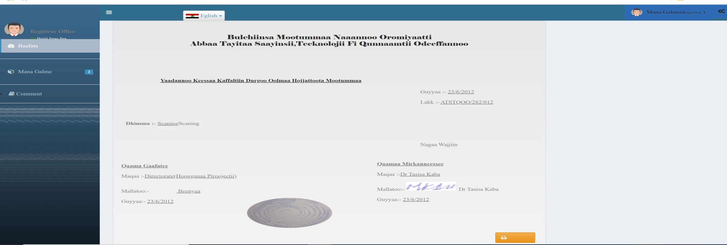

Finance Head Director Activity

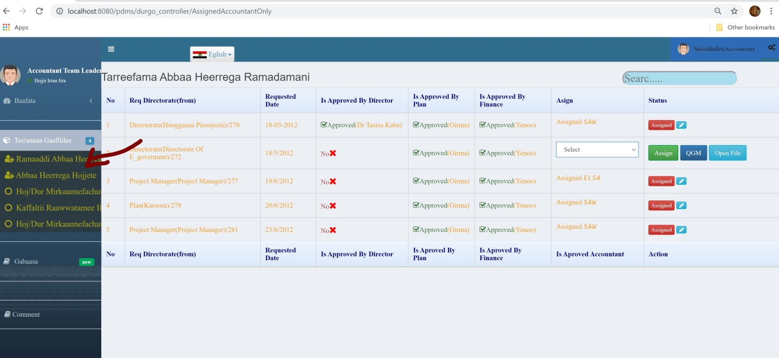

Accountant Team leaders

Accountant Activity

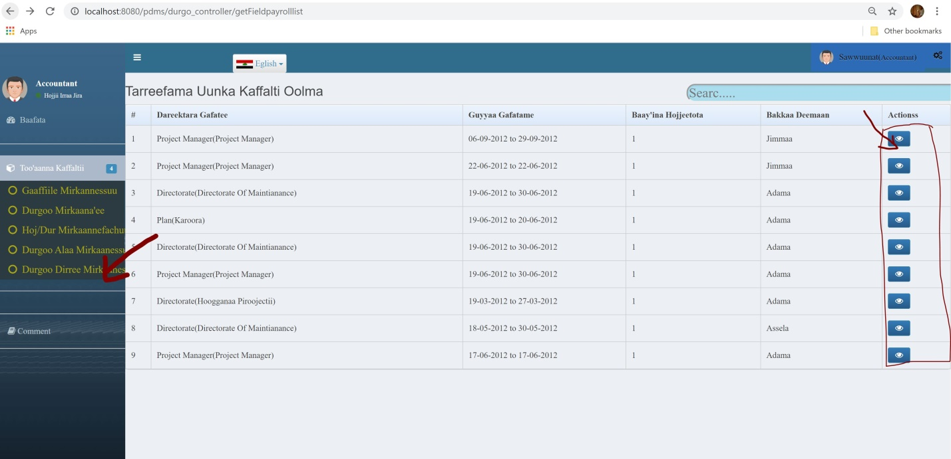

Show Detail info perdiem

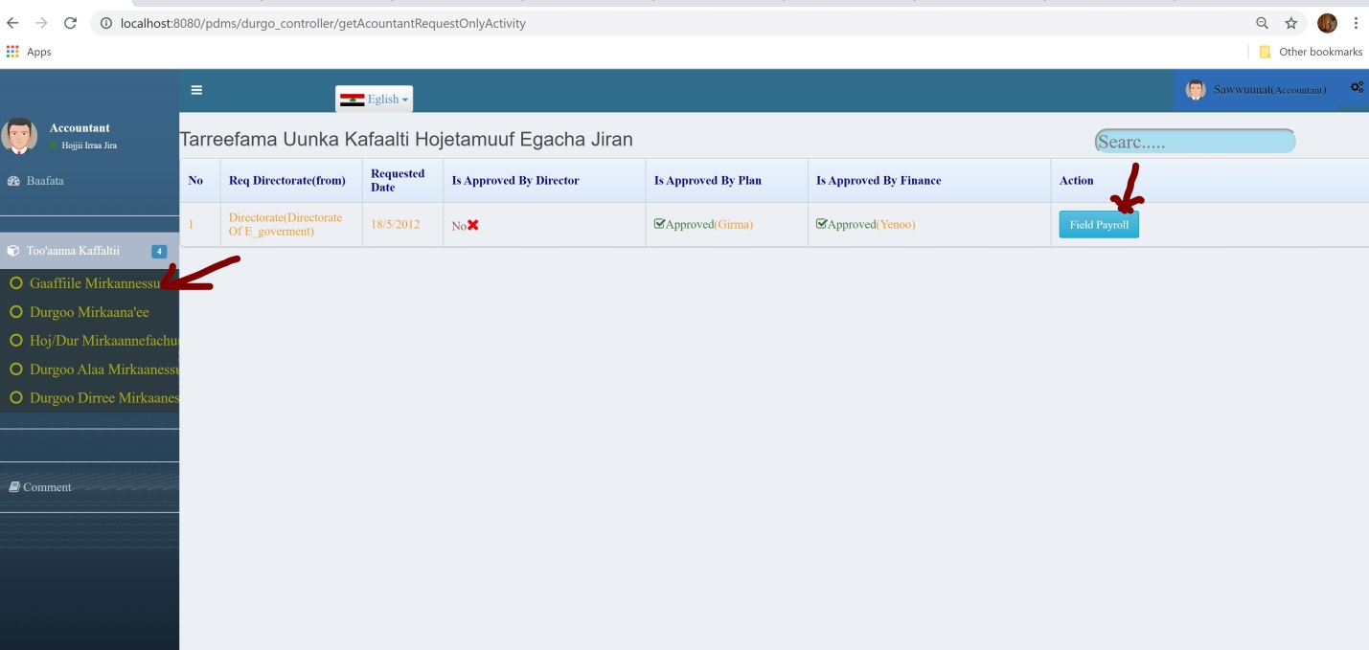

Cashe Activity

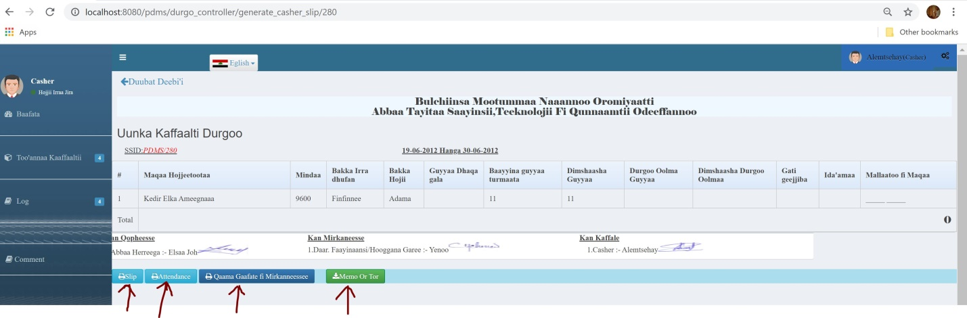

General Director Activity

