COURSEWORK FRONT COVER SHEET

Name
Student Reference Number | [ENTER STUDENT REFERENCE NUMBER]
Module Code | PUSL2023
Module Name | Mobile Application Development
Coursework Title | Villi’s Cafe Android Mobile Application – Final Report
Deadline Date | [ENTER DEADLINE DATE]
Member of staff responsible | [ENTER MEMBER OF STAFF]
Programme | [ENTER PROGRAMME]

Group work declaration and participants
[ENTER PARTICIPANT NAMES OR STATE ‘UNDERTAKEN ALONE’].
Assessment offence declaration
The submitter confirms that the Plymouth University regulations relating to assessment offences have been read and understood, and that this submission represents the group’s independent work.
Signed on behalf of the group / individual: [SIGN BEFORE SUBMISSION]
Use of translation software or a similar writing aid: USED — OpenAI Codex assisted with report drafting and formatting. Technical statements were checked against the project source, emulator run, Git history, and automated validation.


VILLI’S CAFE
Android Mobile Ordering Application
Final Project Report
PUSL2023 Mobile Application Development
Plymouth Batch 13 • 2024/2025 Academic Year
Prepared by: ______________________________
Student Reference Number: [ENTER NUMBER]
Submission date: [ENTER DATE]
Warm bites, made personal.

Table of Contents
Right-click and select Update Field in Microsoft Word if page numbers are not shown.

List of Figures and Tables
- Figure 3.1 Use case diagram
- Figure 3.2 High-level architecture and data flow
- Figure 3.3 SQLite entity–relationship diagram
- Figure 3.4 Customer home interface
- Figure 3.5 Menu and product-details interfaces
- Figure 3.6 Checkout and order-summary interfaces
- Figure 3.7 Order confirmation and loyalty profile
- Figure 3.8 Administrator product-management interface
- Table 2.1 Requirement-gathering evidence
- Table 2.2 Functional requirements
- Table 2.3 Non-functional requirements
- Table 4.1 Technologies and tools
- Table 4.2 Verification results
- Table 5.1 Git contribution summary
- Table A.1 Complete Git commit history

Chapter 01 – Introduction

1.1 Project background
Villi’s Cafe was developed as a compact Android ordering application for a local café. The project responded to a familiar service problem: customers often needed to inspect a menu, compare items, and prepare an order before reaching a counter. A mobile interface reduced that friction by placing browsing, cart calculation, checkout, promotions, order tracking, loyalty information, notifications, and café messaging in one flow. The implementation remained intentionally local and understandable because it was produced for undergraduate mobile application development.
The completed product was implemented with Flutter and Dart. Material 3 supplied the visual foundation, Provider coordinated observable application state, and SQLite stored accounts, sessions, products, cart entries, orders, and chat messages on the Android device. Product photographs were requested from Unsplash over HTTPS, while a branded placeholder protected the layout when a network image could not be loaded. No remote application server or payment gateway was introduced.

1.2 Existing systems and problem definition
Large commercial delivery platforms already support searchable catalogues, card payments, courier tracking, and cloud accounts. However, those systems normally require business onboarding, service fees, continuous network access, and infrastructure that would have exceeded this project’s scope. A small café still benefited from the core interaction pattern, but it did not require a marketplace or a complex backend for a coursework demonstration.
The problem was therefore defined as the absence of a small, café-specific Android experience that could demonstrate the complete ordering journey without processing real money or exposing personal data to a server. The proposed application had to remain approachable for a student developer while still showing reliable state changes, persistence, validation, responsive layouts, and meaningful recovery states.

1.3 Aim and objectives
The project aimed to design and implement a clear, attractive, and locally persistent Android application through which Villi’s Cafe customers could discover products and complete a simulated order.
- To present a branded splash, authentication entry, home experience, searchable catalogue, categories, promotions, and reusable product cards.
- To provide product details, quantity selection, a persistent cart, and trustworthy subtotal, delivery-charge, and total calculations.
- To validate delivery and simulated payment information before saving an order and clearing the cart atomically.
- To retain order history, calculate loyalty points, and support customer notifications and two-way local café chat.
- To provide an administrator interface for product maintenance, order status management, and chat replies.
- To verify behaviour through static analysis, automated unit/widget tests, and execution on an Android emulator.

1.4 Scope of the project
The scope included Android execution, local account registration and sign-in, four menu categories, eight seeded products, text search, product details, cart persistence, three simulated payment choices, order confirmation, order history, promotions, loyalty points, theme switching, notifications, customer–administrator chat, and administrator maintenance. Loading, empty, error, retry, accessibility, and responsive states were also implemented.
Real payment processing, live stock control, delivery routing, cloud synchronisation, production-grade identity management, push notification services, and promotion redemption were excluded. Card values were validated only inside the checkout form and were neither transmitted nor written to SQLite. Product and promotion information remained demonstration data.

Chapter 02 – Requirements and Features

2.1 Requirement-gathering techniques
Requirements were derived through document analysis, scenario decomposition, lightweight competitor observation, and iterative prototype review. The original café brief was translated into user journeys and acceptance checks. The repository’s phase checklist then divided the work into foundation, browsing, cart, checkout, history, and quality stages. Later commits extended the product with local authentication, messaging, notifications, an administrator role, and dark mode.
Technique | Evidence used | Outcome
Brief analysis | Original assignment retained in README | Identified core screens, categories, payment simulation, persistence, and Android target.
Scenario and task analysis | Browse → detail → cart → checkout → confirmation | Established the primary customer journey and validation points.
Prototype review | Responsive layouts and real emulator execution | Refined hierarchy, touch targets, error states, and navigation.
Repository review | Source, tests, README, task checklist, and Git history | Confirmed implemented behaviour and prevented unsupported claims.
Table 2.1 Requirement-gathering evidence

2.2 Functional requirements
ID | Requirement | Status
FR1 | The system shall register local customers, restore a saved session, sign users in, and separate customer and administrator roles. | Implemented
FR2 | Customers shall browse, search, and filter products by Burgers, Pizza, Drinks, and Desserts. | Implemented
FR3 | Customers shall inspect product details, select quantity, and add, adjust, or remove persistent cart items. | Implemented
FR4 | The checkout shall validate delivery details and the selected simulated payment method before submission. | Implemented
FR5 | The system shall calculate totals, save an order, clear the cart in one transaction, and show confirmation/history. | Implemented
FR6 | Customers shall view promotions, loyalty points, notifications, profile details, and café chat. | Implemented
FR7 | Administrators shall manage products, change order status, and reply to customer conversations. | Implemented
Table 2.2 Functional requirements

2.3 Non-functional requirements
Requirement | Acceptance interpretation
NFR1 Usability | The five customer destinations and three administrator destinations shall use clear labels, consistent actions, and restrained visual hierarchy.
NFR2 Reliability | Committed cart and order changes shall not be repeated when a later refresh fails; order creation and cart clearing shall be atomic.
NFR3 Privacy | Accounts and sessions shall remain local. Payment shall be identified as simulated, and card fields shall not be persisted.
NFR4 Accessibility | Semantic labels, large touch targets, readable contrast, reduced-motion awareness, and large-text layouts shall be supported.
NFR5 Responsiveness | Screens shall adapt across narrow phones, landscape layouts, and wider grids without hiding essential actions.
NFR6 Maintainability | Models, providers, repositories, services, screens, widgets, utilities, and tests shall remain separated by responsibility.
NFR7 Compatibility | The deliverable shall build and execute on Android using the configured Flutter and Gradle toolchains.
Table 2.3 Non-functional requirements

2.4 Features of the application
The final application offered more than a catalogue. A two-second branded splash led to local authentication. The customer shell exposed Home, Menu, Cart, Orders, and Profile tabs, with notification and chat entry points. Search and category filters reused the same product state, while product cards and detail views shared cart operations. The checkout supported Cash on Delivery, Credit/Debit Card, and Digital Wallet demonstrations. Card numbers were checked with the Luhn algorithm, expiry dates were compared with the current month, and CVV input was constrained to three or four digits.
The administrator shell separated product, order, and conversation work. Product records could be added, edited, or deleted. Order statuses could be changed among preparing, confirmed, rejected, and delivered states. Customer messages were grouped for administrator replies. Across both roles, Provider exposed loading and error state without placing SQL inside widgets.

Chapter 03 – System Design and User Interface

3.1 Use case diagram
Two actors were supported. Customers controlled their account, discovery, ordering, history, loyalty, and communication journeys. Administrators maintained operational data and replied to conversations. The system boundary in Figure 3.1 shows the intentional separation between these responsibilities.
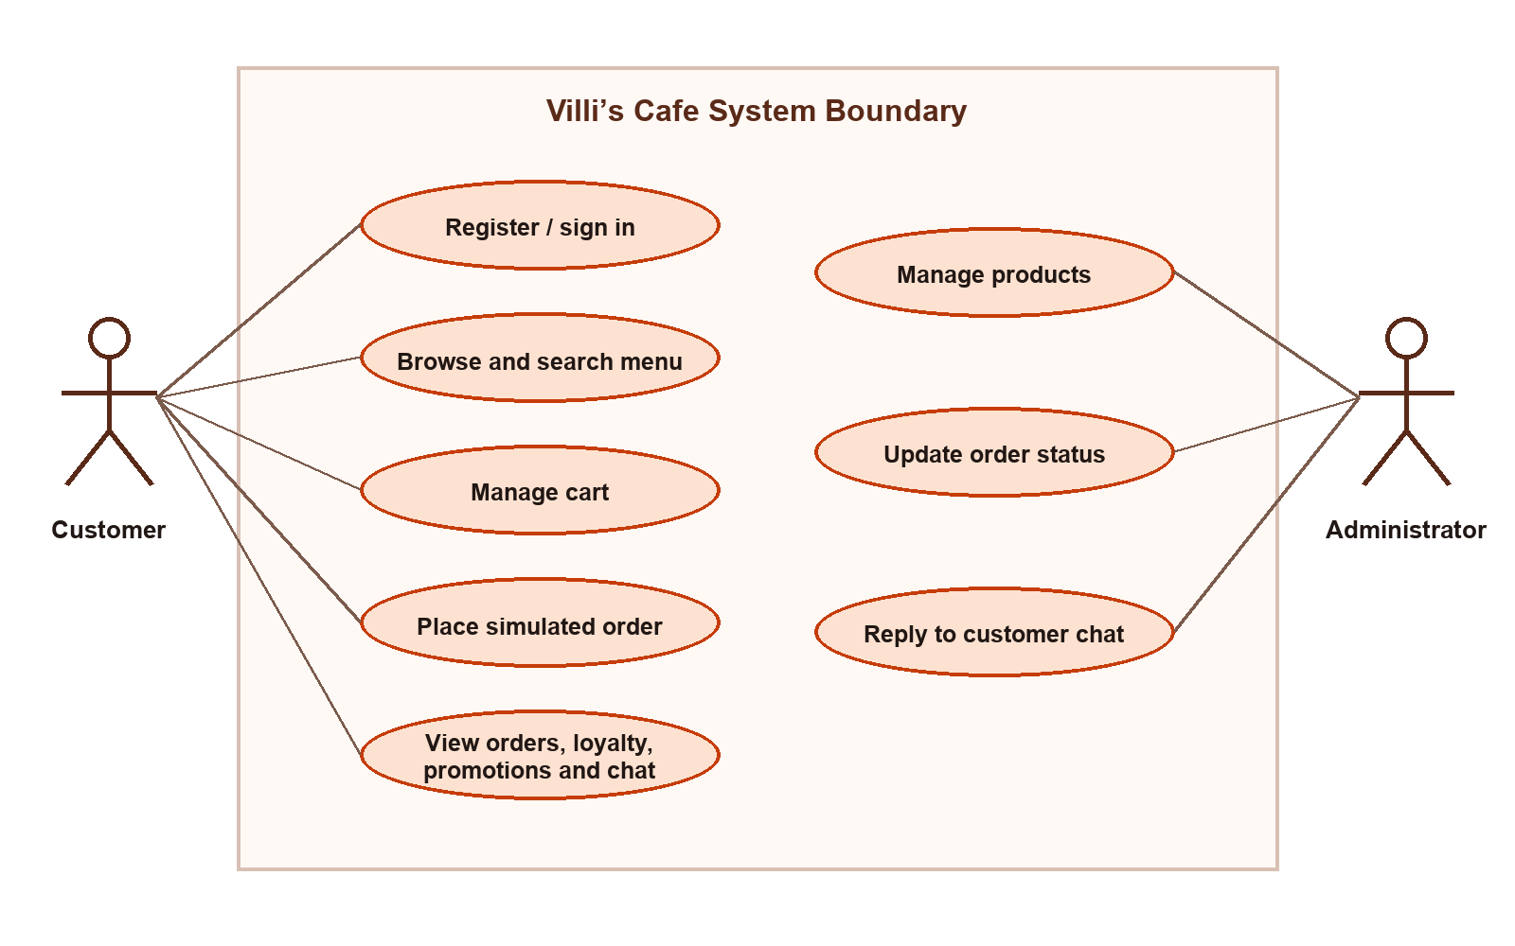
Figure 3.1 Use case diagram

3.2 High-level architecture
A layered architecture was selected so that each state change could be traced from a widget to local storage. Screens and reusable widgets initiated events. ChangeNotifier providers coordinated UI state and error reporting. Repositories implemented database operations, and DatabaseService created or upgraded the SQLite schema. Typed models crossed the boundaries. The arrangement reduced coupling and allowed providers and screens to be tested with repository stubs.
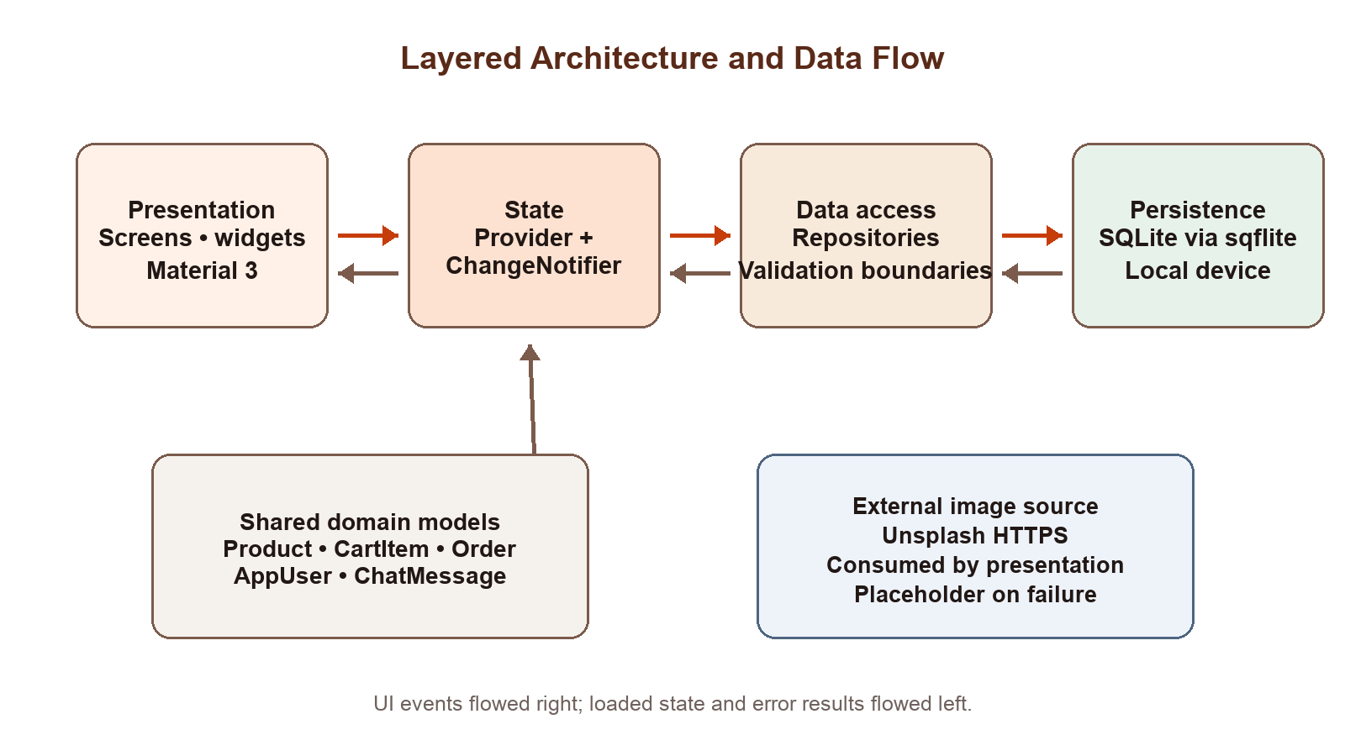
Figure 3.2 High-level architecture and data flow

3.3 Entity–relationship design
SQLite version 4 contained six tables. Products were seeded during database creation. Cart entries referenced products and enforced one row per product. Sessions referenced users and restricted the active-session identifier to one. Chat messages referenced their customer. Orders retained a delivery snapshot rather than a user foreign key, which kept the order record self-contained. Payment credentials were deliberately absent from the schema.
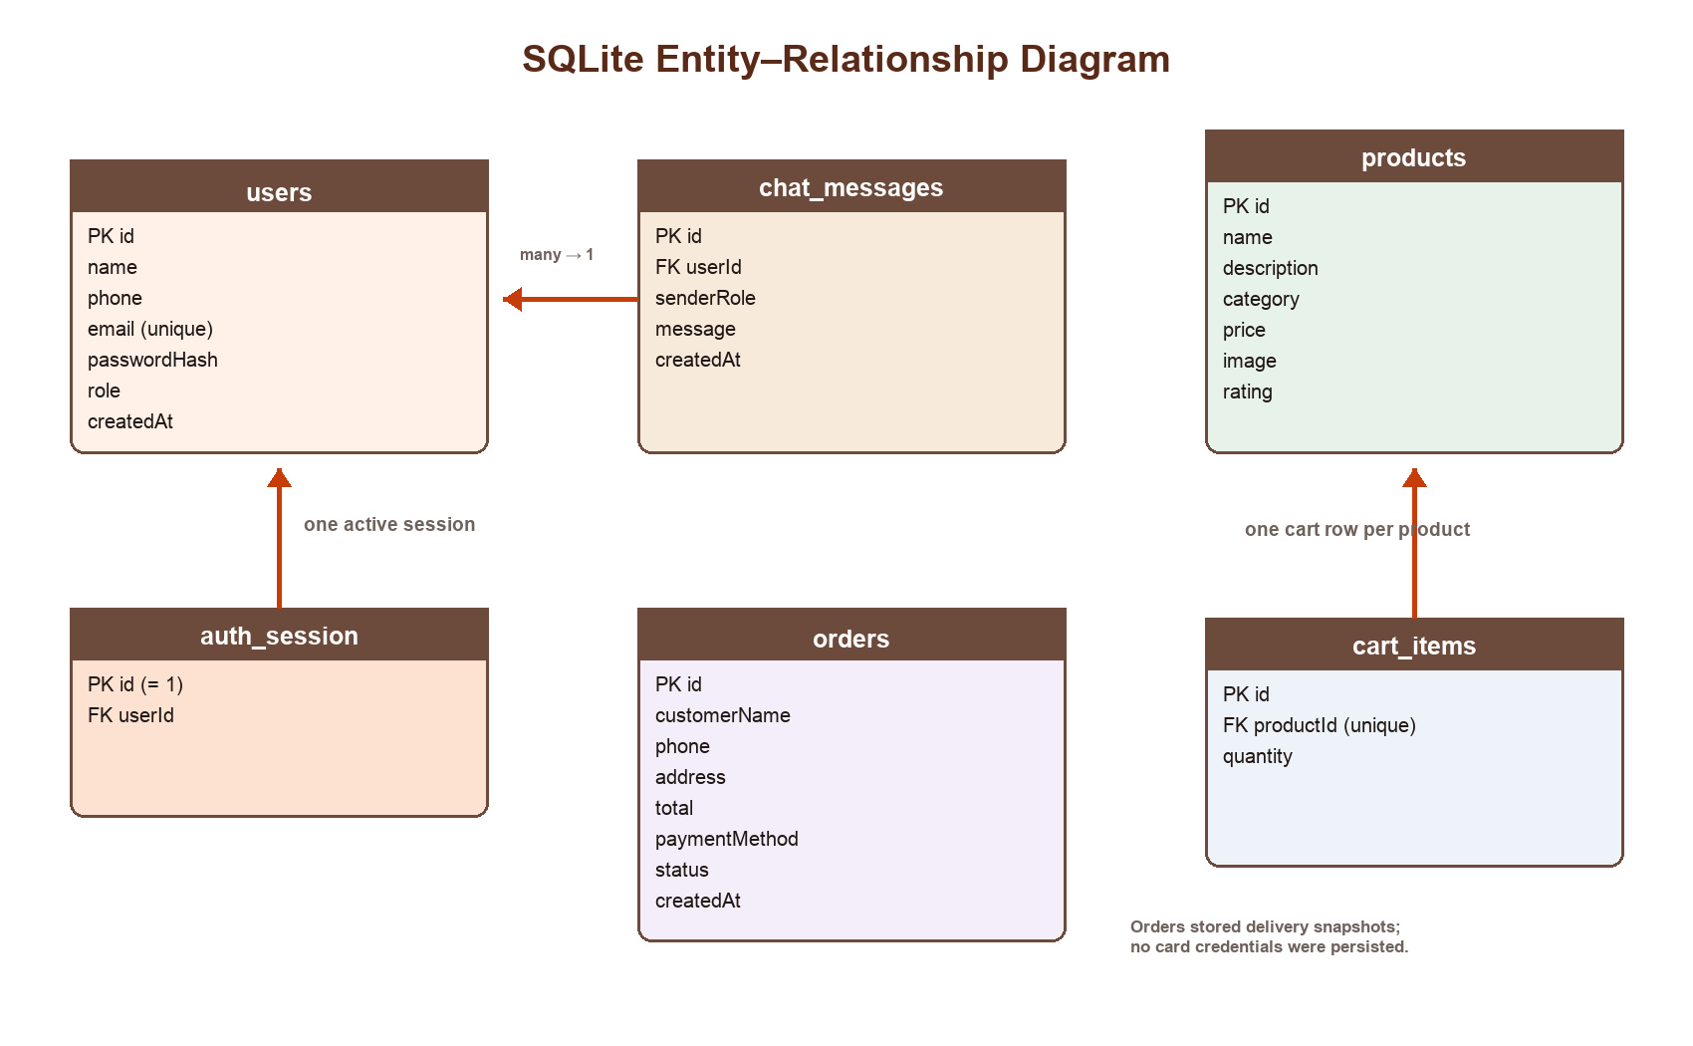
Figure 3.3 SQLite entity–relationship diagram

3.4 User interface of the developed system
The interface used a warm cream background, orange actions, dark brown typography, rounded cards, and the café mark. The Android emulator captures below were recorded from the running debug application on 25 August 2026. They show the most important points in the customer and administrator journeys rather than every screen.
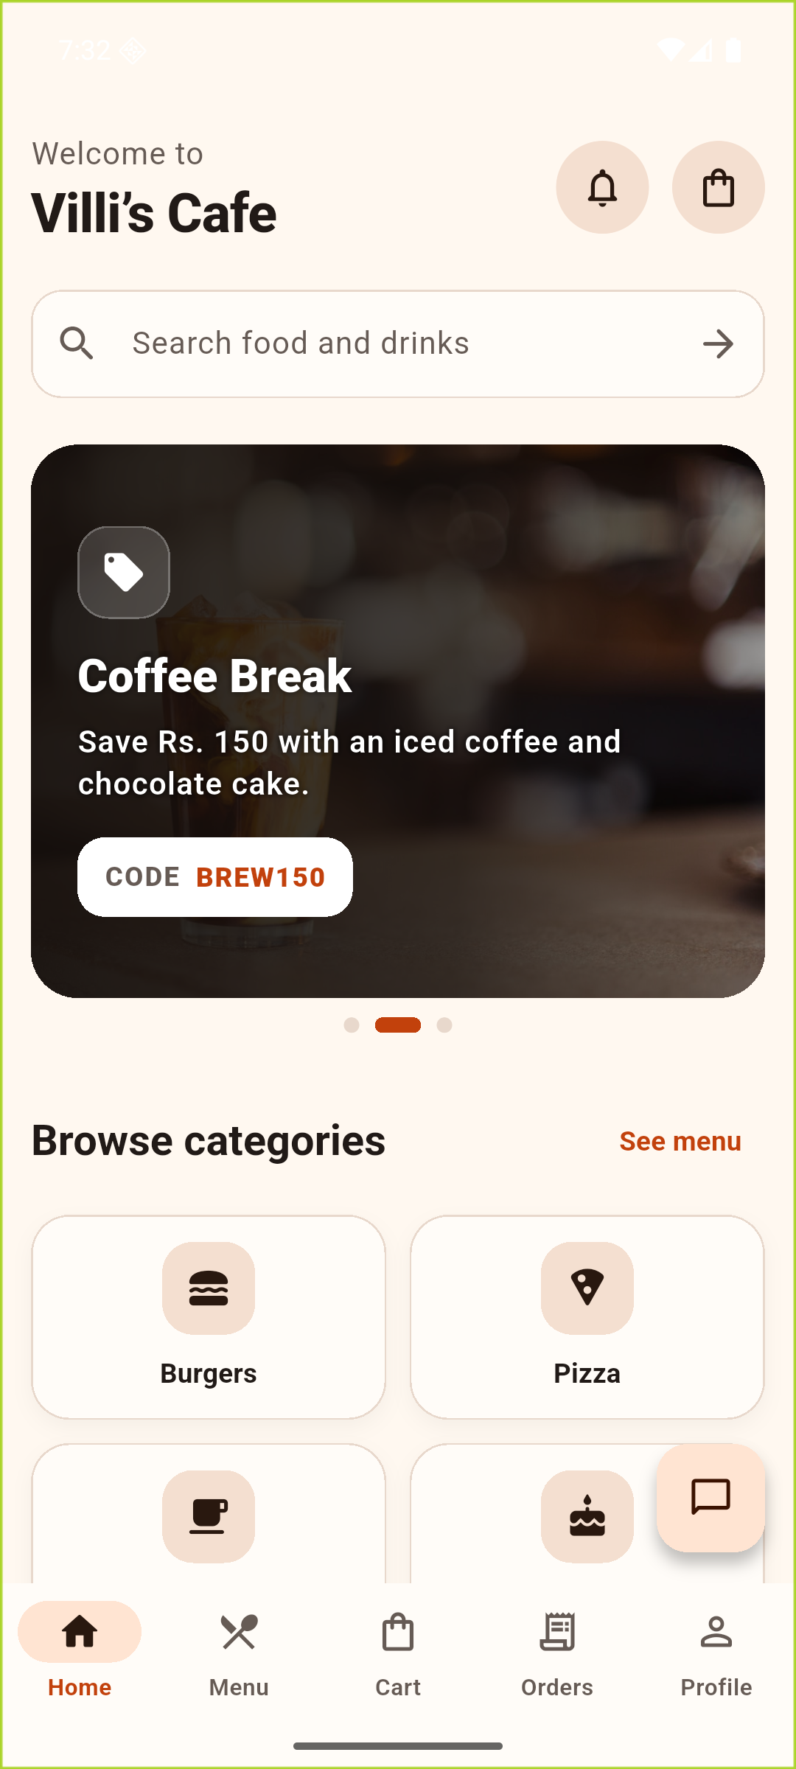
Figure 3.4 Customer home interface with promotion carousel and category navigation
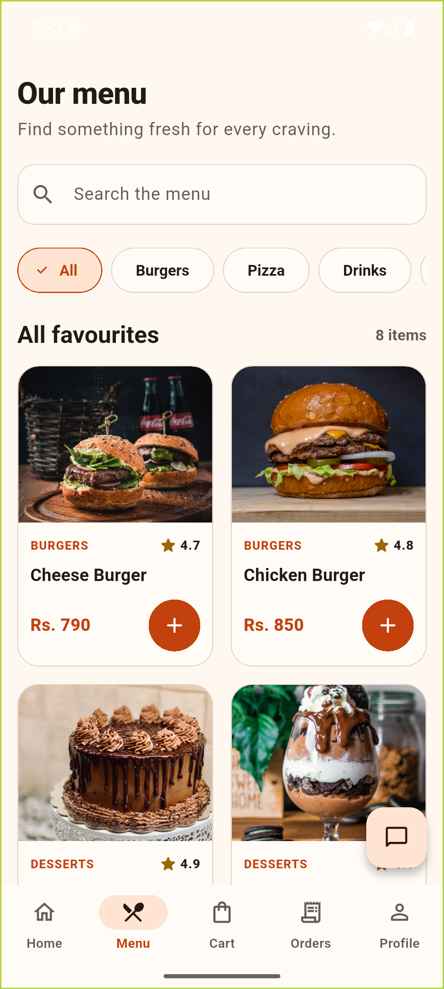  Figure 3.5(a) Searchable and filterable menu | 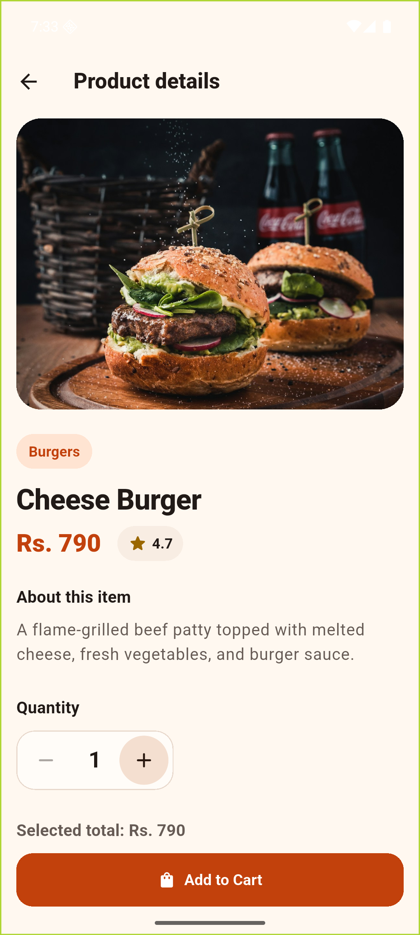  Figure 3.5(b) Product detail and quantity selection

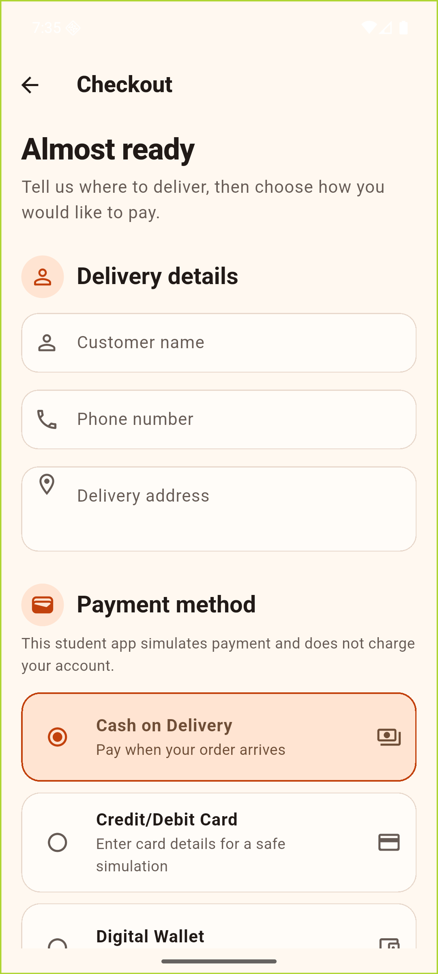  Figure 3.6(a) Delivery and payment selection | 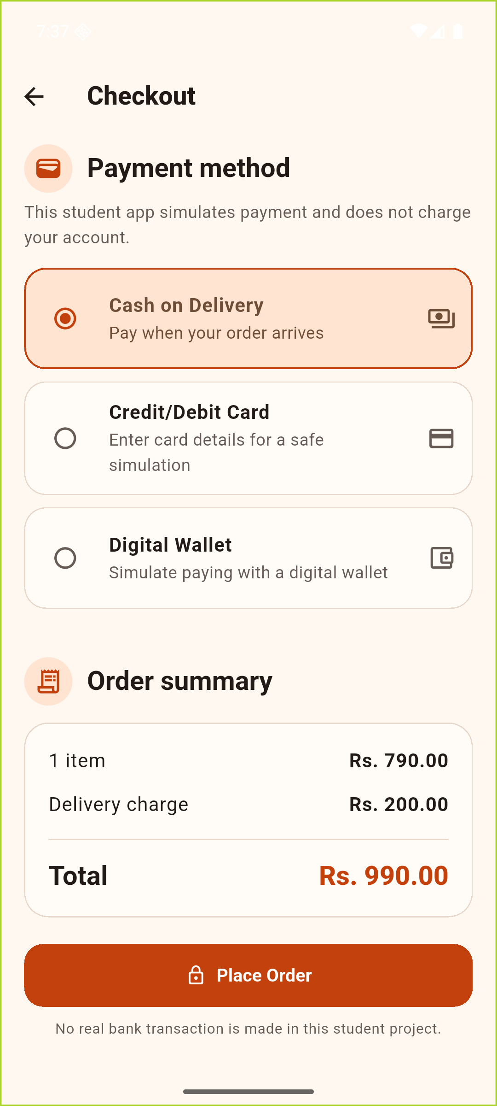  Figure 3.6(b) Simulated checkout summary

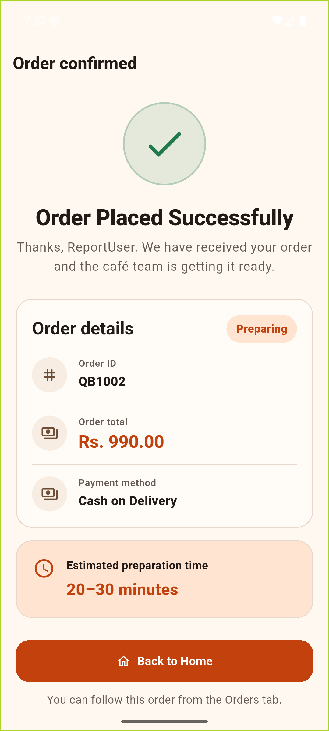  Figure 3.7(a) Saved order confirmation | 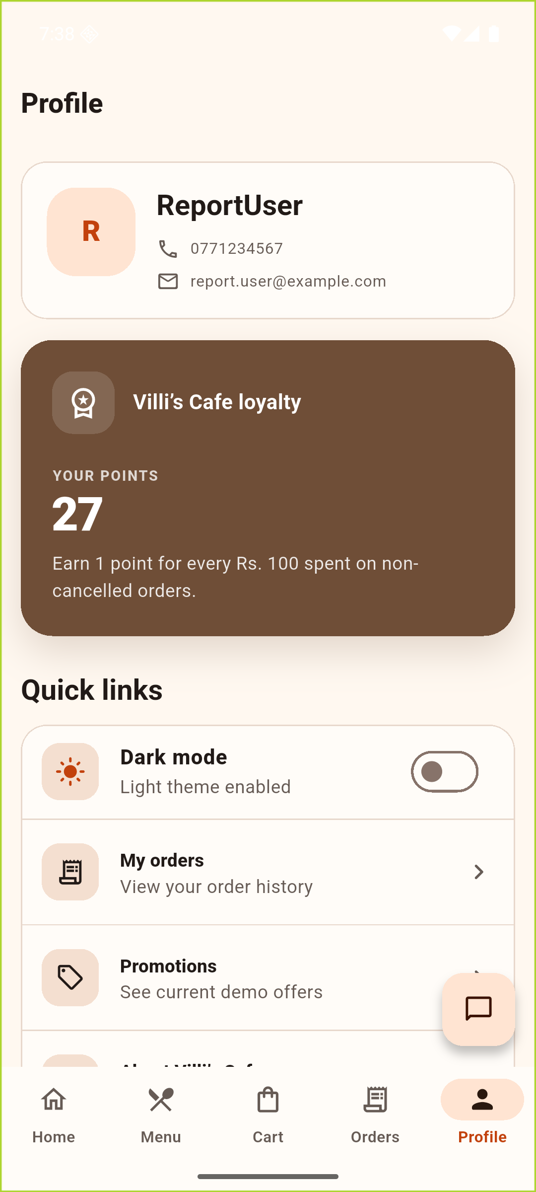  Figure 3.7(b) Local profile and loyalty points

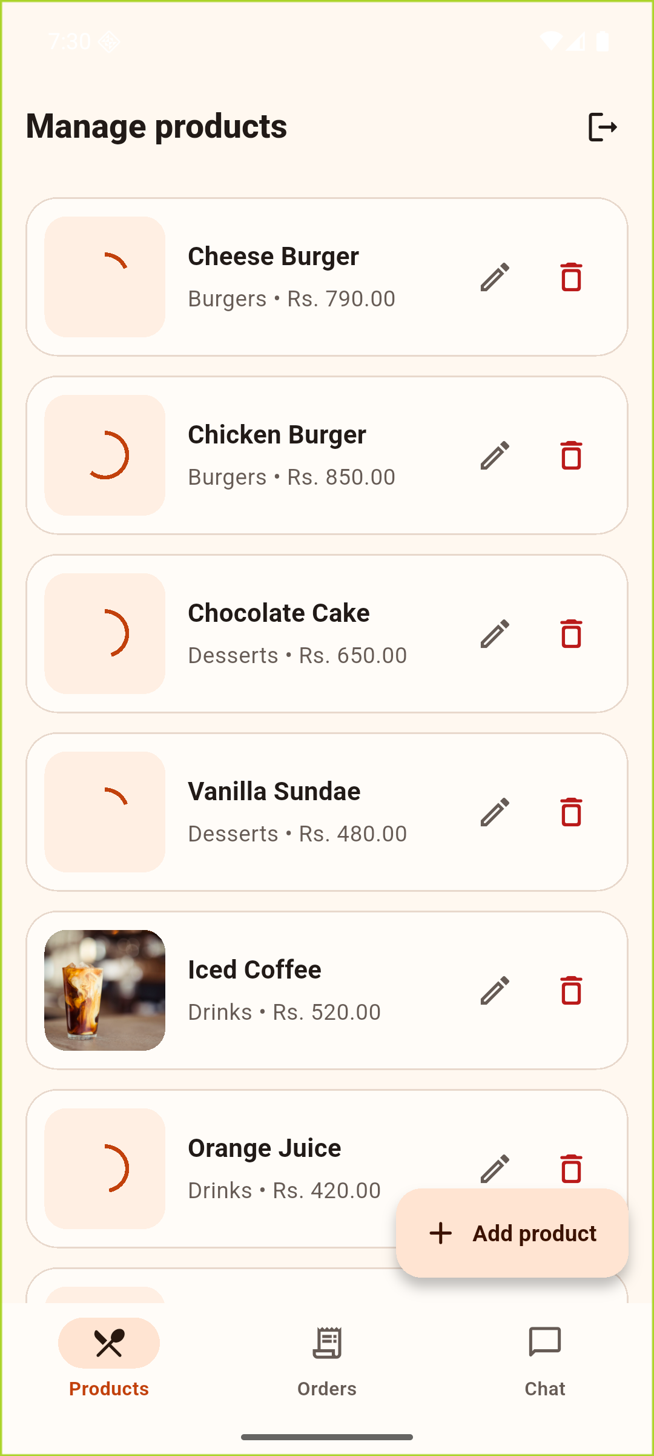
Figure 3.8 Administrator product-management interface

Chapter 04 – Development and Evaluation

4.1 Development methodology
An iterative, feature-based methodology was followed. The foundation introduced the Flutter project, theme, models, SQLite service, repositories, and providers. Product browsing and responsive cards were completed next. Persistent cart behaviour was then added before checkout and order confirmation. History, profile, promotions, and loyalty followed. The quality pass addressed accessibility, responsive behaviour, empty/error states, tests, documentation, authentication, chat, notifications, administrator controls, and dark mode.
This order reduced risk because later screens reused stable models and repository operations. Commits remained small enough to show the development sequence. When resilience tests exposed the possibility of retrying an already committed change, providers were hardened so that refresh failures produced a message without duplicating database mutations.

4.2 Technologies and tools used
Technology/tool | Use in the project
Flutter 3.47.1 / Dart 3.13.1 | Cross-platform UI toolkit and language used for the Android application.
Material 3 | Theme, navigation, controls, forms, cards, colour schemes, and accessible interaction patterns.
Provider 6.1.5+1 | ChangeNotifier-based state delivery for authentication, navigation, theme, products, cart, orders, and chat.
sqflite 2.4.2 + SQLite | Embedded relational persistence, constraints, indexes, migrations, and transactions.
crypto 3.0.7 | SHA-256 hashing for local demonstration passwords.
Android SDK 36 / emulator | Android 16 runtime used for build installation, interaction, and screenshot evidence.
Flutter test and analyzer | Unit, widget, responsive, navigation, validation, and resilience verification.
Git and GitHub | Version history and remote source publication.
Table 4.1 Technologies and tools

4.3 Testing and evaluation
Evaluation combined code inspection, automated validation, and a complete Android walkthrough. Tests covered model mapping, currency and validators, Material theming, splash timing, five-tab navigation, cart and checkout protection, promotions, order history, profile loyalty, chat, administrator functionality, provider recovery, and narrow/landscape/large-text layouts. The emulator journey registered a customer, added a product, placed a Cash on Delivery order, observed confirmation, and reviewed loyalty state.
Check | Result | Evidence
Android debug build | Passed | build/app/outputs/flutter-apk/app-debug.apk was produced and installed.
Runtime walkthrough | Passed | Application launched on Pixel 7 Android 16 emulator and completed the core customer flow.
flutter analyze | Passed | No issues found on 25 August 2026.
flutter test | Passed | 42 tests passed on 25 August 2026.
Privacy inspection | Passed | Cardholder, card number, expiry, and CVV fields were not present in the SQLite orders schema.
Table 4.2 Verification results
The evaluation demonstrated a coherent coursework application rather than a production ordering service. One limitation of the local design was that café data did not synchronise between devices. Network product imagery could also vary with connectivity, although placeholders protected usability. The application made this boundary clear by labelling payments as simulated and keeping account data on the device.

4.4 Future implementation
- Introduce a secured cloud API and managed identity service so that products, orders, chat, and accounts can synchronise across devices.
- Integrate a compliant payment provider using tokenisation; sensitive card data should remain outside the application and its database.
- Add real inventory, configurable café opening hours, promotion redemption, tax rules, receipts, and order cancellation policies.
- Connect push notifications to server-side order status changes and extend administrator access controls and audit logs.
- Run usability sessions with café staff and customers, then add integration, database migration, performance, and physical-device test coverage.

Chapter 05 – Contribution and Source Control

5.1 Individual contribution
The repository contained 23 commits attributed to one contributor through two equivalent Git identities. The history covered the project scaffold, core architecture, product discovery, cart, checkout, confirmation, promotions, profile, loyalty, authentication, administrator controls, chat, notifications, dark mode, Android configuration, testing, resilience, documentation, and the final Villi’s Cafe rebrand. The contributor name was intentionally left blank and must be completed accurately before submission.
Contribution details to verify
If this was group work, add one short, accurate paragraph for every additional member and adjust the cover declaration. Do not submit the single-contributor statement unless it is correct.

Contributor | Commits | Repository-evidenced work
 | 23 | Application architecture, UI, SQLite persistence, customer/admin features, automated tests, Android configuration, documentation, and rebranding.
Table 5.1 Git contribution summary

5.2 GitHub repository and commit history
GitHub repository: [PASTE GITHUB REPOSITORY LINK]
The full commit history is reproduced in Appendix A. The sequence showed an incremental implementation rather than a single bulk upload, with feature and corrective commits describing the behaviour introduced at each stage.

5.3 Project source code link
MANDATORY BEFORE SUBMISSION — PLYMOUTH ONEDRIVE SOURCE LINK
Paste the public/evaluator-accessible Plymouth OneDrive source-code URL here: [PASTE ONEDRIVE LINK]. The supplied guideline states that omission or inaccessible permissions will result in zero marks.

Reference List
Flutter (2026) Material Design for Flutter. Available at: https://docs.flutter.dev/ui/design/material (Accessed: 25 August 2026).
Flutter (2026) General approach to adaptive apps. Available at: https://docs.flutter.dev/ui/adaptive-responsive/general (Accessed: 25 August 2026).
Remi Rousselet and contributors (2025) provider 6.1.5+1. Available at: https://pub.dev/packages/provider (Accessed: 25 August 2026).
Tekartik (2026) sqflite: SQLite plugin for Flutter. Available at: https://pub.dev/packages/sqflite (Accessed: 25 August 2026).
SQLite Project (2026) Transaction. Available at: https://www.sqlite.org/lang_transaction.html (Accessed: 25 August 2026).
Villi’s Cafe project repository (2026) QuickBite-Cafe source code and README. Available at: [PASTE GITHUB REPOSITORY LINK] (Accessed: 25 August 2026).

Appendix A – Complete Git Commit History
Commit | Date | Message
2d37f20 | 2026-08-23 | Initial commit
4b2f381 | 2026-08-23 | Update README.md
49cbe2e | 2026-08-24 | Update README.md
470d61c | 2026-08-24 | Implement core functionality for QuickBite Café app
f1aa2aa | 2026-08-24 | Refactor cart and order providers; update Gradle configuration and add unit tests
39394cc | 2026-08-24 | Add splash, catalogue, and product browsing
a34eeb7 | 2026-08-24 | Add profile and promotions screens with associated UI components
e309fe3 | 2026-08-24 | Streamline SnackBar and MaterialApp widget formatting
8c48546 | 2026-08-24 | Add persistent shopping cart
dff8bf4 | 2026-08-24 | Connect checkout and order confirmation
3332576 | 2026-08-24 | Complete orders, promotions, and loyalty
228f863 | 2026-08-24 | Update README and add responsive layout tests
988ad50 | 2026-08-24 | Harden cart and order recovery
b65cedf | 2026-08-24 | Configure Flutter Android NDK
7474b1e | 2026-08-24 | Improve menu category visibility
6ab618a | 2026-08-24 | Add local account authentication
ab1cdbd | 2026-08-24 | Add food promotion carousel
06ef53c | 2026-08-24 | Add café chat and administrator management
3f1cff9 | 2026-08-24 | Connect customer chat to administrator replies
215297e | 2026-08-24 | Add customer notification panel
ec61ab5 | 2026-08-24 | Add accessible dark mode
e5d6e10 | 2026-08-24 | Improve dark mode icon contrast
0b97f5f | 2026-08-24 | Rebrand application as Villi’s Cafe
Table A.1 Complete Git commit history from the main branch

Appendix B – Validation and Screenshot Evidence
Validation was executed from the project root on 25 August 2026. Flutter built and installed the debug APK on emulator-5554 (Pixel 7, Android 16/API 36). Static analysis completed with no issues, and the test suite completed with 42 passing tests. The selected PNG captures in the report/screenshots folder were obtained with Android Debug Bridge from that running application.
- 08_admin_dashboard.png — administrator product maintenance
- 09_customer_home.png — home, promotions, search, and categories
- 10_menu.png — product catalogue and filters
- 11_product_details.png — product details and cart action
- 13_checkout.png — delivery and simulated payment form
- 14_checkout_summary.png — totals and place-order action
- 15_order_confirmation.png — persisted order confirmation QB1002
- 16_profile_loyalty.png — customer profile and loyalty state

