Name :Harish.S

Reg no : 192121116

Course Code : CSA0726

**COMPUTER NETWORKS LAB EXPERMIENTS**

**DAY-4**

1. Make Computer Lab in Cisco Packet Tracer

**AIM :** To create a Computer Lab in Cisco Packet Tracer

step1:-first take switch

step2:-link that switch with 20 pc’s and after connect it with the server

step3:-connect that pc’s with the switch and the switch to server

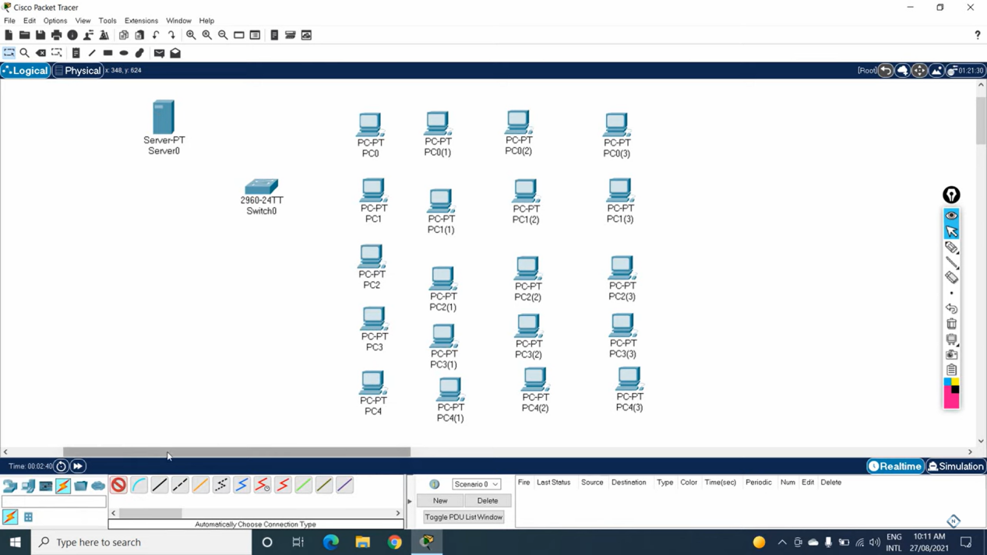

step4:- after connection check the IP address of the all pc’s in the config

step5:- if command send correctly you got successfull other wise recheck the connections

Step6:- then the construction of the computer lab was simulated with 20 pc’s and server and switch

