Name :Harish.S

Reg no : 192121116

Course Code : CSA0726

**COMPUTER NETWORKS LAB EXPERMIENTS**

**DAY-4**

1. **IOT Based Controller with WPA and Radius Server**

**AIM :** to create a IOT Based Controller with WPA and Radius Server

step1:-first take IOT radius server

step2:- link that gateway to the home appliance like celling fan , lamp ,window and coffee maker make a connection between the switch , router and IOT radius server .

step3:-connect that gateway to the appliances and change the IP address in it .

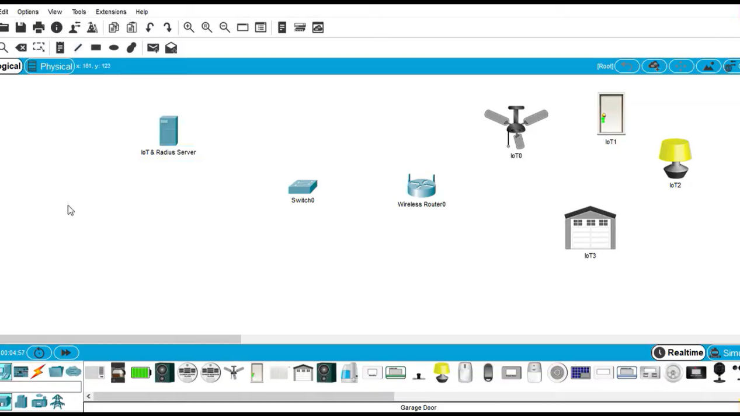

step4:- after connection check the IP address of the all gateway and appliances in the config

step5:- if command send correctly you got successfull other wise recheck the connections

Step6:- Then the IOT Based Controller with WPA and Radius Server was successfully simulated in packet tracer .

