Task 3:
a)
Hackerrank profile:
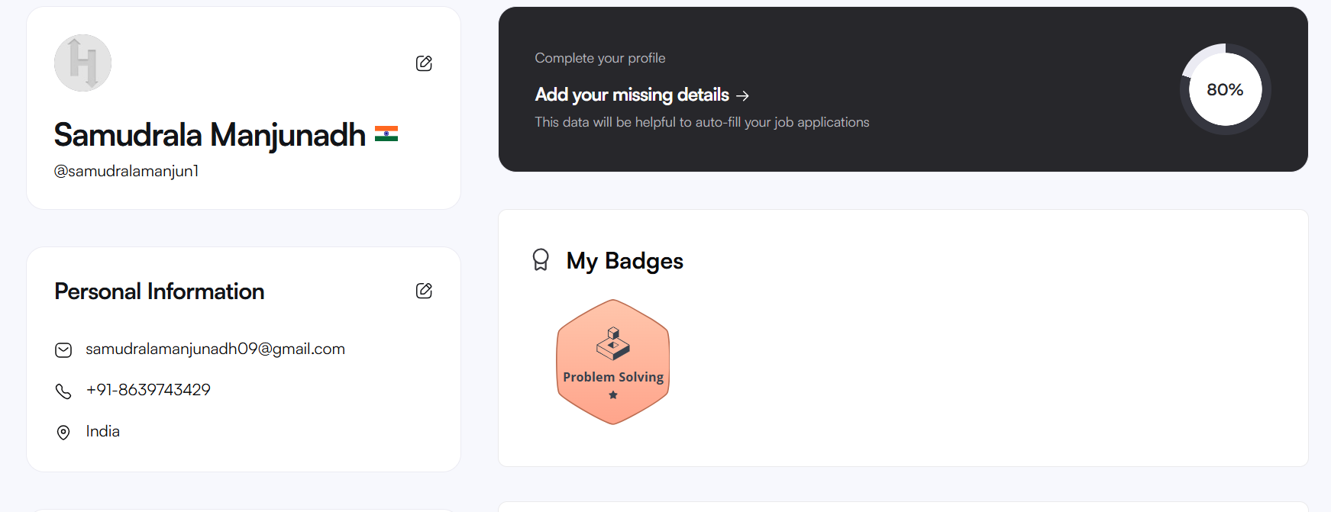
Completed the solve first,simple array sum,compare the trippelets,a very big sum topics mcqs and written some codes of my own here are the screen schots of the work done
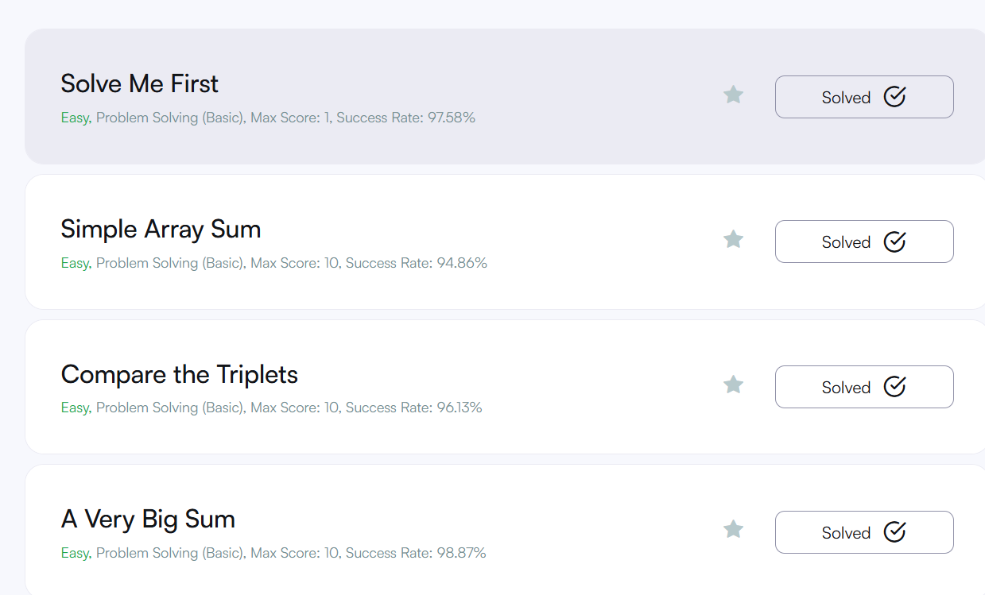
Received the bronze badge which was shown in the profile of me .

b) creating the goggle form and pasting the responses of the goggle form which was done
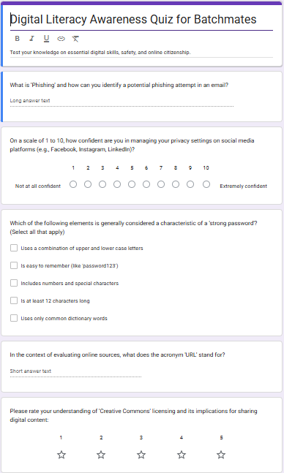
Responses of the forms screen shots!:
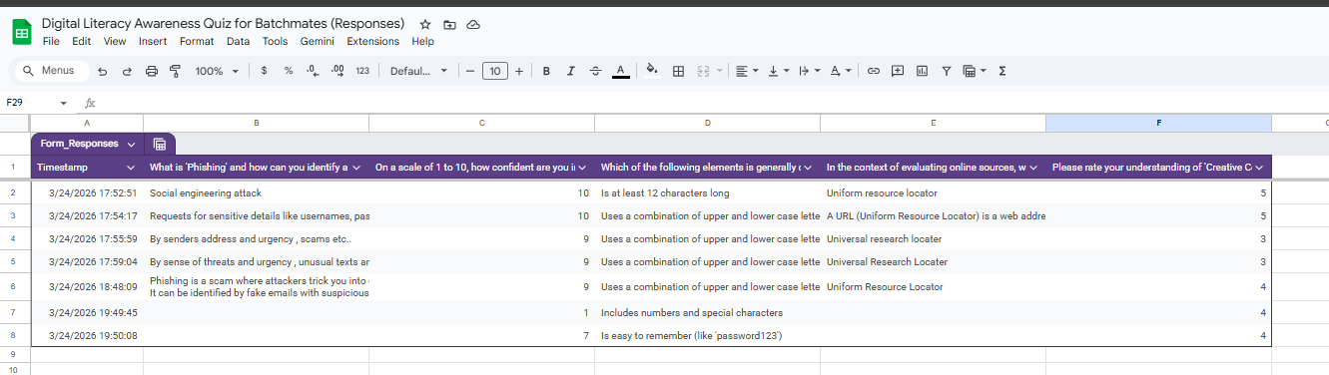

Platform Reflection Notes
- For this task, I explored Hacker Rank for coding and Google Forms for digital collaboration.
- I successfully completed a Python-based beginner challenge to practice logical problem-solving.
- Using Google Forms, I designed a 5-question "Digital Literacy Awareness Quiz" for my peers.
- The quiz includes both multiple-choice and short-answer questions to ensure diverse data.
- I integrated a Google Sheet to capture real-time responses and analyze user feedback.
- These tools taught me how to collect and manage digital information efficiently.
- As an AI student, mastering these platforms is vital for future data-driven projects.
- I learned that clear question design is the key to getting high-quality survey data.
- Practicing on coding platforms helps bridge the gap between theory and actual implementation.
- Overall, this task improved my confidence in using cloud-based tools for academic collaboration.

