Task2 :
Pasting the three screenshots of the following accounts
1.kaggel:
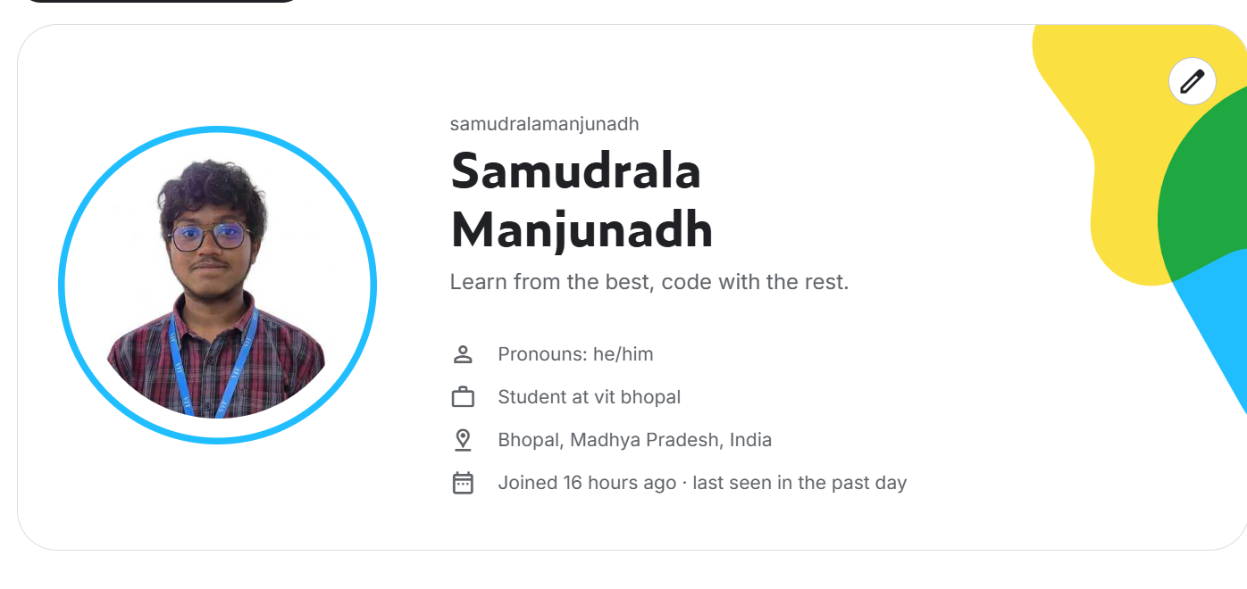
Kaggle Profile Reflection
Current Identity: AIML Student @ VIT Bhopal.
Tagline: "Learn from the best, code with the rest."
Key Optimizations
Refine Tagline: Shift from general to specialized. “AIML Practitioner | Bridging Math & Computer Vision.”
Highlight Strengths: Explicitly mention your foundation in Vector Calculus/Linear Algebra and experience with Python and LabelImg.
Niche Expertise: Leverage your interest in Environmental Science or Physics to stand out as a domain-specific data scientist.
Next Steps: Link your GitHub, upload a clean EDA notebook (e.g., on climate or motor data), and aim for Kaggle Expert in Notebooks.
Goal: Transform "Student" into "Technical Practitioner."

2.Git-hub:

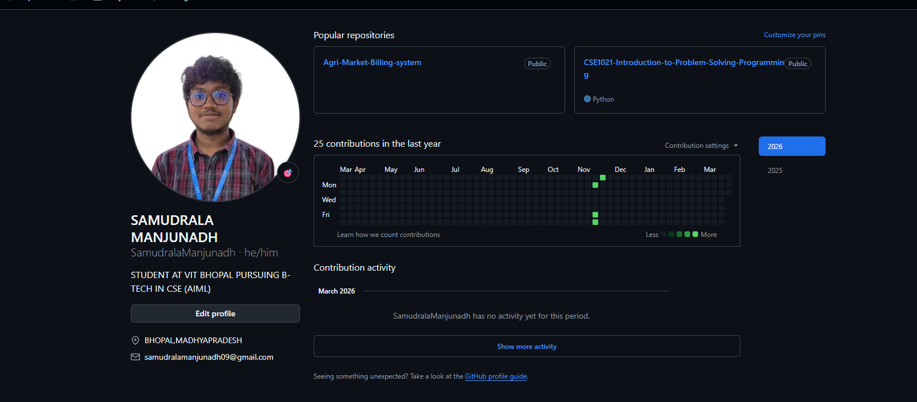
GitHub Profile Reflection
Current State: Clean layout with a strong focus on CSE (AIML) at VIT Bhopal. Pinned projects like Agri-Market-Billing-system show practical application.
Key Optimizations
README Architecture: Create a professional "Profile README." Use it to showcase your Python proficiency and interest in Object Detection (LabelImg).
Mathematical Identity: Since you excel in Linear Algebra/Calculus, add a "Core Competencies" section. It signals you understand the why behind the algorithms.
Repository Polish: Add descriptions, tags, and a README.md to every public repo. For the Agri-Market project, mention if it uses any data analysis or ML.
Activity Consistency: Aim for "green squares" by committing small updates to your coursework or personal AIML experiments regularly.
Goal: Turn your profile into a living portfolio of an AI Engineer.

Linkedin:
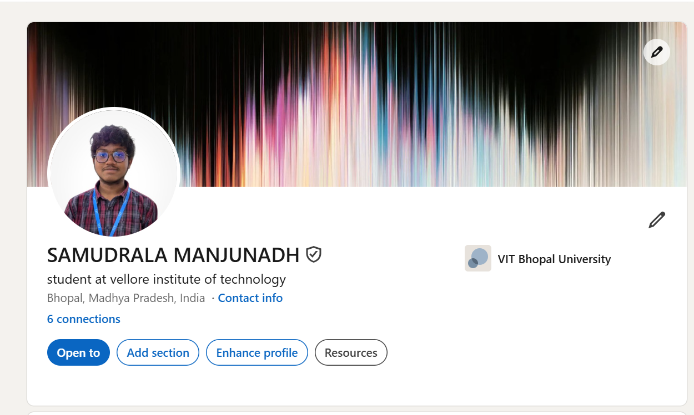
LinkedIn Profile Reflection
Current State: Clean, professional headshot with a great "Data/AI" vibe banner. Explicitly linked to VIT Bhopal University.
Key Optimizations
The Headline: Move beyond "Student at..." to include your expertise. “B.Tech AIML Student at VIT Bhopal | Python Developer | Aspiring ML Engineer.”
The "About" Section: Write a punchy 3-sentence summary. Highlight your mathematical foundation (Calculus/Linear Algebra) and practical skills like Object Detection.
Skills & Endorsements: Add at least 5-10 specific skills: Python, Machine Learning, Data Structures, Image Annotation (LabelImg), and Environmental Data Analysis.
Networking Strategy: Connect with seniors and professionals in the AIML space. Your current "6 connections" is a start—aim for 50+ to increase visibility.
Goal: Pivot from "University Student" to "Hireable AIML Talent."

