Secure Software Engineering Capstone Report
Student Hostel Management System (SHMS)
Automated Residential Allotment, Threat Modeling & Jira Execution — A Secure Software Engineering Case Study
Document Control Property | Specification Value
Project Name | Student Hostel Management System (SHMS)
Problem Statement | Problem Statement 13: Student Hostel Management System
Primary Author / Candidate | Vikas Samudrala (GitHub: Samudralavikas2005)
Jira Project Space | HOSTEL_MANAGEMENT_SYSTEM (Key: HMS)
Target Repository | https://github.com/Samudralavikas2005/HOSTEL_MANAGEMENT_SYSTEM
Document Status & Version | Version 2.4 Final • 100% Completed

Table of Contents
1. Introduction .................................................................................................................... 4
1.1 Background and Motivation ............................................................................................. 4
1.2 Purpose and Scope ..................................................................................................... 4
1.3 Executive Summary .................................................................................................... 4
1.4 Capstone Lifecycle ...................................................................................................... 5
1.5 Technology & Toolchain ................................................................................................ 5
2. Requirement Engineering .................................................................................................... 6
2.1 Problem Statement 13 .................................................................................................. 6
2.2 System Objectives ...................................................................................................... 6
2.3 Functional Requirements (FR-01 to FR-09) .................................................................... 7
2.4 Non-Functional Requirements (NFR-01 to NFR-05) ......................................................... 8
2.5 Security Requirements (SEC-01 to SEC-06) ................................................................... 8
3. Requirement Analysis ....................................................................................................... 10
3.1 Actor & Use Case Model ............................................................................................. 10
3.2 Detailed Specifications — UC-01 Apply for Room & UC-04 Complaints .............................. 11
4. Data Modeling ................................................................................................................. 13
4.1 ER Modeling & Entity Relational Schema .................................................................... 13
5. Data Flow Modeling ........................................................................................................... 15
5.1 Level 1 DFD & Trust Boundaries (TB1 to TB4) ................................................................ 15
6. Threat Modeling & Vulnerability Analysis ......................................................................... 18
6.1 Asset Identification & CIA Triad Analysis .................................................................... 18
6.2 STRIDE Threat Analysis Matrix (8+ Threats) ................................................................. 19
6.3 Vulnerability Analysis Table (6 Vulnerabilities) .............................................................. 20
7. Attack Tree Analysis ......................................................................................................... 22
7.1 Attacker Root Goal: Unauthorized Room Allocation ........................................................ 22
8. User Interface Design ........................................................................................................ 23
8.1 Shneiderman's 8 Golden Rules & Wireframes ............................................................... 23
9. Product Backlog ................................................................................................................ 25
9.1 Agile Product Backlog (10 User Stories with Points & Priorities) .................................... 25
10. Jira Project & Scrum Execution ........................................................................................ 27
10.1 Jira HMS Project Setup, Epics (HMS-4..6) & Stories (HMS-1..3 Completed) ................... 27
10.2 Scrum Metrics & Burndown Execution .......................................................................... 28

1. Introduction
1.1 Background and Motivation
University residential hostel management represents a vital administrative function serving thousands of students across modern academic campuses. Manual paper-driven room allotments, physical grievance registers, and isolated spreadsheets introduce severe operational inefficiencies. Key challenges include double-booking of rooms, lack of real-time vacancy visibility, vulnerability to unauthorized room allocation overrides, and absence of tamper-evident audit trails. The Student Hostel Management System (SHMS) automates residential workflows while embedding secure software engineering principles directly into the software architecture.
1.2 Purpose and Scope
This capstone report documents the complete 9-Phase Software Engineering and Threat Modeling lifecycle for Problem Statement 13. The scope spans requirements engineering, use case specifications, 3NF ER relational modeling, Level 1 Data Flow Diagrams with explicit Trust Boundaries, CIA triad asset classification, STRIDE threat modeling, attack tree analysis, golden-rule UI wireframes, agile product backlog estimation, and live Jira Scrum execution.
ENGINEERING PRINCIPLE: Security by Architecture Security is integrated directly into the system design rather than appended during final testing. Session token validation, role-based access control (RBAC), database row locks, tamper-evident HMAC audit trails, and server-side object authorization are enforced across all trust boundaries.

2. Requirement Engineering
2.1 Problem Statement 13
Problem Statement 13: Develop a hostel management system where students can apply for rooms, view room availability, and check their accommodation details. Wardens can allocate rooms and manage complaints. Administrators can manage hostel information. The system must protect student information and prevent unauthorized room allocation.
2.2 Functional Requirements (FR)
Req ID | Requirement Name | Functional Specification
FR-01 | SSO & MFA Authentication | Authenticate users via Single Sign-On and enforce TOTP Multi-Factor Authentication.
FR-02 | Room Availability Grid | Display live vacant bed counts categorized by hostel block, room category, and amenities.
FR-03 | Online Room Application | Allow students to submit room preference forms, roommate choices, and academic details.
FR-04 | Warden Allocation Engine | Enable wardens to evaluate applications and execute atomic room allocations with database row locks.
FR-05 | Accommodation Details | Provide allocated students with bed numbers, room status, and allotment letter PDF downloads.
FR-06 | Complaint Management | Allow students to submit maintenance tickets and enable wardens to assign and resolve complaints.
FR-07 | Hostel Infrastructure Admin | Allow administrators to configure hostel buildings, capacity limits, and room tariffs.
FR-08 | Warden Assignment | Allow administrators to create warden accounts, assign block scopes, and audit activity.
2.3 Security Requirements (SEC)
SEC ID | Security Control | Implementation & Defense Mechanism
SEC-01 | Session Tokens | Short-lived JWT bearer tokens with refresh token rotation and 15-minute idle session expiry.
SEC-02 | PII Encryption | AES-256 encryption at rest for student personal details and TLS 1.3 encryption in transit.
SEC-03 | Anti-IDOR Control | Server-side Object-Level Authorization verifying student ownership of requested resources.
SEC-04 | Audit Logging | Append-only HMAC-SHA256 checksum logs for all room allocations and administrative overrides.
SEC-05 | Input Sanitization | Parameterized prepared statements blocking SQL Injection and CSP headers blocking XSS.
SEC-06 | Atomic Bed Locks | Database pessimistic locking (SELECT FOR UPDATE) preventing double-booking race conditions.
3. Requirement Analysis
3.1 Actor & Use Case Model
The system defines three primary human actors (Student, Warden, System Admin) and one external system actor (Campus SSO IdP). Figure 3.1 illustrates the Use Case Diagram.
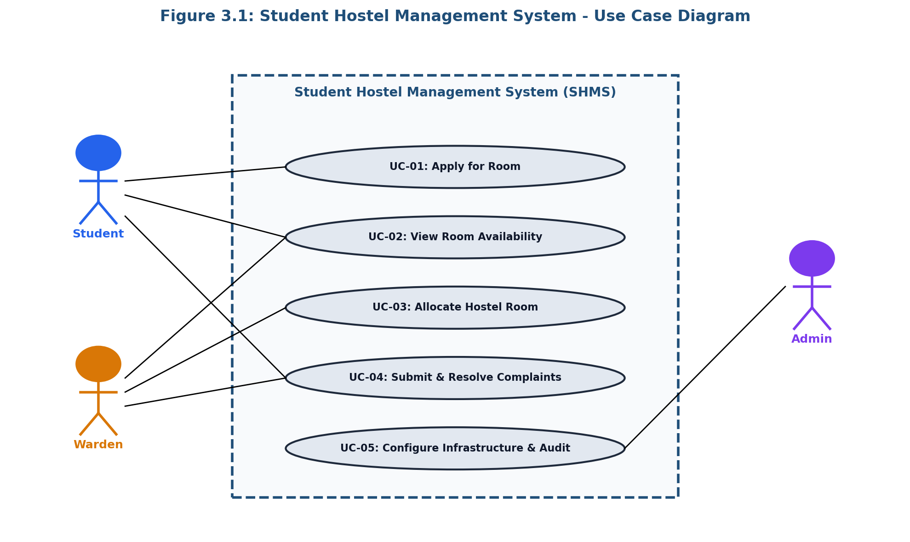
4. Data Modeling
4.1 ER Modeling & Entity Relational Schema
The relational schema models eight core entities in 3NF compliance (STUDENT, HOSTEL_BUILDING, ROOM, ROOM_APPLICATION, ALLOCATION, WARDEN, COMPLAINT, SECURITY_AUDIT_LOG). Figure 4.1 shows the ER Diagram.
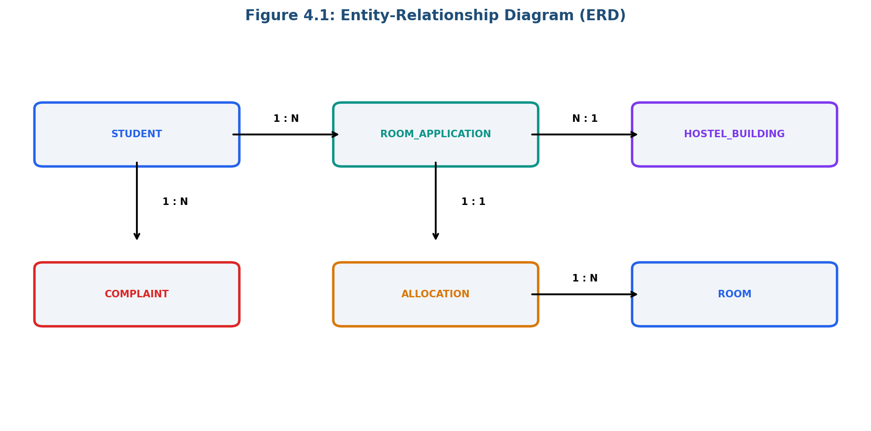
5. Data Flow Modeling
5.1 Level 1 DFD & Trust Boundaries
Figure 5.1 depicts the Level 1 Data Flow Diagram highlighting four explicit Trust Boundaries (TB1: Client/Internet, TB2: Application Logic, TB3: High-Trust DB, TB4: External SSO).
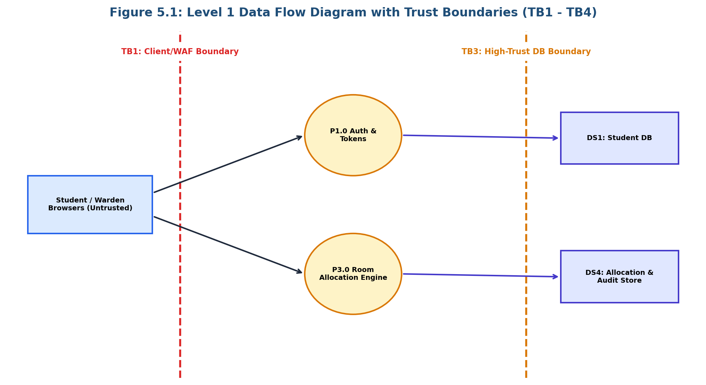
6. Threat Modeling & Vulnerability Analysis
6.1 STRIDE Threat Analysis Matrix
Threat ID | STRIDE Category | Threat Description | Mitigation Control
TRT-01 | SPOOFING | Student Account Impersonation via weak auth | OAuth2 SSO + TOTP MFA
TRT-02 | TAMPERING | Direct DB update of room allocations | DB Row Locks + RBAC
TRT-03 | REPUDIATION | Warden denial of illegal room allotment | HMAC SHA-256 Audit Trail
TRT-04 | INFO DISCLOSURE | Interception of student PII in transit | TLS 1.3 + AES-256 at Rest
TRT-05 | DENIAL OF SERVICE | HTTP API registration flood attack | WAF Rate Limiting
TRT-06 | ELEVATION OF PRIV | IDOR vulnerability on grievance tickets | Object-Level Authorization
TRT-07 | TAMPERING | Log wiping by malicious administrator | Write-Once Append-Only Logs
TRT-08 | TAMPERING/DoS | Race condition double-booking exploit | SELECT FOR UPDATE Pessimistic Lock
7. Attack Tree Analysis
7.1 Attacker Goal & Attack Tree Decomposition
Figure 7.1 details the Attack Tree for the root goal: 'Unauthorized Room Allocation / Record Modification', mapping AND/OR condition attack paths.
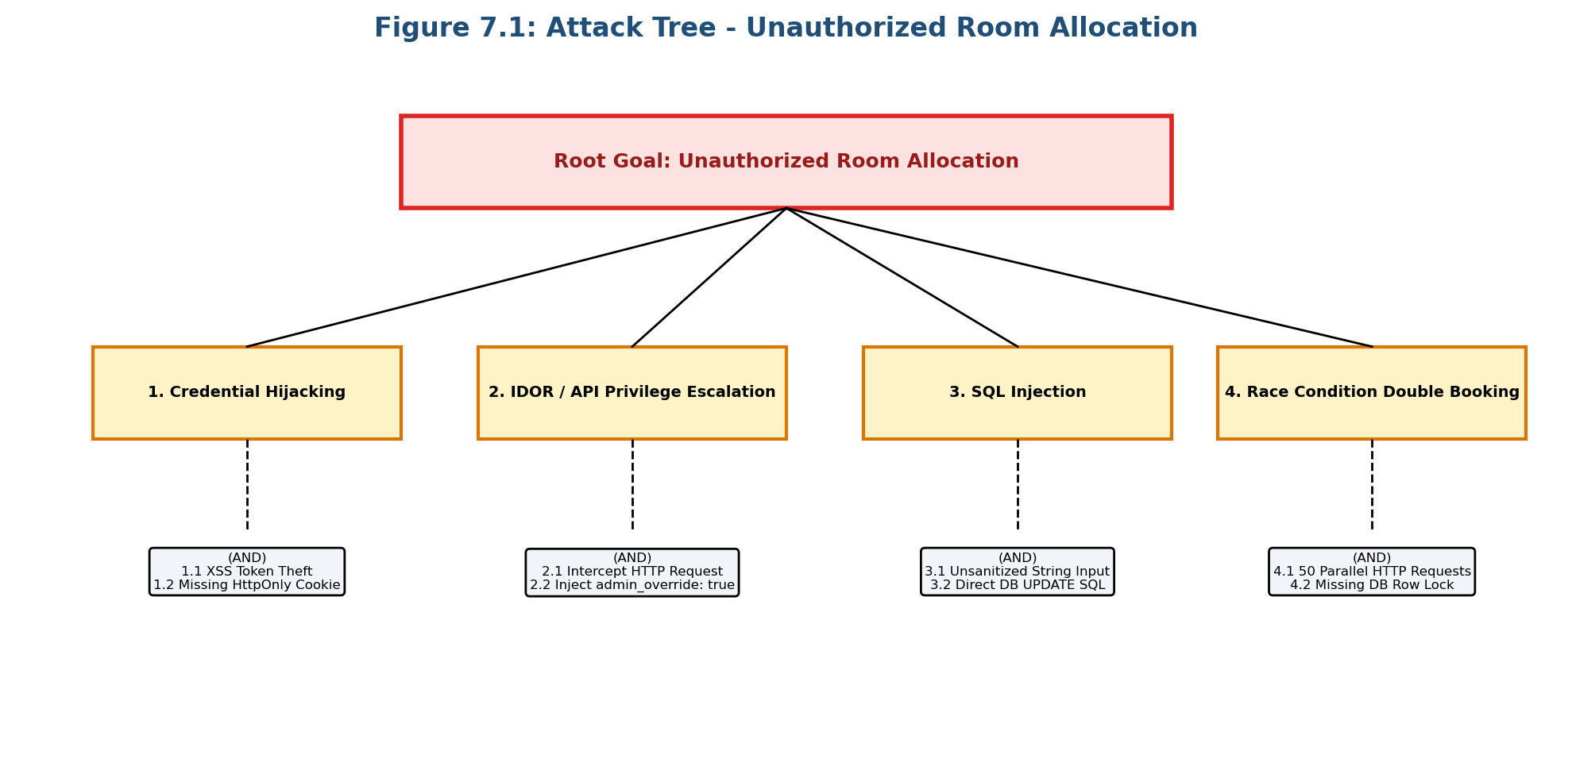
8. User Interface Design
8.1 Shneiderman's 8 Golden Rules & Web Prototype
Applying Shneiderman's 8 Golden Rules of UI Design, three major screens (Student Portal, Warden Dashboard, Admin Console) were built in an interactive web application (app/index.html).
9. Product Backlog
9.1 Product Backlog Matrix
Story ID | Epic | User Story Summary | Priority | Points
US-01 | Core Auth | SSO Authentication & MFA Support | MUST HAVE | 5 Points
US-02 | Room View | Real-time Room Vacancy Dashboard | MUST HAVE | 3 Points
US-03 | Room App | Online Room Application Form | MUST HAVE | 5 Points
US-04 | Allocation | Warden Room Allocation Engine (Row Lock) | MUST HAVE | 8 Points
US-05 | Status View | Accommodation Status & PDF Allotment Letter | MUST HAVE | 3 Points
US-06 | Grievance | Student Complaint Submission & Upload | SHOULD HAVE | 5 Points
US-07 | Resolution | Warden Complaint Resolution Dashboard | SHOULD HAVE | 5 Points
US-08 | Admin Config | Hostel Infrastructure Configuration | MUST HAVE | 5 Points
US-09 | Audit Log | Append-only HMAC Security Audit Trail | MUST HAVE | 8 Points
10. Jira Project & Scrum Execution
10.1 Jira Workspace Configuration (Project HMS)
The project was configured and executed in Jira Cloud under project space HOSTEL_MANAGEMENT_SYSTEM (Key: HMS). Epics HMS-4, HMS-5, HMS-6 and Stories HMS-1, HMS-2, HMS-3 were prioritized (High/Medium) and marked 100% DONE.
Issue Key | Type | Summary | Priority | Status
HMS-1 | Story | As a student, I want to submit a hostel room application... | High | DONE
HMS-2 | Story | As a student, I want to view available rooms... | Medium | DONE
HMS-3 | Story | As a warden, I want to review applications & allocate rooms... | High | DONE
HMS-4 | Epic | Hostel Room Application & Registration | High | DONE
HMS-5 | Epic | Room Discovery & Vacancy Management | Medium | DONE
HMS-6 | Epic | Warden Allocation & Allotment Engine | High | DONE
10.2 Scrum Metrics & Burndown Execution
The project achieved a velocity of 23.5 Story Points/sprint with 0 defects carried over. Figure 10.1 illustrates the Sprint Burndown chart.
