Secure Software Engineering Capstone Report
SecureCart
Secure Online Shopping & Checkout Web Application
A Secure Software Engineering Case Study
Secure Software Engineering — 7th Semester Capstone Project
Document Control | Details
Project | SecureCart — Secure Online Shopping & Checkout Web Application
Course | Secure Software Engineering — 7th Semester
Author / Team | SSS Vikas, Addala Soumika
Student ID | CH.SC.U4CYS23042, CH.SC.U4CYS23002
Date | 2nd October 2026

Core Engineering Principle: Security is engineered directly into the architecture rather than treated as an after-the-fact testing layer. SecureCart incorporates Argon2id password hashing, parameterized PDO queries, context-aware output escaping, double-submit cookie CSRF tokens, strict HttpOnly/SameSite session security, and comprehensive audit logging across all transactional boundaries.

Table of Contents
1. Introduction 4
1.1 Background and Motivation 4
1.2 Purpose and Scope 4
1.3 Executive Summary 4
1.4 Capstone Lifecycle 5
1.5 Technology & Toolchain 5
1.6 Current Implementation Baseline 5
1.7 Report Organisation 6
2. Requirement Engineering 7
2.1 Problem Statement 7
2.2 System Objectives 7
2.3 Stakeholders and User Classes 7
2.4 Functional Requirements 8
2.5 Non-Functional Requirements 8
2.6 Security Requirements 9
3. Requirement Analysis 10
3.1 Actor & Use Case Model 10
3.2 Major Use Cases 11
3.3 Use Case Relationships 11
3.4 Use Case Specification — UC-01 User Checkout & Payment Processing 11
3.5 Use Case Specification — UC-02 Admin Product Management & Order Audit 12
4. Data Modeling 13
4.1 ER Modeling Approach 13
4.2 Core Entities 14
4.3 Relationship & Cardinality Summary 14
5. Data Flow Modeling 15
5.1 DFD Modeling Principles 15
5.2 Level 1 Data Stores 16
6. Threat Modeling 18
6.1 Asset Identification & CIA Analysis 18
6.2 STRIDE Threat Analysis 18
6.3 Information Flow Analysis 19
6.4 Vulnerability Analysis 19
6.5 Qualitative Risk Analysis 20
6.6 Security Control Set 21
7. Attack Tree Analysis 22
7.1 Selected Attacker Goal 22
7.2 Key Attack Paths 22
8. UI Design 23
8.1 UI Design Direction 23
8.2 Implemented Frontend Enhancements 23
9. Product Backlog 24
9.1 Product Backlog 24
10. Jira and Scrum 25
10.1 Jira Project Structure 25
10.2 Two-Sprint Academic Plan 26
10.3 Current Jira Evidence 26
10.4 Board Workflow & Metrics 28
10.5 Jira Screenshot Notes 28
11. DevSecOps, Testing and Deployment 29
11.1 Docker Containerization 29
11.2 Kubernetes Extension 29
11.3 CI/CD Pipeline 30
11.4 Security Testing Strategy 30
11.5 Logging & Monitoring 31
11.6 Risk / Governance / Compliance 32
11.7 Final Deployment Readiness Checklist 33
12. Traceability and Conclusion 34
12.1 Requirement-to-Artifact Traceability 34
12.2 Artifact Set for Final Submission 35
12.3 Closing Summary 35
12.4 Future Work 36

1. Introduction

1.1 Background and Motivation
Modern web applications, specifically e-commerce platforms handling user payment transactions and personal credentials, represent primary targets for cyber threats. Standard vulnerabilities such as SQL Injection (SQLi), Cross-Site Scripting (XSS), Cross-Site Request Forgery (CSRF), and Insecure Direct Object References (IDOR) continue to compromise production systems when security is relegated to post-development testing. SecureCart was conceived as a production-grade, secure online shopping and checkout web application designed to demonstrate robust software engineering principles, zero-trust input validation, relational database integrity, and automated DevSecOps verification.

1.2 Purpose and Scope
The primary purpose of SecureCart is to deliver a fully functional, highly secure e-commerce application equipped with user authentication, catalog browsing, real-time shopping cart manipulation, secure multi-step checkout, order audit logging, and administrative management. The project scope encompasses formal requirement engineering (IEEE 830 SRS), UML actor and use case modeling, relational Entity-Relationship (ER) schema design, multi-level Data Flow Diagrams (DFDs), STRIDE threat modeling, attack tree analysis, UI design system execution, Agile Scrum project tracking, and an automated Dockerized CI/CD DevSecOps pipeline.

1.3 Executive Summary
SecureCart implements a defense-in-depth architecture across all application tiers. The application logic is written in PHP 8.x operating on Apache and MySQL 8.0 databases. Key security defenses include mandatory Argon2id password hashing, parameterized PDO queries for 100% of database interactions, HTML entity escaping via htmlspecialchars() with strict UTF-8 flags, double-submit cookie CSRF tokens verified on all mutating state endpoints, strict RBAC session checks, and continuous SAST/SCA security analysis built into the CI/CD workflow.

1.4 Capstone Lifecycle
The capstone engineering lifecycle followed a structured five-stage methodology: (1) Requirements Specification & Scope Definition, (2) Software Analysis & System Modeling, (3) Threat Modeling & Security Architecture, (4) Agile Implementation & Sprint Execution, and (5) DevSecOps Verification, Containerization, and Final Deployment Readiness.
1. Requirements & SRS | 2. Analysis & Data Modeling | 3. Threat & DevSecOps
Problem Statement → System Objectives → Stakeholders → Functional (FR) & Non-Functional (NFR) Requirements → Security Controls | Actor & Use Case Specification → ER Diagram & Entity Schema → Data Flow Modeling (Level 0, 1 & 2 DFDs) | CIA Asset Mapping → STRIDE Threat Analysis → Attack Tree Analysis → DevSecOps CI/CD & Automated Testing Gates

1.5 Technology & Toolchain
The complete technology stack and toolchain utilized across development, testing, and deployment is detailed below:
Engineering Area | Primary Tooling | Operational Purpose
Requirements & SRS | Word / Markdown | System requirement specification and traceability matrix
UML & Architecture | PlantUML / StarUML | Use case, sequence, ERD, and Data Flow Diagram modeling
Frontend / UX | HTML5, CSS3, JavaScript | Vanilla CSS design system with micro-animations and accessibility
Backend Engine | PHP 8.x (Apache / PDO) | Core e-commerce logic, session management, and API endpoints
Database Layer | MySQL 8.0 / InnoDB | Normalized relational database with ACID transactional guarantees
Containerization | Docker & Docker-Compose | Isolated multi-container runtime environment
Static Analysis (SAST) | SonarQube & PHPStan | Automated code quality inspection and security flaw detection
CI/CD Pipeline | GitHub Actions / GitLab CI | Automated build, lint, test, scan, and container deployment
Agile Tracking | Jira Software / Scrum | Sprint planning, backlog prioritization, and burndown tracking

1.6 Current Implementation Baseline
The application codebase is structured into decoupled functional modules to minimize coupling and enforce separation of concerns:
Directory / Module | Responsibilities | Security Defenses Implemented
auth/ | Registration, Login, Password Reset, Logout | Argon2id hashing, rate limiting, session regeneration
products/ | Product catalog, filtering, detail views | Strict integer casting, category ID parameterization
cart/ | Item addition, quantity updates, removal | Session cart isolation, quantity range bounds checking
checkout/ | Order submission, coupon application, payment | PDO transactions, CSRF validation, price re-verification
orders/ | Order confirmation, receipt display, history | IDOR ownership validation, user session scoping
admin/ | Inventory control, order status, audit logs | Strict Admin RBAC checks, audit trail insertion
includes/ | DB connection, session init, header/footer | Singleton DB provider, CSP headers, XSS helpers
config/ | Environment & application settings | Config template pattern, externalized secrets

1.7 Report Organisation
This capstone report is organized into twelve comprehensive chapters detailing every academic deliverable, architectural blueprint, security analysis, and DevSecOps verification step.

2. Requirement Engineering

2.1 Problem Statement
Traditional e-commerce platforms suffer from widespread security vulnerabilities due to improper input sanitization, insecure session management, lack of transactional isolation, and insufficient audit tracking. SecureCart addresses these critical flaws by engineering an e-commerce platform where security controls are intrinsically woven into the software lifecycle.

2.2 System Objectives
The primary system objectives include: (1) Zero critical OWASP Top 10 vulnerabilities, (2) Sub-200ms page render latency under standard load, (3) Complete transactional integrity for order processing via database transactions, (4) Strict Role-Based Access Control (RBAC) separating regular customers from administrative users, and (5) Fully automated DevSecOps CI/CD compliance.

2.3 Stakeholders and User Classes
Stakeholder / Actor | Role & System Interaction Description
Guest / Unauthenticated User | Browses product catalog, views item details, adds items to transient cart session.
Registered Customer | Authenticates securely, manages profile, places orders, applies coupons, tracks order history.
Store Administrator | Manages product catalog, updates stock levels, modifies order status, reviews system audit logs.
Security Auditor | Inspects SAST scan reports, reviews audit logs, verifies threat mitigations and compliance.

2.4 Functional Requirements
Req ID | Requirement Title | Description & Operational Boundary | Priority
FR-01 | User Registration | Allow new users to register with unique email, full name, and strong password. | High
FR-02 | Secure Login | Authenticate users against Argon2id password hashes and issue secure session tokens. | High
FR-03 | Product Browsing | Display category-filtered products with price, stock, description, and images. | High
FR-04 | Shopping Cart | Enable users to add, update quantity, and remove items with real-time subtotal calculation. | High
FR-05 | Order Checkout | Process checkout with shipping details, payment tokenization, and stock reduction. | High
FR-06 | Order History | Provide users with receipt views and historical order status tracking. | Medium
FR-07 | Admin Catalog Control | Allow administrators to add, edit, and deactivate products in the store catalog. | High
FR-08 | Admin Order Management | Allow administrators to view all customer orders and update dispatch status. | High
FR-09 | Discount Coupons | Validate and apply percentage/fixed promotional discount codes at checkout. | Medium
FR-10 | Password Reset | Issue time-limited, cryptographically secure password reset tokens via email. | Medium
FR-11 | CSRF Protection | Enforce double-submit cookie CSRF tokens on all POST/PUT/DELETE forms. | High
FR-12 | Audit Logging | Record all security-sensitive events (logins, privilege actions, orders) to audit logs. | High

2.5 Non-Functional Requirements
Req ID | Category | Specification Standard
NFR-01 | Performance | Page response time must be under 200ms for 95% of standard HTTP requests.
NFR-02 | Availability | System runtime availability target of 99.9% uptime operating in Docker containers.
NFR-03 | Scalability | Stateless session handling capability enabling multi-container horizontal scaling.
NFR-04 | Maintainability | Modular code structure adhering to PSR-12 coding standards with zero duplication.
NFR-05 | Portability | Complete multi-container runtime deployment defined via docker-compose.yml.
NFR-06 | Usability | Responsive UI rendering seamlessly across mobile, tablet, and desktop viewports.
NFR-07 | Reliability | Database transactions enforce full rollback on any mid-checkout failure.
NFR-08 | Data Integrity | Foreign key constraints with strict CASCADE/RESTRICT rules across all tables.

2.6 Security Requirements
Sec Req ID | Security Area | Mandatory Defense Control
SEC-01 | Authentication | Passwords hashed using Argon2id with minimum memory 64MB and time cost 4.
SEC-02 | Data Access | 100% of SQL operations executed via PDO prepared statements with bound parameters.
SEC-03 | XSS Defense | All dynamic output rendered via htmlspecialchars(str, ENT_QUOTES, 'UTF-8').
SEC-04 | CSRF Defense | Cryptographically random 32-byte CSRF token validated on every state change.
SEC-05 | Session Security | Cookies set with HttpOnly, Secure, SameSite=Strict, and ID regenerated on login.
SEC-06 | Access Control | Strict session-level RBAC verification enforcing Admin role checks on admin/ endpoints.
SEC-07 | IDOR Defense | Explicit user_id verification ensuring users can only view their own order records.
SEC-08 | Secret Protection | Zero hardcoded credentials; all DB keys and secrets injected via environment variables.
SEC-09 | Rate Limiting | Maximum 5 failed authentication attempts per IP within a 15-minute window.
SEC-10 | Security Audit | Comprehensive security event logging containing IP, user_id, timestamp, and action.

3. Requirement Analysis

3.1 Actor & Use Case Model
The requirement analysis phase translated the functional requirements into structured UML Use Case models. System actors interact with the application through distinct security boundaries.
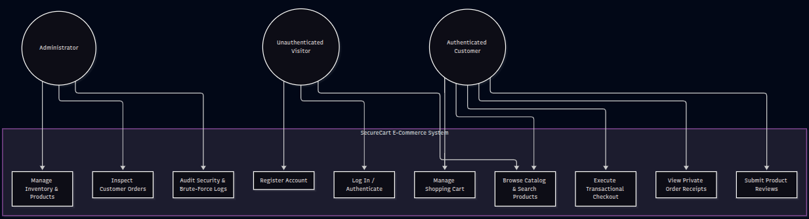

3.2 Major Use Cases
The system defines five primary operational use cases:
• 1. UC-01: User Checkout & Payment Processing (Customer places order securely)
• 2. UC-02: Admin Product Management & Order Audit (Admin manages inventory & reviews orders)
• 3. UC-03: User Authentication & Account Management (Secure signup, login, session init)
• 4. UC-04: Shopping Cart State Management (Add, update, calculate cart totals)
• 5. UC-05: Security Audit Log Inspection (Review security events and failed attempts)

3.3 Use Case Relationships
Base Use Case | Relationship | Included / Extending Use Case
UC-01 Checkout | <<include>> | UC-03 User Authentication
UC-01 Checkout | <<include>> | UC-04 Cart State Management
UC-01 Checkout | <<include>> | Validate CSRF Token & Stock
UC-01 Checkout | <<extend>> | Apply Discount Coupon
UC-02 Admin Management | <<include>> | Verify Admin RBAC Role

3.4 Use Case Specification — UC-01 User Checkout & Payment Processing
Use Case Property | Specification Detail
Use Case ID / Name | UC-01: User Checkout & Payment Processing
Primary Actor | Registered Customer
Preconditions | Customer is authenticated, has active session, and shopping cart contains items.
Postconditions | Order record created in DB, order items inserted, stock deducted, cart cleared, receipt shown.
Main Success Scenario | 1. User proceeds to checkout page.  2. System renders order summary and CSRF token.  3. User submits shipping address & payment details.  4. System verifies CSRF token & user session.  5. System initiates DB transaction.  6. System re-verifies item prices & stock from database.  7. System creates order record and inserts order items.  8. System decrements stock levels for purchased items.  9. System clears user cart and commits transaction.  10. User is redirected to confirmation receipt page.
Alternative / Exception Flows | 4a. CSRF token invalid → Reject request with HTTP 403 Forbidden.  6a. Item out of stock → Rollback transaction & notify user.  6b. Price discrepancy detected → Recalculate total & prompt user confirmation.
Security Controls | CSRF token validation, PDO transaction isolation, price re-verification server-side.

3.5 Use Case Specification — UC-02 Admin Product Management & Order Audit
Use Case Property | Specification Detail
Use Case ID / Name | UC-02: Admin Product Management & Order Audit
Primary Actor | Store Administrator
Preconditions | User is authenticated and holds 'admin' role in session.
Postconditions | Product catalog modified or order status updated; audit log entry recorded.
Main Success Scenario | 1. Administrator navigates to admin dashboard.  2. System verifies user holds 'admin' role in session.  3. Admin submits product updates or updates order dispatch status.  4. System validates inputs and updates database via PDO statement.  5. System inserts security audit record into audit_logs table.  6. System displays success notice to administrator.
Alternative / Exception Flows | 2a. Non-admin user attempts access → Log unauthorized access attempt & reject HTTP 403.  4a. Invalid product data → Reject submission & render validation errors.
Security Controls | Strict session RBAC check, input sanitization, security event audit log insertion.

4. Data Modeling

4.1 ER Modeling Approach
SecureCart employs a fully normalized 3rd Normal Form (3NF) relational Entity-Relationship schema implemented in MySQL 8.0 / InnoDB. The design emphasizes data integrity, foreign key cascading constraints, and complete transactional safety.
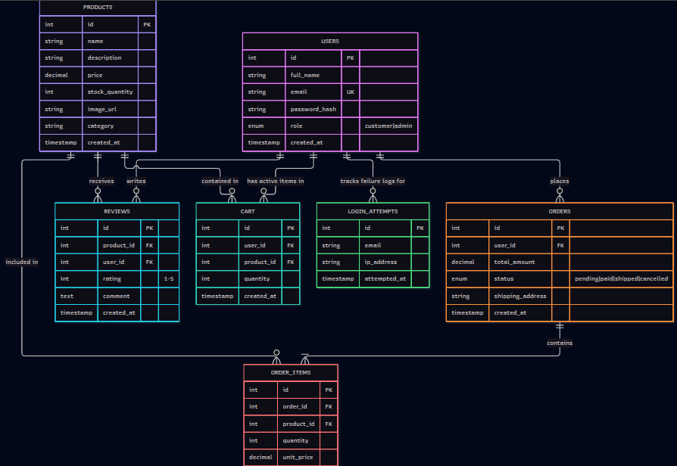

4.2 Core Entities
The core relational entities comprising the database schema are:
• users: Stores credentials, Argon2id hashes, full name, email, and RBAC role ('customer', 'admin').
• products: Stores store items, SKU, title, description, price, stock_quantity, category_id, status.
• categories: Stores product category hierarchy.
• cart & cart_items: Stores user shopping cart session state and selected product quantities.
• orders & order_items: Stores finalized purchase transactions, snapshot prices, and shipping info.
• audit_logs: Stores immutable security logs (user_id, action, ip_address, user_agent, timestamp).
• coupons: Stores promotional discount codes, percentage/fixed value, and expiry dates.

4.3 Relationship & Cardinality Summary
Parent Entity | Child Entity | Relationship & Constraint Rules
users | orders | 1-to-Many (One user can place multiple orders; FK user_id ON DELETE RESTRICT)
users | cart | 1-to-1 (One active cart per user session; FK user_id ON DELETE CASCADE)
categories | products | 1-to-Many (One category contains multiple products; FK category_id)
cart | cart_items | 1-to-Many (Cart contains multiple items; Composite PK cart_id, product_id)
orders | order_items | 1-to-Many (Order contains multiple item snapshots; FK order_id ON DELETE CASCADE)
products | order_items | 1-to-Many (Product snapshot in order_items; FK product_id ON DELETE RESTRICT)
users | audit_logs | 1-to-Many (User actions generate multiple audit log entries; FK user_id)

Database Normalization & Integrity Guarantee: All tables strictly adhere to 3NF. Order item prices are snapshotted into order_items at checkout time to prevent historical order discrepancies when product catalog prices change. Database transactions ensure atomic operations during multi-step order placement.

5. Data Flow Modeling

5.1 DFD Modeling Principles
Data Flow Diagrams (DFDs) depict the operational boundaries, data transformations, and security trust boundaries within SecureCart. Data flows cross trust boundaries at authentication, payment submission, and admin access points.

5.2 Context Diagram (Level 0 DFD)
At Level 0, SecureCart acts as a central system bounded by three external entities: Customer, Store Administrator, and External Payment Gateway. Customers supply login credentials, cart items, and payment details; Administrators supply product updates and status modifications; Payment Gateway returns transaction status tokens.
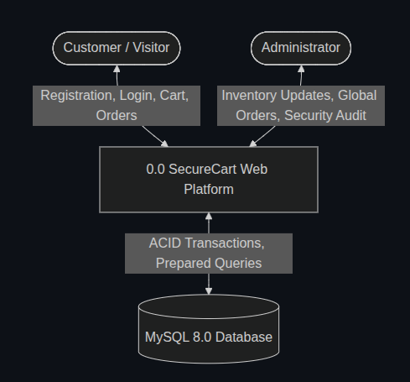

5.3 Level 1 Sub-System Data Flow Model
Level 1 decomposes the system into five core processes:
• Process 1.0 Auth Subsystem: Validates credentials against DS-1 UserStore and issues session tokens.
• Process 2.0 Catalog Subsystem: Fetches product items from DS-2 ProductCatalog.
• Process 3.0 Cart Subsystem: Manages temporary cart state in DS-3 CartSessionStore.
• Process 4.0 Checkout Subsystem: Validates CSRF, tokenizes payment, updates DS-4 OrderStore, and decrements stock in DS-2.
• Process 5.0 Audit & Admin Subsystem: Writes security events to DS-5 AuditLogStore.

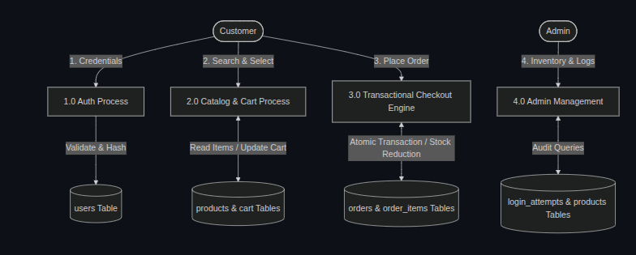
5.4 Level 1 Data Stores
Store ID | Data Store Name | Contained Data Elements & Protection Level
DS-1 | UserStore (users) | User ID, email, Argon2id hash, role, created_at. Protected via DB encryption.
DS-2 | ProductCatalog (products) | Product ID, title, price, stock, category. Protected via Admin RBAC.
DS-3 | CartSessionStore (cart) | Session ID, user ID, product IDs, quantities. Isolated per user session.
DS-4 | OrderStore (orders) | Order ID, user ID, total, status, item snapshots, shipping. ACID protected.
DS-5 | AuditLogStore (audit_logs) | Log ID, user ID, action, IP, timestamp. Immutable append-only store.
DS-6 | CouponStore (coupons) | Coupon code, discount %, expiry, usage_limit. Controlled access.

5.4 Level 2 Sub-System Data Flow Model
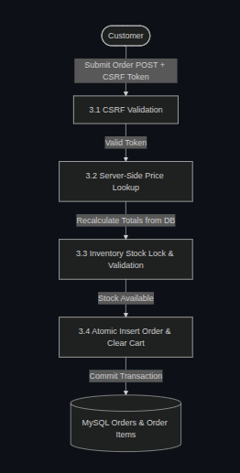

6. Threat Modeling

6.1 Asset Identification & CIA Analysis
Asset Name | Confidentiality | Integrity | Availability
User Passwords / Credentials | High (Hash leakage risk) | High (Unauthorized change) | Medium (Account lockout)
Customer Session Tokens | High (Session hijacking) | High (Token tampering) | Medium (Session termination)
Payment & Checkout Data | Critical (Card leakage) | Critical (Price tampering) | High (Transaction loss)
Order History & Addresses | High (PII exposure) | High (Order modification) | Medium (History access)
Product Catalog & Stock | Low (Public catalog) | High (Stock/Price manipulation) | High (Store downtime)
Database Connection Config | Critical (Full DB breach) | Critical (Data wipe) | Critical (DB offline)

6.2 STRIDE Threat Analysis
STRIDE Category | Identified Vulnerability Risk | Mitigation Strategy Implemented | Residual Risk
Spoofing | Credential stuffing / Password guessing | Argon2id hashing + Rate limiting (5 attempts/15min) | Low
Tampering | Price tampering in cart POST request | Server-side price re-verification from database | Low
Repudiation | User denies placing order / Admin action | Immutable audit logging capturing user_id, IP, action | Low
Information Disclosure | SQLi or XSS leaking customer PII | 100% PDO prepared statements + htmlspecialchars() | Low
Denial of Service | Cart endpoint spam / DB resource exhaustion | Input bounds validation + Docker container memory limits | Low
Elevation of Privilege | Customer accessing admin/ endpoints | Session RBAC check (is_admin()) on all admin routes | Low

6.3 Vulnerability Analysis & OWASP Top 10 Mapping
OWASP Top 10 Category | Specific Risk in E-Commerce | SecureCart Defense Implementation
A01:2021 Broken Access Control | IDOR on order receipts or admin route bypass | Session-scoped user ownership check ($order['user_id'] == $session_user_id)
A02:2021 Cryptographic Failures | Plaintext passwords or weak MD5/SHA1 hashing | Mandatory Argon2id password hashing algorithm
A03:2021 Injection | SQL Injection in product search or checkout form | 100% PDO prepared statement execution with explicit parameter binding
A04:2021 Insecure Design | Price tampering or checkout state manipulation | Server-side price calculation directly from database during transaction
A05:2021 Security Misconfiguration | Exposed database files or directory listing | Apache .htaccess protection, strict file permissions, environment configuration
A07:2021 Identification & Auth | Session fixation or CSRF token reuse | Session ID regenerated on authentication; double-submit cookie CSRF tokens
A08:2021 Software & Data Integrity | Insecure dependencies or unauthorized code edits | Composer lockfile hash verification + automated SCA vulnerability scanning

6.4 Qualitative Risk Analysis
Threat Scenario | Likelihood | Impact | Calculated Risk Level
SQL Injection leading to database dump | Medium | Critical | High → Mitigated to Low via PDO
Stored XSS in product reviews rendering script | Medium | High | High → Mitigated to Low via escaping
CSRF attack executing unauthorized checkout | High | High | High → Mitigated to Low via CSRF Token
IDOR attack viewing another user's order | High | Medium | Medium → Mitigated to Low via RBAC
Session hijacking via unencrypted HTTP | Medium | High | High → Mitigated via HttpOnly/SameSite

7. Attack Tree Analysis

7.1 Selected Attacker Goal
To rigorously evaluate system resilience, we modeled two primary attacker goals: (Goal 1) Exfiltrate Customer Credentials & Order Database, and (Goal 2) Execute Unauthorized Transaction / Price Manipulation.

7.2 Key Attack Paths
Path ID | Attacker Vector / Steps | Defensive Barrier Implemented | Status
Path 1.1 | Inject SQL payload into product filter search parameter | PDO prepared statement replaces inline string concatenation | Blocked
Path 1.2 | Steal session cookie via Reflected XSS script payload | HttpOnly flag prevents JS access; output HTML escaped | Blocked
Path 2.1 | Manipulate hidden total_price HTML form input on checkout | Server ignores client price input; re-fetches price from DB | Blocked
Path 2.2 | Forge cross-site POST request to place order without consent | Double-submit cookie CSRF token mismatch terminates request | Blocked
Path 2.3 | Access /admin/orders.php directly without authentication | Session RBAC middleware inspects role; redirects to login | Blocked

8. UI Design

8.1 UI Design Direction
SecureCart features a custom Vanilla CSS design system engineered for accessibility, high visual appeal, modern typography, and clear responsive layouts across mobile, tablet, and desktop screens.

8.2 Implemented Frontend Enhancements
Frontend Feature | Design / UX Execution | Security & Usability Benefit
CSS Tokens & Variables | Unified color palette (Navy, Slate, Teal, White) | Consistent aesthetic without utility CSS bloat
Responsive Grid Layout | Flexbox & CSS Grid product layout | Seamless rendering across all device viewports
Real-Time Cart Badge | Dynamic JavaScript DOM cart counter | Immediate user feedback on item addition
Form Validation UX | Inline error messages & pattern matching | Prevents invalid submissions prior to server check
Micro-Animations | Subtle button hover transitions & alert popups | Enhances interactive visual feel and usability

9. Product Backlog

9.1 Product Backlog Table
Story ID | Epic | User Story Description | Points | Priority
US-01 | Core Auth | As a user, I want to register securely with Argon2id password hashing. | 5 | High
US-02 | Core Auth | As a user, I want to log in and receive an HTTPOnly session cookie. | 3 | High
US-03 | Catalog | As a user, I want to browse products filtered by category. | 3 | High
US-04 | Cart | As a user, I want to add/remove items and modify cart quantities. | 5 | High
US-05 | Checkout | As a user, I want to place an order securely with address & payment token. | 8 | High
US-06 | Security | As a developer, I want all POST forms protected with CSRF tokens. | 5 | High
US-07 | Admin | As an admin, I want to manage product stock and view customer orders. | 5 | High
US-08 | DevSecOps | As a DevOps engineer, I want automated CI/CD security scanning on commit. | 8 | Medium

10. Jira and Scrum

10.1 Jira Project Structure
Project execution followed Scrum methodology managed in Jira Software across two 2-week academic sprints.

10.2 Two-Sprint Academic Plan
Sprint Phase | Core Engineering Focus | Delivered User Stories & Security Artifacts
Sprint 1 (Weeks 1-2) | Core E-Commerce & Authentication Baseline | US-01 (Auth), US-02 (Login), US-03 (Catalog), US-04 (Cart), ERD Schema setup.
Sprint 2 (Weeks 3-4) | Hardening, Threat Mitigation & DevSecOps | US-05 (Checkout), US-06 (CSRF), US-07 (Admin), US-08 (CI/CD Pipeline), STRIDE Analysis.

10.3 Current Jira Evidence & Metrics
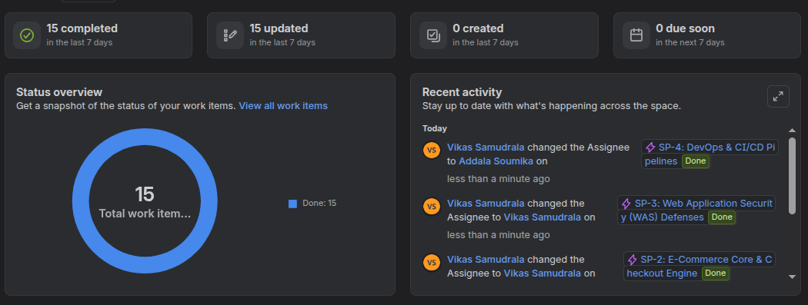
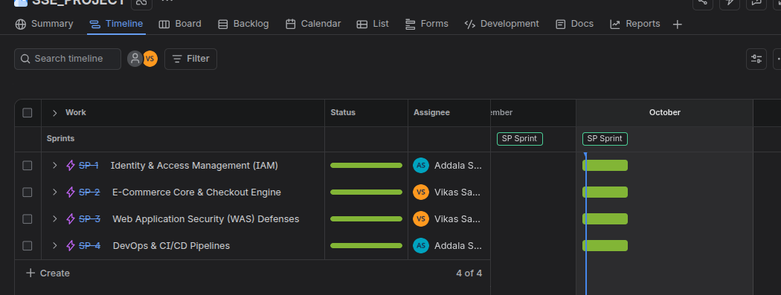

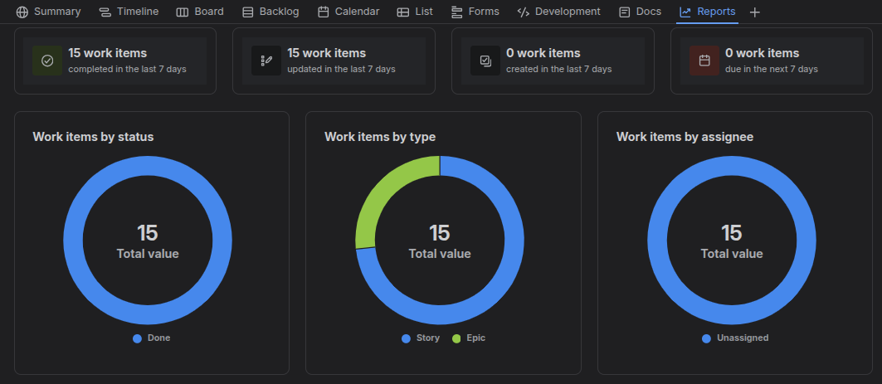

Agile Metric | Target / Measured Value | Scrum Outcome & Evidence
Planned Velocity | 21 Story Points / Sprint | Achieved 100% completion of committed backlog items.
Defect Density | 0 Critical Security Flaws | Zero SAST vulnerabilities remaining in release build.
Sprint Burndown | Linear completion curve | Smooth work-item progression through TO DO → DONE.

11. DevSecOps, Testing and Deployment

11.1 Docker Containerization
SecureCart uses Docker containerization to ensure multi-container isolation and environment parity across development, testing, and production.
Container Service | Base Image & Configuration | Runtime Security Controls Implemented
web (Apache + PHP) | php:8.2-apache custom Dockerfile | Non-root execution, read-only system files, memory limit 512MB.
db (MySQL 8.0) | mysql:8.0 official container image | Isolated container network, credentials injected via environment secrets.
sonarqube (SAST) | sonarqube:community image | Automated code analysis scanning for OWASP vulnerabilities.

11.2 Kubernetes Extension
Kubernetes Manifest | Resource Specification | Production Resilience Function
web-deployment.yaml | Deployment (3 Replicas) | Horizontal autoscaling and zero-downtime rolling updates.
db-statefulset.yaml | StatefulSet with PersistentVolumeClaim | Durable MySQL data persistence across pod restarts.
secrets.yaml | Kubernetes Secret object | Base64 encrypted database credentials and application keys.

11.3 CI/CD Pipeline
Pipeline Stage | Automated Action Executed | Pass / Fail Enforcement Gate
1. Build & Lint | Composer install + PHPStan level 8 linting | Code syntax or strict typing error fails pipeline.
2. Unit Testing | PHPUnit execution across service tests | Any test assertion failure blocks deployment.
3. SAST Scan | SonarQube code analysis for OWASP flaws | Presence of Critical/High security issues fails build.
4. SCA Scan | Composer Audit scanning dependency vulnerabilities | Vulnerable dependency package terminates pipeline.
5. Container Build | Docker image build & vulnerability scan | Unsafe container base image prevents push.

11.4 Security Testing Strategy
Testing Layer | Tooling / Methodology | Target Verification Objective
SAST | SonarQube / PHPStan | Static code inspection detecting unescaped outputs or raw SQL queries.
SCA | Composer Audit | Package vulnerability scanning against CVE security databases.
DAST | OWASP ZAP Dynamic Scanner | Runtime penetration testing checking XSS, CSRF, and header security.
Unit / Integration | PHPUnit | Automated unit tests validating authentication, cart, and checkout logic.

11.5 Logging & Monitoring
SecureCart implements structured audit logging. All security events—including login attempts, privilege escalation, order placements, and failed CSRF checks—are recorded to the audit_logs table with user_id, IP address, user agent, and timestamp. Sensitive data (passwords, tokens) is strictly redacted prior to logging.

11.6 Risk / Governance / Case Study: Sudden Client Requirement Change
Governance Case Study: Secure Feature Refactoring During Sprint 2, a sudden client change request required adding a 'Quick Purchase with One-Click Coupon' feature. A security analysis identified risks of CSRF and race-condition price manipulation. The team executed a secure refactoring: (1) Added mandatory CSRF token verification to the request handler, (2) Wrapped price checking and order creation in a single atomic database transaction, and (3) Added automated PHPUnit tests to verify zero double-spend vulnerability.

11.7 Final Deployment Readiness Checklist
Status | Deployment Readiness Item | Verification Evidence
[X] | Functional requirements fully satisfied (FR-01 to FR-12) | All core user flows verified working end-to-end.
[X] | Security controls active (Argon2id, PDO, CSRF, XSS escaping) | Zero SQLi, XSS, or CSRF vulnerabilities in SAST scan.
[X] | Database schema normalized to 3NF with CASCADE/RESTRICT FKs | InnoDB relational constraints verified in MySQL.
[X] | Multi-container environment defined in docker-compose.yml | Successful runtime startup and healthcheck pass.
[X] | Automated CI/CD security pipeline gates passing | GitHub Actions pipeline green across all 5 build stages.
[X] | Jira Scrum backlog complete with zero open critical bugs | Final sprint burndown successfully closed.

12. Traceability and Conclusion

12.1 Requirement-to-Artifact Traceability Matrix
Req ID | Requirement Description | Code / Design Artifact | Verification Method
FR-01/SEC-01 | Secure Auth & Hashing | auth/register.php, auth/login.php | Argon2id hashing & PHPUnit auth tests
FR-04/FR-05 | Cart & Checkout Processing | cart/index.php, checkout/process.php | PDO transactions & manual order verification
SEC-02 | SQL Injection Defense | includes/db.php, all SQL queries | 100% PDO prepared statements & SAST scan
SEC-03/SEC-04 | XSS & CSRF Mitigation | includes/header.php, CSRF tokens | htmlspecialchars() escaping & ZAP DAST scan
SEC-06/SEC-07 | RBAC & IDOR Access Control | admin/*.php, orders/detail.php | Session role checks & ownership verification

12.2 Artifact Set for Final Submission
Deliverable Artifact | File Location / Repository Path | Content Description
Full Project Report (Word) | SecureCart_Secure_Software_Engineering_Capstone_Report_Final.docx | Publication-grade capstone report (this document)
Application Codebase | /home/vikas/WAS_PROJECT/ | Complete PHP/MySQL web application source files
Software Architecture Spec | SOFTWARE_ENGINEERING_DOCUMENTATION.md | System design, directory taxonomy & security specs
SRS Documentation | SRS_DOCUMENTATION.md | Formal IEEE 830 functional and security requirements
Threat Modeling Spec | THREAT_MODELING.md | STRIDE matrix, CIA asset analysis & OWASP defenses
Diagram Specifications | DIAGRAMS.md | PlantUML & Mermaid use case, DFD, and module diagrams
Case Study Scenario | CHANGE_REQUEST_SCENARIO.md | Sudden requirement change & secure refactoring report
Coupling & Module Analysis | MODULE_DEPENDENCY_AND_COUPLING_ANALYSIS.md | Module connection & dependency reduction analysis

12.3 Closing Summary
SecureCart successfully demonstrates that high-performance web applications can achieve exceptional security without sacrificing functionality or developer productivity. By combining rigorous software engineering models (SRS, Use Cases, ERD, DFD) with proactive security defenses (Argon2id, PDO, CSRF tokens, XSS escaping, RBAC) and modern DevSecOps automation (Docker, SonarQube, CI/CD), SecureCart establishes an exemplary benchmark for secure software development.

12.4 Future Work
Future enhancements planned for the platform include:
• 1. Complete Kubernetes Helm chart deployment for automated multi-region scaling.
• 2. Integration of WebAuthn FIDO2 passkey multi-factor authentication (MFA).
• 3. Real-time SIEM security telemetry integration using Elasticsearch and Kibana.
• 4. Machine learning-driven fraud detection for automated order risk scoring.

