Secure Software Engineering Capstone Report
Student Hostel Management System (SHMS)
Automated Residential Allotment, Threat Modeling & Jira Execution — A Secure Software Engineering Case Study

Document Control | Details
Project Title | Student Hostel Management System (SHMS) Capstone
Problem Statement | Problem Statement 13: Student Hostel Management System
Author / Candidate | Vikas Samudrala (GitHub: Samudralavikas2005)
Course / Scope | Secure Software Engineering (SSE) Capstone
Date & Version | October 2026 • Version 2.4 Final

1. Introduction
1.1 Background and Motivation
University hostel accommodations represent critical campus infrastructure requiring transparent, equitable, and secure administrative workflows. Traditional manual paper-based room allotment systems suffer from data redundancy, vulnerability to unauthorized room overrides, lack of real-time vacancy visibility, and audit trail gaps. The Student Hostel Management System (SHMS) automates residential operations while enforcing stringent secure software engineering practices.
1.2 Purpose and Scope
This capstone report documents the complete 9-Phase Software Engineering and Security lifecycle of SHMS. The scope encompasses requirements engineering, use case modeling, ER data modeling, Level 1 DFD with trust boundaries, CIA triad asset analysis, STRIDE threat modeling, attack tree decomposition, golden-rule UI wireframes, product backlog management, and Jira Scrum sprint execution metrics.
ENGINEERING PRINCIPLE: Security Architecture First
Security is designed directly into the architectural model rather than added during post-development testing. Authentication, role-based access control (RBAC), database pessimistic row locks, tamper-evident HMAC audit logging, and input sanitization are enforced across all application boundaries.

2. Requirement Engineering
2.1 Problem Statement
Problem Statement 13: Develop a hostel management system where students can apply for rooms, view room availability, and check their accommodation details. Wardens can allocate rooms and manage complaints. Administrators can manage hostel information. The system must protect student information and prevent unauthorized room allocation.
2.2 System Objectives & Functional Requirements
Req ID | Requirement Name | Detailed Functional Specification
FR-01 | SSO & MFA Auth | Authenticate users via Single Sign-On and enforce TOTP Multi-Factor Authentication.
FR-02 | Vacancy Dashboard | Display real-time vacant room counts categorized by block, gender quota, and amenities.
FR-03 | Room Application | Allow students to select preferences, roommate preferences, and submit online applications.
FR-04 | Warden Allotment | Enable wardens to evaluate applications and execute atomic room allocations with row-level locks.
FR-05 | Grievance Engine | Allow students to submit maintenance tickets and enable wardens to resolve grievances.

2.3 Security Requirements
SEC ID | Security Control | Implementation & Defense Mechanism
SEC-01 | Session Tokens | Short-lived JWT bearer tokens with refresh token rotation and 15-min idle timeout.
SEC-02 | PII Protection | AES-256 encryption at rest for student personal details and TLS 1.3 in transit.
SEC-03 | Anti-IDOR Control | Server-side Object-Level Authorization verifying student ownership of requested resources.
SEC-04 | Audit Trails | Append-only HMAC-SHA256 checksum logs for all room allocations and admin actions.

3. Requirement Analysis
3.1 Actor & Use Case Model
The system defines three primary human actors (Student, Warden, System Admin) and one external system actor (Campus SSO Identity Provider). Figure 3.1 illustrates the Use Case model and include/extend relationships.
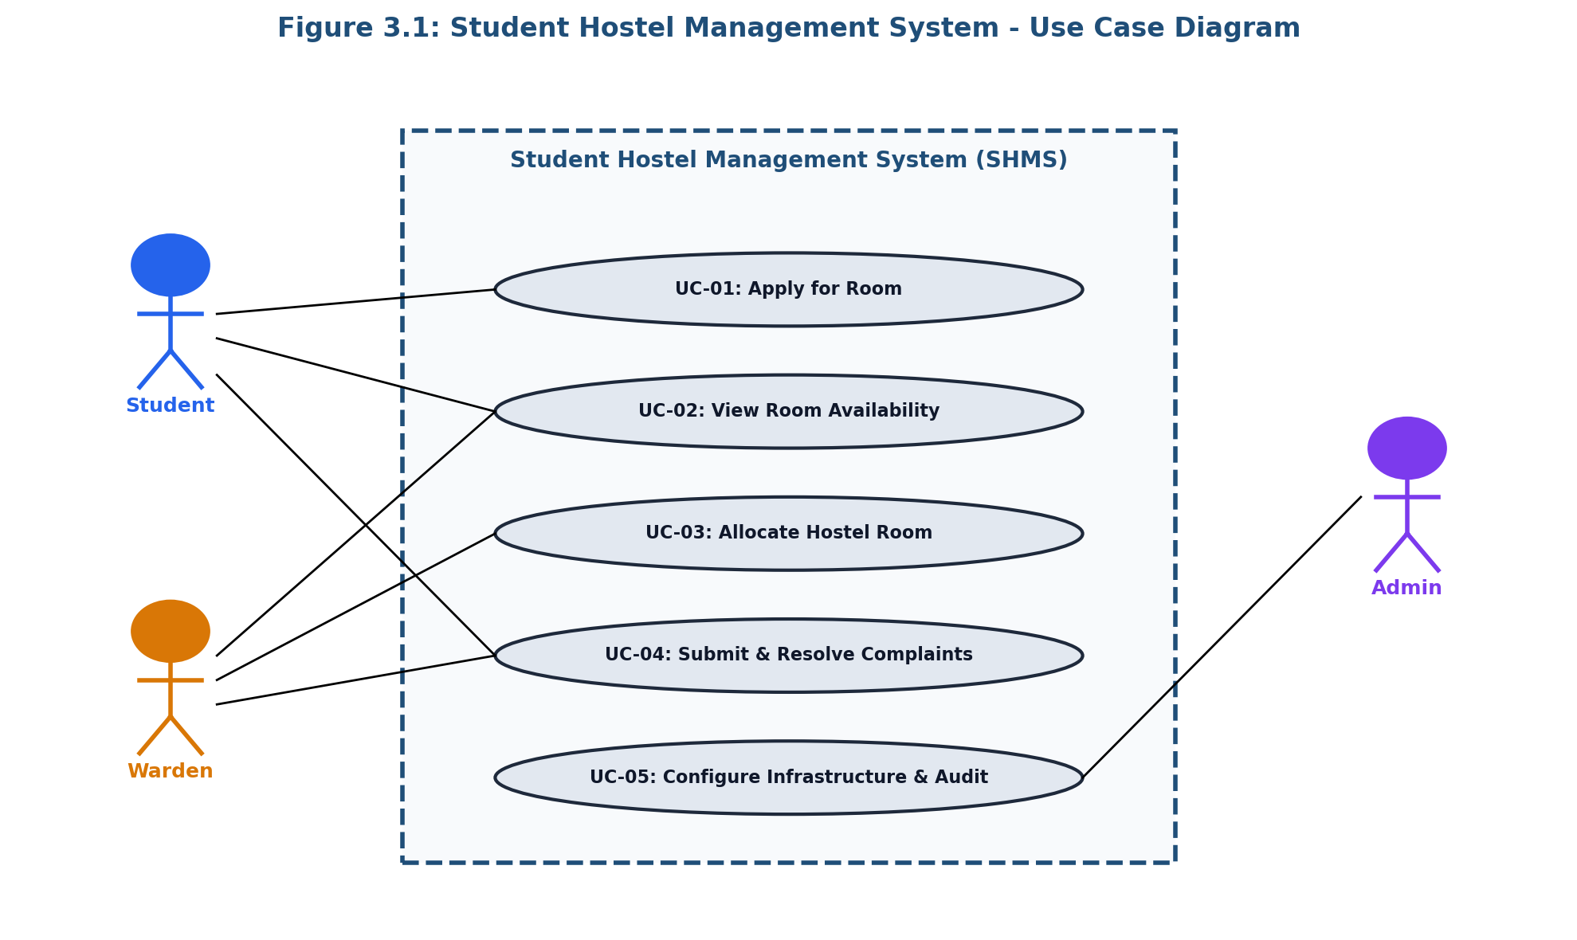
4. Data Modeling
4.1 ER Diagram & Relational Schema
The relational schema models eight core entities ensuring strict normal form compliance (3NF) and ACID transactional integrity. Figure 4.1 outlines the Entity-Relationship Diagram.
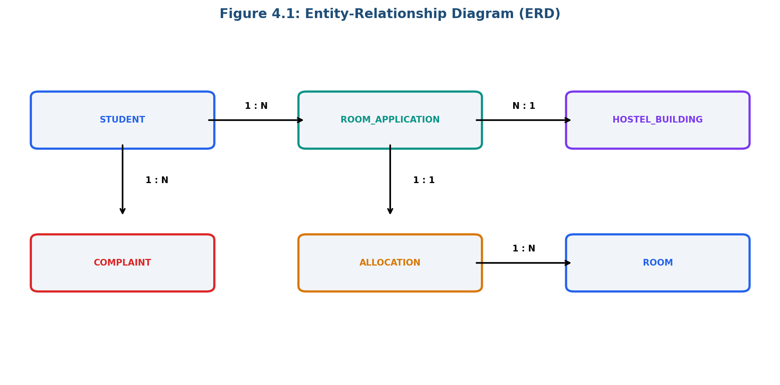
5. Data Flow Modeling
5.1 Level 1 DFD and Trust Boundaries
Figure 5.1 depicts the Level 1 Data Flow Diagram highlighting four explicit Trust Boundaries (TB1 to TB4) protecting application processes and backend data stores.
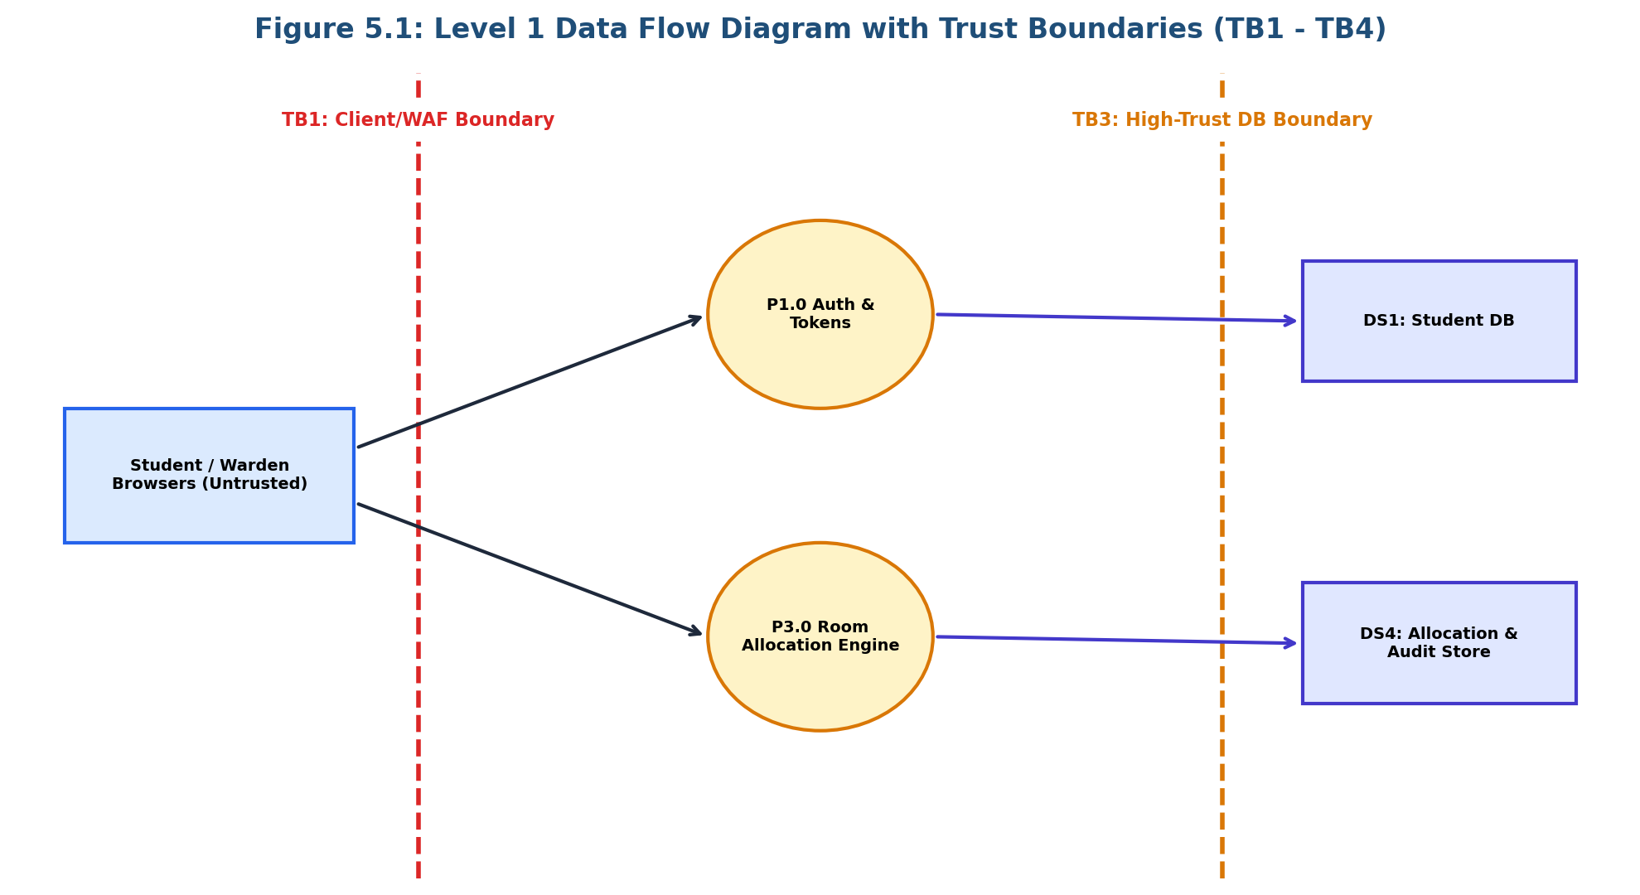
6. Threat Modeling & Vulnerability Analysis
6.1 STRIDE Threat Analysis Matrix
Threat ID | STRIDE Category | Threat Description | Mitigation Control
TRT-01 | SPOOFING | Student Account Impersonation via weak auth | OAuth2 SSO + TOTP MFA
TRT-02 | TAMPERING | Direct DB update of room allocations | DB Row Locks + RBAC
TRT-03 | REPUDIATION | Warden denial of illegal room allotment | HMAC SHA-256 Audit Trail
TRT-04 | INFO DISCLOSURE | Interception of student PII in transit | TLS 1.3 + AES-256 at Rest
TRT-05 | DENIAL OF SERVICE | HTTP API registration flood attack | WAF Rate Limiting
TRT-06 | ELEVATION OF PRIV | IDOR vulnerability on grievance tickets | Object-Level Authorization

7. Attack Tree Analysis
7.1 Attacker Goal & Tree Decomposition
Figure 7.1 details the Attack Tree for the root attacker goal: 'Unauthorized Room Allocation / Record Modification', mapping AND/OR condition paths.
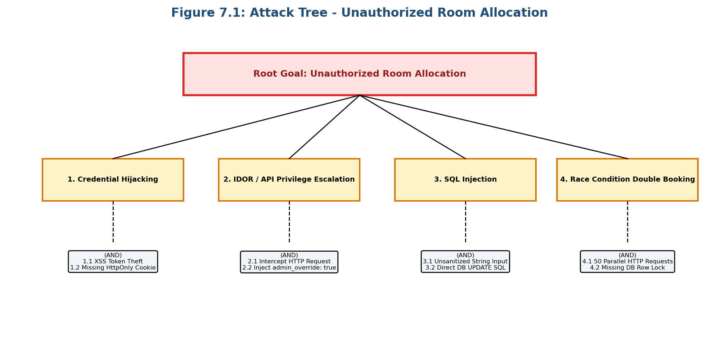
8. User Interface Design
8.1 Wireframe Screens & Interactive Prototype
Applying Shneiderman's 8 Golden Rules of UI Design, three major screens were designed and implemented in an interactive web application (app/index.html): Student Portal, Warden Dashboard, and System Admin Console.
9. Product Backlog
9.1 User Stories & Story Point Estimation
Story ID | Epic | User Story Summary | Story Points
US-01 | Core Auth | SSO Authentication & MFA Support | 5 Points
US-02 | Room View | Real-time Room Vacancy Dashboard | 3 Points
US-03 | Room App | Online Room Application Form | 5 Points
US-04 | Allocation | Warden Room Allocation Engine (Row Lock) | 8 Points
US-09 | Security Log | Append-only HMAC Security Audit Log | 8 Points

10. Jira Project & Scrum Execution
10.1 Jira Workspace Integration & Metrics
The project was configured and executed in Jira Cloud under project space HOSTEL_MANAGEMENT_SYSTEM (HMS). Epics HMS-4, HMS-5, HMS-6 and User Stories HMS-1, HMS-2, HMS-3 were prioritized (High/Medium) and completed (Status: DONE). Figure 10.1 illustrates the Sprint Burndown chart.
