Secure Software Engineering Capstone Report
SkillSim
Browser-Based Hands-On Lab Learning Platform
A Secure Software Engineering Case Study
Secure Software Engineering — 7th Semester Capstone Project

Document Control | Details
Project | SkillSim — Browser-Based Hands-On Lab Learning Platform
Course | Secure Software Engineering — 7th Semester
Authors | Elluru Phani Chandan Reddy, P Sai Vivek Reddy
Student ID | CH.SC.U4CYS23007, CH.SC.U4CYS23034
Date | 01 October 2026
Table of Contents
1. Introduction 4
1.1 Background and Motivation 4
1.2 Purpose and Scope 4
1.3 Executive Summary 4
1.4 Capstone Lifecycle 5
1.5 Technology & Toolchain 5
1.6 Current Implementation Baseline 5
1.7 Report Organisation 6
2. Requirement Engineering 7
2.1 Problem Statement 7
2.2 System Objectives 7
2.3 Stakeholders and User Classes 7
2.4 Functional Requirements 8
2.5 Non-Functional Requirements 8
2.6 Security Requirements 9
3. Requirement Analysis 10
3.1 Actor & Use Case Model 10
3.2 Major Use Cases 11
3.3 Use Case Relationships 11
3.4 Use Case Specification — UC-01 Start Lab Session 11
3.5 Use Case Specification — UC-02 Validate Lab Step 11
4. Data Modeling 13
4.1 ER Modeling Approach 13
4.2 Core Entities 14
4.3 Relationship & Cardinality Summary 14
5. Data Flow Modeling 15
5.1 DFD Modeling Principles 15
5.2 Level 1 Data Stores 16
6. Threat Modeling 18
6.1 Asset Identification & CIA Analysis 18
6.2 STRIDE Threat Analysis 18
6.3 Information Flow Analysis 19
6.4 Vulnerability Analysis 19
6.5 Qualitative Risk Analysis 20
6.6 Security Control Set 21
7. Attack Tree Analysis 22
7.1 Selected Attacker Goal 22
7.2 Key Attack Paths 22
8. UI Design 23
8.1 UI Design Direction 23
8.2 Implemented Frontend Enhancements 23
9. Product Backlog 24
9.1 Product Backlog 24
10. Jira and Scrum 25
10.1 Jira Project Structure 25
10.2 Two-Sprint Academic Plan 26
10.3 Current Jira Evidence 26
10.4 Board Workflow & Metrics 28
10.5 Jira Screenshot Notes 28
11. DevSecOps, Testing and Deployment 29
11.1 Docker Containerization 29
11.2 Kubernetes Extension 29
11.3 CI/CD Pipeline 30
11.4 Security Testing Strategy 30
11.5 Logging & Monitoring 30
11.6 Risk / Governance / Compliance 31
11.7 Final Deployment Readiness Checklist 31
12. Traceability and Conclusion 32
12.1 Requirement-to-Artifact Traceability 32
12.2 Artifact Set for Final Submission 32
12.3 Closing Summary 33
12.4 Future Work 33
List of Figures
Figure 1 — SkillSim UML Use Case Diagram 10
Figure 2 — SkillSim ER Diagram: core schema with optional supporting extensions 13
Figure 3 — Level 0 DFD (Context Diagram) with trust boundaries 15
Figure 4 — Level 1 DFD showing major processes, data stores and trust boundaries 16
Figure 5 — Level 2 DFD: Decomposition of Sandbox Session Management 17
Figure 6 — Attack Tree: Unauthorized Access to Another Student’s Files / Lab Data 22
Figure 7 — Jira Summary Dashboard showing current work-item status and recent activity 26
Figure 8 — Jira Timeline / sprint view for the current implementation workspace 27
Figure 9 — Jira Backlog / active sprint view with current implementation tasks 27
Figure 10 — Jira Reports dashboard with status, type and assignee views 27

1. Introduction
Background, purpose, scope and report organisation

1.1 Background and Motivation
Hands-on practice is essential in technical education, yet it is also the hardest part to deliver at scale. Students usually need to install tools, configure virtual machines and troubleshoot their own environments before they can even begin a lab. Instructors, in turn, can rarely verify what a student actually did and often rely on screenshots or self-reported answers.
SkillSim addresses this gap by moving the lab into the browser. Each learner receives a clean, disposable Linux environment on demand, works through guided steps in an interactive terminal, and has progress verified by server-side scripts that inspect the live environment. Because the platform executes commands entered by many learners on shared infrastructure, security cannot be an afterthought: isolation, authorisation and auditability are central design concerns, which makes SkillSim a suitable subject for a Secure Software Engineering capstone.

1.2 Purpose and Scope
This report carries SkillSim through the secure software engineering lifecycle. It begins with requirements and modelling, continues with threat analysis and secure design, and ends with Agile delivery and the extended DevSecOps pipeline. All academic deliverables are kept consistent with the SRS and with the implemented architecture so that the same system boundaries appear in every diagram and table.
- Included: requirements, use cases, ER and DFD models, threat modelling, attack tree, UI design, backlog, Jira evidence and DevSecOps planning.
- Evidence-based: the Jira screenshots and diagrams are taken from the actual project artifacts.
- Out of scope: detailed source-code listings and performance benchmarking, which belong to the implementation repository.

1.3 Executive Summary
SkillSim is a browser-based hands-on learning platform designed to give students an interactive lab environment without local software installation. The system combines a React frontend, an application backend, a dedicated terminal server, PostgreSQL persistence, and ephemeral Docker sandboxes so that each lab attempt can be executed and validated in an isolated runtime.
Core engineering principle
Security is part of the architecture rather than a final testing step. Authentication, scoped session tokens, multi-tenant isolation, resource controls, validation integrity, internal-service authorization, and session cleanup are designed into the runtime path.

1.4 Capstone Lifecycle
1. Requirements & SRS  Problem → FR/NFR/Security | 2. Analysis & Modeling  Use Cases → Specs → ERD → DFD | 3. Threat & Risk  CIA → STRIDE → Flows → Vulnerabilities → Risk
4. Secure Design  Controls → Attack Tree → Architecture → UI | 5. Agile Delivery  Backlog → Jira → Sprints → Metrics | 6. DevSecOps  Docker → Kubernetes → CI/CD → SAST/SCA/DAST → Tests → Monitoring → Governance

1.5 Technology & Toolchain
Table 1 — Technology and toolchain
Area | Primary Tooling | Purpose
Requirements | Word / Google Docs | SRS, specifications, traceability and report packaging
UML | StarUML / PlantUML | Use cases and system modeling
ERD / DFD / Architecture / Attack Tree | Draw.io / diagram artifacts | Data, flow, trust-boundary and security design models
Threat Modeling | Microsoft Threat Modeling Tool | Threat enumeration and security reasoning
Development | VS Code / IntelliJ | Application and backend development
Containers | Docker / Docker Compose | Ephemeral labs and reproducible environments
Orchestration | Kubernetes | Production-scale deployment extension
CI/CD | GitHub Actions; Jenkins optional | Build, test, security gates and deployment automation
SAST / SCA / DAST | SonarQube / SonarCloud; Snyk; OWASP ZAP | Code, dependency and runtime security checks
Testing / Fuzzing | PyTest; AFL | Functional, regression and input robustness testing

1.6 Current Implementation Baseline
Table 2 — Current implementation baseline
Component | Current role | Security-relevant implementation
Frontend | React 18 + Vite + TypeScript + Tailwind | Split-pane lab UI, xterm terminal, inert Markdown rendering, status indicators, dashboard and progress UI
App Backend | Node.js + Express + Prisma | Auth, catalog, lab session creation, progress persistence, rate limiting and internal API
Terminal Server | Node.js + WebSocket + Dockerode | WebSocket authentication, container provisioning, PTY streaming, validation execution, session cleanup
Database | PostgreSQL | Users, tracks, labs, steps, sessions and step progress
Sandbox Runtime | Docker | Per-session ephemeral containers with capability/resource/network controls
Content Pipeline | YAML + Markdown + shell scripts | Git-driven lab definitions and automated check scripts

Architecture anchor
The terminal server exclusively owns the host Docker socket. The public-facing application backend and the student container do not receive direct Docker-socket access.

1.7 Report Organisation
The report is organised as twelve chapters. Chapters 2 to 10 follow the numbered exercises of the course in order, Chapter 11 adds the DevSecOps extension, and Chapter 12 closes with traceability and conclusions.
Table 3 — Chapter map of the report
Ch. | Title | Contents | Source
2 | Requirement Engineering | SRS, stakeholders, FR / NFR, security requirements | Exercise 1
3 | Requirement Analysis | Use-case model and specifications | Exercises 2–3
4 | Data Modeling | ER diagram, entities, cardinality | Exercise 4
5 | Data Flow Modeling | DFD levels 0–2 with trust boundaries | Exercise 5
6 | Threat Modeling | Assets, STRIDE, flows, vulnerabilities, risk, controls | Exercises 6–9
7 | Attack Tree Analysis | Attacker goal and attack paths | Exercise 10
8 | UI Design | Screens, interaction model, frontend work | Exercise 11
9 | Product Backlog | User stories and priorities | Exercise 12
10 | Jira and Scrum | Sprints, evidence, board, metrics | Exercises 13–15
11 | DevSecOps | Docker, Kubernetes, CI/CD, testing, monitoring, governance | Extended track
12 | Traceability and Conclusion | Matrix, artifacts, summary, future work | Appendix

2. Requirement Engineering
Exercise 1 — Software Requirements Specification (SRS)
This chapter establishes what SkillSim must do and under which security constraints it must operate. Because the platform lets students run arbitrary commands inside shared infrastructure, every functional requirement that touches execution, such as starting a sandbox or validating a step, is paired with a non-functional target and at least one security control. The identifiers FR-xx, NFR-xx and SEC-xx introduced here are reused throughout the report, so that each later design decision can be traced back to a stated requirement.

2.1 Problem Statement
Traditional technical learning frequently relies on passive instructional material or shared environments. Those approaches can leave residual state, make grading dependent on self-reporting, increase infrastructure cost, and introduce multi-tenant execution risks when students are allowed to run arbitrary commands.

2.2 System Objectives
- Provision an isolated, clean Linux sandbox for each student lab session with rapid startup and zero local software setup.
- Validate hands-on tasks using server-side scripts executed against the live runtime state rather than self-reported answers.
- Enforce defense-in-depth sandbox hardening with capability dropping, network isolation, resource quotas and privilege-escalation controls.
- Keep the Docker Engine API socket isolated to the trusted terminal service and away from client-facing paths.
- Use a file-based, Git-driven lab content workflow so instructors can add curriculum content without changing application code.
- Persist learner progress and points so milestone completion is auditable across accounts.

2.3 Stakeholders and User Classes
Table 4 — Stakeholders and user classes
Stakeholder / Actor | Role in SkillSim
Student / Learner | Registers, authenticates, browses tracks, launches labs, uses the terminal, validates steps and reviews progress.
Content Author / Instructor / TA | Creates and manages tracks, labs, instructions and validation scripts.
App Backend | System actor responsible for authentication, catalog access, session creation and progress persistence.
Terminal Server | System actor responsible for WebSocket authentication, container lifecycle, PTY streaming, validation execution and cleanup.
Docker Engine | Runtime actor that creates, starts, executes and removes sandbox containers.

2.4 Functional Requirements
Table 5 — Functional requirements
ID | Requirement | Description | Priority
FR-01 | User Registration & Auth | Validate email/uniqueness, hash password with bcrypt, issue user JWT. | Must Have
FR-02 | Track & Lab Catalog | Browse tracks, labs, difficulty, duration and ordered cards. | Must Have
FR-03 | Lab Session Initiation | Create session record and issue short-lived scoped sandbox token. | Must Have
FR-04 | Ephemeral Sandbox Provisioning | Verify token, enforce concurrency, provision hardened container. | Must Have
FR-05 | Real-Time Interactive Terminal | Stream xterm PTY data over WebSocket and support resize controls. | Must Have
FR-06 | In-Container Step Validation | Execute step-specific validation script and evaluate result. | Must Have
FR-07 | Progress & Points Sync | Persist passed steps and award points through internal service call. | Must Have
FR-08 | Idle Session Reaping | Terminate stale sessions and reclaim containers after inactivity. | Must Have
FR-09 | Student Dashboard | Show points, progress, recent attempts and track completion. | Should Have
FR-10 | File-Based Content Sync | Sync YAML/Markdown/check scripts into the relational catalog. | Should Have

2.5 Non-Functional Requirements
Table 6 — Non-functional requirements
ID | Area | Requirement
NFR-01 | Latency | Interactive terminal round-trip target under 50 ms on standard local/LAN connections.
NFR-02 | Boot Time | Sandbox creation and terminal attach target under 3 seconds.
NFR-03 | Validation | Step validation result target under 2 seconds.
NFR-04 | Fault Isolation | Failure of one sandbox must not affect host, backend or other students.
NFR-05 | Cleanup | Auto-remove and janitor mechanisms reclaim containers after disconnect or idle timeout.
NFR-06 | Concurrency | Global single-host sandbox cap of 20 active sessions.
NFR-07 | Resource Limits | Per-sandbox quota of 0.5 vCPU, 512 MB RAM and 128 PIDs.
NFR-08 | Usability | Resizable split-pane workspace, terminal capability and Markdown instructions.
NFR-09 | Status Feedback | Visible connection, validation and step-progress states.

2.6 Security Requirements
Table 7 — Security requirements
ID | Security Control | Implementation direction
SEC-01 | Password Hashing | bcrypt with cost factor 10; never store plaintext passwords.
SEC-02 | Brute-Force Protection | Rate-limit authentication endpoints.
SEC-03 | Dual JWT Scope | Separate user auth token from short-lived sandbox attach token.
SEC-04 | Internal Service Authorization | Protect progress API with internal service secret.
SEC-05 | Capability Dropping | Drop all Linux capabilities in default sandboxes.
SEC-06 | No New Privileges | Prevent privilege escalation through setuid/setgid behavior.
SEC-07 | Filesystem Immutability | Read-only root with constrained temporary workspace.
SEC-08 | Network Isolation | Default sandbox uses no network egress.
SEC-09 | DinD Isolation | Nested daemon is isolated; host Docker socket is never mounted into student containers.
SEC-10 | Docker Socket Protection | Only terminal-server accesses host Docker socket.
SEC-11 | CSWSH Protection | Validate WebSocket Origin against explicit allowlist.
SEC-12 | Injection Defense | Prisma parameterization plus schema validation.
SEC-13 | Markdown XSS Defense | No raw HTML rendering in step content.
SEC-14 | DoS / Fork Bomb Defense | PID, memory and CPU quotas bound per-sandbox execution.

3. Requirement Analysis
Exercises 2–3 — Use Cases and Use Case Specifications
Requirement analysis converts the written SRS into behaviour that can be modelled, reviewed and tested. The use-case model identifies who interacts with SkillSim and which goals they pursue, and two detailed specifications then describe the most security-critical interactions, starting a lab session and validating a lab step, including their preconditions, main flows, alternative flows and exception flows.

3.1 Actor & Use Case Model
The use-case model intentionally keeps the diagram readable. Student-facing activities are separated from supporting system behavior so the diagram shows the primary user goals without turning every low-level implementation operation into an independent use case.
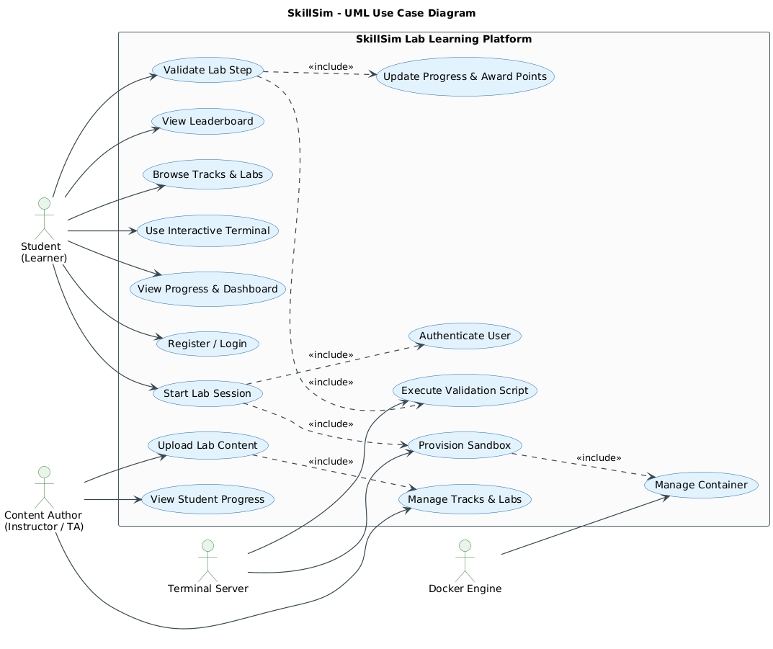
Figure 1 — SkillSim UML Use Case Diagram
Modeling rule
Use <<include>> only where a behavior is mandatory to complete the parent use case. Optional behavior is not forced into the model simply to demonstrate <<extend>>.

Reading the diagram: students are the primary actors and drive the learning goals on the left of the model, content authors manage the curriculum, and the terminal server and Docker Engine appear as supporting systems that fulfil the sandbox-related use cases. Keeping the include relationships to the few that represent real mandatory behaviour, such as authentication before a session starts, keeps the diagram readable and the specifications testable.

3.2 Major Use Cases
Table 8 — Major use cases by actor
Actor | Major Use Cases
Student | Register / Login; Browse Tracks & Labs; Start Lab Session; Use Interactive Terminal; Validate Lab Step; View Progress & Dashboard; View Leaderboard
Content Author | Manage Tracks & Labs; Upload Lab Content; View Student Progress
Terminal Server | Provision Sandbox; Execute Validation Script
Docker Engine | Manage Container

3.3 Use Case Relationships
- Start Lab Session <<include>> Authenticate User.
- Start Lab Session <<include>> Provision Sandbox.
- Validate Lab Step <<include>> Execute Validation Script.
- Validate Lab Step <<include>> Update Progress & Award Points.
- Provision Sandbox <<include>> Manage Container.
- Upload Lab Content can be treated as part of Manage Tracks & Labs rather than a separate optional branch.

3.4 Use Case Specification — UC-01 Start Lab Session
Table 9 — UC-01 Start Lab Session specification
Field | Specification
Actor | Student
Supporting Actors | Terminal Server, Docker Engine
Preconditions | Student is authenticated; requested lab exists; sandbox capacity is available.
Trigger | Student selects a lab and chooses Start Lab.
Main Flow | 1) Select lab → 2) Verify user → 3) Verify lab → 4) Create session → 5) Issue short-lived sandbox token → 6) Send token to terminal server → 7) Verify token → 8) Create/start container → 9) Open shell → 10) Display terminal and instructions.
Alternative Flow | An existing active session can be surfaced rather than creating a duplicate session.
Exception Flow | Invalid auth; lab not found; concurrency limit reached; expired/invalid sandbox token; Docker creation failure.
Postconditions | A valid session exists and the student has access to an isolated interactive sandbox.

3.5 Use Case Specification — UC-02 Validate Lab Step
Table 10 — UC-02 Validate Lab Step specification
Field | Specification
Actor | Student
Supporting Actors | Terminal Server, App Backend, Docker Engine
Preconditions | Active lab session and running sandbox; selected step belongs to the current lab.
Trigger | Student selects Check My Work.
Main Flow | 1) Complete task → 2) Submit validation request → 3) Locate check script → 4) Execute script inside sandbox → 5) Evaluate exit code → 6) Report result → 7) Persist progress → 8) Award points → 9) Unlock next step.
Alternative Flow | Failed validation displays diagnostics/hints and keeps the step available for retry.
Exception Flow | No active session; invalid step; container unavailable; validation execution error; unauthorized internal progress update.
Postconditions | Successful validation persists completion and points; failed validation does not award completion credit.

These two use cases were selected for detailed specification because they cross the most important trust boundaries in the platform. UC-01 provisions an execution environment, which involves issuing a scoped token, contacting the terminal server and creating a restricted container. UC-02 runs a validation script against live runtime state and then writes progress and points, so the integrity of learner achievements depends directly on it. Their exception flows also define how failures are reported without leaking internal details.

4. Data Modeling
Exercise 4 — Entity Relationship Diagram
Data modelling defines what SkillSim stores permanently and how those records relate to each other. The relational model is deliberately compact: runtime infrastructure such as the Docker daemon and the terminal server is kept outside the schema, which limits the amount of sensitive data in the database and keeps integrity rules simple to reason about.

4.1 ER Modeling Approach
The ER model is centered on the six persistent entities present in the Prisma/PostgreSQL schema. Runtime infrastructure such as the Docker daemon and terminal server is kept outside the core relational model; the session entity stores the container identifier needed to correlate application state with a live sandbox. The figure also shows clearly separated optional supporting entities for future capstone extensions, without treating them as part of the current core schema.
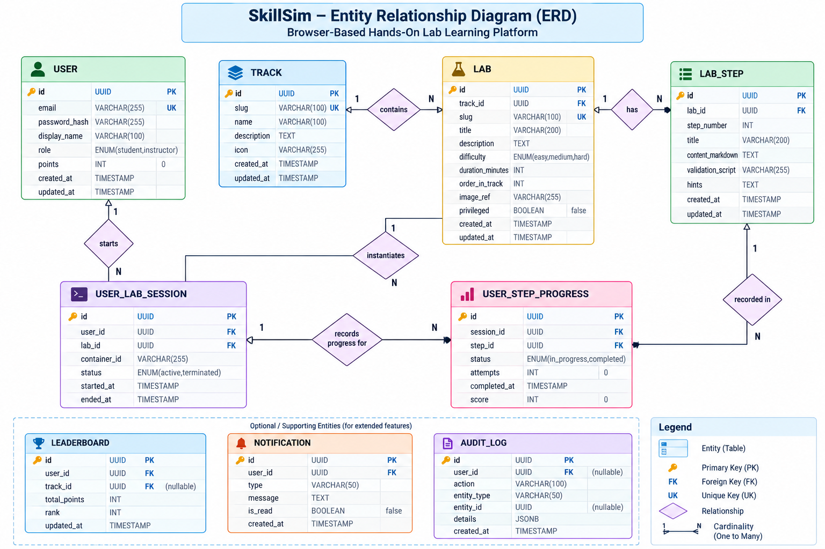
Figure 2 — SkillSim ER Diagram: core schema with optional supporting extensions

The diagram shows learners producing session and progress records against labs that are grouped into tracks. Primary keys, foreign keys and cardinalities are explicit, so that referential integrity is enforced by the database rather than by application convention. Optional supporting extensions are marked separately to distinguish the core schema from possible future additions.

4.2 Core Entities
Table 11 — Core entities of the relational model
Entity | Purpose | Key Fields
USER | Student identity and account data | id, email, passwordHash, displayName, points, createdAt
TRACK | Technology-learning grouping | id, slug, name, description, icon
LAB | A runnable learning activity inside a track | id, trackId, slug, title, difficulty, durationMinutes, imageRef, privileged
LAB_STEP | Ordered instruction and validation unit | id, labId, stepNumber, title, contentMarkdown, validationScript
USER_LAB_SESSION | One student's instantiated lab runtime | id, userId, labId, containerId, status, startedAt, endedAt
USER_STEP_PROGRESS | Completion record for a step within a session | id, sessionId, stepId, status, completedAt

4.3 Relationship & Cardinality Summary
Table 12 — Relationship and cardinality summary
Relationship | Cardinality | Meaning
USER → USER_LAB_SESSION | 1 : N | One user can start many lab sessions.
TRACK → LAB | 1 : N | One track contains many labs.
LAB → LAB_STEP | 1 : N | One lab contains many ordered steps.
LAB → USER_LAB_SESSION | 1 : N | One lab can be instantiated in many student sessions.
USER_LAB_SESSION → USER_STEP_PROGRESS | 1 : N | One session records progress across multiple steps.
LAB_STEP → USER_STEP_PROGRESS | 1 : N | A lab step can have progress records across different sessions.

Normalization / integrity note
Primary keys identify each record, foreign keys preserve referential links, and progress is tied to both a concrete session and a concrete lab step so completion cannot be detached from execution context.

5. Data Flow Modeling
Exercise 5 — DFD with Trust Boundaries
Where the ER diagram describes data at rest, the data flow diagrams describe data in motion. Three levels of decomposition show how credentials, session tokens, lab content and validation results travel between actors, processes and data stores, while trust boundaries mark the points at which input must be authenticated, authorised and validated.

5.1 DFD Modeling Principles
- Level 0 presents SkillSim as a single system process and shows major external interactions.
- Level 1 decomposes the platform into major application processes and data stores.
- Level 2 decomposes the sandbox/session process into a detailed execution path.
- Trust boundaries distinguish the trusted application environment, protected data stores, and external runtime interfaces.
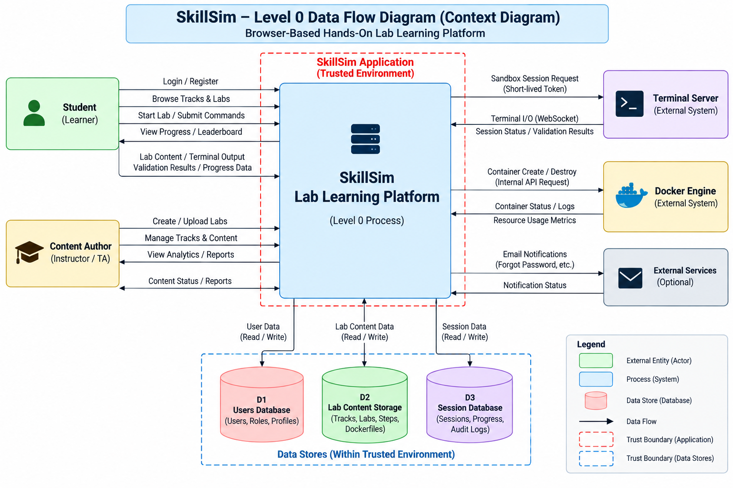
Figure 3 — Level 0 DFD (Context Diagram) with trust boundaries
The Level 0 view keeps the context readable: Student and Content Author interact with SkillSim, while the terminal server, Docker Engine and optional external services appear as controlled system interfaces.
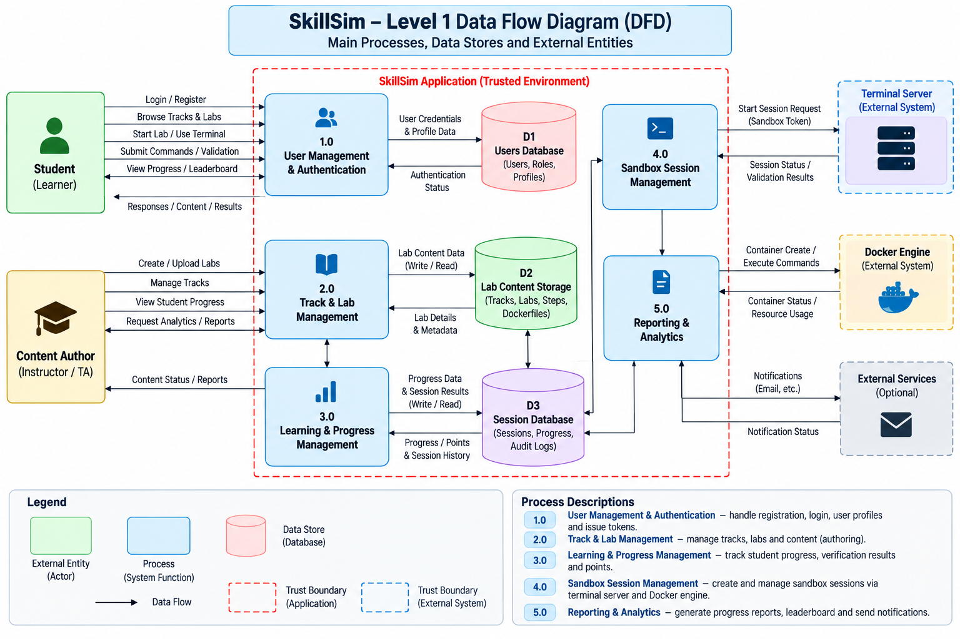
Figure 4 — Level 1 DFD showing major processes, data stores and trust boundaries
The Level 1 model decomposes the system into User Management & Authentication, Track & Lab Management, Learning & Progress Management, Sandbox Session Management, and Reporting & Analytics.

5.2 Level 1 Data Stores
Table 13 — Level 1 data stores
Store | Contents | Primary Process Interaction
D1 Users Database | Users, roles, profiles | Authentication and user management
D2 Lab Content Storage | Tracks, labs, steps, Docker image metadata and content | Track/lab browsing and sandbox configuration
D3 Session Database | Sessions, step results, progress and audit data | Sandbox lifecycle, progress and reporting

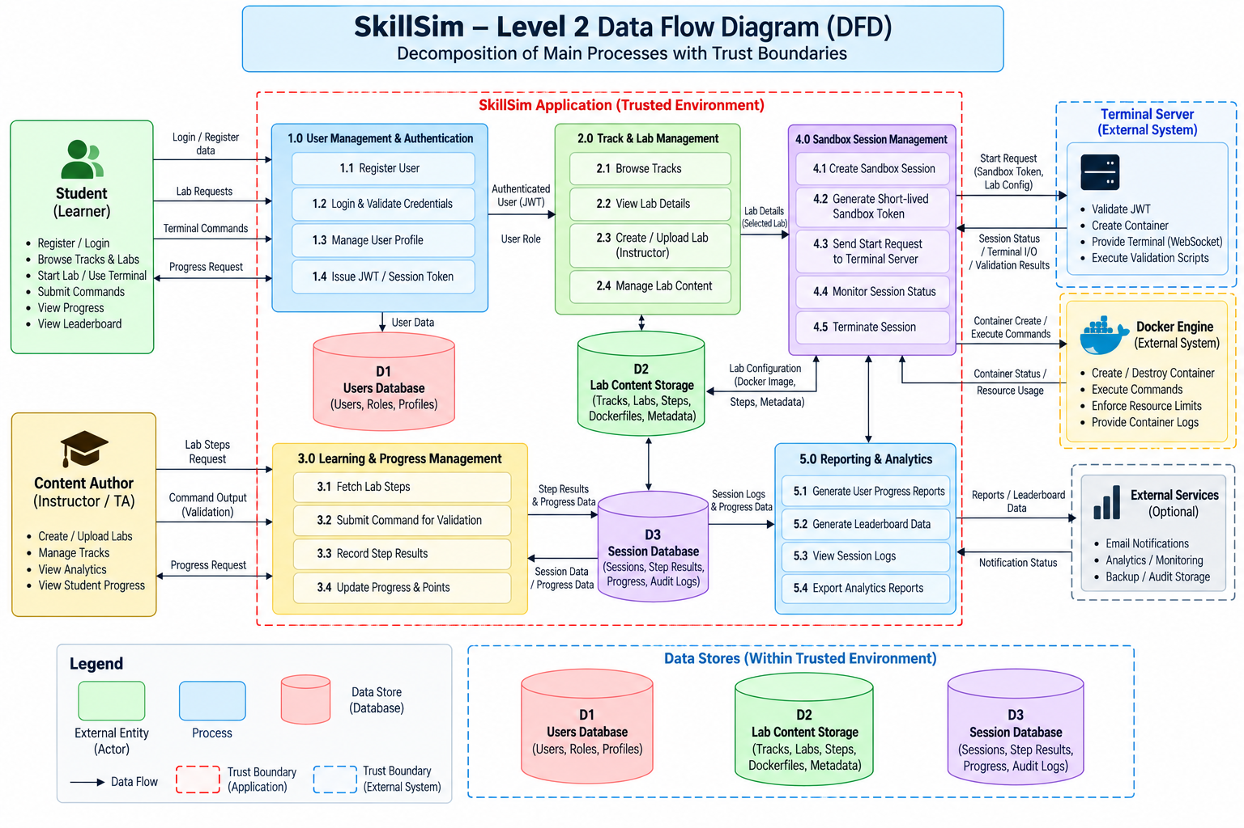
Figure 5 — Level 2 DFD: Decomposition of Sandbox Session Management
The Level 2 flow captures the critical runtime sequence: validate user/lab access, create session record, issue scoped sandbox token, send the start request to the terminal server, verify and authorize the token, create the Docker sandbox, and stream the terminal session.
Trust-boundary focus
Sensitive data crosses boundaries at authentication, the browser-to-service WebSocket path, the internal service-to-service progress path, and the application-to-Docker runtime boundary. Each crossing therefore becomes a direct input to the threat model.

6. Threat Modeling
Exercises 6–9 — Assets, CIA, STRIDE, Information Flow and Vulnerabilities
Threat modelling asks what can go wrong with the system designed in the previous chapters. The analysis moves from assets and their confidentiality, integrity and availability needs, through STRIDE threats on each DFD element and information flow, to concrete vulnerabilities, a qualitative risk rating and the set of controls chosen to reduce the highest risks.

6.1 Asset Identification & CIA Analysis
Table 14 — Asset identification and CIA analysis
Asset | Confidentiality | Integrity | Availability | Why it matters
User Credentials | High | High | — | Compromise enables account takeover or impersonation.
User Profile Data | High | High | — | Contains account identity and personalization information.
Sandbox Attach Token | High | High | High | Short-lived credential authorizing terminal attachment.
Terminal I/O | High | High | High | Contains command input, output and potentially sensitive lab data.
Lab Content | Medium | High | High | Instructions and validation logic determine learning behavior.
Session / Progress Data | Medium | High | High | Controls completion state, points and active sessions.
Container Runtime State | High | High | High | Student workspaces must remain isolated across tenants.
Audit / Security Logs | Medium | High | High | Required for accountability and incident investigation.

6.2 STRIDE Threat Analysis
Table 15 — STRIDE threat analysis
DFD Element | Threat Scenario | STRIDE | Impact | Primary Control
Authentication | Stolen credentials used to impersonate a student | Spoofing | Unauthorized account access | SEC-01, SEC-02
Sandbox Attach Flow | Token replay or forged Origin used to attach to another session | Spoofing | Unauthorized terminal access | SEC-03, SEC-11
Sandbox Token | Attacker alters claims such as lab/session identity or privilege | Tampering | Unauthorized sandbox access | Signed JWT + scope checks
Progress API | Forged progress update causes false completion or points | Tampering | Academic integrity loss | SEC-04 + internal secret
Audit / Progress | Student disputes a validation result or points update | Repudiation | Reduced accountability | Server-side validation + logs
User / Session Data | Cross-user identifiers expose another student's state | Information Disclosure | Privacy / cross-tenant disclosure | Authorization + isolation
Terminal I/O | Sensitive commands or output exposed over a compromised channel | Information Disclosure | Data leakage | HTTPS/WSS + scoped sessions
Sandbox Runtime | Fork bomb or process storm exhausts resources | Denial of Service | Host or cohort degradation | SEC-14 + quotas
WebSocket Endpoint | Excess connection attempts exhaust terminal service capacity | Denial of Service | Session availability loss | Origin validation + concurrency cap
Container / Host Boundary | Container breakout reaches host resources | Elevation of Privilege | Host compromise | CapDrop + no-new-privileges + socket isolation
REST API | Injection or malformed inputs influence database operations | Elevation / Tampering | Unauthorized data modification | Prisma parameterization + validation
DinD Labs | Misuse of privileged sandbox escapes intended isolation | Elevation of Privilege | Cross-boundary compromise | Explicit privileged allowlist + nested daemon

The threats concentrate where trust boundaries are crossed: authentication, the sandbox attach flow, the container runtime and the validation path. Each row names the DFD element it affects, the STRIDE category, the likely impact and the primary control from the security requirement set, so a reviewer can follow any threat to the control expected to address it.

6.3 Information Flow Analysis
Table 16 — Information flow analysis
Asset / Data | Source | Process | Data Store / Runtime | Destination | Flow Character
Credentials | Student | Authentication | D1 Users DB | Authentication response | Trusted after TLS/auth; protected at rest
Sandbox token | App Backend | Sandbox Session Management | Terminal Server | Terminal attachment | Sensitive crossing; short TTL and signed
Terminal I/O | Student Browser | WebSocket session | Ephemeral Container | Student terminal | Sensitive live flow; controlled origin and token
Validation result | Container | Validation execution | D3 Session DB | Progress service/UI | Trusted only after server-side evaluation
Progress / points | Terminal Server | Internal Progress API | D3 Session DB | Dashboard | Internal service boundary; secret protected
Lab configuration | Content Store | Sandbox Session Management | Terminal Server / Docker | Sandbox | Must prevent untrusted content from crossing runtime policy boundaries

6.4 Vulnerability Analysis
Table 17 — Vulnerability analysis
ID | Vulnerability | Affected Element | Threat | Impact | Mitigation
V-01 | Weak authentication controls | Authentication | Spoofing | Account takeover | Rate limiting + strong password policy; optional MFA extension
V-02 | WebSocket CSWSH / Origin trust gap | Terminal session | Spoofing | Cross-site terminal attachment | Strict Origin allowlist + token verification
V-03 | Token replay or token claim manipulation | Sandbox token | Tampering / Spoofing | Unauthorized session access | Short TTL, signed token, scope and session binding
V-04 | Broken object-level authorization | REST/API | Elevation | Cross-user progress or session access | Server-side ownership checks
V-05 | Insecure internal progress endpoint | Internal API | Tampering | False points/progress | Internal secret + network restriction + schema validation
V-06 | Container escape / excessive privileges | Docker runtime | Elevation | Host compromise | CapDrop, no-new-privileges, read-only FS, controlled privileged labs
V-07 | Resource exhaustion / fork bomb | Sandbox | DoS | Host starvation | CPU/RAM/PID quotas + 20-session host cap + idle reaper
V-08 | Stored XSS through lesson content | Markdown renderer | Information Disclosure | Browser compromise / token theft | No raw HTML rendering; sanitize authoring path

6.5 Qualitative Risk Analysis
Table 18 — Qualitative risk analysis
Risk | Scenario | Likelihood | Impact | Risk Level | Control Direction
R-01 | Cross-student sandbox access | Medium | Critical | High | Session binding; isolated containers; no shared volumes
R-02 | Container breakout | Low | Critical | High | Capability drop, no-new-privileges, read-only FS, socket isolation
R-03 | Credential compromise | Medium | High | High | bcrypt, rate limiting, short-lived scoped tokens
R-04 | Progress tampering | Low | High | Medium | Server-side check execution and internal authorization
R-05 | Terminal service DoS | Medium | High | High | Connection cap, backpressure and idle reaper
R-06 | Malicious lab content | Medium | High | High | Content review, fixed scripts, allowlisted privileged labs
R-07 | Data leakage via logs | Low | High | Medium | Structured logging with secret/token redaction
R-08 | Dependency vulnerability | Medium | Medium | Medium | SCA scanning and controlled upgrade policy

Two scenarios receive a High rating: cross-student sandbox access and container breakout. Both would undermine the central promise of the platform, that one learner cannot affect another or the host. They therefore drive the strongest controls in the design, namely session-bound tokens, per-session isolated containers, dropped capabilities, no-new-privileges and resource limits.

6.6 Security Control Set
Table 19 — Security control set
ID | Domain | Control | Mapped Requirements | Threat Focus
SC-01 | Identity | bcrypt + login rate limiting | SEC-01/02 | Credential theft / brute force
SC-02 | Scoped Authorization | Separate user JWT and sandbox attach JWT | SEC-03 | Session token abuse
SC-03 | WebSocket Boundary | Origin allowlist + scoped token | SEC-11 | CSWSH
SC-04 | Internal Trust | Internal service secret for progress updates | SEC-04 | Progress spoofing
SC-05 | Container Least Privilege | CapDrop ALL + no-new-privileges | SEC-05/06 | Privilege escalation
SC-06 | Filesystem Isolation | Read-only root + constrained tmpfs | SEC-07 | Persistence / tampering
SC-07 | Network Isolation | NetworkMode none | SEC-08 | Data exfiltration / lateral movement
SC-08 | Docker Socket Isolation | Only terminal-server can access host socket | SEC-10 | Host compromise
SC-09 | Resource Governance | CPU / memory / PID caps + host concurrency cap | SEC-14 + NFR-06/07 | DoS
SC-10 | Objective Validation | Run check scripts inside sandbox | FR-06 | False reporting / repudiation
SC-11 | Session Cleanup | AutoRemove + idle reaper | FR-08/NFR-05 | Resource leakage
SC-12 | Secure Rendering & Inputs | Prisma parameterization, Zod validation, inert Markdown | SEC-12/13 | Injection / XSS

7. Attack Tree Analysis
Exercise 10 — Critical attacker goal and attack paths
An attack tree complements STRIDE by looking at the system from the attacker's side. A single high-value goal is chosen and decomposed into alternative (OR) and sequential (AND) paths, which makes it straightforward to verify that every route towards the goal meets at least one preventive or detective control.

7.1 Selected Attacker Goal
Root goal: gain unauthorized access to another student’s sandbox data or session artifacts. The attack tree is intentionally readable: high-level branches use OR relationships, while multi-step paths can be interpreted as AND sequences.
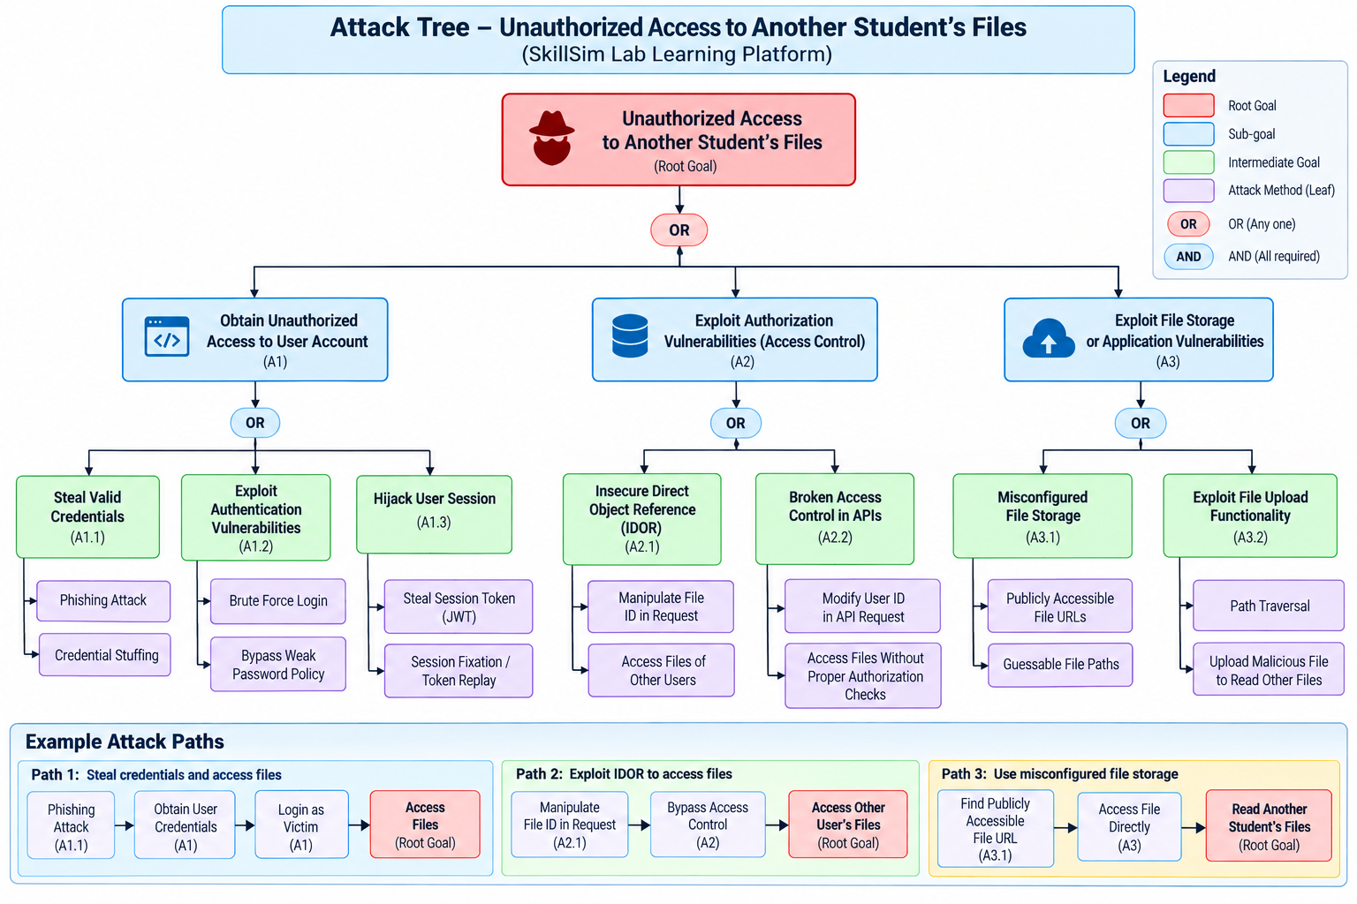
Figure 6 — Attack Tree: Unauthorized Access to Another Student’s Files / Lab Data

7.2 Key Attack Paths
Table 20 — Key attack paths
Path | Sequence | Security Countermeasure
Path 1 — Account compromise | Steal credentials → authenticate as victim → access victim-controlled data | Strong auth, rate limiting, scoped sessions, session monitoring
Path 2 — Authorization flaw | Manipulate object/session identifier → bypass ownership check → access another user's data | Server-side authorization on every protected object
Path 3 — Runtime escape | Exploit container weakness → cross sandbox boundary → reach host/runtime data | Container hardening, no socket mount, capability controls, quotas

Attack-tree interpretation
The attack tree is a design artifact, not an exploitation procedure. Each branch maps directly to a security control family already present in the threat model.

8. UI Design
Exercise 11 — User interface and interaction model
The user interface is where security controls meet usability. The design lets students concentrate on the lab while keeping session state, errors and verification results clearly visible, and it follows established interface-design principles so that the platform feels consistent and predictable.

8.1 UI Design Direction
The current frontend has been upgraded from placeholder styling to a professional developer-platform interface: dark obsidian surfaces, high-contrast text, clean SVG iconography, restrained borders, and a lab-first interaction model inspired by modern technical learning and developer environments.
Table 21 — Primary UI screens
Screen | User | Primary Goal | Key Information / Controls | Error Handling
1. Authentication | Student | Securely sign in or register | Email, password, account action, security notice | Invalid credentials, missing fields, registration conflicts
2. Track Catalog | Student | Find the right learning track | Search, difficulty filters, track cards, lab counts, duration | No matching tracks, unavailable catalog
3. Track Detail | Student | Understand syllabus before launch | Ordered labs, difficulty, duration, tags, launch action | Unavailable lab, session capacity feedback
4. Interactive Lab Workspace | Student | Complete hands-on steps | Resizable split pane, terminal, instructions, stepper, timer, hints, validation | Disconnected terminal, failed validation diagnostics, expired session
5. Dashboard | Student | Review performance and history | Score KPIs, mastery, session history, standings, CLI reference | No history / load error state

Each screen is defined by its user, goal, key controls and error handling. Errors are written to help the learner recover while exposing no tokens, internal paths or stack traces, which directly supports the secure error-handling requirement.

8.2 Implemented Frontend Enhancements
- Draggable 25–75% split pane with maximize/restore behavior.
- Terminal toolbar with connectivity status, clear, reset, font zoom and PTY resize handling.
- Run in Terminal and Copy actions embedded inside command blocks.
- Live session stopwatch and step-navigation pills.
- Hint/troubleshooting accordion and verification diagnostics console.
- Completion modal with elapsed time and points summary.
- Track search and difficulty filters plus structured curriculum cards.
- Dashboard with KPI cards, track mastery, session history, leaderboard and CLI cheat sheet.
- Professional authentication screen with clear sign-in/register switching and security notice.
Golden-rule mapping
Consistency → shared components and iconography. User control → resizable panes, reset/clear actions. Feedback → connection status, validation diagnostics, completion feedback. Error prevention → explicit checks and disabled/guarded actions. Visibility → stepper, timer, points and progress indicators.

9. Product Backlog
Exercise 12 — User stories derived from requirements and use cases
The product backlog translates the requirements into user stories that can be estimated and scheduled. Each story names a user role, a goal and a reason, belongs to an epic, carries a priority and a story-point estimate, and traces back to at least one requirement.

9.1 Product Backlog
Table 22 — Product backlog
ID | User Story | Epic | Priority | Points
US-01 | As a student, I want to register and sign in so that I can access my learning workspace. | Authentication | High | 3
US-02 | As a student, I want to browse tracks and labs so that I can choose the right lab. | Learning Catalog | High | 3
US-03 | As a student, I want to start an isolated lab session so that I can practice safely. | Sandbox | High | 5
US-04 | As a student, I want to use an in-browser terminal so that I do not need local setup. | Sandbox | High | 5
US-05 | As a student, I want to run validation checks so that my work is objectively verified. | Validation | High | 5
US-06 | As a student, I want progress and points saved so that my work remains traceable. | Progress | High | 3
US-07 | As a student, I want a dashboard so that I can monitor mastery and recent sessions. | Analytics | Medium | 3
US-08 | As a content author, I want to publish labs from version-controlled files so that curriculum changes need minimal code changes. | Content | Medium | 5
US-09 | As a content author, I want to manage tracks and lab metadata so that the catalog stays organized. | Content | Medium | 3
US-10 | As a platform, I want stale sessions reaped so that resources are reclaimed automatically. | Reliability | High | 3
US-11 | As a security engineer, I want sandbox capabilities restricted so that privilege escalation paths are reduced. | Security | High | 5
US-12 | As a security engineer, I want host Docker-socket access isolated so that student containers cannot control the host daemon. | Security | High | 5
US-13 | As a student, I want clear diagnostics and hints so that failed validation is actionable. | Frontend | Medium | 3
US-14 | As a student, I want search and difficulty filters so that I can find relevant labs quickly. | Frontend | Medium | 2
US-15 | As a DevSecOps engineer, I want automated SAST/SCA/DAST gates so that insecure changes are caught before deployment. | DevSecOps | High | 5
US-16 | As an administrator, I want auditable activity and monitoring so that security and operational issues can be investigated. | Governance | Medium | 5

Stories are prioritised by security and learning value: authentication, the lab catalog and sandbox provisioning come first because everything else depends on them, while refinement and reporting follow once the secure core exists. Story points use a relative scale so that each sprint can be filled with a realistic amount of work.
Backlog rule
Every story must trace back to an SRS requirement, use case, security control, or explicit implementation capability. This prevents feature drift across Jira and the design documents.

10. Jira and Scrum
Exercises 13–15 — Project setup, sprint planning, board and metrics
Project management for SkillSim follows Scrum and is tracked in Jira. This chapter describes the Jira project structure, the two-sprint academic plan, the evidence captured from the real Jira workspace, and the board workflow and metrics used to monitor progress.

10.1 Jira Project Structure
Table 23 — Jira epics
Epic | Scope
EP-01 — Architecture & Infrastructure | Repository, service boundaries, local environment, database baseline
EP-02 — Auth & Session Management | Registration, login, JWTs, lab session lifecycle
EP-03 — Terminal & Docker Sandbox | WebSocket terminal, PTY, container provisioning and cleanup
EP-04 — Lab Content Authoring | YAML manifests, Markdown steps, check scripts and sync pipeline
EP-05 — Frontend UI/UX | Authentication, catalog, lab workspace, dashboard
EP-06 — Progress & Analytics | Step completion, points, dashboard and leaderboard
EP-07 — Security Hardening | CORS, rate limiting, headers, isolation, service auth
EP-08 — Documentation & Governance | SRS, STRIDE, architecture, compliance and evidence
EP-09 — Testing & QA | Unit/integration, security testing, regression and fuzzing
EP-10 — DevSecOps Delivery | Containers, Kubernetes, CI/CD, SAST, SCA, DAST and monitoring

10.2 Two-Sprint Academic Plan
Table 24 — Two-sprint academic plan
Sprint | Goal | Stories | Planned Points
Sprint 1 — Build Core | Deliver secure authentication, catalog, sandbox and interactive lab foundation. | US-01, US-02, US-03, US-04, US-08, US-09, US-10 | 24
Sprint 2 — Secure & Measure | Deliver validation, progress, UI refinement, security hardening, testing and delivery gates. | US-05, US-06, US-07, US-11, US-12, US-13, US-14, US-15, US-16 | 36

Sprint 1 builds the secure core of the platform, and Sprint 2 hardens it with validation, progress tracking and UI refinement. This split gives the examiners a clear baseline, while the live Jira workspace shown in the next section holds the finer-grained implementation tasks.
Note: The supplied Jira screenshots show the current real workspace containing three sprints and a larger implementation task set. The two-sprint split above is the clean academic submission baseline requested by the exercise; the live Jira workspace can continue to use additional engineering sprints as implementation work evolves.

10.3 Current Jira Evidence
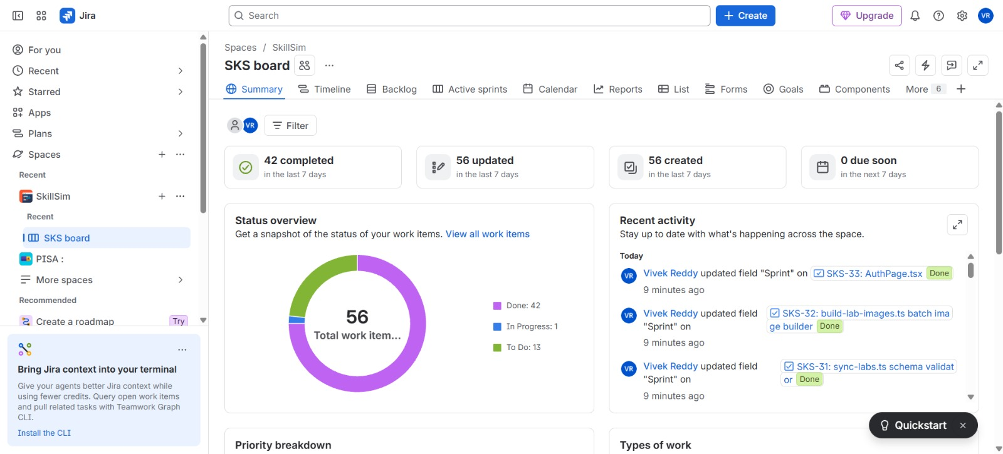
Figure 7 — Jira Summary Dashboard showing current work-item status and recent activity
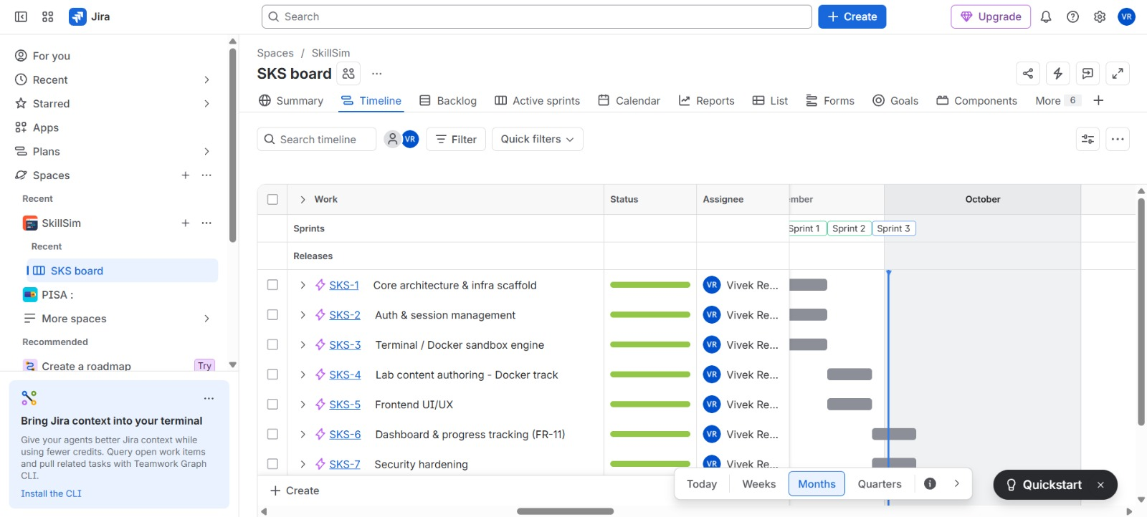
Figure 8 — Jira Timeline / sprint view for the current implementation workspace
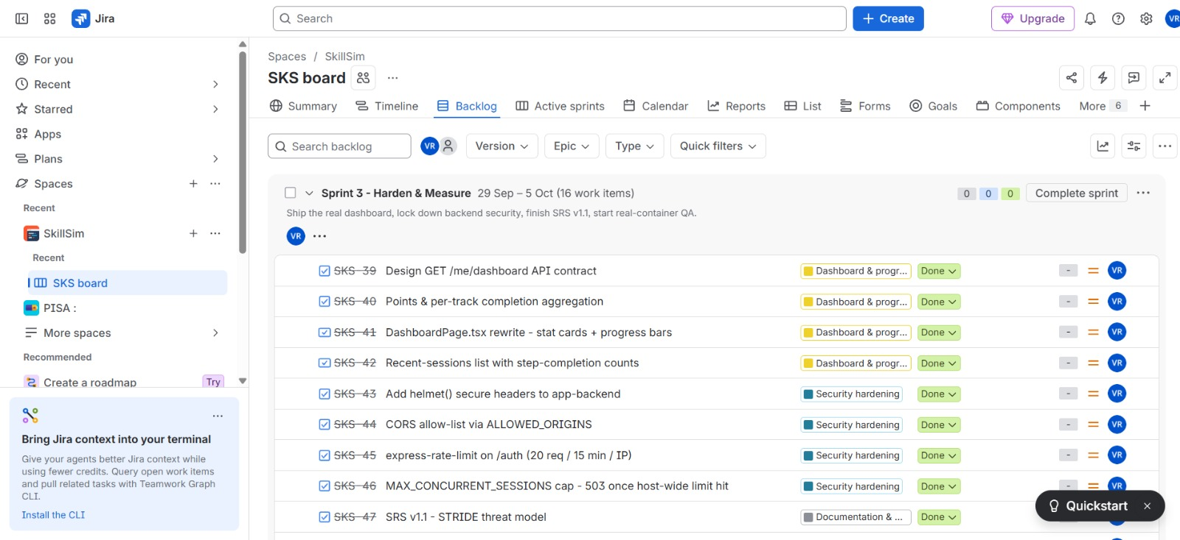
Figure 9 — Jira Backlog / active sprint view with current implementation tasks
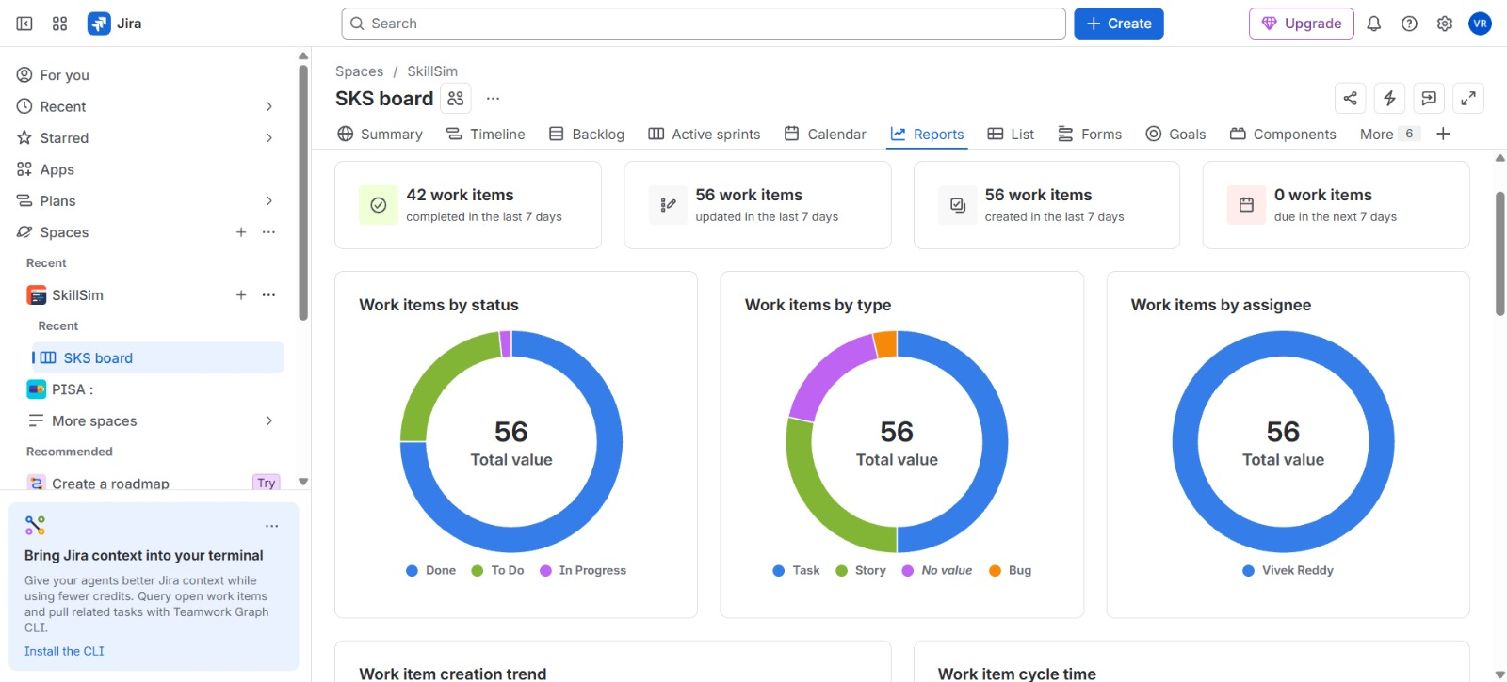
Figure 10 — Jira Reports dashboard with status, type and assignee views

10.4 Board Workflow & Metrics
Required workflow
TO DO → IN PROGRESS → TESTING → DONE. Each story should have a clear Definition of Done covering implementation, validation and security checks appropriate to the story.

Table 25 — Agile metrics and evidence
Metric | How to calculate / identify | Evidence to capture
Velocity | Completed story points per sprint | Jira Velocity Report
Burndown | Remaining story points by date against guideline | Sprint Burndown
Defects | Defect tickets raised and resolved | Bug issue list / dashboard
Defects carried over | Open sprint defects moved into the next sprint | Sprint Report / backlog history
Cycle time | Time from In Progress to Done | Jira cycle-time report
Security gate pass rate | Passed security checks ÷ executed checks | CI/CD and tool reports

10.5 Jira Screenshot Notes
- The provided workspace shows a Summary dashboard with active work status and recent activity.
- The Timeline view shows multiple implementation sprints across the project calendar.
- The backlog view shows grouped implementation items such as authentication, terminal/Docker sandbox, content, UI/UX and security hardening.
- The Reports view provides project-level status and work-type breakdowns suitable for sprint review evidence.

11. DevSecOps, Testing and Deployment
Additional lifecycle stages beyond the original mid-term exercise
Beyond the academic exercises, SkillSim is treated as a deliverable product. This chapter extends the lifecycle with containerisation, orchestration, a security-gated CI/CD pipeline, layered testing, monitoring and governance. These DevSecOps practices keep the designed controls effective after release rather than only on paper.

11.1 Docker Containerization
Docker is already a core part of SkillSim rather than a purely future enhancement. Each student lab session can instantiate an ephemeral image, apply runtime restrictions, open a shell, run validation and then destroy the container when the session closes or becomes idle.
Table 26 — Docker runtime controls
Control | Current design
Isolation | Ephemeral per-session container with no shared student state.
Privileges | Capabilities dropped for default labs; privileged mode explicitly opt-in for selected nested-Docker labs.
Filesystem | Read-only root plus constrained temporary workspace.
Networking | NetworkMode none by default.
Resource Governance | 0.5 CPU, 512 MB memory, 128 PIDs per container; 20 concurrent sessions host-wide.
Lifecycle | Auto-remove and idle reaper reclaim resources.

The controls work as layers. Even if one layer fails, for example a student obtains a shell inside the container, the dropped capabilities, restricted network, resource quotas and absence of the Docker socket still limit what that shell can reach. The design deliberately avoids relying on a single protection.

11.2 Kubernetes Extension
Kubernetes is the next orchestration layer when the single-host runtime becomes a deployment constraint. The design goal is to move from local Docker lifecycle management toward namespaced workloads, resource limits, service accounts, network policies, pod security controls and controlled job cleanup while preserving the same trust-boundary model.
Table 27 — Kubernetes extension workstreams
Workstream | Target outcome | Status
Cluster baseline | Development cluster for SkillSim services | Planned
Namespace isolation | Separate application and runtime namespaces | Planned
Resource policies | CPU/memory/PID-equivalent workload limits | Planned
Network policies | Restrict service and sandbox traffic | Planned
Secrets | Managed storage for JWT/internal secrets | Planned
Runtime cleanup | Jobs/Pods cleaned after session termination | Planned

11.3 CI/CD Pipeline
The CI/CD path should treat every commit as a security-aware delivery candidate. The pipeline should build the application, run unit/integration tests, execute SAST and dependency analysis, perform DAST against a test deployment, publish artifacts, and require defined gates before deployment.
Table 28 — CI/CD pipeline stages and gates
Stage | Typical Check | Gate
Checkout & Build | Dependency install, TypeScript build, container build | Build succeeds
Unit / Integration | PyTest and backend/frontend tests | Test threshold met
SAST | SonarQube / SonarCloud | Quality + security gate
SCA | Snyk | No unaccepted dependency risk
DAST | OWASP ZAP against test instance | No unaccepted high-impact findings
Fuzzing | AFL / targeted parser-input fuzzing | No reproducible crash in scope
Package | Container/image tagging and artifact publication | Immutable versioned artifact
Deploy | Kubernetes / target environment | Health checks pass

The pipeline fails closed: a failed build, test, scan or gate stops the release candidate. Security checks therefore run on every change rather than only before the final submission, and their results become evidence for the deployment-readiness checklist.

11.4 Security Testing Strategy
Table 29 — Security testing layers
Test Layer | Focus | Example evidence
Unit | Auth, validation, progress logic, data access | PyTest reports
Integration | API ↔ DB ↔ terminal server flows | API/integration test results
Container Security | Capabilities, root filesystem, network, quotas | Docker inspection / runtime test logs
SAST | Code smells, vulnerabilities, security hotspots | SonarQube report
SCA | Dependency vulnerabilities and licenses | Snyk report
DAST | Authentication, authorization, headers, WebSocket/API behavior | OWASP ZAP report
Fuzzing | Malformed inputs and parser edge cases | AFL findings / crash triage
Regression | Previously fixed security issues stay fixed | Regression suite

11.5 Logging & Monitoring
- Log authentication success/failure, session creation/termination, validation outcomes, security-relevant API decisions and service errors.
- Redact credentials, JWTs, internal secrets and sensitive command output before logs leave a protected process boundary.
- Collect terminal-server connection counts, session age, container lifecycle events and resource-limit breaches.
- Use dashboards and alerts to detect authentication spikes, abnormal session churn, repeated validation abuse or runtime exhaustion.

11.6 Risk / Governance / Compliance
Table 30 — Governance areas
Governance Area | SkillSim Treatment
Secure Change Management | Tie changes to Jira stories and keep requirement-to-code-to-test traceability.
Access Governance | Separate student, author and service responsibilities; enforce least privilege.
Evidence Management | Retain test reports, threat-model artifacts, sprint evidence and deployment records.
Data Protection | Protect credentials, session tokens, progress and operational logs; apply retention rules.
Incident Readiness | Maintain actionable logs, reproducible build information and security findings.
Compliance | Map the final release to applicable institutional security and data-protection policies before deployment.

11.7 Final Deployment Readiness Checklist
☐ All functional, non-functional and security requirements have traceability to implementation or test evidence.
☐ Use cases, ERD and DFD reflect the same current system boundaries and data model.
☐ Critical STRIDE threats have documented controls and residual risk decisions.
☐ Attack tree branches are covered by preventive or detective controls.
☐ Docker runtime controls are validated in the deployment environment.
☐ CI/CD gates execute successfully for the release candidate.
☐ SAST, SCA, DAST and targeted fuzzing results are reviewed and accepted.
☐ Logging and monitoring are enabled with sensitive-data redaction.
☐ Kubernetes configuration and secrets management are validated for the target environment.
☐ Jira sprint evidence, defect status and final release notes are archived.

12. Traceability and Conclusion
How the academic phases map to the implementation baseline
This final chapter ties the work together. The traceability matrix shows how requirement groups map to artifacts and evidence, the artifact table lists the submission set, and the closing summary and future work reflect on the outcome of the capstone.

12.1 Requirement-to-Artifact Traceability
Table 31 — Requirement-to-artifact traceability
Requirement Scope | Artifact | Primary Capability | Evidence
FR-01 to FR-03 | Use Cases + Auth/Session | User Registration; Start Lab Session | Authentication routes, sandbox start endpoint
FR-04 to FR-05 | DFD + Level 2 | Provision Sandbox; Interactive Terminal | Terminal server, Docker lifecycle, WebSocket PTY
FR-06 to FR-07 | Use Case + Threat Model | Validate Lab Step; Progress Update | Validation scripts + internal progress endpoint
FR-08 | DFD + Reliability | Idle Session Reaping | Terminal janitor + AutoRemove
FR-09 | UI + Backlog | Dashboard | Dashboard implementation and current UI
FR-10 | Use Case + Architecture | Content Sync | YAML/Markdown/check scripts and sync CLI
SEC-01 to SEC-04 | STRIDE + Risk | Identity / token / service auth controls | bcrypt, rate limiting, scoped JWTs, internal secret
SEC-05 to SEC-10 | DFD + Attack Tree | Runtime isolation | Docker capabilities, FS, network and socket isolation
SEC-11 to SEC-14 | STRIDE + Security Tests | Boundary/input/DoS controls | Origin allowlist, validation, inert Markdown, quotas

12.2 Artifact Set for Final Submission
Table 32 — Final submission artifact set
Deliverable | Recommended Tool | Current Evidence / Next Action
SRS | Word / Google Docs | Current SkillSim SRS baseline
Use Case Diagram | StarUML / PlantUML | Current diagram artifact
Use Case Specifications | Word | Two core specifications in this report
ER Diagram | Draw.io / PlantUML | Current schema-aligned ERD
DFD Level 0/1/2 | Draw.io | Current three-level DFD set
Asset + CIA | Word table | Included in report
STRIDE | Microsoft Threat Modeling Tool + report | Threat table prepared; formal tool model next
Information Flow | Word table | Included in report
Vulnerability + Risk | Word tables | Included in report
Security Controls | Word / architecture notes | Included in report
Attack Tree | Draw.io | Current attack-tree artifact
UI Design | Word + frontend screenshots | Current implementation description; screenshot capture recommended
Product Backlog | Jira | 16-story baseline in report; map to live keys
Jira Project / Sprints | Jira | Current workspace screenshots; create/align two-sprint academic plan
DevSecOps Evidence | GitHub Actions + tools | Execute Docker/K8s/SAST/SCA/DAST/fuzzing gates and archive results

12.3 Closing Summary
SkillSim is positioned as a secure software engineering capstone because the platform is modeled and delivered as one continuous engineering system: requirements determine the use cases, the use cases determine the data model and DFD, the DFD determines the threat model, the threat model drives security controls and attack analysis, and the resulting design becomes the basis for the backlog, Jira execution and DevSecOps pipeline.
End state
The target final submission should contain one coherent evidence chain rather than disconnected documents. Every diagram, test, security control and Jira item should be explainable as a continuation of the same SkillSim system model.

12.4 Future Work
The capstone baseline is complete, but several extensions would strengthen SkillSim further:
- Complete the Kubernetes migration with separate namespaces, resource quotas and network policies for lab workloads.
- Automate DAST and targeted fuzzing in the CI/CD pipeline so that runtime weaknesses are found on every release candidate.
- Add alerting on authentication spikes, abnormal session churn and repeated validation abuse.
- Grow the lab catalog through the Git-driven content workflow and re-run the threat model whenever a new lab type changes the attack surface.

