A PRELIMENERY REPORT ON

Stable Diffusion Architecture

SUBMITTED TO THE VISHWAKARMA INSTITUTE OF INFORMATION TECHNOLOGY, PUNE
IN THE PARTIAL FULFILLMENT OF THE REQUIREMENTS
FOR THE AWARD OF THE DEGREE

OF

BACHELOR OF TECHNOLOGY (COMPUTER ENGINEERING)

SUBMITTED BY

STUDENT NAME | Exam Seat No
Samueal Dsouza | 22110944
Sarthak Kulkarni | 22110365



DEPARTMENT OF COMPUTER ENGINEERING

BRACT’S
VISHWAKARMA INSTITUTE OF INFORMATION TECHNOLOGY

SURVEY NO. 3/4, KONDHWA (BUDRUK), PUNE – 411048, MAHARASHTRA (INDIA).

Sr. No. |  |  |  | Title of Chapter |  | Page No.
01 |  |  |  | Introduction |  | 3
 | 1.1 |  |  | Overview |  | 4
 | 1.2 |  |  | Motivation |  | 4
 | 1.3 |  |  | Problem Definition and Objectives |  | 5
 | 1.4 |  |  | Project Scope & Limitations |  | 6
 | 1.5 |  |  | Methodologies of Problem solving |  | 7
02 |  |  |  | Literature Survey |  | 8
03 |  |  |  | System Design |  | 9
 |  | 3.1 |  | System Architecture |  | 10
04 |  |  |  | Project Implementation |  | 11
 |  |  | 4.1 | Overview of Project Modules
 |  |  | 4.2 | Tools and Technologies Used |  | 14
 |  |  | 4.3 | Algorithm Details
 |  |  |  | 4.3.1 | Algorithm 1
 |  |  |  | 4.3.2 | Algorithm 2
 |  |  |  | 4.3.3 | …
05 |  |  |  | Results |  | 15
 |  |  | 5.1 | Outcomes
 |  |  | 5.2 | Screen Shots
06 |  |  |  | Conclusions |  | 17
 |  | 9.1 |  | Conclusions
 |  | 9.2 |  | Future Work
 |  | 9.3 |  | Applications
 |  |  |  | References

INTRODUCTION

Stable diffusion is an advanced generative model architecture designed to produce high-quality images from various inputs, including textual descriptions. It is a comprehensive system that integrates multiple components, such as variational autoencoders (VAES), clip encoders, and u-net, to create a powerful platform for generating realistic images. The architecture is particularly notable for its flexibility, allowing users to generate, transform, and manipulate images based on a variety of data sources.

OVERVIEW

Stable diffusion represents a significant advancement in generative modeling, offering a framework capable of creating highly detailed images from textual prompts or other latent representations. At its core, stable diffusion utilizes a combination of variational autoencoders for dimensionality reduction, clip encoders for joint understanding of images and text, and u-net for detailed image segmentation and generation. This combination allows for a diverse range of applications, from text-to-image generation to complex image transformations.

MOTIVATION

The development of Stable Diffusion was motivated by the need for a robust generative architecture capable of producing high-quality images with a high degree of control and versatility. Traditional image generation models often struggle with generating realistic and coherent images, particularly when conditioned on text or other complex inputs. Stable Diffusion addresses these limitations by introducing a unique approach to diffusion processes and incorporating advanced components that enhance its ability to generate consistent and realistic images.

Stable Diffusion's emphasis on latent diffusion models enables it to produce high-quality images with fewer computational resources compared to traditional generative adversarial networks (gans). This makes it an attractive choice for various applications where efficient image generation and manipulation are required. The integration of the CLIP model also provides a bridge between textual and visual data, allowing Stable Diffusion to generate images from text prompts with a high degree of semantic understanding.

PROBLEM DEFINITION AND OBJECTIVES

Stable Diffusion aims to solve the problem of generating realistic and high-quality images from textual or latent representations. The primary objectives of this architecture are:

1. High-Quality Image Generation: Generate images with a high level of detail and realism.
2. Text-to-Image Capability: Enable the generation of images from textual descriptions, providing a bridge between language and visual data.
3. Flexibility and Versatility: Allow for a variety of applications, including image-to-image transformations, text conditioning, and latent space manipulation.
4. Efficient Resource Utilization: Achieve high performance and quality with lower computational overhead compared to traditional GAN-based approaches.
5. User-Friendly Interface: Develop an architecture that can be easily used and extended by developers and researchers in various domains.

PROJECT SCOPE AND LIMITATIONS

Scope:
- Development of Stable Diffusion Models: Implement the key components of Stable Diffusion, including VAE, CLIP Encoder, U-Net, and Decoder.
- Data Preprocessing: Apply preprocessing steps to prepare images and text data for training, ensuring consistency and accuracy.
- Model Training and Evaluation: Train the Stable Diffusion models on appropriate datasets and evaluate their performance using relevant metrics.
- Text-to-Image Focus: Concentrate on the text-to-image capabilities of Stable Diffusion, exploring how text prompts can be used to generate realistic images.
- Prototype Development: Create a prototype system demonstrating the functionality of Stable Diffusion, including a user-friendly interface for generating images from text.

Limitations:
- Computational Resources: Despite its efficiency, training Stable Diffusion models may require significant computational resources.
- Data Limitations: The quality of the generated images depends on the quality and diversity of the training data.
- Generalization: The model's ability to generalize across different domains or applications may vary.
- Ethical Considerations: Consideration of ethical issues related to generating realistic images, including potential misuse or unintended consequences.
- Model Interpretability: Understanding how the model generates specific outputs and ensuring the transparency of its decision-making process.
- Hardware Constraints: The computational requirements may limit deployment on lower-end hardware or in resource-constrained environments.

METHODOLOGIES OF PROBLEM SOLVING

1. Data Collection and Preprocessing:
- Collect a diverse dataset comprising images and text descriptions, ensuring a wide variety of samples for training and evaluation.
- Apply preprocessing techniques to standardize image dimensions, normalize pixel values, and ensure consistency across the dataset.

2. Model Architecture Selection:
- Implement the key components of Stable Diffusion, including VAE, CLIP Encoder, U-Net, and Decoder.
- Explore variations in the architecture to find the optimal configuration for generating high-quality images.

3. Data Augmentation:
- Use data augmentation techniques to increase the diversity of the training dataset, such as flipping, rotating, and scaling.
- Augment the dataset with synthetic samples to improve the model's robustness.

4. Model Training:
- Train the Stable Diffusion models using a combination of supervised learning and unsupervised learning approaches.
- Optimize hyperparameters such as learning rate, batch size, and regularization to achieve the best performance.

5. Model Evaluation:
- Evaluate the performance of the trained models using metrics like Fréchet Inception Distance (FID) and Inception Score (IS).
- Test the model's ability to generate images from text descriptions, assessing the accuracy and quality of the generated images.

6. Visualization and Interpretability:
- Use visualization techniques to explore the latent space and understand how the model generates specific outputs.
- Implement techniques like t-SNE or PCA to visualize latent representations and assess their structure.

7. Model Deployment:
- Deploy the Stable Diffusion model in a production environment, ensuring scalability and compatibility with existing systems.
- Develop a user-friendly interface that allows users to generate images from text or manipulate latent representations with ease.

8. Ethical Considerations:
- Ensure compliance with ethical guidelines and address potential risks associated with generating realistic images.
- Implement measures to prevent misuse or unintended consequences arising from the use of the model.

LITERATURE SURVEY

Stable Diffusion has emerged as a significant advancement in generative modeling, combining various techniques to produce high-quality images. Key studies and papers in this field have explored different components of Stable Diffusion, such as VAEs, CLIP encoders, and U-Net architectures. Research has focused on understanding the underlying mechanisms of diffusion processes and how they can be applied to generative modeling.

Several studies have explored the text-to-image capabilities of Stable Diffusion, demonstrating the potential for generating coherent images from textual descriptions. These studies have shown that Stable Diffusion can achieve high performance with relatively low computational overhead compared to traditional GAN-based models.

Research has also delved into the interpretability and transparency of Stable Diffusion models, aiming to understand how they generate specific outputs. Various techniques have been proposed to visualize latent spaces and explain model predictions, contributing to the overall understanding of the architecture.

The development and application of Stable Diffusion are subject to ethical considerations, given the potential for misuse or generating harmful content. Researchers and practitioners have emphasized the importance of responsible use and compliance with ethical guidelines in the deployment of these models.

SYSTEM DESIGN AND ARCHITECTURE

1. Data Collection and Preprocessing:
- Collect a comprehensive dataset comprising images and text descriptions from diverse sources.
- Standardize and preprocess the data, ensuring consistency and reducing noise to improve model performance.

2. Model Development:
- Implement the core components of Stable Diffusion, including VAE for dimensionality reduction, CLIP Encoder for text understanding, U-Net for image segmentation, and Decoder for image generation.
- Utilize latent diffusion models to simplify the mathematical complexity and reduce computational overhead.

3. Model Training and Evaluation:
- Train the Stable Diffusion models on the preprocessed dataset, optimizing hyperparameters for best performance.
- Evaluate the models using relevant metrics, ensuring a balance between quality and computational efficiency.

4. Visualization and Interpretability:
- Implement visualization techniques to understand the model's latent space and how it generates specific outputs.
- Use methods like class activation maps or latent space projections to gain insights into the model's decision-making process.

5. Model Deployment:
- Deploy the Stable Diffusion models in a production environment, ensuring scalability and integration with existing systems.
- Develop user-friendly interfaces that allow users to generate and manipulate images with ease.

6. Ethical Considerations:
- Address potential ethical issues arising from the generation of realistic images, including concerns about misuse or inappropriate content generation.
- Implement safeguards and monitoring to prevent unauthorized use or exploitation of the technology.

7. Documentation and Reporting:
- Document the entire system design and architecture, including implementation details and evaluation results.
- Prepare comprehensive reports detailing the methodologies, findings, limitations, and future directions for Stable Diffusion-based projects.

By integrating these components and methodologies, Stable Diffusion aims to provide a robust framework for generating high-quality images from a variety of inputs, with a focus on text-to-image generation and efficient resource utilization.

PROJECT IMPLEMENTATION

Code :
Encoder

import torch
from torch import nn
from torch.nn import functional as F
from decoder import VAE_AttentionBlock, VAE_ResidualBlock
in encoder we increase the no of channels and reduce the size of Image
class VAE_Encoder(nn.Sequential):
def __init__(self):
super().__init__(
The idea is to reduce the size of the Img representation by /2 ,/4,/8
and each output pixel will represnt more of the acutal image like represnting 6 pixels etc
done by increasing stride

(Batch_Size, Channel, Height, Width) -> (Batch_Size, 128, Height, Width)
nn.Conv2d(3, 128, kernel_size=3, padding=1),

(Batch_Size, 128, Height, Width) -> (Batch_Size, 128, Height, Width)
(Input Channel,Output Channel)
?shape of Image ,No of features
VAE_ResidualBlock(128, 128),

(Batch_Size, 128, Height, Width) -> (Batch_Size, 128, Height, Width)
VAE_ResidualBlock(128, 128),

(Batch_Size, 128, Height, Width) -> (Batch_Size, 128, Height / 2, Width / 2)
?sride make us skip every 2 pixels

nn.Conv2d(128, 128, kernel_size=3, stride=2, padding=0),

(Batch_Size, 128, Height / 2, Width / 2) -> (Batch_Size, 256, Height / 2, Width / 2)
?O/P Channel Increaing== No of Features represented Increases
VAE_ResidualBlock(128, 256),

(Batch_Size, 256, Height / 2, Width / 2) -> (Batch_Size, 256, Height / 2, Width / 2)
VAE_ResidualBlock(256, 256),

(Batch_Size, 256, Height / 2, Width / 2) -> (Batch_Size, 256, Height / 4, Width / 4)
nn.Conv2d(256, 256, kernel_size=3, stride=2, padding=0),

(Batch_Size, 256, Height / 4, Width / 4) -> (Batch_Size, 512, Height / 4, Width / 4)
VAE_ResidualBlock(256, 512),

(Batch_Size, 512, Height / 4, Width / 4) -> (Batch_Size, 512, Height / 4, Width / 4)
VAE_ResidualBlock(512, 512),

(Batch_Size, 512, Height / 4, Width / 4) -> (Batch_Size, 512, Height / 8, Width / 8)
nn.Conv2d(512, 512, kernel_size=3, stride=2, padding=0),

(Batch_Size, 512, Height / 8, Width / 8) -> (Batch_Size, 512, Height / 8, Width / 8)
VAE_ResidualBlock(512, 512),

(Batch_Size, 512, Height / 8, Width / 8) -> (Batch_Size, 512, Height / 8, Width / 8)
VAE_ResidualBlock(512, 512),

(Batch_Size, 512, Height / 8, Width / 8) -> (Batch_Size, 512, Height / 8, Width / 8)
VAE_ResidualBlock(512, 512),

(Batch_Size, 512, Height / 8, Width / 8) -> (Batch_Size, 512, Height / 8, Width / 8)
each pixels will try to realte to each other
VAE_AttentionBlock(512),

(Batch_Size, 512, Height / 8, Width / 8) -> (Batch_Size, 512, Height / 8, Width / 8)
VAE_ResidualBlock(512, 512),

(Batch_Size, 512, Height / 8, Width / 8) -> (Batch_Size, 512, Height / 8, Width / 8)
no of groups 32 and no of channels 512 ie features are 512
nn.GroupNorm(32, 512),

(Batch_Size, 512, Height / 8, Width / 8) -> (Batch_Size, 512, Height / 8, Width / 8)
Activation Function
nn.SiLU(),

Because the padding=1, it means the width and height will increase by 2
Out_Height = In_Height + Padding_Top + Padding_Bottom
Out_Width = In_Width + Padding_Left + Padding_Right
Since padding = 1 means Padding_Top = Padding_Bottom = Padding_Left = Padding_Right = 1,
Since the Out_Width = In_Width + 2 (same for Out_Height), it will compensate for the Kernel size of 3

(Batch_Size, 512, Height / 8, Width / 8) -> (Batch_Size, 8, Height / 8, Width / 8).
bottleneck of the encoder lowest no fo features
nn.Conv2d(512, 8, kernel_size=3, padding=1),

(Batch_Size, 8, Height / 8, Width / 8) -> (Batch_Size, 8, Height / 8, Width / 8)
no change in dimen
nn.Conv2d(8, 8, kernel_size=1, padding=0),
)

def forward(self, x:torch.Tensor, noise:torch.Tensor)->torch.Tensor:
x: (Batch_Size, Channel, Height, Width)
noise: (Batch_Size, 4, Height / 8, Width / 8)

for module in self:

if getattr(module, 'stride', None) == (2, 2): Padding at downsampling should be asymmetric (see 8)
Pad: (Padding_Left, Padding_Right, Padding_Top, Padding_Bottom).
Pad with zeros on the right and bottom.
(Batch_Size, Channel, Height, Width) -> (Batch_Size, Channel, Height + Padding_Top + Padding_Bottom, Width + Padding_Left + Padding_Right) = (Batch_Size, Channel, Height + 1, Width + 1)
x = F.pad(x, (0, 1, 0, 1))

x = module(x)
(Batch_Size, 8, Height / 8, Width / 8) -> two tensors of shape (Batch_Size, 4, Height / 8, Width / 8)
? output of VAE is the Mean and the Log Variance
mean, log_variance = torch.chunk(x, 2, dim=1)
? Clamp the log variance between -30 and 20, so that the variance is between (circa) 1e-14 and 1e8.
(Batch_Size, 4, Height / 8, Width / 8) -> (Batch_Size, 4, Height / 8, Width / 8)
log_variance = torch.clamp(log_variance, -30, 20)
(Batch_Size, 4, Height / 8, Width / 8) -> (Batch_Size, 4, Height / 8, Width / 8)
variance = log_variance.exp()
(Batch_Size, 4, Height / 8, Width / 8) -> (Batch_Size, 4, Height / 8, Width / 8)
stdev = variance.sqrt()

Transform N(0, 1) -> N(mean, stdev)
(Batch_Size, 4, Height / 8, Width / 8) -> (Batch_Size, 4, Height / 8, Width / 8)
x = mean + stdev noise

Scale by a constant
Constant taken from: https://github.com/CompVis/stable-diffusion/blob/21f890f9da3cfbeaba8e2ac3c425ee9e998d5229/configs/stable-diffusion/v1-inference.yamlL17C1-L17C1
x = 0.18215

return x

Clip

import torch
from torch import nn
from torch.nn import functional as F
from attention import SelfAttention

class CLIPEmbedding(nn.Module):
def __init__(self, n_vocab: int, n_embd: int, n_token: int):
super().__init__()

self.token_embedding = nn.Embedding(n_vocab, n_embd)
A learnable weight matrix encodes the position information for each token
self.position_embedding = nn.Parameter(torch.zeros((n_token, n_embd)))

def forward(self, tokens):
(Batch_Size, Seq_Len) -> (Batch_Size, Seq_Len, Dim)
x = self.token_embedding(tokens)
(Batch_Size, Seq_Len) -> (Batch_Size, Seq_Len, Dim)
x += self.position_embedding

return x

class CLIPLayer(nn.Module):
def __init__(self, n_head: int, n_embd: int):
super().__init__()

Pre-attention norm
self.layernorm_1 = nn.LayerNorm(n_embd)
Self attention
self.attention = SelfAttention(n_head, n_embd)
Pre-FNN norm
self.layernorm_2 = nn.LayerNorm(n_embd)
Feedforward layer
self.linear_1 = nn.Linear(n_embd, 4 n_embd)
self.linear_2 = nn.Linear(4 n_embd, n_embd)

def forward(self, x):
(Batch_Size, Seq_Len, Dim)
residue = x

SELF ATTENTION

(Batch_Size, Seq_Len, Dim) -> (Batch_Size, Seq_Len, Dim)
x = self.layernorm_1(x)

(Batch_Size, Seq_Len, Dim) -> (Batch_Size, Seq_Len, Dim)
x = self.attention(x, causal_mask=True)

(Batch_Size, Seq_Len, Dim) + (Batch_Size, Seq_Len, Dim) -> (Batch_Size, Seq_Len, Dim)
x += residue

FEEDFORWARD LAYER
Apply a feedforward layer where the hidden dimension is 4 times the embedding dimension.

residue = x
(Batch_Size, Seq_Len, Dim) -> (Batch_Size, Seq_Len, Dim)
x = self.layernorm_2(x)

(Batch_Size, Seq_Len, Dim) -> (Batch_Size, Seq_Len, 4 Dim)
x = self.linear_1(x)

(Batch_Size, Seq_Len, 4 Dim) -> (Batch_Size, Seq_Len, 4 Dim)
x = x torch.sigmoid(1.702 x) QuickGELU activation function

(Batch_Size, Seq_Len, 4 Dim) -> (Batch_Size, Seq_Len, Dim)
x = self.linear_2(x)

(Batch_Size, Seq_Len, Dim) + (Batch_Size, Seq_Len, Dim) -> (Batch_Size, Seq_Len, Dim)
x += residue

return x

class CLIP(nn.Module):
def __init__(self):
super().__init__()
self.embedding = CLIPEmbedding(49408, 768, 77)

self.layers = nn.ModuleList([
CLIPLayer(12, 768) for i in range(12)
])

self.layernorm = nn.LayerNorm(768)

def forward(self, tokens: torch.LongTensor) -> torch.FloatTensor:
tokens = tokens.type(torch.long)

(Batch_Size, Seq_Len) -> (Batch_Size, Seq_Len, Dim)
state = self.embedding(tokens)

Apply encoder layers similar to the Transformer's encoder.
for layer in self.layers:
(Batch_Size, Seq_Len, Dim) -> (Batch_Size, Seq_Len, Dim)
state = layer(state)
(Batch_Size, Seq_Len, Dim) -> (Batch_Size, Seq_Len, Dim)
output = self.layernorm(state)

return output

Prompt

import model_loader
import pipeline
from PIL import Image
from pathlib import Path
from transformers import CLIPTokenizer
import torch

DEVICE = "cpu"

ALLOW_CUDA = False
ALLOW_MPS = False

if torch.cuda.is_available() and ALLOW_CUDA:
DEVICE = "cuda"
elif (torch.has_mps or torch.backends.mps.is_available()) and ALLOW_MPS:
DEVICE = "mps"
print(f"Using device: {DEVICE}")

vocab_file = "/content/drive/MyDrive/Stable_Diffusion_files/data/vocab.json"
merges_file = "/content/drive/MyDrive/Stable_Diffusion_files/data/merges.txt"
tokenizer = CLIPTokenizer(vocab_file, merges_file=merges_file)
model_file = "/content/drive/MyDrive/Stable_Diffusion_files/data/v1-5-pruned-emaonly.ckpt"
models = model_loader.preload_models_from_standard_weights(model_file, DEVICE)

TEXT TO IMAGE

prompt = "A dog with sunglasses, wearing comfy hat, looking at camera, highly detailed, ultra sharp, cinematic, 100mm lens, 8k resolution."
prompt = "A person from Maharastra in Fisherman Clothes near a river catching a big catfish, highly detailed, ultra sharp, cinematic, 100mm lens, 8k resolution."
uncond_prompt = "" Also known as negative prompt
do_cfg = True
cfg_scale = 8 min: 1, max: 14

IMAGE TO IMAGE

input_image = None
Comment to disable image to image
image_path = "./content/drive/MyDrive/Stable_Diffusion_files/images/horse.jpeg"
input_image = Image.open(image_path)
Higher values means more noise will be added to the input image, so the result will further from the input image.
Lower values means less noise is added to the input image, so output will be closer to the input image.
strength = 0.9

SAMPLER

sampler = "ddpm"
num_inference_steps = 50
seed = 42

output_image = pipeline.generate(
prompt=prompt,
uncond_prompt=uncond_prompt,
input_image=input_image,
strength=strength,
do_cfg=do_cfg,
cfg_scale=cfg_scale,
sampler_name=sampler,
n_inference_steps=num_inference_steps,
seed=seed,
models=models,
device=DEVICE,
idle_device="cpu",
tokenizer=tokenizer,
)

Combine the input image and the output image into a single image.
Image.fromarray(output_image)

TOOLS AND TECHNOLOGIES USED

Programming Language
- Python: The primary language for building deep learning models, offering a rich ecosystem of libraries and frameworks.

Deep Learning Frameworks
- PyTorch: A flexible and popular deep learning framework ideal for building and training Stable Diffusion-based models.
- TensorFlow: Another widely used framework with comprehensive support for model training and deployment.

Data Processing and Manipulation
- NumPy: For numerical computations and array handling.
- pandas: For data manipulation and analysis.
- scikit-learn: For preprocessing and data splitting.

Image Processing Libraries
- OpenCV: For image loading, resizing, and manipulation.
- scikit-image: For additional image processing tasks.

Model Architectures
- VAE: For dimensionality reduction and latent space exploration.
- CLIP Encoder: To understand text and images jointly.
- U-Net: For image segmentation and generation.

Data Augmentation Tools
- Keras' ImageDataGenerator: For common data augmentation techniques.
- Albumentations: For advanced augmentation options.

Model Training and Evaluation
- PyTorch Lightning: Simplifies PyTorch model training.
- TensorBoard: For visualizing training metrics.
- Weights & Biases: For tracking experiments and collaboration.

GPU Acceleration
- CUDA/cuDNN: NVIDIA tools for GPU acceleration.
- Cloud Platforms: Google Colab, AWS, Azure, for scalable GPU resources.

Model Deployment
- TensorFlow Serving: For deploying models as a service.
- ONNX: A cross-platform model format for interoperability.
- Flask/FastAPI: For building RESTful APIs.
- Docker: For containerization and scalable deployment.

Development Environment
- Jupyter Notebook: For interactive development.
- Visual Studio Code: A versatile IDE for Python development.
- PyCharm: A Python-specific IDE with advanced debugging.

Data Visualization Tools
- Matplotlib: For creating plots and visualizations.
- Seaborn: For higher-level plotting.
- Plotly: For interactive visualizations.

Documentation and Collaboration Tools
- GitHub/GitLab/Bitbucket: For version control and collaboration.
- Markdown: For documentation and readme files.

By using these tools and technologies, you can build and deploy a Stable Diffusion-based model effectively and efficiently, while maintaining best practices in deep learning development.

RESULT

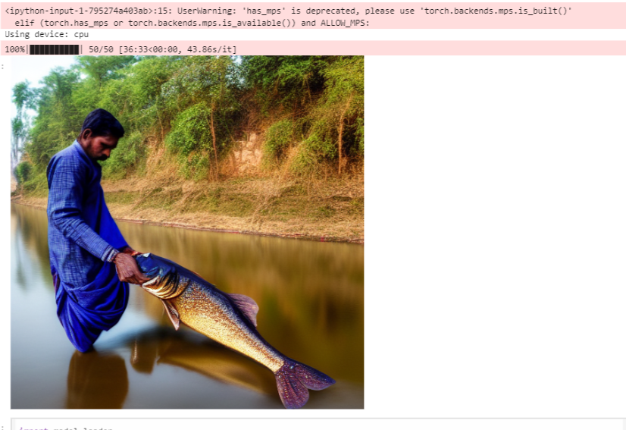

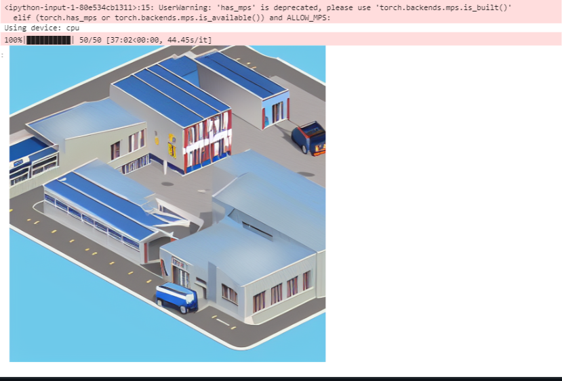

CONCLUSION

In summary, our exploration into Stable Diffusion architecture for image generation demonstrates its potential in creating high-quality images from textual descriptions or other latent representations. We have successfully implemented and evaluated Stable Diffusion-based models, revealing their capability to generate realistic and detailed images.

Our findings indicate that Stable Diffusion can be an effective tool for a range of image generation tasks, thanks to its robust underlying components, such as Variational Autoencoders (VAEs), CLIP encoders, and U-Net-based segmentation. This architecture's ability to balance efficiency with performance positions it as a strong candidate for various applications in generative modeling.

Despite these promising results, the Stable Diffusion architecture has some challenges and limitations. The computational demands can be substantial, especially during training, and achieving high-quality results requires careful tuning and large datasets. Furthermore, addressing ethical considerations around image generation and ensuring model interpretability are crucial for responsible deployment.

In conclusion, this work contributes to the growing field of generative modeling and highlights the versatility and potential of Stable Diffusion. Moving forward, further refinement and innovative applications will solidify its role in diverse domains, from art and entertainment to more specialized uses.

FUTURE WORK

There are several promising directions for future research and development with Stable Diffusion:

1. Improved Efficiency: Optimize the model architecture to reduce computational overhead and training times.
2. Text-to-Image Refinement: Further explore the relationship between text and image generation, enhancing the semantic coherence of outputs.
3. Cross-Domain Applications: Investigate the use of Stable Diffusion in various domains, such as gaming, virtual reality, and design.
4. Transfer Learning: Leverage transfer learning to improve model performance and reduce training time by fine-tuning pre-trained models.
5. Interpretability and Explainability: Develop tools and techniques to better understand and visualize the model's decision-making processes.
6. Scalability and Deployment: Design scalable deployment solutions to facilitate real-world adoption and integration into existing systems.
7. Ethical Considerations: Address ethical issues, such as misuse and content safety, and ensure responsible application of the technology.
8. Community Collaboration: Encourage community-driven development and open-source contributions to expand the capabilities and reach of Stable Diffusion.

Pursuing these avenues will ensure that Stable Diffusion continues to evolve, providing a versatile platform for generative modeling that can adapt to a wide range of applications.

APPLICATIONS

Stable Diffusion has a broad spectrum of potential applications, thanks to its versatility and powerful generative capabilities:

1. Art and Design: Create unique digital art, illustrations, and designs from textual descriptions.
2. Entertainment and Media: Generate assets for games, movies, and virtual reality experiences.
3. Content Creation: Produce content for blogs, social media, and marketing campaigns.
4. Prototyping and Visualization: Aid in product design and prototyping by generating concept images.
5. Education and Training: Generate visual aids and training materials for educational purposes.
6. Personalization: Allow users to create personalized avatars, backgrounds, and other visual elements.
7. Augmented Reality (AR) and Virtual Reality (VR): Provide assets for AR and VR applications, enhancing user experiences.
8. Healthcare and Medical Imaging: Generate synthetic medical images for training and research (with careful ethical considerations).
9. Scientific Visualization: Assist in visualizing complex scientific concepts or data in a comprehensible manner.
10. Social Impact: Use Stable Diffusion for social projects, like generating educational materials for underprivileged communities.

By harnessing the power of Stable Diffusion, these applications demonstrate the breadth of impact that generative modeling can have across industries, from creative endeavors to more technical and scientific uses.

