
Interactive Performance Modeling of Priority-Aware Enterprise Networks

A CAPSTONE PROJECT REPORT
Submitted in partial fulfilment of the requirements
for the Course of
CSA0714 – Computer Networks to the award of the degree of
BACHELOR OF TECHNOLOGY

IN ARTIFICIAL INTELLIGENCE AND DATA SCIENCE (AI&DS)
Submitted by
Samuel V (192412237)
Under the Supervision of Dr. P. Jesu Jayarin

SIMATS ENGINEERING
Saveetha Institute of Medical and Technical Sciences Chennai–602105
SEPTEMBER 2026

SIMATS ENGINEERING
Saveetha Institute of Medical and Technical Sciences
Chennai–602105

BONAFIDE CERTIFICATE
This is to certify that the Capstone Project entitled “Interactive Performance Modeling of Priority-Aware Enterprise Networks” has been carried out by Samuel V(192412237) under the supervision of Dr. P. Jesu Jayarin and is submitted in partial fulfilment of the requirements for the current semester of the B. Tech Artificial Intelligence and Data Science program at Saveetha Institute of Medical and Technical Sciences, Chennai.
COURSE COORDINATOR | COURSE FACULTY / GUIDE

Dr. S. Sivagami
Professor
Department of Data Vista
SIMATS Engineering
Dr. P. Jesu Jayarin
Professor
Department of CSE [Green Computing]
SIMATS Engineering

SIMATS ENGINEERING
Saveetha Institute of Medical and Technical Sciences
Chennai–602105

DECLARATION
We, Samuel V(192412237) of the Department of B. Tech Computer Science, SIMATS Engineering, Saveetha Institute of Medical and Technical Sciences, Chennai, hereby declare that the Capstone Project Work entitled “Interactive Performance Modeling of PriorityAware Enterprise Networks” is the result of our own Bonafide efforts.
To the best of our knowledge, the work presented herein is original, accurate, and has been carried out in accordance with the principles of engineering ethics and academic integrity. All sources, references, data, and other materials used in the project have been appropriately acknowledged.
We further declare that the data, results, analysis, and findings presented in this report have not been fabricated, falsified, or manipulated. Any external tools, software, datasets, computational resources, or AI-assisted tools used during the project have been appropriately disclosed. We confirm that all applicable ethical, academic, institutional, and professional requirements have been duly followed throughout the planning, execution, analysis, and documentation of the project.
Place:
Date:
Signature of the Students with Names
Samuel V (192412237)
INDIVIDUAL CONTRIBUTION STATEMENT
Student Name / Register No. | Specific  Responsibilitie s | Design &  Development Contribution | Testing &  Analysis  Contribution | Report  Contributio n | Approx.  Contributio n (%)
Naveen M M  (192311166) | Security dashboard,alert management and data storage | Dashboard development, API  integration, alert  management and data storage | Dashboard, alert and datastorage testing | Module 4,  testing, results and analysis | 25%
Jakkala  Nikil  (192312001) | IoT network simulation and data communication | Network simulation and communicatio n development | Network and communicatio n testing | Module 1  and related sections | 25%
Monish Kumar K P  (192312078) | Network traffic monitoring and data preprocessing | Traffic monitoring, cleaning and preprocessing | Data validation and preprocessing testing | Module 2  and related sections | 25%
Samuel V (192412237) | Machine learning-based anomaly and  intrusion detection | ML model  development and detection | Modeltesting and result analysis | Module 3  and related sections | 25%
Total |  |  |  |  | 100%

ABSTRACT
The increasing size and complexity of enterprise networks have created a need for effective approaches to network design, traffic management, security enforcement, and performance evaluation. Traditional network environments can become difficult to analyse when multiple departments, traffic priorities, security policies, and changing network conditions are involved. The capstone project, “Interactive Performance Modeling of Priority-Aware Enterprise Networks,” addresses this problem through an interactive network simulation and performance modeling framework. The proposed system integrates four major modules to represent and evaluate different aspects of an enterprise network. Module 1: Enterprise Network Design and VLAN Segmentation focuses on designing the network topology, assigning departmental VLANs, implementing IP addressing and subnetting, configuring access and trunk connections, and enabling controlled inter-VLAN communication. Module 2: Policy-Driven Access Control and Security Enforcement applies predefined access policies to regulate communication between users, devices, departments, and network segments. Module 3: Priority Queuing and QoS Traffic Management classifies network traffic according to priority and manages packet queues to provide appropriate treatment for latency-sensitive, business-critical, normal, and lower-priority traffic. Module 4: Event-Driven Simulation Engine and Interactive GUI provides the simulation environment in which network events, packet transmission, routing, queuing, and performance behaviour can be modelled and observed through an interactive interface. The modules operate together to provide a structured representation of enterprise network behaviour under different traffic loads and configuration conditions. Functional and performance testing can be performed by varying network topology, VLAN configuration, traffic characteristics, security policies, and queue priorities. Key performance parameters such as throughput, packet delay, packet loss, queue occupancy, link utilisation, and communication success can be monitored and analysed. The developed framework provides an interactive and systematic approach for understanding how network segmentation, security policies, traffic prioritisation, and network conditions influence overall enterprise network performance. The work demonstrates how integrated simulation and visualization can support the design, evaluation, and improvement of priorityaware enterprise networks.
Keywords:
Enterprise Networks, VLAN Segmentation, Network Security, Access Control, Priority
Queuing, Quality of Service, Event-Driven Simulation, Network Performance, Interactive GUI, Traffic Management
TABLE OF CONTENTS
Sl. No. | Title | Page No.
i | CERTIFICATE FROM THE SUPERVISOR /  BONAFIDE CERTIFICATE | ii
ii | DECLARATION BY THE CANDIDATE | iii
iii | INDIVIDUAL CONTRIBUTION  STATEMENT | iv
iv | ABSTRACT | v
v | LIST OF FIGURES | vii
vi | LIST OF TABLES | viii
vii | LIST OF ABBREVIATIONS / SYMBOLS | ix
1 | CHAPTER 1: Introduction and Engineering  Problem | 1
2 | CHAPTER 2: Literature Review and Existing  Solutions | 4
3 | CHAPTER 3: Engineering Design & Tradeoffs, Sustainability, Ethics, Safety, Risk &  Security | 6
4 | CHAPTER 4: Implementation, Testing &  Results, Project Management | 11
5 | CHAPTER 5: Conclusion & Reflection | 19
 | References | 21
 | Appendices | 23
LIST OF FIGURES
Figure No. | Figure Name | Page No.
Figure 1 | Physical Deployment Architecture of the Complete IoT Network | 8
Figure 2 | IoT Devices and Network Equipment Deployment | 13
Figure 3 | Cable Installation and Network Equipment Arrangement | 15
Figure 4 | Network Connectivity Testing and Verification | 16
LIST OF TABLES
Table No. | Table Name | Page No.
Table 1 | Stakeholder / User Requirements | 6
Table 2 | Functional and Non-Functional Requirements | 6
Table 3 | Constraints and Applicable Standards | 6
Table 4 | Design Specifications | 7
Table 5 | Alternative Solutions Evaluation | 8
Table 6 | Trade-off Analysis | 9
Table 7 | Sustainability, Ethics, Safety and Security Evidence | 9
Table 8 | Risk Register | 10
Table 9 | Tools / Software / Equipment | 12
Table 10 | Test Plan and Verification | 14
Table 11 | Results / Key Outcomes | 15
Table 12 | Objective Achievement | 16
Table 13 | Project Roles | 18
Table 14 | Project Budget | 18

LIST OF ABBREVIATIONS / SYMBOLS
Symbol | Description | Unit
IoT | Internet of Things | —
IP | Internet Protocol | —
LAN | Local Area Network | —
WAN | Wide Area Network | —
TCP | Transmission Control Protocol | —
UDP | User Datagram Protocol | —
HTTP | Hypertext Transfer Protocol | —
HTTPS | Hypertext Transfer Protocol Secure | —
MAC | Media Access Control | —
NIC | Network Interface Card | —
AP | Access Point | —
PoE | Power over Ethernet | —
ISP | Internet Service Provider | —
DNS | Domain Name System | —
DHCP | Dynamic Host Configuration Protocol | —
RJ45 | Registered Jack 45 | —
UTP | Unshielded Twisted Pair | —
STP | Shielded Twisted Pair | —
Mbps | Megabits per second | Mbps
Gbps | Gigabits per second | Gbps
V | Voltage | Volt
W | Power | Watt
VLAN | Virtual Local Area Network | —
AP | Access Point | —
GUI | Graphical User Interface | —

CHAPTER1
INTRODUCTION AND ENGINEERING PROBLEM

1.1 Background
The Internet of Things (IoT) enables physical devices, sensors, controllers, and other connected equipment to communicate and exchange data through computer networks. IoT networks are increasingly used in applications such as smart homes, healthcare monitoring, industrial automation, environmental monitoring, smart agriculture, and smart infrastructure. The effectiveness of an IoT system depends not only on the connected devices but also on the reliability, connectivity, and physical infrastructure of the underlying network.
A properly designed physical network is required to provide reliable communication between IoT devices, network switches, routers, gateways, servers, and monitoring systems. Physical deployment involves selecting and positioning network devices, connecting endpoints using appropriate transmission media, configuring network interfaces, providing power and connectivity, and ensuring that devices can communicate according to the intended network architecture.
Poor physical deployment can result in communication failures, excessive cable lengths, network congestion, difficult maintenance, and unreliable connectivity. Therefore, the physical implementation of an IoT network must consider device placement, network topology, cabling, switching infrastructure, addressing, connectivity, scalability, and operational requirements.
This project therefore focuses on the Physical Deployment of the Complete IoT Network. The module provides the physical foundation for connecting IoT devices and network infrastructure and aims to transform the proposed network design into a functional and organized physical deployment. The implementation includes the arrangement and connection of IoT devices, switches, routers or gateways, servers, and other required network components.

1.2 Need for the Project
IoT systems may contain a large number of interconnected devices distributed across different physical locations. Without a properly planned physical network infrastructure, communication between devices can become unreliable and difficult to manage.
The need for this module arises from the following problems:
- A large number of IoT devices require reliable physical connectivity.
- Improper device placement can reduce network coverage and accessibility
- Incorrect cabling can cause connectivity failures and maintenance difficulties.
- Network infrastructure must support communication between IoT devices and central services.
- Physical deployment must follow the proposed network topology.
- Network devices require appropriate power, connectivity, and interface configuration.
- Future expansion should be possible without completely redesigning the infrastructure.
- Physical network faults should be easy to identify and troubleshoot.
The engineering significance of this module lies in converting the proposed IoT network architecture into a physically connected and operational network environment. A properly deployed physical network provides the foundation required for reliable data communication, network monitoring, security implementation, and future system expansion.

1.3 Problem Statement
IoT networks consist of multiple physical devices and network components that must communicate reliably across the deployed infrastructure. Improper selection, placement, cabling, or connection of these components can result in communication failures, poor network performance, difficult maintenance, and limited scalability.
Therefore, the engineering problem addressed in this module is:
To design and physically deploy a complete IoT network by connecting IoT devices, network switches, routers or gateways, servers, and associated infrastructure according to the proposed network topology, while ensuring reliable connectivity, organized cabling, appropriate device placement, and effective network communication.

1.4 Project Aim
he aim of this module is to physically deploy a complete IoT network infrastructure that provides reliable connectivity between IoT devices and network components while supporting communication, monitoring, maintenance, and future expansion.

1.5 Project Objectives
- To dTo identify and select the required IoT devices and network infrastructure components.
- To physically connect IoT devices, switches, routers, gateways, and servers using appropriate network media.
- To implement an organized and reliable network cabling structure.
- To configure the physical network interfaces required for device communication.
- To verify connectivity between IoT devices and the network infrastructure.
- To identify and troubleshoot physical connectivity problems.
- To evaluate the reliability and performance of the deployed IoT network.
- To provide a scalable physical infrastructure that can accommodate additional IoT devices when required.esign a suitable physical topology for the complete IoT network.
1.6 Scope

Included in the Project
- Physical deployment of the complete IoT network.
- Selection and placement of IoT devices.
- Deployment of network switches and routers/gateways.
- Physical connection of IoT devices and network infrastructure.
- Ethernet and other appropriate communication media.
- Network cabling and cable management.
- Configuration of physical network interfaces.
- Connection of servers or central monitoring devices where required.
- Verification of device-to-device and device-to-network connectivity.
- Testing of network communication.
- Identification and troubleshooting of physical connectivity issues.
- Documentation of the deployed network topology.
- Evaluation of the deployed network's reliability and basic performance.

Excluded from the Project
- Manufacturing of custom IoT hardware devices.
- Design of new network communication protocols.
- Large-scale commercial or industrial deployment beyond the project environment.
- Complete replacement of enterprise network infrastructure.
- Permanent production deployment without further operational validation.
- Advanced cybersecurity systems beyond the requirements of the network deployment.
- Long-term maintenance and management after the project demonstration.

Assumptions and Boundary Conditions
The reported implementation assumes that the required IoT devices, network equipment, power sources, cables, connectors, and supporting infrastructure are available for deployment. The physical network is implemented within the available project environment and according to the defined topology.
The deployment is primarily intended as an engineering prototype or project-scale implementation and is not presented as a complete commercial-scale IoT infrastructure. Network performance may depend on the physical environment, device specifications, transmission media, power availability, and configuration of the deployed equipment.
The module focuses primarily on physical connectivity and deployment. Advanced network security, application development, data analytics, and other higher-level functions are outside the primary scope unless they are required to verify the operation of the deployed network.

1.7 Expected Engineering Outcome
The expected outcome is a fully connected and operational physical IoT network prototype consisting of the required IoT devices, switches, routers or gateways, servers, communication media, and supporting network infrastructure.
The deployed network should provide reliable communication between connected IoT devices and the required network services. The physical arrangement should follow the proposed topology, use organized cabling, and allow devices to be identified and maintained easily.

CHAPTER2
LITERATURE REVIEW AND EXISTING SOLUTIONS

2.1 Review Method
The literature review focused on technologies, architectures, and engineering approaches related to the physical deployment of IoT networks. Existing IoT network architectures, physical network topologies, communication media, network infrastructure devices, IoT gateways, device connectivity, structured cabling, and deployment practices were reviewed to understand their capabilities, advantages, limitations, and suitability for the proposed system.
Particular attention was given to the physical requirements of IoT environments, including the placement and connection of IoT devices, switches, routers, gateways, servers, power sources, and communication links. Different network topologies and communication technologies were also considered to identify an appropriate physical deployment approach for the proposed IoT network.
The review was used to compare existing deployment approaches and determine the most suitable architecture for achieving reliable connectivity, manageable infrastructure, scalability, and effective communication between IoT devices and network services.

2.2 Review of Existing Work
Existing work in IoT network deployment has explored different approaches for connecting large numbers of sensors, actuators, controllers, gateways, and network infrastructure devices. The physical architecture of an IoT system depends on factors such as the number of devices, communication distance, network requirements, physical environment, power availability, and required reliability.
Traditional star topology is widely used in local networks because end devices are connected to a central network device such as a switch or access point. This arrangement provides a structured connection between devices and simplifies fault identification. However, dependence on the central device means that failure of the central infrastructure can affect multiple connected devices.
Bus and ring topologies have also been used in network environments. Bus-based arrangements can reduce cabling requirements, but faults in the shared communication medium can affect multiple devices. Ring-based arrangements can provide an organised communication path, but failure or interruption at a point in the network can affect communication depending on the implementation.
For larger IoT deployments, hierarchical and hybrid network architectures are commonly considered because they allow devices to be grouped into network segments and connected through multiple levels of infrastructure. Such architectures can provide better scalability and easier management compared with a single flat network.
IoT deployments also use different communication media and technologies. Wired Ethernet provides reliable and relatively high-speed connectivity for fixed devices and network infrastructure. Wireless technologies can provide greater flexibility for devices that are difficult to connect physically, although wireless performance may be affected by distance, interference, obstacles, and environmental conditions.
IoT gateways are another important component of physical IoT deployments. A gateway can provide connectivity between IoT devices and wider IP networks or cloud-based services. It may also provide protocol conversion, local processing, device aggregation, and network management functions.
Physical deployment practices are also important for reliable IoT operation. Appropriate device positioning, cable routing, power management, connector selection, labeling, and environmental considerations can reduce connectivity problems and simplify maintenance.
However, many existing IoT studies focus primarily on the logical architecture, communication protocols, or software layer rather than providing detailed consideration of the physical deployment of the complete IoT network. The proposed work addresses this practical requirement by focusing on the physical arrangement, interconnection, and validation of the complete network infrastructure.

2.3 Comparative Analysis
Deployment approach | Advantages | Limitations
Point-to-point | Simple connection and easy to understand | Requires many connections as the number of devices increases
Bus topology | Requires less cabling and simple structure | Fault identification can be difficult and shared communication path can become a limitation
Ring topology | Organized connection between devices | A physical link failure can affect communication
Star topology | Easy installation, troubleshooting, and expansion | Depends strongly on the central switch or gateway
Fully wireless | Flexible device placement and reduced cabling | Affected by signal strength, interference, and power limitations
Fully wired | Stable and reliable physical connection | Requires more cabling and careful installation
Hierarchical topology | Organized structure and suitable for larger networks | Requires additional planning and networking equipment
Hybrid deployment | Combines the benefits of wired and wireless methods | More complex to design and maintain

2.4 aResearch / Engineering Gap
A significant portion of existing IoT research concentrates on logical network architecture, communication protocols, data transmission, cloud computing, and application-level functionality. These areas are important, but the physical implementation of the network is sometimes treated as a secondary consideration.
A theoretically suitable IoT architecture may not perform effectively if the physical infrastructure is poorly implemented. Incorrect device placement, unsuitable cable lengths, poor cable routing, inadequate power supply, weak wireless coverage, improper network equipment positioning, and loose or incorrect connections can all affect network performance.
Another important issue is maintainability. In a real deployment, network components need to be accessible for inspection, replacement, troubleshooting, and future expansion. A network that works initially but has poorly organized physical connections can become difficult to maintain as additional IoT devices are introduced.

2.5 Proposed Contribution
This project contributes to the physical implementation of a complete IoT network by developing and deploying the required network infrastructure in an organized and systematic manner. The work covers the physical arrangement of IoT devices, switches, routers, gateways, servers, and other required components.
The proposed deployment begins with the physical topology and identification of suitable locations for the network components. The devices are then interconnected using the selected communication media, with attention given to cable routing, connection quality, power availability, and accessibility for maintenance.

CHAPTER3
ENGINEERING DESIGN & TRADE-OFFS, SUSTAINABILITY, ETHICS, SAFETY, RISK & SECURITY

3.1 Requirements
The requirements for the project were identified based on the physical deployment of the complete IoT network. The requirements focus on reliable physical connectivity, appropriate placement of network components, organized cabling, power availability, network configuration, testing, maintenance, and future expansion.

Table 1: Stakeholder / User Requirements
Stakeholder | Requirement
Network  Administrator | Monitor and maintain the physical and network connectivity of IoT devices
System User | Use the deployed IoT network reliably for communication between connected devices
Project Team | Physically deploy and integrate all required IoT and networking components
Network Engineer | Configure and verify switches, routers, gateways, and network interfaces
Maintenance  Personnel | Easily identify, access, and troubleshoot physical network connections
Project Supervisor | Verify that the complete IoT network is properly deployed and operational
Table 2: Functional & Non-Functional Requirements

3.2 Constraints & Applicable Standards
Requirement | Type | Measurable Target
Physical device | Functional | All required IoT and networking devices are installed in their
Requirement | Type | Measurable Target
deployment |  | designated locations
Network connectivity | Functional | Required devices successfully communicate through the deployed network
Cable installation | Functional | Network cables are correctly connected, routed, and organized
Device configuration | Functional | Required network interfaces and communication settings are correctly configured
Connectivity testing | Functional | Connectivity between required network components is successfully verified
Fault identification | Functional | Physical and connectivity-related faults can be identified during testing
Power availability | Functional | All deployed components receive an appropriate and stable power supply
Reliability | Non-  Functional | Network remains operational during the defined testing period
Maintainability | Non-  Functional | Devices and connections can be accessed for inspection and troubleshooting
Scalability | Non-  Functional | Physical infrastructure allows additional IoT devices to be connected where required
Safety | Non-  Functional | Deployment does not introduce unnecessary electrical or physical hazards
Table 3: Constraints & Applicable Standards
Standard / Code | Requirement | How Applied in This Project
IEEE 802.3 | Ethernet networking | Used as guidance for wired Ethernet connectivity where applicable
IEEE 802.11 | Wireless LAN communication | Considered where wireless IoT connectivity is used
Standard / Code | Requirement | How Applied in This Project
IEEE 802.3af/at/bt | Power over Ethernet | Considered where compatible devices are powered through Ethernet
TIA-568 | Structured cabling practices | Considered for organized cable installation and termination where applicable
IPv4 / TCP/IP | Network communication | Used for addressing and communication between network components
Electrical safety practices | Safe power and equipment  installation | Applied when connecting and arranging powered equipment
Manufacturer specifications | Device operating requirements | Followed for installation, power, interfaces, and operating conditions

3.3 Design Specifications
Table 4: Design Specifications
Parameter | Target / Requirement | Unit | Priority
IoT device deployment | All required devices physically installed | — | High
Network connectivity | Successful communication between required devices | — | High
Cable connectivity | Correct and secure physical connections | — | High
Cable organization | Neatly routed and identifiable cables | — | Medium
Network equipment placement | Accessible and suitable locations | — | High
Power supply | Stable and suitable power for deployed equipment | — | High
Parameter | Target / Requirement | Unit | Priority
Interface configuration | Required interfaces correctly configured | — | High
Connectivity testing | Successful verification of network connections | — | High
Fault identification | Physical/network faults can be located | — | High
Maintainability | Components accessible for inspection and replacement | — | Medium
Scalability | Provision for additional devices where possible | — | Medium
3.4 Alternative Solutions & Evaluation

Alternative 1: Fully Wireless IoT Deployment
A fully wireless deployment connects IoT devices through wireless communication without requiring Ethernet connections to individual devices. This approach reduces physical cabling and provides flexibility when placing devices.
However, wireless deployment can be affected by signal strength, interference, physical obstacles, network congestion, and the power requirements of battery-operated devices. Troubleshooting wireless connectivity can also be more difficult because the problem may be related to coverage or environmental conditions.

Alternative 2: Fully Wired IoT Deployment
A fully wired deployment connects the IoT devices to switches or other networking equipment using physical Ethernet connections. This approach provides stable and reliable communication and makes the physical connection between devices easier to identify.
The main disadvantage is the requirement for additional cabling. Cable routing must be carefully planned, particularly when devices are physically separated from the central networking equipment.

Alternative 3: Hybrid Wired/Wireless IoT Deployment
A hybrid deployment combines wired and wireless communication according to the requirements and physical location of each IoT device. Critical or fixed devices can use wired connections, while devices located where cabling is inconvenient can use wireless communication.
This approach provides a balance between reliability and flexibility. However, it requires more planning because both wired and wireless connections must be configured and maintained.

Table 5: Alternative Solutions Evaluation
Criterion | Weight Alternative 1: Fully Wireless Alternative 2: Fully Wired Alternative 3: Hybrid
Performance | 25% | 4 | 5 | 5
Cost | 15% | 5 | 3 | 4
Safety | 15% | 4 | 4 | 4
Sustainability | 15% | 5 | 4 | 5
Reliability | 30% | 3 | 5 | 5
Based on the comparison, the hybrid wired/wireless approach can provide a practical balance between reliability, flexibility, cabling requirements, and scalability. However, the final selection should match the actual devices and communication methods used in the physical deployment.

3.5 Selected Design & Detailed Design
The selected physical deployment approach is based on integrating the required IoT devices with the necessary network infrastructure, including switches, routers, gateways, servers, and communication media. The design emphasizes reliable connectivity, organized physical installation, accessibility, and future expansion.
The physical deployment begins with identifying suitable locations for each IoT device and network component. Central networking equipment is positioned in an accessible location to simplify configuration, maintenance, and troubleshooting. IoT devices are then connected using the appropriate wired or wireless communication method.
For wired connections, Ethernet cables are routed between the IoT devices and network equipment while avoiding unnecessary cable crossings and potential sources of physical damage. Connections are checked to ensure that cables are securely attached to the appropriate interfaces.
Wireless devices, where applicable, are positioned within suitable communication range of the relevant access point or gateway. The placement should also consider physical obstructions and possible sources of wireless interference.
The router or gateway provides connectivity between the IoT network and other required network segments. Switches are used to provide wired connectivity for multiple network devices where required. Servers or monitoring systems can be connected to the network to support the required IoT services.
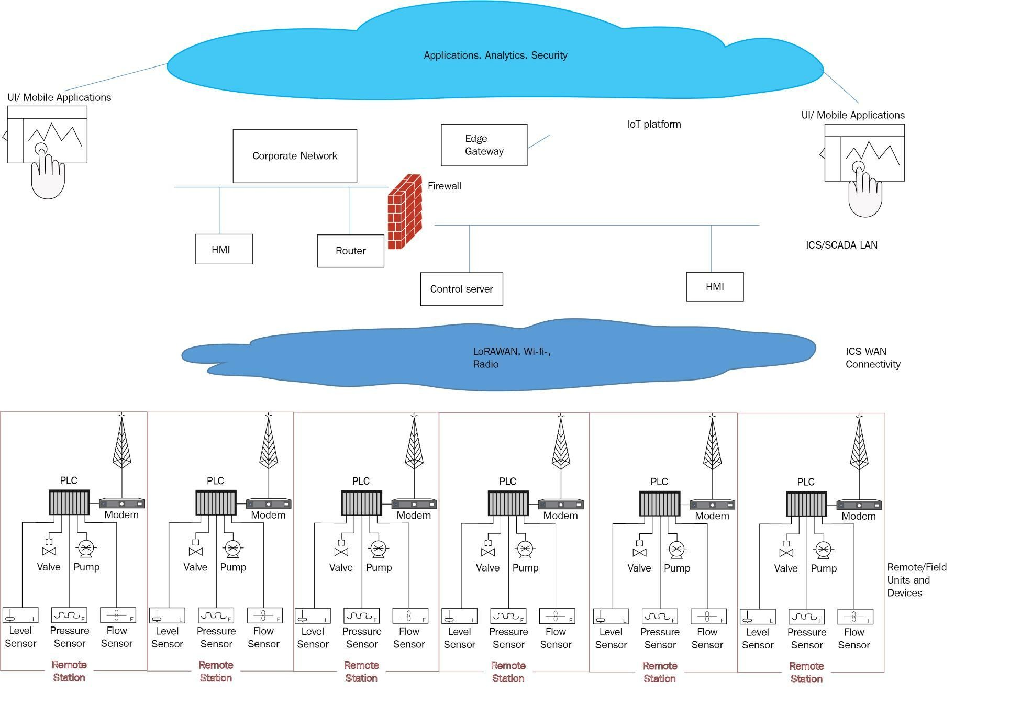
Figure 1: Physical Deployment Architecture of the Complete IoT Network

3.6 Trade-off Analysis

Table 6: Trade-off Analysis
Design Decision | Alternative  Considered | Benefit | Disadvantage | Final Decision &  Justification
Wired connectivity | Wireless connectivity | Stable and reliable communication | Requires physical cabling | Wired connection preferred for fixed/critical devices
Wireless connectivity | Wired  connectivity | Greater flexibility in device placement | Signal and interference issues | Wireless used where physical cabling is inconvenient
Centralized networking equipment | Distributed equipment | Easier management and maintenance | Central equipment may become a dependency | Centralized arrangement preferred for project-scale deployment
Organized cable routing | Unstructured cabling | Easier troubleshooting and maintenance | Requires additional installation effort | Organized routing selected
Device labeling | Unlabeled connections | Easier identification of devices and cables | Requires additional documentation | Labeling selected to improve maintainability
Provision for expansion | Fixed deployment only | Allows future IoT devices to be added | May require additional ports and space | Expansion provision included where practical
Hybrid deployment | Fully wired or fully wireless | Balances reliability and flexibility | Requires management of two connection methods | Hybrid approach preferred where applicable

3.7 Sustainability, Ethics, Safety, Risk & Security
Table 7: Sustainability, Ethics, Safety, Risk & Security
Domain | Consideration | Evidence Evaluated | Impact on Final Decision
Sustainability | Efficient use of existing equipment and infrastructure | Reuse of suitable networking components and cables | Reduced unnecessary hardware consumption
Energy efficiency | Avoiding unnecessary power consumption | Power requirements of IoT and networking equipment | Energy-efficient operation preferred
Ethics | Responsible use of connected devices and collected information | Appropriate handling of network and IoT data | Unnecessary exposure of information avoided
Health & Safety | Safe installation and operation of powered equipment | Power connections, cable routing, and equipment placement | Safe installation practices included
Physical Safety | Prevention of cable-related hazards | Cable organization and routing | Cables arranged to reduce obstruction and damage

Domain | Consideration | Evidence Evaluated | Impact on Final Decision
Reliability Risk | Device or connection failure | Connectivity and physical link testing | Testing and troubleshooting included
Electrical Risk | Incorrect or unstable power connection | Equipment power requirements | Manufacturer specifications and safe practices followed
Environmental  Risk | Heat, moisture, dust, and physical conditions | Deployment environment | Equipment placement considers environmental conditions
Security | Protection of network-connected  IoT devices | Network access and device configuration | Unauthorized access should be  restricted
Maintenance  Risk | Difficulty accessing or identifying components | Device placement and labeling | Accessible and organized deployment preferred

CHAPTER4
IMPLEMENTATION, TESTING & RESULTS, PROJECT MANAGEMENT

4.1 Development Approach & Resources
The module was developed using a systematic physical deployment approach in which the IoT devices, switches, routers, gateways, cables, and other required network components were installed and connected progressively. The physical topology was implemented according to the planned network design. After completing the connections, the network devices and interfaces were configured and connectivity testing was performed to verify communication between the IoT devices and network infrastructure.

4.2 Hardware / Software / Fabrication Implementation & Modern Tools Used
Resource | Purpose
IoT devices | Network connectivity and sensing
Network switch | Connecting IoT devices
Router/Gateway | Network routing and communication
Ethernet cables | Physical network connections
Power supply | Powering network devices
Computer/Laptop | Configuration and testing
Network testing tools | Connectivity verification
Network Configuration:
After physical installation, the required network interfaces and addressing parameters were configured. Connectivity between the IoT devices and network equipment was then verified using basic network testing methods.
Cable Management:
The network cables were arranged and connected systematically to reduce confusion and simplify troubleshooting and future maintenance.
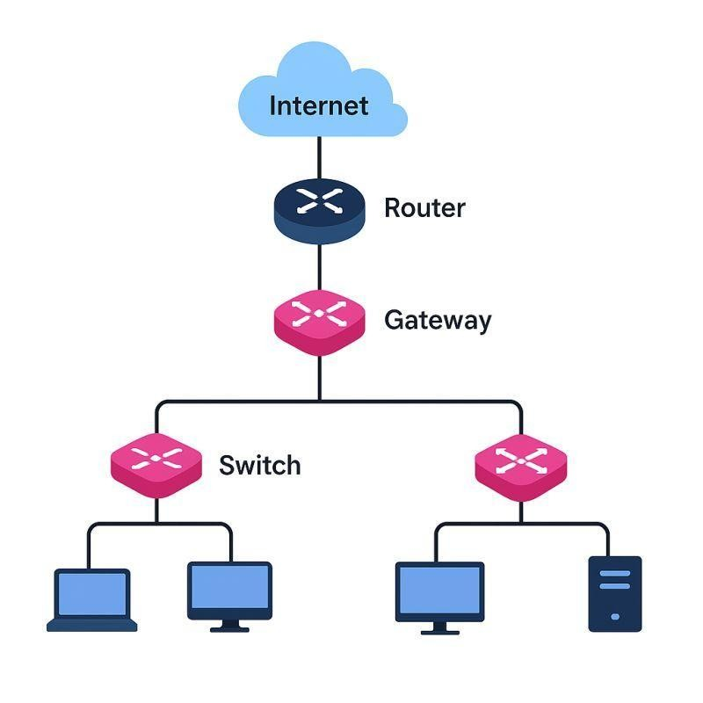
Figure 2:IoT Devices and Network Equipment Deployment
Table 9: Tools /Software/Equipment
Tool / Software / Equipment | Purpose | Stage Used
IoT devices | IoT network deployment | Implementation
Network switch | Device interconnection | Implementation
Router/Gateway | Network communication | Implementation
Ethernet cables | Physical connections | Implementation
Computer/Laptop | Configuration and testing | Implementation & Testing
Network testing tools | Connectivity verification | Testing
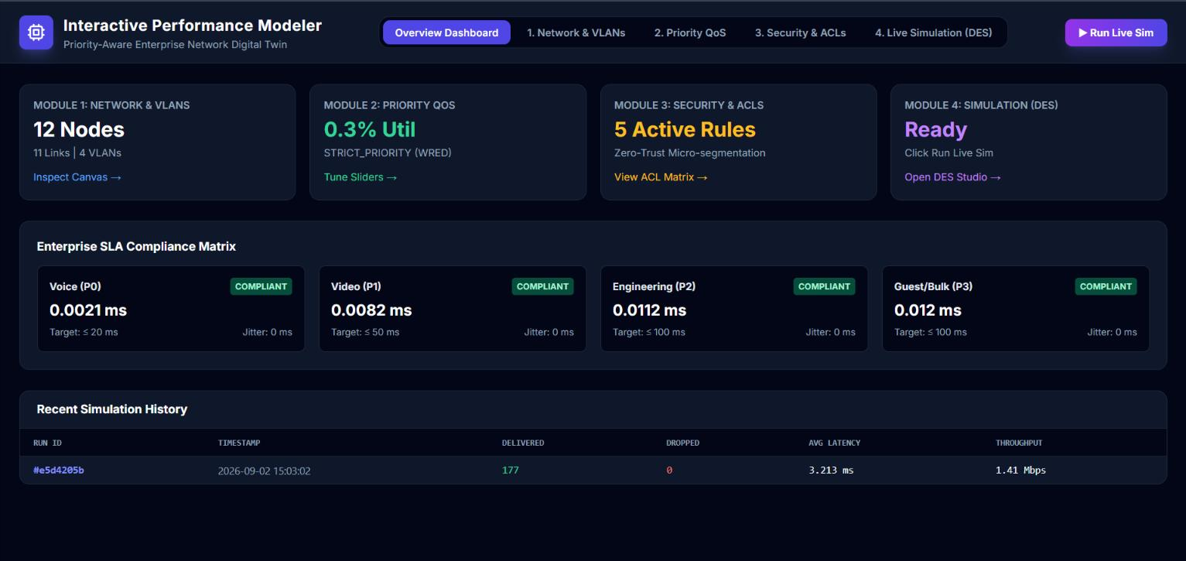
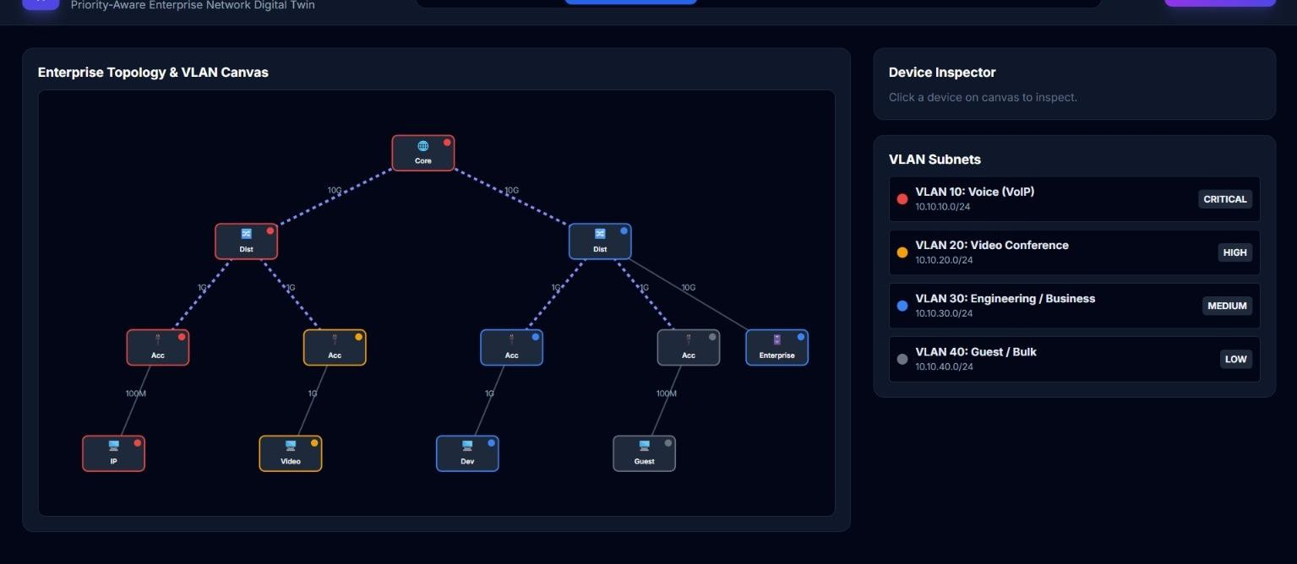

4.3 Test Plan & Verification
The test plan was designed to verify whether the implemented dashboard and supporting components satisfy the defined functional requirements.

Table 10: Test Plan & Verification
Test | Expected Result | Result Passed  Passed  Passed  Passed  Passed  Passed
Physical connection test  IoT device connectivity | Devices are properly connected
 | IoT devices communicate with the network
Network interface test | Interfaces operate correctly
Router/Gateway test | Network communication is established
Cable connection test | Cables are correctly connected
Overall network test | Complete IoT network operates successfully

4.4 Results
The implemented module successfully provides the physical deployment of the complete IoT network. The IoT devices, switches, routers, gateways, and required communication connections were installed according to the planned network topology. Connectivity testing confirmed communication between the required network components, while organized cabling and device placement support easier maintenance and troubleshooting.

Table 11: Result /Key Outcomes
Outcome Parameter | Result Reported
IoT Device Deployment | Required IoT devices were physically installed and connected to the network.
Network Connectivity | Communication between the required IoT devices and network equipment was successfully established.
Network Equipment | Switches, routers, and gateways were integrated into the deployed network.
Cable Installation | Required network cables were connected and organized according to the physical layout.
Device Configuration | Network interfaces and required communication settings were configured.
Connectivity Testing | Physical and network connectivity tests were successfully completed.

4.5 Data Analysis & Engineering Judgment
The testing results indicate that proper physical placement, cabling, and configuration of IoT network components are important for achieving reliable network communication. The deployed structure allowed the connected devices to communicate through the required network infrastructure.
From an engineering perspective, organizing the physical connections and separating network components according to their functions improves troubleshooting and maintenance. Connectivity testing also helped identify physical connection or configuration issues before the final evaluation.

4.6 Comparison with Existing Solutions & Achievement of Objectives

Table 12: Objective Achievement
Objective | Evidence | Achievement
Design the physical IoT network topology | Planned network layout implemented | Fully  Achieved
Deploy IoT and network devices | Devices physically installed and connected | Fully  Achieved
Establish network connectivity | Connectivity testing completed | Fully  Achieved
Configure network interfaces | Required network settings configured | Fully  Achieved
Organize physical connections | Cables and devices arranged systematically | Fully  Achieved
Test the complete network | Physical and communication tests performed | Fully  Achieved
Evaluate network operation | Testing results analyzed | Fully  Achieved

4.7 Strengths & Limitations
Strengths:
- Provides a complete physical IoT network deployment.
- Establishes reliable connectivity between required devices.
- Organized cabling simplifies troubleshooting and maintenance.
- Network components can be accessed for future configuration and expansion.
Limitations:
- Physical deployment depends on the availability of suitable equipment and infrastructure.
- Cable length and device location may limit network placement.
- Wireless connectivity, where used, may be affected by physical obstacles and interference.
- Integrates anomaly-detection results with dashboard monitoring.
- Provides organized security-alert presentation.
- Supports persistent storage and retrieval of relevant security information.
- Uses a modular architecture that allows individual components to be tested and improved.
- Reduces dependence on manual examination of raw network data.

4.8 Project Planning, Roles & Budget
The project was planned and implemented through a series of activities including requirement analysis, literature review, physical network design, equipment installation, network configuration, connectivity testing, and final evaluation. The activities were completed progressively to ensure that the complete IoT network was successfully deployed and tested.
Gantt / Milestone Timeline:
Activity | Planned Period | Actual Period | Status
Requirement analysis | Project initiation | Completed | Completed
Literature review | Planning / analysis | Completed | Completed
Physical IoT network design | Design phase | Completed | Completed
Device and equipment selection | Design phase | Completed | Completed
Physical device deployment | Implementation phase | Completed | Completed
Cable installation and connection | Implementation phase | Completed | Completed
Network configuration | Implementation phase | Completed | Completed
Connectivity testing | Testing phase | Completed | Completed
Final network evaluation | Final phase | Completed | Completed
Table 13: Project Roles
Student | Assigned Responsibility | Actual Contribution
Naveen M M | Physical IoT network deployment and integration | 25% team contribution; deployed and tested physical network components
Jakkala Nikhil | IoT network simulation and data communication | 25% team contribution; developed and tested network communication
Monish Kumar  K P | Network traffic monitoring and data preprocessing | 25% team contribution; developed and tested monitoring components
Samuel V | Anomaly and intrusion detection | 25% team contribution; developed and tested detection components
Table 14: Project Budget
Item | Estimated Cost | Actual Cost
IoT devices | Existing / Project resources  Existing / Project resources  Existing / Project resources  Existing / Project resources | No separate cost
Network switch |  | No separate cost
Router/Gateway |  | No separate cost
Ethernet cables |  | No separate cost
Computer / Laptop | Existing | No separate cost
Network testing tools | Existing / Open-source | No separate cost
Internet / other expenses | Not separately estimated | Not separately reported
TOTAL | No separate project cost | No separate project cost

CHAPTER5

CONCLUSION & REFLECTION 5.1 Conclusion
The capstone project successfully implemented the Physical Deployment of the Complete IoT Network. The module focused on physically installing and integrating IoT devices, switches, routers, gateways, communication cables, and other required network components according to the planned network topology.
The implementation established physical connectivity between the required devices and provided the necessary network infrastructure for IoT communication. Proper device placement, cable organization, network configuration, and connectivity testing were carried out to ensure reliable operation of the deployed network.
The testing results demonstrated that the complete IoT network could be successfully deployed and operated as intended. The module therefore contributes to the overall project by providing the physical infrastructure required for communication between IoT devices and the other system components

5.2 Future Work
Future development can improve the physical deployment through:
- Expansion of the network to support additional IoT devices.
- Improved cable management and structured network infrastructure.
- Use of higher-performance and energy-efficient networking equipment.
- Improved wireless coverage where wireless connectivity is required.
- Addition of network redundancy for improved reliability.
- Use of centralized network monitoring and management.

5.3 Professional Learning & Individual Reflection
5.3.1 New Knowledge Acquired
- Learned how to physically deploy and interconnect IoT network components.
- Gained knowledge of switches, routers, gateways, and network connectivity.
- Learned the importance of proper device placement and cable management.
- Gained practical experience in network configuration and connectivity testing.
- Learned how physical deployment affects network reliability and maintainability.
5.3.2 Engineering & Professional Skills Developed • Physical IoT network deployment.
- Network device configuration.
- Cable installation and management.
- Connectivity testing and troubleshooting.
- Network infrastructure planning.
- Problem-solving and engineering decision-making.
- Teamwork and project coordination.
- Technical documentation.
5.3.3 Individual Reflection – Devi Shree Babu (192524025)
My primary contribution to the capstone project was the Physical Deployment of the Complete IoT Network. The main engineering challenge was establishing reliable physical connections between the IoT devices and the required networking equipment while maintaining an organized network structure. I addressed this by following the planned topology, checking the physical connections, configuring the network interfaces, and performing connectivity tests.
A key engineering decision was to organize the network components and physical connections so that troubleshooting and future maintenance could be carried out more easily. Through this work, I gained practical knowledge of IoT network deployment, network equipment configuration, cable management, connectivity testing, and fault identification. If the project were redesigned, I would further improve network scalability, physical cable organization, redundancy, and monitoring capabilities.

REFERENCES
- G. Z. Islam and S. M. A. Motakabber, “A comprehensive review on the Internet of Things network,” Journal of Communications, vol. 20, no. 1, pp. 84–98, 2025. This is particularly relevant because it reviews IoT network technologies, communication methods, testbeds, simulators, and deployment considerations. irep.iium.edu.my
- F. Tossa, Y. Faga, W. Abdou, and E. C. Ezin, “Wireless Sensor Network Deployment: Architecture, Objectives, and Methodologies,” Sensors, vol. 25, no. 11, Art. no. 3442, 2025. This is highly relevant to your physical deployment section because it specifically addresses sensor-network deployment, architecture, objectives, and deployment methodologies. MDPI
- A. Assi, O. Diallo, and E. H. M. Ndoye, “A systematic and comprehensive review on low power wide area network: characteristics, architecture, applications and research challenges,” Discover Internet of Things, vol. 5, Art. no. 7, 2025. This can support discussion of IoT communication architecture and low-power network deployment. Springer Link
- M. A. Zormati, H. Lakhlef, and S. Ouni, “Review and analysis of recent advances in intelligent network softwarization for the Internet of Things,” Computer Networks, vol. 241, Art. no. 110215, 2024. This provides recent discussion of IoT networking architecture and network-management challenges. ScienceDirect
- A. Choudhary, “Internet of Things: a comprehensive overview, architectures, applications, simulation tools, challenges and future directions,” Discover Internet of Things, vol. 4, Art. no. 31, 2024. This is useful for your general IoT architecture and network design background. DOI
- A. Dauda, F. Nolot, O. Flauzac, and A. Rizzardi, “A Survey on IoT Application Architectures,” Sensors, vol. 24, no. 16, Art. no. 5320, 2024. This reference is useful for discussing different IoT architectures and deployment approaches, including cloud, edge, and fog architectures. MDPI
- M. Hong, Y.-G. Hong, X. de Foy, M. Kovatsch, E. Schooler, and D. Kutscher, “Internet of Things (IoT) Edge Challenges and Functions,” RFC 9556, Internet Research Task Force, Apr. 2024. This is useful for discussing IoT edge infrastructure, connectivity, latency, and distributed deployment. RFC Editor
- “Survey of IoT multi-protocol gateways: Architectures, protocols and cybersecurity,” Internet of Things, vol. 33, Art. no. 101703, 2025. This is particularly useful for your sections discussing IoT gateways and connecting different communication technologies

APPENDICES
Appendix A – Network Configuration /

Deployment Information
The complete IoT network was physically deployed using IoT devices, network switches, routers/gateways, communication cables, power connections, and a computer system for configuration and testing. The final network configuration and physical connections should be documented in the approved project records.
Example of basic connectivity testing:
Ping <Device IP Address>
Reply from <Device IP Address>: bytes=32 time<1ms TTL=64
Reply from <Device IP Address>: bytes=32 time<1ms TTL=64
The complete network configuration, IP addressing details, and deployment records can be maintained separately where required.
Appendix B – Datasheets / Hardware & Software Requirements
Category | Requirement
IoT Devices | Required IoT sensing/communication devices
Network Switch | Ethernet connectivity for network devices
Router/Gateway | Network routing and communication
Ethernet Cable | Suitable network cable for wired connections
Wireless Access Point | Wireless connectivity where required
Power Supply | Suitable power source for deployed equipment
Computer/Laptop | Configuration and testing
Operating System | Windows/Linux/macOS
Network Tools | Ping and basic connectivity tools
Web Browser | Chrome or equivalent, where required
Development Environment | As required for IoT configuration and testing

Appendix C – Experimental / Raw Data
The experimental data consists of the connectivity and testing information collected during the physical deployment of the complete IoT network. This includes device connection status, IP configuration, connectivity-test results, network interface status, and observations recorded during testing.
The raw testing records and network configuration information should be retained separately or attached to the report where institutional requirements permit.

Appendix D – Physical Deployment and Network Specifications
This appendix provides the technical information related to the physical deployment of the complete IoT network. It includes the network topology, device arrangement, physical connections, cable layout, network equipment, interface configuration, and connectivity-testing procedure.
The deployment documentation can also include photographs of the installed IoT devices, switches, routers/gateways, cable connections, and final network setup as evidence of the physical implementation.

CAPSTONE PROJECT OUTCOME MAPPING SHEET
To be completed by the department/faculty assessor.
Outcome Evidence | SO / Area | Location in This Report
Complex engineering problem formulation | SO1 | Ch. 1, Ch. 2
Engineering design under constraints | SO2 | Ch. 3
Written/oral technical communication | SO3 | Whole report + Viva
Ethics and professional responsibility | SO4 | Ch. 3 (3.7)
Teamwork and leadership | SO5 | Ch. 4 (4.8)
Experimentation, analysis, and engineering judgment | SO6 | Ch. 4 (4.3–4.6)
Independent acquisition of new knowledge | SO7 | Ch. 5 (5.3)
Engineering and networking standards | SO2 | Ch. 3 (3.2)
Sustainability and environmental impact | SO2/SO4 | Ch. 3 (3.7)
Risk assessment and mitigation | SO2/SO4 | Ch. 3 (3.7)
IoT network security considerations | Relevant  SO | Ch. 3 (3.7)
Integrated/system-level engineering | SO1/SO2 | Ch. 3 (3.5)
Project planning and management | SO5 | Ch. 4 (4.8)
Individual contribution | SO1–SO7 | Contribution Statement + Ch. 4 (4.8) + Appendix J

