Assignment 2: MLR-ACE-AVAS-MARS

**Samuel Andrews and Mikolaj Wieczorek**

2/9/2020

|  |  |  |  |  |  |
| --- | --- | --- | --- | --- | --- |
| Model Method | (training data) | (predicting validation set) | (MPa) | (MPa) | (%) |
| MLR orig | 61.38% | 62.52% | 10.19 | 8.08 | 32.59% |
| MLR trans | 77.33% | 75.16% | 8.77 | 6.86 | 22.25% |
| **MARS (deg 1)** | **86.94%** | 84.92% | **6.92** | **5.27** | **17.41%** |
| MARS (deg 2) | 86.93% | 86.51% | 7.29 | 5.34 | 18.05% |

load("~/OneDrive - MNSCU/myGithub/Statistics/Regression_models/Multiple_Linear_Regression/MLR-ACE-AVAS-MARS/mult.Rdata")  
load("~/OneDrive - MNSCU/myGithub/Statistics/Regression_models/Multiple_Linear_Regression/MLR-ACE-AVAS-MARS/Regression.Rdata")

# PROBLEM 1

Concrete = read.csv("Concrete.csv")  
set.seed(1)  
sam = sample(1:1030, size = floor(.6666*1030), replace = F)  
Concrete.trans = Concrete  
#str(Concrete.trans)  
#summary(Concrete.trans)

## PART A

Fit a MLR model with all variables in their original scales using the training data. Summarize this model and discuss any model deficiencies.

# BlastFurn, FlyAsh, and Superplast have zeros  
lm1 = lm(Strength~., data = Concrete.trans[sam,])  
par(mfrow=c(2,2))  
plot(lm1)

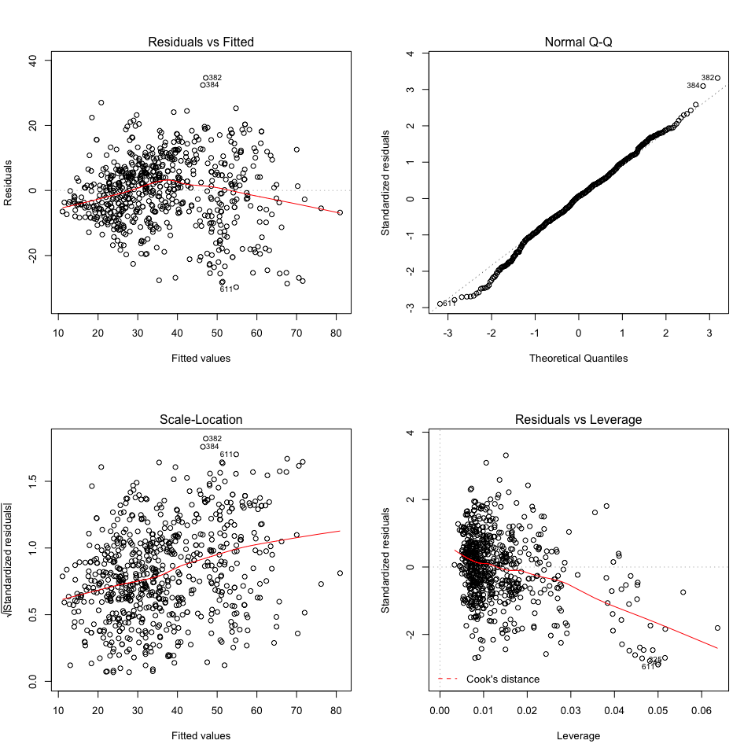

There is a little bit of constant variance - some transformation could help it. High leverage pulling the model to the right. We also have some outliers. They are not, however, that terrible in this case.Normality does not seem to be affected. But there also seems to be some curvature present that our current model is not addressing.

#vif(lm1)  
VIF(lm1)

##   
##   
## Variance Inflation Factor Table  
##   
##

## Variable VIF Rsquared  
## Cement Cement 7.091990 0.8589959  
## BlastFurn BlastFurn 6.958864 0.8562984  
## FlyAsh FlyAsh 5.768564 0.8266466  
## Water Water 6.610213 0.8487189  
## Superplast Superplast 2.925361 0.6581619  
## CourseAgg CourseAgg 4.987540 0.7995003  
## FineAge FineAge 6.599370 0.8484704  
## Age Age 1.130082 0.1151086

Multicollinearity does not seem to be an issue in this model as the variance inflation factor is not larger than 10 for predictors.

#Check the training and validation sets nrow()  
nrow(Concrete.trans[sam,])

## [1] 686

nrow(Concrete.trans[-sam,])

## [1] 344

## PART B

Use the model from part (a) to predict the response value using the validation data and compute the prediction accuracy (RMSEP,MAEP,MAPEP) of these predictions by comparing the actual compression strengths of the concrete samples in the validation set.

Our model’s name from part (a) is lm1

#Predicting  
y = Concrete$Strength[-sam]  
ypred = predict(lm1, newdata = Concrete[-sam,])  
MLR_orig = PredAcc(Concrete[-sam,]$Strength, ypred)

## RMSEP  
## ================  
## 10.18963   
##   
## MAE  
## ================  
## 8.083964   
##   
## MAPE  
## ================  
## 32.59265

**RMSEP = 10.19 MAEP = 8.08 MAPEP = 32.59%**

summary(lm1)$r.squared*100

## [1] **61.38168**

R^2 training data: 61.38%

summary(update(lm1, Strength~., data = Concrete[-sam,]))$r.squared*100

## [1] **62.51582**

Validation data: R^2 = 62.52%

##Actual vs. predicted  
ehat = y-ypred  
trendscat(y, ypred, xlab = "Actual Strentgh", ylab = "Predicted Strength")  
abline(0,1,lwd=2,col='red')

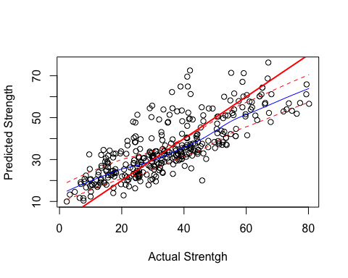

trendscat(ypred, ehat, xlab = "Predicted Strength of Concrete", ylab = "Residuals")  
abline(h=0,lwd=2,col="red")

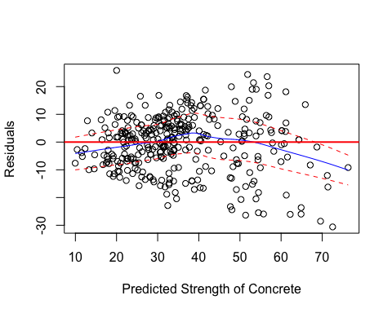

To improve our model, we are going to use the stepwise selection method:

## PART C

Use tools such as Box-Cox transformations, CERES plots, ACE/AVAS, and stepwise model selection to create and choose terms and choose a potential response transformation to address the deficiencies exhibited by the model from part (a). You should explain what tools you used and give a summary of your final MLR model selected. This model should not have the deficiencies identified in part (a). Use this model to predict the compression strength of the validation case in the ORIGINAL SCALE (MPa). Compute the prediction accuracy measures (RMSEP, MAEP, MAPEP) and compare to the results from part (b). Does your more complex MLR model do a better job in terms of these prediction accuracy measures? If it doesn’t you might rethink your model. (10 pts.)

#Stepwise: mixed model on lm1  
lm1.step = step(lm1)

## Start: AIC=3238.68  
## Strength ~ Cement + BlastFurn + FlyAsh + Water + Superplast +   
## CourseAgg + FineAge + Age  
##   
## Df Sum of Sq RSS AIC  
## - CourseAgg 1 82 75119 3237.4  
## - FineAge 1 99 75136 3237.6  
## <none> 75037 3238.7  
## - Superplast 1 385 75422 3240.2  
## - Water 1 1518 76556 3250.4  
## - FlyAsh 1 3400 78437 3267.1  
## - BlastFurn 1 6764 81802 3295.9  
## - Cement 1 14385 89422 3357.0  
## - Age 1 32391 107429 3482.8  
##   
## Step: AIC=3237.42  
## Strength ~ Cement + BlastFurn + FlyAsh + Water + Superplast +   
## FineAge + Age  
##   
## Df Sum of Sq RSS AIC  
## - FineAge 1 19 75138 3235.6  
## <none> 75119 3237.4  
## - Superplast 1 309 75428 3238.2  
## - FlyAsh 1 5271 80390 3281.9  
## - Water 1 6352 81471 3291.1  
## - BlastFurn 1 15001 90119 3360.3  
## - Age 1 32312 107430 3480.9  
## - Cement 1 32538 107656 3482.3  
##   
## Step: AIC=3235.6  
## Strength ~ Cement + BlastFurn + FlyAsh + Water + Superplast +   
## Age  
##   
## Df Sum of Sq RSS AIC  
## <none> 75138 3235.6  
## - Superplast 1 365 75503 3236.9  
## - FlyAsh 1 6586 81725 3291.2  
## - Water 1 7659 82797 3300.2  
## - BlastFurn 1 21646 96785 3407.3  
## - Age 1 32494 107632 3480.1  
## - Cement 1 48835 123973 3577.1

lm1.step$anova

## Step Df Deviance Resid. Df Resid. Dev AIC  
## 1 NA NA 677 75037.33 3238.676  
## 2 - CourseAgg 1 81.50305 678 75118.83 3237.421  
## 3 - FineAge 1 19.33849 679 75138.17 3235.598

summary(lm1)

##   
## Call:  
## lm(formula = Strength ~ ., data = Concrete.trans[sam, ])  
##   
## Residuals:  
## Min 1Q Median 3Q Max   
## -29.716 -6.470 0.699 6.510 34.619   
##   
## Coefficients:  
## Estimate Std. Error t value Pr(>|t|)   
## (Intercept) -1.777400 32.355436 -0.055 0.956208   
## Cement 0.117305 0.010297 11.392 < 2e-16 ***  
## BlastFurn 0.096680 0.012376 7.812 2.15e-14 ***  
## FlyAsh 0.083865 0.015142 5.538 4.37e-08 ***  
## Water -0.180741 0.048834 -3.701 0.000232 ***  
## Superplast 0.215061 0.115461 1.863 0.062946 .   
## CourseAgg 0.009781 0.011407 0.858 0.391463   
## FineAge 0.012453 0.013197 0.944 0.345681   
## Age 0.118584 0.006937 17.095 < 2e-16 ***  
## ---  
## Signif. codes: 0 '***' 0.001 '**' 0.01 '*' 0.05 '.' 0.1 ' ' 1  
##   
## Residual standard error: 10.53 on 677 degrees of freedom  
## Multiple R-squared: 0.6138, Adjusted R-squared: 0.6093   
## F-statistic: 134.5 on 8 and 677 DF, p-value: < 2.2e-16

It removes CourseAgg and Fine Age. We are deciding to remove the two predictors before conducting any transformations. Also, the p-values of those two predictors in the lm1 model were not significant.

lm2 = update(lm1, Strength~. - CourseAgg - FineAge, data = Concrete.trans[sam,])  
lm2.step = step(lm2)

## Start: AIC=3235.6  
## Strength ~ Cement + BlastFurn + FlyAsh + Water + Superplast +   
## Age  
##   
## Df Sum of Sq RSS AIC  
## <none> 75138 3235.6  
## - Superplast 1 365 75503 3236.9  
## - FlyAsh 1 6586 81725 3291.2  
## - Water 1 7659 82797 3300.2  
## - BlastFurn 1 21646 96785 3407.3  
## - Age 1 32494 107632 3480.1  
## - Cement 1 48835 123973 3577.1

lm2.step$anova

## Step Df Deviance Resid. Df Resid. Dev AIC  
## 1 NA NA 679 75138.17 3235.598

Now, it is not removing any more predictors based on the Akaike’s information criterion.

#Let's plot our model  
par(mfrow=c(2,2))  
plot(lm2.step)

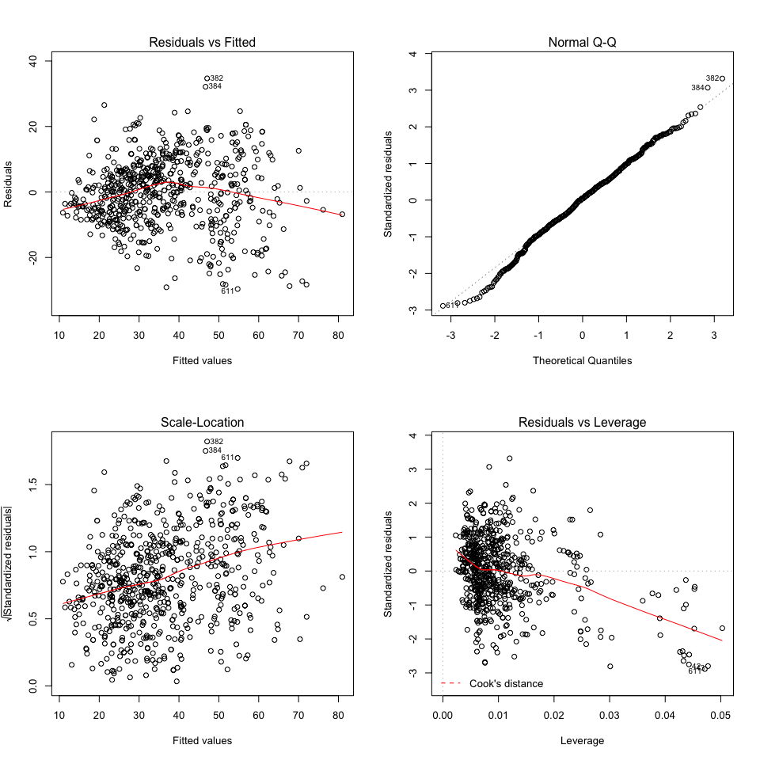

There still seems to be some curvature present in our model - we might want to consider doing some transformations.

#Now, we're going to transform and add polynomial terms  
#Check for skewness with pairs.plus  
pairs.plus(Concrete.trans)

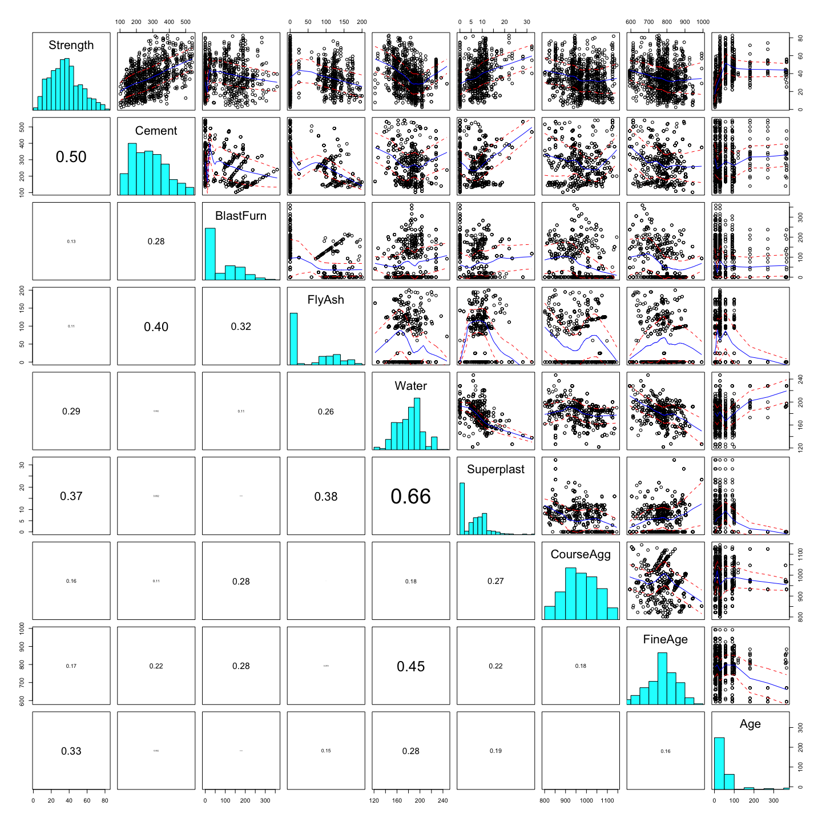

CourseAgg and FineAge are removed, so we do not consider them. Because they are the most right-skewed, we will consider transforming variables such as Age, Superplast, FlyAsh, and BlastBurn. We will also look at Cement, Water, and the resposne Strength to check if the transforming them would make the distribution look better.

#Log age  
myBC(Concrete.trans$Age)

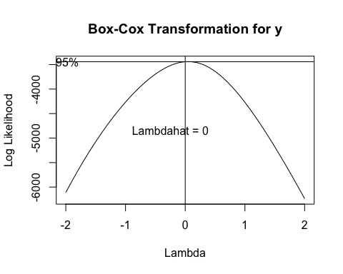

## bcPower Transformation to Normality   
## Est Power Rounded Pwr Wald Lwr Bnd Wald Upr Bnd  
## y 0.049 0.05 0.0042 0.0938  
##   
## Likelihood ratio test that transformation parameter is equal to 0  
## (log transformation)  
## LRT df pval  
## LR test, lambda = (0) 4.557327 1 0.032778  
##   
## Likelihood ratio test that no transformation is needed  
## LRT df pval  
## LR test, lambda = (1) 1663.54 1 < 2.22e-16

Concrete.trans$Age = log(Concrete.trans$Age)  
Statplot(Concrete.trans$Age)

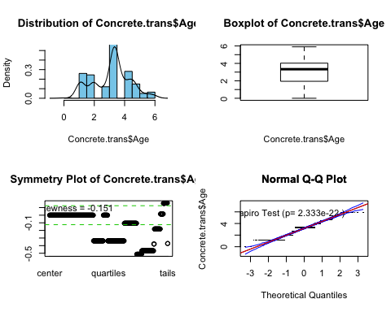

Logging it may seem better.

#lambda .3 for Superplast  
myBC(Concrete.trans$Superplast+1)

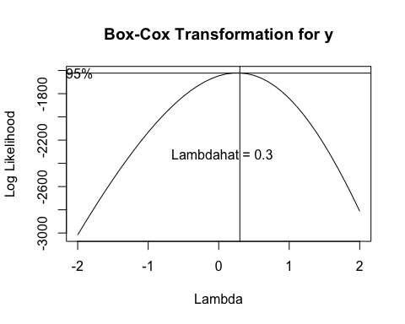

## bcPower Transformation to Normality   
## Est Power Rounded Pwr Wald Lwr Bnd Wald Upr Bnd  
## y 0.2642 0.33 0.1934 0.3349  
##   
## Likelihood ratio test that transformation parameter is equal to 0  
## (log transformation)  
## LRT df pval  
## LR test, lambda = (0) 51.84316 1 6.0119e-13  
##   
## Likelihood ratio test that no transformation is needed  
## LRT df pval  
## LR test, lambda = (1) 439.7912 1 < 2.22e-16

Concrete.trans$Superplast = yjPower(Concrete.trans$Superplast, 0.3)  
Statplot(Concrete.trans$Superplast)

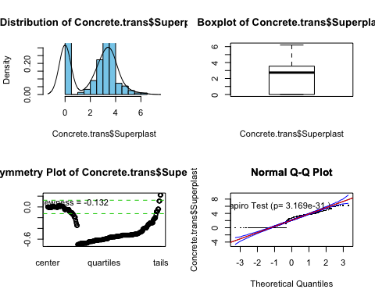

#lambda -0.1 for FlyAsh  
myBC(Concrete.trans$FlyAsh+1)

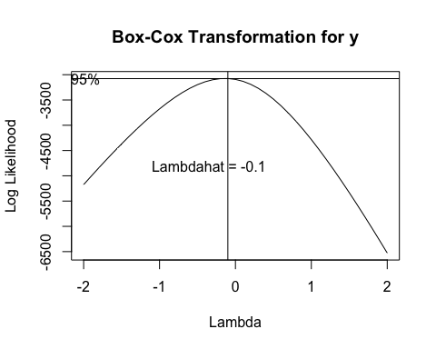

## bcPower Transformation to Normality   
## Est Power Rounded Pwr Wald Lwr Bnd Wald Upr Bnd  
## y -0.1365 -0.14 -0.1805 -0.0925  
##   
## Likelihood ratio test that transformation parameter is equal to 0  
## (log transformation)  
## LRT df pval  
## LR test, lambda = (0) 37.53461 1 8.9805e-10  
##   
## Likelihood ratio test that no transformation is needed  
## LRT df pval  
## LR test, lambda = (1) 2417.681 1 < 2.22e-16

Concrete.trans$BlastFurn = yjPower(Concrete.trans$FlyAsh, -0.1)  
Statplot(Concrete.trans$FlyAsh)

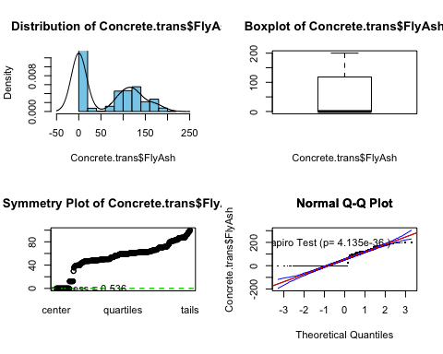

#lamda = -0.4 for BlastFurn  
myBC(Concrete.trans$BlastFurn+1)

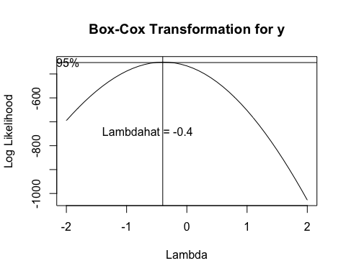

## bcPower Transformation to Normality   
## Est Power Rounded Pwr Wald Lwr Bnd Wald Upr Bnd  
## y -0.3893 -0.5 -0.5253 -0.2533  
##   
## Likelihood ratio test that transformation parameter is equal to 0  
## (log transformation)  
## LRT df pval  
## LR test, lambda = (0) 31.82083 1 1.6907e-08  
##   
## Likelihood ratio test that no transformation is needed  
## LRT df pval  
## LR test, lambda = (1) 404.8716 1 < 2.22e-16

Concrete.trans$BlastFurn = log(Concrete.trans$BlastFurn+1)  
Statplot(Concrete.trans$BlastFurn)

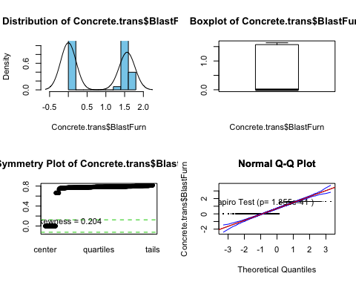

#lambda .2  
myBC(Concrete.trans$Cement)

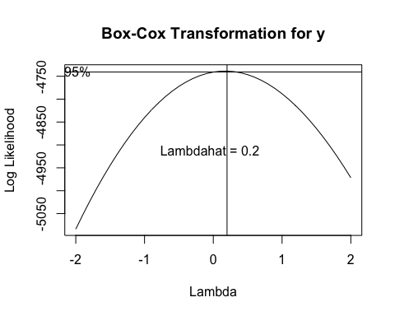

## bcPower Transformation to Normality   
## Est Power Rounded Pwr Wald Lwr Bnd Wald Upr Bnd  
## y 0.1723 0.33 0.0107 0.3339  
##   
## Likelihood ratio test that transformation parameter is equal to 0  
## (log transformation)  
## LRT df pval  
## LR test, lambda = (0) 4.373801 1 0.036495  
##   
## Likelihood ratio test that no transformation is needed  
## LRT df pval  
## LR test, lambda = (1) 99.09702 1 < 2.22e-16

Concrete.trans$Cement = bcPower(Concrete.trans$Cement, 0.2)  
Statplot(Concrete.trans$Cement)

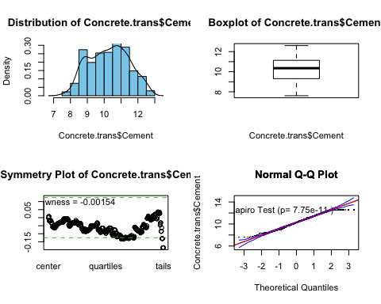

#water .8  
myBC(Concrete.trans$Water)

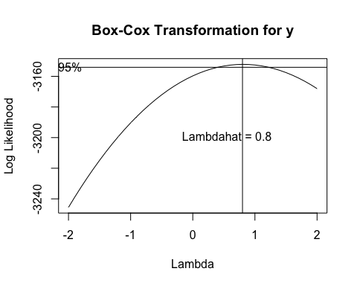

## bcPower Transformation to Normality   
## Est Power Rounded Pwr Wald Lwr Bnd Wald Upr Bnd  
## y 0.8096 1 0.3987 1.2204  
##   
## Likelihood ratio test that transformation parameter is equal to 0  
## (log transformation)  
## LRT df pval  
## LR test, lambda = (0) 15.08393 1 0.00010283  
##   
## Likelihood ratio test that no transformation is needed  
## LRT df pval  
## LR test, lambda = (1) 0.8230891 1 0.36428

Concrete.trans$Water = bcPower(Concrete.trans$Water, 0.8)  
Statplot(Concrete.trans$Water)

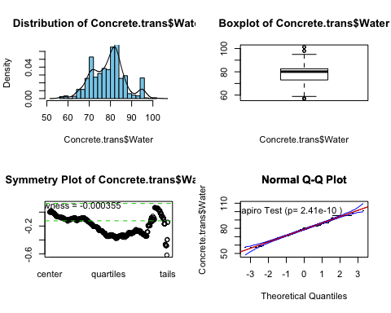

#myBC(Concrete.trans$Strength)  
#Concrete.trans$Strength = log(Concrete.trans$Strength)  
Concrete.trans$Strength = bcPower(Concrete.trans$Strength, 0.6)  
Statplot(Concrete.trans$Strength)

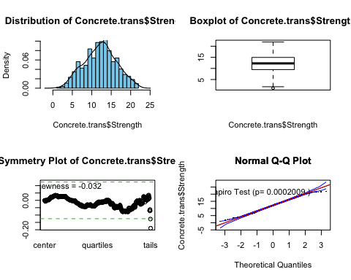

#Make sure to take the 0.6th root of the response when predicting on the validation set to have it be back in its original scale

**lm2.step** is the model after removing the CourseAgg and FineAge predictors. We are going to update the model with the data that we have applied the above transformations to.

lm.trans = update(lm2.step, Strength~. , data = Concrete.trans[sam,])

#Plot the lm.trans model to see how it looks like now  
par(mfrow=c(2,2))  
plot(lm.trans)

There still seems to be some curvature present in the model. Let’s check how we are predicting so far:

##Actual vs. predicted  
  
#Original scale  
#invBoxCox(2, 0)  
#This function will

This function is invBoxCox(transformed, lambda). If we logged a reposne, we would use the function as such: invBoxCox(ypred, 0) and this would do the same computation as exp(ypred). Check the function:

#Transformed  
summary(Concrete.trans$Strength)

## Min. 1st Qu. Median Mean 3rd Qu. Max.   
## 1.102 9.471 12.269 12.199 14.939 21.886

#Original scale  
summary(Concrete$Strength)

## Min. 1st Qu. Median Mean 3rd Qu. Max.   
## 2.33 23.71 34.45 35.82 46.13 82.60

check = invBoxCox(Concrete.trans$Strength, 0.6)  
summary(check)

## Min. 1st Qu. Median Mean 3rd Qu. Max.   
## 2.33 23.71 34.45 35.82 46.13 82.60

summary(Concrete$Strength)

## Min. 1st Qu. Median Mean 3rd Qu. Max.   
## 2.33 23.71 34.45 35.82 46.13 82.60

Thus, for our case, we took the resposne to the power of lambda = 0.6, and we will bring it back to the original scale by doing this:

require(Ecfun)  
y = Concrete$Strength[-sam]  
ypred = predict(lm.trans, newdata = Concrete.trans[-sam,])  
ypred.orig = invBoxCox(ypred, 0.6)

results.trans = PredAcc(y, ypred.orig)

## RMSEP  
## ================  
## 9.322811   
##   
## MAE  
## ================  
## 7.037621   
##   
## MAPE  
## ================  
## 22.87769

results.trans

**## RMSEP MAE MAPE  
## 1 9.322811 7.037621 22.87769**

summary(lm.trans)

##   
## Call:  
## lm(formula = Strength ~ Cement + BlastFurn + FlyAsh + Water +   
## Superplast + Age, data = Concrete.trans[sam, ])  
##   
## Residuals:  
## Min 1Q Median 3Q Max   
## -6.0073 -1.3095 -0.0943 1.3112 6.4732   
##   
## Coefficients:  
## Estimate Std. Error t value Pr(>|t|)   
## (Intercept) -5.588259 1.490870 -3.748 0.000193 ***  
## Cement 1.561681 0.078134 19.987 < 2e-16 ***  
## BlastFurn 0.124788 0.330590 0.377 0.705941   
## FlyAsh -0.008643 0.004046 -2.136 0.033041 *   
## Water -0.082995 0.014192 -5.848 7.72e-09 ***  
## Superplast 0.835677 0.069809 11.971 < 2e-16 ***  
## Age 2.178609 0.068751 31.689 < 2e-16 ***  
## ---  
## Signif. codes: 0 '***' 0.001 '**' 0.01 '*' 0.05 '.' 0.1 ' ' 1  
##   
## Residual standard error: 2.073 on 679 degrees of freedom  
## Multiple R-squared: 0.7461, Adjusted R-squared: 0.7439   
## F-statistic: 332.6 on 6 and 679 DF, p-value: < 2.2e-16

The model is performing better than the original so far with R^2 of 74.61%.

Let’s look at the predictors and their relationships with the resposne first by using CERES plots:

#CERES plots with lm2.step  
ceresPlots(lm2.step)

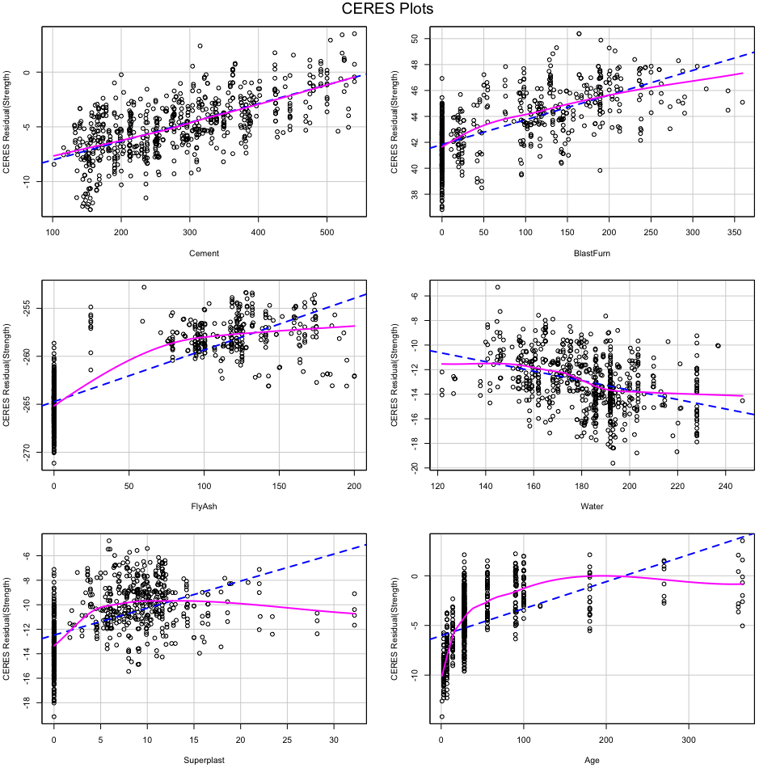 It seems like Superplast and Age would definitely need some adjustment for functional form. FlyAsh also seems like it’s having some curvature there.

Let’s add poly terms one at the time to our lm.trans model

lm.poly = update(lm.trans, Strength~. + poly(Water, 2))  
data.frame(R.sq = c(summary(lm.poly)$r.squared*100), Adj.R.sq=c(summary(lm.poly)$adj.r.squared*100))

## R.sq Adj.R.sq  
## 1 74.63759 74.37574

lm.poly = update(lm.trans, Strength~. + poly(Age, 3))  
data.frame(R.sq = c(summary(lm.poly)$r.squared*100), Adj.R.sq=c(summary(lm.poly)$adj.r.squared)*100)

## R.sq Adj.R.sq  
## 1 75.58042 75.29186

lm.poly = update(lm.trans, Strength~. + poly(Age, 3) + poly(Water, 2))  
data.frame(R.sq = c(summary(lm.poly)$r.squared*100), Adj.R.sq=c(summary(lm.poly)$adj.r.squared)*100)

## R.sq Adj.R.sq  
## 1 75.7428 75.41985

lm.poly = update(lm.trans, Strength~. + poly(Superplast, 2))  
data.frame(R.sq = c(summary(lm.poly)$r.squared*100), Adj.R.sq=c(summary(lm.poly)$adj.r.squared)*100)

## R.sq Adj.R.sq  
## 1 76.3248 76.08037

However, just by adding a Superplast polynomial degree=2, the R^2 went up. Also, let’s look at the significance of the predictors in this model by looking at the p-values:

summary(lm.poly)

##   
## Call:  
## lm(formula = Strength ~ Cement + BlastFurn + FlyAsh + Water +   
## Superplast + Age + poly(Superplast, 2), data = Concrete.trans[sam,   
## ])  
##   
## Residuals:  
## Min 1Q Median 3Q Max   
## -5.8008 -1.3070 -0.1437 1.3144 6.2337   
##   
## Coefficients: (1 not defined because of singularities)  
## Estimate Std. Error t value Pr(>|t|)   
## (Intercept) -4.895104 1.444246 -3.389 0.000741 ***  
## Cement 1.628079 0.076106 21.392 < 2e-16 ***  
## BlastFurn -0.470555 0.330631 -1.423 0.155137   
## FlyAsh -0.006571 0.003922 -1.675 0.094301 .   
## Water -0.098429 0.013892 -7.086 3.48e-12 ***  
## Superplast 0.902099 0.068131 13.241 < 2e-16 ***  
## Age 2.179759 0.066444 32.806 < 2e-16 ***  
## poly(Superplast, 2)1 NA NA NA NA   
## poly(Superplast, 2)2 -16.663141 2.381242 -6.998 6.26e-12 ***  
## ---  
## Signif. codes: 0 '***' 0.001 '**' 0.01 '*' 0.05 '.' 0.1 ' ' 1  
##   
## Residual standard error: 2.004 on 678 degrees of freedom  
## Multiple R-squared: 0.7632, Adjusted R-squared: 0.7608   
## F-statistic: 312.3 on 7 and 678 DF, p-value: < 2.2e-16

Water and FlyAsh are not significant right now. But let’s keep going and check with some more polies.

lm.poly = update(lm.trans, Strength~. + poly(Superplast, 2) + poly(Age,3))  
data.frame(R.sq = c(summary(lm.poly)$r.squared*100), Adj.R.sq=c(summary(lm.poly)$adj.r.squared)*100)

## R.sq Adj.R.sq  
## 1 76.93469 76.6276

lm.poly = update(lm.trans, Strength~. + poly(Superplast, 2) + poly(Age,3) + poly(Water, 2))  
data.frame(R.sq = c(summary(lm.poly)$r.squared*100), Adj.R.sq=c(summary(lm.poly)$adj.r.squared)*100)

## R.sq Adj.R.sq  
## 1 77.37653 77.04137

Plus in this model, FlyAsh has a significant p-value. So only Water is not a significant predictor right now.

lm.poly = update(lm.trans, Strength~. + poly(Superplast, 2) + poly(Age,3) + poly(Water, 2) + poly(FlyAsh, 2))  
data.frame(R.sq = c(summary(lm.poly)$r.squared*100), Adj.R.sq=c(summary(lm.poly)$adj.r.squared)*100)

## R.sq Adj.R.sq  
## 1 77.3773 77.00808

Now, adding FlyAsh made the adjusted R^2 go down - FlyAsh poly does not benefit this model.

lm.poly = update(lm.trans, Strength~. + poly(Superplast, 2) + poly(FlyAsh, 2))  
data.frame(R.sq = c(summary(lm.poly)$r.squared*100), Adj.R.sq=c(summary(lm.poly)$adj.r.squared)*100)

## R.sq Adj.R.sq  
## 1 76.32822 76.04849

And just by having FlyAsh and Superplast polies by themselves does not make the model explain more variation.

We are going to keep the following polies:

* Age, degree=3 and Water, degree=2 and Superplast, degree=2

lm.poly = update(lm.trans, Strength~. + poly(Superplast, 2) + poly(Age,3) + poly(Water, 2))  
data.frame(R.sq = c(summary(lm.poly)$r.squared*100), Adj.R.sq=c(summary(lm.poly)$adj.r.squared)*100)

**## R.sq Adj.R.sq  
## 1 77.37653 77.04137**

summary(lm.poly)

##   
## Call:  
## lm(formula = Strength ~ Cement + BlastFurn + FlyAsh + Water +   
## Superplast + Age + poly(Superplast, 2) + poly(Age, 3) + poly(Water,   
## 2), data = Concrete.trans[sam, ])  
##   
## Residuals:  
## Min 1Q Median 3Q Max   
## -5.6960 -1.2989 -0.0687 1.3203 5.9388   
##   
## Coefficients: (3 not defined because of singularities)  
## Estimate Std. Error t value Pr(>|t|)   
## (Intercept) -4.285272 1.444184 -2.967 0.003111 **   
## Cement 1.616544 0.075322 21.462 < 2e-16 ***  
## BlastFurn -0.392323 0.324433 -1.209 0.226988   
## FlyAsh -0.007794 0.003855 -2.022 0.043617 *   
## Water -0.099745 0.013740 -7.259 1.07e-12 ***  
## Superplast 0.807397 0.068891 11.720 < 2e-16 ***  
## Age 2.125427 0.066313 32.051 < 2e-16 ***  
## poly(Superplast, 2)1 NA NA NA NA   
## poly(Superplast, 2)2 -16.891127 2.419334 -6.982 6.99e-12 ***  
## poly(Age, 3)1 NA NA NA NA   
## poly(Age, 3)2 -9.148240 2.119633 -4.316 1.83e-05 ***  
## poly(Age, 3)3 -5.563960 2.021774 -2.752 0.006082 **   
## poly(Water, 2)1 NA NA NA NA   
## poly(Water, 2)2 7.879352 2.170116 3.631 0.000304 ***  
## ---  
## Signif. codes: 0 '***' 0.001 '**' 0.01 '*' 0.05 '.' 0.1 ' ' 1  
##   
## Residual standard error: 1.963 on 675 degrees of freedom  
## Multiple R-squared: 0.7738, Adjusted R-squared: 0.7704   
## F-statistic: 230.9 on 10 and 675 DF, p-value: < 2.2e-16

Now, we need to adjust for the NA of some repetitive predictors in the model: Superplast is the same as poly(Superplast, 2)1; Age is the same as poly(Age, 3)1; and Water is the same as poly(Water, 2)1.

lm.poly.2 = step(lm.poly)

## Start: AIC=936.34  
## Strength ~ Cement + BlastFurn + FlyAsh + Water + Superplast +   
## Age + poly(Superplast, 2) + poly(Age, 3) + poly(Water, 2)  
##   
##   
## Step: AIC=936.34  
## Strength ~ Cement + BlastFurn + FlyAsh + Water + Superplast +   
## poly(Superplast, 2) + poly(Age, 3) + poly(Water, 2)  
##   
##   
## Step: AIC=936.34  
## Strength ~ Cement + BlastFurn + FlyAsh + Water + poly(Superplast,   
## 2) + poly(Age, 3) + poly(Water, 2)  
##   
##   
## Step: AIC=936.34  
## Strength ~ Cement + BlastFurn + FlyAsh + poly(Superplast, 2) +   
## poly(Age, 3) + poly(Water, 2)  
##   
## Df Sum of Sq RSS AIC  
## - BlastFurn 1 5.6 2606.8 935.82  
## <none> 2601.2 936.34  
## - FlyAsh 1 15.7 2617.0 938.48  
## - poly(Water, 2) 2 234.4 2835.6 991.52  
## - poly(Superplast, 2) 2 648.3 3249.5 1084.99  
## - Cement 1 1775.0 4376.2 1291.20  
## - poly(Age, 3) 3 4161.7 6762.9 1585.79  
##   
## Step: AIC=935.82  
## Strength ~ Cement + FlyAsh + poly(Superplast, 2) + poly(Age,   
## 3) + poly(Water, 2)  
##   
## Df Sum of Sq RSS AIC  
## <none> 2606.8 935.82  
## - FlyAsh 1 199.9 2806.7 984.49  
## - poly(Water, 2) 2 239.0 2845.8 992.00  
## - poly(Superplast, 2) 2 674.7 3281.5 1089.72  
## - Cement 1 1780.4 4387.3 1290.93  
## - poly(Age, 3) 3 4170.9 6777.8 1585.30

lm.poly.2$anova

## Step Df Deviance Resid. Df Resid. Dev AIC  
## 1 NA NA 675 2601.202 936.3360  
## 2 - Age 0 8.185452e-12 675 2601.202 936.3360  
## 3 - Superplast 0 4.547474e-13 675 2601.202 936.3360  
## 4 - Water 0 3.183231e-12 675 2601.202 936.3360  
## 5 - BlastFurn 1 5.635166e+00 676 2606.837 935.8205

But Superplast, Water, and Age stayed in as polies of first degree - as mentioned above, they are they were representing the same terms.

Let’s check back how we are predicting so far:

require(Ecfun)  
y = Concrete$Strength[-sam]  
ypred = predict(lm.poly.2, newdata = Concrete.trans[-sam,])  
ypred.orig = invBoxCox(ypred, 0.6)

results.trans

## RMSEP MAE MAPE  
## 1 9.322811 7.037621 22.87769

results.poly

## **RMSEP MAE MAPE  
## 1 8.7673 6.861779 22.24517**

With the polynomials added to our model, all of our prediction accuracy metrics went down. Great so far.

Lastly, let’s consider ACE/AVAS and confirm if the transformations we did so far are in fact the recomended ones. We are going to choose AVAS because it is better and agrees with the analyses we conducted with Box-Cox and CERES plots.

require(acepack)

## Loading required package: acepack

Concrete.ace_avas = Concrete

#Create X matrix of all predictors and y vector of the response  
X = model.matrix(Strength~., data =Concrete.ace_avas)[,-1]

y = Concrete.ace_avas$Strength  
ace = ace(X,y)  
#par(mfrow=c(4,4))  
maceplot(X,y,ace)

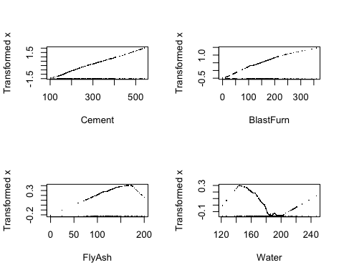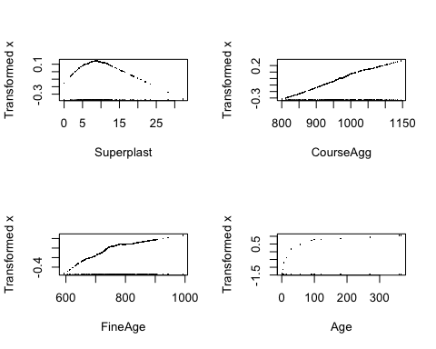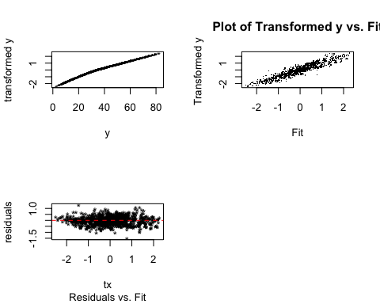

FineAge and CourseAgg were removed with the stepwise at the begining. Age, SuperPlast, and Water graphs do show needed transformations. Water looks like a cubic here; FlyAsh like a quadratic; and Age like a square root.

Let’s look at AVAS - which is usually more adept than ACE at finding the optimal transformations.

require(acepack)  
avas = avas(X,y)  
maceplot(X,y,avas)

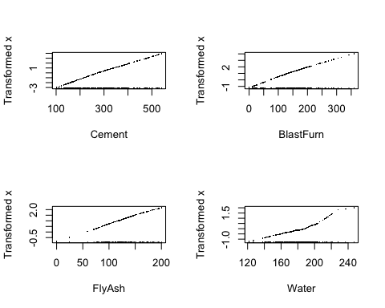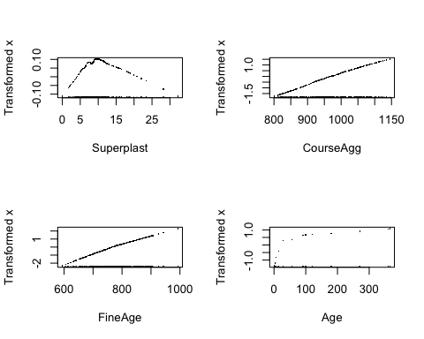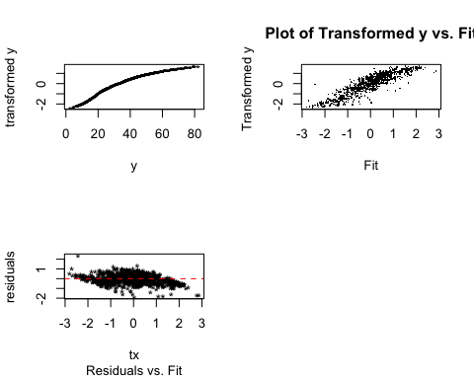

By looking at the plots results from AVAS, it seems like Water should have, after all, a quadriatic transformation; FlyAsh, Cement, and BlastFurn are very close to linear - so we are not going to be changing their functional forms; Superplast seems quadriatic; and Age once again seems like a square root. These transformations seem to check out with what we inferred from CERES plots and Box-Cox power transformations.

Our results from the final model are: lm.poly2

R^2 from training:

summary(lm.poly.2)$r.squared*100

## [1] **77.32752**

R^2 from predicting validation set:

summary(update(lm.poly.2, Strength~., data = Concrete.trans[-sam,]))$r.squared*100

## [1] **75.16345**

Prediction Accuracy metrics:

results.poly

## **RMSEP MAE MAPE  
## 1 8.7673 6.861779 22.24517**

## PART D

Fit a MARS model to the training data with degree = 1 (i.e. no interactions). Use the internal cross-validation features of the earth() function to choose the “best” MARS model with degree = 1. Again predict the compression strength of the concrete samples in the validation set in the original scale and compute RMSEP, MAEP, and MAPEP. How does this compare to the models in part (a) and (c)? (10 pts.)

We will use our variable transformed dataset.

#install.packages("earth")  
require(earth)

## Loading required package: earth

## Loading required package: Formula

## Loading required package: plotmo

## Loading required package: plotrix

## Loading required package: TeachingDemos

Concrete.mars = earth(Strength~.,data = Concrete.trans[sam,], degree = 1 )  
plot(Concrete.mars)

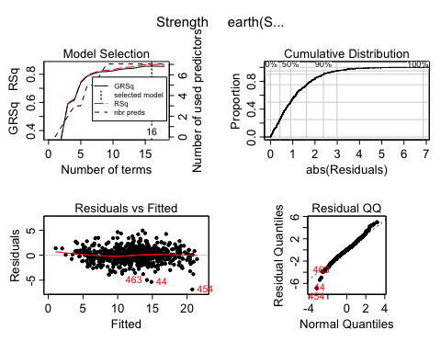

plotmo(Concrete.mars)

## plotmo grid: Cement BlastFurn FlyAsh Water Superplast CourseAgg  
## 10.37688 0 0 79.8021 2.767612 968  
## FineAge Age  
## 779.3 3.332205

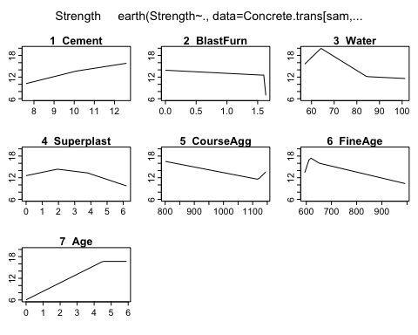

summary(Concrete.mars)

## Call: earth(formula=Strength~., data=Concrete.trans[sam,], degree=1)  
##   
## coefficients  
## (Intercept) 44.98765  
## h(10.1023-Cement) -1.39049  
## h(Cement-10.1023) 0.86871  
## h(1.61584-BlastFurn) 0.86224  
## h(BlastFurn-1.61584) -335.91117  
## h(Water-64.1823) -0.99725  
## h(84.3518-Water) -0.60879  
## h(Water-84.3518) 0.96606  
## h(Superplast-1.9354) -1.49568  
## h(3.79503-Superplast) -0.93534  
## h(1118.8-CourseAgg) 0.01563  
## h(CourseAgg-1118.8) 0.07881  
## h(FineAge-614) -0.25340  
## h(652-FineAge) -0.21101  
## h(FineAge-652) 0.23684  
## h(4.51086-Age) -2.36132  
##   
## Selected 16 of 18 terms, and 7 of 8 predictors  
## Termination condition: Reached nk 21  
## Importance: Age, Cement, Water, CourseAgg, FineAge, Superplast, ...  
## Number of terms at each degree of interaction: 1 15 (additive model)  
## GCV 2.401118 RSS 1501.662 GRSq 0.8571581 RSq 0.8693958

Upon a quick runthrought of the Mars Method, we selected 16 terms from 8 predictors and got a GRSq of 0.857, which is impressive compared to the time required to due a more traditional Multiple Linear regression in order to achieve similar results. Still, we have yet to check the model using internal Cross-validation methods or after adjusting paramters, so we aren’t done yet.

Concrete.mars = earth(Strength~.,data = Concrete.trans[sam,], degree = 1, keepxy = T, nfold = 10, ncross = 30 )  
  
plot(Concrete.mars)

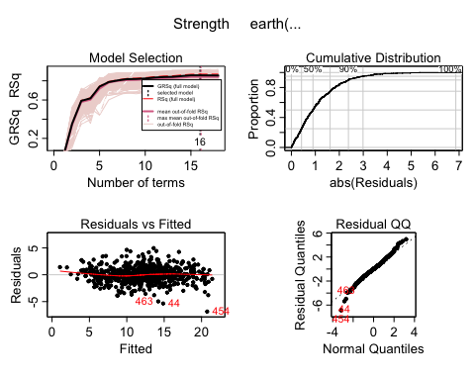

Based on 10 Kfolds, crossing 30 times, we seem to picking from 16 to 19 terms for our model when degree is 1, which is similar to our intial. We also should look at how variables are contributing to the model, just to make sure nothing seems out of wack.

evimp(Concrete.mars, trim = FALSE)

## nsubsets gcv rss  
## Age 15 100.0 100.0  
## Cement 14 76.6 76.7  
## Water 12 40.8 41.7  
## CourseAgg 11 37.0 37.7  
## FineAge 11 37.0 37.7  
## Superplast 9 43.5> 43.8>  
## BlastFurn 9 24.8 25.9  
## FlyAsh-unused 0 0.0 0.0

As indicated by the summary, all but one of the variables are used. This is intereting given what we learned through our MLR efforts, as CourseAgg tended to be a poor predictor simply in general and was decied to be left out for those models as well. Otherwise, like we found earlier age and cement seem to be big ticket contributors, while superplasta and flyash are weaker as indivdals. Although we should note that water is much more effective here, likely due to its structure being more akin to mappign vai checkmar functions than linear models with polynomial terms.

For the sake of being thorough, we will also attempt this process again after goading the model to utilize less variables to see if it has any effect on the GRSq. Due to it already using almost everything, it makes little sense to force more, but a simpler model may potentially prove more effective. However, given what we know about out variables thus far, it seems unlikely that much success will be found as truncating from seven likely decrease our model.

Concrete.mars2 = earth(Strength~.,data = Concrete.trans[sam,], degree = 1, nprune = 5, nfold = 10, keepxy = T, ncross = 30 )  
plot(Concrete.mars2)

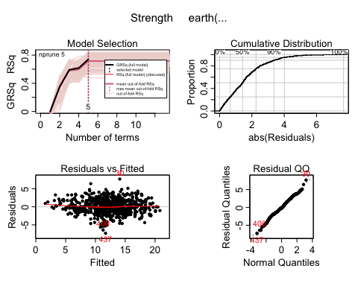

plotmo(Concrete.mars2)

## plotmo grid: Cement BlastFurn FlyAsh Water Superplast CourseAgg  
## 10.37688 0 0 79.8021 2.767612 968  
## FineAge Age  
## 779.3 3.332205

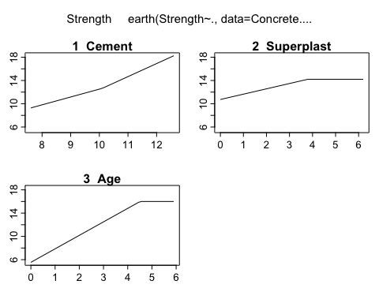

summary(Concrete.mars2)

## Call: earth(formula=Strength~., data=Concrete.trans[sam,], keepxy=T,  
## degree=1, nprune=5, nfold=10, ncross=30)  
##   
## coefficients  
## (Intercept) 16.3226123  
## h(10.1023-Cement) -1.3500764  
## h(Cement-10.1023) 2.2426498  
## h(3.79503-Superplast) -0.9152549  
## h(4.51086-Age) -2.3178730  
##   
## Selected 5 of 18 terms, and 3 of 8 predictors  
## Termination condition: Reached nk 21  
## Importance: Age, Cement, Superplast, Water-unused, BlastFurn-unused, ...  
## Number of terms at each degree of interaction: 1 4 (additive model)  
## GCV 4.373979 RSS 2922.334 GRSq 0.7397931 RSq 0.7458354 CVRSq 0.8402712  
##   
## Note: the cross-validation sd's below are standard deviations across folds  
##   
## Cross validation: nterms 16.17 sd 0.85 nvars 7.46 sd 0.50  
##   
## CVRSq sd MaxErr sd  
## 0.84 0.042 -9.48 5.22

evimp(Concrete.mars2, trim = FALSE)

## nsubsets gcv rss  
## Age 4 100.0 100.0  
## Cement 3 72.2 72.1  
## Superplast 1 40.7 40.5  
## Water-unused 1 18.6 19.2  
## BlastFurn-unused 0 0.0 0.0  
## FlyAsh-unused 0 0.0 0.0  
## CourseAgg-unused 0 0.0 0.0  
## FineAge-unused 0 0.0 0.0

As expected, our GRSq lowered by a little over .10, as well as other similar measures. While our k-fold cross validation does more concretly setttle on a specific nunmber of terms (5), the massive loss in predictive ability likely isn’t worth it.

Overall, while minor gains have been made in our favored metrics, it was decided that these small improvments were not worth taking hits to the conistancy, therefore the inital model was chosen despite some of its less desireable features.

#Predict  
ypredtransformed = predict(Concrete.mars, newdata = Concrete.trans[-sam,])  
ypred = invBoxCox(ypredtransformed, 0.6)  
#ypred = ypredtransformed^(1/0.6)  
PredAcc(Concrete[-sam,]$Strength, ypred)

## RMSEP  
## ================  
## 6.93158   
##   
## MAE  
## ================  
## 5.271546   
##   
## MAPE  
## ================  
## 17.40764

##  **RMSEP MAE MAPE  
## 1 6.93158 5.271546 17.40764**

**RMSEP = 6.92 MAE = 5.27 MAPE = 17.41%**

R^2 from training:

summary(Concrete.mars)

## Call: earth(formula=Strength~., data=Concrete.trans[sam,], keepxy=T,  
## degree=1, nfold=10, ncross=30)  
##   
## coefficients  
## (Intercept) 44.98765  
## h(10.1023-Cement) -1.39049  
## h(Cement-10.1023) 0.86871  
## h(1.61584-BlastFurn) 0.86224  
## h(BlastFurn-1.61584) -335.91117  
## h(Water-64.1823) -0.99725  
## h(84.3518-Water) -0.60879  
## h(Water-84.3518) 0.96606  
## h(Superplast-1.9354) -1.49568  
## h(3.79503-Superplast) -0.93534  
## h(1118.8-CourseAgg) 0.01563  
## h(CourseAgg-1118.8) 0.07881  
## h(FineAge-614) -0.25340  
## h(652-FineAge) -0.21101  
## h(FineAge-652) 0.23684  
## h(4.51086-Age) -2.36132  
##   
## Selected 16 of 18 terms, and 7 of 8 predictors  
## Termination condition: Reached nk 21  
## Importance: Age, Cement, Water, CourseAgg, FineAge, Superplast, ...  
## Number of terms at each degree of interaction: 1 15 (additive model)  
## GCV 2.401118 RSS 1501.662 GRSq 0.8571581 **RSq 0.8693958** CVRSq 0.8418  
##   
## Note: the cross-validation sd's below are standard deviations across folds  
##   
## Cross validation: nterms 16.14 sd 0.87 nvars 7.43 sd 0.50  
##   
## CVRSq sd MaxErr sd  
## 0.842 0.04 -9.62 5.23

**R^2 from training: 86.94%**

R^2 from predicting validation set:

summary(update(Concrete.mars, Strength~., data = Concrete.trans[-sam,]))

## Call:  
## earth(formula=Strength~Cement+BlastFurn+FlyAsh+Water+Superplast+...),  
## data=Concrete.trans[-sam,], keepxy=T, degree=1, nfold=10,  
## ncross=30)  
##   
## coefficients  
## (Intercept) 19.6792088  
## h(10.6954-Cement) -0.9844564  
## h(Cement-10.6954) 1.2192013  
## h(173.5-FlyAsh) 0.0112272  
## h(FlyAsh-173.5) -0.2236732  
## h(Water-65.6282) -0.3171435  
## h(Water-89.3563) 0.3366837  
## h(3.58418-Superplast) -0.3875986  
## h(Superplast-3.58418) -1.4507915  
## h(1111.6-CourseAgg) 0.0140383  
## h(CourseAgg-1111.6) 0.1047891  
## h(664.3-FineAge) -0.0266744  
## h(FineAge-664.3) -0.0964341  
## h(FineAge-688) 0.0817412  
## h(4.02535-Age) -2.1974409  
## h(Age-4.02535) 2.4389689  
## h(Age-4.60517) -3.0970676  
##   
## Selected 17 of 18 terms, and 7 of 8 predictors  
## Termination condition: Reached nk 21  
## Importance: Age, Cement, Water, FineAge, CourseAgg, FlyAsh, ...  
## Number of terms at each degree of interaction: 1 16 (additive model)  
## GCV 3.036011 RSS 853.6221 GRSq 0.8165205 **RSq 0.8491588** CVRSq 0.7825785  
##   
## Note: the cross-validation sd's below are standard deviations across folds  
##   
## Cross validation: nterms 15.52 sd 0.87 nvars 7.62 sd 0.49  
##   
## CVRSq sd MaxErr sd  
## 0.783 0.082 -8.4 4.36

**R^2 from validation set: 84.92%**

## PART E

Fit a MARS model to the training with degree = 2 (i.e. including potential interactions). Again use the internal cross-validation capabilities of the earth() function to choose the best degree = 2 MARS model for these data. Again predict the compression strength of the concrete samples in the validation set in the original scale and compute RMSEP, MAEP, and MAPEP. How does this compare to the earlier models? Which predictors seem most important for predicting strength? (10 pts.)

Next, we will try with degree 2, allowing interactions to be considered.

Concrete.mars.deg2 = earth(Strength~.,data = Concrete.trans[sam,], degree = 2, keepxy = T, nfold = 10, ncross = 30 )  
  
plot(Concrete.mars.deg2)

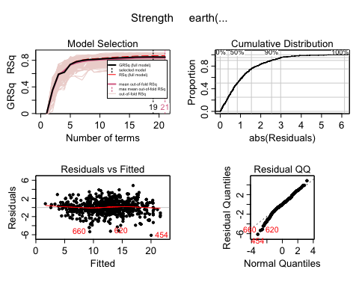 Across 30 run-throughs, it seems to sway between 17 and 19 terms.

plotmo(Concrete.mars.deg2)

## plotmo grid: Cement BlastFurn FlyAsh Water Superplast CourseAgg  
## 10.37688 0 0 79.8021 2.767612 968  
## FineAge Age  
## 779.3 3.332205

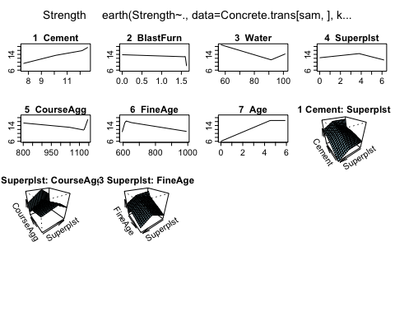

summary(Concrete.mars.deg2)

## Call: earth(formula=Strength~., data=Concrete.trans[sam,], keepxy=T,  
## degree=2, nfold=10, ncross=30)  
##   
## coefficients  
## (Intercept) 13.494700  
## h(10.1023-Cement) -1.911947  
## h(Cement-10.1023) 1.423760  
## h(1.61584-BlastFurn) 0.645982  
## h(BlastFurn-1.61584) -283.420391  
## h(91.5772-Water) 0.220552  
## h(Water-91.5772) 0.309281  
## h(3.79503-Superplast) -0.738698  
## h(Superplast-3.79503) -1.345565  
## h(1125-CourseAgg) 0.008867  
## h(CourseAgg-1125) 0.280067  
## h(614-FineAge) -0.299200  
## h(FineAge-614) -0.010863  
## h(4.51086-Age) -2.330198  
## h(12.1518-Cement) * h(3.79503-Superplast) 0.257772  
## h(Cement-12.1518) * h(3.79503-Superplast) 2.258980  
## h(3.79503-Superplast) * h(CourseAgg-1047) -0.008977  
## h(3.79503-Superplast) * h(FineAge-652) -0.002130  
## h(3.79503-Superplast) * h(652-FineAge) 0.013634  
##   
## Selected 19 of 21 terms, and 7 of 8 predictors  
## Termination condition: Reached nk 21  
## Importance: Age, Cement, Water, CourseAgg, FineAge, Superplast, ...  
## Number of terms at each degree of interaction: 1 13 5  
## GCV 2.517786 RSS 1503.331 GRSq 0.8502175 RSq 0.8692506 CVRSq 0.8362127  
##   
## Note: the cross-validation sd's below are standard deviations across folds  
##   
## Cross validation: nterms 17.65 sd 1.16 nvars 7.02 sd 0.14  
##   
## CVRSq sd MaxErr sd  
## 0.836 0.044 10.2 5.15

evimp(Concrete.mars.deg2, trim = FALSE)

## nsubsets gcv rss  
## Age 18 100.0 100.0  
## Cement 17 76.5 76.7  
## Water 15 40.9 42.3  
## CourseAgg 14 36.3 37.7  
## FineAge 14 36.3 37.7  
## Superplast 12 43.2> 43.9>  
## BlastFurn 12 24.9 26.9  
## FlyAsh-unused 0 0.0 0.0

With a GRSq of just of 0.841, with interaction, we get a slightly worse model. We also are using less variables, despite there being more terms used. CourseAgg being removed makes sense, as it was not very useful in MLR and had a structure that was difficult to work with.

Overall, adding interaction did not make a huge difference in our model’s performance, however we may be able to widen the gap a bit if we adjust some parameters.

Concrete.mars2.deg2 = earth(Strength~.,data = Concrete.trans[sam,], degree = 2, keepxy = T, nfold = 10, ncross = 30 , nk = 30, nprune = 10)  
  
plot(Concrete.mars2.deg2)

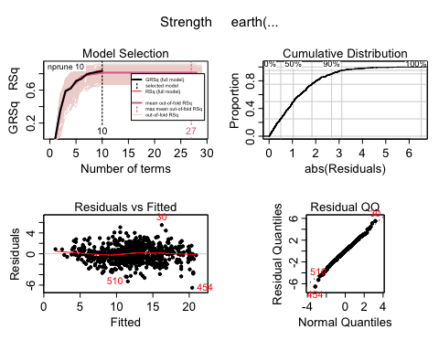

plotmo(Concrete.mars2.deg2)

## plotmo grid: Cement BlastFurn FlyAsh Water Superplast CourseAgg  
## 10.37688 0 0 79.8021 2.767612 968  
## FineAge Age  
## 779.3 3.332205

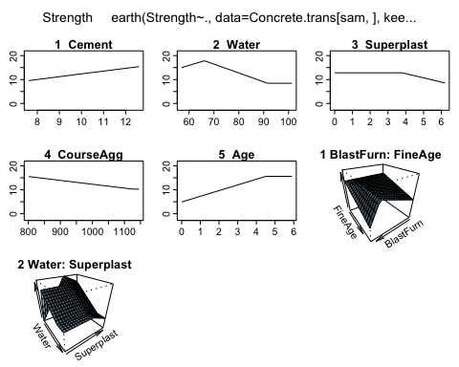

summary(Concrete.mars2.deg2)

## Call: earth(formula=Strength~., data=Concrete.trans[sam,], keepxy=T,  
## degree=2, nprune=10, nfold=10, ncross=30, nk=30)  
##   
## coefficients  
## (Intercept) 11.3542062  
## h(10.1023-Cement) -1.1829257  
## h(Cement-10.1023) 1.1522480  
## h(91.5772-Water) 0.3711850  
## h(Superplast-3.79503) -1.7535589  
## h(1125-CourseAgg) 0.0161930  
## h(4.51086-Age) -2.3776162  
## h(1.32616-BlastFurn) * h(FineAge-614) -0.0135069  
## h(BlastFurn-1.32616) * h(FineAge-614) -0.0869214  
## h(66.2192-Water) * h(3.79503-Superplast) -0.6635553  
##   
## Selected 10 of 29 terms, and 7 of 8 predictors  
## Termination condition: Reached nk 30  
## Importance: Age, Cement, Water, BlastFurn, CourseAgg, FineAge, ...  
## Number of terms at each degree of interaction: 1 6 3  
## GCV 2.825437 RSS 1807.729 GRSq 0.8319155 RSq 0.8427762 CVRSq 0.8590087  
##   
## Note: the cross-validation sd's below are standard deviations across folds  
##   
## Cross validation: nterms 22.15 sd 1.41 nvars 7.24 sd 0.43  
##   
## CVRSq sd MaxErr sd  
## 0.859 0.043 -10.2 5.28

evimp(Concrete.mars2.deg2, trim = FALSE)

## nsubsets gcv rss  
## Age 9 100.0 100.0  
## Cement 8 75.9 75.8  
## Water 6 50.9 51.0  
## BlastFurn 4 33.9 33.9  
## CourseAgg 4 33.9 33.9  
## FineAge 4 33.9 33.9  
## Superplast 3 24.2 24.7  
## FlyAsh-unused 0 0.0 0.0

Pruning at 10 and leaving a max terms of 30 gives us an ultimatley weaker model, although we have manged to remain with measures above 0.8 whilst only using 10 terms. However, we the amount of varition across folds is astounding with anywhere from 10 to 29 terms being used from run-through to run-through. Due to such inconsistancy, this iteration will likely be shelved.

Next we’ll try using no prunes but forcing a higher minimum, though this may risk overfitting the model.

Concrete.mars3.deg2 = earth(Strength~.,data = Concrete.trans[sam,], degree = 2, keepxy = T, nfold = 10, ncross = 30 , nk = 25)  
  
summary(Concrete.mars3.deg2)

## Call: earth(formula=Strength~., data=Concrete.trans[sam,], keepxy=T,  
## degree=2, nfold=10, ncross=30, nk=25)  
##   
## coefficients  
## (Intercept) 11.274754  
## h(10.1023-Cement) -1.738902  
## h(Cement-10.1023) 1.118083  
## h(1.61584-BlastFurn) 0.847676  
## h(BlastFurn-1.61584) -261.679959  
## h(91.5772-Water) 0.337417  
## h(Water-91.5772) 0.264352  
## h(Superplast-3.79503) -1.655759  
## h(1125-CourseAgg) 0.012184  
## h(CourseAgg-1125) 0.257004  
## h(614-FineAge) -0.304775  
## h(FineAge-614) -0.014447  
## h(4.51086-Age) -2.319247  
## h(12.1518-Cement) * h(3.79503-Superplast) 0.171076  
## h(Cement-12.1518) * h(3.79503-Superplast) 1.909270  
## h(1.61584-BlastFurn) * h(1.9354-Superplast) -1.041273  
## h(66.2192-Water) * h(3.79503-Superplast) -0.664159  
## h(Water-66.2192) * h(3.79503-Superplast) 0.025977  
## h(3.79503-Superplast) * h(CourseAgg-1047) -0.006367  
## h(3.79503-Superplast) * h(FineAge-652) -0.001374  
## h(3.79503-Superplast) * h(652-FineAge) 0.012714  
##   
## Selected 21 of 25 terms, and 7 of 8 predictors  
## Termination condition: Reached nk 25  
## Importance: Age, Cement, Water, FineAge, CourseAgg, BlastFurn, ...  
## Number of terms at each degree of interaction: 1 12 8  
## GCV 2.238803 RSS 1315.949 GRSq 0.8668142 RSq 0.8855478 CVRSq 0.8508196  
##   
## Note: the cross-validation sd's below are standard deviations across folds  
##   
## Cross validation: nterms 19.91 sd 1.20 nvars 7.07 sd 0.25  
##   
## CVRSq sd MaxErr sd  
## 0.851 0.041 9.66 5.2

evimp(Concrete.mars3.deg2, trim = FALSE)

## nsubsets gcv rss  
## Age 20 100.0 100.0  
## Cement 19 77.0 77.2  
## Water 18 56.5 57.2  
## FineAge 17 53.3 53.9  
## CourseAgg 16 45.2 45.9  
## BlastFurn 15 32.1 33.6  
## Superplast 14 30.9 32.3  
## FlyAsh-unused 0 0.0 0.0

plot(Concrete.mars3.deg2)

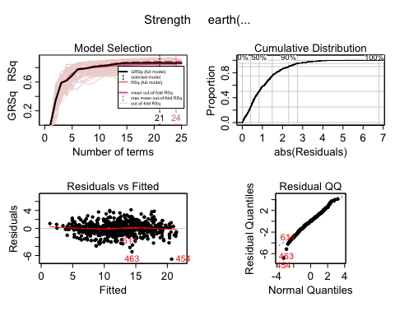

When forcing a higher minimum term count, we get a model with the best GRSq yet at about 0.861 that hovers between 15 and 25. Once again, it suffers from inconsistany, which is a considerable negative. for the next iteration, we will try this same model but re-add in nprune to seee if less greed can increase it further.

Concrete.mars4.deg2 = earth(Strength~.,data = Concrete.trans[sam,], degree = 2, keepxy = T, nfold = 10, ncross = 30 , nk = 25, nprune = 21)  
  
summary(Concrete.mars4.deg2)

## Call: earth(formula=Strength~., data=Concrete.trans[sam,], keepxy=T,  
## degree=2, nprune=21, nfold=10, ncross=30, nk=25)  
##   
## coefficients  
## (Intercept) 11.274754  
## h(10.1023-Cement) -1.738902  
## h(Cement-10.1023) 1.118083  
## h(1.61584-BlastFurn) 0.847676  
## h(BlastFurn-1.61584) -261.679959  
## h(91.5772-Water) 0.337417  
## h(Water-91.5772) 0.264352  
## h(Superplast-3.79503) -1.655759  
## h(1125-CourseAgg) 0.012184  
## h(CourseAgg-1125) 0.257004  
## h(614-FineAge) -0.304775  
## h(FineAge-614) -0.014447  
## h(4.51086-Age) -2.319247  
## h(12.1518-Cement) * h(3.79503-Superplast) 0.171076  
## h(Cement-12.1518) * h(3.79503-Superplast) 1.909270  
## h(1.61584-BlastFurn) * h(1.9354-Superplast) -1.041273  
## h(66.2192-Water) * h(3.79503-Superplast) -0.664159  
## h(Water-66.2192) * h(3.79503-Superplast) 0.025977  
## h(3.79503-Superplast) * h(CourseAgg-1047) -0.006367  
## h(3.79503-Superplast) * h(FineAge-652) -0.001374  
## h(3.79503-Superplast) * h(652-FineAge) 0.012714  
##   
## Selected 21 of 25 terms, and 7 of 8 predictors  
## Termination condition: Reached nk 25  
## Importance: Age, Cement, Water, FineAge, CourseAgg, BlastFurn, ...  
## Number of terms at each degree of interaction: 1 12 8  
## GCV 2.238803 RSS 1315.949 GRSq 0.8668142 RSq 0.8855478 CVRSq 0.8496982  
##   
## Note: the cross-validation sd's below are standard deviations across folds  
##   
## Cross validation: nterms 19.98 sd 1.24 nvars 7.10 sd 0.30  
##   
## CVRSq sd MaxErr sd  
## 0.85 0.043 12.8 5.32

evimp(Concrete.mars4.deg2, trim = FALSE)

## nsubsets gcv rss  
## Age 20 100.0 100.0  
## Cement 19 77.0 77.2  
## Water 18 56.5 57.2  
## FineAge 17 53.3 53.9  
## CourseAgg 16 45.2 45.9  
## BlastFurn 15 32.1 33.6  
## Superplast 14 30.9 32.3  
## FlyAsh-unused 0 0.0 0.0

plot(Concrete.mars4.deg2)

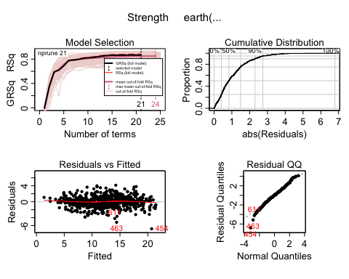

We get pretty much the same result other than minor variation not really worth discussing. As a result, this model continues to suffer from all of the same pitfalls as before with no real benefit. The only thing left to try that may help is reducing nk outright, to see if forcing a simpler model may fit something better after pruning.

Concrete.mars5.deg2 = earth(Strength~.,data = Concrete.trans[sam,], degree = 2, keepxy = T, nfold = 10, ncross = 30 , nk = 15, nprune = 13)  
  
summary(Concrete.mars5.deg2)

## Call: earth(formula=Strength~., data=Concrete.trans[sam,], keepxy=T,  
## degree=2, nprune=13, nfold=10, ncross=30, nk=15)  
##   
## coefficients  
## (Intercept) 14.1797084  
## h(10.1023-Cement) -2.1217413  
## h(Cement-10.1023) 2.2977252  
## h(91.5772-Water) 0.1436338  
## h(3.79503-Superplast) -0.7608137  
## h(Superplast-3.79503) -1.0144037  
## h(4.51086-Age) -2.3629874  
## h(12.1518-Cement) * h(3.79503-Superplast) 0.4134259  
## h(Cement-12.1518) * h(3.79503-Superplast) 3.2488883  
## h(3.79503-Superplast) * h(CourseAgg-1047) -0.0058044  
## h(3.79503-Superplast) * h(1047-CourseAgg) 0.0031559  
## h(3.79503-Superplast) * h(FineAge-652) -0.0057536  
## h(3.79503-Superplast) * h(652-FineAge) -0.0106664  
##   
## Selected 13 of 15 terms, and 6 of 8 predictors  
## Termination condition: Reached nk 15  
## Importance: Age, Cement, Water, Superplast, FineAge, CourseAgg, ...  
## Number of terms at each degree of interaction: 1 6 6  
## GCV 2.993081 RSS 1871.875 GRSq 0.8219424 RSq 0.8371972 CVRSq 0.8077652  
##   
## Note: the cross-validation sd's below are standard deviations across folds  
##   
## Cross validation: nterms 13.15 sd 1.04 nvars 6.01 sd 0.10  
##   
## CVRSq sd MaxErr sd  
## 0.808 0.043 -8.68 5.08

evimp(Concrete.mars5.deg2, trim = FALSE)

## nsubsets gcv rss  
## Age 12 100.0 100.0  
## Cement 11 75.5 75.7  
## Water 10 53.1 53.7  
## Superplast 9 39.3 40.3  
## FineAge 9 39.3 40.3  
## CourseAgg 5 18.3 19.7  
## BlastFurn-unused 0 0.0 0.0  
## FlyAsh-unused 0 0.0 0.0

plot(Concrete.mars5.deg2)

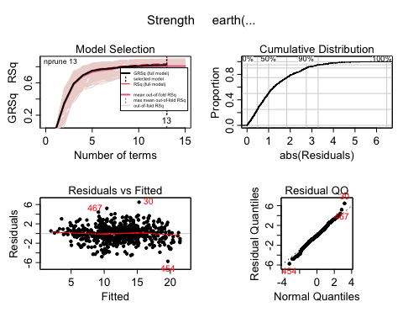

While this version is much more consistant, it fails to be as effective as just our initial degree 2 model, with it having a GRSq about 3% lower. For one final iteration, we will try to make a previous model more conistant with pruning by focusing on less prunes.

Concrete.mars4.deg2.md = earth(Strength~.,data = Concrete.trans[sam,], degree = 2, keepxy = T, nfold = 10, ncross = 30 , nk = 25, nprune = 15)  
  
summary(Concrete.mars4.deg2.md)

## Call: earth(formula=Strength~., data=Concrete.trans[sam,], keepxy=T,  
## degree=2, nprune=15, nfold=10, ncross=30, nk=25)  
##   
## coefficients  
## (Intercept) 10.352286  
## h(10.1023-Cement) -1.412997  
## h(Cement-10.1023) 0.701591  
## h(1.61584-BlastFurn) 0.946321  
## h(BlastFurn-1.61584) -276.714382  
## h(91.5772-Water) 0.403339  
## h(Superplast-3.79503) -1.731188  
## h(1125-CourseAgg) 0.015643  
## h(614-FineAge) -0.170704  
## h(FineAge-614) -0.018726  
## h(4.51086-Age) -2.316221  
## h(Cement-12.1518) * h(3.79503-Superplast) 2.061643  
## h(1.61584-BlastFurn) * h(1.9354-Superplast) -1.355006  
## h(66.2192-Water) * h(3.79503-Superplast) -0.747445  
## h(Water-66.2192) * h(3.79503-Superplast) 0.056173  
##   
## Selected 15 of 25 terms, and 7 of 8 predictors  
## Termination condition: Reached nk 25  
## Importance: Age, Cement, Water, FineAge, CourseAgg, BlastFurn, ...  
## Number of terms at each degree of interaction: 1 10 4  
## GCV 2.294577 RSS 1413.205 GRSq 0.8634962 RSq 0.8770891 CVRSq 0.8493075  
##   
## Note: the cross-validation sd's below are standard deviations across folds  
##   
## Cross validation: nterms 19.87 sd 1.23 nvars 7.12 sd 0.32  
##   
## CVRSq sd MaxErr sd  
## 0.849 0.04 10.7 5.25

evimp(Concrete.mars4.deg2.md, trim = FALSE)

## nsubsets gcv rss  
## Age 14 100.0 100.0  
## Cement 13 76.9 76.9  
## Water 12 56.3 56.6  
## FineAge 11 53.1 53.2  
## CourseAgg 10 44.9 45.1  
## BlastFurn 9 31.5 32.3  
## Superplast 8 30.3 30.9  
## FlyAsh-unused 0 0.0 0.0

plot(Concrete.mars4.deg2.md)

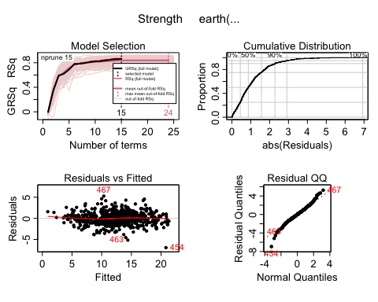 Alas, we once again arrive at the conondrum of minor improvements in the GRSq (about +0.2) in exchange for less consistency derrived from the internal CV methods. Favoring conistancy over vartion, we wil once again go with the defualt output from the mars function, as it seems like the best candidate among the ones we have managed to produce in contrast to it.

#Predict  
ypredtransformed2 = predict(Concrete.mars.deg2, newdata = Concrete.trans[-sam,])  
ypred2 = invBoxCox(ypredtransformed2, 0.6)  
#ypred2 = ypredtransformed2^(1/0.6)  
  
PredAcc(Concrete[-sam,]$Strength, ypred2)

## RMSEP  
## ================  
## 7.288078   
##   
## MAE  
## ================  
## 5.338156   
##   
## MAPE  
## ================  
## 18.0453

## **RMSEP MAE MAPE  
## 1 7.288078 5.338156 18.0453**

**RMSEP = 7.29**

**MAE = 5.34**

**MAPE = 18.05%**

R^2 from training:

summary(Concrete.mars.deg2)

## Call: earth(formula=Strength~., data=Concrete.trans[sam,], keepxy=T,  
## degree=2, nfold=10, ncross=30)  
##   
## coefficients  
## (Intercept) 13.494700  
## h(10.1023-Cement) -1.911947  
## h(Cement-10.1023) 1.423760  
## h(1.61584-BlastFurn) 0.645982  
## h(BlastFurn-1.61584) -283.420391  
## h(91.5772-Water) 0.220552  
## h(Water-91.5772) 0.309281  
## h(3.79503-Superplast) -0.738698  
## h(Superplast-3.79503) -1.345565  
## h(1125-CourseAgg) 0.008867  
## h(CourseAgg-1125) 0.280067  
## h(614-FineAge) -0.299200  
## h(FineAge-614) -0.010863  
## h(4.51086-Age) -2.330198  
## h(12.1518-Cement) * h(3.79503-Superplast) 0.257772  
## h(Cement-12.1518) * h(3.79503-Superplast) 2.258980  
## h(3.79503-Superplast) * h(CourseAgg-1047) -0.008977  
## h(3.79503-Superplast) * h(FineAge-652) -0.002130  
## h(3.79503-Superplast) * h(652-FineAge) 0.013634  
##   
## Selected 19 of 21 terms, and 7 of 8 predictors  
## Termination condition: Reached nk 21  
## Importance: Age, Cement, Water, CourseAgg, FineAge, Superplast, ...  
## Number of terms at each degree of interaction: 1 13 5  
## GCV 2.517786 RSS 1503.331 GRSq 0.8502175 **RSq 0.8692506** CVRSq 0.8362127  
##   
## Note: the cross-validation sd's below are standard deviations across folds  
##   
## Cross validation: nterms 17.65 sd 1.16 nvars 7.02 sd 0.14  
##   
## CVRSq sd MaxErr sd  
## 0.836 0.044 10.2 5.15

**R^2 from training: 86.93%**

R^2 from predicting validation set:

summary(update(Concrete.mars.deg2, Strength~., data = Concrete.trans[-sam,]))

## Call:  
## earth(formula=Strength~Cement+BlastFurn+FlyAsh+Water+Superplast+...),  
## data=Concrete.trans[-sam,], keepxy=T, degree=2, nfold=10,  
## ncross=30)  
##   
## coefficients  
## (Intercept) 25.6684127  
## h(10.6954-Cement) 2.4462931  
## h(Cement-10.6954) 2.3183017  
## h(Water-65.6282) -0.6266125  
## h(89.3563-Water) -0.2684592  
## h(Water-89.3563) 0.6306622  
## h(1111.6-CourseAgg) 0.0175290  
## h(FineAge-664.3) -0.0200846  
## h(4.02535-Age) -2.2776526  
## h(10.6954-Cement) * h(BlastFurn-1.32616) -12.8459082  
## h(10.6954-Cement) * h(1.32616-BlastFurn) -1.8416414  
## h(10.6954-Cement) * h(Superplast-2.10104) -0.7245387  
## h(10.6954-Cement) * h(2.10104-Superplast) -0.4706116  
## h(Cement-11.5872) * h(1111.6-CourseAgg) -0.0215673  
## h(10.6954-Cement) * h(Age-3.3322) 1.0617628  
##   
## Selected 15 of 20 terms, and 7 of 8 predictors  
## Termination condition: Reached nk 21  
## Importance: Age, Cement, BlastFurn, Water, FineAge, CourseAgg, ...  
## Number of terms at each degree of interaction: 1 8 6  
## GCV 2.76749 RSS 763.1836 GRSq 0.8327484 **RSq 0.8651399** CVRSq 0.7816861  
##   
## Note: the cross-validation sd's below are standard deviations across folds  
##   
## Cross validation: nterms 15.63 sd 1.44 nvars 6.94 sd 0.30  
##   
## CVRSq sd MaxErr sd  
## 0.782 0.077 -11.9 4.98

**R^2 from validation set: 86.51%**

|  |  |  |  |  |  |
| --- | --- | --- | --- | --- | --- |
| Model Method | (training data) | (predicting validation set) | (MPa) | (MPa) | (%) |
| MLR orig | 61.38% | 62.52% | 10.19 | 8.08 | 32.59% |
| MLR trans | 77.33% | 75.16% | 8.77 | 6.86 | 22.25% |
| **MARS (deg 1)** | **86.94%** | 84.92% | **6.92** | **5.27** | **17.41%** |
| MARS (deg 2) | 86.93% | 86.51% | 7.29 | 5.34 | 18.05% |

For MARS (deg 1), all the prediction accuracy metrics are the smallest; the R^2 for the training data is the highest; R^2 for predicting the validation set is a bit lower than that of MARS (deg2), but taking everything into account, MARS (deg 2) seems like the optimal model method.