Assignment 4 Samuel A Mikolaj W. Question #1

#libraries  
library(tidyr)  
library(dplyr)

##   
## Attaching package: 'dplyr'

## The following objects are masked from 'package:stats':  
##   
## filter, lag

## The following objects are masked from 'package:base':  
##   
## intersect, setdiff, setequal, union

library(ggplot2)  
require(nnet)

## Loading required package: nnet

require(Ecfun)

## Loading required package: Ecfun

## Warning in library(package, lib.loc = lib.loc, character.only = TRUE,  
## logical.return = TRUE, : there is no package called 'Ecfun'

require(car)

## Loading required package: car

## Warning in library(package, lib.loc = lib.loc, character.only = TRUE,  
## logical.return = TRUE, : there is no package called 'car'

require(ISLR)

## Loading required package: ISLR

require(MASS)

## Loading required package: MASS

##   
## Attaching package: 'MASS'

## The following object is masked from 'package:dplyr':  
##   
## select

require(glmnet)

## Loading required package: glmnet

## Loading required package: Matrix

##   
## Attaching package: 'Matrix'

## The following objects are masked from 'package:tidyr':  
##   
## expand, pack, unpack

## Loaded glmnet 3.0-2

#setup  
  
  
  
College2 = data.frame(PctAccept=100*(College$Accept/College$Apps),College[,-c(2:3)])  
  
  
attach(College)  
  
College4 = data.frame(logApps=log(Apps),Private,logAcc=log(Accept),logEnr=log(Enroll),Top10perc,  
 Top25perc,logFull=log(F.Undergrad),logPart=log(P.Undergrad),Outstate,Room.Board,Books,Personal,PhD,Terminal,S.F.Ratio,perc.alumni,logExp=log(Expend),Grad.Rate)  
  
detach(College)  
  
X = model.matrix(PctAccept~.,data=College2)[,-1]  
y = College2$PctAccept

# 1

1. Split the data into a training set and a test set by forming the indices for the training and test sets. Use p = .667, i.e. use two-thirds of the data to train the models. Note: That none of commands below show fitting to just a training set! (1 pt.)

set.seed(1)  
sam = sample(1:length(y), floor(.667*length(y)), replace = F)

We created this index vector (where length y is the number of rows) to be used as a way to single out a training and test set

1. Fit an OLS model for number of applications using the training set, and report the mean RMSEP for the test set. (4 pts.)

X = model.matrix(PctAccept~.,data=College2)[,-1]  
y = College2$PctAccept  
Xs = scale(X)  
College2.temp = data.frame(y,Xs)  
PA.ols = lm(y~Xs,data=College2.temp,subset=sam)  
ypred = predict(PA.ols,newdata=College2.temp[-sam,])

## Warning: 'newdata' had 259 rows but variables found have 777 rows

RMSEP.ols = sqrt(mean((y[-sam]-ypred)^2))  
RMSEP.ols

## [1] 16.35887

RMSEP.ols 1 16.82557

1. Fit a sequence of ridge and lasso regression models on the training data set using the commands below given for the ridge models. The lambda sequence (grid) is formed to create the sequence of models. Create two plots showing the parameter shrinkage, one with the norm constraint on the x-axis and one with log lambda values on the x-axis. Discuss. (6 pts.)

grid = 10^seq(10,-2,length=200)  
ridge.mod = glmnet(Xs[sam,],y[sam],alpha=0,lambda=grid)  
  
lasso.mod = glmnet(Xs[sam,],y[sam],alpha=1,lambda=grid)  
  
plot(ridge.mod)

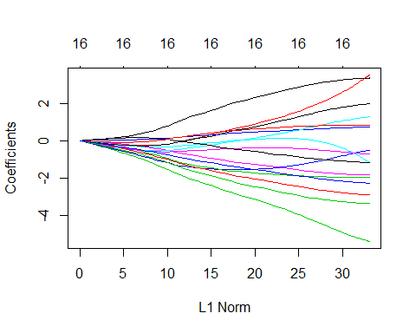

plot(ridge.mod,xvar="lambda")

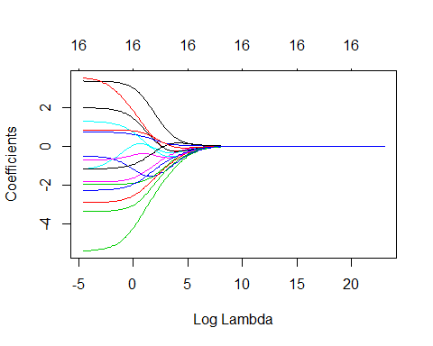

Both using lambda and the L1 norm tell the same story in different scales. Overall, they look fairly stadnard and we can definetly see that certain varaibles are more important that others by a noatable margain. From the plot with x = lambda we also can note that likley would never want a lambda value greater than 5, as subesquent increases won’t have any notable impact. It will be interesting to see how this stacks up against the LASSO versions

plot(lasso.mod)

## Warning in regularize.values(x, y, ties, missing(ties)): collapsing to unique  
## 'x' values

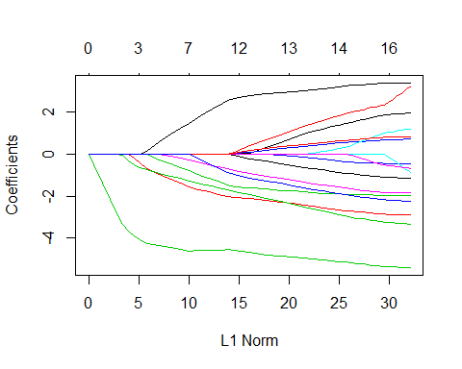

plot(lasso.mod,xvar="lambda")

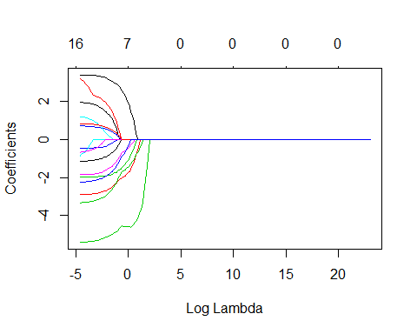

As expected, Lasso is much more contrasting and rigid with its regularization, capping out with a lambda closer to 4 and showing certain varaibles to be leeps and bounds ahead of others. Furthermore, for both ridge and LASSO, while the overall lambda values shown may be much smaller then many of the examples we looked at, given that the college dataset only has 18 to start with, narrowing it down to even sub 5 is an admirable result. However, these plots alone are not a preffered way to choose lambda, as cross-validation tends to be much more prescise in that regard.

1. Use cross-validation to determine the “optimal” values for the shrinkage parameter  for both ridge and lasso and plot the results. The commands for ridge regression are given below. (4 pts.)

cv.out_ridge = cv.glmnet(Xs[sam,],y[sam],alpha=0)  
plot(cv.out_ridge)

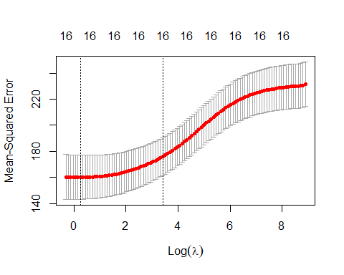

bestlam_ridge = cv.out_ridge$lambda.min  
bestlam_ridge

## [1] 1.281041

# 0.7006997  
  
  
cv.out_lasso = cv.glmnet(Xs[sam,],y[sam],alpha=1)  
plot(cv.out_lasso)

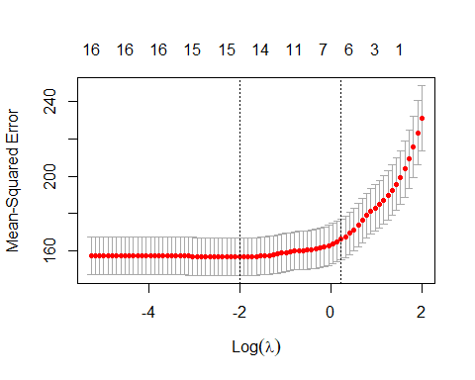

bestlam_lasso = cv.out_lasso$lambda.min  
bestlam_lasso

## [1] 0.1342038

# 0.1065001

1. Using the optimal lambda (bestlam) for both ridge and Lasso regression fit both models and compare the estimated coefficients for the OLS, ridge, and Lasso regressions. Discuss. (3 pts.)

lasso.mod = glmnet(Xs[sam,], y[sam], alpha = 1, lambda = bestlam_lasso)  
lasso.pred = predict(lasso.mod, newx = Xs[-sam,])  
  
coef(lasso.mod)

## 17 x 1 sparse Matrix of class "dgCMatrix"  
## s0  
## (Intercept) 74.2782424  
## PrivateYes 3.2152233  
## Enroll 1.8533614  
## Top10perc -5.1233543  
## Top25perc -0.3341361  
## F.Undergrad .   
## P.Undergrad -1.5962736  
## Outstate 1.4048898  
## Room.Board -2.6620104  
## Books -1.9073798  
## Personal 0.5296245  
## PhD 0.2792780  
## Terminal .   
## S.F.Ratio -0.8713244  
## perc.alumni 0.6186085  
## Expend -2.9018913  
## Grad.Rate -1.8937267

# 17 x 1 sparse Matrix of class "dgCMatrix"  
# s0  
# (Intercept) 74.78642725  
# PrivateYes 2.97828704  
# Enroll 1.88664016  
# Top10perc -5.12584834  
# Top25perc .   
# F.Undergrad .   
# P.Undergrad -1.46944963  
# Outstate 1.52456756  
# Room.Board -2.84813667  
# Books -1.09240424  
# Personal 0.08458621  
# PhD .   
# Terminal 0.18881525  
# S.F.Ratio -1.50029175  
# perc.alumni 0.39489197  
# Expend -3.48052571  
# Grad.Rate -1.89225948  
  
  
ridge.mod = glmnet(Xs[sam,], y[sam], alpha = 0, lambda = bestlam_lasso)  
ridge.pred = predict(ridge.mod, newx = Xs[-sam,])  
  
coef(ridge.mod)

## 17 x 1 sparse Matrix of class "dgCMatrix"  
## s0  
## (Intercept) 74.2925714  
## PrivateYes 3.3192856  
## Enroll 3.0331949  
## Top10perc -5.1840562  
## Top25perc -0.6404216  
## F.Undergrad -0.7377095  
## P.Undergrad -1.8249602  
## Outstate 1.8973906  
## Room.Board -2.8616885  
## Books -1.9701122  
## Personal 0.7131275  
## PhD 1.1832746  
## Terminal -0.6697476  
## S.F.Ratio -1.1382127  
## perc.alumni 0.8349835  
## Expend -3.3250787  
## Grad.Rate -2.2261292

# 17 x 1 sparse Matrix of class "dgCMatrix"  
# s0  
# (Intercept) 74.80034676  
# PrivateYes 3.05989001  
# Enroll 3.84015012  
# Top10perc -5.23619146  
# Top25perc -0.09616916  
# F.Undergrad -1.79839190  
# P.Undergrad -1.55654831  
# Outstate 1.88266710  
# Room.Board -3.01241402  
# Books -1.17509769  
# Personal 0.27983585  
# PhD 0.13618524  
# Terminal 0.36713206  
# S.F.Ratio -1.67566162  
# perc.alumni 0.52068348  
# Expend -3.84823795  
# Grad.Rate -2.19810475  
  
  
#compare to OLS  
  
  
coef(PA.ols)

## (Intercept) XsPrivateYes XsEnroll XsTop10perc XsTop25perc   
## 74.2958687 3.3547579 3.6393426 -5.4151974 -0.4896388   
## XsF.Undergrad XsP.Undergrad XsOutstate XsRoom.Board XsBooks   
## -1.2915070 -1.8441877 1.9806690 -2.9151817 -1.9780636   
## XsPersonal XsPhD XsTerminal XsS.F.Ratio Xsperc.alumni   
## 0.7383929 1.2889255 -0.7281067 -1.1766801 0.8339128   
## XsExpend XsGrad.Rate   
## -3.3684036 -2.2834184

# (Intercept) XsPrivateYes XsEnroll XsTop10perc XsTop25perc XsF.Undergrad XsP.Undergrad XsOutstate XsRoom.Board   
# 74.8034528 3.0824234 4.5978281 -5.4983918 0.1320567 -2.5290500 -1.5431593 1.9605473 -3.0547464   
# XsBooks XsPersonal XsPhD XsTerminal XsS.F.Ratio Xsperc.alumni XsExpend XsGrad.Rate   
# -1.1763839 0.2956915 0.1537753 0.3688423 -1.7119667 0.5165208 -3.8963058 -2.2630644

We see similar themes in all three for certain variable getting effictvely dropped, with Top25perc and PHD particularly not being liked by any of these methods. Moreover, variables such as privateyes, enroll, expend, and top10percent are focused by all of them as well, does bode well the overall determination of the importance of them. However, the real differences between the three occur in how harsh and how widespread their zeroing out is. Ridge is by far the wide spread in its punishment, as it effectively is removing roughly 5 variables by setting them to near zero. Lasso is more lowering across the board, but only completely commits to removing just 4 of them. OLS, meanwhile, is much more conservative dut to the nature of its functionality and only heavily demphasises a few key variables like the ones discussed earlier without truly removing anything.

1. Construct a plot of the predicted test y values vs. the actual y test values for both the ridge and Lasso regression models. Discuss. (4 pts.)

plot(y[-sam],predict(ridge.mod,newx=Xs[-sam,]),xlab="Test y-values",ylab="Predicted Test y-values")

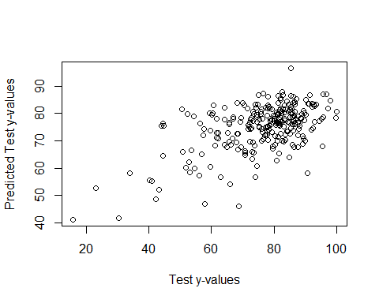

plot(y[-sam],predict(lasso.mod,newx=Xs[-sam,]),xlab="Test y-values",ylab="Predicted Test y-values")

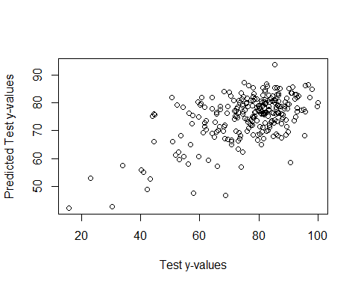

While these models are not dreadful, they due seem to be a bit impercise, particularly when dealing with lower cases, where massive over predictions are common. However, as test cases get larger in value, the models seems to a much more satisfactory job of landing on target. As for comparisons, it is interesting to note that while ridge is arguable a bit tighter in its predictions, they appear to be similar in terms of the final result. However, we suspect that that this will not be the case upon using a log transformed y into the log scale for question i, as algrorithms such as this often perform similarly when given inefficent data, though this simply conjecture

1. Using the optimal lambda (bestlam) for both ridge and Lasso regression find the mean RMSEP for the test set. How do the mean RMSEP compare for the OLS, ridge, and Lasso regression models? Discuss. (3 pts.)

These models are already fit with their associated best lambda values.

RMSEP.ridge = sqrt(mean((y[-sam]-ridge.pred)^2))  
RMSEP.ridge

## [1] 11.20777

# > RMSEP.ridge  
# [1] 11.4058  
  
  
lasso.pred = predict(lasso.mod, newx = Xs[-sam,])  
  
RMSEP.lasso = sqrt(mean((y[-sam]-lasso.pred)^2))  
RMSEP.lasso

## [1] 11.16651

# > RMSEP.lasso  
# [1] 11.45826

1. Use Monte Carlo Split-Sample Cross-Validation to estimate the mean RMSEP for the OLS, Ridge, and Lasso regressions above. Which model has best predictive performance? (5 pts.)

# MLR.ssmc = function(fit,p=.667,M=100) {  
# RMSEP = rep(0,M)  
# MAEP = rep(0,M)  
# MAPEP = rep(0,M)  
# y = fit$model[,1]  
# x = fit$model[,-1]  
# data = fit$model  
# n = nrow(data)  
# for (i in 1:M) {  
# ss = floor(n*p)  
# sam = sample(1:n,ss,replace=F)  
# fit2 = lm(formula(fit),data=data[sam,])  
# ypred = predict(fit2,newdata=as.data.frame(x[-sam,]))  
# RMSEP[i] = sqrt(mean((y[-sam]-ypred)^2))  
# MAEP[i] = mean(abs(y[-sam]-ypred))  
# yp = ypred[y[-sam]!=0]  
# ya = y[-sam][y[-sam]!=0]  
# MAPEP[i]=mean(abs(yp-ya)/ya)  
# }  
# cat("RMSEP =",mean(RMSEP)," MAEP=",mean(MAEP)," MAPEP=",mean(MAPEP))  
# cv = return(data.frame(RMSEP=RMSEP,MAEP=MAEP,MAPEP=MAPEP))  
# }  
#   
#   
#   
# ols.results = MLR.ssmc(fit = PA.ols, M = 1000)  
#   
# # ols.results = MLR.ssmc(fit = PA.ols, M = 1000)  
# # RMSEP = 17.20675 MAEP= 13.12478 MAPEP= 0.2195358  
#   
#   
#   
#   
# glmnet.ssmc = function(X,y,p=.667,M=100,alpha=1,lambda=1) {  
# RMSEP = rep(0,M)  
# MAEP = rep(0,M)  
# MAPEP = rep(0,M)  
# n = nrow(X)  
# for (i in 1:M) {  
# ss = floor(n*p)  
# sam = sample(1:n,ss,replace=F)  
# fit = glmnet(X[sam,],y[sam],lambda=lambda,alpha=alpha)  
# ypred = predict(fit,newx=X[-sam,])  
# RMSEP[i] = sqrt(mean((y[-sam]-ypred)^2))  
# MAEP[i] = mean(abs(y[-sam]-ypred))  
# yp = ypred[y[-sam]!=0]  
# ya = y[-sam][y[-sam]!=0]  
# MAPEP[i]=mean(abs(yp-ya)/ya)  
# }  
# cat("RMSEP =",mean(RMSEP)," MAEP=",mean(MAEP)," MAPEP=",mean(MAPEP))  
# cv = return(data.frame(RMSEP=RMSEP,MAEP=MAEP,MAPEP=MAPEP))   
# }  
#   
#   
# ols.results = MLR.ssmc(fit = PA.ols, M = 1000)  
#   
# # RMSEP = 17.20675 MAEP= 13.12478 MAPEP= 0.2195358  
#   
# ridge.results = glmnet.ssmc(Xs,y,M=1000,alpha=0,lambda=bestlam_ridge)  
#   
# # RMSEP = 12.15456 MAEP= 9.547365 MAPEP = 0.1508027  
#   
# lasso.results = glmnet.ssmc(Xs,y,M=1000,alpha=0,lambda=bestlam_lasso)  
#   
# # RMSEP = 12.14273 MAEP= 9.538953 MAPEP= 0.1500236

Thoguh it wasn’t by much, the lasso model was ever so slightly better then ridge across all metrics. However, the difference is so miniscule that it likey would have little impact on the larger result. Was is much more telling is how poorly the OLS model did by comparison, as itwas outclassed by nearly 7% in MAPE by both models in addition to lagging behind in the RMSEP abd MAE departments. In this case, either the full ridge or LASSO would be fairly useful.

I Repeat (a) – (h) using the College4 data frame with logApps as the response. (30 pts.)

ia) Split the data into a training set and a test set by forming the indices for the training and test sets. Use p = .667, i.e. use two-thirds of the data to train the models. Note: That none of commands below show fitting to just a training set! (1 pt.)

we once again can use this same vector as a means to seperate our training and test set

set.seed(1)  
sam = sample(1:length(y), floor(.667*length(y)), replace = F)

ib) Fit an OLS model for number of applications using the training set, and report the mean RMSEP for the test set. (4 pts.)

X = model.matrix(PctAccept~.,data=College2)[,-1]  
y = College2$PctAccept  
Xs = scale(X)  
College2.temp = data.frame(y,Xs)  
PA.ols = lm(y~Xs,data=College2.temp,subset=sam)  
ypred = predict(PA.ols,newdata=College2.temp[-sam,])

## Warning: 'newdata' had 259 rows but variables found have 777 rows

RMSEP.ols = sqrt(mean((y[-sam]-ypred)^2))  
RMSEP.ols

## [1] 16.35887

#> RMSEP.ols  
#[1] 16.82557

ic) Fit a sequence of ridge and lasso regression models on the training data set using the commands below given for the ridge models. The lambda sequence (grid) is formed to create the sequence of models. Create two plots showing the parameter shrinkage, one with the norm constraint on the x-axis and one with log lambda values on the x-axis. Discuss. (6 pts.)

training model versions

grid = 10^seq(10,-2,length=200)  
ridge.mod = glmnet(Xs[sam,],y[sam],alpha=0,lambda=grid)  
  
lasso.mod = glmnet(Xs[sam,],y[sam],alpha=1,lambda=grid)  
  
  
plot(ridge.mod)



plot(ridge.mod,xvar="lambda")



These plots certainly look more exotic when used on this variable, aswe can see certain columns being overtly important compared to there peers. Moreover, it also appears that more variables are found closer to the middle, meaning that we have found a greater dichotomy within the predictors when looking at logApp compared to PctAcc. This could potenitally allow for some more effective models. We also should try to keep log lambda below 5

plot(lasso.mod)

## Warning in regularize.values(x, y, ties, missing(ties)): collapsing to unique  
## 'x' values



plot(lasso.mod,xvar="lambda")

 As if to put the ridge visuals to shame we see the massive importance of a single variable when compared to other predictors. This make sense given that we are now trying to predict whether or not a application was submitted rather then acceptance, which is likely to be further dominated by a singular variable due to the more fluid nature of the response. Still, this level of strength in a single predictor is uncommon and should be heavily considered as we continue to through our process. The favored lambda here should be excessivly low.

id) Use cross-validation to determine the “optimal” values for the shrinkage parameter  for both ridge and lasso and plot the results. The commands for ridge regression are given below. (4 pts.)

# cv.out_ridge4 = cv.glmnet(Xs[sam,],y[sam],alpha=0)  
# plot(cv.out_ridge4)  
# bestlam_ridge4 = cv.out_ridge4$lambda.min  
# bestlam_ridge4  
  
# 0.1053238  
  
#   
# cv.out_lasso4 = cv.glmnet(Xs[sam,],y[sam],alpha=1)  
# plot(cv.out_lasso4)  
# bestlam_lasso4 = cv.out_lasso4$lambda.min  
# bestlam_lasso4  
  
# 0.001883874

ie) Using the optimal lambda (bestlam) for both ridge and Lasso regression fit both models and compare the estimated coefficients for the OLS, ridge, and Lasso regressions. Discuss. (3 pts.)

#IE Using the optimal lambda (bestlam) for both ridge and Lasso regression fit both models and compare the estimated coefficients for the OLS, ridge, and Lasso regressions. Discuss. (3 pts.)  
  
#   
# lasso.mod4 = glmnet(Xs[sam,], y[sam], alpha = 1, lambda = bestlam_lasso4)  
# lasso.pred4 = predict(lasso.mod4, newx = Xs[-sam,])  
#   
# coef(lasso.mod4)  
  
# 18 x 1 sparse Matrix of class "dgCMatrix"  
# s0  
# (Intercept) 7.434554036  
# PrivateYes -0.050212639  
# logAcc 0.978489742  
# logEnr .   
# Top10perc 0.120233645  
# Top25perc -0.013589483  
# logFull 0.002427057  
# logPart .   
# Outstate -0.035255855  
# Room.Board 0.046391800  
# Books 0.029873737  
# Personal -0.006419158  
# PhD -0.016155247  
# Terminal .   
# S.F.Ratio 0.018329497  
# perc.alumni -0.005792954  
# logExp 0.052494941  
# Grad.Rate 0.025481693  
  
  
# ridge.mod4 = glmnet(Xs[sam,], y4[sam], alpha = 0, lambda = bestlam_ridge4)  
# ridge.pred4 = predict(ridge.mod4, newx = Xs[-sam,])  
#   
# coef(ridge.mod4)  
  
# 18 x 1 sparse Matrix of class "dgCMatrix"  
# s0  
# (Intercept) 7.431726e+00  
# PrivateYes -4.613620e-02  
# logAcc 5.442206e-01  
# logEnr 2.378991e-01  
# Top10perc 5.841218e-02  
# Top25perc 1.653745e-02  
# logFull 1.535466e-01  
# logPart 4.039733e-03  
# Outstate 1.366960e-02  
# Room.Board 6.627776e-02  
# Books 2.905095e-02  
# Personal -7.616220e-03  
# PhD 1.060173e-02  
# Terminal 5.501221e-05  
# S.F.Ratio 3.390973e-02  
# perc.alumni -9.093081e-03  
# logExp 7.079713e-02  
# Grad.Rate 4.357336e-02  
  
#compare to OLS  
  
  
# coef(PA.ols4)  
  
# (Intercept) Xs4PrivateYes Xs4logAcc Xs4logEnr Xs4Top10perc Xs4Top25perc Xs4logFull Xs4logPart Xs4Outstate   
# 7.434888467 -0.051106674 1.024491953 -0.085700196 0.143223598 -0.032688771 0.045728097 -0.003907068 -0.052228771   
# Xs4Room.Board Xs4Books Xs4Personal Xs4PhD Xs4Terminal Xs4S.F.Ratio Xs4perc.alumni Xs4logExp Xs4Grad.Rate   
# 0.046303453 0.030927966 -0.009831579 -0.027649468 0.005828063 0.022345217 -0.005731006 0.062056412 0.031134728

We once again see some similarities among the three, with variables such as phd, terminal, gradrate, part, and a bunch of other variables that would not seem to correlate with the response all being lowered in priority. In addition, all three of these heavily emphasze the acceptance variable which makes sense given that if somebody is accepted, they almost assurdely sent in an application. Otherwise, we patterns similar to what was desribed on the PctAccept variable in terms of how each model punishes low performing variables. Although, OLS in particular is much more restrained in not effectively zeroing out certain variables this time around, with ridge also feeling a bitmore conservative with how many it effectively zeroes out.

IF) Construct a plot of the predicted test y values vs. the actual y test values for both the ridge and Lasso regression models. Discuss. (4 pts.)

# plot(y4[-sam],lasso.pred,xlab="Test y-values",ylab="Predicted Test y-values")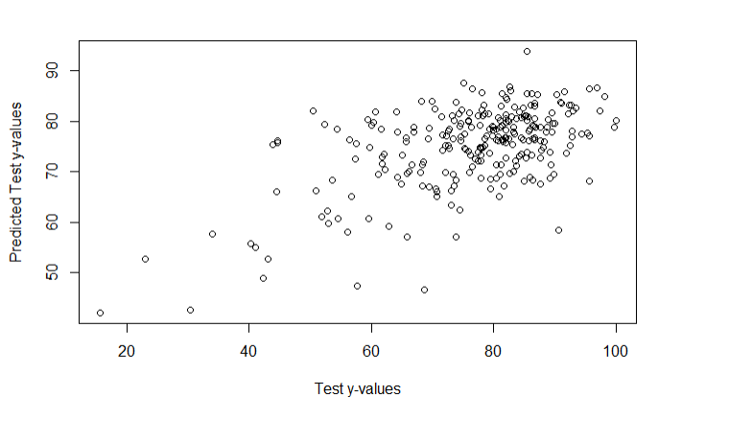

# plot(y[-sam], lasso.pred,xlab="Test y-values",ylab="Predicted Test y-values")



These plots look nigh indistinguishable from each other, as each one is so precise due to having such a highly correlated variable within the model. Lasso looks ever so slightly more precise, and based on our accuracy metric from before is likely the better model, but both of these two would be more then effecitve going off of the graph alone.

ig)

these models are already fit with their associated best lambda values. We will also undo the logs, as we likely want to predict outside of the log scale

# ridge.pred4 = predict(ridge.mod4, newx = Xs[-sam,])  
#   
# ya = exp(y[-sam])  
# ridge.ypred4a = exp(ridge.pred4)  
#   
# RMSEP.ridge4 = sqrt(mean(ya[-sam]-ridge.ypred4a)^2)  
# RMSEP.ridge4  
  
# > RMSEP.ridge4  
# [1] 1008.431  
  
# lasso.pred4 = predict(lasso.mod4, newx = Xs[-sam,])  
#   
# lasso.ypred4a = exp(lasso.pred4)  
#   
# RMSEP.lasso4 = sqrt(mean(ya-lasso.ypred4a)^2)  
#   
# RMSEP.lasso4  
  
  
# > RMSEP.lasso4  
# [1] 1098.562

hile all of the models performed well, OLS was left in the dust with its values of roughly 4.5, as both ridge and LASSO Both get beneath 1 and are hovering around 1,000. As for which is better among the two, much like previously while the answer is LASSO, the ridge is close enough to the point that it practically does not matter. The methods are likey to simply be to similar to get a meaningfully different results when fed the same predictors. Still, if one were to try some amount of elastic net one may be able to improve these metrics yet. This does not discount the power of these models though, as they both are improvments.

HI Use Monte Carlo Split-Sample Cross-Validation to estimate the mean RMSEP for the OLS, Ridge, and Lasso regressions above. Which model has best predictive performance? (5 pts.)

# MLR.ssmclog = function(fit,p=.667,M=100) {  
# RMSEP = rep(0,M)  
# MAEP = rep(0,M)  
# MAPEP = rep(0,M)  
# y = fit$model[,1]  
# x = fit$model[,-1]  
# data = fit$model  
# n = nrow(data)  
# for (i in 1:M) {  
# ss = floor(n*p)  
# sam = sample(1:n,ss,replace=F)  
# fit2 = lm(formula(fit),data=data[sam,])  
# ypred = predict(fit2,newdata=as.data.frame(x[-sam,]))  
# RMSEP[i] = sqrt(mean((exp(y[-sam])-exp(ypred))^2))  
# MAEP[i] = mean(abs(exp(y[-sam])-exp(ypred)))  
# yp = exp(ypred[y[-sam]!=0])  
# ya = exp(y[-sam][y[-sam]!=0])  
# MAPEP[i]=mean(abs(yp-ya)/ya)  
# }  
# cat("RMSEP =",mean(RMSEP)," MAEP=",mean(MAEP)," MAPEP=",mean(MAPEP))  
# cv = return(data.frame(RMSEP=RMSEP,MAEP=MAEP,MAPEP=MAPEP))  
# }  
#   
#   
#   
#   
# glmnet.sslog = function(X,y,p=.667,M=100,alpha=1,lambda=1) {  
# RMSEP = rep(0,M)  
# MAEP = rep(0,M)  
# MAPEP = rep(0,M)  
# n = nrow(X)  
# for (i in 1:M) {  
# ss = floor(n*p)  
# sam = sample(1:n,ss,replace=F)  
# fit = glmnet(X[sam,],y[sam],lambda=lambda,alpha=alpha)  
# ypred = predict(fit,newx=X[-sam,])  
# ya = exp(y[-sam])  
# ypred = exp(ypred)  
# RMSEP[i] = sqrt(mean((ya-ypred)^2))  
# MAEP[i] = mean(abs(ya-ypred))  
# MAPEP[i]=mean(abs(ypred-ya)/ya)  
# }  
# cat("RMSEP =",mean(RMSEP)," MAEP=",mean(MAEP)," MAPEP=",mean(MAPEP))  
# cv = return(data.frame(RMSEP=RMSEP,MAEP=MAEP,MAPEP=MAPEP))  
#   
# }  
#   
  
  
  
# ols.results = MLR.ssmclog(fit = PA.ols4, M = 1000)  
  
# RMSEP = 5574.74 MAEP= 3335.772 MAPEP= 0.2528052  
  
# glmnet.sslog(X,y, p=.667,M=100,alpha = 1, lambda = bestlam_lasso4)  
  
# RMSEP = 1102.624 MAEP= 502.6463 MAPEP= 0.1447807  
  
# glmnet.sslog(X,y, p=.667,M=100,alpha = 0, lambda = bestlam_ridge4)  
  
# RMSEP = 1213.98 MAEP= 539.2485 MAPEP= 0.1777687

While the matchup was close and the lasso and ridge models were very close, the lasso method came out on top by roughly 3% MAPE. Given its more punishing nature and likelehood to focus on fewer varibles more, this makes sense given that we were working with a small number of variables. It should also be noted that both the ridge and the lasso method blew the OLS by itself completely out of the water, speaking volumes about just how effective shrinkage can be even on smaller datasets.