[Spell Checker]

Final Report

**<Samuel Jessee, Selena Turner>**

**CSC316: Data Structures for Computer Scientists**

**<sijessee@ncsu.edu, snturner@ncsu.edu>**

**North Carolina State University**

**Department of Computer Science**

**<April 25, 2016>**

Executive Summary

In the Problem Statement, the problem to be addressed by this project will be stated and explained. This statement will elaborate how this project can be of use to the client and why this project would help the client’s current system.

The Project goals & Benefits section will detail the most important outcomes of the project. While the Problem Statement lists the problem to be fixed by the project, this section shows what the project will accomplish that is more effective for the client than the present arrangement.

The algorithm psuedocode of the project will be located in the Algorithm Design section, as well as the design rationale and analysis of the algorithm. The psuedocode will act as an easier way to read the code and understand what is going on in the project, while the rationale and analysis will further explain the reasoning behind the psuedocode. The estimated runtime of the project will also be located in this section.

The UML diagram and the rationale for its design pattern for the project will be inserted into the Software Design section. This section shows a visual depiction of the algorithm and shows the relationship between Java classes to further elaborate on the effectiveness of the project.

In the Black Box Test Plan section, there are five test cases to test on the external workings of the project to ensure that the algorithm works as it was written. The test plan will be a guide for the user so that he or she knows how to run and use the program.

The Task Plan is an overview of the different tasks for the author of the algorithm before the project is completed. The major parts of creating the proposal and code are listed so that the author has a schedule of when different sections are completed.

Lastly, the Case Study and Conclusion analyze and discuss the results of the project.

Table of Contents

Problem Statement 1

Project goals & Benefits 2

Algorithm Design 3

Proposed algorithm 3

Algorithm Design Rationale 3

Algorithm Analysis 4

Algorithm Changes 4

Software Design 5

Design Pattern(s) 5

Software Design Changes 6

Black Box Test Plan 7

Black Box Test Plan Changes 8

Task Plan 3

Task Plan Changes 3

Discussion 4

Challenges 4

Threats to Validity 4

Reflection 4

Conclusions 6

# Problem Statement

For this project, the problem is to create a program that can use a hash table to read in over 25,000 words from a dictionary and then check a text file for spelling errors. Currently, there is not a program specified by the project that was created using a hash table to spell check, so the present system would be to manually search through the text file and compare each word to the entire dictionary. This current system is extremely time consuming, since the runtime would be the amount of words in the dictionary times however many words are in the text file. This program would simplify the current system’s runtime, so instead of taking hours or even days to complete a spell check on the given text file, the runtime would be a few seconds.

# Project goals & Benefits

The major goal of this project is to create a program that effectively uses a hash table to search through a dictionary text file to make sure that a given text file has words that are correctly spelled. If the word is possibly not spelled correctly, the program will flag that word. At the end of the check, the program will output the alphabetical list of these misspelled words, along with the total number of dictionary words, the total number of text file words, the total number of misspelled words, and different numbers of probes that the program made. Other goals for this project include: creating tests for the project that cover over eighty percent of the code, commenting the code correctly with Javadoc, and having no flagged errors in the code.

With these goals, the project will be much faster than the current system of manually searching through the text file and dictionary. The user will also easily be able to access the system through the Graphical User Interface, which simplifies the way the spell checker will be run. The client will be benefitted by this system, especially if they run a business that deals with checking the spelling of words in a text file. This program can also be of use to the client, since it deals with code that, if thought of generally, can search through items and find targets. Being able to search and find objects does not have to be limited to spell checking, so for the client, this program leads to other possible systems that can be created.

# Algorithm Design

## Proposed algorithm

------------------------------------

**Algorithm** hashCode(word)  
 **Input** the word from either the dictionary or the text file  
 **Output** a hash coded number depending on the word that is input

p <- a prime number //1  
 c <- 1 //1  
 for i <- size(word)-1 to 0 do //n  
 c <- word(charAt(i)) + (c * p) //n  
 return c //1

**Algorithm** lookup(word)  
 **Input** the word to look up in the dictionary  
 **Output** the word, if it is not found in the dictionary  
 otherwise, null  
 A is an array that holds the dictionary words

hNum <- 0 //1  
 hNum <- hashCode(word) //T(n) hashCode

i <- (hNum)mod(size(A)) //2  
 while A has next space do //n+1  
 if A[i] does not equal word then //n-1  
 i++ //n-1  
 else //n-1  
 return A[i] //n-1  
 return null //1

**Algorithm** insert(word)  
 **Input** the word from the dictionary text file  
 **Output** no output

hNum <- hashCode(word) //T(n) hashCode  
 i <- (hNum)mod(size(A)) //2  
 A[SIZE] <- new array //1  
 while A has next space do //n+1  
 if A[i] is empty then //n-1  
 A[i] <- word //n-1  
 break //n-1  
 else //n-1  
 i++ //n-1

------------------------------------

## Algorithm Design Rationale

The hashCode algorithm creates a specific number for each word so that they can be stored and looked at very easily.

The lookUp algorithm takes a word from the text file and then compares it to where the same word should be in the dictionary array depending on the hashCode value. This algorithm also makes sure that the word is a root word, so it doesn’t contain the extra end letters that can be written in normal text.

The insert algorithm takes a word from the dictionary text file and uses the generated hashCode value to put the word into an array. If the array space is already taken, it will go to the next array space. This linear probing takes away the need for collision resolution, because if there is a collision, the probe moves to the next spot in the array. Also, taking the hashCode value and modding it with the size of the dictionary array satisfies the need for compression in the HashTable because it still inserts into an unique space but makes sure the hashCode number does not get too large.

## Algorithm Analysis

Algorithm hashCode:  
T(n) hashCode = 2n+3  
T(n) hashCode is in O(n) because the highest bound of T(n) is n  
n represents the word size

Algorithm lookUp:  
T(n) lookUp = T(n) hashCode)+5n+1 = (2n+3)+5n+1 = 7n+4  
T(n) lookUp is in O(n) because the highest bound of T(n) is n  
n represents the dictionary array size

Algorithm insert:  
T(n) insert = (T(n) hashCode)+1 = (2n+3)+1 = 2n+4  
T(n) insert is in O(n) because the highest bound of T(n) is n  
n represents the dictionary array size

## Algorithm Changes

The algorithm for lookup changed because the Simplification Rules were not needed in the HashTable class, but instead the SpellCheckerManager class. Other than that, the algorithms in HashTable were the same as the algorithms created in the original proposal.

# Software Design

----------

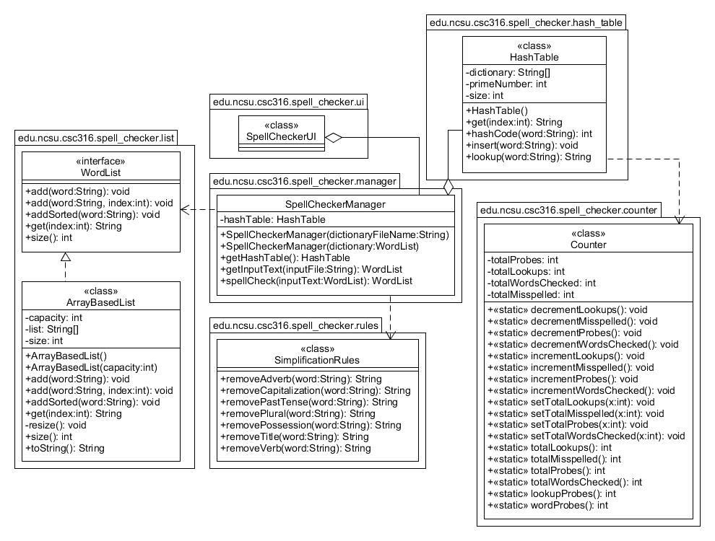

---------

## Design Pattern(s)

For this project, I implemented the Model-View-Controller pattern. This pattern deals with the interaction between the user and the program, with the Model making up the data of the program, the View having the contents of the program, and the Controller being the way the user can interact with the program.

In the UML diagram above, the Model is made up of the SpellCheckerManager class, because all of the data will be stored in it. The View is made up of the HashTable class, because the contents that make up the data will be coded in it. The Controller is made up of the SpellCheckerUI class, because the Graphical User Interface is the way the user can interact with the program. There is an association relationship between SpellCheckerManager and SpellCheckerUI, and two “has-a” relationships, one between SpellCheckerManager and SpellCheckerUI, and the other between SpellCheckerManager and HashTable. These classes have “has-a” relationships because SpellCheckerUI “has-a” SpellCheckerManager variable and SpellCheckerManager “has-a” HashTable.

## Software Design Changes

In the second part of the project, more classes were added like ArrayBasedList, WordList, Counter, and SimplificationRules. While SimplificationRules and Counter were only added to help the SpellCheckerManager class with the simplification of the words and counting the probes, lookups, and words checked, ArrayBasedList and the WordList interface were required by the project write-up of the second part of the project.

# Black Box Test Plan

To start up the program, the user will right click on the SpellCheckerUI and select Run As -> Java Application. The system will then pop up with a file chooser. Select the file indicated by each of the test cases. In all test cases except the first and the fifth, the dictionary chosen by the user will be the “testDictionary.txt” These text files have all already been created.

The first test deals with an “empty” dictionary file. This file will be named “emptyDictionary.txt” and will contain no text.

The first and second tests deal with a text file with five misspelled words. It will be called “fiveWords.txt” and has the following input:

No

ne

wunts

to

sove

th

problom.

The third test deals with an “empty” text file. This file will be named “emptyText.txt” and will contain no text.

The fourth test deals with a text file with no misspelled words. This file will be named “correctWords.txt” and has the following input:

Having

fun

yet

I

am

The fifth test deals with a dictionary file with only ten words in it. This file will be named “smallDictionary.txt” and has the following input:

have

never

will

to

the

start

I

a

The text file for this test will be called “smallText.txt” and contains the following input:

I

am

a

great

file

maker

I

have

never

done

anything

incorrectly

## Black Box Test Plan Changes

The black box tests changed have changed slightly since the proposal. The first test changed from giving an error message to simply having each word be labeled as incorrect because an empty dictionary simply means that there are no correct words at all. The rest of the tests are the same, except now the expected results have been modified because the write-up of the second part of the project changed how we should be outputting our misspelled lists.

|  |  |  |  |
| --- | --- | --- | --- |
| Test ID | Description | Expected Results | Actual Results |
| Empty dictionary file | The user starts up the program.  The user selects file “emptyDictionary.txt” from the file chooser.  The user selects file “fiveWords.txt” from the file chooser.  The user clicks the “Check the Spelling” button.  The user quits the system. | The console prints out:  WordList[ne, No, problom, sove, th, to, wunts] | The console printed out: WordList[ne, No, problom, sove, th, to, wunts] |
| Five misspelled words | The user starts up the program.  The user selects the dictionary from the file chooser.  The user selects file “fiveWords.txt” from the file chooser.  The user clicks the “Check the Spelling” button.  The user quits the system. | The console prints out: WordList[problom, sove, th, wunts] | The console printed out: WordList[problom, sove, th, wunts] |
| Empty text file | The user starts up the program.  The user selects the dictionary from the file chooser.  The user selects file “emptyText.txt” from the file chooser.  The user quits the system. | An error message is displayed, which says: Text file should not be empty. | The error message popped up, saying: Text file should not be empty. |
| No misspelled words | The user starts up the program.  The user selects the dictionary from the file chooser.  The user selects file “correctWords.txt” from the file chooser.  The user clicks the “Check the Spelling” button.  The user quits the system. | The console prints out: WordList[] | The console printed out: WordList[] |
| Small dictionary file | The user starts up the program.  The user selects the dictionary “smallDictionary.txt” from the file chooser.  The user selects file “smallText.txt” from the file chooser.  The user clicks the “Check the Spelling” button.  The user quits the system. | The console prints out: WordList[am, anything, done, file, great, incorrectly, maker] | The console printed out: WordList[am, anything, done, file, great, incorrectly, maker] |

# Task Plan

|  |  |  |  |  |
| --- | --- | --- | --- | --- |
| Task Description | Owner | Planned  Start Date | Planned  End Date | Status |
| Part 1: Start   * Start Executive Summary, Problem Statement, Project Goals & Benefits, Algorithm Design, Software Design, and Black Box Text Plan | Individual  Selena T  Samuel J | 4/6/16 | 4/9/16 | Complete |
| Part 1: Finish   * Finish any proposal items that aren’t done yet | Individual  Selena T  Samuel J | 4/9/16 | 4/12/16 | Complete |
| Part 2: Start   * Create code skeleton | Selena T | 4/12/16 | 4/15/16 | Complete |
| Part 2: Test   * “Complete” code * Start testing for bugs | Selena T  Samuel J | 4/15/16 | 4/19/16 | Complete |
| Part 2: Finalize   * Finish the code * Add/fix comments * Make sure all Jenkins tests pass | Selena T  Samuel J | 4/19/16 | 4/25/16 | Complete |

**Team Contact Information**

Selena Turner, co-programmer, snturner@ncsu.edu , 919-610-8825

Samuel Jessee, co-programmer, sijessee@ncsu.edu, 919-610-1546

## Task Plan Changes

In part two of the project, the task plan changed by adding another person to the Owner section and changing the due date of Part 2: Finalize to 4/25/16. These changes were added because part two of the project was done with a partner, and the due date was moved back.

# Discussion

Words in dictionary: 25144

Total Words Checked: 6976

Total Misspelled: 139

Total Probes: 10148

Total Lookups: 2639

Average probes per word: 1

Average probes per lookup operation: 3

## Challenges

One challenge faced when completing the project was figuring out the counter, since it was not checked by Jenkins tests. However, after configuring and checking how the write-up described how to implement the counter, we were able to figure out how to increment each count.

## Threats to Validity

A threat to Internal Validity for this project would possibly be selection bias, since for the tests we created for the project were completely made by us. This causes the tests to be “written to pass,” meaning that the tests will pass because we, as the creators of the program, know how to get the tests to pass. However, since our program passed the teaching staff tests, which are completely hidden from us, it shows that our program does work correctly despite perhaps having some selection bias on our tests. Another threat to Internal Validity is experimenter bias, because we wrote tests that we knew would pass due to our intimate understanding of the project. While these tests showed that the project worked correctly, the fact that the creators of the project wrote the tests is experimenter bias.

A threat to External Validity would be replication, since our tests involve taking the same parts of the tests but switching them up a little so that we can test all the aspects of the program. By replicating the tests and only changing them slightly, we are essentially testing the same parts of the program the way we had in all of the other tests. The teaching staff tests correct this threat because we cannot see the teaching staff tests, therefore, they test the program without replication of our tests. Another threat to External Validity might be situation external validity, since the specifics of our tests limit the ability to generalize the project tests to show that they work no matter what parts are tested.

Finally, a threat to Construct Validity for our project would be a bias in the experimental design, since our initial beliefs about how the project would be constructed confused us when we got the part two write-up for the project. Another threat to Construct Validity is researcher expectations, since for our project we already knew what the output for the program should look like.

## Reflection

In our project, the number of probes per word was 1.

We performed the best on the hash table, most likely due to the fact that the algorithms for it were planned out well in advance by the initial proposal.

The part of the project we performed the least well would definitely be the spellCheck method in the SpellCheckerManager class. There were issues with how the words should be spellchecked, since not everything that we needed to know was in the write-up and had to be manually figured out through debugging.

Improvements could be made on the SpellCheckerManager class by adding more of what is currently in the spellCheck method to the SimplificationRules class. This would simplify the code in spellCheck and also perhaps make the runtime of the project go faster.

# Conclusions

One of our major findings was that spell checking has a very quick runtime when using a hash table to store and look up words in the dictionary. After only a few seconds, a dictionary with over 25000 words was stored and a large text file filled with words was spell checked. A limitation we noticed was that the dictionary spell checking is not completely accurate. For example, checking a word like “happyly” would not be marked as misspelled once the “-ly” is taken away and “happy” is checked in the dictionary. We could have improved upon these simplification rules by compiling more of the rules into the class SimplificationRules so that SpellCheckerManager is not as cluttered as it is currently. The runtime of the project would also improve by doing so, since it would only need to go into the SimplifcationRules a few times, compared to going through the SpellCheckerManager many more times.