3/9/2017

GROUP 1

SOFTWARE REQUIREMENT DOCUMENT

A HOSPITAL RECORDS AUTOMATION SYSTEM

**INTRODUCTION**

A medical record documents a person’s treatment past and present health status, treatment plans for future health care and is an integral component in the delivery of quality. As such the storage of these records is a major priority of every health institution. They store them in rooms with restricted access in a supposed to be organized way but many times the retrieval process of a record is very difficult.

**USER REQUIREMENT**

* The system should store the patient health records using a web-based application.
* The system should allow for easy retrieval of records of patients.
* The System should track of bills and payments.
* The system should allow the transfer of medical records to other remote system.

**SYSTEM ARCHITECTURE**

Output

Processing

Input

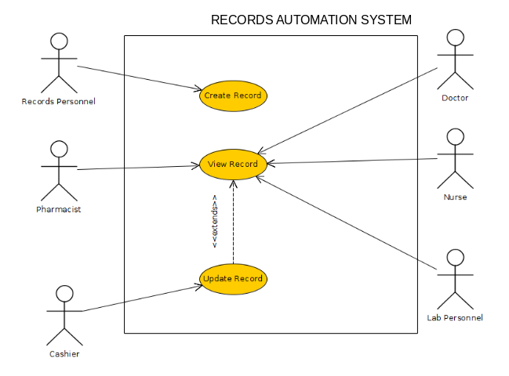

**SYSTEM REQUIREMENTS**

*Functional Requirements*

* The system should record all personal biographical data and contact details.
* The system should keep record of all patient visits.
* Medical records of patients (including tests and results) should be stored by the system.
* System must keep record of bills and payments.
* The system should allow the transfer of medical records to other remote systems.

*Non-Functional Requirements*

* The system should allow only authorized users to access data.
* The system should be accessible at all times.
* The system should have a user friendly interface.
* The system’s response time must be short.
* There should be easily accessible documentation for users of the system.