**A BRIEF INTRODUCTION AND THE PURPOSE OF THE WEBSITE.**

This project aims to create a comprehensive website for the Computer Science Department, featuring 10 pages, each dedicated to a different aspect of the department. The purpose of this website is to provide information about various facets of the Computer Science Department, including courses, faculty, research, events, and more.

**Table of Contents**

* Introduction
* Setup Instructions
* Author Information
* Screenshots
* Project Reflection

**SETUP INSTRUCTIONS**

**Requirements**

* Make sure you have Git installed on your machine.
* Ensure you have a code editor (e.g., Visual Studio Code) installed.

**Clone The Repository**

* Open a terminal on your machine.
* Navigate to the directory where you want to clone the project.
* Run the following command:

git clone https://github.com/your-username/computer-science-dept-website.git

* Change into the project directory:

cd computer-science-dept-website

**Run the Project**

* Open the project in your preferred code editor.
* Open the index.html file in a web browser to navigate through the pages.

## **Author Information**

* **Name:** Samuel Osei
* **Student ID:** 11117640

**Screenshot**

**Project Reflection**

In the process of creating this website, I have gained valuable experience in web development and project management. Some key takeaways from this project include:

CSS and HTML Proficiency: I've become more adept at structuring HTML documents and applying CSS styling.

Git Version Control: Enhanced my understanding of version control using Git, including cloning repositories and managing branches.

Project Organization: Learned how to structure a multi-page website, ensuring clarity and coherence in the user experience.

Documentation: Realized the importance of clear and concise documentation for both the codebase and the project as a whole.

This project has not only contributed to my technical skills but also provided insights into effective colla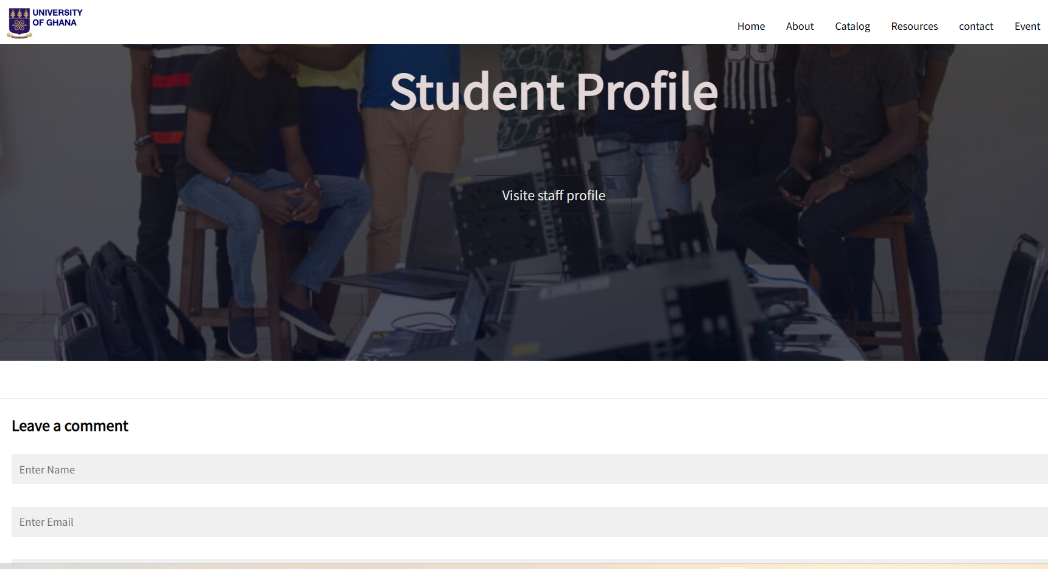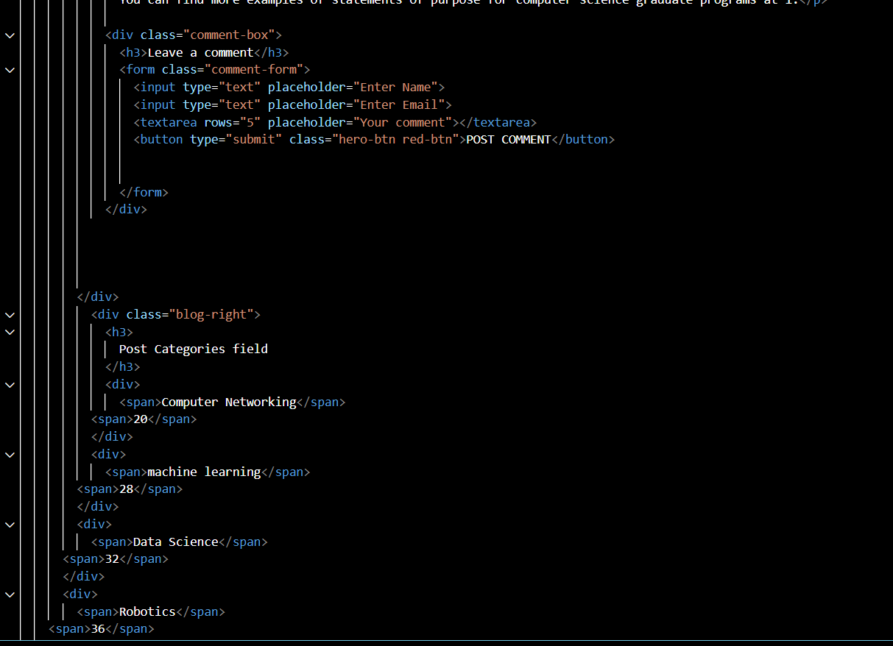boration and communication in a development environment.

