Multimodal Media Classifier:
Classification of Images, Audio and Text with Python
Authors: Alejandro Garcia Castro and Samuel Riaño Patiño
Introduction
Every day a vast number of media files are created: photos, recordings and documents. Classifying them, that is, giving each file a label based on its content, is the base of many real systems, like photo galleries that group pictures by color, apps that detect noisy recordings or search engines that find the topic of a document. In this final project we joined the three main topics of the course in one Python program: image processing, audio analysis and text processing. The program reads a folder with 30 real files (10 images, 10 sounds and 10 texts), detects the type of each file automatically and classifies it: the images by color and pattern, the sounds by noise level and dominant pitch, and the texts by word frequencies and keywords.
General objective
- To design a Python program that automatically processes, analyzes and classifies images, audio files and texts based on their attributes.
Specific objectives
- To classify images by their dominant color and pattern using OpenCV.
- To detect the noise level and the dominant pitch of real sounds using Librosa and the Fourier Transform.
- To extract word frequencies and keywords from texts with NLTK and classify them by topic.
- To summarize, compare and visualize the results with Pandas, Matplotlib and Seaborn.
Methods
The data is real and is saved in the Datasets folder: 10 sample images of OpenCV and scikit-image, 10 recordings of 5 seconds of the ESC-50 dataset of environmental sounds (2 of rain, vacuum cleaner, cow, siren and chirping birds) and 10 texts of about 2,000 words of the Brown Corpus of NLTK (4 news, 3 religion and 3 romance texts). The script MediaClassifier_Code.py goes through the folder with os.walk and sends each file to its analysis function depending on its extension. The results are saved in Pandas DataFrames, summarized with describe() and groupby(), plotted with Matplotlib and Seaborn, and the class of every file is saved in Results/classification_results.csv.
- Images: each image is read with OpenCV and converted to grayscale and HSV. A hue histogram (cv2.calcHist) of the pixels with a pure color gives the dominant color (red, orange, yellow, green, cyan, blue or purple); if less than 15% of the pixels have a pure color, the image is Grayscale. For the pattern, the edges are found with the Canny detector, and the percentage of edge pixels gives the class: Smooth (< 3%), Medium texture (3% to 10%) or highly textured (> 10%).
- Audio: each sound is loaded with librosa.load and filtered with a high-pass Butterworth filter of 50 Hz. The RMS energy of each frame is converted to dB: the quietest frames are the background noise, and the loudest ones are the sound, so their difference is the signal-to-noise ratio (SNR). The noise level is High (SNR < 8 dB), Medium (8 to 20 dB) or Low (> 20 dB). The dominant pitch is the frequency with the highest magnitude in the Fourier Transform (fft of SciPy); if it has less than 5% of the energy the sound has no clear pitch, otherwise it is Low (< 500 Hz), Medium (500 to 2,000 Hz) or High (> 2,000 Hz).
- Text: each text is tokenized with word_tokenize, converted to lowercase, and the punctuation and English stopwords of NLTK are removed. FreqDist gives the word frequencies and the top words. Each text gets a score for three topics (Politics/News, Religion and Romance/Fiction): the percentage of its words that are in a list of 16 keywords of that topic. The topic with the highest score is the class of the text.
Results
Images
Figure 1 shows the 10 images with their class. By color, 3 images were blue (the baboon, the house with the sky and the Starry Night), 3 grayscale (the coins, the gravel and the moon), 2 orange (the apple and the coffee), 1 green (the circuit board) and 1 red (the smarties). By pattern, 3 were smooth (apple, moon and smarties, with 0.6% of edge pixels on average), 4 had medium texture (5.4%) and 3 were highly textured (circuit board, gravel and Starry Night, 15.0%). This shows that color and pattern are independent: there are smooth and textured images in grayscale and in color.
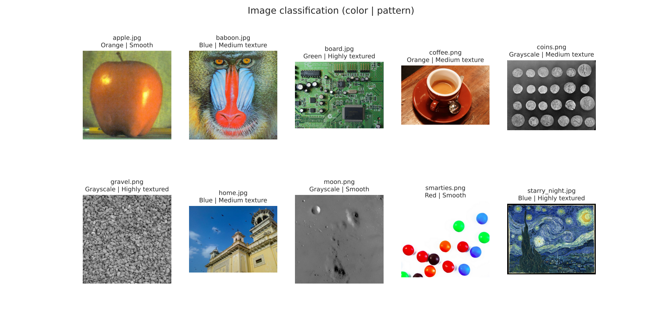
Figure 1. Automatic classification of the images (color | pattern).

Audio
Figure 2 shows the spectrogram of one sound of each type. The rain and the vacuum cleaner fill all the frequencies all the time, while the cow, the siren and the birds show clear lines, which are their pitch. The dominant pitch was 383 Hz (G4) for the cow, 573 Hz (D5) for the siren and 3,312 Hz (G#7) for the birds. The SNR separated very well the constant noises from the short sounds (Figure 3): the rain (4.2 dB on average) and the vacuum cleaner (2.9 dB) were classified as High noise, while the cows had the highest SNR (70.4 dB) because they sound for a moment and then there is silence, so they were Low noise. In total, 6 sounds were High noise, 1 Medium and 3 Low; and by pitch, 3 had no clear pitch (both rains and one vacuum cleaner), 3 were Low, 2 Medium and 2 High. Some sounds were harder: in one bird recording and one siren recording the background was stronger than the main sound, so they got a low pitch and High noise.
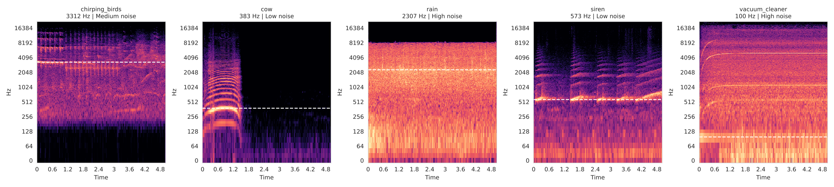
Figure 2. Spectrograms of one sound of each type; the dashed line is the dominant pitch.
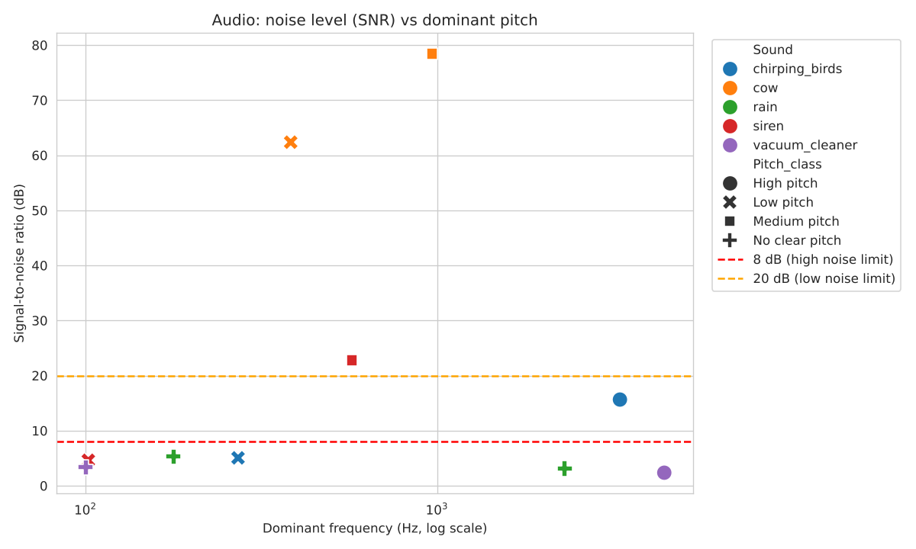
Figure 3. Noise level (SNR) vs dominant pitch of the 10 sounds.
Text
The 10 texts have 19,839 words (about 2,000 each) and the most frequent words, without stopwords, were "would" (117 times), "said" (92) and "one" (63). The top words of each text describe it very well, for example "jury, county, fulton, election" for a news text, "theology, church, catholic" for the religion texts and character names like "maggie" or "jenny" for the romance texts. As Figure 4 shows, the keyword score classified the 10 texts in the topic of the category they come from in the Brown Corpus: the news texts had between 2.3% and 8.6% of political keywords, the religion texts about 4.2% of religious keywords and the romance texts between 2.3% and 3.3% of romance keywords. The news texts also had the most varied vocabulary (lexical diversity of 0.387, against 0.347 for religion and 0.360 for romance).
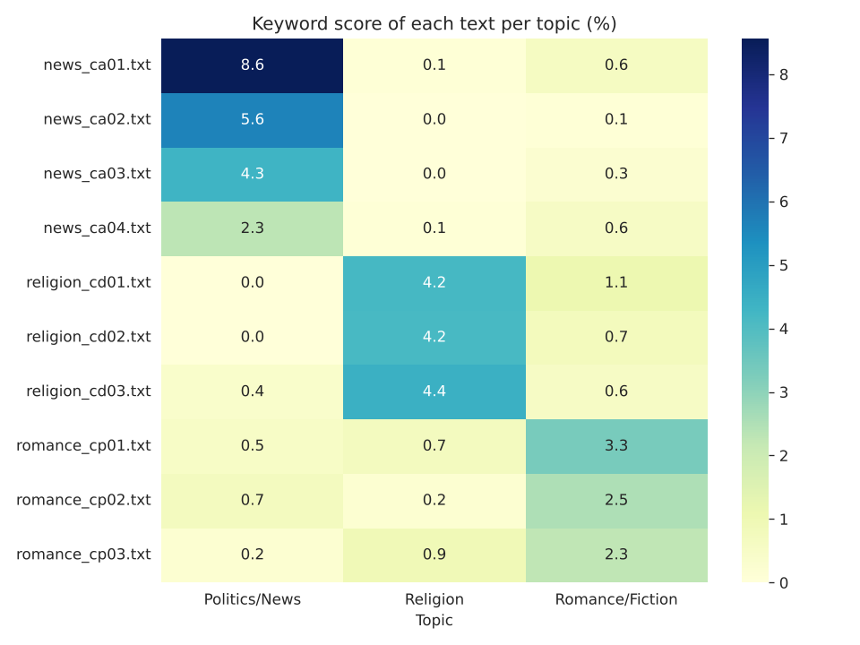
Figure 4. Keyword score of each text for each topic (%).
Table 1. Summary of the classification of the three media types.
Media | Files | Features | Result of the classification
Image | 10 | Hue histogram, saturation, brightness, Canny edge density | Blue 3, Grayscale 3, Orange 2, Green 1, Red 1; Smooth 3, Medium 4, Textured 3
Audio | 10 | Noise floor, SNR (RMS in dB), dominant frequency (FFT) | High noise 6, Medium 1, Low 3; No clear pitch 3, Low 3, Medium 2, High 2
Text | 10 | Word frequencies (FreqDist), top words, keyword scores | Politics/News 4, Religion 3, Romance/Fiction 3

The program also saves the edge density of each image, the most frequent words and the number of files per class (Results folder), which are explained in the video.
Link with the video explanation uploaded to drive:
https://drive.google.com/drive/folders/1ibK3pPUOVlPS5vnjybw3dWAnfyCNDlP2?usp=sharing
GitHub with the different files and results:
https://github.com/Samuel-RP22/Final-Project
Conclusions
- It was possible to integrate image, audio and text processing in one automated program: every file is detected by its extension, converted into numerical features and classified with simple rules, and the results of the three media types are summarized and plotted with the same tools.
- Simple features gave good results: the hue histogram and the Canny edges described the color and the texture of very different images, the SNR separated the constant noises from the short sounds, and a short list of keywords was enough to find the topic of all the texts.
- The main limitation is that the limits of the rules were chosen by us, and in some recordings the background is stronger than the main sound. With more data these limits could be learned with machine learning.
- This kind of program can be used to organize photo libraries by color or texture, detect noisy recordings or alarms like sirens, monitor animal and environmental sounds, and sort documents or news by topic.

