**ACCOUNT REGISTRATION**

Name:

* First and Last Name (Required)
* Middle Name (Optionam)
* 2-50 Characters
* Letters, spaces, hyphens, and apostrophes (Allowed)
* Input sanitation

Email:

* Required
* Checks for valid email format
* Checks for disposable email domains
* Checks if email is already registered in the db
* Sends a 6 digit-code to verify email ownership to create the account

Password:

* 8-32 Characters (At least one of these: Uppercase, Lowercase, Number, Special Character)
* Checks if the password is common
* Checks if password and confirm password input matches

Rate Limiting and Security:

* Max 5 registration attempts (15 mins cooldown)
* Verification Code (Expires 15 mins)
* Max 3 attempts to resend verification code per 5 mins
* Max 10 code entry attempts
* Tracks verification attempts
* Maintains session data for pending registration
* Clears sensitive data after successful verification
* Uses secure constant-time comparison for verification codes
* Prevents submission with empty fields (except middle name)

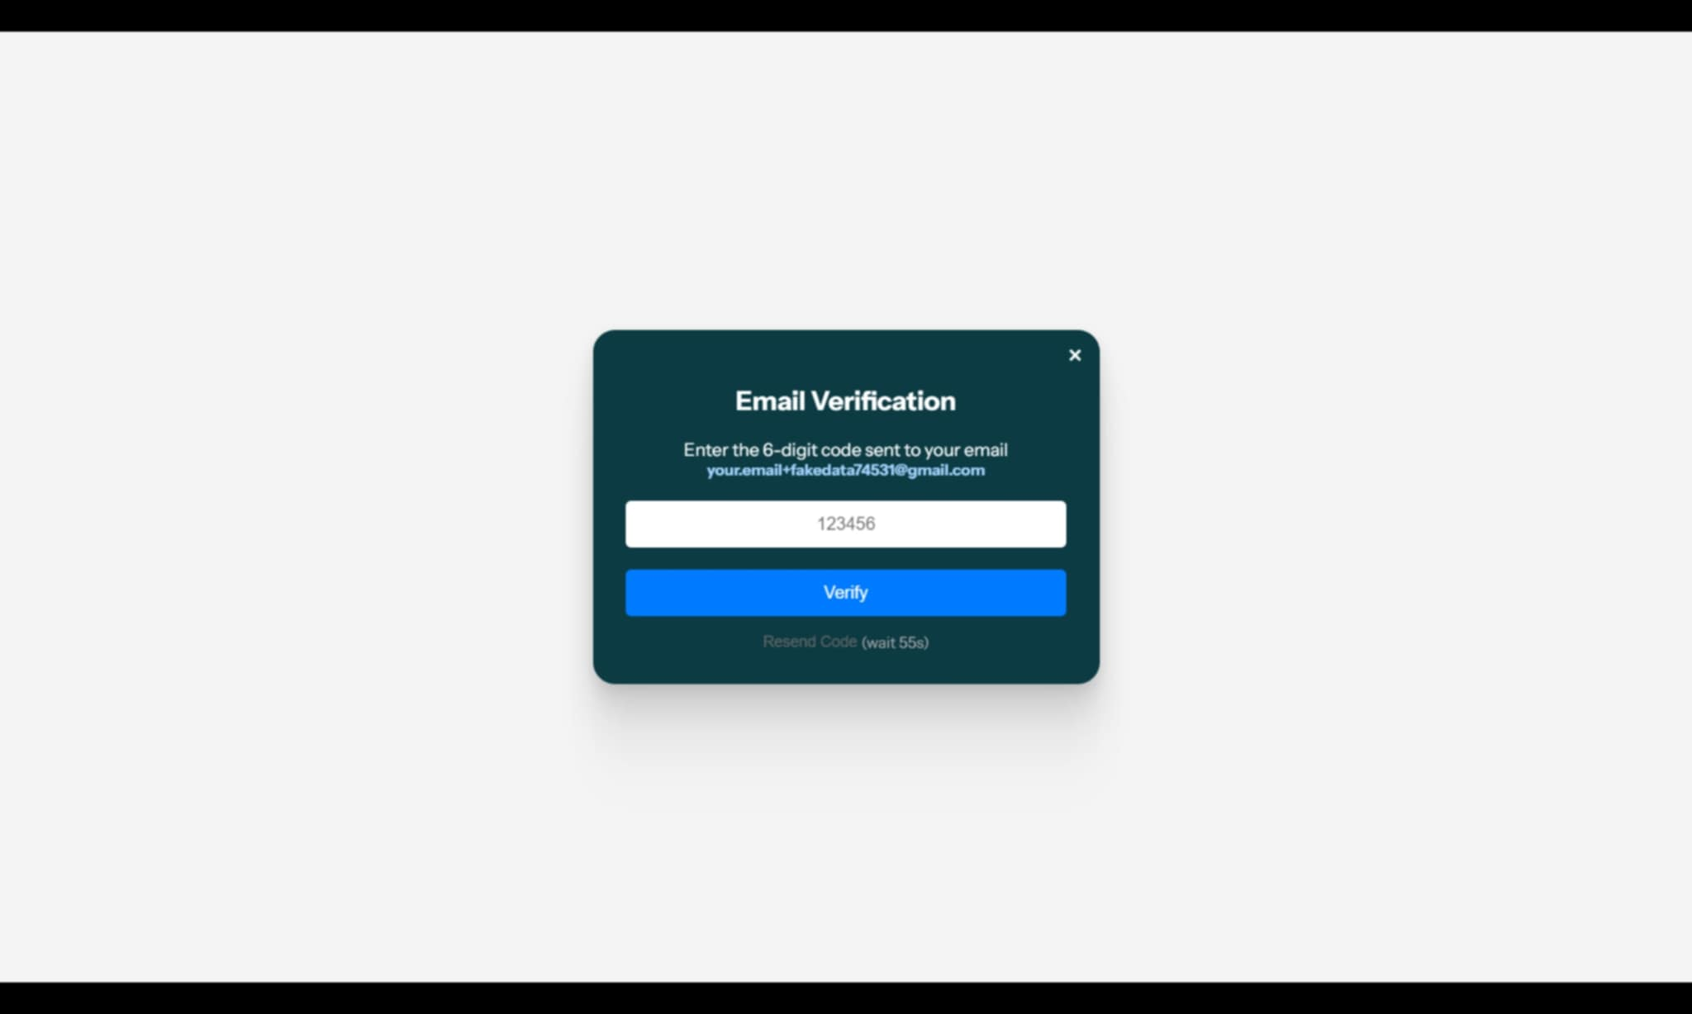

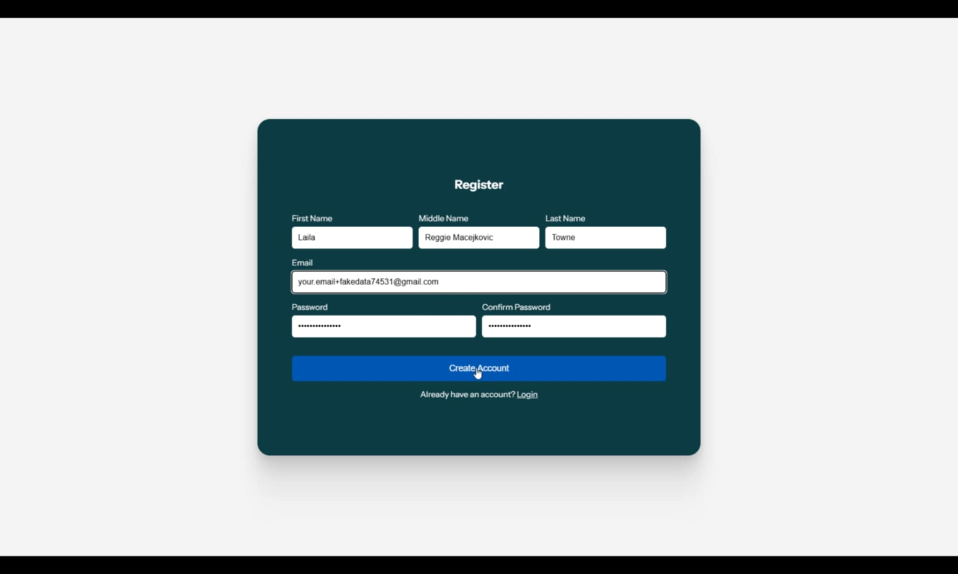

**LOGIN**

Email and Password:

* Empty fields (Can't submit)
* Maximum five attempts within a 5 minute timeframe
* Blocks attempts for 15 mins, after exceeding failed attempts
* Checks email format
* Sanitise input
* Error message if the email/password is wrong
* Redirects user to their page based on the user role (Admin/Normal User)

Not yet working:

* Remember me button
* Forgot password function

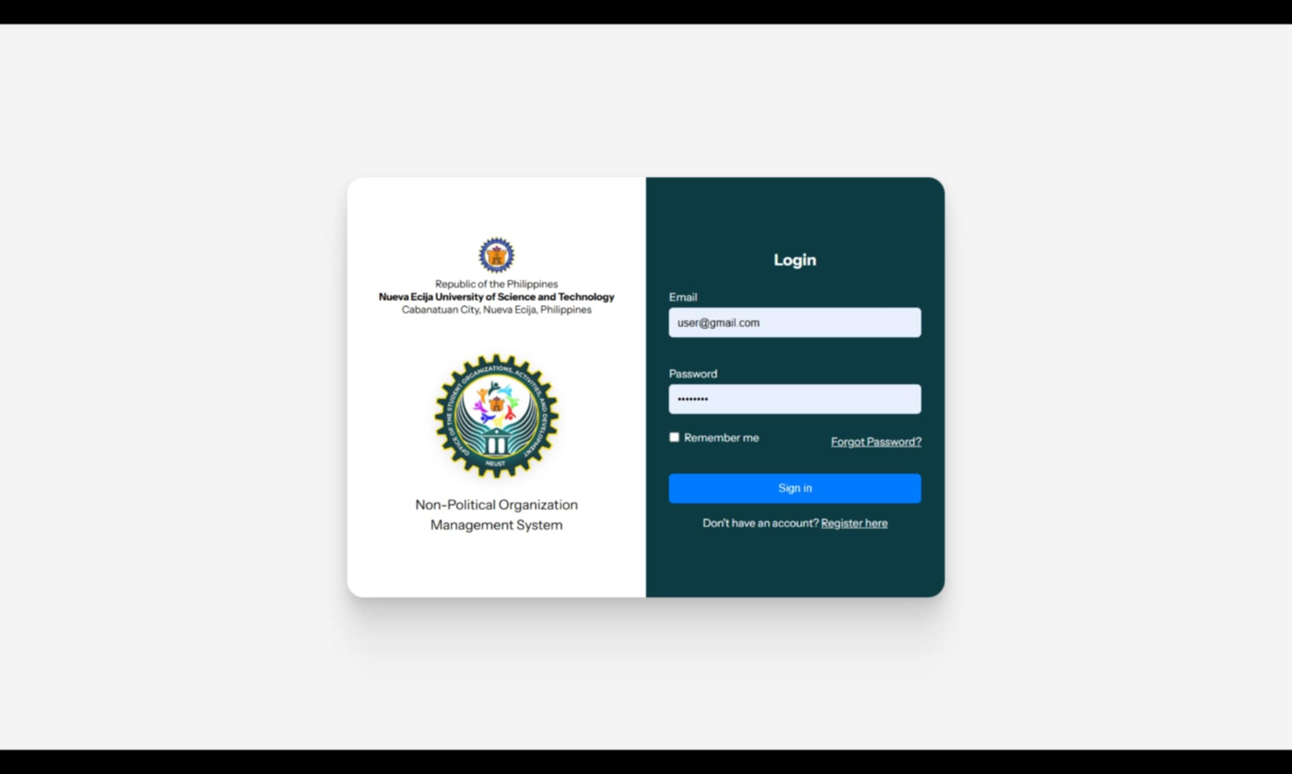

**APPLICATION STEP 1 (NEW ORGANIZATION)**

New Organization Form (Org Name, Type, Logo, Logo Desc)

* Required to proceed to next step
* Checks for similar organization name in the database
* Dropdown for Organization Type
* Logo upload (png, jpg, gif)
* Checks for required fields to prevent submitting missing information
* Input sanitation & Validation

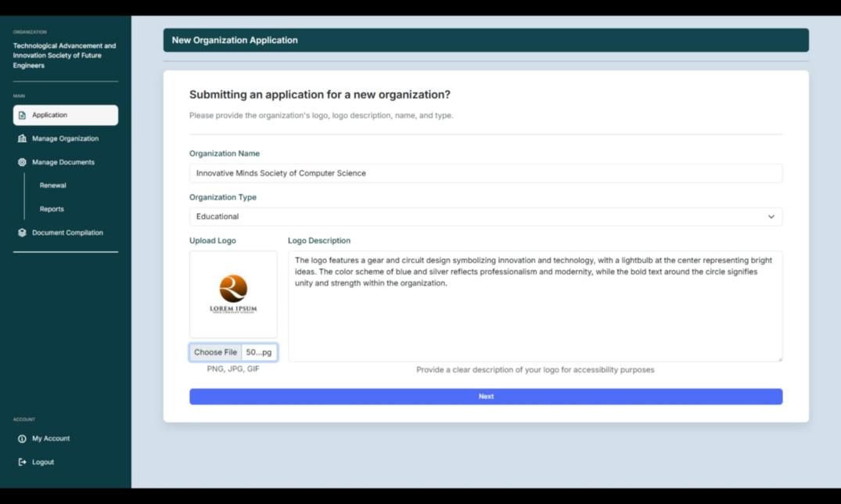

**APPLICATION STEP 2 (FILE REQUIREMENTS)**

Option to update the information submitted in first step:

* Once the first step is submitted, the user can't go back to the first step anymore (even if they logged back in), but there is an option in the second step to update the information submitted in first step in cases where incorrect information was submitted in the first step.
* Updating: Organization name (with duplicate name check) Organization type, Logo and logo description
* Logo type validation (png, jpg, gif)
* Validation and Sanitation

Application Progress:

* Type immediately set to: New
* Progress immediately set to: Incomplete
* File Status Count for (Verified, Pending, Needs Revision, Rejected)
* Automatically updates Application Progress to Pending (Once all required files are submitted)
* Automatically updates Application Progress to Verified (Once all required files are verified)

File Requirement:

* Seven Required Files (7 Forms)
* Drag and Drop Upload Zone / Select File Button
* Only allows PDF type for consistency
* Upload Button (Appears once a file is dropped/selected)
* Upload Button (Can’t be clicked if no file is selected)
* Select File button and Upload button (Disappears once the file is verified by the admin, to avoid resubmitting verified files)
* Preview button (Clickable once a file is uploaded)
* File status tracking (Per card)
* Download Button (In preview modal)
* Once a file is submitted, the file status is immediately set to: Pending
* Once all files are submitted: Application Progress is set to Pending, and saved a submission date & time in the database.

Not Working Yet:

* Feedback sending and Feedback Viewing

(Nilagay ko lang yung delete and refresh button for testing sa pag update ng status)

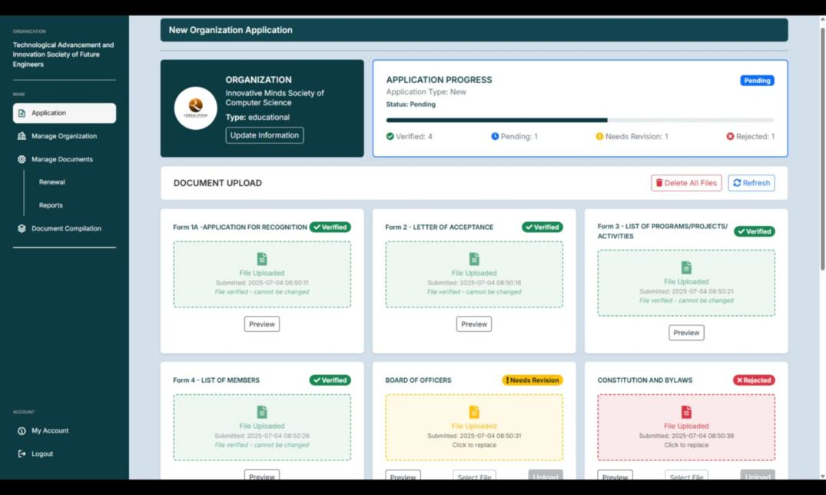

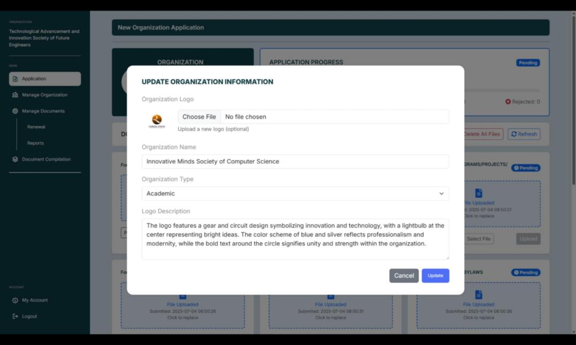

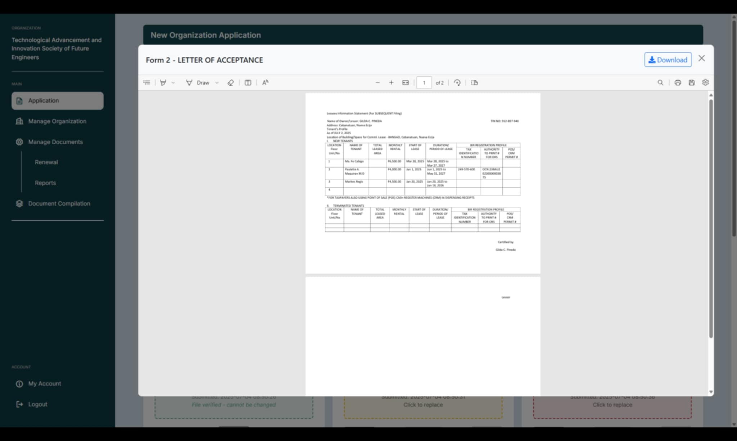

**ADMIN SIDE: VIEWING NEW ORGANIZATION APPLICATION**

* Views the list of new organization application (Including the data & time submitted, pending files, org name, logo)
* Only shows the organizations with pending application progress (If there are any missing files in the submissions of user, it will not appear in the list)
* Shows the number of files pending

Not yet working:

* Order the organization based on submission time

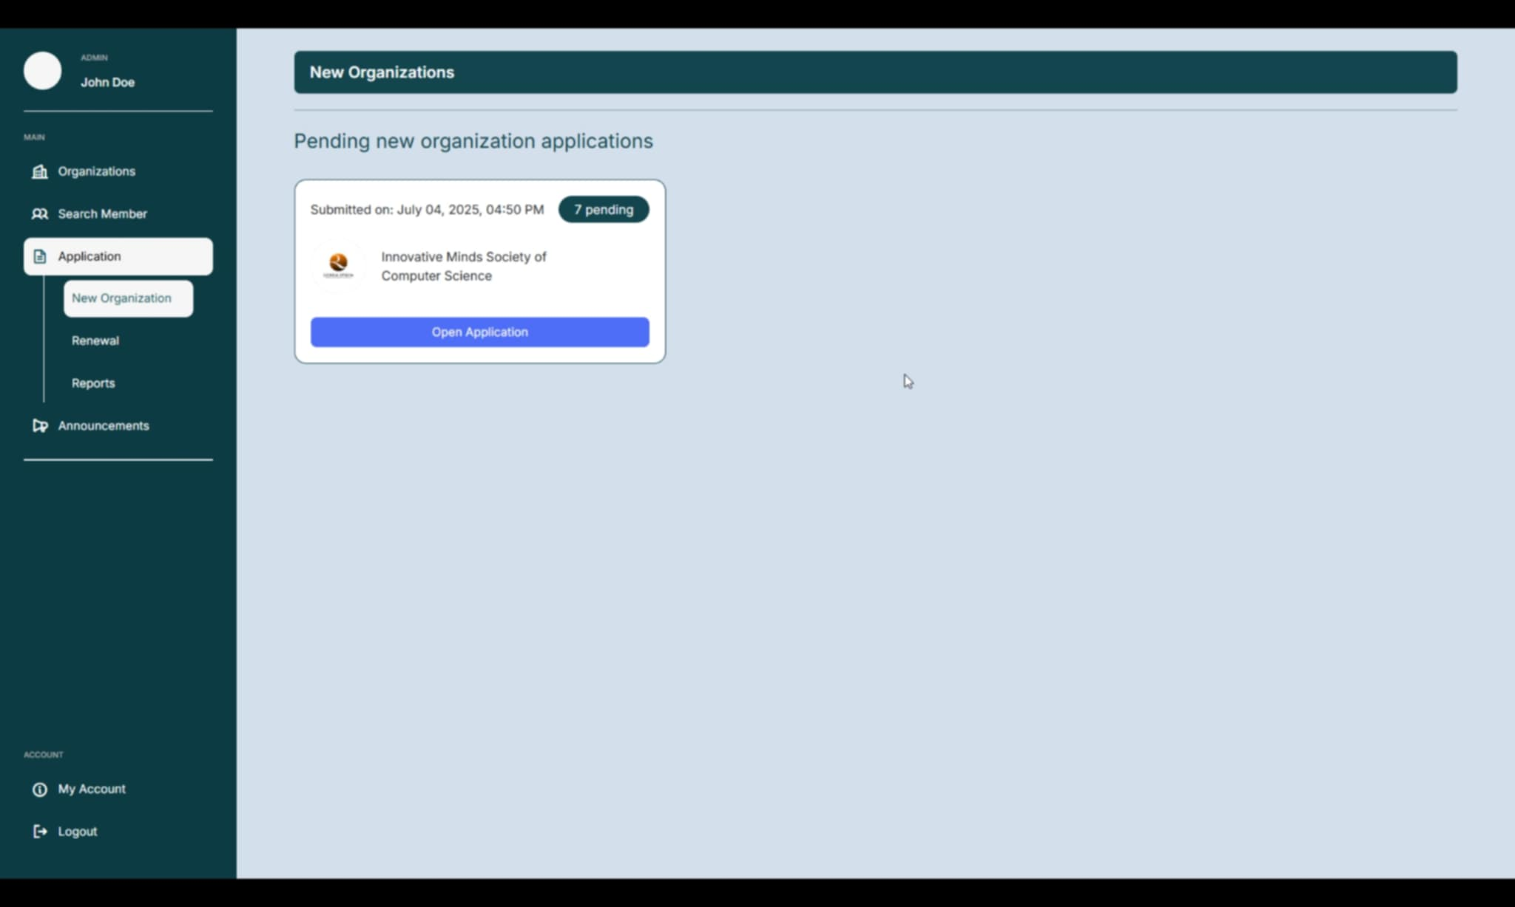

**ADMIN SIDE: VIEWING THE FILES UPLOADED**

* Shows Org name and the Submission Date and Time
* Shows all required submitted files
* Orders the files
* Shows the submission date and time of each file
* Shows the status of each file
* Allows previewing the file
* Allows downloading the file in the preview modal
* Allows updating status (Verified, Needs Revision, Rejected)

Not Working Yet:

* Feedback sending and Feedback Viewing

