### Unit 5 Assignment 2: Scope of Variables: **Identifiers in Each Scope:**

Global Scope (available everywhere in the file)

* Constants: PI, RATE
* Functions: main, findArea, findCircumference

Main Function – Outer Block

* Global identifiers: PI, RATE, findArea, findCircumference
* Local variable: radius

Main Function – First Inner Block

* Inherited: PI, RATE, findArea, findCircumference, radius (from outer main)
* Local variable: area

Main Function – Second Inner Block

* Inherited: PI, RATE, findArea, findCircumference
* Local variables: radius (this one shadows the outer radius), circumference

Main Function – After All Calls

* Same as outer main block:
  + PI, RATE, findArea, findCircumference, radius

Inside findArea(float rad, float& answer)

* Inherited: PI, RATE, findCircumference, main (but not directly callable recursively here)
* Parameters: rad, answer

Inside findCircumference(float length, float& distance)

* Inherited: PI, RATE, findArea, main
* Parameters: length, distance

Unit 5 Assignment 2:  
  
Scope of Variables:

Exercise 4:  
In the first inner block of main, the radius from the outer block (which is 12) is passed to findArea, because there’s no new radius declared inside that block. In the second inner block, a new radius variable is declared and set to 10, so that value is passed to findCircumference. This shows how C++ variable scope works: the inner block uses its own radius if declared, otherwise it uses the outer one. As a result, findArea receives 12, and findCircumference receives 10.  
  
The code:  
  
  
  
  
  
  
  
Unit 5 Assignment 2:  
  
Parameters and Local Variables:  
  
Every time normalizeMoney is called, it converts the given cents to dollars and adds it to a running total stored in the static variable sum. First, adding 95 cents would give $0.95, with a total of $0.95. Next, adding 193 cents converts to $1.93, making the total $2.88. Finally, calling it with the default 150 cents adds $1.50, bringing the total to $4.38. The program will print each conversion along with the updated running total and the local total variable, which matches the dollars added in that specific call.

Unit 5 Assignment 2:  
  
Parameters and Local Variables:

Unit 5 Assignment 2:  
  
Value Returning and Overloading Functions:  
  
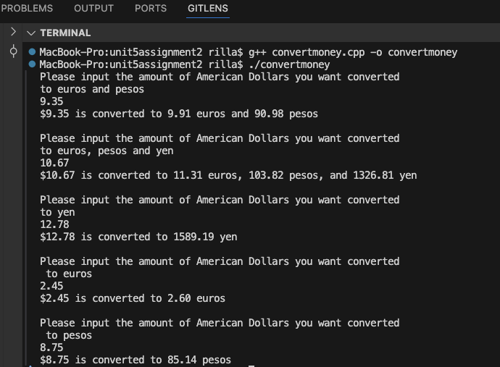

Unit 5 Assignment 2:  
  
Student Generated:

