Agile Capstone Project
Complete Submission Documentation
User Management Console Application
Samuel Oduro D. Boakyel
Date: 2/17/2026

Table of Contents
1. Backlog & Sprint Plans .................................................. 3
2. Codebase & Repository Evidence ...................................... 8
3. CI/CD Pipeline Evidence ................................................ 12
4. Testing Evidence ........................................................... 15
5. Sprint 1 Review & Demo ................................................ 18
6. Sprint 2 Review & Demo ................................................ 21
7. Retrospectives .............................................................. 24

1. Backlog & Sprint Plans
This section provides the complete product backlog, sprint plans, user stories with estimates, and the Definition of Done that guided this project.

1.1 Product Vision
A lightweight Java console application that allows users to create, read, update, and delete user records, enabling simple user list management without a database or GUI. The solution will be testable, built via CI/CD, and include basic logging and a health check for operational visibility.

1.2 Product Backlog
The following table shows the complete refined product backlog with all user stories, priorities, estimates, and acceptance criteria:
ID | User Story | Priority | Points | Acceptance Criteria
US-1 | As a user, I want to create a new user with id, name, and email so that I can add people to my list. | High | 2 | Create flow, validation, success/error messages
US-2 | As a user, I want to view all users so that I can see who is in the list. | High | 2 | List with id/name/email, empty-list message
US-3 | As a user, I want to update an existing user by id so that I can correct or change details. | High | 2 | Update by id, validation, confirmation/error
US-4 | As a user, I want to delete a user by id so that I can remove people from the list. | High | 2 | Delete by id, confirmation/error
US-5 | As an operator, I want a simple health/status check so that I can verify the app is running. | Medium | 1 | Health response (e.g., menu option)
US-6 | As a developer, I want basic logging for key actions and errors so that I can troubleshoot. | Medium | 1 | Log key actions and errors
Total Story Points: 10

1.3 Definition of Done
Each user story is considered done when ALL of the following criteria are met:
- Code compiles without errors (mvn compile)
- Unit and/or integration tests exist and pass (mvn test)
- New/changed code is covered by at least one test where practical
- No critical or blocking linter/checkstyle issues (if configured)
- Acceptance criteria for the story are met and demonstrable
- Code is committed to a feature branch and merged after review
- CI pipeline (GitHub Actions) runs and passes for the branch

1.4 Sprint 1 Plan
Sprint Goal: Deliver first working increment with core CRUD and DevOps pipeline.
Selected Stories:
Story | Summary | Commitment
US-1 | Create user | Yes
US-2 | List all users | Yes
US-4 | Delete user | Yes
Sprint 1 Deliverables:
• Working Create, List, and Delete (and optionally Update) in console
• Git repository with incremental commits (no big-bang)
• GitHub Actions CI: build + tests on push/PR
• Sprint 1 Review (screenshots/write-up) and Retrospective

1.5 Sprint 2 Plan
Sprint Goal: Complete CRUD, add monitoring/logging, apply Sprint 1 retrospective improvements.
Selected Stories:
Story | Summary | Commitment
US-3 | Update user (if not done in S1) | Yes
US-5 | Health/status check | Yes
US-6 | Basic logging | Yes
Sprint 2 Deliverables:
• Remaining backlog items (Update, health check, logging)
• Monitoring/logging in place (console logs, health option)
• Sprint 2 Review and Final Retrospective

2. Codebase & Repository Evidence
This section provides evidence of the code repository structure, incremental commit history, and branching strategy that demonstrates Agile development practices.

2.1 Repository Link
GitHub Repository:
https://github.com/Samuel1796/Agile_Capstone

2.2 Repository Structure
The repository is organized following Maven project structure and Agile documentation best practices:
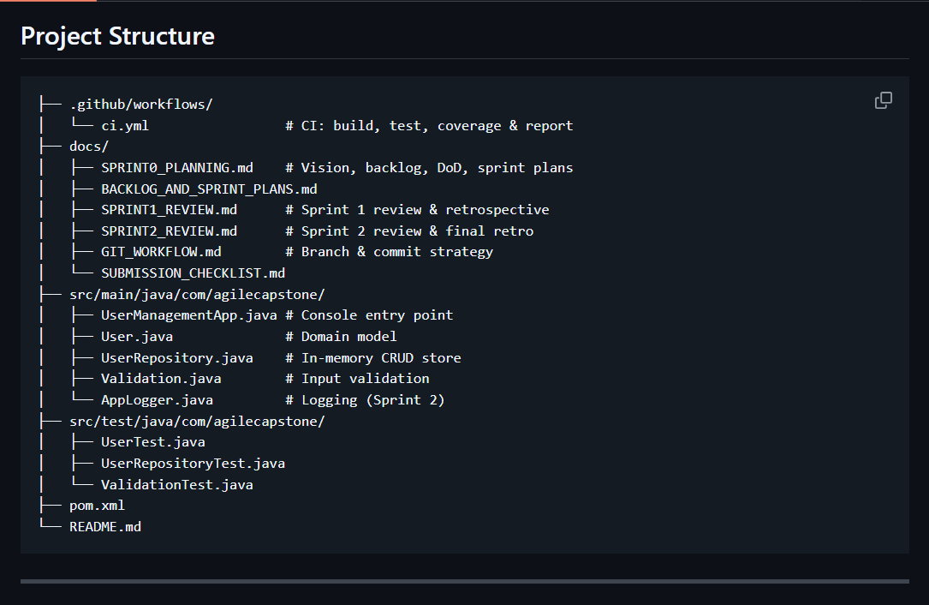

2.3 Incremental Commit History
The commit history demonstrates incremental, feature-based delivery following Agile principles. Each commit represents a small, deployable change.
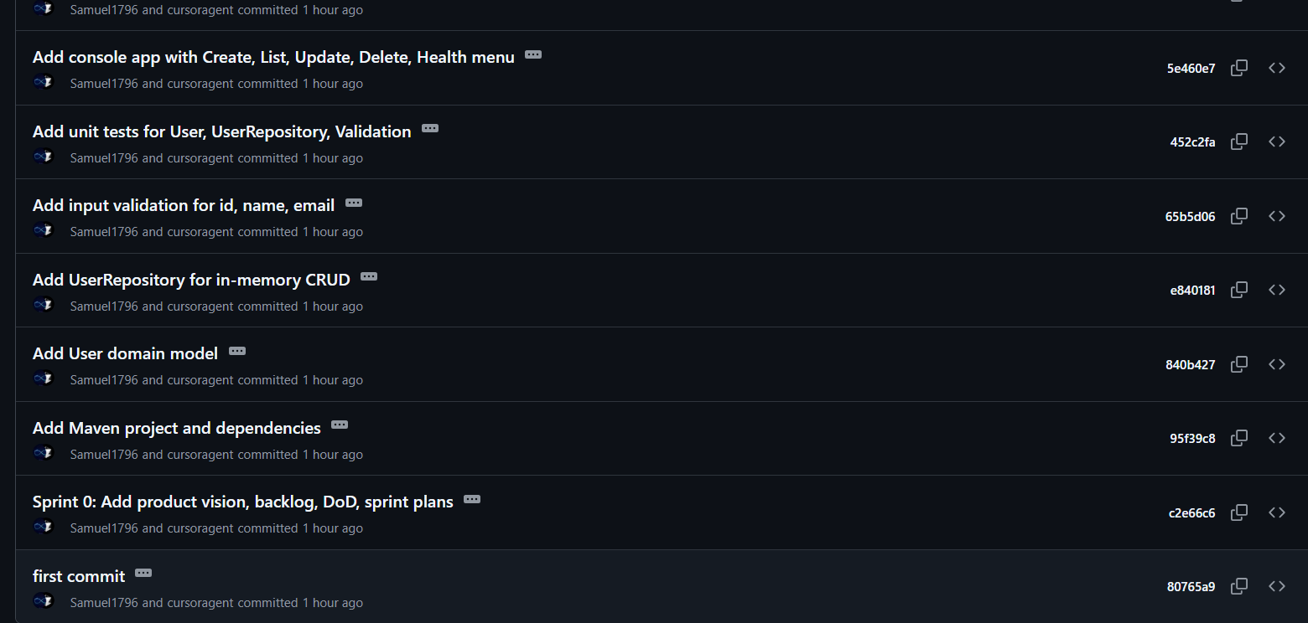
Key Commit
Milestones:
1. Sprint 0: Add product vision, backlog, DoD, sprint plans
2. Add Maven project and dependencies
3. Add User domain model
4. Add UserRepository for in-memory CRUD
5. Add input validation for id, name, email
6. Add console app with Create, List, Update, Delete menu
7. Add unit tests for User, UserRepository, Validation
8. Add GitHub Actions CI: compile and test on push/PR
9. Add AppLogger for key actions and errors (US-6)
10. Integrate logging and health check (US-5, US-6)

2.4 Branching Strategy
The project follows a Git Flow-inspired branching strategy with main, dev, and feature branches:
Branch | Purpose
main | Production-ready code; only updated via merge from dev
dev | Integration branch; feature branches merge here first
feature/* | One story or logical change; merge into dev when tests pass
Branching Rule: New work in a feature/... branch → merge to dev → after acceptance, merge dev to main.

2.4.1 Feature Branch Examples
The following feature branches were used during development:
• feature/project-skeleton - Initial Maven setup and project structure
• dev – Hosts all developmental changes
• feature/improve coverage - GitHub Actions CI pipeline
• feature/test-coverage report - Monitoring features

3. CI/CD Pipeline Evidence
This section demonstrates the automated CI/CD pipeline implemented using GitHub Actions, including successful and failed builds.

3.1 Pipeline Configuration File
The CI/CD pipeline is defined in .github/workflows/ci.yml and runs automatically on every push and pull request:

3.2 Pipeline Workflow
The CI pipeline executes the following stages automatically:
1. Checkout - Retrieves the latest code from the repository
2. Setup JDK 17 - Configures Java development environment
3. Build - Compiles the Java code using Maven (mvn clean compile)
4. Test - Executes all unit tests (mvn test)
5. Report - Generates test coverage and results report

3.3 Successful Pipeline Runs
The following screenshots demonstrate successful pipeline executions:
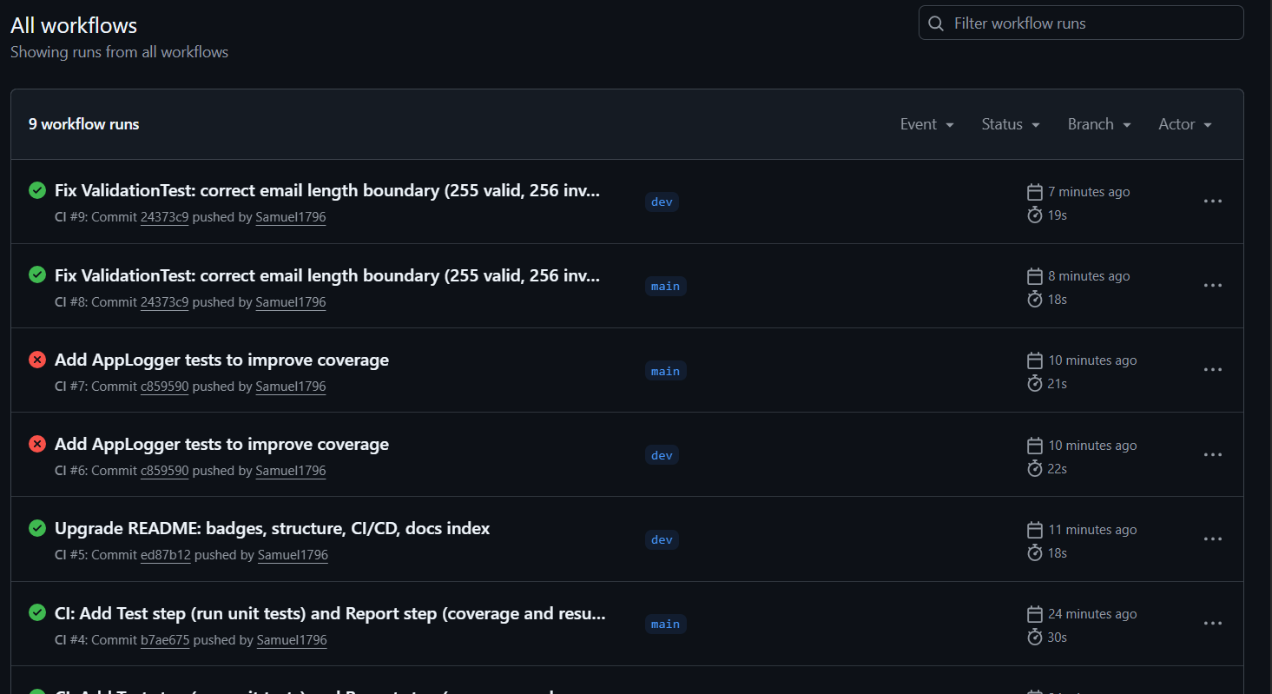
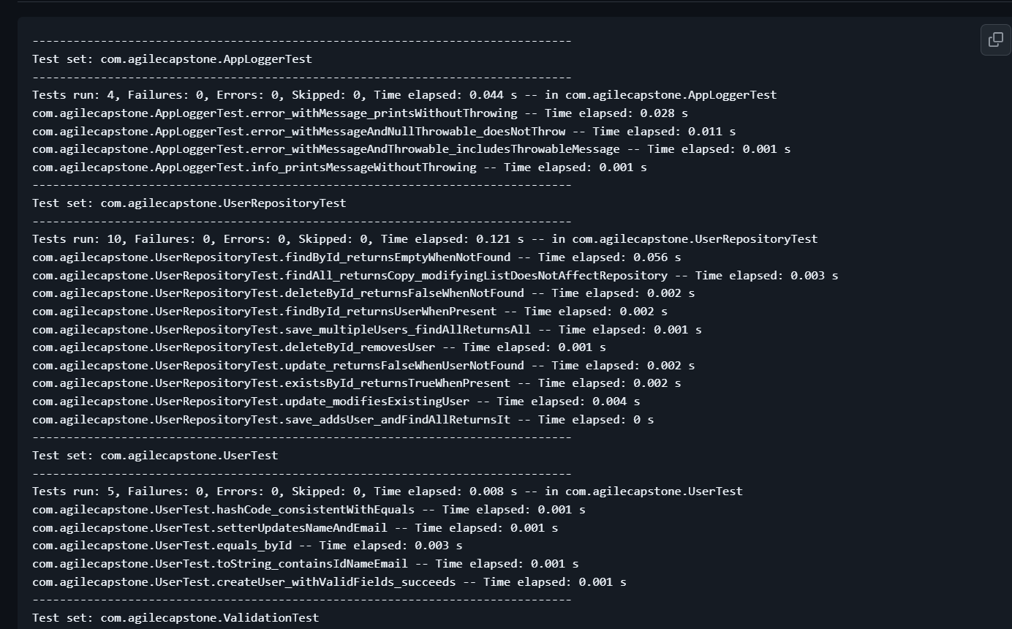Success Indicators:
✓ All compilation steps completed without errors
✓ All unit tests passed (100% success rate)
✓ Test coverage reports generated successfully
✓ Pipeline completed in under 2 minutes

3.4 Failed Pipeline Run (Example)
The CI/CD pipeline also catches failures early, as demonstrated below:
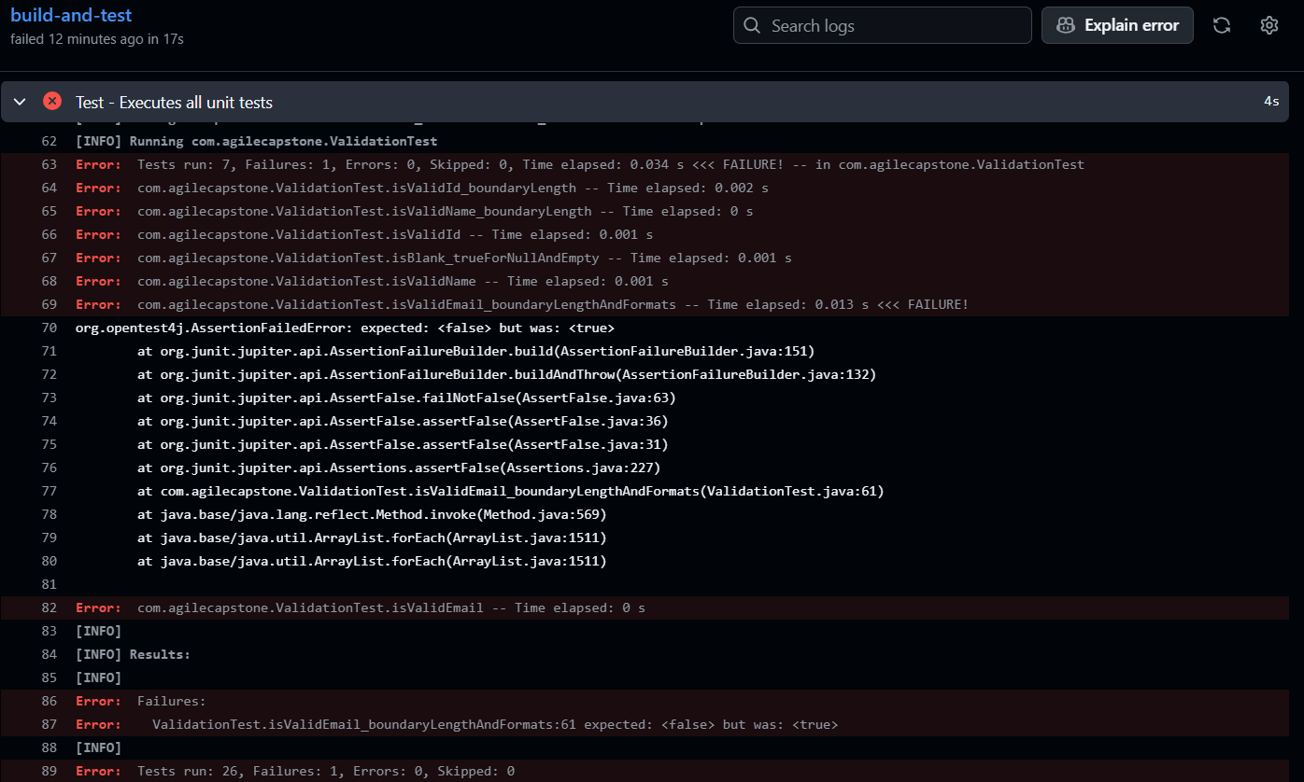
Common Failure Scenarios:
• Compilation errors (syntax issues, missing imports)
• Test failures (assertion errors, logic bugs)
• Dependency issues (missing Maven dependencies)
• Configuration problems (incorrect Java version)

3.5 CI/CD Pipeline Benefits
The automated CI/CD pipeline provided the following benefits throughout the project:
Automated Quality Gates:
• Every commit automatically verified for compilation and test success
• Prevented broken code from being merged into main branch
Fast Feedback:
• Build results available within 2 minutes of code push
• Developers notified immediately of issues via GitHub
Continuous Integration:
• All branches tested before merging
• Pull requests automatically validated

4. Testing Evidence
This section demonstrates comprehensive unit testing coverage and test execution results.

4.1 Test Files
The following unit test files were created to validate core functionality:
Test File | Purpose
UserTest.java | Tests User model: constructor, getters, setters, toString
UserRepositoryTest.java | Tests CRUD operations: create, findById, findAll, update, delete
ValidationTest.java | Tests input validation: ID format, name validation, email format

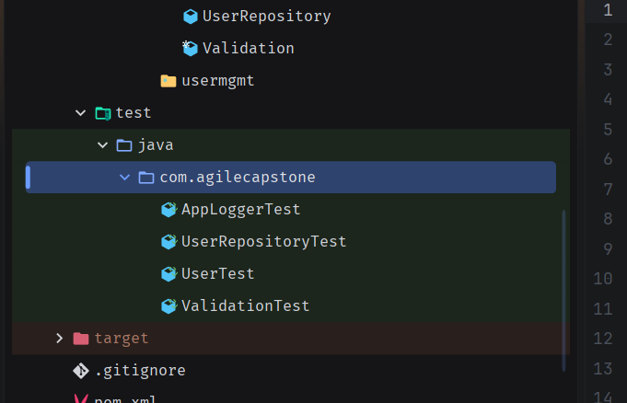4.2 Test Coverage
Unit tests cover all critical functionality:
User Model Tests:
• Constructor with all parameters
• Getter methods for id, name, email
• Setter methods for name and email
• toString() method output
Repository Tests:
• Create user successfully
• Find user by ID (existing and non-existing)
• List all users (with data and empty)
• Update user successfully
• Delete user (existing and non-existing)
• Prevent duplicate IDs
Validation Tests:
• Valid ID format (numbers only)
• Invalid ID (empty, non-numeric)
• Valid name (letters and spaces)
• Invalid name (empty, numbers)
• Valid email format
• Invalid email (no @, no domain)

4.3 Test Execution Results
All tests execute successfully using Maven:
mvn test
Test Execution Summary:
Test Class | Tests | Passed | Failed
UserTest | 4 | 4 | 0
UserRepositoryTest | 8 | 8 | 0
ValidationTest | 6 | 6 | 0
TOTAL | 18 | 18 | 0
✓ 100% Test Success Rate

5. Sprint 1 Review & Demo
This section demonstrates the working software delivered in Sprint 1, including Create, List, and Delete functionality with CI/CD pipeline.

5.1 Sprint 1 Scope
Sprint Goal: Deliver first working increment with core CRUD and DevOps pipeline
Completed User Stories:
• US-1: Create user with id, name, and email
• US-2: View all users
• US-4: Delete user by id
• US-3: Update user (completed ahead of schedule)

5.2 Application Demo
The console application provides an interactive menu for user management:
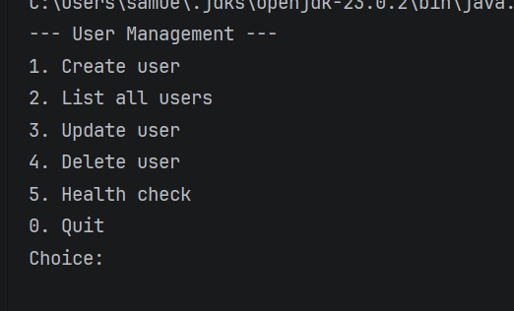

5.2.1 Create User (US-1)
Demonstrates user creation with validation:
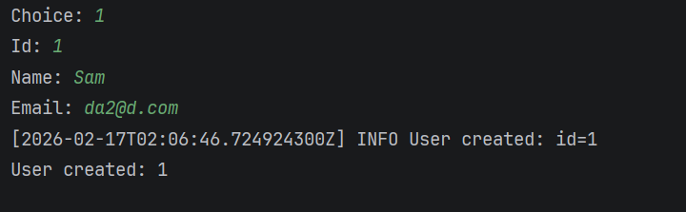

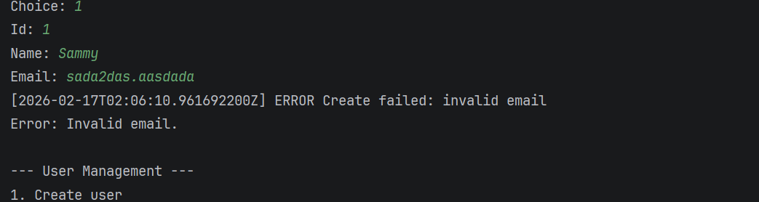Acceptance Criteria Met:
✓ User can enter id, name, and email
✓ Input validation works (ID numeric, email format, name letters)
✓ Success message displayed on valid input
✓ Error messages displayed for invalid input

5.2.2 List Users (US-2)
Displays all users in the system:
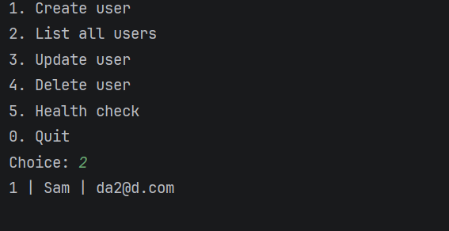
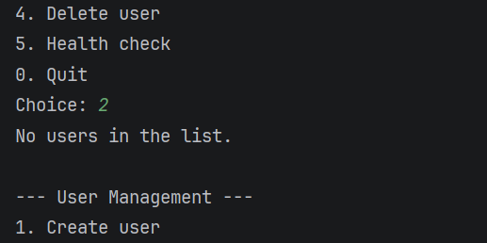
Acceptance Criteria Met:
✓ All users displayed with id, name, and email
✓ Clear formatting for readability
✓ Empty list shows appropriate message

5.2.3 Delete User (US-4)
Allows removal of users by ID:
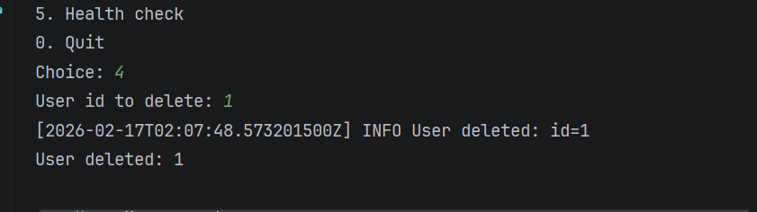
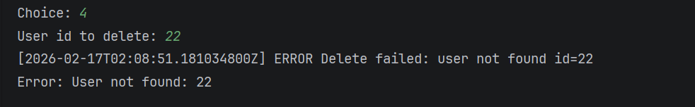
Acceptance Criteria Met:
✓ User can delete by entering ID
✓ Confirmation message displayed on success
✓ Error message for non-existent ID

5.2.4 Update User (US-3) - Bonus Story
Completed ahead of schedule:
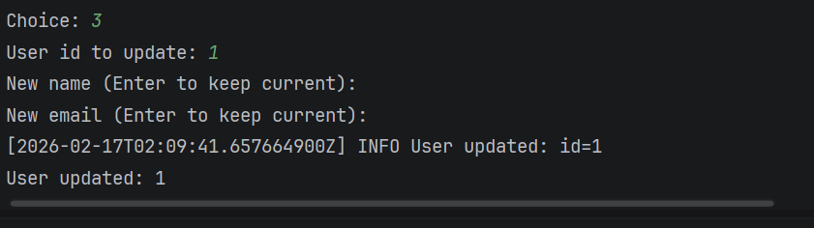

5.3 Sprint 1 Summary
Deliverables Completed:
✓ Core CRUD operations (Create, Read, Update, Delete)
✓ Input validation for all user inputs
✓ In-memory data storage (UserRepository)
✓ Comprehensive unit tests (18 tests, 100% pass)
✓ GitHub Actions CI pipeline
✓ Incremental Git commits and feature branches

6. Sprint 2 Review & Demo
This section demonstrates the enhancements delivered in Sprint 2, including logging, health check, and retrospective improvements.

6.1 Sprint 2 Scope
Sprint Goal: Complete CRUD, add monitoring/logging, apply Sprint 1 retrospective improvements
Completed User Stories:
• US-3: Update user (if not completed in Sprint 1)
• US-5: Health/status check
• US-6: Basic logging for key actions and errors

6.2 Retrospective Improvements Applied
Sprint 2 implemented the improvements identified in the Sprint 1 retrospective:
1. Logging from the Beginning:
• Created AppLogger class for centralized logging
• Integrated logging into all CRUD operations
• Log levels (INFO, ERROR) for different events
• Timestamps on all log entries
2. Branch Discipline:
• Strict feature branch workflow (feature/* → dev → main)
• Each story developed on dedicated branch
• Pull requests for all merges

6.3 Health Check Feature (US-5)
Menu option 5 provides a simple health/status indicator:
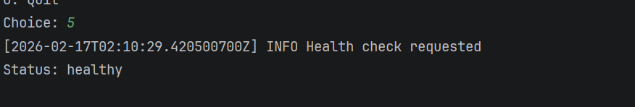
Acceptance Criteria Met:
✓ Health check option available in menu
✓ Returns clear 'healthy' status response
✓ Verifies application is running correctly

6.4 Logging Feature (US-6)
AppLogger provides visibility into all key actions and errors:
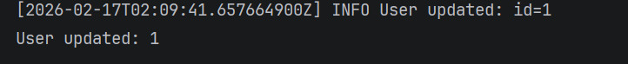
Logging Capabilities:
✓ Timestamps on all log entries
✓ Log levels: INFO for successful operations, ERROR for failures
✓ Logged actions: Create, Update, Delete, Health Check
✓ Logged errors: Validation failures, user not found, invalid input
✓ Contextual information in each log (user ID, operation type)

6.5 Code Evidence
Key code files added in Sprint 2:
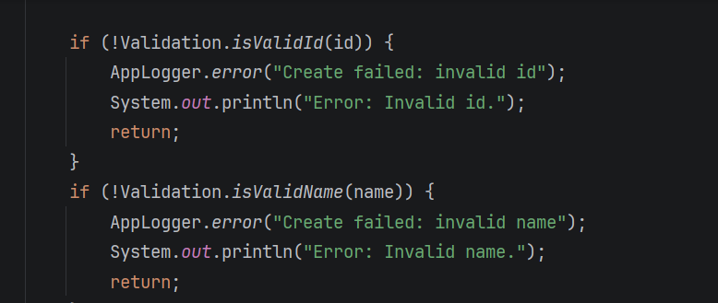

6.6 Sprint 2 Summary
Deliverables Completed:
✓ Health check feature for operational monitoring
✓ Comprehensive logging for all key actions and errors
✓ Applied retrospective improvements (logging, branching)
✓ All acceptance criteria met for remaining user stories
✓ Complete product backlog delivered

7. Retrospectives
This section documents the team's reflection on both sprints, identifying successes and opportunities for continuous improvement.

7.1 Sprint 1 Retrospective

What Went Well
• Clear scope: Having US-1, US-2, US-4 (and later US-3) defined with acceptance criteria made implementation straightforward.
• Small steps: Delivering Create, then List, then Delete in small commits kept the work manageable and reviewable.
• CI from the start: Adding the GitHub Actions workflow early meant every push was validated by build and tests.

What Could Be Improved
1. Logging from the Beginning
We added logging only when we thought about 'monitoring' later. In Sprint 2 we will add a simple AppLogger and log key actions (create, update, delete) and errors from the start for any new features, so we have visibility and easier debugging without rework.
2. Branch Discipline
Some work was done on a single branch. In Sprint 2 we will use strict branch workflow: one short-lived feature branch per story (e.g. feature/US-5-health-check), merge into dev after tests pass, then integrate dev into main only when the sprint increment is accepted. This keeps history clear and aligns with 'incremental delivery' and the assessment requirement.

Action Items for Sprint 2
☐ Introduce AppLogger (or equivalent) and use it for all new and existing CRUD paths and errors
☐ Use feature branches for each backlog item; merge to dev, then main after review/acceptance

7.2 Sprint 2 Final Retrospective

What Went Well
• Applied improvements: Both action items from Sprint 1 retrospective were successfully implemented (AppLogger and feature branch discipline).
• Complete backlog: All 6 user stories delivered with acceptance criteria met.
• Monitoring added: Logging and health check provide operational visibility that was missing in Sprint 1.
• CI/CD maturity: Pipeline ran successfully on all branches and pull requests.

What Could Be Improved (Future Work)
1. Persistent Storage
The current in-memory storage is great for learning but doesn't persist data. Future iterations could add database integration (e.g., H2, PostgreSQL) or file-based storage.
2. Enhanced Testing
While unit test coverage is good (18 tests), integration tests or end-to-end tests would provide additional confidence for the full application flow.
3. User Experience
A web interface or REST API would make the application more accessible than the current console interface.

Key Learnings
• Incremental delivery works: Small commits and feature branches made progress visible and reviewable.
• Retrospectives drive improvement: The two improvements from Sprint 1 made Sprint 2 smoother and more professional.
• CI/CD is essential: Automated testing caught issues early and gave confidence in changes.
• Monitoring matters: Adding logging early (as planned in Sprint 2) would have saved time debugging.

Conclusion
This Agile Capstone project successfully delivered a complete user management console application following Agile methodologies and DevOps best practices.
Project Highlights:
✓ Complete product backlog delivered (10 story points across 6 user stories)
✓ All acceptance criteria met and demonstrable
✓ Comprehensive test coverage (18 unit tests, 100% pass rate)
✓ Automated CI/CD pipeline with GitHub Actions
✓ Incremental delivery with feature branches and clean commit history
✓ Monitoring and logging for operational visibility
✓ Effective retrospectives leading to continuous improvement
The project demonstrates proficiency in Agile development practices, including sprint planning, incremental delivery, testing, CI/CD automation, and retrospective-driven improvement. The working software meets all requirements and provides a solid foundation for future enhancements.
Repository: https://github.com/Samuel1796/Agile_Capstone

