

**VERITAS UNIVERSITY ABUJA**

**(THE CATHOLIC UNIVERSITY OF NIGERIA)**

**NAME**

**IZUCHUKWU ZEAL CHIDUBEM**

**MATRIC NO**

**VUG/CSC/20/3969**

**COURSE CODE**

**CSC 417**

**COURSE TITLE**

**MOBILE APPLICATION DEVELOPMENT**

**DEPARTMENT**

**COMPUTER SCIENCE**

**DATE**

**22ND NOVEMBER, 2023**

**QUESTION:**

**Case Study 1: Travel Exploration App**

Design a mobile app that helps users discover unique and off-the-beaten-path travel destinations. Users should be able to plan their trips efficiently, considering both popular attractions and hidden gems.

**DELIVERABLES**

1. **WIREFRAMES:**

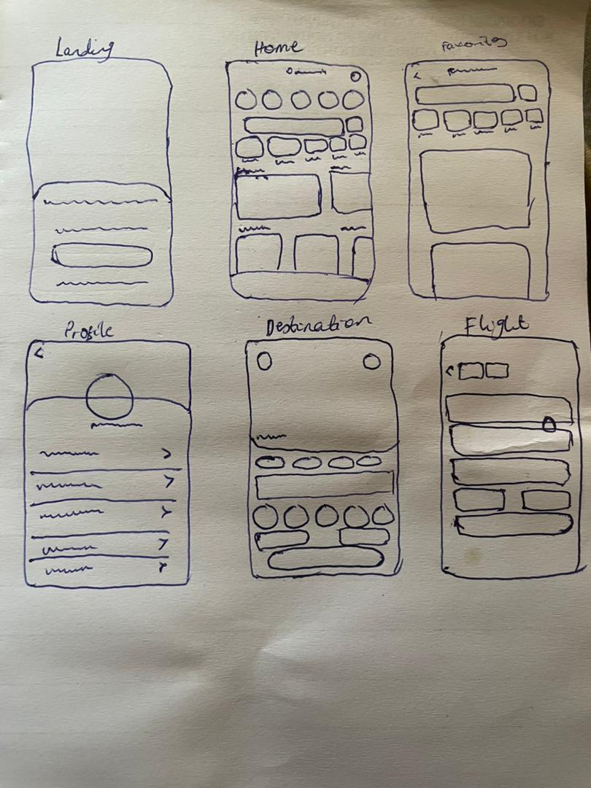

1. **PERSONAS:**

**Persona 1: Adventure Enthusiast - Jane**

Background:

Jane is a 28-year-old adventure seeker who works remotely.

Goals:

- Wants to discover unique and off-the-beaten-path destinations.

- Seeks thrilling activities like hiking, paragliding, and exploring local cultures.

Behaviors:

- Uses the app to find unconventional destinations and plan adventurous itineraries.

- Prefers spontaneous travel and values last-minute booking options.

Pain Points:

- Frustrated when information on adventurous activities is limited.

- Dislikes complex booking processes that hinder spontaneity.

**Persona 2: Family Vacation Planner - David**

Background

David, 35, is a father of two and works a demanding job.

Goals:

- Aims to plan family-friendly vacations with activities for all ages.

- Values convenience and ease of planning to maximize quality time with family.

Behaviors:

- Relies on the app to find family-friendly destinations and attractions.

- Prefers user-friendly interfaces for quick planning and booking.

Pain Points:

- Annoyed by limited options for family-oriented activities.

- Stressed when the booking process is time-consuming.

**Persona 3: Budget Traveler - Elena**

Background:

Elena, a 24-year-old student, is passionate about exploring on a tight budget.

Goals:

- Seeks affordable accommodation, transportation, and budget-friendly activities.

- Values discounts, deals, and budget tips to maximize her travel budget.

Behaviors:

- Uses the app to find budget-friendly destinations and affordable travel options.

- Actively engages with the app's budgeting and discount features.

Pain Points:

- Frustrated when budget options are limited.

- Dislikes hidden fees and unexpected costs during the booking process.

These personas, representing different aspects of the app's target audience, help guide the development and design process by aligning features and user experiences with the diverse needs, goals, and pain points of potential users.

1. **STYLE GUIDE:**

**COLOR SCHEME**

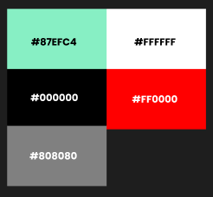

**TYPOGRAPHY**

Poppins – Bold, Semi-bold, Medium, Regular

Headings- 24

Sub-headings-20

Body-15

Others-13

**ICONGRAPHY**

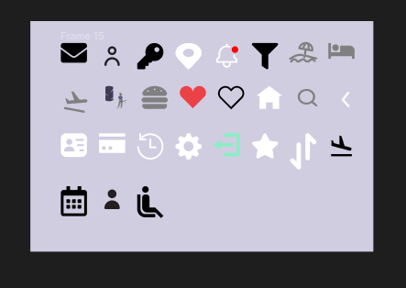

1. **USER FLOW:**
2. **UX USABILITY REPORT:**

Introduction:

The purpose of this usability report is to evaluate the user experience (UX) of the Travel Exploration App. The evaluation was conducted through user testing to identify strengths and areas for improvement.

Methodology:

We conducted usability tests with a diverse group of participants, ranging from novice to experienced travelers. Tasks included exploring destinations, planning itineraries, and booking accommodations. Observations were made, and participants provided feedback during and after the testing sessions.

Findings:

1. Intuitive Navigation:

- Positive: Users praised the app's intuitive navigation, with clear menu structures and easily accessible features.

- Recommendation: Maintain consistency and simplicity in navigation to enhance user engagement.

2. Destination Exploration:

- Positive: The app effectively presented diverse destinations with engaging visuals and relevant information.

- Recommendation: Consider incorporating personalized recommendations based on user preferences for a more tailored experience.

3. Itinerary Planning:

- Positive: Users found the itinerary planning feature helpful, but some struggled with adjusting dates and times.

- Recommendation: Streamline date and time adjustments, ensuring a seamless itinerary customization process.

4. Booking Process:

- Positive: Most users successfully completed bookings, highlighting the app's straightforward booking process.

- Recommendation: Optimize the checkout process for efficiency and clarity, minimizing steps and providing clear confirmation messages.

5. Search Functionality:

- Positive: Users appreciated the robust search functionality for flights, accommodations, and activities.

- Recommendation: Implement advanced filters and sorting options to accommodate users with specific preferences.

Conclusion:

The Travel Exploration App exhibits strong usability with an intuitive interface, effective destination exploration, and a generally seamless booking process. Addressing minor issues in date adjustments and further enhancing personalization features could contribute to an even more exceptional user experience.

Next Steps:

1. Conduct further testing to validate improvements.

2. Implement recommended enhancements.

3. Monitor user feedback for ongoing improvements.

This report serves as a foundation for refining the Travel Exploration App's UX, ensuring it remains user-friendly and aligned with the needs of its diverse user base.

1. **PROTOTYPE:**

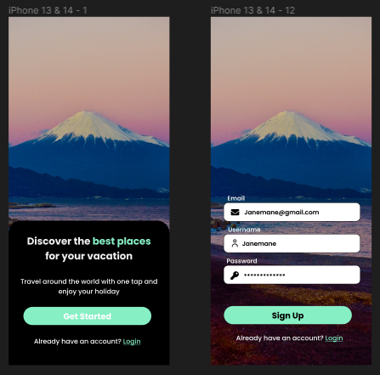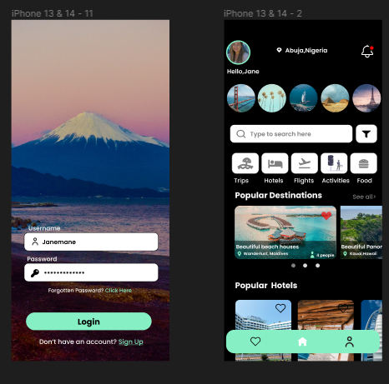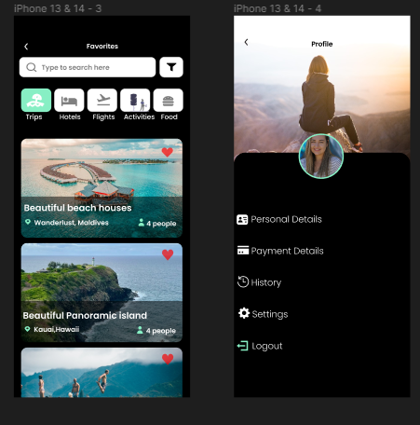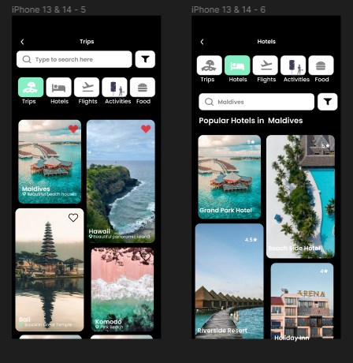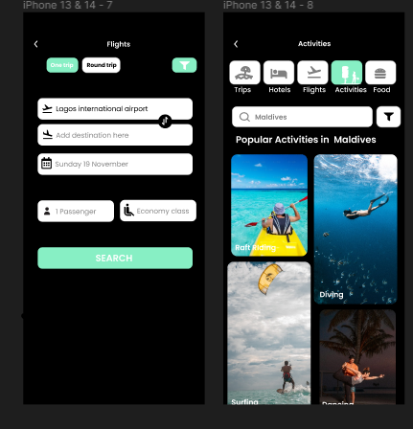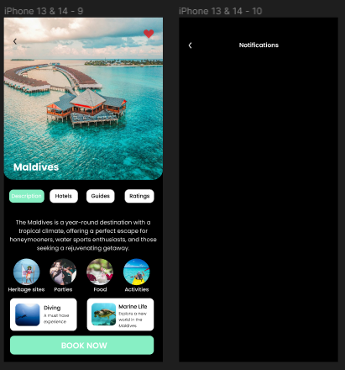

**ANALYSIS AND JUSTIFICATION OF DEVELOPMENT APPROACH:**

1. Performance:

- Observation: The app currently demonstrates strong performance, and users appreciate its responsiveness.

- Justification: Native development is well-suited for prioritizing performance, as it allows for the utilization of platform-specific optimizations. This choice ensures an optimal and smooth user experience, aligning with the positive feedback on the app's current performance.

2. User Experience:

- Observation: Users highly value the intuitive navigation and engaging features of the app but have identified areas for improvement in date adjustments and personalization.

- Justification: Native development excels in providing a platform-specific user experience. This approach allows for fine-tuning of UI/UX elements to meet user expectations, addressing the identified areas of improvement more effectively than hybrid or cross-platform solutions.

3. Development Time:

- Observation: The app is well-developed, but certain areas require refinement and enhancement.

- Justification: While native development may require more time due to separate codebases for each platform, the investment is justified by the benefits in performance and user experience. A well-structured development plan and the use of modern development tools can help mitigate potential delays.

4. Maintenance:

- Observation: Maintenance is crucial for ongoing user satisfaction and app relevance.

- Justification: Native development, although involving multiple codebases, can lead to more efficient maintenance. Platform-specific updates can be applied promptly, ensuring a streamlined process. This aligns with the need for continuous improvement identified in the usability study.

Conclusion:

Considering the emphasis on performance, user experience, and efficient maintenance, a native development approach is justified for the Travel Exploration App. While it may involve additional development time and maintenance effort compared to hybrid or cross-platform alternatives, the benefits in terms of app performance and tailored user experience make it the optimal choice for a travel exploration app aiming for a top-tier user interface and responsiveness.