Samuel Adamson
CSCI 260
Form to SQL Assignment

Flight data is collected using a Google Form. Data related to flights includes departure airport, arrival airport, departure time, arrival time, airline, and on time status. After data is collected using Google Forms, the results are download in comma-separated values format (.csv). The data is extracted, parsed, and inserted into the flight database using python. The data is queried using the SQLite3 command line interface.

Google Form: Link

Google Form Screenshots:
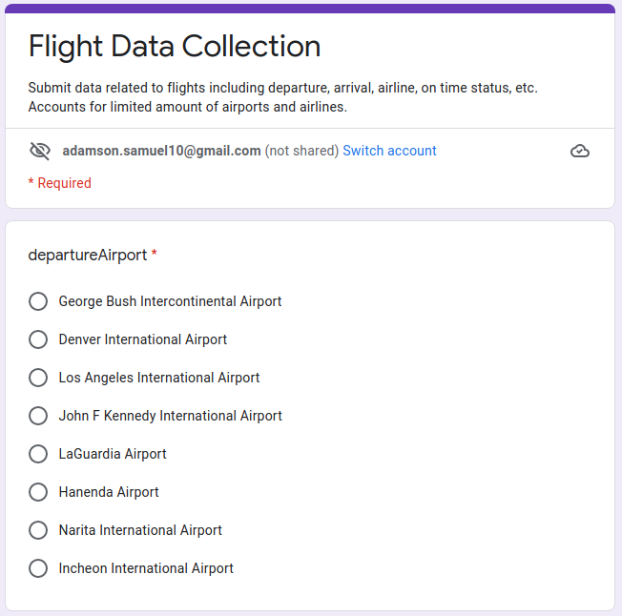
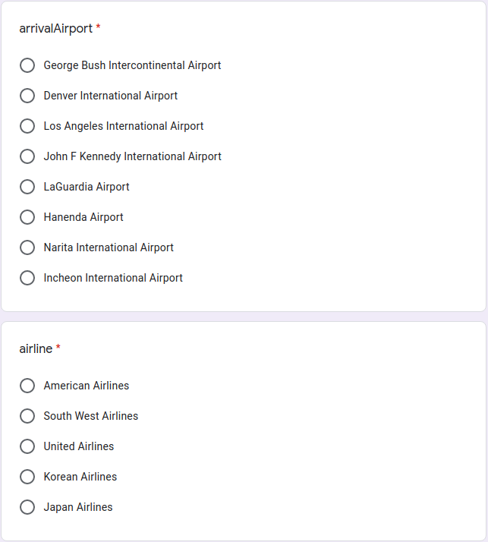
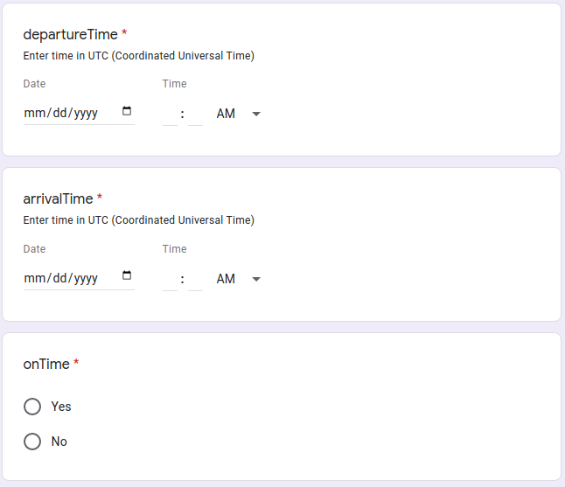

Downloaded Data from Google Forms (.csv format):

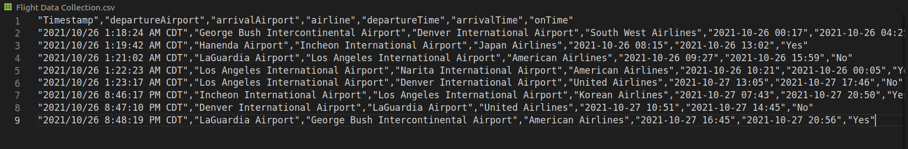
* For better visibility, see full file in attached source code

Sqlite3 query of flight table after initial table setup:

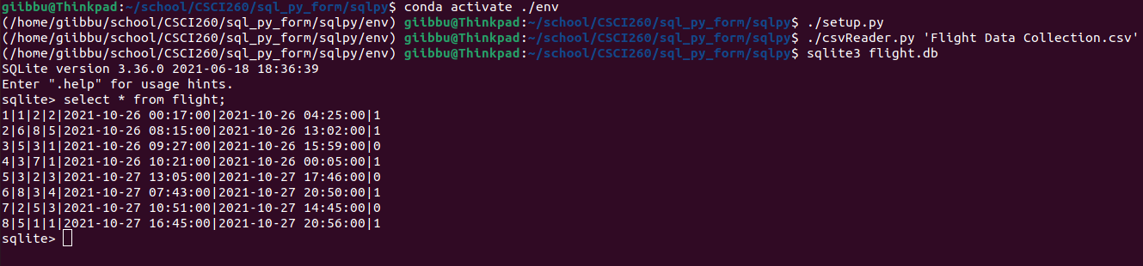

Sqlite3 query of flight table data using inner joins:

