 | | Process Definition Document

UIBANK – Login, Apply for a Loan, Check Loan

Table of Contents

| Process Definition Document 0
Table of Contents 1
I. Introduction 2
I.1 Purpose of the document 2
I.2 Objectives 2
I.3 Process key contact 2
I.4 Minimum Pre-requisites for automation 2
II. As-Is process description 3
II.1 Process Overview 3
II.2. Applications used in the process 4
II.3 As-Is Process map 4
II.4 Process statistics 5
II.5 Detailed As-Is Process Actions 6
II.6 Exceptions Handling 7
III. To-Be Process Description 8
III.1 To-Be Detailed Process Map 8
III.2 Parallel Initiatives/ Overlap (if applicable) 8
III.3 In Scope of RPA 8
III.4 Out of Scope of RPA 9
III.5 Business Exceptions Handling 9
III.6 Application Error and Exception Handling 10
III.7 Reporting 11
IV. Other Observations 11
V. Additional sources of process documentation 12

Introduction

I.1 Purpose of the document
The Process Definition Document outlines the business process chosen for automation using UiPath Robotic Process Automation (RPA) technology.
The document describes the sequence of actions performed as part of the business process, the conditions and rules of the process prior to automation and how they are envisioned to work after automating it, partly or entirely. This specifications document serves as a base for developers, providing them with the details required for applying robotic process automation to the selected business process.

I.2 Objectives
The business objectives and benefits expected by the Business Process Owner after automation of the selected business process are:
- Reduce average handling time per application from 4 min 10 s today [A-01] to 50 seconds or less per transaction (approximately 80%).
- Better Monitoring of the overall activity by using the logs provided by the robots.
- Eliminate manual re-keying after a verification mismatch, which affects about 6% of applications today [A-02]; every mismatch is raised as BE-17 instead.
- Provide a full audit trail per application of what was submitted, what UiBank decided and what was stored.
Baseline note: the 16.2 seconds in II.4 is the Task Capture recording of one happy-path run and is click time only. It excludes think time, data lookup and exception handling, and must not be used as the benefit baseline. Objectives 1 and the FTE figure in II.1 cannot be signed off until [A-01] and [A-03] are measured from a time-and-motion sample of 20 applications.

I.3 Process key contact
The specifications document includes concise and complete requirements of the business process and it is built based on the inputs provided by the process Subject Matter Expert (SME)/ Process Owner.
The Process Owner is expected to review it and provide signoff for accuracy and completion of the actions, context, impact and a set of process exceptions. The details are to be included in the table below.
Role | Name | Contact details  (email, phone number) | Notes
Process Owner (Loan Operations) | TBC | TBC | Accountable for signing off the exception catalogue in III.5 and III.6
Process SME | TBC | TBC | Confirms the data dictionary in II.5.1
Business Analyst | Samuel Simao | - | Author of this revision
RPA Solution Architect | TBC | TBC | Owns the To-Be design in III.2
Application Owner (UiBank) | TBC | TBC | Confirms environments, authentication and UI release notice
Data Protection / Security | TBC | TBC | Confirms log masking and retention constraints in III.10
No signatures are held. This is the blocking gate for development: without a named Process Owner there is nobody to accept the exception catalogue or to escalate to during UAT.

I.4 Minimum Pre-requisites for automation
- A filled in Process Definition Document
- Test Data to support development
- User access and creation of user accounts (licenses, permissions, restrictions to create accounts for robots)
Status of each pre-requisite at the time of writing:
# | Pre-requisite | Status | Owner
1 | Filled-in Process Definition Document signed off by the Process Owner | Not met - this revision is a draft | Business Analyst
2 | Test data covering the happy path and every BE and AE condition below | Not met | Business Analyst + SME
3 | Robot account in UiBank with permission to submit a loan application | Not met | Application Owner
4 | Credential asset created in Orchestrator | Not met | RPA support
5 | DEV / TEST / PROD UiBank URLs confirmed, and whether PROD submissions are reversible | Not met | Application Owner
6 | Unattended robot licence and machine template available | Not met | RPA support

I.5 Assumptions register
Every figure in this document tagged [A-nn] was supplied by the Business Analyst, not by the business, and is listed here for confirmation. No assumption marked Low confidence may be treated as a requirement, and development must not start against [A-06], which is the highest-risk item in the document.
ID | Assumption | Confidence | Confirm with
A-01 | Average manual handling time is 4 min 10 s per application | Low | Time-and-motion sample
A-02 | About 6% of applications are re-keyed after a verification mismatch today | Low | Loan Operations
A-03 | 3.0 FTE currently support this activity | Low | Loan Operations manager
A-04 | Volume is about 400 applications per business day and 700 at month-end peak | Low | Loan Operations MI
A-05 | Applications arrive as one row per applicant in a spreadsheet on a shared drive | Medium | Loan Operations
A-06 | Loan Term is expressed in MONTHS and restricted to 12 / 24 / 36 / 48 / 60 | Low | Application Owner
A-07 | Amount is permitted between 1,000 and 1,000,000 in a single product currency | Low | Product / Credit
A-08 | Minimum applicant age is 18 and maximum age at maturity is 75 | Medium | Credit policy
A-09 | Amount may not exceed 5 x Yearly Income | Low | Credit policy
A-10 | Only one active loan per email address is permitted | Low | Credit policy
A-11 | The duplicate window for the same email, amount and term is 30 days | Low | Loan Operations
A-12 | Loan ID is a system-generated numeric string, stable and unique | Medium | Application Owner
A-13 | Declined and Pending are valid business outcomes, not automation failures | High | Loan Operations
A-14 | Applications submitted after 18:00 local are dated the next business day | Low | Loan Operations
A-15 | Maximum acceptable transaction duration is 3 minutes | Medium | Solution Architect
A-16 | UiBank permits concurrent sessions for the same robot account | Low | Application Owner

As-Is process description

II.1 Process Overview
General information about the process selected for RPA prior to automation.
# | Item | Description
1 | Process full name | UiBank - Loan Application Submission and Verification
2 | Process Area | Retail Lending
3 | Department | Loan Operations
4 | Process short description  (operation, activity, outcome) | For each applicant: log in to UiBank, submit a loan application, capture the returned Loan ID and decision, then look the loan up again and verify that the stored details match what was submitted.
5 | Role(s) required for performing the process | Loan Operations Administrator
6 | Process schedule and frequency | Continuous during business hours, 07:00-19:00 local, Monday to Friday [A-04]
7 | # of items processed /reference period | About 400 applications per business day [A-04]
8 | Process execution time | Average manual handling time 4 min 10 s per application [A-01]. The 16.2 sec. below is the Task Capture recording of one happy-path run (click time only) and is not a processing time.
9 | Peak period (s) | Last three business days of the month; also the first Monday after a rate change [A-04]
10 | Transaction Volume During Peak period | About 700 applications per day [A-04]
11 | Total # of FTEs supporting this activity | 3.0 [A-03]
12 | Expected increase of volume in the next reference period | +15% over the next 12 months [A-04]
13 | Level of exception rate | About 8% of applications hit a business exception today [A-02]
14 | Input data | Spreadsheet on a shared drive, one row per applicant: Email, Amount, Loan Term, Yearly Income, Age [A-05]
15 | Output data | Loan ID, loan decision and verification result written back to the source row; exception report for every failed row

*Add more rows to the table to include relevant data for the automation process. No fields should be left empty. Use “n/a” for the items that don`t apply to the selected business process.

II.2. Applications used in the process
The table includes a comprehensive list of all the applications that are used as part of the process to be automated to perform the given actions in the flow.
# | Application name & version | System Language | Thin/Thick  Client | Environment/  Access method | Comments
1 | UiBank web application (version TBC) | English | Thin (browser) | DEV / TEST / PROD URLs all TBC. Username and password; confirm whether MFA or SSO is enforced | Robot account must hold permission to submit. Confirm concurrent-session support [A-16] before sizing more than one robot
2 | Google Chrome (version TBC) | English | Thick | Robot machine template; UiPath browser extension required | The recording was made in Chrome. Pin the version and disable auto-update on robot machines, or accept AE-11
3 | Microsoft Excel - loan application source file | English | Thick | Shared drive path TBC; Windows / file share ACL | Robot account needs read and write. The file must not be held open by a user - see AE-14
4 | UiPath Orchestrator (Automation Cloud) | English | Thin | Tenant TBC, folder TBC; robot authentication | Holds the queue, the credential asset and the configuration assets
*Add more rows to the table to include the complete list of applications.
Credentials are held in an Orchestrator credential asset and read at runtime with Get Credential. They are never placed in the workflow or in the configuration sheet. Orchestrator asset types include a Credential type whose value is split into Username and Password fields, and it can be backed by an external credential store rather than the Orchestrator database. See docs.uipath.com/orchestrator/automation-cloud/latest/user-guide/managing-assets-in-orchestrator

II.3 As-Is Process map

High Level As-Is Process Map:
This chapter depicts the As-Is business process at a High Level to enable developers to have a high-level understanding of the current process.
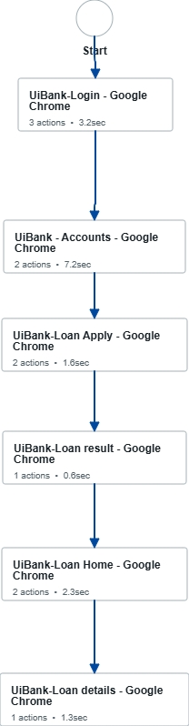

II.4 Process statistics

High level statistics
Processes | Windows | Actions | Mouse clicks | Keys pressed | Text entries | Hotkeys used | Time
1 | 7 | 11 | 11 | 0 | 0 | 0 | 16.2 sec.

Detailed statistics
Window name | Mouse Clicks | Text entries | Keys pressed
UiBank-Login - Google Chrome | 3 | 0 | 0
UiBank - Accounts - Google Chrome | 1 | 0 | 0
UiBank-Loan Apply - Google Chrome | 2 | 0 | 0
UiBank-Loan result - Google Chrome | 1 | 0 | 0
UiBank-Loan Home - Google Chrome | 2 | 0 | 0
UiBank-Loan details - Google Chrome | 1 | 0 | 0
UiBank-Loan Lookup - Google Chrome | 1 | 0 | 0

These figures are Task Capture telemetry, not process metrics. "Text entries: 0" cannot be right, because the process types five form fields plus a username and password, so the recording is known to be incomplete. Treat the recorded step titles as a checklist, not as a specification.

II.5 Detailed As-Is Process Actions
The recorded steps below are numbered A01 to A11 and referenced by those IDs throughout this document (II.5.2, III.3, III.5, III.6). A01-A03 log in, A04 navigates to the loan form, A05 enters the request data, A06 submits, A07 reads the decision and captures the Loan ID, A08-A09 open Check Loan and enter the Loan ID, A10 opens the loan details and A11 verifies them against what was submitted.
Task Capture recorded the action type of every step as "Click", including the typing steps and a Ctrl+V. The Action fields below have been corrected; see III.11 for the full list of defects carried over from the recording.

UiBank-Login - Google Chrome
Est. time: 3.2 sec.

Type Username
 | Est. time: 1.3 sec.
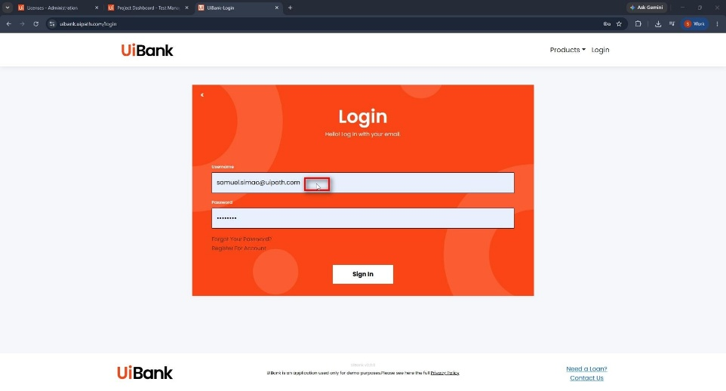 | Action: Type Into (username from the Orchestrator credential asset, never from the source file)

Type Password
 | Est. time: 0.8 sec.
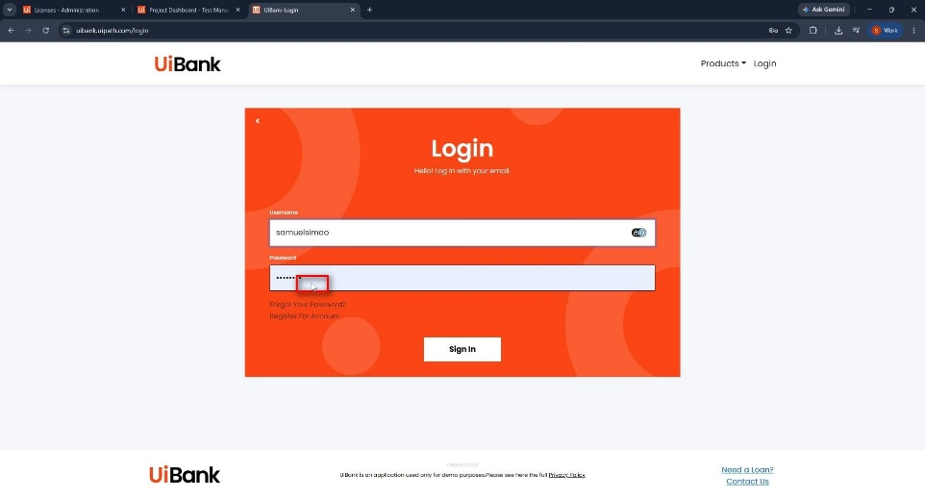 | Action: Type Into (secure string; SimulateType preferred over hardware events)

Click Sign In
 | Est. time: 1.1 sec.
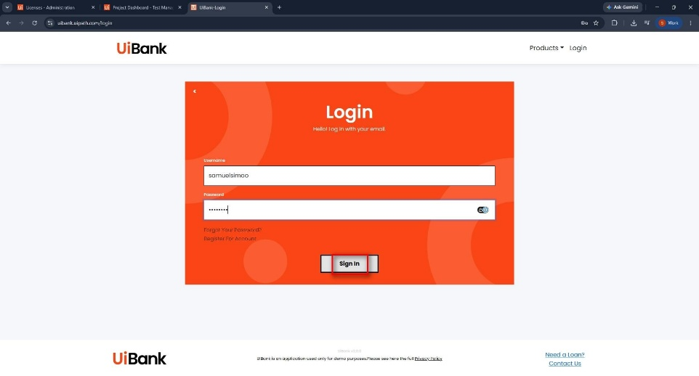 | Action: Click (wait for the Accounts page as the success anchor, not a fixed delay)

UiBank - Accounts - Google Chrome
Est. time: 7.2 sec.

Navigate to Apply Loans page
 | Est. time: 5.9 sec.
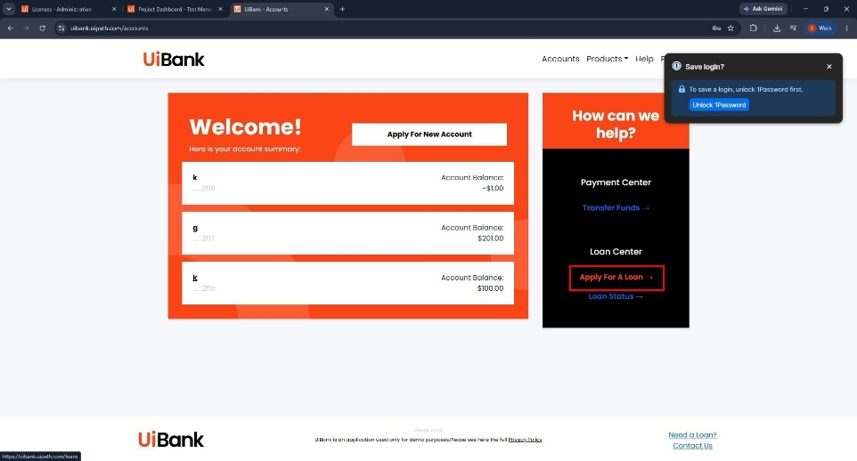 | Action: Click

Click Apply for A Loan
 | Est. time: 1.3 sec.
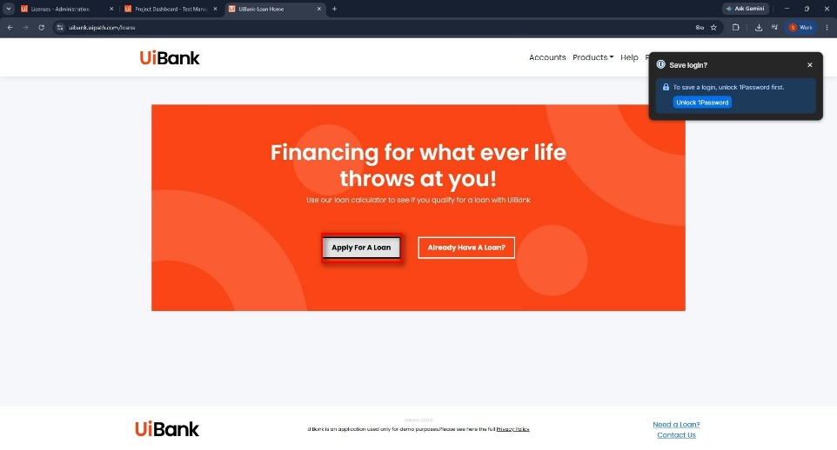 | Action: Click

UiBank-Loan Apply - Google Chrome
Est. time: 1.6 sec.

Type Loan request data
Type  - Email  - Amount  - Loan Term  - Yearly Income  - Age | Est. time: 0.9 sec.
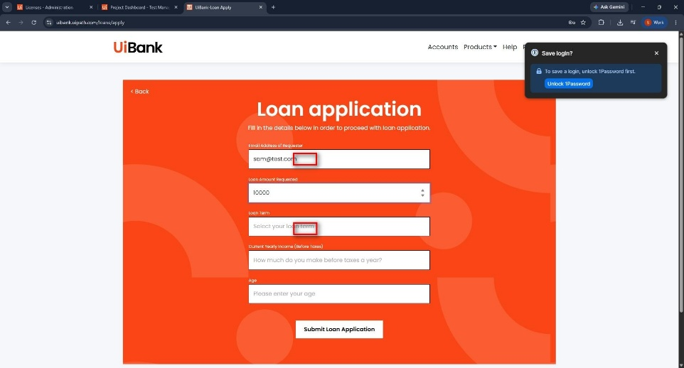 | Action: Type Into / Select Item (field rules in II.5.1)

Click Submit
 | Est. time: 0.7 sec.
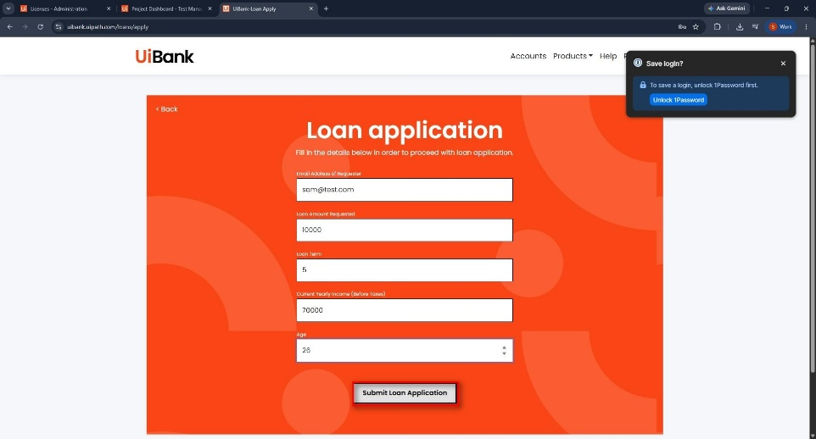 | Action: Click - A06, the only state-changing action in the process (see III.6.1)

UiBank-Loan result - Google Chrome
Est. time: 0.6 sec.

Check the results and Grab the Loan Id
 | Est. time: 0.6 sec.
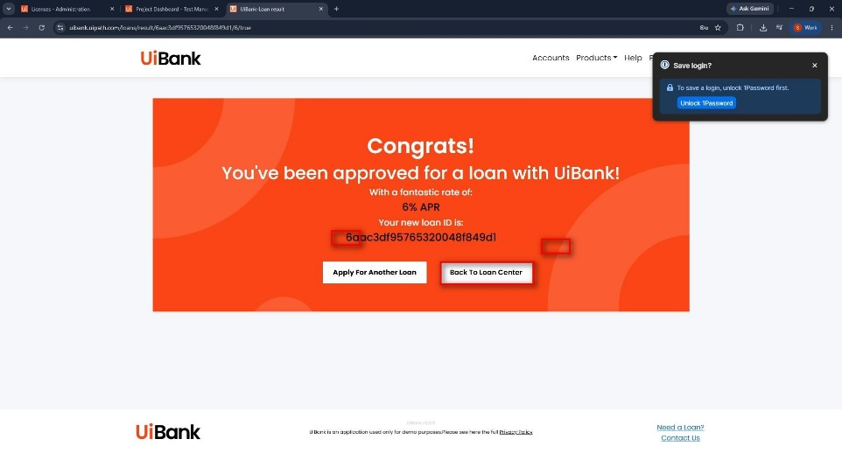 | Action: Get Text - capture the decision (Approved / Declined / Pending) AND the Loan ID

UiBank-Loan Home - Google Chrome
Est. time: 2.3 sec.

Go to Check Loan
 | Est. time: 1.5 sec.
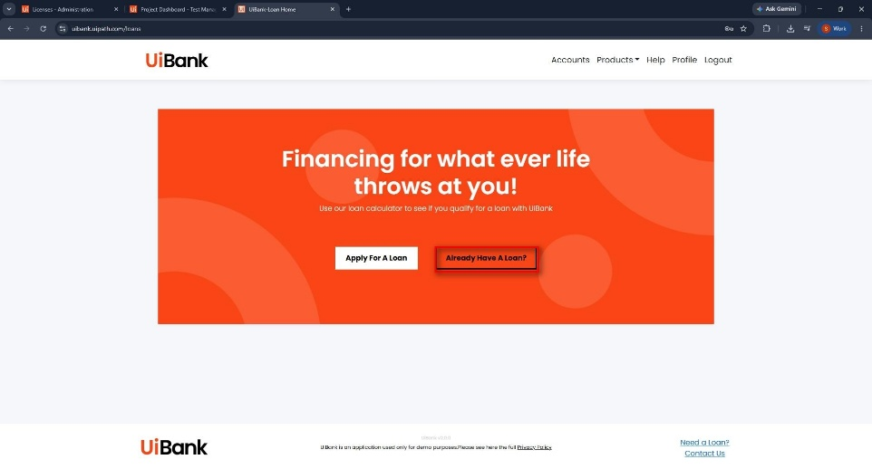 | Action: Click

Press 'Ctrl+v'
 | Est. time: 0.9 sec.
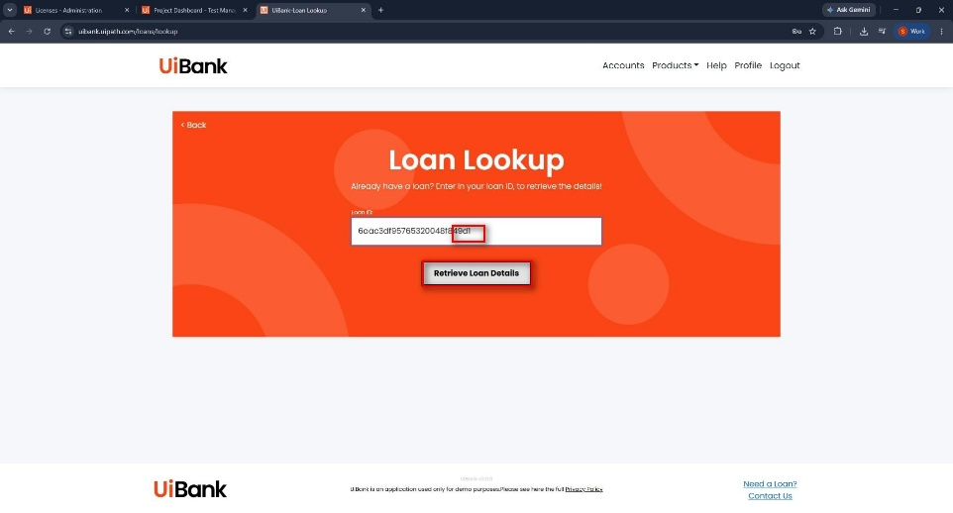 | Action: Type Into - the Loan ID is passed as a workflow argument. The clipboard is NOT used (defect D-02)

UiBank-Loan details - Google Chrome
Est. time: 1.3 sec.

Check Loan Details Match
 | Est. time: 1.3 sec.
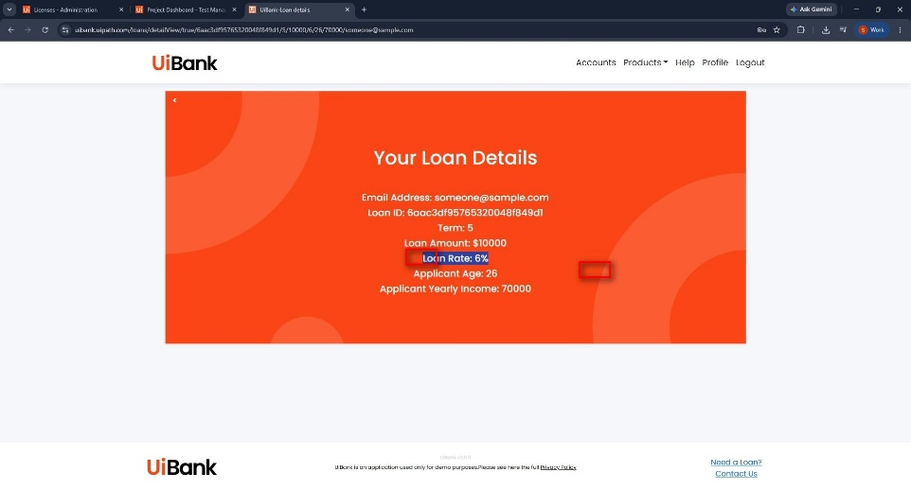 | Action: Get Text and compare field by field against the submitted values (II.5.2)

II.5.1 Data dictionary and validation rules
A05 types five fields and the recording names them without stating a single type, format or permitted value. Developers and testers work from the table below.
Field | Type | Format | Mandatory | Valid range or values | Rule
Email | String | local-part@domain, one address, trimmed, lower-cased for comparison | Yes | Must belong to a registered UiBank customer | A-05
Amount | Decimal | 2 decimal places, "." separator, no thousands separator, no currency symbol | Yes | 1,000.00 to 1,000,000.00 | A-07
Loan Term | Integer | Whole months, from a fixed list | Yes | 12, 24, 36, 48, 60 | A-06
Yearly Income | Decimal | Same formatting rule as Amount | Yes | Greater than 0 | A-07
Age | Integer | Whole years | Yes | 18 to 75, and Age + (Loan Term / 12) not greater than 75 | A-08
Loan ID (output) | String | System-generated, numeric | n/a | Non-empty, unique per application | A-12
Loan decision (output) | Enum | Approved / Declined / Pending | n/a | Any of the three is a valid outcome | A-13
Derived credit rules applied before submission: Amount not greater than 5 x Yearly Income [A-09], and only one active loan per email address [A-10].
Highest-risk unconfirmed item: if the UiBank Loan Term field is in years while the source data is in months, every application submits a term twelve times wrong and still returns a valid Loan ID. Nothing fails and the process quietly produces bad loans. Confirm [A-06] before development starts and cover it explicitly in UAT.

II.5.2 Verification rules for A11
A11 ("Check Loan Details Match") is the business purpose of the whole process and the recording describes it in one line. The comparison is specified below. The source of truth is what UiBank stored; any mismatch is BE-17 and is never silently corrected and never resubmitted.
Submitted field | Compared against | Comparison | Tolerance
Email | Loan details - applicant email | Case-insensitive, trimmed string equality | None
Amount | Loan details - loan amount | Numeric, parsed to decimal, compared at 2 dp | Plus or minus 0.01 (rounding only)
Loan Term | Loan details - term | Integer equality after normalising units per [A-06] | None
Yearly Income | Loan details - declared income | Numeric at 2 dp | Plus or minus 0.01
Age | Loan details - applicant age | Integer equality | None
Loan ID | The ID captured at A07 | Exact string equality | None

II.6 Exceptions Handling
How the process copes today, before automation. The last row is the reason the To-Be design in III.6.1 needs an explicit safe-resubmit rule.
Situation today | Current human behaviour | Consequence
Validation error on submit | Administrator corrects the value inline from memory of the policy | No record of what was changed or why
Loan declined | Row annotated and the applicant emailed manually | Inconsistent wording, no SLA
Details do not match after lookup | Application re-keyed from scratch | Creates duplicate applications [A-02]
UiBank unavailable | Batch parked and resumed by whoever is on shift | Work silently ages with no visibility
Submitted but no Loan ID shown | Administrator resubmits | Primary source of duplicate loans today - the reason III.6.1 exists

To-Be Process Description
This chapter highlights the expected design of the business process after automation.

III.1 To-Be Detailed Process Map
Highlight Bot interventions/ To-Be automated actions with different legend/ icon (purple)
*Mention below if process improvements were performed on the To-Be design and provide details.
The decision logic the To-Be map must express, pending the drawn diagram:
1. Source file: the Dispatcher validates each row against the data dictionary (II.5.1) and the credit rules, then pushes it to the Orchestrator queue UIBANK_LoanApplications.
2. PERFORMER INIT: read configuration and assets, launch Chrome, log in to UiBank (A01-A03).
3. Decision - is the input data valid against the business rules? If no: BE-01 to BE-12, Business Exception, no retry, row flagged in the exception report.
4. A04-A06: navigate to the loan form, enter the request data and submit.
5. Decision - was a Loan ID returned on the result page (A07)? If no: BE-13, run the duplicate-safe check in III.6.1 before any retry.
6. A08-A10: look the loan up by Loan ID in Check Loan and open the details.
7. Decision - do the retrieved details match the submitted values (A11)? If no: BE-17, park the item for business review.
8. If yes: Set Transaction Status = Success and write the Loan ID and decision back to the source row.

III.1.1 Solution shape
Item | Decision | Rationale
Pattern | Dispatcher and Performer on the Robotic Enterprise Framework | Transactional, one applicant per queue item, so a bad row cannot stop the batch
Transaction | One loan application | Matches the natural business unit and the verification boundary
Input | Orchestrator queue UIBANK_LoanApplications, loaded by the Dispatcher from the source file [A-05] | Gives retry semantics, SLA tracking and per-item audit
Mode | Unattended, queue trigger | No human in the happy path
Configuration | Orchestrator assets for URLs, thresholds and notification addresses; nothing hard-coded | Credit thresholds [A-07] to [A-11] change without redeployment
Credentials | Orchestrator credential asset read with Get Credential | See the note in II.2
Output | Loan ID, decision and verification result written back to the source row; exception report per run | -
Clipboard | Not used anywhere | See defect D-02 in III.11
Legend | Description
 | Action number in the process. Referred to in details or Exceptions and Errors table
 | This process action is proposed for automation
 | This process action remains manual (to be performed by a human agent)

III.2 Parallel Initiatives/ Overlap (if applicable)
This chapter covers the proposed Business, Process & System changes to be made in the near future and their impact.
S.No | Initiative Name | Process Acion(s) where it is identified | Impact on current automation request? How? | Expected Completion Date | Contact person for more details
 | n/a

III.3 In Scope of RPA
The activities In scope of RPA, are listed here:
- Actions A01 to A11 inclusive, for every row of the source file, plus Dispatcher validation, queue management, write-back to the source row and exception reporting.
The recording contains 6 windows and 11 actions, so the earlier reference to "Actions 1-10" did not reconcile with II.5. A01 to A11 is now the single numbering scheme used in this document.

III.4 Out of Scope of RPA
The activities Out of scope of RPA, are listed here:
Sub-process (if applicable) | Activity (action) | Reasons for Out of scope* | Impact on the To-Be | Possible measures to be taken into consideration for future automation
Loan application intake | Creating the source file | Upstream of this process, owned by the branch network | The robot depends on the file being present and schema-stable by 07:00 | Replace the file with an API or a Data Service entity
Credit | Credit decisioning | Performed inside UiBank | The robot records the decision and never overrides it | None
Underwriting | Manual underwriting of Pending cases | Requires human judgement | BE-15 parks the item for an underwriter | Action Center task instead of an exception report
Customer contact | Communicating the decision to the applicant | Owned by Loan Operations; template and tone not agreed | The robot produces the data, not the email | Candidate for phase 2
KYC | Onboarding applicants whose email is not registered | Separate KYC process | BE-09 rejects the row | None
Product | Multi-currency applications | Single product currency [A-07] | BE-11 rejects the row | Phase 2 if the product expands
*Add more rows to the table to reflect the complete documentation provided to support the RPA process.

III.5 Business Exceptions Handling
The Business Process Owner and Business Analysts are expected to document below all the business exceptions identified in the automation process. These can be classified as:
Known | Unknown
Previously encountered. A scenario is defined with clear actions and workarounds for each case. | New situation never encountered before. It can be caused by external factors. Cannot be predicted with precision, however if it occurs, it must be communicated to an authorized person for evaluation.

Known Exceptions
The table below reflects all the business process exceptions encountered during the process evaluation and documentation. These are known exceptions that occurred before. For each of these exceptions, define a corresponding expected action that the robot should complete if it encounters the exception.
A Business Exception is rooted in the data the automation depends on being incomplete or missing. Retrying it has no chance of helping, so Orchestrator does not retry a transaction failed this way and the correct response is to notify a human. Every row below is therefore no-retry, Set Transaction Status = Failed / Business Exception, with the reason written to queue item specific data and to the daily exception report. Reference: docs.uipath.com/orchestrator/automation-cloud/latest/user-guide/business-exception-vs-application-exception
BE # | Exception name | Action | Parameters | Action to be taken
BE-01 | Applicant below minimum age | Dispatcher, re-checked before A06 | Age < 18 [A-08] | Do not submit; flag the row in the exception report
BE-02 | Applicant above maximum age at maturity | Dispatcher | Age + (Term / 12) > 75 [A-08] | Do not submit; flag the row
BE-03 | Amount outside the product range | Dispatcher | Below 1,000 or above 1,000,000 [A-07] | Do not submit; flag the row
BE-04 | Loan Term is not an offered value | Dispatcher | Not in 12 / 24 / 36 / 48 / 60 [A-06] | Do not submit; flag the row
BE-05 | Amount exceeds the income multiple | Dispatcher | Amount > 5 x Yearly Income [A-09] | Do not submit; flag the row
BE-06 | Yearly Income zero, blank or negative | Dispatcher | Income not greater than 0, or empty | Do not submit; flag the row
BE-07 | Mandatory field blank | Dispatcher | Any of the five fields in II.5.1 is empty | Do not submit; flag the row
BE-08 | Email fails format validation | Dispatcher | Regex plus single-address check | Do not submit; flag the row
BE-09 | Email is not a registered UiBank customer | A06 validation message | UiBank rejects the email | Flag the row; do not retry. Refer to KYC
BE-10 | Amount or Income cannot be parsed | Dispatcher | Locale or currency formatting, for example 10.000,00 or a currency symbol | Do not submit; flag the row with the raw string
BE-11 | Currency other than the product currency | Dispatcher | Currency differs from the product currency [A-07] | Do not submit; flag the row
BE-12 | Duplicate application inside the duplicate window | Dispatcher, against the processed log | Same Email, Amount and Term within 30 days [A-11] | Do not submit; flag as a suspected duplicate for Loan Operations
BE-13 | Submit appeared to succeed but no Loan ID was returned | A07 | Loan ID field empty or absent once the result page renders | Do NOT resubmit. Run the duplicate-safe check in III.6.1, then flag
BE-14 | Loan declined by UiBank | A07 | Decision = Declined | Valid outcome, not a failure. Write the decision back, Set Transaction Status = Success and continue to A08-A11
BE-15 | Loan referred to manual underwriting | A07 | Decision = Pending | Valid outcome. Write back, mark for underwriter review and skip the decision-field comparison
BE-16 | Loan ID not found by Check Loan | A09-A10 | The lookup returns no record | Retry the lookup once after 30 s to allow for indexing delay, then flag. Never resubmit the application
BE-17 | Retrieved details differ from the submitted values | A11 | Any comparison in II.5.2 fails outside tolerance | Flag with a field-level diff of submitted versus retrieved. Do not correct and do not resubmit
BE-18 | Applicant already holds an active loan above the limit | A06 validation message | UiBank rejects on the concurrency rule [A-10] | Flag the row
BE-19 | Source row already carries a Loan ID | Dispatcher | Loan ID column is not empty | Skip the row and do not enqueue it. This is the outer idempotency guard
BE-20 | Application submitted after the daily cut-off | A07 | The result page shows a next-business-day effective date [A-14] | Accept as success and record the effective date
BE-14 and BE-15 are the two rows most often mishandled. A declined or pending loan is the system working correctly. If a BusinessRuleException is thrown for either, the queue fills with false failures, the exception report becomes noise and Loan Operations stops reading it. Both must complete as Success with the decision recorded.

Unknown Exceptions
For all other unanticipated or unknown business (process) exceptions, the robot should:
- Capture a screenshot and the full page text.
- Fail the transaction as a Business Exception, quoting the UiBank message verbatim.
- Write that message to queue item specific data.
- Continue with the next transaction rather than stopping the job.
- Include the item in the daily exception report tagged UNCLASSIFIED.
Any UNCLASSIFIED condition that appears three times in one week is raised to the Business Analyst for classification into a new BE row and a matching Test Manager requirement.

III.6 Application Error and Exception Handling
A comprehensive list of all errors, warnings or notifications should be consolidated here with the description and action to be taken, for each, by the robot.
Errors identified in the automation process can be classified as:

Area | Known | Unknown
Technology/Applications | Experienced previously, an action plan or a workaround available. | Never encountered before, or may happen independently of the applications used in the process.

Known Errors or Exceptions
The table below reflects all the errors identified in the process evaluation and documentation.
For each of these errors or exceptions, define a corresponding expected action that the robot should complete if it is encountered.
An Application Exception is rooted in a technical issue such as an application not responding, and retrying it has a genuine chance of succeeding, which is why Orchestrator retries transactions failed this way. The single generic row in the original document ("recover and retry 3 times") is replaced by the catalogue below.

# | Error name | Action | Parameters | Action to be taken
AE-01 | UiBank unreachable - DNS failure, connection refused or 5xx | INIT or any action | Error message and screenshot | Fail as an Application Exception. 3 attempts with 60 s / 5 min / 15 min backoff, then stop the job and alert RPA support and the Application Owner
AE-02 | Credentials rejected - rotated or expired password | A01-A03 | Login error message | Stop the job immediately. NO retry: repeated attempts risk locking the robot account
AE-03 | Robot account locked or disabled | A01-A03 | Account status message | Stop the job immediately. No retry. Alert IAM and RPA support
AE-04 | MFA or CAPTCHA challenge presented | A01-A03 | Challenge page | Stop the job and flag as not automatable in the current design. No retry
AE-05 | Credential or configuration asset missing, empty or malformed | INIT | Asset name | Abort before any transaction is picked up. No retry
AE-06 | Session expired mid-transaction | A04-A11 | Redirect to the login page | Re-run INIT, then restart the transaction only after the duplicate-safe check in III.6.1. Maximum 2 retries
AE-07 | Page load timeout or partial render | Any action | Timeout and screenshot | Retry the step, then fail the transaction. Maximum 2 retries
AE-08 | Selector not found after a UiBank UI change | Any action | Selector and screenshot | Screenshot and fail the transaction. 1 retry only: this usually needs a code fix, not a retry
AE-09 | Submit clicked but the result page never renders | A06 | Screenshot | NEVER blind-retry. Follow III.6.1 to determine whether the loan was created
AE-10 | Two Loan IDs found for one source row | A09 | Both Loan IDs | Stop the transaction and flag both IDs for duplicate remediation by Loan Operations
AE-11 | Browser crash or Chrome auto-update mid-run | Any action | Process exit | Close and relaunch the browser, then restart the transaction after III.6.1. Maximum 2 retries
AE-12 | Unexpected modal intercepts clicks - cookie banner or release notes | Any action | Modal title | Dismiss modals listed in the configuration asset; otherwise fail the transaction and add the modal to the list
AE-13 | Network drop mid-transaction | Any action | Connection error | Treat as AE-06. Maximum 2 retries
AE-14 | Source file locked by another user | Dispatcher | File path | Retry 3 times at 5 minute intervals, then abort the job without partial enqueueing
AE-15 | Orchestrator queue unreachable or not found | Dispatcher or Performer | Queue name | Abort the job after 2 attempts and alert RPA support
AE-16 | Transaction exceeds the maximum duration [A-15] | Performer | Elapsed time | Terminate the transaction and fail it as an Application Exception. 1 retry
AE-17 | Result page returns HTTP 200 with a generic error banner | A06 | Banner text | Treat as AE-09, not as a loan decision
AE-18 | Screenshot or log folder unavailable | Any action | Folder path | Log to Orchestrator only and continue. Never fail a transaction over telemetry

Unknown Errors and Exceptions
For all the other unanticipated or unknown application exceptions/errors, the robot should:
- Capture a screenshot named with the transaction reference.
- Log the full exception and stack trace at Error level.
- Fail the transaction as an Application Exception.
- Run the duplicate-safe check in III.6.1 if the failure occurred at or after A06.
- Continue with the next transaction.
If three consecutive transactions fail with unlisted errors, stop the job and alert RPA support rather than burning through the queue.

III.6.1 Idempotency and the safe-resubmit rule
A06 (Click Submit) is the only state-changing action in this process, so it is the only place where a retry can cause real damage. Resubmitting an application that already landed creates a second loan for the same applicant, which is the main source of duplicates in the As-Is process (II.6).
On any of AE-06, AE-07, AE-09, AE-11, AE-13, AE-16 or AE-17 occurring at or after A06, the robot must never retry A06 without first establishing whether the loan already exists. It must:
1. Re-establish the session (INIT).
2. Query Check Loan by the applicant email for applications created within the current run window.
3. If exactly one matching application is found, adopt its Loan ID, skip A05 and A06 entirely and continue at A08.
4. If none is found, the submission did not land and A05-A06 may be retried once.
5. If more than one is found, stop: raise AE-10 and do not create another.
6. If the lookup itself cannot be completed, fail the transaction as an Application Exception with status INDETERMINATE and stop the job. A human decides; a robot must never guess here.
Additional guards:
- BE-19 prevents the Dispatcher re-enqueueing a row that already carries a Loan ID, so re-running the whole batch is safe.
- The queue item Reference is a deterministic key (source file name, row number and a hash of the email), so the unique-reference check blocks accidental double enqueueing.
- MaxRetryNumber is configured on the queue and applies only to Application Exceptions. Business Exceptions are never retried, which is precisely the behaviour the choice of exception type exists to control.

III.7 Reporting
# | Report type | Update frequency | Details | Monitoring Tool to visualise the data
1 | Queue throughput and SLA | Daily | Items New / In Progress / Successful / Failed, average processing time and the age of the oldest item | Orchestrator queue view and Insights
2 | Business exception report | Daily 08:00 | Every BE row with the reason, the offending value and the source row reference | Excel attachment to the Loan Operations mailbox
3 | Verification mismatch report (BE-17) | Daily, immediately if more than 5 in an hour | Field-level diff of submitted versus retrieved values | Email to Loan Operations with a priority flag
4 | Application error report | Daily | AE rows grouped by ID with the retry outcome | Insights dashboard and email to RPA support
5 | Loan decision summary | Weekly | Approved / Declined / Pending counts and values | Insights dashboard for the Process Owner
6 | Benefit tracking | Monthly for the first 3 months | Transactions processed, average handling time against the [A-01] baseline and FTE released | Business Analyst, for the post-implementation review
7 | Unclassified exceptions | Weekly | UNCLASSIFIED items for Business Analyst triage | Email to the Business Analyst
* For complex reporting requirements, include them into a separate document and attach it to the present documentation

III.8 Non-functional requirements
# | Requirement | Value
1 | Throughput | 400 transactions per business day, 700 at peak [A-04]
2 | Maximum transaction duration | 3 minutes, otherwise AE-16 [A-15]
3 | Target average transaction duration | 50 seconds or less
4 | Run window | 07:00-19:00 Monday to Friday; queue trigger, no fixed schedule
5 | SLA | Every item enqueued before 18:00 is processed the same business day
6 | Concurrency | Sized on one robot; scaling beyond one requires [A-16] confirmed
7 | Recovery | The job is resumable after an outage with no duplicate loans, per III.6.1
8 | Logging | Orchestrator logs at Information level. No values for Email, Amount, Yearly Income or Age in log messages
9 | Availability dependency | UiBank availability during the run window; below 95% the SLA is void

III.9 Data protection
Email, Yearly Income and Age are personal financial data. The original document addressed this nowhere.
- Test data is synthetic. No production applicant data in DEV or TEST.
- The robot must not write Email, Amount, Yearly Income or Age into log messages. Queue item specific data holds only what exception handling requires and is subject to queue retention.
- The Task Capture screenshots embedded in II.5 of this document must be reviewed for real applicant data before the file is shared any further.
- Screenshot-on-error captures whole pages and therefore personal data. Restrict the folder ACL to RPA support and set a retention period (TBC).
- Confirm the retention period for queue items and exception reports with Data Protection.

III.10 Acceptance criteria
The original document had none, which is why it could not be meaningfully signed off. Development is complete when all ten criteria below are evidenced.
# | Criterion | Evidence
AC-01 | A valid application submits, returns a Loan ID, and all six fields in II.5.2 verify | Test run, happy path
AC-02 | Each of BE-01 to BE-20 is triggered by its own test row and produces the specified status, reason and report entry | 20 test rows, one per BE
AC-03 | BE-14 and BE-15 complete as Success with the decision recorded, not as failures | Test rows for Declined and Pending
AC-04 | Killing the browser immediately after A06 produces exactly one loan on resume | Injected-fault test, run three times
AC-05 | Re-running the whole batch after a partial run creates no duplicate loans | Re-run test with BE-19 verified
AC-06 | Wrong credentials stop the job at the first attempt with no second login attempt | Injected-fault test, Orchestrator log inspected
AC-07 | No field value from the data dictionary appears in any Orchestrator log message | Log inspection after a full run
AC-08 | Average transaction duration is 50 seconds or less over 100 transactions | Queue statistics
AC-09 | A verification mismatch produces a field-level diff naming the field, the submitted value and the retrieved value | Test row with a deliberately altered stored value
AC-10 | No clipboard activity occurs during a full run | Code review of A09

III.11 Defects carried over from the Task Capture recording
Corrected in this revision rather than left for a developer to discover.
# | Defect in the recorded document | Correction
D-01 | Every step recorded as "Action: Click", including the typing steps and a Ctrl+V | Action types corrected in II.5
D-02 | Step "Press Ctrl+v" introduces a clipboard dependency, which is unreliable unattended and not concurrency-safe | A09 passes the Loan ID as a workflow argument. The clipboard is not used anywhere
D-03 | Process full name contained the export timestamp "17/09/2026 at 16:21" | Corrected in II.1
D-04 | In Scope said "Actions 1-10" against 6 windows and 11 recorded actions | Single A01-A11 scheme, stated in II.5 and III.3
D-05 | Out of Scope and Additional Sources still carried the ACME template example | Replaced with the real UiBank content
D-06 | "Check the results and Grab the Loan Id" defined no branch on the loan decision | A07 captures decision and Loan ID; BE-14 and BE-15 define the branches
D-07 | "Check Loan Details Match" defined no comparison | Specified in II.5.2
D-08 | Applications table was empty, so no environment, browser or credential detail existed | Filled in II.2, with the outstanding items marked TBC

Other Observations
Include below any other relevant observations you consider needed to be documented here.
Example: Specific Business monitoring requirements (audit and reporting) etc.

IV.1 The exception catalogue is also the test backlog
BE-01 to BE-20, AE-01 to AE-18 and AC-01 to AC-10 map one to one onto Test Manager requirements. Test cases are then assigned to those requirements to give end-to-end traceability and coverage analysis.
PDD artefact | Test Manager requirement | Test type
II.5.2 verification rules | REQ-VERIFY | RPA testing, data-driven over the field matrix
BE-01 to BE-12 | REQ-INPUT-VALIDATION | Data-driven, one test row per BE
BE-13 to BE-20 | REQ-OUTCOME-HANDLING | RPA testing
AE-01 to AE-18 | REQ-RESILIENCE | RPA testing with injected faults
III.6.1 safe-resubmit rule | REQ-IDEMPOTENCY | RPA testing, highest priority
III.8 requirements 1 and 3 | REQ-THROUGHPUT | Performance testing under concurrent virtual users

IV.2 Audit and monitoring
The process creates financial commitments, so every transaction needs a retrievable record of what was submitted, what UiBank decided, what was stored and who or what resolved any exception. Queue item specific data plus the daily reports in III.7 cover this. Confirm that the retention period is long enough for the lending audit requirement (TBC).

IV.3 Change control on UiBank
Selector fragility is the main ongoing maintenance cost (AE-08). Request UI release notice from the Application Owner and hold the UiBank selectors in an Object Repository so that a UI change is a single-place fix.

IV.4 Open questions for the Process Owner
- Is Loan Term in months or years in UiBank, and is it a free field or a fixed list? ([A-06] - blocks development)
- What are the actual amount, age and income-multiple thresholds? ([A-07] to [A-09])
- Are Declined and Pending valid outcomes to record, or do they require a human action today? ([A-13])
- Where does the application data come from, in what format, and who owns that file? ([A-05])
- What are the real daily and peak volumes, and the current handling time? ([A-01], [A-04])
- Is MFA or SSO enforced on UiBank, and can a robot account be exempted?
- Is a submitted loan application reversible? If not, how is UAT performed without creating real loans?
- Who receives the daily exception report, and what is the response SLA on BE-17?
- What retention applies to queue items, error screenshots and exception reports?
- Is more than one concurrent UiBank session permitted for the same account? ([A-16] - blocks scaling)

Additional sources of process documentation
If there is additional material created to support the process automation please mention it here, along with the supported documentation provided.

Additional Process Documentation
Video recording of the process (optional) | UIBANK_Login_ApplyForALoan_CheckLoan - Task Capture recording and .ssp project, held beside this document. Provenance only; superseded by II.5 and III of this revision. | Insert any relevant comments
Standard Operating Procedure (optional) | MISSING. Needed to confirm the As-Is exception handling in II.6. | Insert any relevant comments
Business Rules Library (optional) | MISSING. Credit policy and product rules are needed to confirm [A-06] to [A-11]. | Insert any relevant comments
Other documentation (optional) | MISSING: source file schema and sample ([A-05], needed to build the Dispatcher); test data set (pre-requisite I.4 #2); UiBank environment list (pre-requisite I.4 #5). Sibling recording UIBANK_ApplyForALoan.docx covers a narrower scope and should be retired or merged to avoid two competing specifications. | Insert any relevant comments
*Add more rows to the table to reflect the complete documentation provided to support the RPA process.

