Your Name and Pawprint :

p01 / main.cc

Listing 1 (overleaf) shows the source code in file ./p01/main.cc. This source code provides a template function named compare (lines 10 – 15) that compares its two parameters t1 and t2 and returns an integer value that is greater than one when t1 > t2, or zero when t1 == t2, or negative when t1 < t2.

As indicated on line 12, the compare function’s parameters t1 and t2 are the same data type, as indicated by the type template parameter type T.

As indicated on line 14, the comparison of t1 and t2 is performed by subtracting t2’s value from t1’s value t2 – t1. Therefore, T must be a data type that allows the C++ compiler to emit code that evaluates the subtraction expression t2 – t1, and this expression must yield an rvalue result, whose data type is int or any data type that is implicitly convertible to an rvalue whose type is int—i.e.,
( t₂ - t₁ ) → int_{rvalue}
( t₂ - t₁ ) → result_{rvalue} → std::static_cast<int>(result_{rvalue}) → int_{rvalue}
(See also: implicit conversions.) The compare function returns the resulting integer rvalue to the caller (lines 11, 14).

The program in Listing 1 does not yet use the template function compare; every call to function compare is commented out. If you compile file main.cc in its present state and then use the program nm to look at the symbol table inside the object code file main.o, you’ll discover the symbol table does not contain a function named compare:

$ cd ~/template-functions/p01/
$ g++ -std=c++11 -c main.cc
$ nm -C main.o # < That’s an uppercase ‘-C’
U __cxa_atexit
U __dso_handle
0000000000000049 t _GLOBAL__sub_I_main
0000000000000000 T main
000000000000000b t __static_initialization_and_destruction_0(int, int)
U std::ios_base::Init::Init()
U std::ios_base::Init::~Init()
0000000000000000 r std::piecewise_construct
0000000000000000 b std::__ioinit

Listing 1: Source code for the ./p01/main.cc problem set.
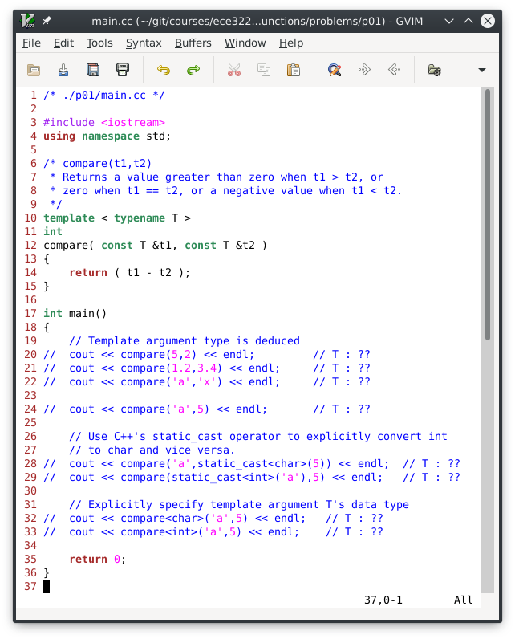

The Makefile in folder ./p01/ compiles main.cc → main.o, and then it invokes program nm to print main.o’s symbol table. Program nm’s output is then filtered through the program grep which discards all lines that DO NOT contain the word compare. At this point the symbol table does not contain the symbol compare, so grep discards every line that nm outputs:

$ g++ -std=c++11 -O0 -c -o main.o main.cc
$ nm -C main.o | grep compare
# The nm|grep command line produces no output

# OR

$ make # Invoking ‘make’ performs the two steps shown above
g++ -std=c++11 -O0 -c -o main.o main.cc
nm -C main.o | grep compare
--- compare template specializations ---------------------------
# No compare template specializations exist, so none are listed

PROBLEM 1.1
In folder ./p01/, edit file main.cc and uncomment line 20 only (see Listing 1). Save this change and then invoke make.

When the C++ compiler encounters line 20 it instantiates a specialized (a type-specific) compare function from the template function compare. In the specialized compare function the C++ compiler replaces the template parameter type T with what specific data type?

Answer (5 points): Int

In the specialized compare function, when the expression t2 – t1 is evaluated it yields an rvalue result. What is the rvalue result’s data type? (NB: Give the rvalue’s data type, not its numeric value.)

Answer (5 points): Int

PROBLEM 1.2
Edit file main.cc and comment out line 20 and then uncomment line 21 (see Listing 1). Save this change and then invoke make.

When the C++ compiler encounters line 21 it instantiates a specialized (type-specific) compare function from the template function compare. In the specialized compare function the C++ compiler replaces the template parameter type T with what specific data type?

Answer (5 points): Double

In the specialized compare function, when the expression t2 – t1 is evaluated it yields an rvalue result. What is the data type of the resulting rvalue (i.e., before the rvalue is implicitly typecast into an rvalue of type int)?

Answer (5 points): Double

PROBLEM 1.3
Edit file main.cc and comment out line 21, and uncomment line 22 (see Listing 1). Save this change and then run make.

When the C++ compiler encounters line 22 it instantiates a specialized (type-specific) compare function from the template function compare. In the specialized compare function the C++ compiler replaces the template parameter type T with what specific data type?

Answer (5 points): Char

In the specialized compare function, when the expression t2 – t1 is evaluated it yields an rvalue result. What is the rvalue result’s data type (not its numeric value) before the rvalue is implicitly converted to an rvalue of type int?

Answer (5 points): Char

PROBLEM 1.4
Edit file main.cc and comment out line 22, and uncomment line 24 (see Listing 1). Save this change and then run make.

Does the code compile? YES | NO

Answer (5 points): NO

Describe in your own words why the code does or does not compile.

Answer (10 points): Our compare function does not hold instructions for comparing two different templated data types. Because we are attempting to compare two different data types (char and int), the compiler throws an error because it deduces conflicting data types.

PROBLEM 1.5
Edit file main.cc and comment out line 24, and uncomment lines 20, 21, and 22 (see Listing 1). Save this change and then run make.

How many specialized compare functions are present in the object code file main.o?

Answer (5 points): 3

Invoke the program demo:

$ ./demo

Record as your answer the three integer values that are printed. These three values are emitted by the three “cout” statements on lines 19, 20, and 21.

Answer (5 points): 3, -2, -23

PROBLEM 1.6
Edit file main.cc and comment out lines 20, 21, and 22, and uncomment lines 28 and 29 (see Listing 1). Save this change and then run make.

Does the code compile? YES | NO

Answer (5 points): YES

Describe in your own words why the code does or does not compile.

Answer (10 points): Static typecasting was performed on either of the data types that did not match the other in order to convert it into the same data type. Because the variable was typecast to be the same type as the other variable, the compare function will work because it contains two variables of the same type.

PROBLEM 1.7
Edit file main.cc and comment out lines 28 and 29, and uncomment lines 32 and 33 (see Listing 1). Save this change and then run make.

Does the code compile? YES | NO

Answer (5 points): YES

Describe in your own words why the code does or does not compile.

Answer (10 points): The code compiles because the user explicityl specified the compare template argument’s data type.

p02 / main.cc

Listing 2 shows the source code in file ./p02/main.cc. This source code provides a template function named compare (lines 10 – 15) that compares its two parameters t1 and t2 and returns an integer value that is greater than one when t1 > t2, or zero when t1 == t2, or negative when t1 < t2.

Function parameters t1 and t2 may be the same data type, or they may be different data types, as indicated on line 12 by the two type template parameters T1 and T2.

Listing 2: Source code for the ./p02/main.cc problem set.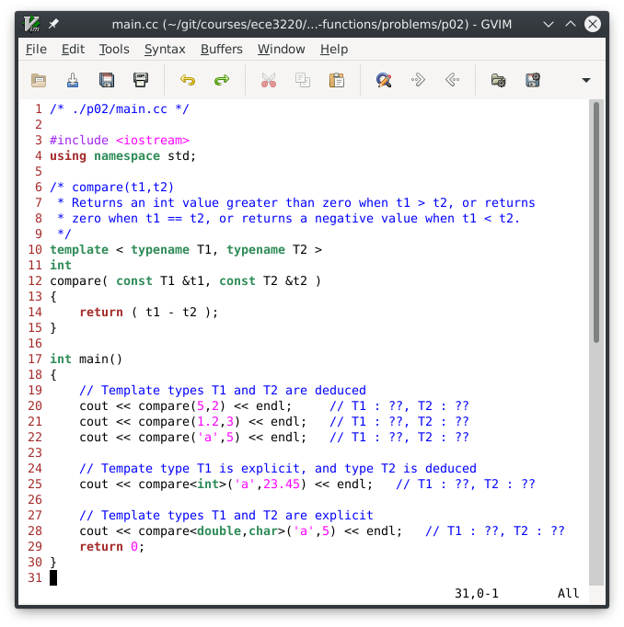

The comparison of t1 and t2 is performed by subtracting t2’s value from t1’s value t2 – t1 (line 14). Therefore, data types T1 and T2 must be data types that allow the C++ compiler to emit code that evaluates the subtraction expression t2 – t1, and this expression must yield an rvalue result whose data type is int or any data type that is implicitly convertible to an rvalue whose type is int—i.e.,
( t₂ - t₁ ) → int_{rvalue}
( t₂ - t₁ ) → result_{rvalue} → std::static_cast<int>(result_{rvalue})→int_{rvalue}
(See also: implicit conversions.) The compare function returns to the caller the resulting integer rvalue (lines 11, 14).

PROBLEM 2.1
Invoke make within folder ./p02/ to build the C++ source file main.cc which creates files main.o and demo.

$ cd ~/template-folders/p02/
$ make

When the C++ compiler encounters the compare function call in line 20, the C++ compiler emits a specialization of the template function compare. For that specialization, what are the “real” data types for template type parameters T1 and T2?

Answer (10 points): int, int

When the C++ compiler encounters the compare function call in line 21, the C++ compiler emits a specialization of the template function compare. For that specialization, what are the “real” data types for template type parameters T1 and T2?

Answer (10 points): double, int

When the C++ compiler encounters the compare function call in line 22, the C++ compiler emits a specialization of the template function compare. For that specialization, what are the “real” data types for template type parameters T1 and T2?

Answer (10 points): char, int

PROBLEM 2.1 (cont.)
When the C++ compiler encounters the compare function call in line 25, the C++ compiler emits a specialization of the template function compare. For that specialization, what are the “real” data types for template type parameters T1 and T2?

Answer (10 points): int, double

When the C++ compiler encounters the compare function call in line 28, the C++ compiler emits a specialization of the template function compare. For that specialization, what are the “real” data types for template type parameters T1 and T2?

Answer (10 points): double, char

p03 / main.cc
In Listing 3 (overleaf) class X has a method that overloads the subtraction operator ‘-’ (line 22 and lines 33 – 37), and another method that defines a type conversion (a type cast) from class X to int (operator int) (lines 25, 26).

On line 42 where compare(x1,x2) is invoked, the C++ compiler instantiates a class X specialization of the compare template function:

int compare<X>( X const& t1, X const& t2) { return (t1-t2); }

In this specialization t1 references x1, and t2 references x2, and the subtraction expression t1-t2 (i.e., x1-x2) is evaluated by invoking class X’s overloaded subtraction operator method, which instantiates and returns a class X rvalue result:

t1.operator-(t2) → X_{rvalue} /* t1-t2 */

The C++ compiler then implicitly performs a “narrowing conversion” that converts the X rvalue result’s value data member (type double) into a value of type int by invoking class X’s operator int method:

X_{rvalue} → static_cast<int>( X_{rvalue}.value ) → X_{rvalue}.operator int() → int_{rvalue}

Although this procedure successfully performs the subtraction x1-x2, and it successfully converts the resulting X_{rvalue}’s value data member (type double) into a value of type int, this procedure introduces a bug (a logic error) that, in some cases, causes the the compare function to return an incorrect int value.

For example, in Listing 3 x1.value == 1.02, x2.value == 1.01, and therefore the compare function should return a positive integer (int_{rvalue} > 0) because x1.value > x2.value. However, the compare function incorrectly returns the value zero which indicates x1.value == x2.value, which is wrong.

PROBLEM 3.1
Find and describe the logic error that causes this bug. (Hint: How does C++ perform a “narrowing conversion” from a value whose type is double to a value whose type is int?)

Answer (10 points): The bug is caused when the comparison operator is applied on the values on the initialized values of the X class. Currently, how the program is codded will truncate the processed rvalue from the comparison operator causing incorrect results. For example, in the code we have two X objects with values 1.02 and 1.01, because the comparison function will cast the result of this value to int (0.01) the comparison function will return 0 and not 1. In order to correct this error we might want to implement logic statements which return -1, 0, and 1 instead.
Listing 3: Source code for ./p03/main.cc problem set.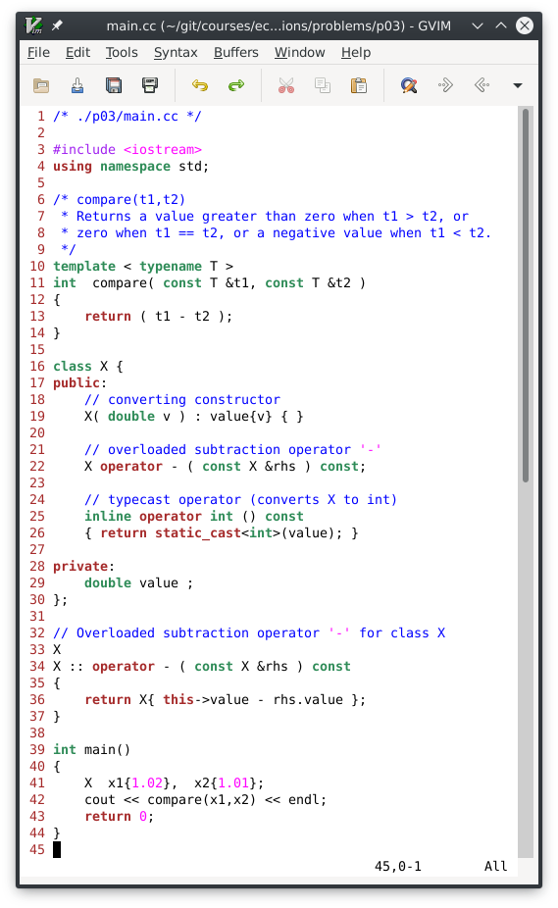

For example, evaluating the expression 5 - 3 yields the rvalue result 2.
See: https://docs.microsoft.com/en-us/cpp/cpp/lvalues-and-rvalues-visual-cpp

