Samuel Bishop

Fischer

Software Dev in C/C++

September 6, 2019

LAB 3 Report: GNU Debugger

**SegFault_Example.c**

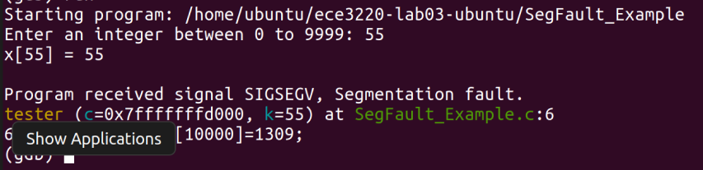

Type of seg fault: memory allocation error

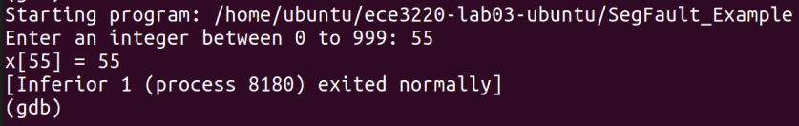

**Gdb-ex1.c**

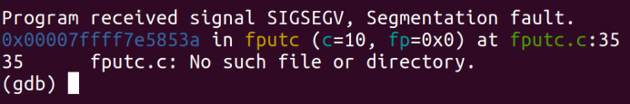

Type of seg fault: memory addressing reference error

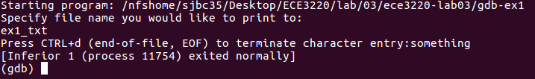

**gdb-ex2.c**

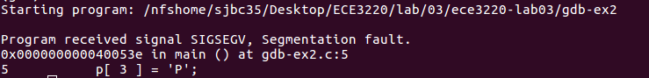

Type of seg fault: memory allocation error



**gdb-ex3.c**

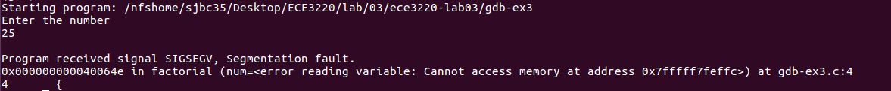

Type of seg fault: untracked function reference

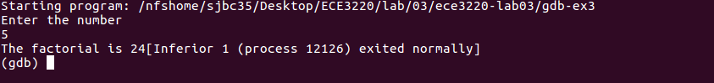

**gdb-ex4.c**



Type of seg fault: Does not exist. And debugging not necessary