**You Won’t Believe This: How News Medium Affects Perceived Credibility**

|  |  |  |  |  |
| --- | --- | --- | --- | --- |
| **Rahul Banala**  University of Washington Information School  Seattle, USA  rbanala@uw.edu | **Jackson Brown**  University of Washington Information School  Seattle, USA  jmax825@uw.edu | **Elisabeth Chin**  University of Washington Information School  Seattle, USA  esc11@uw.edu | **Samuel Cochrane**  University of Washington Information School  Seattle, USA  samueldc@uw.edu | **Abhishek Joshi**  University of Washington Information School  Seattle, USA  joshi1@uw.edu |

# ABSTRACT

Many people now get the majority of their news from digital sources, while still occasionally getting information from print media such as the newspaper. However, the reader could subconsciously be biased on the news they receive depending on the medium (website or print). Given the same article, how would the medium affect its perceived credibility? What about its perceived neutrality and bias? Here we present a study that attempts to answer these questions, as well as our preliminary findings; which suggest there is an inherent bias to read content from the two mediums differently.

## Author Keywords

Credibility; Reliability; Digital vs Physical; News; Perceived Bias; Perceived Neutrality;

## ACM Classification Keywords

K.4.0 COMPUTERS AND SOCIETY: General,   
K.4.m COMPUTERS AND SOCIETY: Miscellaneous

# INTRODUCTION

Staying informed and in-the-know is more important than ever and has been made exponentially easier with the advent of online news sources that report news faster and can be accessed instantaneously at all hours of the day.

However, our search yielded a lack of research done into the effects of news source medium on how that news is perceived. Even a small implicit bias to see physical media as more trustworthy could have massive and far-reaching results when scaled up to the countless times articles are read every year.

Therefore, we conducted a study to gather more information on this subject. First, we created a short online survey asking respondents for details on how they got their news and their perceptions of each format. The questions asked respondents which medium they found to generally be more biased, as defined by the respondents, which they found to generally be more factual, etc.   
Secondly, we conducted 20 in-person interviews where participants read one article in each format (digital and print), and were asked for their opinions of the article. The questions asked participants about their perception of the article’s bias, ethical quality, and fairness.

We found several interesting trends in our data. Many of those interviewed in our study get their news exclusively or near-exclusively from digital sources; of our respondents, only 4.5% still got the majority of their news from print media sources. After analyzing the data received from the surveys, we found that many respondents did not view online media as favorably as print media. With 85% of our 66 respondents viewing the physical media as fair whereas only 70% viewed digital media as such. We also found that 60% of respondents found digital media as more sensationalistic compared with only 45% who felt that physical media was as such. However, we noticed that people had little difference in the perceived ethics of news formats.

The contributions of this work are new data in a growing and increasingly ubiquitous subject (online news consumption), and strong preliminary data that points to important issues of media and perception.

# RELATED WORK

There are multiple sources of work that helped establish how to examine predictors of perceived credibility between both online and print media. Johnson & Kaye’s research on internet credibility among Weblog users is often cited among other works as it was one of the first to ask the question of how web (specifically ‘Weblog’) users view the credibility of print mediums as sources of information in relation to their web usage (2004). They found that the perception of credibility could be influenced by receiving most news from Weblogs and established methods of researching online news source credibility.

Chung, Nam, & Stefanone’s (2012) work expanded on the idea of using multiple factors to predict an individual's perceived credibility of the news source by including online-web-specific concepts that included: interactivity, multimediality, and hypertextuality. With the added web-specific features, they found that while these web-specific features somewhat helped with predicting the perceived credibility of a news source, they didn’t have the same effect as the traditional methods used by Johnson & Kaye (2004).

Meanwhile, Cassidy (2007) asks the question of whether there is a significant difference in perceived credibility for print and online journalists regarding online journalism, finding that online journalists rate online journalism as having a higher perceived credibility than that of their print counterparts.

Our work highlighted a specific portion of the population: university students. Using similar methods established by Chung, Nam, & Stefanone (2012), we narrowed our interviews to asking about the fairness, bias, accuracy, respect for people’s privacy, separation of fact and opinion, trustworthiness, concern for public interest, profit motive, professionalism, sensationalism, and ethical quality of each article. These features were established by Johnson & Kaye (2004) as factors in perceived credibility. Similar to Cassidy (2007), our research focuses on how an upcoming technology-dependent generation perceives the credibility of print and online news sources.

**AN EXPLORATION INTO PERCEIVED CREDIBILITY**

We conducted a survey and interview with participants to gather their responses for criteria matching credibility, based on relevant work done, including bias, trustworthiness, ethics, accuracy, sensationalism, and relevancy. Our goal was to discern potential implicit bias of holding one news format in higher regard than the other.

**Participants**

This exploration consisted of two research methods for data collection, a survey and an interview. Participants for both the survey and interview were university students gathered using convenience sampling. Participants for the study and the conducted interviews were closely known by the authors. 66 people responded to the survey, and 20 people participated in the interviews. Of our in-person interviews, we achieved a 50% split in male and female genders. All participants had achieved or were completing an undergraduate level of education. The participants had a mean age of 20.9 years and an age variance of 3.29 years.

**Theory**

After deciding on exploring the individual’s perceived credibility for a news article, we acknowledged that credibility is a nuanced concept; simply asking a participant whether or not they believed or trusted a news source was limiting. Thus, we explored several models of credibility, most notably from Gaziano and McGrath (Gaziano 1986), who identified the multiple dimensions of credibility and their relations to each other. There were eleven factors in particular that readers cared about in a newspaper: whether it was fair, unbiased, sensationalistic, factual, ethical, accurate, respected people’s privacy, was concerned about the public interest, separated fact and opinion, was concerned about making profits, and had professional reporters (Gaziano 1986). While these factors appear to be valid and measure credibility reliably, they can be problematic and convoluted when understanding credibility as a multidimensional concept (West 1994). However, as we are using these factors for interview questions to get a more all-inclusive understanding of a participant’s perceived credibility of media, we utilized Gaziano’s model for our interview questions, prompting participants with every credibility factor for each article.

**Procedure**

An online survey was crafted to get the general opinions of each medium, as well as details of their use, from a larger sample size. The survey asked how often the participant read from a news source of each format (daily, weekly, monthly, or less than monthly / not at all), and whether they had a paid subscription or membership to a news source of that format (such as a newspaper subscription). It then asked a series of questions with the respondee having to choose between Physical and Digital as their responses. They were asked to choose which medium they perceived as being generally more: trustworthy, ethical, accurate, unbiased, sensationalistic, and relevant. Finally, data about the respondent was gathered such as age, work & education status (part-time, full-time, none), and highest level of education achieved or currently pursuing.   
All participants of the in-person interview were led through the interview by an interviewer following a script. After an introduction, participants were asked to respond to this exploration’s survey on a laptop provided by the interviewer. For all participants, laptops were configured with the same screen brightness (maximum for the device), the same operating system (Windows 10), and utilized the same web browser (Chrome).   
After completing the survey, participants were given one of two chosen news articles from *The Seattle Times*. News articles were chosen by the authors for not being politically charged opinion articles at the time. The two articles chosen were “From milk to lightbulbs, Fidel Castro reshaped life in Cuba” by Andrea Rodriguez and Michael Weissenstein, and “Nancy Pelosi survives challenge to her leadership of House Democrats” by Lisa Mascar. Both articles came in a digital format on the Seattle Times website (that was viewed by participants on the same configuration used for the survey) and a print format in the Seattle Times newspaper.   
As we had two articles, Castro and Pelosi, with two separate mediums, we counterbalanced our interviews by having each individual participant read each article in a different medium in a different order. While we didn’t change the procedure based off the additional gender differences, we used equal Male and Female participants for our study to maintain a closer representation of our population. The variants of the process are shown below:

*Figure 1: Participant Reading Order*

|  |  |
| --- | --- |
| **Participant #1:** | First Article: Castro, Digital  Second Article: Pelosi, Physical |
| **Participant #2:** | First Article: Pelosi, Digital  Second Article: Castro, Physical |
| **Participant #3:** | First Article: Castro, Physical  Second Article: Pelosi, Digital |
| **Participant #4:** | First Article: Pelosi, Physical  Second Article: Castro, Digital |

One article was chosen and participants were given as much time as needed to read the given article, and then asked a series of questions in the interview about the first article. Interview questions were formatted to gain an understanding of the participant’s perception of the article’s fairness, bias, accuracy, respect for people’s privacy, separation of fact and opinion, trustworthiness, concern for public interest, profit motive, professionalism, sensationalism, and ethical quality. The same procedure for the first article was repeated with the second chosen article and the participants’ responses recorded.

**Analysis**

Following our individual observations and collection of data, we analyzed the data through an inductive research approach known as grounded theory. We independently found patterns and themes from our interview responses through open coding. By using this analysis method, we could make sense of the textual data without a prior hypothesis. There are four main stages to this approach: (1) open coding, where data is indicated, labelled, and grouped into concepts; (2) axial coding, where these concepts are developed into categories; (3) selective coding, where categories are related into a single core category that can define a descriptive narrative; and lastly, (4) the formation of the theory (Adams 2008). This empirically based method will provide guidance for applicable design solutions to this nuanced question.

# RESULTS

*Figure 2: Responses, In-Person Interviews*

|  |  |  |  |
| --- | --- | --- | --- |
| **Question**  **(“Article was...”)** | **Physical  % who agree** | **Digital  % who agree** | **% Change**  **(Phys. -> Dig.)** |
| Fair | 85% (17/20) | 70% (14/20) | -15% |
| Biased | 50% (10/20) | 75% (15/20) | +25% |
| Accurate & Factual | 90% (18/20) | 70% (14/20) | -20% |
| Respectful of Privacy | 95% (19/20) | 95% (19/20) | 0% |
| Separated fact & opinion | 70% (14/20) | 60% (12/20) | -10% |
| Trustworthy | 90% (18/20) | 70% (14/20) | -20% |
| concerned with Public Interest | 75% (15/20) | 65% (13/20) | -10% |
| concerned with Profits | 70% (14/20) | 60% (12/20) | -10% |
| Professional | 90% (18/20) | 85% (17/20) | -5% |
| Sensationalistic | 45% (9/20) | 60% (12/20) | +15% |
| Ethical | 85% (17/20) | 85% (17/20) | 0% |

*Figure 3: Results For News Consumption By Source*

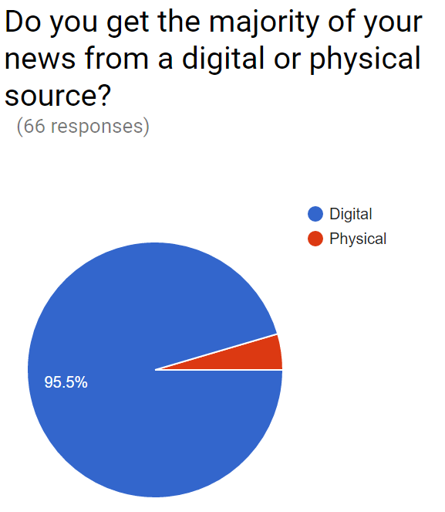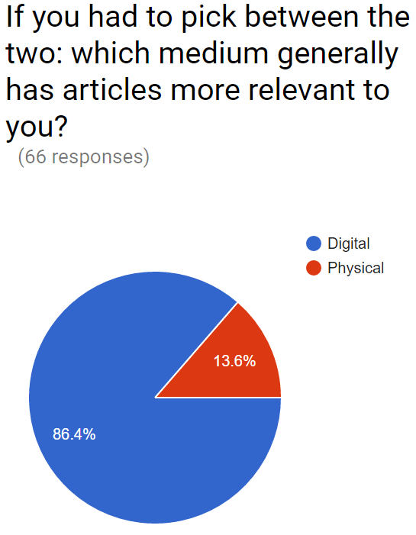

**Open Coding**

Our interview questions prompted participants to describe each factor of credibility in relation to the article they had just read, such as “Would you consider this article fair or unfair?”. An initial pass of our observations examined each participant's’ responses, recorded in a spreadsheet for reference. This revealed 24 independently coded patterns. Open codes included participants’ recalling of specific instances of biased language, participants’ level of trust and doubt in factual evidence, and how often participant’s identified and referenced the news source. For instance, when asked, “Would you consider this article trustworthy?”, 14 participants recalled *The Seattle Times*, mentioning their trust in the paper’s name. It should be noted that more instances of biased language, purely anecdotal events, lack of factual evidence, and persuasive writing were recalled for digital articles rather than physical ones.

**Axial Coding**

We identified higher level patterns in open coding, noting the following axial codes: statistics versus anecdotal events, selective evidence, participants’ memory and recall, strength of language, relationship between fact and opinion, and news source.

**Selective Coding**

Many of the answers to our questions regarding credibility were repetitive or similar between factors of credibility; for example, participants’ perceived journalists being selective of instances to support a positive representation of a political figure was often viewed as biased, unfair, inaccurate, not trustworthy, and/or unethical. While Gaziano’s factors of credibility were similarly interpreted among participants and their read articles, more factors had stronger, negative responses from participants when asked about an article from the digital medium, regardless of the content. Because participants read digital articles with stronger skepticism and incredulity over their physical counterparts, our selective code is the implicit bias that results from an article’s medium. This is seen in Figure 2.

# DISCUSSION

The results from the online survey in this exploration provide surprising insight into the consumption of news in print versus digital formats, as well as potential underlying implicit bias that readers have towards news sources based on their format. Based on the results of the survey, a clear trend is seen where the majority of respondents consistently stated that physical news formats had a higher degree of trustworthiness, ethics, authenticity, accuracy, and fairness, with less bias and sensationalism.

The high percentage of respondents who receive the majority of their news from digital sources is not entirely surprising, along with the high percentage of respondents who state that digital news sources have content more relevant to them. This result *is* surprising when juxtaposed to the higher credibility standing given to print news sources than digital sources. These findings would imply that while student readers may receive more content that they enjoy from digital news sources, there is an underlying understanding that those sources have a lesser degree of credibility. These findings alone confirm the hypothesis that students would show a greater regard for print news sources’ credibility. However, could the results differ when moving from the theoretical to reviewing an actual article?  
As you can see from Figure 2, despite counterbalancing exposure to each article and each medium, there were significant differences in how people reported their impressions of the articles depending on the medium.

We saw the largest gap in the “Biased” category, with a 25% gap - that is to say 25% more respondents said the article was biased when they saw the article digitally. We similarly saw a 20% drop on trustworthiness. This shows a clear bias to see digital news media as having less neutrality in their reporting. One could argue that the large amount of semi-professional news sites could bias readers to think of digital articles as having less ‘journalistic integrity’ as a whole. Surprisingly, we saw little to no difference in how people perceived the ethicality of the article or privacy concerns about its content (if the article overstepped its bounds, reported something that should have remained private). We see this as an indication that people do not see digital content as universally worse; people are biased against digital media, but not every aspect. We expected bias against digital media before starting, but were surprised at the degree of the bias and the gaps in bias.

# CONCLUSION

This empirical study presented an understanding that the medium of a news source affects the perceived credibility of its content. Based on our findings, the majority of readers consume their news from digital sources. However, while readers may find more relevant articles they enjoy through digital news sources, there is an implicit bias to believe that print new sources are more credible. Thus, as the consumption of news expands, a more accurate understanding of its perceived credibility is necessary to better convey news across mediums.

# FUTURE WORK

We still believe this to be an under-explored field and a highly relevant topic. While this will be the last research paper many of us write for some time, we do hope another team can pick up and use what we have learned to further their own work, or expand on this question.

# ACKNOWLEDGMENTS

The authors would like to thank Dr. Jacob O. Wobbrock and Kristen Shinohara for their contributions.

# REFERENCES

1. Abdulla, R. A., Garrison, B., Salwen, M., Driscoll, P., & Casey, D. (2002, August). The credibility of newspapers, television news, and online news. In *Education in Journalism Annual Convention, Florida USA*.

<https://www.researchgate.net/profile/Bruce_Garrison/publication/237343900_THE_CREDIBILITY_OF_NEWSPAPERS_TELEVISION_NEWS_AND_ONLINE_NEWS/links/0046353c3ca10efe56000000.pdf>

2. Adams, A., Lunt, P. and Cairns, P. (2008). [A qualitative approach to HCI research](https://faculty.washington.edu/wobbrock/teaching/info470/Adams-2008_7.pdf). Chapter 7 in *Research Methods for Human-Computer Interaction*, P. Cairns & A.L. Cox (eds.). Cambridge, UK: Cambridge University Press, pp. 138-157.

3. Cassidy, W. P. (2007). Online news credibility: An examination of the perceptions of newspaper journalists. *Journal of Computer‐Mediated Communication*, *12*(2), 478-498. <http://onlinelibrary.wiley.com/doi/10.1111/j.1083-6101.2007.00334.x/full>

4. Chung, C. J., Nam, Y., & Stefanone, M. A. (2012). Exploring online news credibility: The relative influence of traditional and technological factors.*Journal of Computer‐Mediated Communication*, *17*(2), 171-186.

<http://onlinelibrary.wiley.com/doi/10.1111/j.1083-6101.2011.01565.x/full>

5. Gaziano, C., & McGrath, K. (1986). Measuring the concept of credibility. *Journalism and Mass Communication Quarterly*, *63*(3), 451.

<http://www.aejmc.org/home/wp-content/uploads/2012/09/Journalism-Quarterly-1986-Gaziano-451-621.pdf>

6. Johnson, T. J., & Kaye, B. K. (2004). Wag the blog: How reliance on traditional media and the Internet influence credibility perceptions of weblogs among blog users. *Journalism & Mass Communication Quarterly*, *81*(3), 622-642.

<https://www.researchgate.net/profile/Thomas_Johnson18/publication/242574728_Wag_the_Blog_How_Reliance_on_Traditional_Media_and_the_Internet_Influence_Credibility_Perceptions_of_Weblogs_Among_Blog_Users/links/549895fd0cf2519f5a1de741.pdf>

7. Nguyen, A., & Western, M. (2007). Socio-structural correlates of online news and information adoption/use implications for the digital divide. *Journal of Sociology*, *43*(2), 167-185. <http://www.academia.edu/download/32477315/Socio-structural_correlates_-_v2.pdf>

8. West, M. D. (1994). Validating a scale for the measurement of credibility: A covariance structure modeling approach. *Journalism and Mass Communication Quarterly*, *71*(1), 159.

<https://www.researchgate.net/profile/Mark_West3/publication/234765523_Validating_a_Scale_for_the_Measurement_of_Credibility_A_Covariance_Structure_Modeling_Approach/links/5638f0ff08ae4624b75ef6cb.pdf>