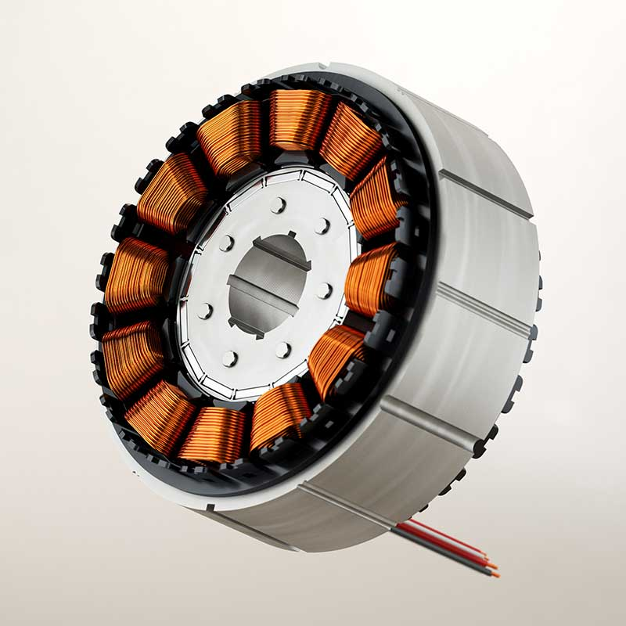

# BLDC Motor Controller Simulation

# USING MATLAB SIMULINK

V. Samuel Cripps 210108060 EEE

## Introduction:

A BLDC motor stands for Brushless DC motor. It is an electric motor that uses electronic commutation instead of brushes and a mechanical commutator to control the rotation. The BLDC motor is usually a synchronous motor composed of a trapezoidal back EMF waveform and a permanent magnet. It has a wide range of applications in various industries and technologies such as, automotive, robotics, aerospace and drones due to it’s advantages like high efficiency, reliability, speed control, durability.

Motor controllers are vital in managing the speed and direction of BLDC motors by providing precise commutation control, speed regulation, direction control, dynamic response, and energy efficiency. They enable the motors to operate with accuracy, responsiveness, and optimal performance in various applications ranging from electric vehicles to industrial automation.

The objective of the project is to-

1. Validate the design- Simulation allows to test and validate the design of the BLDC motor controller. It helps to identify performance characteristics before physical implementation.
2. Performance Analysis- Simulation enables us to evaluate parameters such as speed response, torque output, efficiency. This analysis helps in fine-tuning the controller’s parameters and optimizing its performance.
3. Control Algorithm development- Simulating a BLDC motor controller provides a platform to develop and test the control algorithms and implement control strategies such as closed- loop speed control.
4. Education- This BLDC motor simulation project served as a educational tool in learning about motor controller principles and techniques. It provides a platform to experiment with different control strategies, observe their effects, gain hands-on experience in motor control system design and analysis.

## Literature Review-

Trapezoidal Control method:

Trapezoidal control is a common method used to control the operation of BLDC motors. It is relatively simple and widely employed technique that provides efficient speed and torque control. In this technique, the motor’s three phases are energized in a six-step commutation pattern, creating a trapezoidal back-EMF waveform. Hall effect sensors are typically used to detect the rotor position and determine the appropriate phase commutation sequence.

1. Commutation Pattern- The motor’s three phases are energized in a six-step commutation pattern. The three phases are typically driven using six power switches, such as MOSFETs or IGBTs, which are arranged in pairs to form three half- bridges.
2. Hall Effect Sensors- Trapezoidal control relies on Hall effect sensors to determine the rotor position and initiate the appropriate phase commutation sequence. Hall effect sensors are placed near the motor’s permanent magnets to detect the changes in the magnetic field as the rotor spins. These sensors provide electrical signals indicating the position of the rotor relative to the stator windings.
3. Phase Commutation- Based on the information from the Hall effect sensors, the controller determines the correct timing and sequence for phase commutation. The six-step commutation pattern involves sequentially energizing the three phases to create a rotating magnetic field. By switching the power devices in the half-bridges, the controller controls the current flow and changes the magnetic field’s direction, propelling the rotor.
4. Back EMF-During operation, the motor generates a back-emf due to the rotor’s motion. The back emf is used as feedback to determine the rotor speed and position. By monitoring the back-emf waveforms, the controller can adjust the commutation timing to maintain synchronization between the stator’s magnetic field and the rotor’s position.
5. Speed and torque control- Trapezoidal control allows for basic speed and torque control of BLDC motor. By adjusting the commutation frequency and duty cycle of the control signals, the controller regulates the motor’s rotational speed and torque output. Increasing the frequency increases the motor’s speed, while adjusting the duty cycle alters the average voltage applied to the motor and affects the torque output.

## System Modelling-

1. PMSM model- The Permanent Magnet Synchronous Motor block in MATLAB Simulink is a specialized block used to model and simulate the behaviour of a PMSM and BLDC motor. The PMSM and BLDC motors are the type of electric motors that uses permanent magnets to create magnetic field required for operation. This model allows us to change the parameters such as electric parameters, mechanical parameters, control inputs, etc. for the study and analysis of the motor.
2. Three phase inverter- The three-phase inverter is modelled using six MOSFETs. These MOSFETs act as power electronic switches, which turn ON when they get a gate signal.
3. Boolean Algebra- The NOT gate and AND gates are used to define the emf inputs to the motor using the response from HALL sensors.
4. Controlled Voltage Source- This is the block that represents a voltage source whose output is controlled based on an input signal or a mathematical equation. It allows us to specify the voltage output as a function of time or other variables, enabling us to create complex voltage waveforms or implement dynamic voltage control.

## Simulink Implementation-

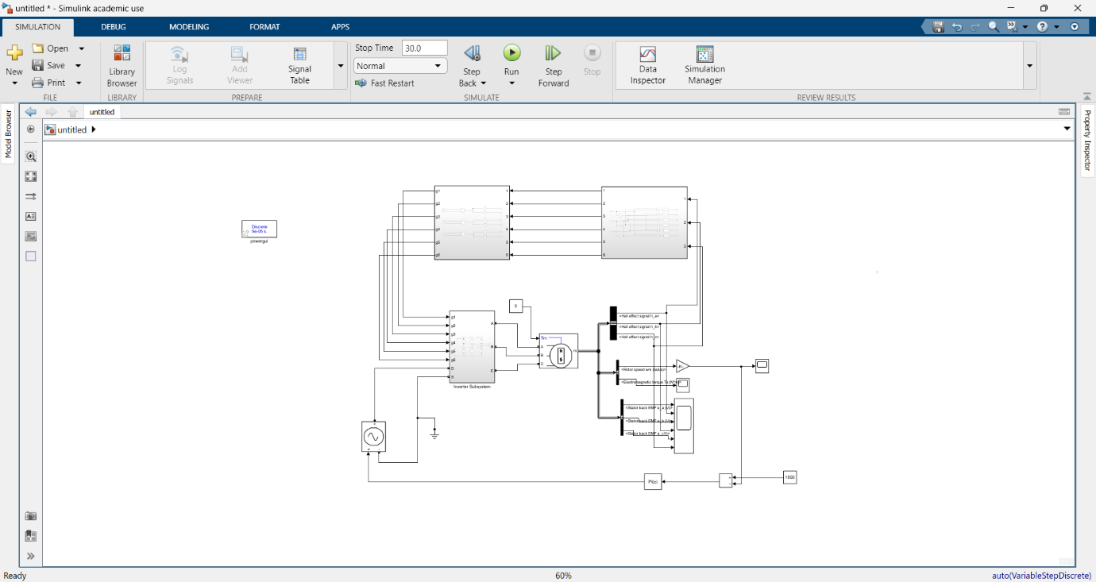

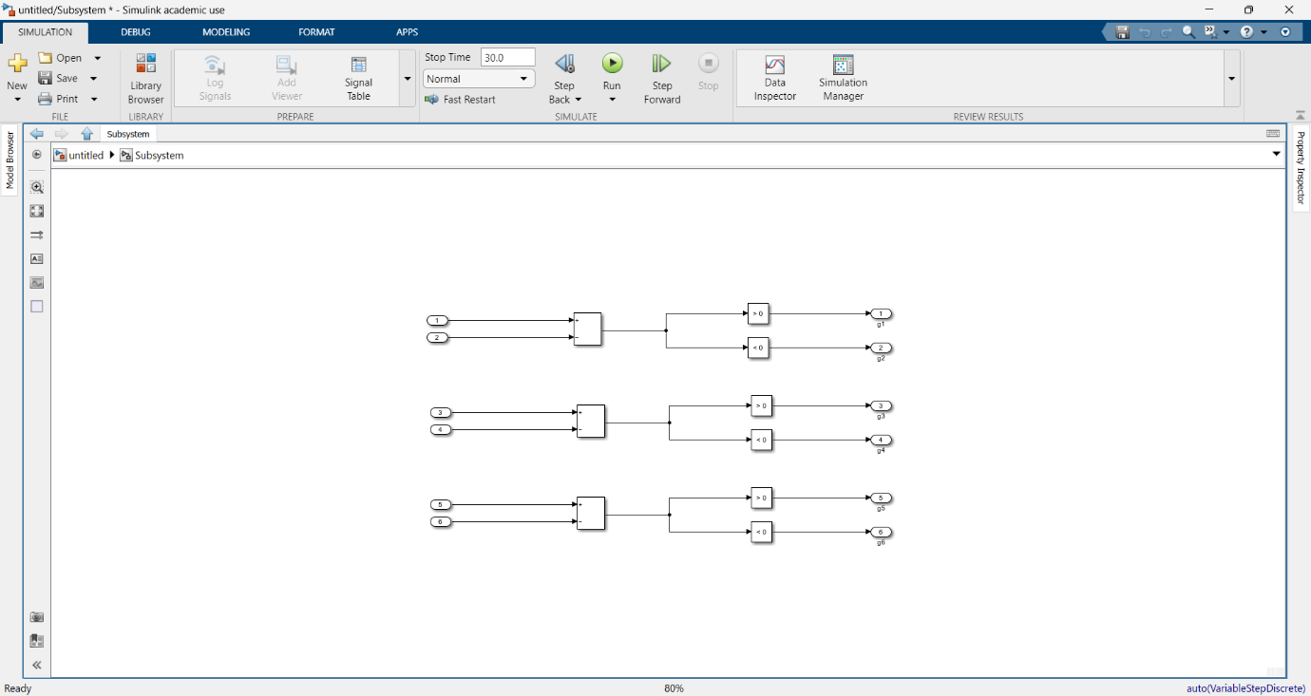

## Simulation Result-

