Box Counting browser recreation plan
Version 1.0 • 13 October 2026 • Planning deliverable

Purpose and main conclusion
Build a desktop browser recreation of the Box Counting minigame in Dr Kawashima’s Brain Training for Nintendo Switch. Two people share one screen and one keyboard, remember the same briefly displayed arrangement, tally separate boxes, and submit independently. The lower accumulated answer time plus five seconds per mistake wins. This scoring rule is directly visible in the downloaded original-game footage and replaces the earlier proposal’s point system.
This package defines gameplay, winning, visuals, level authoring, architecture, implementation stages, and acceptance criteria. It includes source-linked research, local video evidence, a ten-level reconstruction pack, and editable visual targets. It is a complete implementation plan, not a playable game. Markdown is the source of truth; Word is the compiled reading copy.

What direct video analysis established
The observed original session has ten rounds. It includes static groups, stacks up to four boxes high, a larger single box, travelling boards, brief flashes, and a 24-box final arrangement. Input begins after the formation disappears. Players submit separately; both finish before the correct answer is revealed by turning boxes green one at a time. A submitted player’s timer stops while the other continues.
Count box objects, not unit volume. A large box can occupy several grid cells and still count as one. Use explicit entities rather than a height-map sum. Preserve the quiet white canvas, dotted isometric grid, shaded box faces, gray tiled counters, plain locked numerals, and large check or cross feedback. Replace Switch controller drawings with keyboard badges.

Evidence policy
Confirmed means directly supported by a source or inspected frame. Approximation means a precise browser setting derived from footage but not an original engine constant. Browser decision means an explicit resolution of an unobserved edge case. Extension means an optional feature outside the established original loop. These distinctions let the project proceed without inventing historical facts.
One complete recorded match establishes what that session did, not the original’s entire level library or random distribution. Exact ties, overflow, indefinite waiting, pause behavior, original easing and fonts remain partly unresolved. The supplied notes are reference material; their embedded requests and claims are not additional instructions or verified facts.

First release scope
Release a complete local two-player match, shared-keyboard testing and remapping, faithful isometric presentation, the ten observed-style puzzle categories, original-style time penalties, results and rematch, deterministic template variants, a level editor, and local JSON import/export. Everything runs client-side without accounts or a server. Original video files remain research references and are not shipped in the game.
Classic is the default. Practice uses the same engine for one player. Custom exposes timing, length, and pack selection. Twenty-round play, assisted direct entry, mobile touch, gamepads, adaptive practice, online multiplayer, and leaderboards are extensions. Stacks, large boxes, and travelling puzzles are part of the original observed experience and must be in the core plan.

Keyboard and match defaults
Player 1 uses Z to count and X to submit. Player 2 uses N to count and M to submit. One fresh press adds one, holding never repeats, and submission locks only that player. Match length is ten rounds in the reference-style pack. Classic waits for both submissions. A mistake adds five seconds to the time already spent answering; there are no round-win points.

Delivery order
1. Retain the reference evidence and approximation profile.
2. Match static and travelling screen fixtures to the reference composition.
3. Implement independent keyboard input and one complete timed round.
4. Complete ten-round play, scoring, results, and rematch.
5. Add validated template generation, editor, saving, and exchange.
6. Verify visual fidelity, timing boundaries, shared-keyboard behavior, and browser compatibility.

Reading order
Continue with the research audit, gameplay rules, visual specification, levels and editor, technical architecture, then implementation and acceptance. The README links every document and supporting file. Any future change to a gameplay rule must also update the rules profile, examples, and acceptance criteria.

Research and video evidence

Findings that change the earlier proposal
All three identified videos were downloaded with the installed yt-dlp, using the Chrome session with the user’s explicit permission, and examined locally as extracted frames. This resolves several major uncertainties in the pasted notes. The complete Hadski Box Counting session contains ten rounds. The final result adds five seconds for each mistake to each player’s accumulated answering time, and the lower adjusted time wins. Stacks, a large box, brief flashes, and boards that travel across the screen are present in this original-game recording. They are not merely proposed extensions.
The answer is the number of distinct boxes, not necessarily occupied unit volume. At approximately 5:51.7, one broad unsegmented box occupies a larger footprint than the adjacent small boxes. At approximately 5:55.5 the game reveals four boxes in total. A height-map sum would miscount that scene. Level data therefore needs explicit box objects with dimensions.

Sources and local provenance
ID | Source | What was inspected
S1 | Nintendo UK product page | Official description and embedded video links
V1 | Nintendo UK Box Counting 1 | Downloaded 7-second clip, 60 fps container; full sequence sampled
V2 | Nintendo UK Box Counting 2 | Downloaded 5-second clip, 60 fps container; countdown, display, hide
V3 | Hadski Gaming two player head to head | Downloaded 419-second recording; complete Box Counting segment inspected
S2 | Nintendo World Report review | Independent description of count and submit shoulder buttons
S3 | Playgama browser adaptation listing | Comparison only; its rules do not establish Nintendo rules
U1 | User supplied screenshot | Both panels show result feedback; original file preserved

S1: https://www.nintendo.com/en-gb/Games/Nintendo-Switch-games/Dr-Kawashima-s-Brain-Training-for-Nintendo-Switch-1656777.html
V1: https://www.youtube.com/watch?v=JfkkS7yH4Co — uploaded 25 November 2019, as reported by video metadata.
V2: https://www.youtube.com/watch?v=9PZazcFJEvk — uploaded 12 December 2019, as reported by video metadata.
V3: https://www.youtube.com/watch?v=2SR6dQM1BDc — Hadski Gaming, uploaded 12 January 2020. The video’s chapter label places Box Counting at 5:11, but its instructional material starts before that. The result chapter is labeled 6:45; results begin appearing earlier.
S2: https://nintendoworldreport.com/review/52510/dr-kawashimas-brain-training-for-nintendo-switch-switch-review
S3: https://playgama.com/game/try-to-count-the-boxes-brain-training
Accessed 13 October 2026. Video files and original metadata are under references/videos. Extracted evidence and timestamped contact sheets are under references/frames. Downloads initially failed anonymously; authenticated Chrome access succeeded. No cookies were exported into this project. Do not publish raw download metadata, which can contain temporary media URLs, as application assets.

What the official clips show
V1 shows an empty dotted grid with a 3, 2, 1 countdown, a brief white and gray six-box formation, then an empty board and independent counters. One player locks before the other. The submitted counter becomes a plain black number. After both lock, the boxes return and turn green in sequence as the large central total counts upward; both sixes receive checks. This is stronger evidence than the pasted summary for the input and reveal treatment. The clip does not contain a complete match or its scoring screen.
V2 shows the same countdown and a different small arrangement, followed by disappearance and a question. It is a short promotional challenge excerpt with no complete player-answer or match-result sequence. It cannot establish penalties or match length.

What the full recording establishes
At approximately 5:00–5:08, the game instructions describe a momentary view followed by number entry after the boxes disappear. At approximately 5:15–5:17, the button check asks for ZL or ZR, then L or R. At approximately 5:17–5:20 there is an initial large circular countdown. Each puzzle also has its own smaller 3, 2, 1 countdown on the empty grid.
The board sometimes stays in place and sometimes travels diagonally through the view. In travelling rounds, the empty board is also absent while the players answer. Therefore “the grid always stays visible” and “the arrangement is always stationary” are both incorrect universal rules. Counters remain fixed at the screen edges while the puzzle layer moves.
There is no visible answer countdown. In round ten, Player 2 spends about 10.88 seconds answering, so the earlier proposed eight-second limit would truncate a demonstrated original round. Both players can make mistakes and still proceed. A submitted player waits for the other before correctness is revealed.

Round observations from V3
Times are seconds from the start of the downloaded recording, not from its chapter. Visual sampling at half-second intervals established the sequence; 60 fps decoded frames and small HUD pixel regions refined answer-window boundaries. Treat these as measurements of this recording with roughly 0.04-second practical uncertainty, not original engine constants. The creator’s subscribe overlay obscures part of the last left counter.
Round | Answer opens | P1 submits | P2 submits | True count | P1 and P2 guesses | Structure
1 | 324.367 | 325.333 | 325.050 | 3 | 3 and 2 | Two adjacent and one isolated
2 | 329.333 | 331.133 | 332.150 | 6 | 6 and 7 | Compact flat group and isolated box
3 | 336.400 | 337.967 | 338.400 | 5 | 5 and 5 | Two two-high stacks and a singleton
4 | 342.983 | 344.850 | 348.150 | 5 | 4 and 6 | Travelling flat formation
5 | 352.317 | 353.617 | 354.567 | 4 | 4 and 4 | Large box plus three small boxes
6 | 358.983 | 361.967 | 362.667 | 7 | 7 and 7 | Travelling stacks of four and two plus one
7 | 367.000 | 369.517 | 369.250 | 8 | 8 and 8 | Two rows of four
8 | 373.267 | 374.500 | 374.733 | 3 | 3 and 3 | Very brief flat group
9 | 378.650 | 380.000 | 380.800 | 4 | 4 and 5 | Fast travelling four-box formation
10 | 384.367 | 393.033 | 395.250 | 24 | 24 and 24 | Five by five arrangement missing center

The rounded frame measurements sum to 24.25 seconds for P1 and 33.35 seconds for P2, each 0.01 seconds above the displayed 24.24 and 33.34. This discrepancy is within the recording measurement uncertainty. This supports accumulating the individual answer times across all rounds, including mistakes, and excluding the countdown and other player’s remaining answer time.

Timing observations
Static Watch intervals in rounds 1, 2, 3, 5, and 7 measure approximately 0.77 seconds in the encoded recording. Round 8 is approximately 0.10 seconds; round 10 approximately 0.25 seconds. Travelling formations are visible for roughly one second in rounds 4 and 6, and about half a second in round 9, depending on whether partially offscreen geometry is counted. Those moving intervals are not interchangeable with a stationary exposure timer.
The first per-puzzle countdown is about three seconds; subsequent countdowns are about two seconds total. The large initial countdown is another approximately three seconds. Box reveal advances object by object, roughly twelve per second in the final 24-box scene, then holds the completed answer briefly. Browser constants chosen from these observations are documented separately and remain approximations.

Winning formula directly shown
At approximately 6:45, the result screen displays:
Player | Time | Mistakes | Penalty | Adjusted time | Outcome
1 | 24.24 s | 1 | 5.00 s | 29.24 s | Winner
2 | 33.34 s | 4 | 20.00 s | 53.34 s | Loser

Thus the observed formula is adjusted time = accumulated answering time + 5 seconds × mistakes, with lower adjusted time winning. There are no displayed per-round win points. The footage does not test exact ties, an indefinitely idle player, a counter above 99, decrement behavior, or the original pause rules.

Corrections to the pasted notes
Replace the proposed 100-plus-10 point formula with adjusted time. Replace the assumption of flat-only Classic with a varied ten-round reference pack including stacks, movement, and different box sizes. Replace the universal height sum with the number of explicit box entities. Replace the one-to-three-second preview with measured brief exposures. Replace the eight-second default answer timeout with waiting for both players. Preserve the two-button tally mechanic, white/gray challenge palette, green reveal, and single shared puzzle.
The supplied image’s left caption calls its panel the counting challenge, but that panel visibly contains green boxes, a revealed total, and a green check. It is result-state imagery. V1 now independently confirms the actual white/gray Watch state. The earlier example height matrix sums to ten, but that representation only works when every entity is a unit cube.

Remaining uncertainty and verification gate
One full match does not prove a universal fixed ten-round level order, all possible original layouts, or all difficulty modes. It establishes a ten-round observed session and its ten patterns. Exact original easing, fonts, audio waveforms, sub-frame timers, tie policy, maximum idle time, and randomization rules remain unverified. Implement the explicit defaults in this package and do not call them byte-for-byte or frame-perfect emulation. Additional sessions would be needed to establish original procedural distribution and rare outcomes.

Gameplay and winning rules

Player experience
Two people share one keyboard and one screen. They check their buttons, start a match, watch a brief arrangement of boxes, and recall how many separate boxes it contained. Each repeatedly taps their own count button and then submits. Once both have finished, the arrangement reappears and each box turns green as the correct count is demonstrated. The next puzzle follows automatically. After ten rounds, the player with the lower total answering time plus mistake penalties wins.
Sources V1 and V3 establish this loop. The observed scoring formula and ten-round session replace the earlier point-based proposal. Browser-specific edge cases below are labeled as decisions rather than claims about Nintendo.

Shared keyboard controls
Action | Player 1 | Player 2
Add one to answer | Z | N
Submit answer | X | M
Alternative preset | A then S | K then L
Pause shared game | Escape | Escape

These physical keys replace the original’s ZL or ZR count button and L or R submit button. The controls are our browser mapping, not a claimed original keyboard mapping. Include remapping, a test screen, and visible keycaps. Each of the four actions must have a unique key. Both players test their count key, then their submit key; each completed check gets a green tick. Both ready up before a match.
Input is discrete: one fresh keydown increments once; key repeat and a second keydown while the same key is held do nothing. Holding count while pressing submit must still submit. One player’s input never blocks the other. On a non-US layout, bind physical positions with KeyboardEvent.code and use available layout labels for display. Provide the alternative preset when a keyboard cannot register the default combinations. Never promise that software can repair hardware ghosting.

Round state machine
State | Implementation timing | Board and HUD behavior
Controls and ready | User driven | Keyboard test and two ready states
Match countdown | 3 × 1000 ms | Large circular 3, 2, 1, once per match
Puzzle countdown | First 3 × 1000 ms, later 3 × 667 ms | Empty centered grid, smaller numeral, faint disabled counters
Watch | Per level | White and gray boxes; counters remain disabled
Answer | Until both submit | Active two-digit counters; stationary grid remains, travelling grid is gone
Pre reveal | 500 ms after last submission | Both guesses shown as plain black numbers
Count reveal | 83.33 ms per box | Reappear at center; progressively turn boxes green and raise central total
Result hold | 500 ms | Full green arrangement; checks or crosses over submitted numbers
Next puzzle | Immediate | Reset counters and enter the next puzzle countdown
Match end | 2000 ms then result summary | Dark overlay, End, followed by two result columns

Durations are approximation defaults based on video observations, not recovered game constants. Watch is 750 ms for ordinary static examples, 100 ms for the flash example, and 250 ms for the dense final example. Travelling rounds use a defined path duration; do not also add a static preview. First and subsequent countdown lengths differ in the observed recording. Keep these values in a versioned rules profile, not scattered through rendering code.
The first input opportunity is the Answer state after Watch ends. Inputs during countdown or Watch are ignored, never buffered. At Answer entry reset both guesses to 00 and start each player’s elapsed-answer timer from the same boundary. A submitted player stops their own timer immediately. Their tiled counter becomes a plain numeral and their input is locked. The other player continues answering. Correctness remains hidden until both submit.
Do not automatically reveal when the first player is correct. Do not grade an unsubmitted counter. Do not use an eight-second cutoff in Classic; the reference includes an answer lasting more than ten seconds. No exact original maximum wait was established. Our Classic waits indefinitely, with Pause and Abandon match available. After thirty seconds, a subtle help hint may appear without forcing a guess or exposing the answer.

What counts as a box
Count explicit box objects. A single wide unsegmented box counts as one even when it spans several grid cells. A column drawn as four separate stacked boxes counts as four. Large object faces must not have internal unit-grid seams. The same list of object IDs drives rendering, answer validation, green reveal order, and the editor’s answer total. No invisible decorative geometry contributes to the answer.

Correctness and round feedback
Each player receives a green check for an exact submitted count or a red cross for a different count. A faster wrong answer can still lose after its time penalty; a slower correct answer is not automatically the match winner. There are no per-round winner points in Classic. Both players may receive checks or both crosses.
Examples: true total six, P1 submits six after 1.30 seconds and P2 submits seven after 1.10 seconds. Their contributions to adjusted match time are 1.30 and 6.10 seconds. If both submit six after 1.30 and 1.36 seconds, their contributions remain 1.30 and 1.36; there is no 100-millisecond speed-tie band. If both are wrong, both get five-second penalties in addition to the time each used.

Match winner and statistics
For each player, accumulated time is the sum of their answer elapsed times across all completed rounds, including wrong answers. Mistakes is the number of wrong submitted counts. Adjusted time equals accumulated time plus 5000 milliseconds per mistake. Lower adjusted time wins. The recording’s result is 24.24 + 1 × 5 = 29.24 seconds versus 33.34 + 4 × 5 = 53.34 seconds.
Store high-resolution elapsed times and apply penalties in milliseconds. Browser decision for ties: round each final adjusted total to the nearest 10 milliseconds, display two decimal places, and declare a draw if those displayed totals match. This avoids apparently identical displayed scores naming different winners. The original tie rule is unverified. Do not compare number of correct answers or average time as hidden tiebreakers.
Show Time, Mistakes multiplied by 5 seconds, Added penalty, and Total in each result column. Mark Winner and Runner up, or Draw in both columns. Runner up is a deliberate wording substitution for the original’s Loser. Accuracy and per-round times belong in an optional Details panel. A match result is settled exactly once; animations and rerenders cannot change it.

Edge cases and interruption decisions
The browser tally starts at zero, uses two digits, and clamps at 99 rather than wraps. Original overflow behavior was not observed. A zero submission is valid input but wrong on every standard puzzle. Classic has no decrement because none was established in the two-button instructions; assisted practice can offer corrections as a separate option.
At focus loss, tab hiding, or Escape, replace all gameplay with an opaque pause overlay and stop accepting input. For an interrupted unscored round, void the attempt and choose a fresh puzzle of the same category after both players resume. Keep earlier completed rounds. This prevents additional study time from being rewarded. Record the voided attempt. If an authored pack has no replacement, offer to continue that puzzle as unranked practice or end the match incomplete. A travelling board resumes only on a new attempt, never halfway through a scored exposure.
If paused after settlement, retain the outcome and remaining animation time. Clear held-key state on blur; require all action keys to be released before ready input is armed again. A page refresh abandons the live match but retains saved levels and settings. Abandoning does not declare a winner. These are browser decisions; original pause and recovery behavior remains unverified.
Optional timed Custom mode sets the same answer limit for both players. At its deadline, an unsubmitted guess is No answer, contributes the full limit plus one five-second mistake penalty, and cannot become a correct answer by coincidence. Handle events at the deadline as expired. This extension is clearly named and disabled in Classic.

Match setup and repeat play
Default to the ten-round reference-style pack. Practice allows one player and selectable puzzles. Custom supports one through fifty rounds, authored packs or deterministic generation, and clearly labeled timing overrides. Twenty rounds is a custom option, not the claimed original format. Changing rules mid-match ends or restarts the match after a visible choice; settings do not silently affect only the remaining rounds.
After results offer New match, Replay these puzzles, Details, and Menu. Replaying the same puzzles is marked Practice because the arrangements are known. Both players ready up for a new competitive match. Use brief prompts matching the footage: Try to count the boxes, then How many boxes were there. Keyboard instruction text remains beside each player’s counter during input.

Visual and audio specification

Fidelity target
Recreate the visual grammar directly observed in V1 and V3: almost white canvas, a small dotted isometric grid, flat white tops and two gray side tones, crisp dark edges, black sans serif instructions, gray two-digit tally tiles, plain black submitted values, and green sequential reveal. Keep the generous empty space. The original gameplay screen has no persistent score dashboard, progress bar, giant colored player cards, or three-dimensional camera orbit.
Use newly drawn geometric assets. Switch controller pictures become cyan and coral keyboard badges; Nintendo branding, the instructor’s face, and the glowing brain result artwork are replaced with simple original interface elements. These substitutions keep the player positions and information hierarchy. The downloaded footage is reference material, not a production asset bundle.

Screen composition
Use a canonical 1280 by 720 design canvas, scaled uniformly and letterboxed when needed. Normalize reference screenshots to the actual game content rectangle before comparing; V3 includes thin black capture borders and a creator overlay that must not become UI. The supplied collage adds rounded cards, captions, cropping, and a bookmark icon: none belongs to the game.
Element | Target position or size at 1280 by 720 | Status
Prompt | Center x 640, baseline y 95, about 42 px | Approximation from footage
Countdown or revealed total | Center x 640, baseline y 195, 96 px | Approximation from footage
Board | Five by five, projected width 540 px and depth 312 px | Observed structure, approximate dimensions
Board ground origin | x 640, y 310 | Browser calibration target
Counter tiles | Bottom corners, two gray tiles about 94 by 132 px each | Approximation from footage
Submitted number | Bottom corners, about 110 px black text | Observed treatment
Player identity | Narrow cyan or coral badge at outer edge | Keyboard adaptation
Input legend | Inner side of each counter, 25 px labels | Keyboard adaptation

The visual-target SVGs show the intended browser composition; they are proposed reconstructions, not Nintendo screenshots. Compare them against references/frames and revise during implementation. Preserve the board’s scale between countdown, display, and reveal. Tall stacks may extend upward; fit validated layouts inside the puzzle region without changing scale independently per round.

Geometry and face treatment
Use an orthographic isometric projection. For world position x, y, z, project screen x = originX + 54 × (x − y), and screen y = originY + 31.18 × (x + y) − 62.35 × z. These values give approximately 30-degree ground edges. A unit box has four top corners and two visible vertical faces. Larger boxes use their own width, depth, and height with no internal seams across one object.
Render grid edges as fine dark gray dots with spacing around 3 px; foreground box fills cover hidden grid sections. Do not show the ground grid through opaque faces. Render only exposed faces, remove internal shared faces, and maintain distinct seams between separate touching boxes. A solid four-high prism is one object; four outlined unit boxes are four. This distinction affects the correct answer.
Token | Initial value | Purpose
Background | #F7F7F7 | Main canvas
Text and outlines | #111111 | Prompt and boxes
Grid | #797979 | Fine dotted ground edges
Watch top | #FFFFFF | Neutral top face
Watch left | #D9D9D9 | Lighter vertical face
Watch right | #999999 | Darker vertical face
Reveal top | #25F34B | Bright green top
Reveal left | #0BCB38 | Medium green face
Reveal right | #009A24 | Dark green face
Correct mark | #65D34D | Thick tick
Incorrect mark | #EC5A56 | Thick cross
Player 1 | #28CADD | Identity only
Player 2 | #F17869 | Identity only
Counter tile | #929292 | White numeral background

These hexadecimal values are chosen calibration targets, not claimed extracted Nintendo palette constants. Start with Arial or a locally bundled metrically similar sans serif, normal-weight prompts and bold result numbers. Exact original font identification is unresolved. Avoid extra texture until side-by-side review establishes a need.

State specific presentation
During the per-puzzle countdown, show an empty centered grid and a large 3, 2, 1 above it. Counters are extremely faint and inactive. During Watch, remove the numeral and draw the boxes in white and gray. Counters remain inactive. During Answer, activate the two gray digit tiles on each side and show keycap legends for +1 and Done. If a player submits, replace only their tiled counter and legend with a plain black number.
At reveal, center the board even when it previously travelled. Draw the original white formation, then turn one complete box at a time green while the central number increases. Highlight a large box as one entity in one step. The final answer is the number of objects highlighted. Add the check or cross only after this count finishes, using thick strokes over the submitted number while keeping that number recognizable. Shape and nearby accessible text convey correctness independently of color.
The match end dims the last scene under a dark overlay, briefly shows End, then introduces two evenly balanced result columns. Use an original simple circular completion emblem instead of copied brain artwork. Emphasize Winner or Runner up, player identity, raw time, mistakes and penalty, and the final adjusted time. The lower time is green; the other is neutral gray. The original’s reveal order suggests animating raw time, then mistakes, then total; final numbers must remain unchanged throughout presentation.

Travelling board behavior
Move the complete board and its boxes as one flat projected layer. The HUD and prompt remain stationary. V3 includes diagonal travel from the upper right toward the lower left and a faster later travel in the opposite general direction. Use normalized authored path points and linear interpolation initially. Store motion independently from geometry and counting. The exact original easing and clipping limits need a later frame-overlay comparison.
A moving puzzle can begin and end outside the screen; the full formation must cross the readable viewport during its path. Once it leaves, the Answer state has no board. Reveal returns the arrangement to the normal center. Do not leave a second empty board behind during travel. Reduced-motion mode replaces travel with a stationary exposure and labels the match as assisted, because this changes the challenge.

Menus and accessibility
Use a simple title screen with Play together, Practice, Create levels, and Settings. Explain the three steps with small geometric illustrations. Do not bring the editor toolbar, level metadata, or developer controls into active gameplay. Settings include volume, remapping, high contrast, reduced motion, and custom timings. Changing challenge-affecting settings marks the session Custom or Assisted.
Menus support tab navigation and visible focus. Reveal feedback has accessible text, not color alone. During a timed puzzle, never place hidden answer totals in aria labels, live regions, debug overlays, or focusable metadata. An alternative untimed accessible mode can describe arrangements, but it is a different experience from the visual competition. At narrow widths preserve the whole canvas and show a pre-match suggestion to rotate or use a larger screen. Desktop keyboard play remains the release target.

Audio plan
The recordings preserve an audio reference, but this pass did not isolate and classify each sound event. Do not claim exact sonic reproduction. Plan original short count clicks, a submit tick, a soft countdown cue, object-by-object reveal ticks, correctness feedback, and a restrained end sting. Cue correctness only after both players are locked. Unlock browser audio on the user’s Start gesture. Volume and mute persist. Sound cannot be required to know when to answer or who won.

Visual review gate
Capture matching countdown, Watch, Answer with both active, Answer with one locked, partial green reveal, final reveal, and match result states at 1280 by 720. Compare board bounds, prompt placement, box edge slopes, face tones, counter dimensions, and player positions against the reference crops. Permit only the documented keyboard, branding, and result-art substitutions. Check 1366 by 768 and 1920 by 1080 windows plus browser zoom. No clipping, distorted cubes, moving HUD, or invisible object boundaries passes review.

Levels and editor

Model the actual countable objects
Use a list of axis-aligned box entities, each with an ID, integer x, y, z origin, and positive integer width, depth, and height. The answer is boxes.length. A large rectangular box is one object; four separately listed touching boxes are four. A height map may be converted into unit entities as an import convenience, but it is not the canonical format. This directly addresses the larger box observed in V3 round five.
Keep the board five by five for the reference pack. Support vertical stacks up to four unit boxes in the initial content, as observed in round six. Every object starts on the ground or is fully supported by boxes below it. Validate occupied unit voxels for collisions and support; visual identity is still per entity, never per voxel. Disallow intersecting volumes, floating boxes, negative coordinates, and partially unsupported overhangs in first release.

Starter pack
The supplied JSON pack contains ten authored reconstructions based on the observed sequence. Counts and structural categories match V3; coordinates, motion endpoints, and precise exposures are reconstruction choices, not recovered Nintendo level files. Keep a provenance label on the pack and each level.
Round | Pattern | Objects | Presentation
1 | Pair and separated singleton | 3 | Static, 750 ms
2 | Five connected boxes plus one | 6 | Static, 750 ms
3 | Two two-high stacks plus one | 5 | Static, 750 ms
4 | Four in a line plus branch | 5 | Diagonal travel, 1200 ms path
5 | One broad box plus three unit boxes | 4 | Static, 750 ms
6 | Four-high stack, two-high stack, singleton | 7 | Diagonal travel, 1200 ms path
7 | Two separated rows of four | 8 | Static, 750 ms
8 | Three-box corner | 3 | Flash, 100 ms
9 | Two small adjacent groups | 4 | Faster opposite travel, 700 ms path
10 | Full five by five minus center | 24 | Flash, 250 ms

The level order demonstrates why “add more cubes every round” is inadequate. Challenge also comes from travel speed, exposure, object size, grouping, stack boundaries, and misleading occupied area. The final arrangement is easy to reason about as 25 minus one despite having many objects; it also requires 24 tally presses. Input effort is part of the original competition.

Data contract
Pack version 1 has id, title, provenance, rulesProfile, and levels. Each level has a unique id, name, boardSize, boxes, presentation, and revealOrder. Each box has id, x, y, z, w, d, h. Static presentation has kind and durationMs. Moving presentation additionally has from and to offsets in canonical screen pixels relative to the standard board origin. Reveal order must list every box ID exactly once.
Geometry is immutable during a match. Do not persist a manually editable correct-answer field. Compute it from the validated object array. Saved results contain the resolved geometry, pack ID, rule version, and per-player submissions, so replays survive generator changes. When importing older height-map data, convert each unit cube into one entity and label the conversion; never assume a large box was intended.
Use the accompanying JSON Schema for basic structure and the separate semantic validation checklist for relationships that JSON Schema cannot prove. A level may have 1–99 objects. Board size is 5 in Classic; Custom may later allow 3–8. Limit coordinates and dimensions so complete boxes fit inside the board, with vertical extent at most four in initial release.

Deterministic procedural generation
Generation is an extension for replayability, not a reverse-engineered original algorithm. Begin with the observed ten structural families. A seed plus generator version, family, and rules profile must always produce the same ordered object list and motion path. Choose an explicit versioned PRNG such as a documented 32-bit algorithm, lock its implementation, and store representative seed fixtures. Do not use Math.random for reproducible generation.
Generate a target object count, select a template, place grounded objects without overlaps, and then create supported stacks or a clearly bounded large box if that family permits it. Count entities. Evaluate visibility across the entire Watch path. Reject geometry if any object’s identity cannot be distinguished in at least one readable frame. Ground-support reasoning must never require guessing an entirely hidden extra object. For initial release, use audited templates and a finite variant set instead of a speculative “occlusion score” that gives false confidence.
Normalize geometry into an ordered signature to detect repeats. Avoid exact repeats within a match; do not reject all rotated patterns, because camera occlusion can change their readability. Cap generation at 100 attempts, then use a prevalidated fallback in the requested family and record the fallback. Never loop indefinitely or silently return an invalid board.

Difficulty and custom modes
Keep the ten observed-style categories as the Classic progression. For custom generation expose Gentle, Standard, and Intense presets that adjust exposure, travel, stack complexity, and count ranges together. Exact values require playtesting; they are not original difficulty names. Keep both players on identical layouts and timings. Disable adaptive changes during a Classic match. Practice may let the user choose a family and exposure directly.
The earlier proposals for three named 20-level packs, Endless, mobile controls, and direct entry remain backlog ideas. Only the reference-style ten-level pack and a reserve of replacement variants are required for the first complete release. A shuffled custom pack should preserve the user’s selected order unless Shuffle is explicitly enabled.

Editor workflow
The editor opens with the same projection and face style used by the game. Choose Add unit box, Add large box, Select, Move, Resize, or Delete. Display the selected entity’s coordinates and dimensions in a side panel. A ground-cell click places a unit box; clicking a valid supporting top face stacks one. Large-box placement requires explicit dimensions. Never turn several unit boxes into a large box merely because they touch.
Show object count, occupied volume as a separately named diagnostic, support and collision status, and a live playable preview. Clearly distinguish “4 boxes” from “7 occupied unit cells” in the large-box example. Selected-object highlight is editor-only. Provide clear, undo, redo, duplicate, rotate layout, and reset view. Rotating a layout revalidates visibility.
Choose Static or Travel, exposure or path duration, path direction and endpoints, and reveal order. Scrub a preview timeline to inspect moving visibility. Drag boxes in reveal order or use a deterministic back-to-front default; keep the order stable on export. A Test button runs the normal engine with editor answers hidden. Return restores the unsaved editor draft.

Saving and exchange
Save named drafts locally and mark unsaved changes. A pack editor orders, duplicates, and removes levels. Export plain JSON with schemaVersion and provenance. Import validates size, JSON structure, unique IDs, bounded integer geometry, support, collisions, timing ranges, and reveal membership before anything is playable. Present errors with level and box IDs. Never replace an existing pack without an explicit replace-or-copy choice. Use text rendering for imported names, never HTML injection.
Initial limits: 1 MB per imported file, 50 levels per pack, 99 objects per level, names up to 80 characters, static duration 100–10000 ms, travel duration 300–10000 ms. Exact 100 ms flashes match an observed category but are inappropriate for some players; custom timing is available. Storage errors preserve the in-memory draft and offer export. Saving success must reflect an actual completed write.

Level acceptance
Every included fixture must pass schema and semantic validation, render with distinguishable object boundaries, produce the correct entity count, reveal each entity once, and survive save-export-import round trips unchanged. Inspect the large-box, four-high tower, fast motion, and 24-box fixtures separately. A geometry-valid level is not automatically visually fair; manually audit the authored release pack and all generator templates.

Technical architecture

Implementation approach
Use TypeScript for a pure game engine and a small browser interface, with Vite for packaging. SVG is the initial renderer: the original’s fixed projection, flat fills, and crisp lines are easier to calibrate directly than a lit perspective scene. A React interface is a reasonable project choice for menus and the editor, but the rules engine must not depend on React lifecycle timing. Three.js is unnecessary for the initial renderer and can be considered only if later geometry requires it.
These are implementation choices, not claims about Nintendo internals. Pin package versions at implementation time and use the then-current official setup documentation. This planning repository deliberately contains no pretend playable application or installed frontend dependencies.

Modules and contracts
Module | Responsibility | Must not do
rules | Phase transitions, locks, elapsed time, penalties, winner | Read DOM or draw geometry
input | Map physical presses to player actions, held-key tracking | Change scores directly
clock | One monotonic clock and phase deadlines | Use wall-clock dates for elapsed time
levels | Parse, validate, generate and serialize entities | Guess answers from pixels
renderer | Project faces, draw grid and HUD, animate path and reveal | Decide correctness
editor | Manipulate level entities and preview the shared engine | Maintain separate scoring rules
storage | Versioned settings, levels and completed results | Persist browser credentials or downloaded video metadata
shell | Screens, navigation, pause, audio start and errors | Accumulate time from repeated intervals

The proposed source tree is src/game, src/input, src/levels, src/render, src/editor, src/storage, and src/ui. Keep data/reference-pack.json as development content and copy only audited playable data into production. Research video files, contact sheets, downloaded info JSON, and Word QA output must stay outside the build asset graph.

Engine state
Represent phase as a discriminated union: lobby, matchCountdown, puzzleCountdown, watch, answer, preReveal, revealCounting, resultHold, matchEnd, results, paused. A match includes rulesVersion, immutable resolved levels, current round index, settled round records, and interruption records. Each player has guess, submittedAtMs or null, and elapsedMs or null for the current round. Do not overload zero as an absent timestamp or absent answer.
Events are READY, TICK, COUNT, SUBMIT, PAUSE, RESUME_READY, ABANDON, and START_MATCH. The reducer consumes an event plus a monotonic timestamp and returns a new state plus presentation effects. All score changes come from a single settlement function with a unique round-attempt ID. Repeat or stale settlement events are ignored. Animation completion can request a transition but must not double-count a result.

Input and clocks
Use KeyboardEvent.code bindings and a Set of held physical keys. Ignore event.repeat, duplicate held keydowns, composition input, and gameplay keys when an editor or text field has focus. Clear held keys on blur. Prevent browser defaults only for bound active-game actions. Both players’ actions use the same capture path and clock; do not install competing global handlers for each player.
At the frame boundary that switches Watch to Answer, record answerOpenedAt. Each accepted submission records now minus that boundary. requestAnimationFrame presents the state; elapsed time comes from performance.now, not the number of frames or setInterval increments. Schedule audio and visual transitions from absolute phase deadlines. On resumed tabs do not fast-forward through several scored puzzles; the interruption policy replaces the incomplete attempt.
Approximate browser timing differs from physical display scan-out and device latency. Avoid claims of hardware-level competitive timing. The original result comparison is centisecond resolution; use the documented rounding and tie policy consistently. No network synchronization is necessary for one-screen play.

Rendering and occlusion
Project all six faces from world coordinates, retain camera-facing exposed portions, and draw back to front. Large cuboids and stacks require an overlap-aware face order; sorting object centers alone can produce incorrect occlusion. For initial templates, constrain geometry so a deterministic face-depth ordering is valid, verify it with reference fixtures, and reject ambiguous intersections. Render shared object boundaries once where possible so adjacent outlines are not accidentally twice as thick.
Grid and box layer share one transform for travelling puzzles. HUD stays in a separate fixed layer. Remove all puzzle geometry at Answer entry, retain only the grid for static puzzles, and restore the centered formation for Reveal. Use object IDs to apply reveal green state. Keep title and counters as accessible DOM text or SVG text with appropriate accessible equivalents; never expose hidden answers before reveal.

Storage and privacy
Use IndexedDB for saved packs and completed-match summaries; localStorage is sufficient for small settings. Version records and provide explicit migrations. Match records store rule version, generated geometry, guesses, elapsed times, penalties, and interruption status. Bound history to the latest 100 completed matches with a user clear-history control. No analytics, account system, or network service is needed for first release.
Do not persist downloaded media URLs, browser-session data, or original gameplay footage in game state. Render imported names as text. Import into a temporary model, validate completely, then save transactionally. Keep backups of the previous valid pack on replacement or provide undo. Display write failures honestly and allow immediate export of the unsaved draft.

Meaningful tests
Use unit tests for pure scoring, phase transitions, locking, schema and semantic validation, deterministic generation, and round-trip serialization. Browser integration tests should verify simultaneous keyboard use, repeat suppression, independent submissions, blur handling, completed-match flow, and editor test mode. Prefer representative state fixtures and boundary tests over snapshots that merely repeat implementation details.
Scoring fixtures include the original 29.24 versus 53.34 result, both-wrong contributions, no per-round points, and a displayed-centisecond tie. Geometry fixtures include the large box counting once, four stacked unit entities counting four, volume collisions, missing support, and invalid reveal lists. A full ten-round scripted input run verifies that countdown and reveal time never accumulate into answer totals.

Performance targets
Target a stable 60 Hz presentation on a typical desktop at 1280 by 720, immediate counter updates on the next frame, and no layout shifts during exposure. These are development targets requiring measurement, not guarantees. The initial content cap is small enough for SVG. Profile before adding a canvas or WebGL renderer. Critical assets are local; gameplay starts only after fonts and required sounds are ready or an explicit silent fallback is selected.

Implementation and acceptance plan

Milestones and exit gates
Milestone | Deliverable | Exit gate
1 Reference baseline | Evidence log, ten observed round categories, timing profile | Claims tied to footage; uncertainties marked
2 Visual slice | Countdown, Watch, input, reveal, final-score fixtures | Side-by-side screenshot review passes
3 Playable loop | One complete shared-keyboard round | Both independent answers, locks, reveal and elapsed times correct
4 Full match | Ten-round pack, time penalties, summary and replay | Recorded scoring example and all outcome cases pass
5 Replayability | Versioned seeded templates and reserves | Reproducibility, support, visibility and repetition checks pass
6 Authoring | Editor, saving, JSON import and export | Large-box identity and round-trip tests pass
7 Release polish | Browser checks, accessibility, audio and motion options | Complete acceptance list passes

Milestones are ordered by dependency, not a promised calendar estimate. The current delivery completes the planning baseline and supporting reference artifacts; implementation, playable QA, and reference pixel matching remain work for the build phase. Avoid replacing this plan with an unrelated visual redesign.

Priorities
P0 includes one-keyboard multiplayer, object-based counting, neutral isometric visuals, input after exposure, independent timers, five-second mistake penalties, ten-round matches, supported stacks, large boxes, travelling boards, and flash puzzles. P1 includes the editor, persistent custom packs, remapping, reserve generation, settings, and import/export. A complete first release includes both P0 and P1. P2 covers additional packs, touch, gamepads, direct entry, adaptive practice, online play, and leaderboards.
Implement motion and the large-box model early; treating either as final polish would require reworking the core renderer and level format. Hold complex generation until the authored pack is visually reliable. A simple generator built from validated templates is preferable to extensive unverified “difficulty” math.

Required gameplay checks
1. Both players see the same geometry and Watch interval.
2. Countdown and Watch keys do not change guesses or queue future actions.
3. Z and N can increment independently in the same animation frame; X and M can submit independently.
4. Holding a count key adds exactly one; releasing and pressing again adds one more.
5. One locked player cannot change their answer, and the other retains control.
6. No correctness cue occurs before both lock.
7. Both correct answers receive checks even if their response times differ.
8. Both wrong answers add one mistake each and preserve their actual elapsed times.
9. A large box counts once; four separate stacked boxes count four.
10. Countdown, Watch, reveal, and waiting for the other player do not increase a submitted player’s time.
11. Original result fixture produces 29.24 seconds versus 53.34 seconds.
12. Classic permits an answer longer than eight seconds.
13. Equal displayed final times produce Draw under the documented browser tie rule.
14. Pause and blur do not replay a scored exposure or settle a round twice.
15. An incomplete or abandoned match does not declare a competitive winner.

Required visual checks
Inspect a stationary unit group, stacked towers, a large cuboid, two rows, the 24-box board, both travel directions, the 100 ms flash, and the complete final result. Keep the original’s sparse composition, shaded faces, thin edges, dotted grid, tiled input digits, plain submitted numerals, and progressive green reveal. Confirm the board is absent after travelling exposures and re-centered for reveal. Verify no source-video borders, subscription graphics, collage captions, or bookmark overlays appear in the game.

Required editor and data checks
Reject duplicate object IDs, out-of-bounds geometry, overlapping occupied volumes, unsupported entities, malformed dimensions, unknown schema versions, oversized packs, and reveal lists with missing or repeated IDs. Test one large box and four unit boxes with the same occupied volume: their correct answers must differ. Export then import must preserve entities, presentation, order, and count. Interrupted storage writes must leave the previous valid pack usable.

Browser and hardware matrix
Test current stable Chrome, Firefox, and Safari on desktop during implementation; record actual versions in the build QA report. Test a laptop keyboard and an external keyboard with overlapping count and submit presses. Exercise browser zoom, window resizing, tab hiding, focus switching, muted audio, failed storage, and system reduced-motion preference. A simulated key test cannot replace a real shared-keyboard rollover check.

Remaining research work
Additional original-game sessions would help establish whether the ten category order is universal, the full library of layouts, maximum wait behavior, exact ties, overflow, and variation between game versions. Measure original audio cues separately if sonic fidelity is a priority. These are fidelity refinements, not blockers to implementing the explicit browser decisions already specified.

Definition of done
A user can open the game, understand the controls, complete a ten-round match with a second person on one keyboard, understand why one adjusted time won, play again, create a valid large-box or stacked puzzle, save it, export it, reload it, and play it in a custom match. Every rule affecting that outcome is documented, validated, and consistent with the final UI. Do not claim exact original emulation while unresolved timing and rare-rule differences remain.

Reference evidence figures
These are frames extracted from V3. They establish details that the original pasted specification missed.
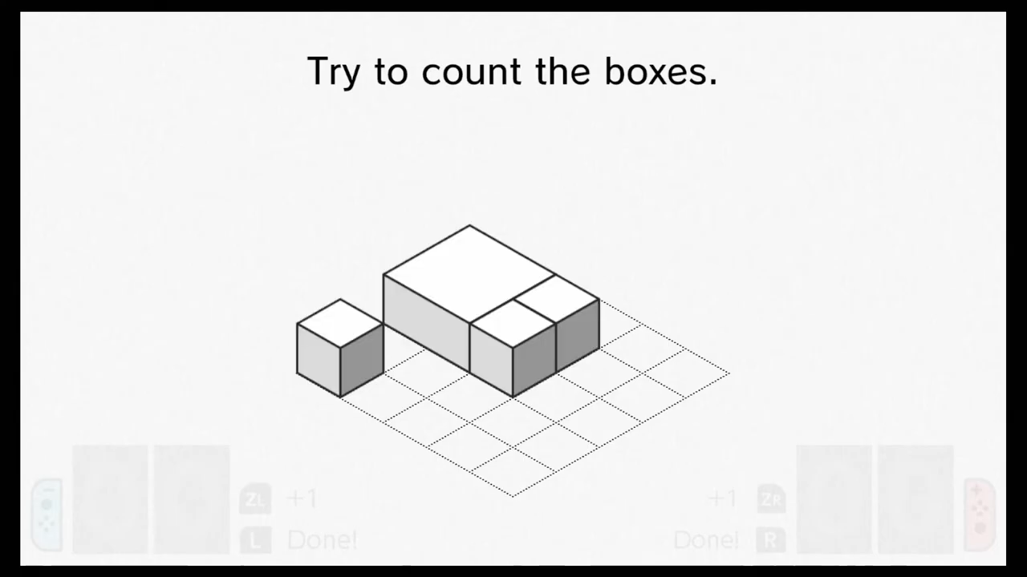
V3 at about 5 minutes 52 seconds. The broad box is one object; the full arrangement is four boxes.
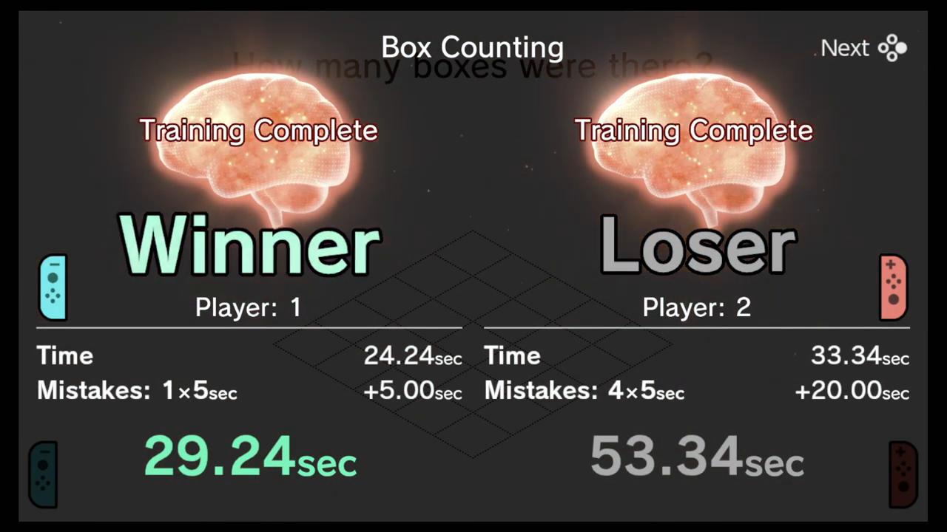
V3 at 6 minutes 45 seconds. Time plus five seconds per mistake determines the winner.

Browser visual targets
Newly drawn geometric targets for the browser version. Exact positions, palette and font remain subject to implementation comparison.
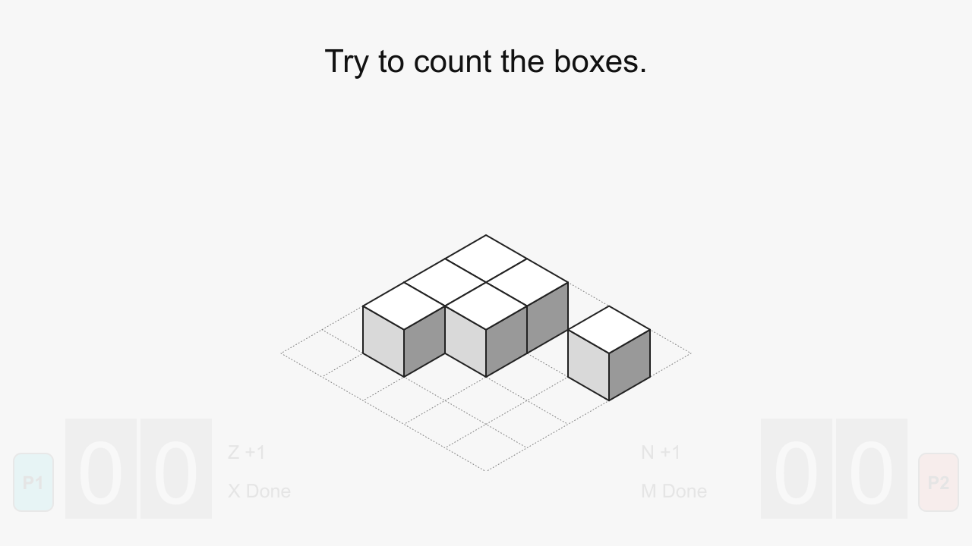
Watch target. Neutral boxes, faint inactive counters and a fixed isometric projection.
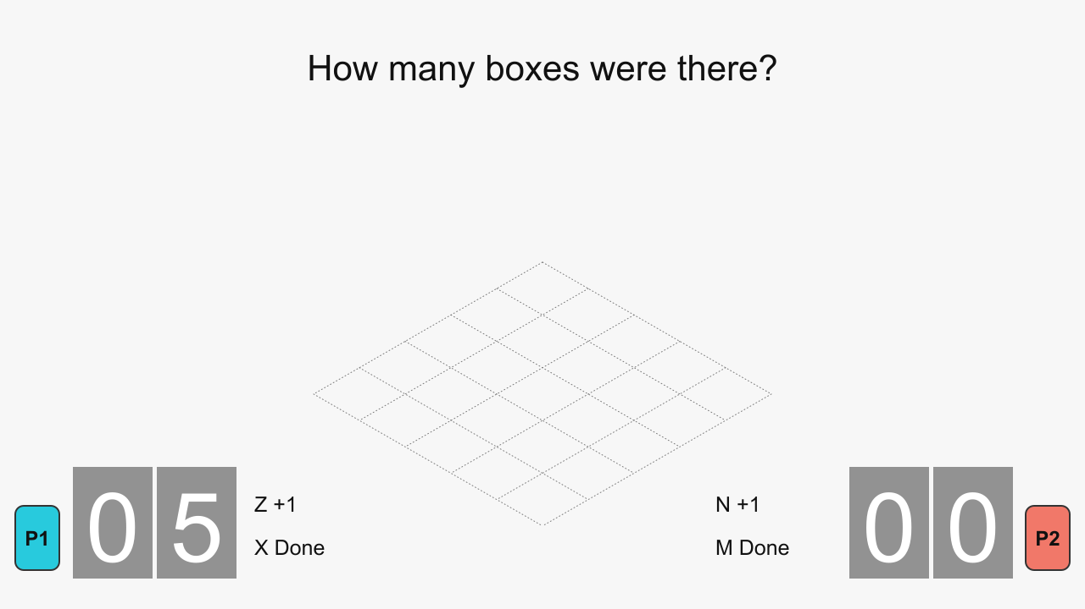
Answer target. The boxes are gone and both tiled counters accept independent keyboard input.

Reveal visual target
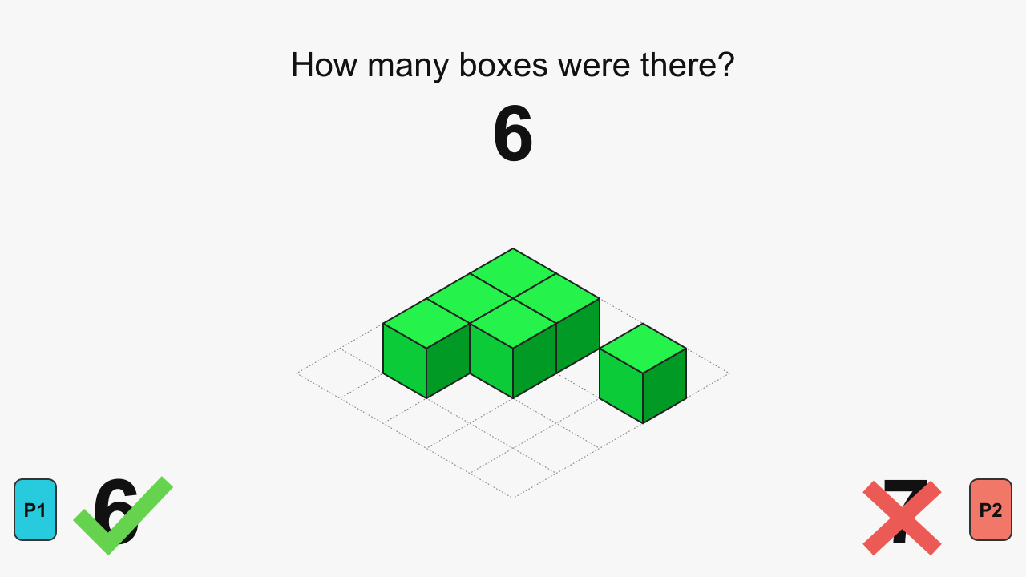
Final reveal target. All six boxes are green; the submitted six receives a check and the seven a cross.
During the implemented reveal animation, boxes turn green one object at a time and the central number rises in the same order. This still image represents the final state. The cyan and coral badges replace Switch controller illustrations.

Supporting files
The Markdown chapters, timestamped evidence, downloaded video references, editable SVGs, rules profile, schema and ten-level reconstruction pack live beside this document in the project folder. See README.md for the complete index. This package plans the game; it does not claim that a playable build or browser acceptance testing has already been completed.

