MazeGenerator – CellularMazesv1 (2026)

Introduction
This is a free to use web app for generating, editing, exporting, saving and solving cellular mazes, inspired by the previous Java-Swing project: https://github.com/SamuelFleming/CellularMaze-v1
- Instead of using the Java swing library, we want to implement this as a web service, with persistent data storage, and aim for a very simplistic deployment. We want to focus on a clean, smooth UI, with good design implemented.

We want to have a simple user system (for the purposes of saving and loading mazes) but also include a guest mechanism. For user Auth, we will not use MFA, we will simply use the auth mechanism from the react project template repository
- https://github.com/SamuelFleming/ReactLoginTemplate_1
I also want to create a ‘guest’ mechanism, where you do not have to necessarily create an account to run the app, but you cannot save any mazes without one (very simple role-based access control, and token management).

Why This Project?
In 2026, I want to uphold the notion of ALWAYS WRITE CODE, to ensure I am engaged with my career skill progression and always alert to the mindset of being a tech professional. In this, I have set the goal of completing 3-4 deployed home projects in the year (this being the first, and simple, of them), and also to better position myself for entering the Job market for 2027.

Specifically, I want practice in areas that BAU dev work often hides/prevents, this can be summarised in the following remarks:
- Architecture choices, deployment, observability, trade-offs
- Choosing a stack, testing skills of said stack
Essentially, in order to learn and be confident in a technology/stack/skillset, I feel the best way to do this is to complete a project from inception to deployment, and I want to get this experience started with this app

High Level User Stories
As a user I can
- Create an account
- Sign into my account
- Open the app as a guest

As a User (All levels) I can
- Create a Maze in session, by specifying the orientation, start cell, end cell and inserting blockers on cells
  - Generate a maze automatically
  - Generate a maze manually by removing individual or consecutive walls, placing individual or consecutive walls, and auto generating the remainder of the maze
- Edit a Maze in session by placing/removing cellular walls, inserting blockers on cells and auto generating remainder of maze
- Export a Maze in session as an Image
- View the shortest solve path for my maze

As a User (Signed In) I can
- Generate a maze and save it
- Publish my own mazes (allocate for public viewing)
- Load my own saved mazes
- View and solve all publicly published mazes from other users
- View and solve me own mazes

The Abstract Data Structure

In the original:
- Maze has LxW Cells
- Cells have Four Walls
- Walls are visible or invisible
.. but this made unnecessary complexity, where as to break a wall, you were really breaking two adjacent walls (one for each adjacent cell). Instead, I would like to implement a core model of Mazes being made up of walls in the web API, and then the frontend are graphical translations of these models (I think).

For the Type of Cellular Maze in the original project
If we have a 5x6 Maze for instance:

0, 5 | 1, 5 | 2, 5 | 3, 5 | 4, 5
0, 4 | 1, 4 | 2, 4 | 3, 4 | 4, 4
0, 3 | 1, 3 | 2, 3 | 3, 3 | 4, 3
0, 2 | 1, 2 | 2, 2 | 3, 2 | 4, 2
0, 1 | 1, 1 | 2, 1 | 3, 1 | 4, 1
0, 0 | 1, 0 | 2, 0 | 3, 0 | 4, 0

The number of walls is:
W = (number of cells * [N + W walls]) + far east walls + far south walls
W = (l*h * 2) + h + l
W = 2lh + h + l
W = 2*5*6 + 6 + 5=71

But, we are only interested (for now) in the walls that connect cells. So it does not include the outer walls (we can assume these outer walls are always blocked).

So it is really
Wi = 2lh + h + l - (West wall + East wall + North wall+ South wall)
Wi = 2lh + h + l - 2l - 2h
Wi = 2lh - l - h
Wi = (2*5*6) - 5 - 6=49

So, this data structure essentially can be modelled as a graph (discrete structures), where the vertices are the cells, and the sides (paths) are the walls (or open walls when there). This would correspond to Maze Type 1 (see below)
- However, we have also identified a second potential maze type (maze type 2)
Maze Type 1  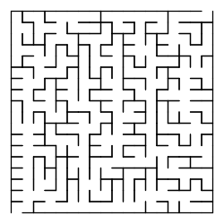  Where there are two definitive objects, a cell, and a wall (connection between two cells). What it has already been implemented to do.  * However, there is potentially another cellular maze type (Maze Type 2) which I noticed researching maze generation algorithms. This maze type does not have a differentiation for wall and cell, Instead, wall and open cells occupy the same amount of space. (See besides us) | Maze Type 2  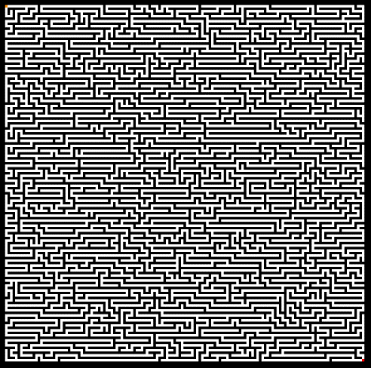  Here, the same space can be either a wall or a cell, but there never appears to be the case a square of cells.  Could this be the logic (for generating)  - All cells are ‘walls’ accept the starting cell  - Prospective next cell is a random adjacent wall  - The next cell is accepted if it is not adjacent to an existing cell (except the current cell)  Here the data structure is merely all the cells annotated as a wall (black) or cell (white) as an array.

As an MVP I want to focus on implementing the app for Maze Type 1, but I want it feasible as a future iteration to extend functionality to Maze Type 2, and other maze types (more on this below).

Maze Type One and Two

For solving logic (In the API)
- Essentially both a graph

Generation, Editing and Display Logic is where they differ
Maze Type 1 | Maze Type 2 (Cellular Automata Maze)
Example Maze Image  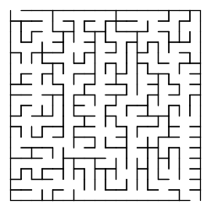 | Example Maze Image  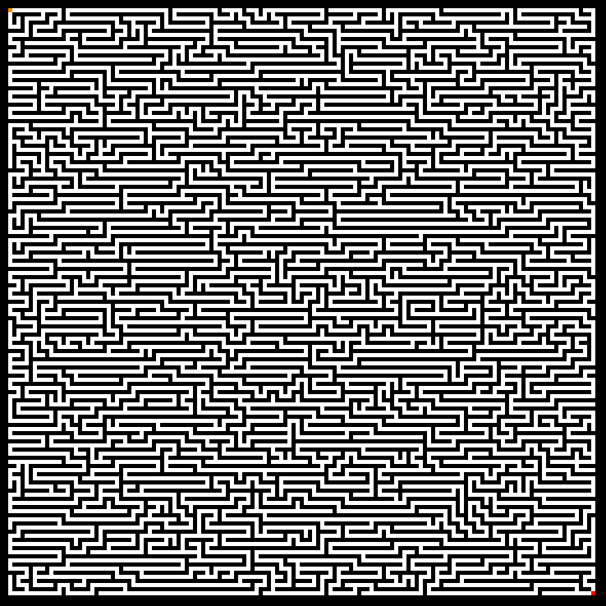
Starting State | Starting State
  E
  S
  E
  S
Partially generated | Partially Generated
  E
  S
  E
  S
Fully Generated | Fully Generated
  E
  S
  E
  S

ADS and Key Competitor Analysis
Ok, this is a preliminary competitor analysis to help scope what the App could scale to, which will inform how we will implement the MVP, to be suitable for scaling up.
https://www.mazegenerator.net/
It offers three distinct cellulary maze types (Called ‘Styles’):
- Orthogonal (Square Cells)
- Sigma (Hexagonal Cells)
- Delta (Triangular Cells)
But also has Maze shapes (higher level):
- Rectangular
- Circular
- Triangular
- Hexagonal
Here are some examples from the App
Shape: rectangular  Style: Hexagonal  With solution (not as lines)  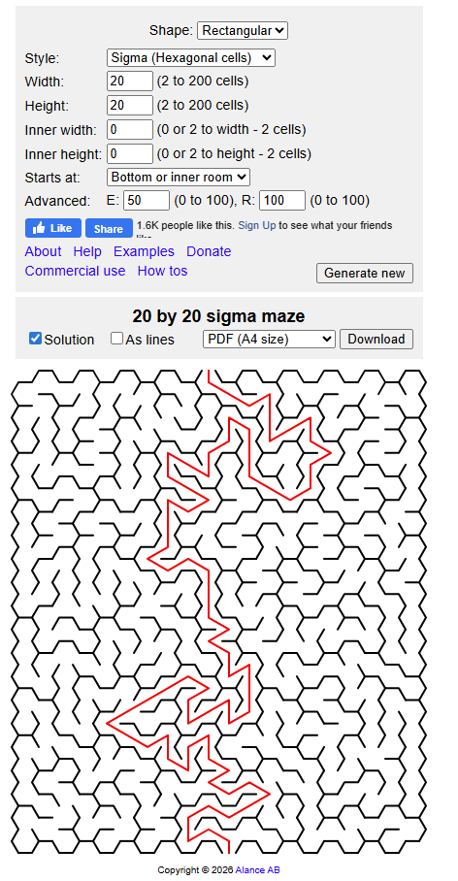 | Shape: rectangular  Style: Hexagonal  With solution (as lines)  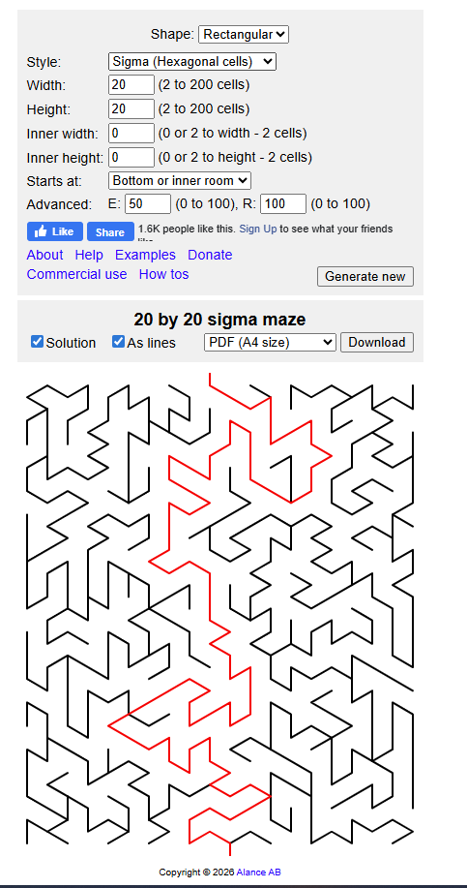 | Shape: circular  Style (no options)  Without Solution  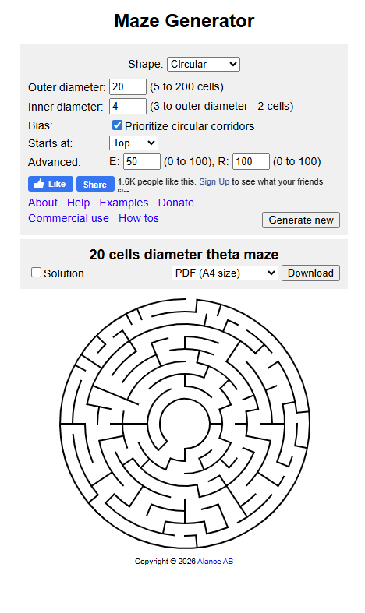
Unique to this app:
- representing maze as lines (or not)
- Cell shapes / types and dynamic input values for these
What this app lacks:
- Selection/nomination of specific start and end cells
- Clear depiction of start and end cells
- Cell blocking / inserting of images
- Manual editing
- Solve complexity

We had already identified two different maze types, both square, one with distinct walls, the other with active vs inactive. Now, could we expand to different maze types, combined with whether it is walled or not: Would it work?

Further logic
- During Generation
  - Either Pre Auto Gen Or,
  - During Manual gen (and editing)
- User can ‘block’ cell, or areas of cells
  - Can insert an image on these blocked cells.

Our Goal
- Develop and MVP of the maze generation/ edit and solve interface for Maze Type 1
  - (Rectangular and walled)
- Plan how to expand into maze type 2…. [This is the design challenge of this project. Although, rapid MVP to then test deployment is main priority, I want to implement this MVP with the notion of expansion at its core]
    - (Rectangular and not walled)
  - … and then to different shapes (Hexagonal, Triangular, Circular) and cell styles (Hexagonal, triangular)

We Need to…
- Define a model that can capture behaviours across all cellular maze types
  - Same frontend interfaces for solving (UI for user to try and solve)
    - Start at cell and with mouse (or arrows) move with the maze (Can only move between cells that are joined)
  - Same API structure for solving
    - Graph Search Algorithm (Breadth First Search?)
  - Start / End Cells
  - Maze Dimensions
    - Rect: Height and Width
    - Hex and Tirangular: Side Length (assuming only Equalateral)
  - GetOptimalSolve() / IsSolvable() (Some mazes that have been manually generated would be in state of not being able to be solved)
- Shared Canvas where all styles/shapes can appear on
- Decide on a stack: MERN Stack (good opportunity to tick this stack off the portfolio list)
  - MongoDB (noSQL)
  - Express (Backend framework)
  - React (Frontend framework)
  - Node

Some Additional Notes

From Initial ChatGPT Chat

Stack Considerations with App Scale?
Minimal layer stack would provide the least deploymet complexity and is not entirely unfeasible for this application (Next.js where logic is in frontend)
- but we want to emulate industry-level principles.
- We could do most of the heavy lifting in the frontend (this would allow a the maze project (GUI) to evolve during auto generation – compare algorithms) – and then have all the crud-level operations through an API (Mazes, Users (Auth etc), Users and their published mazes)

Infrastructure Plan
- Repo (GitHub), CI/CD (Github Actions), Hosting (?), Simple Page Analytics
- Persistence for Mazes and Profiles (container?)

Maze Type 2 : AKA ‘Cellular Automata Maze’
- Start with random noise, apply N iterations of rules, ensure connectivity between start and the end, then solver works the same.
- Visual Web app win

Potential Architecture
- Frontend:
  - Maze renderer + editor (Canvas?)
  - Calls API
  - Maze Generation/Solving - here or in API?
    - To enable solve/generate in-real-time – here? Otherwise, easier (at first) to have in the API
  - Handles guest mode locally – Offline mode?
- API:
  - Auth Gate + RBAC
  - CRUD Operations
- Database (SQL [requiring data access API] or Mongo [noSQL]):
  - Mazes as well as profiles
  - Reference Data (for scaling requirements?)

Preliminary API Reqs
- POST /auth/register
- POST /auth/login
- POST /auth/guest (returns a “guest token” with no write permissions)
- POST /mazes/generate (returns maze JSON, not saved)
- POST /mazes/solve (returns path + visited stats; supports “optimal” via BFS/A*)
- POST /mazes (save — signed-in only)
- GET /mazes/:id (load)
- GET /mazes/public (browse public mazes)
- POST /mazes/:id/publish (owner only)
- GET /mazes/:id/export (returns PNG via server render, or just do client-side export in v1)

From v0 Code Deconstruct Chat

From v0:
- BFS optimal solver
- Radnomized maze generator algorithm
- Meta-data and export thinking
What we want to add:
- Cleaner UI
- Separation between domain and presentation
- Interface to expand upon
- Statelessness

Domain Layer Pattern: One endpoint, typed responses
- POST /api/mazes/generate
- Request includes { type: "graph-v1" | "cellular-v2" | ... , params: {...} }
- Response always wraps a common envelope:
  - type
  - schemaVersion
  - payload (type-specific)
Where the frontend has a ‘type registry’
- Chooses the right renderer + editor based on the shape (rectangular) + type (square cells), (for Default Maze Type 1)
This achieves ‘frontend logic that covers a breadth of types’:
- Shared frontend shell
  - pages, layout, toolbar, undo/redo, save/load, export, etc.
- Pluggable type modules
  - render(type, payload)
  - edit(type, payload, userAction)
  - solve(type, payload, algorithm)

JSON Contract: MazeEnvelope
{
"type": "maze.type1.graph",
"schemaVersion": 1,
"meta": {
"id": "optional-uuid",
"title": "Untitled",
"author": "optional",
"createdAt": "2025-12-24T10:00:00.000Z"
},
"payload": { }
}

- type (Would realistically be shape [Rectangular] and cellStyle [square] for instance)
  - lets the frontend choose the correct renderer/editor/solver module
- schemaVersion - lets you evolve the payload safely over time
- payload - is type-specific

Maze Type One (Rectangular with Square Cells) payload: graph-based grid
{
"width": 20,
"height": 20,
"validCells": ["0,0", "0,1", "1,1"],
"start": "0,0",
"end": "19,19",
"edges": {
"0,0": ["0,1"],
"0,1": ["0,0", "1,1"]
}
}

Frontend Architecture that scales across maze types
In the frontend Build a registry
mazeTypeRegistry["maze.type1.graph"] = {
render: renderGraphMaze,
editReducer: graphEditReducer,
solveOverlay: overlayPath,
};

Maze Type 1 (Rectangular Walled, Square Cell) and 2 (Rectangular Cellular Automata, Square Cell)
Shared Contract
Maze Envelope | Shared Request Envelope | Shared Solution Envelope
type MazeEnvelope<TType extends string, TPayload> = {  type: TType  schemaVersion: 1  meta: {  id?: string  title?: string  author?: string  createdAt: string  }  payload: TPayload  } | type GenerateRequest<TParams> = {  type: string  params: TParams  }  type SolveRequest<TMaze> = {  type: string  params: { algorithm: "bfs" | "astar" }  maze: TMaze  } | type MazeSolution = MazeEnvelope<"maze.solution", {  algorithm: "bfs" | "astar"  found: boolean  path: string[] // array of NodeIds (more on NodeId below)  visitedCount?: number  cost?: number  }>
Common Identity: NodeId
- NodeId = "${x},${y}"
Maze Type 1 (Rectangular Walled, Square Cell) | Maze Type 2 (Rectangular Cellular Automata, Square Cell)
Type string "maze.type1.graph"  Payload:  type MazeType1GraphPayload = {  width: number  height: number  // Cells that exist / are traversable  validCells: string[] // NodeId[]  // Start/end must be valid cells  start: string  end: string  // Undirected adjacency list (store both directions)  edges: Record<string, string[]> // NodeId -> NodeId[]  } | The point of Type 2 is: instead of “walls as missing edges”, you represent cell states and allow different rules.  There are a few ways Type 2 could go. The most flexible (and still simple) is:  - every coordinate is a cell  - each cell has a state (e.g. blocked/open/water/forest/etc.)  - movement rules depend on state (or weights)  Type string "maze.type2.cellular"  Payload:  type CellState = "OPEN" | "BLOCKED" | "START" | "END" | "CUSTOM"  type MazeType2CellularPayload = {  width: number  height: number  // Dense representation is easiest for cellular automata style mazes  // Row-major array length = width * height  cells: {  state: CellState  // optional extension point:  // e.g. terrain cost, temperature, etc.  cost?: number  tag?: string  }[]  start: string // NodeId  end: string // NodeId  // Movement model defines shared behavior with Type 1 solver endpoints  movement: {  neighbourhood: "VON_NEUMANN" | "MOORE" // 4-way vs 8-way  allowDiagonal?: boolean // shortcut convenience  blockedStates: CellState[] // usually ["BLOCKED"]  defaultCost?: number // for A*  }  }
Frontend breadth without chaos
- In the UI, you keep a stable “app shell”, and plug type modules:
  - MazeCanvas (shared)
  - Toolbar (shared)
  - MazeTypeRegistry (pluggable)
- Each maze type module provides:
  - toRenderPrimitives(maze) (walls vs cells)
  - applyEditAction(maze, action) (toggle edge vs paint cell)
  - serialize/deserialize (same envelope anyway)
  - deriveNeighbours(nodeId) for interactive solve previews (optional)

