Environmental complexity constrains parasite evolution
Samuel TE Greenrod^{1#}, Daniel Cazares¹, Weronika Slesak¹, Tobias E Hector¹, R. Craig MacLean¹, Kayla C King^{1,2,3,#}
¹ Department of Biology, University of Oxford, Oxford, UK
² Department of Zoology, University of British Columbia, Vancouver, Canada
³ Department of Microbiology & Immunology, University of British Columbia, Vancouver, Canada
#Correspondence: greenrodsam@gmail.com (Samuel Greenrod); kayla.king@ubc.ca (Kayla King)

Abstract
Environmental complexity shapes evolutionary trajectories by imposing multiple selection pressures simultaneously. Temporal heterogeneity is an important aspect of environmental complexity and is generally thought to promote evolution through diversifying selection. However, whether temporal heterogeneity promotes or constrains evolution when combined with other selection pressures remains unclear. In this study, we propagated two bacteriophages under fluctuating temperatures (37-42°C) in the absence and presence of a phage competitor. Through comparison with previously analysed static lines, we show that fluctuating temperatures select for generalist phenotypes relative to static conditions. However, combined selection by fluctuating temperatures and competition lead to restricted thermal adaptation, slower evolutionary rates and fewer putative adaptive mutations. These findings suggest that temporal heterogeneity promotes the maintenance of genetic diversity on its own but constrains evolution when combined with other selection pressures. Our study highlights the potential for reduced species adaptive capacity as environmental perturbations increase under global climate change.

Introduction
Environmental complexity plays a key role in shaping species’ evolutionary trajectories. In natural populations, species often encounter selection pressures from multiple environmental stressors simultaneously [1]. Multiple stressor environments can constrain evolution rates through synergistic negative effects on species fitness which reduce population sizes and mutational supply [2,3]. Multiple stressor selection can also restrict adaptation through fitness trade-offs whereby high fitness under one stressor reduces fitness under another [4,5]. Despite such constraints, species can adapt to multiple stressors through the evolution of generalists which have intermediate growth across selection pressures [6]. Stressors also occasionally have antagonistic interactions [2] or can enhance adaptation by co-selecting for the same phenotypes [7,8]. Whether adaptation to multiple stressors can occur depends on both the diversity of stressors and the direction that stressors select in. The ability of species to adapt to multiple stressors plays an important role in the maintenance of global biodiversity and species extinction risk [2,9,10].
An important contributor to environmental complexity is temporal heterogeneity where different selection pressures occur over time. Frequent environmental change selects for the evolution of phenotypic plasticity enabling organisms to rapidly respond to heterogeneity within their lifetimes [6,11]. In contrast, moderate change selects for generalists which have intermediate fitness across conditions [6]. Generalists can arise from either pleiotropic mutations [12,13], the acquisition of multiple specialist mutations [14], or population division into specialist sub-populations [15]. Finally, infrequent change selects for specialists which undergo recurring selective sweeps [16]. While very rapid or very slow fluctuations can reduce diversity by encouraging selective sweeps, intermediate fluctuations impose diversifying selection and so can promote the maintenance of genetic diversity [13,16,17]. By increasing standing genetic variation, moderate fluctuations may offset some of the diversity-suppressing impacts of multiple stressor selection [18]. However, when applied alongside other stressors, fluctuations may contribute to stressor synergies and further constrain evolution [19].
Parasites are highly sensitive to environmental stressors due to their multi-stage life cycles. Parasites have both free-living, vector-based, and host-associated life stages. By moving through numerous external environments during and between replicative cycles, parasites experience high temporal and spatial heterogeneity [20]. Hosts and parasites also undergo reciprocal co-evolution of anti-parasite resistance and parasite infectivity, respectively, which underpin parasite evolution rates and trajectories [21]. Finally, parasites rarely infect in isolation but instead exist in diverse communities which compete for access to host resources [22]. Competition with con-specifics can interact with environmental stressors to drive parasite evolution (Greenrod et al., unpublished, [23]). Microbial parasites are an ideal system to study environmental complexity and evolution due to their sensitivity to environmental stress (Greenrod et al., in press) and rapid growth and evolution rates [24]. By altering growth conditions and the presence of competitors, experimenters can directly assess parasite evolution under a variety of environmental stressors [25].
Temporal heterogeneity is predicted to select for generalist populations and promote genetic diversity [6]. However, combined selection of temporal heterogeneity and other environmental stressors is predicted to constrain evolution rates and prevent adaptation [19]. To test these predictions, we passaged two lytic viral parasites (thermal generalist φLUZ19 and specialist φ14-1) under a fluctuating thermal regime (37-42°C) in the absence and presence of a phage competitor. Phages were evolved with a non-evolving bacterial host, Pseudomonas aeruginosa. We then compared fluctuating evolved populations with parallel evolving static temperature lines (37°C and 42°C) presented in Greenrod et al. (unpublished). We evaluated phage phenotypic adaptation through growth assays at 37°C and 42°C. We also conducted phage population sequencing to identify adaptive mutations and measure evolutionary rates.

Methods and Materials
Strains, Storage, and Culture Conditions
This study builds on a previously published experimental framework (Greenrod et al., unpublished) using the same bacterial host and bacteriophage strains. Pseudomonas aeruginosa PAO1 was used as the non-evolving bacterial host throughout. Two lytic phages, φLUZ19 and φ14-1, were used due to their known thermal response differences: φLUZ19 performs well at both 37°C and 42°C, while φ14-1 is growth-restricted at 42°C [26]. Phage lysates and bacterial stocks were prepared as in ref [26].
Experimental Evolution
The experimental evolution design closely followed that of Greenrod et al., with additional treatments incorporating fluctuating temperatures. Phages were serially passaged for 15 days under four conditions: monoculture and co-culture, each at either static or fluctuating temperatures (daily shifts between 37°C and 42°C). Each treatment included six independent replicate populations initiated from a single ancestral lysate.
Phage were propagated without shaking with a non-evolving ancestral PAO1 bacterial host. For the initial passage, ancestral phage lysates were diluted to 10⁸ PFU/ml and 300μl were added to 2.7ml 10⁸ CFU/ml bacterial culture in loose-lid 14ml falcon tubes. Phage co-culture lines were prepared by combining 150μl each of φLUZ19 and φ14-1 10⁸ PFU/ml lysates prior to mixing with bacteria. The initial passage phage densities were ~10⁷ PFU/ml resulting in a phage/bacteria ratio (multiplicity of infection, MOI) = ~0.1. Following addition of bacterial cultures, tubes were incubated statically at 37°C or 42°C in circulating water baths for 8h. Fluctuating passages started and ended at 37°C.
After incubation, phage populations were harvested by centrifugation (3,095×g, 5 min) to pellet bacteria, followed by sterile filtration through 0.2 μm filters. Filtrates were stored at 4°C. In subsequent passages, 300 μl of lysate was transferred into fresh PAO1 cultures.
Phage Quantification
Phage titres were determined via the double-layer overlay method [27] using φLUZ19- or φ14-1-resistant PAO1 strains for selective plating. These resistant strains were derived by isolating colonies growing on high titre phage plaques and confirmed via sequencing (Greenrod et al., unpublished). All monoculture and co-culture samples were quantified using the appropriate resistant strains to ensure consistency.
Phage Purification and Concentration
To generate high-titre and pure phage lysates for downstream assays and sequencing, we employed selective double-layer overlays with resistant hosts, followed by phage extraction from top agar through overnight mixing with phage buffer (NaCl (100 mM), MgSO₄ (10 mM), CaCl₂ (5 mM), Tris-HCl (pH 8) (50 mM), Gelatin (0.01%)). This process was performed three times to ensure removal of phage competitors from co-culture populations. The purification and extraction protocols were identical to those described in Greenrod et al.
Fitness Assays
Growth Rates
The fitness of purified evolved phage lines relative to the ancestor was assessed by measuring phage and bacterial growth across an 8h window under static incubation at 37°C and 42°C. Phage lysates were diluted to 10⁵ PFU/ml and mixed with 10⁸ CFU/ml wild-type PAO1 to a final MOI = ~0.0001. φLUZ19 was sampled at 2h, 4h, and 8h; φ14-1 at 4h and 8h due to delayed replication. Phage quantification was performed through sterile-filtration through 0.22μm filters (Agilent) followed by centrifugation at 2,230xg for 5 mins before spotting onto resistant PAO1 double-layer overlay plates. Each fitness assay included a single replicate of each evolved phage line and three replicates of the phage ancestor. Fitness assays were repeated three times across a two-week period to produce three technical replicates.
Competitive ability
We assessed the competitiveness of phage populations across time. Competitive ability was determined by growing phages for 8h at 37°C and 42°C either alone or in co-culture with an ancestral phage competitor (ancestral φLUZ19 for φ14-1 evolved lines, ancestral φ14-1 for φLUZ19 evolved lines). Phage and bacterial densities were kept the same as in the fitness assays resulting in a final MOI = ~0.0001. Phage competitiveness was determined by calculating the log₁₀ ratio of phages (evolved and ancestral competitor) in monoculture relative to co-culture [28]. Changes to phage competitiveness were assessed using MANOVA with log₁₀ growth ratio of focal phage and competitor as two separate response variables and an interaction term between temperature and evolved line as explanatory variable. Competition assays were repeated three times across a four-week period to produce three technical replicates.
Phage Population Genomics
DNA Extraction and Sequencing
Phage DNA was extracted from purified lysates as described in Greenrod et al. Briefly, ancestral and evolved phage lysates were treated with DNase and RNase to remove bacterial DNA and RNA. Phage particles were lysed using lysis (AL) buffer and proteinase K. Cell debris was precipitated using precipitation (N4) buffer and removed. Finally, DNA was precipitated and washed using isopropanol and ethanol. DNA quality was assessed with NanoDrop 2000c (Thermo Scientific) and quantified with Qubit 4 (Thermofisher). Short-read Illumina sequencing was performed by AZENTA/GENEWIZ using their Microbe-EZ pipeline for evolved and ancestral lines. Bacterial genomes (wild-type and phage-resistant strains) were sequenced by MicrobesNG using hybrid (short and long-read) approaches.
Sequence Analysis
Sequences are analysed using identical protocols to Greenrod et al., (unpublished). Reads were pre-processed with Trim Galore (v.0.5.0) (https://github.com/FelixKrueger/TrimGalore) and downsampled using bbnorm from the bbmap package (v.39.18) (https://sourceforge.net/projects/bbmap/). Reads were then mapped to de novo ancestral assemblies generated with shovill (v1.1.0) (https://github.com/tseemann/shovill) using Bowtie2 (v.2.3.4.2) [29]. Variants were identified using breseq (v.0.36.1) [30] under default parameters with default parameters. Ancestral assemblies were annotated with prokka (v.1.14.5) [31], guided by the NCBI GenBank file for each phage (φ14-1: NC_011703; φLUZ19: NC_010326).
Wild-type and resistant PAO1 genomes were assembled using Autocycler (v. 0.4.0) [32] and polished via Polypolish (v. 0.6.0) [33]. Final assemblies were re-oriented with Dnaapler (v. 1.2.0) [34] and annotated using prokka (v.1.14.5) [31]. The workflow was deployed using a Dockerised Nextflow pipeline (v. 1.0.2) available at https://doi.org/10.5281/zenodo.15706447. Mutations in resistant PAO1 strains were identified by mapping long reads to the wild-type assembly with minimap2 (v.2.24) [35] and variant calling with medaka (v.2.1) (https://github.com/nanoporetech/medaka).
Statistical Analyses and Visualisation
All statistical analyses and data visualisation were conducted using packages in R and RStudio [36,37]. Phage growth and evolution rates were compared between lines using linear mixed effect models where the response variable was phage density (pfu/ml) or genetic distance from ancestor, explanatory variable was evolved line, and batch was a random effect. Phage genetic distance between groups was also compared by constructing neighbour-joining trees based on Euclidean genetic distance. All data and analysis scripts are available at

Results
Fluctuating temperatures select for generalist phenotypes
Fluctuating environments are expected to select for generalists which have intermediate phenotypes across conditions [6]. We hypothesised that φ14-1 passaged under fluctuating conditions would rapidly adapt to 42°C passages but have lower fitness at 37°C and 42°C compared to static evolved populations. Population dynamic results showed that, in monoculture, φ14-1 grew during 37°C passages but showed little growth in 42°C passages (Figure 1a). φLUZ19 monoculture populations reached and maintained high densities in all passages and showed low inter-passage density variation.
We assessed phage evolution by measuring the fitness of static and fluctuating evolved lines relative to the ancestral phage through growth assays at 37°C and 42°C (Figure 1b). We found a significant interaction between evolved line and temperature regarding growth rates for both phages (φ14-1: F_{3,29} = 125.8, p < 0.001; φLUZ19: F_{3,29} = 96.0, p < 0.001). At 42°C, φ14-1 fluctuating populations were found to have an intermediate phenotype between those evolved under static conditions. φ14-1 fluctuating populations had significantly higher growth rates at 42°C than 37°C static populations (t(29) = -12.4, p < 0.001) but lower growth rates than 42°C static populations (t(29) = 12.7, p < 0.001). At 37°C, φ14-1 fluctuating lines had no significant difference to static populations possibly due to phage growth being measured after phages had reached carrying capacity. For φLUZ19, fluctuating evolved populations had significantly higher growth at 42°C than 37°C static populations (t(29) = -19.3, p < 0.001). However, growth was not significantly different to 42°C evolved populations (t(29) =-1.65, p = 0.37). The opposite findings were observed at 37°C; fluctuating evolved lines had significantly higher growth rates than 42°C evolved lines but similar growth rates to 37°C evolved lines (42°C static: t(29) = -5.2, p < 0.001; 37°C static: t(29) = -0.99, p = 0.75).
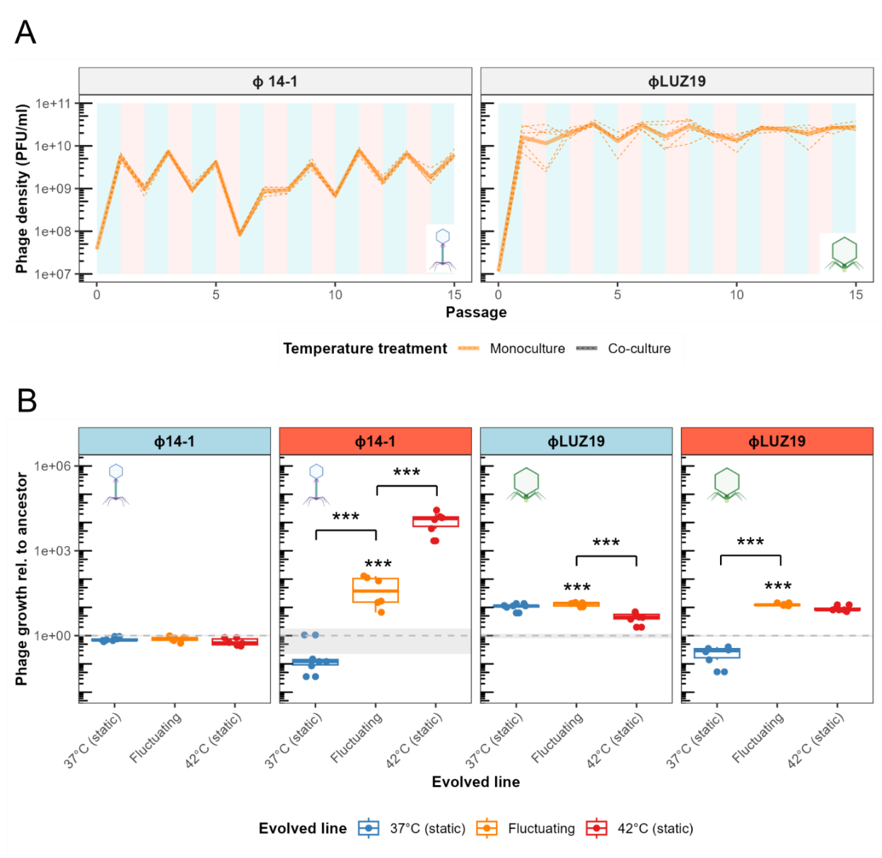
These findings indicate that fluctuating temperatures selected for φ14-1 thermal generalists. In contrast, φLUZ19 evolved increased overall fitness indicating thermal adaptation was not constrained by weak selection or evolutionary trade-offs.

Figure 1. Fluctuating environments select for thermal generalism. A) Population dynamics of phages evolved in monoculture. Plot background colour reflects the temperature during that passage where blue is 37°C and red is 42°C. B) Boxplots show growth rates of evolved phage lines relative to the ancestor measured after 2h for φLUZ19 and 4h for φ14-1. Static temperature data was adapted from Greenrod et al (unpublished). Panel strip colour reflects the temperature that growth was tested at where blue is 37°C and red is 42°C. *** = p < 0.001. Absence of asterisk reflects non-significance. Phage icons reflect electron microscopy images of each phage [38] and are used hereafter to refer to phages in figures.

Combined fluctuation and competition selection constrains thermal adaptation
Fluctuating environments are expected to constrain adaptation when combined with other selection pressures by reducing mutational supply and compounding fitness trade-offs [2]. We hypothesised that phages evolved under combined fluctuating temperatures and competition would have lower fitness at 37°C and 42°C than those evolved at under static and monoculture conditions. While φ14-1 densities were found to fluctuate between passages in monoculture, co-culture densities rapidly stabilised between passages (Figure 2a). In contrast, φLUZ19 populations changed from being stable in monoculture to fluctuating in co-culture with high growth at 37°C and low growth at 42°C.
We then assessed evolved phage growth rates at 37°C and 42°C (Figure 2b). We found a significant interaction between evolved line (monoculture and co-culture) and temperature regarding growth rates for both phages (φ14-1: F_{6,59} = 75.0, p < 0.0001; φLUZ19: F_{6,59} = 103.5, p < 0.0001). While competition had no impact on the fitness of static φ14-1 populations (37°C: t(59) = -0.78, p = 0.99; 42°C: t(59) = -0.98, p = 0.99), fluctuating co-culture evolved populations had significantly higher fitness at 42°C compared to populations evolved in monoculture (t(59) = -6.7, p < 0.0001). No significant difference was observed at 37°C (t(59) = -1.0, p = 0.99). Similar to φ14-1, there was no impact of competition on static temperature φLUZ19 population fitness (37°C: t(59) = -0.42, p = 1.0; 42°C: t(59) = -0.21, p = 1.0). However, φLUZ19 populations evolved with fluctuations and competition had significantly lower fitness at both 37°C and 42°C compared to monoculture (37°C: t(59) = 10.1, p < 0.0001; 42°C: t(59) = 4.9, p < 0.001).
These findings indicate that, for φLUZ19, combined selection by thermal fluctuations and competition constrained thermal adaptation and inhibited growth in 42°C passages. However, for φ14-1, fluctuations and competition synergised to accelerate high temperature adaptation.

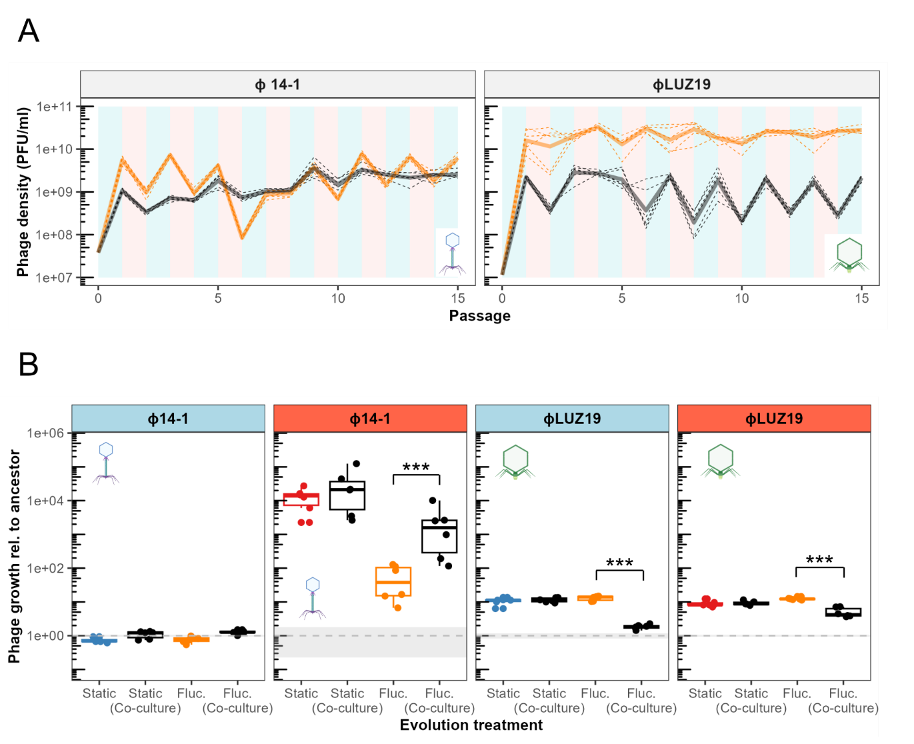Figure 2. Environmental complexity constrains thermal adaptation. A) Population dynamics of phages evolved in monoculture. Plot background colour reflects the temperature during that passage where blue is 37°C and red is 42°C. B) Boxplots show growth rates of evolved phages as in panel 1B but compare fluctuating regime populations evolved in monoculture (orange) and co-culture (black). Assay temperature and significance values are presented as in panel B. Static label refers to static monoculture treatment. Static and static (co-culture) show values for phages evolved at experimentally assessed temperatures (37°C evolved lines shown in 37°C plot and 42°C lines shown in 42°C plot). Error bars show standard errors and * = p < 0.05. Absence of asterisk reflects non-significant difference.

Fluctuating environments select for specialist mutations
Fluctuating temperatures are expected to select for generalist genotypes that form either unique genetic clades due to pleiotropic mutations or which show genetic similarities to both high and low temperature static lines. We assessed phage genomic evolution through sequencing and the identification of putative adaptive variants. Fluctuating evolved phage populations did not form a unique or genetically intermediate clade but instead were found to cluster with either high or low temperature static populations (Figure 3a). φ14-1 fluctuating populations were distributed among both 37°C and 42°C static clades. In contrast, φLUZ19 fluctuating populations were primarily found within the 42°C static clade.
We further analysed static and fluctuating population genetic similarities by determining the frequency of shared genetic variants (Figure 3b). In φ14-1 populations, 50% of fluctuating mutations were line-specific compared to 67% in 37°C static lines and 56% in 42°C static lines. In the φLUZ19 populations, only 29% of fluctuating mutations were line-specific compared to 78% in 37°C lines and 73% in 42°C lines.
Finally, we assessed the most prevalent genetic variants in fluctuating lines (Figure 3c). No mutations were observed across all φ14-1 fluctuating lines although two replicate populations contained a deletion in a hypothetical protein with high similarity to a DNA ligase (BlastP: 97.83% identity, 95% sequence overlap), previously associated with high temperature adaptation (Greenrod et al., unpublished). In contrast, φLUZ19 populations all evolved fixed mutations in a tail fiber gene and 5/6 populations contained an insertion in an intergenic region between two hypothetical proteins. While the tail fiber mutation was previously found in all evolved lines, the intergenic insertion was only found in 42°C monoculture lines (Greenrod et al., unpublished).
Overall, these findings suggest that fluctuating temperatures select for specialist mutations and lead to genomic signatures similar to static evolved populations. For φ14-1, fluctuating temperatures selected for populations resembling both high and low temperature genotypes. In contrast, φLUZ19 fluctuating populations more closely resembled 42°C adapted genotypes.
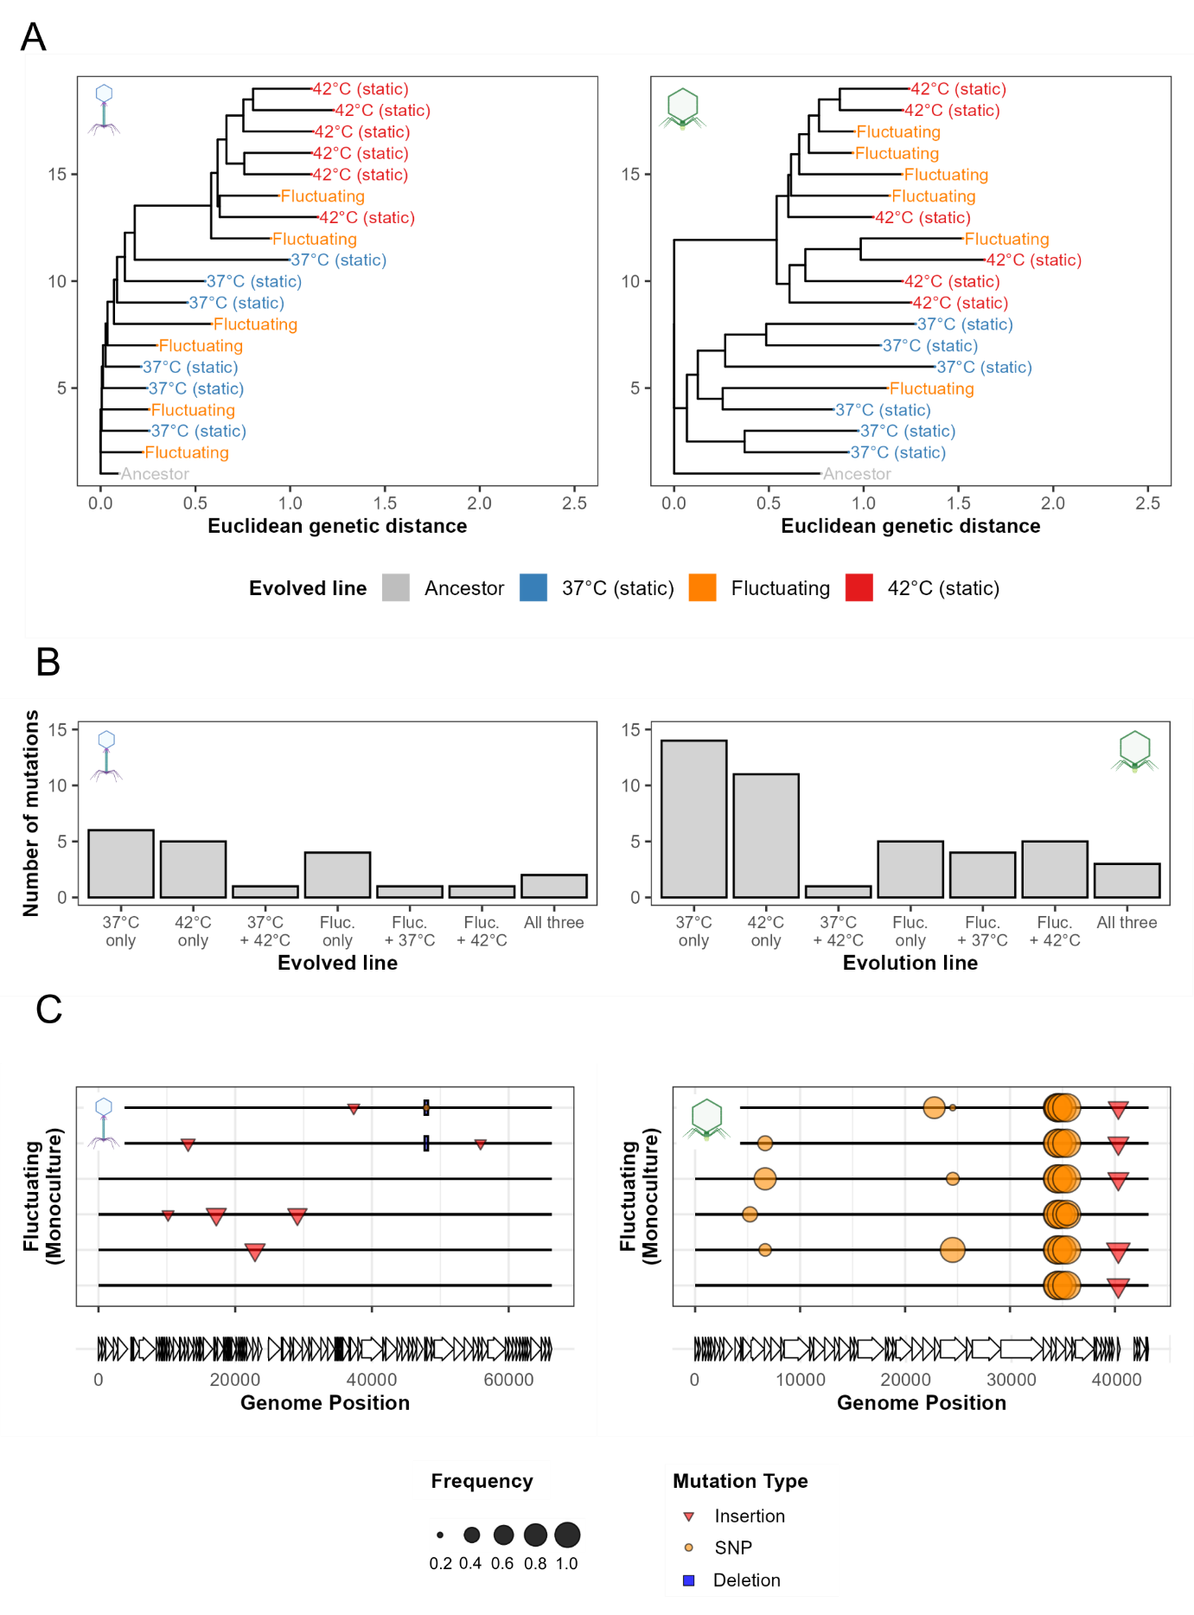
Figure 3. Fluctuating temperatures select for specialist mutations. A) Neighbour-joining trees constructed using Euclidean genetic distances. Genetic distances were calculated based on the presence and frequency of mutations present at > 10% frequency. Tree is rooted at the ancestor and populations are coloured by evolved treatment. B) Bar charts showing the number of putative adaptive variants in the same genome position (> 20% frequency) that are unique to or shared between evolved lines. C) Mutation plots show mutations associated with fluctuating temperature selection in phage lines. Lines represent individual biological replicates. Symbols show mutations across the phage genome at > 20% prevalence and which were not observed in the ancestral population. Deletion bar at φ14-1 48kb is a 1bp deletion but given a fixed size for visibility.

Combined fluctuating temperature and competition selection constrains genomic evolution
By reducing growth rates, combined fluctuating temperatures and competition are expected to reduce evolution rates and restrict the acquisition of adaptive mutations [2]. Due to their elevated growth rates, we hypothesised that φ14-1 fluctuating co-culture populations would have higher evolution rates than monoculture populations. While there was a significant effect of evolved line on evolution rate for φ14-1 (F_{5,30} = 4.9, p < 0.01), there was no significant difference between fluctuating co-culture and monoculture population evolution rates (t(30) = -2.04, p = 0.34) (Figure 4a). For φLUZ19, we hypothesised that fluctuating co-culture populations would have lower evolution rates than monoculture populations. We further hypothesised that fluctuating co-culture populations would have lower evolution rates than 37°C or 42°C static co-culture populations. We observed a significant effect of evolved line on evolution rates (F_{5,30} = 31.4, p < 0.0001). φLUZ19 fluctuating co-culture populations were found to have significantly lower evolution rates than monoculture populations (t(30) = 9.45, p < 0.0001). In addition, fluctuating co-culture populations had significantly lower evolution rates than both 37°C and 42°C static co-culture populations (37°C: t(30) = 5.5, p < 0.0001; 42°C: t(30) = 3.7, p < 0.05).
We then assessed the impact of competition on the acquisition of putative adaptive mutations (Figure 4b). For both φ14-1 and φLUZ19 fluctuating populations, fewer putative adaptive SNPs (> 20% frequency) were observed in co-culture compared to monoculture. Consistent with findings under static temperatures (Greenrod et al., unpublished), φ14-1 fluctuating co-culture lines all acquired a SNP or deletion in a putative DNA ligase. This mutation was previously identified in 42°C static evolved lines and is thought to contribute to high temperature adaptation. For φLUZ19, while co-culture populations maintained a small number of mutations in tail fiber genes, the populations no longer acquired the intergenic insertion associated with 42°C static populations.
These findings indicate that, for φ14-1, fluctuating temperatures and competition synergised to promote high temperature adaptation by selecting on a putative DNA ligase. In contrast, for φLUZ19, combined selection constrained evolution rates and led to loss of putative adaptive mutations.

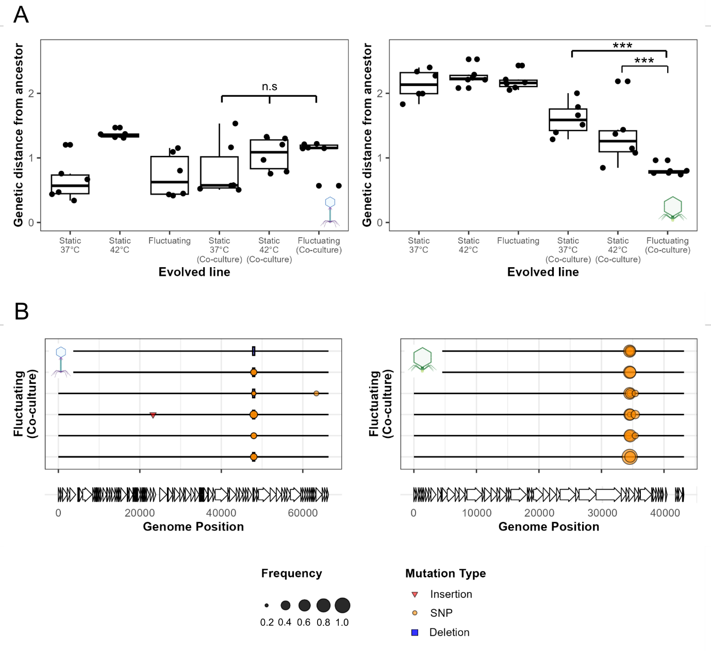
Figure 4. High environmental complexity constrains evolution rates. A) Box plots show evolution rates, measured based on Euclidean genetic distance from the ancestor, for each evolved phage line. Error bars show standard errors and *** = p < 0.001. N.S is used to denote lack of statistical significance. B) Mutation plots are shown for fluctuating co-culture populations. Plot layout is the same as in Figure 3c.

Discussion
While multiple stressor selection generally constrains evolution [3], temporal heterogeneity imposes diversifying selection leading to the evolution of generalists and the maintenance of genetic diversity [6,13]. We found that fluctuating temperatures select for thermal generalist phenotypes with intermediate fitness across temperatures. The evolution of intermediate fitness is typically associated with either selection being weaker in fluctuating environments or the presence of fitness trade-offs [39]. For one phage, we found that fluctuating population thermal fitness was the same as each static evolved populations. Given the same phage was shown to exhibit fitness costs under static selection (Greenrod et al., unpublished), this finding is indicative of no-cost generalism [40]. The lack of fitness costs may reflect an epistatic pleiotropy, whereby the costs of adaptive mutations depend on the genetic background [40]. Alternatively, costs may instead occur in unmeasured traits such as virulence [41] or tolerance to other stresses [5]. These findings confirm that fluctuating temperatures can limit but not prevent thermal adaptation.
Fluctuating environments generally select for pleiotropic mutations [12] or populations containing multiple specialist mutations [14]. We found that fluctuating evolved populations were genetically similar to statically evolved populations with one phage clustering with the 42°C clade. Further, we found that the mutations acquired under fluctuating selection were the same as those previously identified in statically evolved lines (Greenrod et al., unpublished). These findings could be explained by selective sweeps whereby mutations that are adaptive at low or high temperatures become fixed in a subset of populations [16]. Depending on the timing of mutation appearance, fluctuating populations may then resemble individual static environments. Fluctuating environments have also previously been shown to select on the most extreme environment [42]. The clustering of φLUZ19 fluctuating populations with 42°C static populations likely reflects selective sweeps combined with asymmetrical selection where 42°C adaptive variants are fixed more rapidly.
While fluctuating environments can promote genetic diversification, they are expected to constrain adaptation when combined with other selection pressures [2]. We found that combined fluctuating temperature and competition selection constrains both thermal adaptation and evolution rates. Further, fluctuating temperatures resulted in greater evolutionary constraint during co-selection than static temperatures. Interactions between environmental stressors are often non-additive and instead exhibit synergies [2]. In our previous study, we showed that high temperature selection synergises with competition to constrain evolution rates (Greenrod et al., unpublished). This study extends these findings by showing that evolutionary constraint is further exacerbated through synergies between competition and temporal heterogeneity. One potential explanation for these findings is that fluctuating environments reduce the strength of selection for adaptive mutations [43]. Weaker directional selection combined with suppression by competitors may constrain both the supply and fixation of beneficial mutations leading to low evolution rates.
Anthropogenic activities, including global climate change, mean that species are facing increasingly variable and complex environments [44]. Our findings highlight that while species can rapidly adapt in response to environmental variation, combined selection with other stressors may restrict species adaptive capacity. Increasing environmental variability, in addition to environmental extremes, may exacerbate ongoing global biodiversity loss.

Acknowledgments
We thank R. Salguero-Gomez, T. Richards, T. Barraclough, and K. Foster for feedback on the experimental design and results. This work was supported by the Biotechnology and Biosciences Research Council (BB/T008784/1) to S.T.E.G. as well as the Natural Environment Research Council (NE/X000540/1) and NSERC Canada Excellence Research Chair to K.C.K. The funders had no role in study design, data collection and interpretation, or the decision to submit the work for publication.

References
1. Gunderson AR, Armstrong EJ, Stillman JH. Multiple Stressors in a Changing World: The Need for an Improved Perspective on Physiological Responses to the Dynamic Marine Environment. Annual Review of Marine Science. 2016 Jan 3;8(Volume 8, 2016):357–78.
2. Crain CM, Kroeker K, Halpern BS. Interactive and cumulative effects of multiple human stressors in marine systems. Ecology Letters. 2008;11(12):1304–15.
3. Hiltunen T, Cairns J, Frickel J, Jalasvuori M, Laakso J, Kaitala V, et al. Dual-stressor selection alters eco-evolutionary dynamics in experimental communities. Nat Ecol Evol. 2018 Dec;2(12):1974–81.
4. Burmeister AR, Fortier A, Roush C, Lessing AJ, Bender RG, Barahman R, et al. Pleiotropy complicates a trade-off between phage resistance and antibiotic resistance. Proceedings of the National Academy of Sciences. 2020 May 26;117(21):11207–16.
5. Schou MF, Engelbrecht A, Brand Z, Svensson EI, Cloete S, Cornwallis CK. Evolutionary trade-offs between heat and cold tolerance limit responses to fluctuating climates. Science Advances. 2022 May 27;8(21):eabn9580.
6. Kassen R. The experimental evolution of specialists, generalists, and the maintenance of diversity. Journal of Evolutionary Biology. 2002;15(2):173–90.
7. Yang H, Yao S, Zhang M, Wu C. Heat Adaptation Induced Cross Protection Against Ethanol Stress in Tetragenococcus halophilus: Physiological Characteristics and Proteomic Analysis. Front Microbiol [Internet]. 2021 Jun 18 [cited 2025 Aug 5];12. Available from: https://www.frontiersin.org/journals/microbiology/articles/10.3389/fmicb.2021.686672/full
8. Huang M, Khan J, Kaur M, Vanega JDT, Patiño OAA, Ramasubramanian AK, et al. CgSTE11 mediates cross tolerance to multiple environmental stressors in Candida glabrata. Sci Rep. 2019 Nov 19;9:17036.
9. D. Vinebrooke R, L. Cottingham K, Norberg J Marten Scheffer, I. Dodson S, C. Maberly S, Sommer U. Impacts of multiple stressors on biodiversity and ecosystem functioning: the role of species co-tolerance. Oikos. 2004;104(3):451–7.
10. Halpern BS, Walbridge S, Selkoe KA, Kappel CV, Micheli F, D’Agrosa C, et al. A Global Map of Human Impact on Marine Ecosystems. Science. 2008 Feb 15;319(5865):948–52.
11. Sekajova Z, Fossen EIF, Rosa E, Ratikainen II, Tourniaire-Blum M, Bolund E, et al. Evolution of phenotypic plasticity during environmental fluctuations. j evol Biol. 2025 Jun 11;voaf078.
12. Sandberg TE, Lloyd CJ, Palsson BO, Feist AM. Laboratory Evolution to Alternating Substrate Environments Yields Distinct Phenotypic and Genetic Adaptive Strategies. Appl Environ Microbiol. 2017 Jun 16;83(13):e00410-17.
13. Abdul-Rahman F, Tranchina D, Gresham D. Fluctuating Environments Maintain Genetic Diversity through Neutral Fitness Effects and Balancing Selection. Molecular Biology and Evolution. 2021 Oct 1;38(10):4362–75.
14. Lambros M, Pechuan-Jorge X, Biro D, Ye K, Bergman A. Emerging Adaptive Strategies Under Temperature Fluctuations in a Laboratory Evolution Experiment of Escherichia Coli. Front Microbiol. 2021 Oct 22;12:724982.
15. Turner CB, Buskirk SW, Harris KB, Cooper VS. Negative frequency-dependent selection maintains coexisting genotypes during fluctuating selection. Mol Ecol. 2020 Jan;29(1):138–48.
16. Harrison E, Laine AL, Hietala M, Brockhurst MA. Rapidly fluctuating environments constrain coevolutionary arms races by impeding selective sweeps. Proc Biol Sci. 2013 Aug 7;280(1764):20130937.
17. Chesson P. Mechanisms of Maintenance of Species Diversity. Annual Review of Ecology, Evolution, and Systematics. 2000 Nov 1;31(Volume 31, 2000):343–66.
18. Yamamichi M, Letten AD, Schreiber SJ. Eco-evolutionary maintenance of diversity in fluctuating environments. Ecol Lett. 2023 Sep;26 Suppl 1:S152–67.
19. Cairns J, Borse F, Mononen T, Hiltunen T, Mustonen V. Strong selective environments determine evolutionary outcome in time-dependent fitness seascapes. Evol Lett. 2022 Jun 1;6(3):266–79.
20. Silva LM, King KC, Koella JC. Dissecting transmission to understand parasite evolution. PLoS Pathog. 2025 Mar 25;21(3):e1012964.
21. Buckingham LJ, Ashby B. Coevolutionary theory of hosts and parasites. j evol Biol. 2022 Feb 1;35(2):205–24.
22. Pedersen AB, Fenton A. Emphasizing the ecology in parasite community ecology. Trends in Ecology & Evolution. 2007 Mar 1;22(3):133–9.
23. Limberger R, Fussmann GF. Adaptation and competition in deteriorating environments. Proceedings of the Royal Society B: Biological Sciences. 2021 Mar 10;288(1946):20202967.
24. Poulin R, Salloum PM, Bennett J. Evolution of parasites in the Anthropocene: new pressures, new adaptive directions. Biological Reviews. 2024;99(6):2234–52.
25. Buckling A, Craig Maclean R, Brockhurst MA, Colegrave N. The Beagle in a bottle. Nature. 2009 Feb;457(7231):824–9.
26. Greenrod STE, Cazares D, Johnson S, Hector TE, Stevens EJ, MacLean RC, et al. Warming alters life-history traits and competition in a phage community. Applied and Environmental Microbiology. 2024 Apr 16;0(0):e00286-24.
27. Kropinski AM, Mazzocco A, Waddell TE, Lingohr E, Johnson RP. Enumeration of Bacteriophages by Double Agar Overlay Plaque Assay. In: Clokie MRJ, Kropinski AM, editors. Bacteriophages: Methods and Protocols, Volume 1: Isolation, Characterization, and Interactions [Internet]. Totowa, NJ: Humana Press; 2009 [cited 2023 Jun 2]. p. 69–76. (Methods in Molecular BiologyTM). Available from: https://doi.org/10.1007/978-1-60327-164-6_7
28. Lenski RE, Rose MR, Simpson SC, Tadler SC. Long-Term Experimental Evolution in Escherichia coli. I. Adaptation and Divergence During 2,000 Generations. The American Naturalist. 1991;138(6):1315–41.
29. Langmead B, Salzberg SL. Fast gapped-read alignment with Bowtie 2. Nat Methods. 2012 Apr;9(4):357–9.
30. Deatherage DE, Barrick JE. Identification of mutations in laboratory evolved microbes from next-generation sequencing data using breseq. Methods Mol Biol. 2014;1151:165–88.
31. Seemann T. Prokka: rapid prokaryotic genome annotation. Bioinformatics. 2014 Jul 15;30(14):2068–9.
32. Wick RR, Howden BP, Stinear TP. Autocycler: long-read consensus assembly for bacterial genomes [Internet]. bioRxiv; 2025 [cited 2025 Jul 29]. p. 2025.05.12.653612. Available from: https://www.biorxiv.org/content/10.1101/2025.05.12.653612v1
33. Wick RR, Holt KE. Polypolish: Short-read polishing of long-read bacterial genome assemblies. PLOS Computational Biology. 2022 Jan 24;18(1):e1009802.
34. Bouras G, Grigson SR, Papudeshi B, Mallawaarachchi V, Roach MJ. Dnaapler: A tool to reorient circular microbial genomes. Journal of Open Source Software. 2024 Jan 11;9(93):5968.
35. Li H. Minimap2: pairwise alignment for nucleotide sequences. Bioinformatics. 2018 Sep 15;34(18):3094–100.
36. RStudio Team. RStudio: Integrated Development for R. [Internet]. RStudio, PBC, Boston, M; 2020. Available from: http://www.rstudio.com/
37. R Core Team. R: A language and environment for statistical computing. [Internet]. Foundation for Statistical Computing, Vienna, Austria.; 2021. Available from: https://www.R-project.org/
38. Tabare E, Glonti T, Cochez C, Ngassam C, Pirnay JP, Amighi K, et al. A Design of Experiment Approach to Optimize Spray-Dried Powders Containing Pseudomonas aeruginosaPodoviridae and Myoviridae Bacteriophages. Viruses. 2021 Oct;13(10):1926.
39. Visher E, Boots M. The problem of mediocre generalists: population genetics and eco-evolutionary perspectives on host breadth evolution in pathogens. Proc Biol Sci. 2020 Aug 26;287(1933):20201230.
40. Remold S. Understanding specialism when the jack of all trades can be the master of all. Proceedings of the Royal Society B: Biological Sciences. 2012 Oct 24;279(1749):4861–9.
41. Ashrafi R, Bruneaux M, Sundberg LR, Pulkkinen K, Valkonen J, Ketola T. Broad thermal tolerance is negatively correlated with virulence in an opportunistic bacterial pathogen. Evolutionary Applications. 2018;11(9):1700–14.
42. Arribas M, Kubota K, Cabanillas L, Lázaro E. Adaptation to Fluctuating Temperatures in an RNA Virus Is Driven by the Most Stringent Selective Pressure. PLOS ONE. 2014 Jun 25;9(6):e100940.
43. Cvijović I, Good BH, Jerison ER, Desai MM. Fate of a mutation in a fluctuating environment. Proc Natl Acad Sci U S A. 2015 Sep 8;112(36):E5021–8.
44. Jaureguiberry P, Titeux N, Wiemers M, Bowler DE, Coscieme L, Golden AS, et al. The direct drivers of recent global anthropogenic biodiversity loss. Science Advances. 2022 Nov 9;8(45):eabm9982.

