Competition constrains parasite adaptation to thermal heterogeneity
Samuel TE Greenrod^{1#}, Daniel Cazares¹, Weronika Slesak¹, Tobias E Hector¹, R. Craig MacLean^{1,2}, Kayla C King^{1,3,4,#}
¹ Department of Biology, University of Oxford, Oxford, UK
² All Souls College, High Street, Oxford OX1 4AL, UK
³ Department of Zoology, University of British Columbia, Vancouver, Canada
⁴ Department of Microbiology & Immunology, University of British Columbia, Vancouver, Canada
#Correspondence: greenrodsam@gmail.com (Samuel Greenrod); kayla.king@ubc.ca (Kayla King)

Abstract
Temporal thermal heterogeneity is expected to favour intermediate, generalist phenotypes that can maintain growth across a broad thermal range but have sub-optimal growth at any single temperature. Yet, thermal variation typically occurs in the presence of additional selection pressures which may interact to constrain adaptation to temperature. We propagated competing lytic viral parasites (bacteriophages, thermal specialist φ14-1 and thermal generalist φLUZ19) of Pseudomonas aeruginosa under fluctuating temperatures (37-42°C) in monoculture and in co-culture. Without competition, fluctuating temperatures favoured intermediate thermal phenotypes in the phage φ14-1 and resulted in more variable evolutionary outcomes across both phages compared to static conditions. Co-selection from fluctuating temperatures and competition accelerated thermal adaptation in the phage 14-1. However, co-selection also led to restricted thermal adaptation, slower evolutionary rates, and fewer putative adaptive mutations in the phage φLUZ19. Our study highlights the potential for variable adaptive capacity in interacting communities amidst global climate change.

Key words: temperature, thermal heterogeneity, competition, evolution, co-selection, phage

Introduction
Thermal heterogeneity plays a key role in shaping species’ evolutionary trajectories. Spanning a broad range of timescales, temperatures fluctuate across multi-year periods (ENSO), between seasons, and even on the order of hours through diurnal (24-hour) cycles. Very slow or rapid thermal fluctuation frequencies, with respect to generation times, typically lead to similar adaptation to static environments through selective sweeps by specialist variants [1,2]. Moderate fluctuation frequencies select for thermal generalists which have intermediate phenotypes across temperatures [1–3]. Generalist phenotypes often arise through the acquisition of multiple specialist mutations [4] or single pleiotropic mutations [5]. Thermal heterogeneity can also promote diversifying selection [6–8] leading to the maintenance of thermal specialist sub-populations [7]. The mechanisms of adaptation to thermal heterogeneity depend on the fluctuation frequency relative to generation time [9]; fluctuations that exceed generation times in fast-reproducing species may favour specialists, but in slow-reproducing species may instead select for generalists.
Thermal heterogeneity typically occurs in the context of multiple selective pressures. For example, fluctuating temperatures can impose selection on species that are simultaneously adapting to other abiotic factors or to interactions with predators, competitors, or antagonists [10,11]. The presence of multiple selection pressures can constrain evolution rates through combined negative effects on species fitness which reduce population sizes and mutational supply [12,13]. Co-selection can also restrict adaptation through pleiotropic fitness trade-offs; high fitness under one stressor reduces fitness under another [14,15]. Temporal thermal heterogeneity is expected to promote genetic diversification by increasing niche differences [16] and so may offset the diversity-suppressing impacts of co-selection. However, some studies have indicated that co-selection involving temporal heterogeneity can exacerbate evolutionary constraint [17–19]. The ability of species to adapt to thermal heterogeneity amidst other selection pressures plays an important role in the maintenance of global biodiversity and species extinction risk [12,20–22].
Parasites provide an ideal group of organisms to study adaptation to thermal heterogeneity. Parasites are often exposed to diverse environments and stressors across their multi-stage life cycles. They can have both free-living, vector-based, and host-associated life stages [23]. By moving through numerous external environments during and between replicative cycles, parasites experience high temporal thermal heterogeneity [24,25]. During the infection stage, parasites can also induce fevers in hosts, driving thermal changes [26]. Finally, parasites are expected to face increasingly frequent thermal extremes as a result of global climate change [27]. While contending with variable thermal environments, parasites must adapt to host immune responses [28] and competition with co-infecting parasites in the same host population or individual [29]. Within and between-host competition are primary determinants of parasite virulence [30] signifying that interactions between competition and environment-based selection can shape parasite evolution [31].
We predicted that thermal heterogeneity would select for generalist parasite populations, which have intermediate phenotypes, and promote genetic diversity [1]. We also predicted that co-selection with other environmental stressors would constrain parasite adaptation [17]. We passaged two lytic viral parasites (thermal generalist φLUZ19 and specialist φ14-1) under a fluctuating thermal regime (37-42°C) in the absence and presence of a phage competitor. Phages evolved with a static bacterial host, Pseudomonas aeruginosa. We compared populations evolved under fluctuating temperatures concurrently with those evolved under a static regime (37°C and 42°C), the latter presented in ref. [32]. We evaluated phage phenotypic adaptation through growth assays at 37°C and 42°C. We also conducted phage population sequencing to identify adaptive mutations and measure evolutionary rates.

Methods and Materials
Strains, Storage, and Culture Conditions
This study builds on a previously published experimental framework [32] using the same bacterial host and bacteriophage strains. Pseudomonas aeruginosa PAO1 was used as the non-evolving bacterial host throughout. Two lytic phages, φLUZ19 and φ14-1, were used due to their known thermal response differences: φLUZ19 performs well at both 37°C and 42°C, while φ14-1 is growth-restricted at 42°C [32,33]. Phage lysates and bacterial stocks were prepared as in refs [32,33].
Experimental Evolution
The experimental evolution design closely followed that of ref. [32] with additional treatments incorporating fluctuating temperatures. Phages were serially passaged for 15 days under four conditions: monoculture and co-culture, each at either static or fluctuating temperatures (daily shifts between 37°C and 42°C). Each treatment included six independent replicate populations and all populations were initiated from a single ancestral lysate.
Phages were propagated without shaking with a non-evolving ancestral PAO1 bacterial host. For the initial passage, ancestral phage lysates were diluted to 10⁸ PFU/ml and 300μl were added to 2.7ml 10⁸ CFU/ml bacterial culture in loose-lid 14ml falcon tubes. Phage co-culture populations were prepared by combining 150μl each of φLUZ19 and φ14-1 10⁸ PFU/ml lysates prior to mixing with bacteria. The initial passage phage densities were ~10⁷ PFU/ml resulting in a phage/bacteria ratio (multiplicity of infection, MOI) = ~0.1. Following addition of bacterial cultures, tubes were incubated statically at 37°C or 42°C in circulating water baths for 8h. Fluctuating passages started and ended at 37°C.
After incubation, phage populations were harvested by centrifugation (3,095×g, 5 min) to pellet bacteria, followed by sterile filtration of the supernatant through 0.2μm filters. Filtrates were then stored at 4°C overnight. In subsequent passages, 300μl of lysate was transferred into fresh PAO1 cultures. One 8h passage was performed per day leading to 15 passages in total.
Phage Quantification
Phage titres were determined via the double-layer overlay method [34] following the same protocols as in refs [32,33]. Briefly, bacterial lawns were prepared by mixing 10mL of melted LB-top agar with 300µL of a P. aeruginosa PAO1 overnight culture. Phage lysates were serially diluted, and 10µL was spotted onto the bacterial lawns. After incubating plates for 6–8 h at 37°C, spots with the highest number of discernible plaques were counted and reported. φLUZ19- or φ14-1-resistant PAO1 strains were used for selective plating enabling separate counting of φLUZ19 and φ14-1 densities in co-cultures. These resistant strains were derived by isolating colonies growing on high titre phage plaques and confirmed via sequencing [32]. All monoculture and co-culture samples were quantified using the appropriate resistant strains to ensure consistency.

Phage Separation and Concentration
To generate high-titre and pure phage lysates for downstream assays and sequencing, we employed selective double-layer overlays with resistant hosts. Briefly, phages and φLUZ19- or φ14-1-resistant PAO1 strains were seeded into top agar plates to allow phage propagation. Phages were extracted from plates by scraping top-agar into 15ml falcon tubes containing 5ml of phage buffer (NaCl (100 mM), MgSO₄ (10 mM), CaCl₂ (5 mM), Tris-HCl (pH 8) (50 mM), Gelatin (0.01%)). Tubes were mixed overnight after which phages were separated from top agar using sterile-filtration. This process was performed three times to ensure removal of phage competitors from co-culture populations. The purification and extraction protocols were identical to those described in ref. [32].
Phage Growth Rate Assays
The thermal phenotypes of purified evolved phage populations relative to the ancestor were assessed by measuring phage densities across an 8h window under static incubation at 37°C and 42°C. Phage lysates were diluted to 10⁵ PFU/ml and 300uL was mixed with 2.7ml of 10⁸ CFU/ml wild-type PAO1 to a final MOI = ~0.0001. φLUZ19 was sampled at 2h, 4h, and 8h; φ14-1 at 4h and 8h due to delayed replication. Phage quantification was performed through sterile-filtration through 0.22μm filter plates (Agilent) followed by centrifugation at 2,230xg for 5 mins before spotting onto resistant PAO1 double-layer overlay plates. Phage growth rate was determined based phage densities after 2h of growth (φLUZ19) and 4h of growth (φ14-1). Given phage populations started at equal densities, populations with higher densities after growth have faster growth rates. Each growth rate assay included a single replicate of each evolved phage population and three replicates of the phage ancestor. Growth rate assays were repeated three times across a two-week period to produce three technical replicates.
Phage Population Genomics
DNA Extraction and Sequencing
Phage DNA was extracted from purified lysates as described in [32]. Briefly, ancestral and evolved phage lysates were treated with DNase and RNase to remove bacterial DNA and RNA. Phage particles were lysed using lysis (AL) buffer and proteinase K. Cell debris was precipitated using precipitation (N4) buffer and removed. Finally, DNA was precipitated and washed using isopropanol and ethanol. DNA quality was assessed with NanoDrop 2000c (Thermo Scientific) and quantified with Qubit 4 (Thermofisher). Paired-end 2 x 250bp read Illumina sequencing was performed by AZENTA/GENEWIZ using their Microbe-EZ pipeline for evolved and ancestral populations. One extraction was performed for each evolved population and three extractions were performed for each phage ancestor. Bacterial genomes (wild-type and phage-resistant strains) were sequenced by MicrobesNG using hybrid (long- and short-read) approaches.
Sequence Analysis
Phage reads were pre-processed with Trim Galore (v.0.5.0) (https://github.com/FelixKrueger/TrimGalore) using default settings. As read depth was uneven across the phage genome, reads were downsampled to a target read depth of 1500x and a minimum depth of 1000x using bbnorm from the bbmap package (v.39.18) (https://sourceforge.net/projects/bbmap/). Ancestral phage genomes were assembled using shovill (v1.1.0) (https://github.com/tseemann/shovill) with default parameters. Ancestral assemblies were annotated with prokka (v.1.14.5) [35], guided by the NCBI GenBank file for each phage (φ14-1: NC_011703; φLUZ19: NC_010326). Phage reads were mapped to de novo ancestral assemblies using Bowtie2 (v.2.3.4.2) [36]. Variants were identified using breseq (v.0.36.1) [37] using polymorphism mode, using the annotated ancestral genomes as a reference. A standard polymorphism E-value was used as a threshold for variant calling (E =< 10⁻²). Only variants with >10% allele frequency (~100-150 read support) were analysed. Potential sequencing biases were accounted for by removing variants from evolved populations that co-occurred in the ancestral population. Genetic distance between evolved populations and from the ancestor was determined by calculating Euclidean distances between populations based on the frequency of variants at >10% allele frequency.
Wild-type and resistant PAO1 genomes were assembled using Autocycler (v. 0.4.0) [38] and polished via Polypolish (v. 0.6.0) [39]. Final assemblies were re-oriented with Dnaapler (v. 1.2.0) [40] and annotated using prokka (v.1.14.5) [35]. The workflow was deployed using a Dockerised Nextflow pipeline (v. 1.0.2) available at https://doi.org/10.5281/zenodo.15706447. Mutations in resistant PAO1 strains were identified by mapping long reads to the wild-type assembly with minimap2 (v.2.24) [41] and variant calling with medaka (v.2.1) (https://github.com/nanoporetech/medaka). All bioinformatic analyses were conducted with default parameters.
Statistical Analyses and Visualisation
All statistical analyses and data visualisation were conducted using packages in R (v.4.3.2) and RStudio [42,43]. Data wrangling was performed using “Tidyverse” (v.2.0.0) R packages [44]. Phage per-population total progeny, growth rates, and evolution rates (genetic distance from ancestor) were compared between evolution treatments using linear mixed effect models with the “lme4” (v.1.1-36) R package [45] where the response variable was total phage progeny, phage density (pfu/ml) after 2h (φLUZ19) or 4h (φ14-1) of growth, or genetic distance from ancestor, respectively. Statistical analyses of phage growth rates are presented in Fig. 1B and 1C. Estimates are provided in log₁₀ units as phage densities were logged prior to analysis to meet statistical assumptions. Explanatory variables were an interaction term between evolution treatment and temperature, and batch (technical replicate) was a random effect. Genetic distance from ancestor was determined by using the ”dist” function in the “stats” (v.4.5.2) R package [46]. Pairwise comparisons between populations were determined for each temperature separately using the “emmeans” (v.2.0.0) [47] R package. Separate models were run for each phage. Within-group variation in genetic distance from ancestor was analysed using Levene’s test. The prevalence of unique compared to shared mutations across evolution treatments was analysed using Fisher’s exact test. Phage genetic distance between groups was also compared by constructing neighbour-joining trees based on Euclidean genetic distance using the “ggtree” (v.3.10.1) R package [48]. Data and code used in analyses can be found at https://github.com/SamuelGreenrod/Evol_fluctuating.

Results
Fluctuating temperatures select for generalist phenotypes in monoculture
Fluctuating environments can favour generalists with intermediate phenotypes across conditions [1]. Given the ancestral φ14-1 has previously been shown to grow very poorly at 42°C [32], we hypothesised that φ14-1 populations passaged under fluctuating conditions would rapidly adapt to 42°C but have lower fitness at 37°C and 42°C compared to static evolved populations. In monoculture, φ14-1 densities increased during 37°C passages but decreased in 42°C passages (Fig. 1A). As phage lysates were diluted 10-fold in between passages, phage density decreases reflect lower than 10-fold φ14-1 population growth during 42°C passages. φLUZ19 monoculture populations reached and then maintained high densities in all passages. This phage showed low variation in inter-passage densities. We assessed phage evolutionary potential by measuring the total number of progeny produced by each phage population across the experiment (Fig. S1). We did not observe a significant difference in per-population total progeny between evolution treatments in monoculture for either phage.
We assessed phage evolution by measuring the growth rates of static and fluctuating evolved populations relative to the ancestral phage through growth assays at 37°C and 42°C (Fig. 1B). We found that growth rates of both phages in monoculture depended on the interaction between evolution treatment and assay temperature (φ14-1: F_{3,116} = 238.6, p < 0.001; φLUZ19: F_{3,116} = 137.4, p < 0.001). At 42°C, φ14-1 fluctuating populations were found to have an intermediate phenotype between those evolved under static conditions. φ14-1 fluctuating populations had significantly higher growth rates at 42°C than 37°C static populations (37°C static vs fluctuating: estimate = -2.6 (log₁₀), t(116) = --17.6, p < 0.001) but lower growth rates than 42°C static populations (fluctuating vs 42°C static: estimate = 2.5 (log₁₀), t(116) = 16.8, p < 0.001). At 37°C, φ14-1 fluctuating populations had no significant difference to static populations possibly due to phage growth being measured after phages had reached carrying capacity (see ref. [32]). For φLUZ19, fluctuating evolved populations had significantly higher growth at 42°C than 37°C static populations (37°C static vs fluctuating: estimate = -1.9 (log₁₀), t(116) = -22.8, p < 0.001). However, growth was not significantly different to 42°C evolved populations (fluctuating vs 42°C static: estimate = -0.15 (log₁₀), t(116) =-1.79, p = 0.28). The opposite findings were observed at 37°C; fluctuating evolved populations had significantly higher growth rates than those evolved at 42°C but similar growth rates to 37°C evolved populations (42°C static vs fluctuating:: estimate = -0.52 (log₁₀), t(116) = -6.1, p < 0.001; 37°C static vs fluctuating: estimate = -0.07 (log₁₀), t(29) = -0.84, p = 0.83).

Co-selection from fluctuating temperatures and competition constrains thermal adaptation
The presence of additional selection pressures is expected to constrain adaptation to fluctuating temperatures by reducing mutational supply and compounding fitness trade-offs [12,18,19]. Indeed, phage populations evolved in co-culture had significantly lower per-population total progeny than those evolved in monoculture for both φ14-1 (37°C static co. vs mono: estimate = -0.93 (log₁₀), t(30) = -9.9, p < 0.001; 42°C static co. vs mono: estimate = -0.33 (log₁₀), t(30) = -3.6, p < 0.05; fluctuating co. vs mono: estimate = -0.65, t(30) = -7.0, p < 0.0001) and φLUZ19 (37°C static co. vs mono: estimate = -2.0 (log₁₀), t(30) = -25.6, p < 0.001; 42°C static co. vs mono: estimate = -2.6 (log₁₀), t(30) = -32.2, p < 0.001; fluctuating co. vs mono: estimate = -2.7, t(30) = -33.8, p < 0.0001) (Fig. S1). We hypothesised that phages evolved under co-selection from fluctuating temperatures and competition would have lower growth rates at 37°C and 42°C than those evolved under static temperatures or fluctuating monoculture conditions. While φ14-1 densities fluctuated between passages in monoculture, co-culture densities rapidly increased and then stabilised between passages (Fig. 1A). In contrast, φLUZ19 populations were stable in monoculture, but during fluctuations in co-culture, experienced high growth at 37°C and low growth at 42°C.
We then assessed evolved phage growth rates at 37°C and 42°C by comparing phage population densities after 2h (φLUZ19) and 4h (φ14-1) of growth (see methods for details) (Fig. 1C). We found a significant interaction between evolution treatment (monoculture and co-culture) and temperature regarding growth rates for both phages (φ14-1: F_{6,218} = 178.9, p < 0.0001; φLUZ19: F_{6,218} = 123.2, p < 0.0001). While competition had no impact on the growth rates of static φ14-1 populations at their respective evolved temperatures (37°C static mono vs comp: estimate = -0.41 (log₁₀), t(218) = -1.2, p = 0.89; 42°C static mono vs comp: estimate = -0.44 (log₁₀), t(218) = -1.3, p = 0.85), fluctuating co-culture evolved populations had significantly higher growth rates at 42°C compared to populations evolved in monoculture (fluctuating mono vs comp: estimate = -3.4 (log₁₀), t(218) = -10.1, p < 0.0001). No significant difference was observed at 37°C (fluctuating mono vs comp: estimate = -0.54 (log₁₀), t(218) = -1.6, p = 0.69). Similar to φ14-1, there was no impact of competition on static evolved φLUZ19 population growth rates at their respective evolved temperatures (37°C static mono vs comp: estimate = 0.07 (log₁₀), t(218) = 0.87, p = 0.97; 42°C static mono vs comp: estimate = -0.02 (log₁₀), t(218) = -0.20, p = 1.0). However, φLUZ19 populations evolved with fluctuations and competition had significantly lower growth rates at both 37°C and 42°C compared to monoculture (fluctuating mono vs comp 37°C: estimate = 0.82 (log₁₀), t(218) = 10.2, p < 0. 0001; fluctuating mono vs comp 42°C: estimate = 0.48 (log₁₀), t(218) = 6.1, p < 0.001).

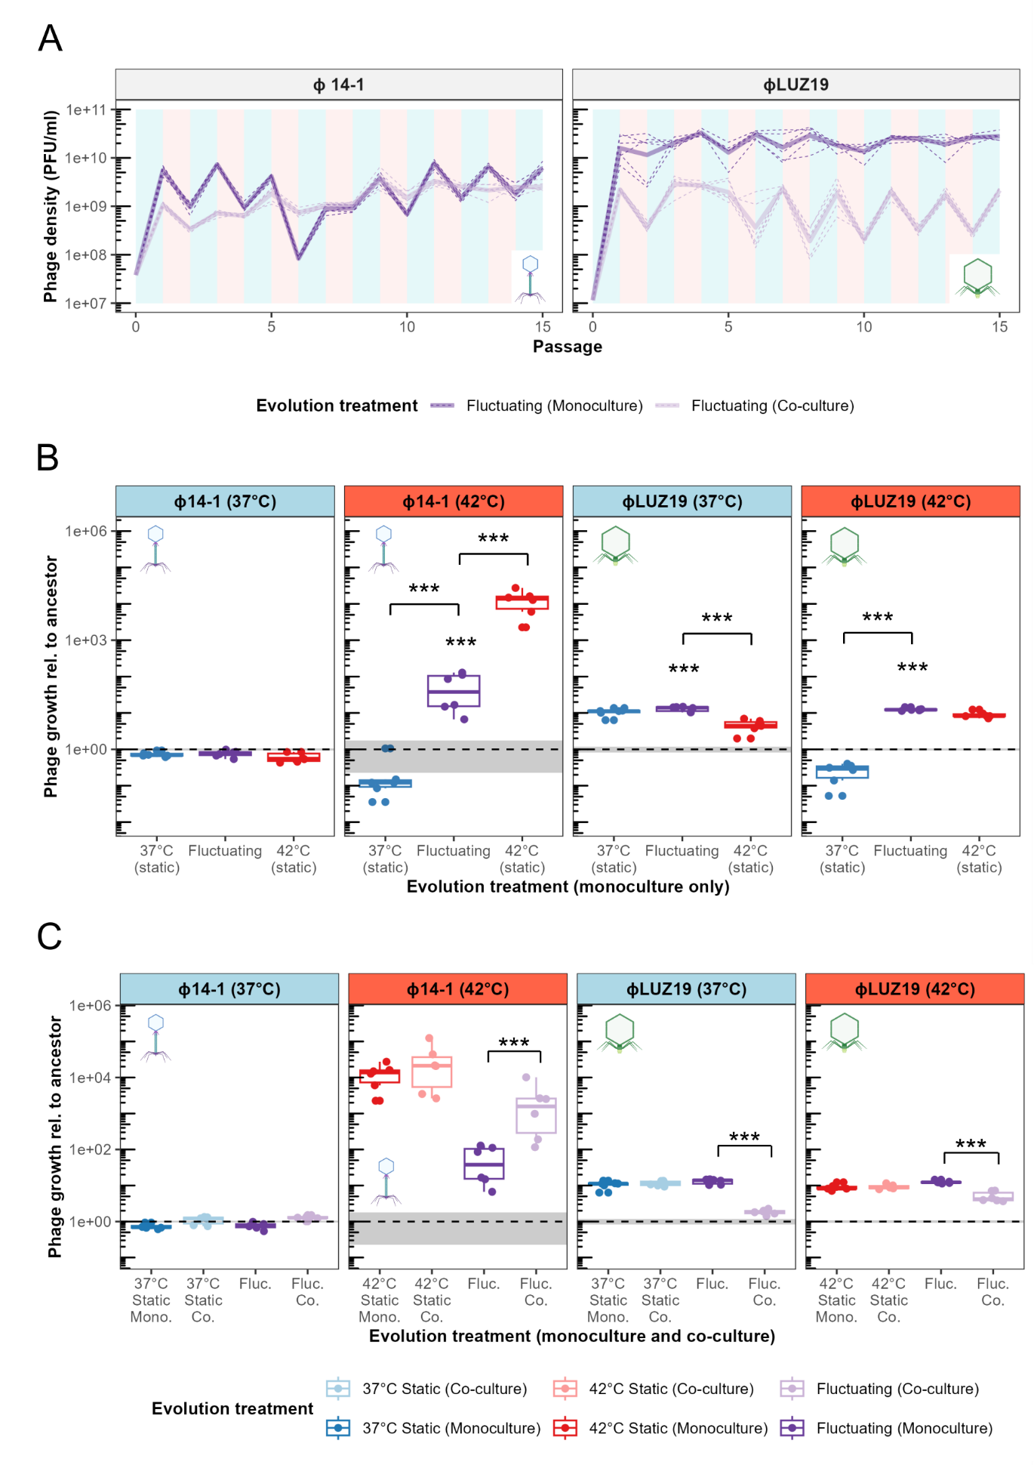

Figure 1. Co-selection in communities constrains adaptation to thermal fluctuations. A) Population dynamics of phages passaged in monoculture and co-culture under fluctuating temperatures. Values show densities at the end of each passage prior to dilution. As phage lysates were diluted 10-fold in between passages, density decreases reflect less than 10-fold population growth during passages. Plot background colour reflects the temperature during that passage where light blue is 37°C and light red is 42°C. Phage icons illustrate the two different phages used in the experiments (φ14-1, myovirus in blue; φLUZ19, autographivirus in green) [49] and are used hereafter to refer to phages in figures. B) Fluctuating and static temperature evolved population growth rates relative to the ancestor. Growth rates were measured after 2h for φLUZ19 and 4h for φ14-1. While plot shows growth relative to ancestor, statistical analysis directly compared evolved and ancestral population growth rates. Six biological replicates were assayed, and data points show the average of three technical replicates (batches). Technical replicates were not averaged in the statistical model but were included as a random effect. Growth assay temperature is shown in panel strips and represented by panel strip colour (light blue = 37°C and red = 42°C). Fluctuating population boxes and points are presented in purple with 37°C static populations in blue and 42°C static populations in red. Ancestral growth is shown by dashed grey line with standard errors shown as a grey box (n = 3). *** = p < 0.001. Asterisks above boxes show statistical comparisons with the ancestor. Asterisks above contrast lines show statistical comparisons between evolved populations. Absence of asterisk reflects non-significance. Static monoculture temperature data was adapted from ref. [32]. C) Growth rates of fluctuating and static temperature monoculture evolved populations compared to co-culture evolved populations. Boxes and points are coloured by evolution treatment with monoculture in dark (37°C static in blue, 42°C static in red, and fluctuating in purple) and co-culture in light (37°C static in light blue, 42°C static in light red, and fluctuating in light purple). Assay temperature and significance values are presented as in Fig. 1B. Six biological replicates were assayed and data points show the average of three technical replicates (batches). Technical replicates were not averaged in the statistical model but were included as a random effect. Ancestral growth rates and significance signs are presented as in Fig. 1B. Static co-culture data was adapted from ref. [32].

Fluctuating environments favour specialist mutations
Fluctuating temperatures generally select for multiple specialist mutations [4]. We hypothesised that fluctuating evolved populations would show genetic similarities to both high and low temperature static populations. Phage genomic evolution was assessed by constructing neighbour-joining trees of end-point populations based on Euclidean genetic distances (Fig. 2A). Genetic distances were calculated based on the presence and frequency of genetic variants (SNPs, indels) that had > 10% frequency. Fluctuating evolved populations did not form a unique clade but instead were found to co-locate with either high or low temperature static populations. φ14-1 fluctuating populations were distributed across the tree and generally did not cluster with static populations. Conversely, φLUZ19 fluctuating populations were primarily found within the 42°C static clade.
We further analysed static and fluctuating population genetic similarities by measuring evolution rates based on Euclidean genetic distance from ancestor (Fig. 2B). For φ14-1, fluctuating evolved populations had significantly lower evolution rates than 42°C static populations (t(15) = -4.1, p < 0.01). However, there was no significant difference in evolution rates between fluctuating and 37°C static populations (t(15) = -0.51, p = 0.87). There was no significant difference in evolution rates between φLUZ19 fluctuating populations and either 37°C or 42°C static populations (37°C: t(15) = -0.46, p = 0.89; 42°C: t(15) = -0.75, p = 0.74). Notably, φ14-1 fluctuating populations had significantly greater within-group variation in evolution rates compared to 42°C static populations (t(15) = 2.9, p < 0.05) but not 37°C static populations (t(15) = -0.70, p = 0.77). φLUZ19 fluctuating populations had no significant difference in within-group variation compared to static populations (37°C: t(15) = 2.0, p = 0.15; 42°C: t(15) = -0.10, p = 0.99). The number of variants in each phage population can be found in Fig. S2.
We then determined the prevalence of individual genetic variants (SNPs, indels) that were unique to or shared between evolution treatments (Fig. 2C). Only putative adaptive variants with >20% frequency were included. For φ14-1, 2/11 (18%) of 37°C static variants and 5/15 (33%) of 42°C static variants were shared with other evolution treatments compared to 4/9 (44%) variants in fluctuating evolved populations. For φLUZ19, shared variants constituted 8/32 (35%) of 37°C static and 9/20 (45%) of 42°C static variants compared to 12/17 (71%) in fluctuating evolved populations. To assess the overall impact of evolution treatment on the ratio of unique and shared mutations, we pooled mutations from φ14-1 and φLUZ19 observing a significant difference in the prevalence of shared mutations relative to unique mutations between evolution treatments (Fisher’s exact test: p < 0.05). Significant differences were not observed when analysing phages independently (φ14-1, p = 0.47; φLUZ19, p = 0.08). φ14-1 fluctuating mutations were primarily shared with 42°C static populations. In contrast, φLUZ19 fluctuating mutations were shared equally with 37°C and 42°C static populations.
Finally, we investigated which mutations drove clustering between fluctuating and static populations (Fig. S3; Table S1). While φ14-1 fluctuating and 37°C static populations showed little clustering, two fluctuating populations clustered with the 42°C static clade. These two replicate populations contained parallel deletions in a hypothetical protein with high similarity to a DNA ligase (BlastP: 97.47% identity, 95% sequence overlap with Pseudomonas phage PhL_UNISO_PA-DSM_ph0031 DNA ligase protein), previously identified in all φ14-1 42°C static populations [32]. As found with static evolved populations [32], all fluctuating φLUZ19 populations acquired mutations in tail fiber genes indicating selection on these genes is strong but independent of thermal regime. The clustering of 5/6 φLUZ19 fluctuating populations with the 42°C static populations were attributed to parallel insertions in an intergenic region between two hypothetical proteins. This intergenic insertion was previously identified in all φLUZ19 42°C static populations [32].

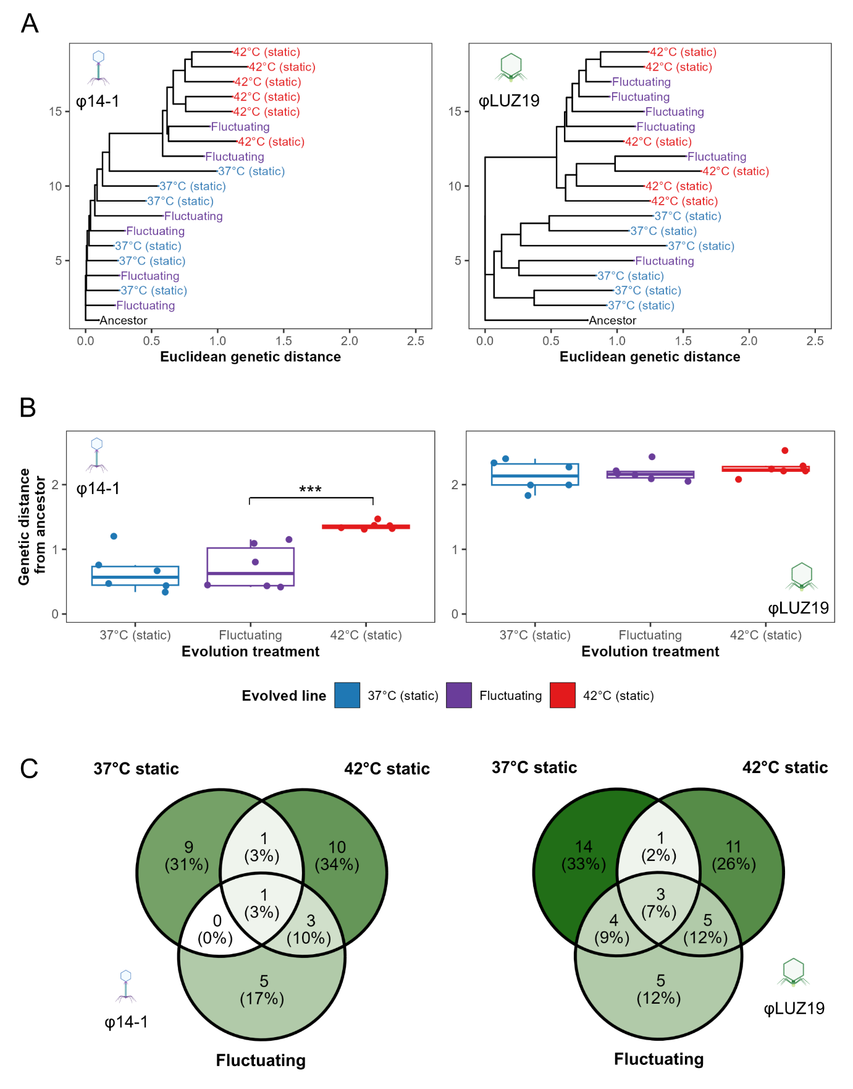
Figure 2. Fluctuating temperatures select for specialist mutations. A) Neighbour-joining trees of evolved and ancestral phage populations constructed using Euclidean genetic distances. Genetic distances were calculated based on the presence and frequency of mutations present at > 10% frequency. Tree is rooted at the ancestor and populations are coloured by evolved treatment. B) Phage evolution rates, measured based on Euclidean genetic distance from the ancestor, for evolved monoculture phage populations. *** = p < 0.001. C) Venn diagrams show the number of high frequency (>20% frequency), putative adaptive variants that are unique to or shared between evolution treatments. Venn diagram sections are coloured based on the number of variants. Static temperature data was adapted from ref. [32].

Co-selection constrains molecular evolution
By reducing population growth rates, co-selection from fluctuating temperatures and competition are expected to reduce evolution rates and restrict the acquisition of adaptive mutations [12]. Due to their elevated growth rates, we hypothesised that φ14-1 fluctuating co-culture populations would have higher evolution rates than monoculture populations. No significant difference in evolution rate was observed for φ14-1 co-culture populations compared to monoculture populations (F_{1,10} = 4.1, p = 0.07) (Fig. 3A). However, non-significance was driven by a single low evolution rate replicate in the co-culture treatment; when the replicate was removed, co-culture populations had significantly greater evolution rates than monoculture (F_{1,9} = 8.6, p < 0.05). We also found no significant difference in within-group variation in evolution rates between monoculture and co-culture populations (t(10) = 1.50, p = 0.17), although the difference was also significant once the low evolution rate co-culture replicate was removed (t(10) = 3.6, p < 0.01).
For φLUZ19, we hypothesised that fluctuating co-culture populations would have lower evolution rates than monoculture populations due to the suppression of φLUZ19 by φ14-1 (Fig. S1). φLUZ19 fluctuating co-culture populations had significantly lower evolution rates than monoculture populations (F_{1,10} = 470, p < 0.001). We further hypothesised that φLUZ19 fluctuating co-culture populations, but not φ14-1 populations, would have lower evolution rates than 37°C or 42°C static co-culture populations. Evolution rates were equal between co-culture populations for φ14-1 (F_{2,15} = 1.2, p = 0.3) (Fig. 3B). However, φLUZ19 fluctuating co-culture populations were found to have significantly lower evolution rates than both 37°C static and 42°C static monoculture populations (37°C: t(15) = 4.5, p < 0.01; 42°C: t(30) = 3.0, p < 0.05).
Finally, we assessed the impact of competition on the acquisition of high frequency mutations (> 20% frequency) in fluctuating populations (Fig. S4). For φ14-1, while populations no longer acquired singleton mutations, all populations acquired a deletion or SNP in a putative DNA ligase gene. Mutations in this gene are thought to contribute to high temperature adaptation [32] and were also found in the two monoculture populations which clustered with 42°C static populations in Fig. 2A. For φLUZ19, while co-culture populations maintained mutations in tail fiber genes, the populations no longer acquired singleton mutations or the intergenic insertion associated with 42°C static populations.

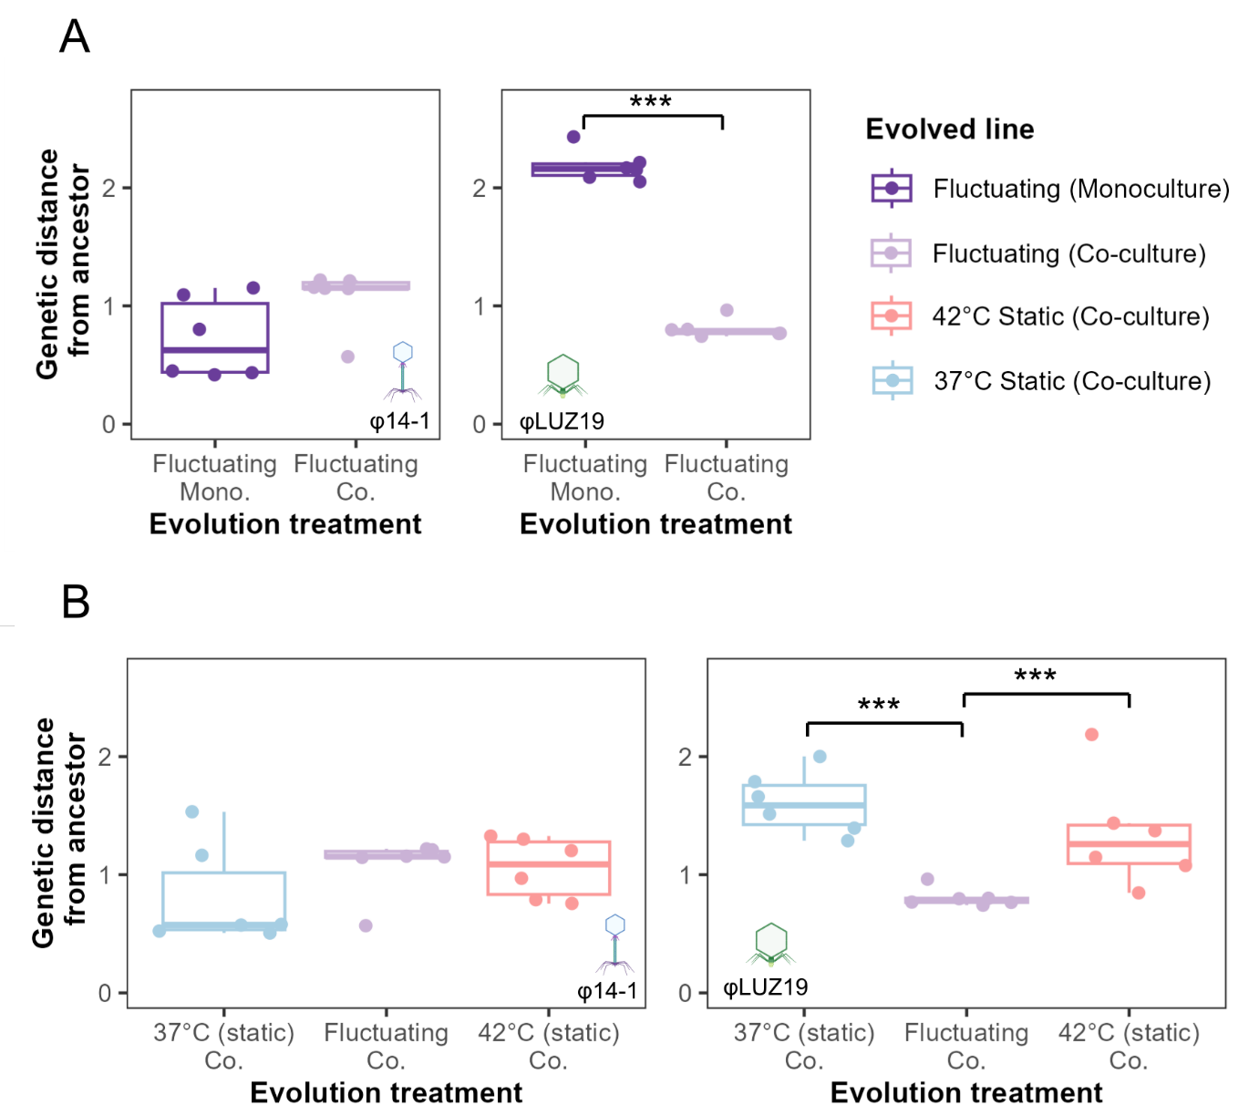
Figure 3. High environmental complexity constrains evolution rates in the φLUZ19 phage. A) Evolution rates, measured based on Euclidean genetic distance from the ancestor, of phage populations evolved under fluctuating temperatures in monoculture (deep purple) and co-culture (light purple). B) Evolution rates of 37°C static, fluctuating, and 42°C static co-culture populations. Plot layout is the same as panel A. *** = p < 0.001. Static temperature data was adapted from ref. [32].

Discussion
Under fluctuating selection, both phages were found to rapidly evolve increased growth rates at high temperatures. For phage φ14-1, fluctuating temperatures resulted in intermediate thermal phenotypes with lower growth rates at high temperatures compared to phages evolved under static temperatures. The evolution of intermediate growth rates is likely due to weaker selection for adaptation to high temperatures in the fluctuating treatment. Alternatively, adaptation to high temperatures may be constrained during fluctuations due to fitness trade-offs at lower temperatures [50]. For phage φLUZ19, fluctuating temperature populations had the same growth rates as static-evolved populations when measured at their evolved temperature. Given φLUZ19 was shown to exhibit growth rate trade-offs under static selection [32], this finding is indicative of a no-cost generalist strategy [51]. The lack of growth rate costs may reflect an epistatic pleiotropy, whereby the costs of adaptive mutations depend on the genetic background [51]. Costs may also occur in unmeasured traits such as virulence [52] or tolerance to other stresses [15]. These findings highlight that, while fluctuating temperatures select for greater high temperature growth, the exact phenotypic outcomes of fluctuating selection vary between phage taxa [53].
We found that fluctuating temperatures resulted in more variable evolutionary trajectories; while static evolved populations generally formed clusters, fluctuating populations were genetically similar to both 37°C and 42°C static evolved populations. Further, we found that parallel mutations acquired under fluctuating selection were the same as those previously identified in static evolved populations [32]. These findings could be explained by historical contingency [54] whereby a small number of random mutations that are adaptive at low or high temperatures become fixed in a subset of populations [7]. As phage populations only acquired a small number of mutations during the experiment, the early acquisition and fixation of large fitness effect mutations may have caused fluctuating populations to resemble those that evolved under static environments. Fluctuating environments have also been shown to select for mutations conferring fitness in the most extreme environment [55]. The clustering of φLUZ19 fluctuating populations with 42°C static populations likely reflects selective sweeps combined with asymmetrical selection where 42°C adaptive variants are fixed more rapidly. Diversification and allele fixation is an expected outcome of our experimental set-up where fluctuations occurred at a much longer frequency than phage generation times. If fluctuations had occurred at the same rate or faster than generation times, we would expect less diversification through the evolution of plasticity or an increased risk of extinction [56,57].
While fluctuating environments can promote genetic diversification, co-selection with other environmental stressors can constrain adaptation [12]. Uiterwaal et al [18] showed that combined fluctuating temperatures and predation restricted adaptation to both selection pressures in Paramecium caudatum populations. Similar findings have also been observed in Daphnia magna with co-selection from thermal fluctuations and predation/pollutants [19,58]. We found that combined fluctuating temperature- and competition-based selection constrained both thermal adaptation and slowed evolutionary rates in phage φLUZ19 but accelerated adaptation in φ14-1. Further, co-selection resulted in greater φLUZ19 evolutionary constraint with fluctuating temperatures than static temperatures. In a previous study, we demonstrated that competition accelerates thermal adaptation in φ14-1 but constrains evolution rates in φLUZ19 [32], indicative of a selective synergy [12]. The present study extends these findings by showing that the selective synergy between temperature and competition is greater under fluctuating temperatures than static temperatures. One potential explanation for these findings is that fluctuating environments reduce the strength of selection for adaptive mutations [59]. Weaker directional selection combined with suppression by competitors may constrain both the supply and fixation of beneficial mutations leading to particularly low evolution rates.
Anthropogenic activities, including global climate change, mean that species are facing increasingly variable and complex environments [60]. With ongoing global biodiversity loss, species must adapt to tolerate environmental stressors to avoid extinctions. Our findings highlight that while large-population species, such as viruses and bacteria, can rapidly adapt in response to thermal variation, co-selection with other factors, such as competition, may restrict species adaptive capacity. These results have particular relevance for parasites which, in addition to having large population sizes, must simultaneously adapt to both thermal heterogeneity, community competition in coinfections, and host immune responses. With global parasite biodiversity at risk due to climate change [27], evolutionary constraint caused by co-selection may prevent parasite adaptation to thermal stress and further increase the probability of parasite extinctions. The risk of extinction is likely higher for small population, slower growing species due to their slower evolution rates and the higher probability that fluctuations will occur within generations. Future studies should consider the evolution-constraining effects of co-selection when assessing species extinction risk in thermally variable environments.
Data and Code Availability
Data and code used in analyses can be found at https://github.com/SamuelGreenrod/Evol_fluctuating. Phage sequence reads are accessible on NCBI (https://www.ncbi.nlm.nih.gov/) under BioProject ID: PRJNA1332698. Bacterial sequence reads are available on NCBI under BioProject ID: PRJNA1332799.
Acknowledgments
We thank R. Salguero-Gomez, T. Richards, T. Barraclough, and K. Foster for feedback on the experimental design and results. This work was supported by the Biotechnology and Biosciences Research Council (BB/T008784/1) to S.T.E.G. as well as the Natural Environment Research Council (NE/X000540/1) and NSERC Canada Excellence Research Chair to K.C.K. The funders had no role in study design, data collection and interpretation, or the decision to submit the work for publication. Fluctuating evolved phage sequence reads are accessible on NCBI (https://www.ncbi.nlm.nih.gov/) under BioProject ID: PRJNA1334331. Static evolved phage sequence reads and bacterial sequence reads from ref. [32] are accessible under BioProject IDs: PRJNA1332698 and PRJNA1332799, respectively.

References
1. Kassen R. The experimental evolution of specialists, generalists, and the maintenance of diversity. Journal of Evolutionary Biology. 2002;15(2):173–90.
2. Sachdeva V, Husain K, Sheng J, Wang S, Murugan A. Tuning environmental timescales to evolve and maintain generalists. Proceedings of the National Academy of Sciences. 2020 Jun 9;117(23):12693–9.
3. Kassen R, Bell G. Experimental evolution in Chlamydomonas. IV. Selection in environments that vary through time at different scales. Heredity. 1998;80(6):732–41.
4. Lambros M, Pechuan-Jorge X, Biro D, Ye K, Bergman A. Emerging Adaptive Strategies Under Temperature Fluctuations in a Laboratory Evolution Experiment of Escherichia Coli. Front Microbiol. 2021 Oct 22;12:724982.
5. Sandberg TE, Lloyd CJ, Palsson BO, Feist AM. Laboratory Evolution to Alternating Substrate Environments Yields Distinct Phenotypic and Genetic Adaptive Strategies. Appl Environ Microbiol. 2017 Jun 16;83(13):e00410-17.
6. Abdul-Rahman F, Tranchina D, Gresham D. Fluctuating Environments Maintain Genetic Diversity through Neutral Fitness Effects and Balancing Selection. Molecular Biology and Evolution. 2021 Oct 1;38(10):4362–75.
7. Harrison E, Laine AL, Hietala M, Brockhurst MA. Rapidly fluctuating environments constrain coevolutionary arms races by impeding selective sweeps. Proc Biol Sci. 2013 Aug 7;280(1764):20130937.
8. Chesson P. Mechanisms of Maintenance of Species Diversity. Annual Review of Ecology, Evolution, and Systematics. 2000 Nov 1;31(Volume 31, 2000):343–66.
9. Gilchrist GW. Specialists and Generalists in Changing Environments. I. Fitness Landscapes of Thermal Sensitivity. The American Naturalist. 1995;146(2):252–70.
10. Gunderson AR, Armstrong EJ, Stillman JH. Multiple Stressors in a Changing World: The Need for an Improved Perspective on Physiological Responses to the Dynamic Marine Environment. Annual Review of Marine Science. 2016 Jan 3;8(Volume 8, 2016):357–78.
11. Hector TE, Hoang KL, Li J, King KC. Symbiosis and host responses to heating. Trends in Ecology & Evolution. 2022 Jul 1;37(7):611–24.
12. Crain CM, Kroeker K, Halpern BS. Interactive and cumulative effects of multiple human stressors in marine systems. Ecology Letters. 2008;11(12):1304–15.
13. Hiltunen T, Cairns J, Frickel J, Jalasvuori M, Laakso J, Kaitala V, et al. Dual-stressor selection alters eco-evolutionary dynamics in experimental communities. Nat Ecol Evol. 2018 Dec;2(12):1974–81.
14. Burmeister AR, Fortier A, Roush C, Lessing AJ, Bender RG, Barahman R, et al. Pleiotropy complicates a trade-off between phage resistance and antibiotic resistance. Proceedings of the National Academy of Sciences. 2020 May 26;117(21):11207–16.
15. Schou MF, Engelbrecht A, Brand Z, Svensson EI, Cloete S, Cornwallis CK. Evolutionary trade-offs between heat and cold tolerance limit responses to fluctuating climates. Science Advances. 2022 May 27;8(21):eabn9580.
16. Yamamichi M, Letten AD, Schreiber SJ. Eco-evolutionary maintenance of diversity in fluctuating environments. Ecol Lett. 2023 Sep;26 Suppl 1:S152–67.
17. Cairns J, Borse F, Mononen T, Hiltunen T, Mustonen V. Strong selective environments determine evolutionary outcome in time-dependent fitness seascapes. Evol Lett. 2022 Jun 1;6(3):266–79.
18. Uiterwaal SF, Lagerstrom IT, Luhring TM, Salsbery ME, DeLong JP. Trade-offs between morphology and thermal niches mediate adaptation in response to competing selective pressures. Ecology and Evolution. 2020;10(3):1368–77.
19. Barbosa M, Pestana J, Soares AMVM. Predation Life History Responses to Increased Temperature Variability. PLoS One. 2014 Sep 24;9(9):e107971.
20. D. Vinebrooke R, L. Cottingham K, Norberg J Marten Scheffer, I. Dodson S, C. Maberly S, Sommer U. Impacts of multiple stressors on biodiversity and ecosystem functioning: the role of species co-tolerance. Oikos. 2004;104(3):451–7.
21. Halpern BS, Walbridge S, Selkoe KA, Kappel CV, Micheli F, D’Agrosa C, et al. A Global Map of Human Impact on Marine Ecosystems. Science. 2008 Feb 15;319(5865):948–52.
22. Bellard C, Bertelsmeier C, Leadley P, Thuiller W, Courchamp F. Impacts of climate change on the future of biodiversity. Ecology Letters. 2012;15(4):365–77.
23. Nguyen PL, Gokhale CS. On multiple infections by parasites with complex life cycles. Oikos. 2025;2025(4):e10493.
24. Silva LM, King KC, Koella JC. Dissecting transmission to understand parasite evolution. PLoS Pathog. 2025 Mar 25;21(3):e1012964.
25. Greenrod STE, Hector TE, Blazanin M, Cazares D, King KC. Temperature as a Driver of Phage Ecology and Evolution. Annual Review of Microbiology. 2025 Oct 23;79(Volume 79, 2025):497–522.
26. Oakley MS, Gerald N, McCutchan TF, Aravind L, Kumar S. Clinical and molecular aspects of malaria fever. Trends in Parasitology. 2011 Oct 1;27(10):442–9.
27. Carlson CJ, Burgio KR, Dougherty ER, Phillips AJ, Bueno VM, Clements CF, et al. Parasite biodiversity faces extinction and redistribution in a changing climate. Science Advances. 2017 Sep 6;3(9):e1602422.
28. Buckingham LJ, Ashby B. Coevolutionary theory of hosts and parasites. j evol Biol. 2022 Feb 1;35(2):205–24.
29. Pedersen AB, Fenton A. Emphasizing the ecology in parasite community ecology. Trends in Ecology & Evolution. 2007 Mar 1;22(3):133–9.
30. Hasik AZ, King KC, Hawlena H. Interspecific host competition and parasite virulence evolution. Biology Letters. 2023 May 3;19(5):20220553.
31. Limberger R, Fussmann GF. Adaptation and competition in deteriorating environments. Proceedings of the Royal Society B: Biological Sciences. 2021 Mar 10;288(1946):20202967.
32. Greenrod ST, Cazares D, Slesak WA, Hector T, MacLean RC, King KC. Evolutionary rescue accelerates competitive exclusion in a parasite community [Internet]. bioRxiv; 2025 [cited 2025 Sep 28]. p. 2025.09.25.678511. Available from: https://www.biorxiv.org/content/10.1101/2025.09.25.678511v1
33. Greenrod STE, Cazares D, Johnson S, Hector TE, Stevens EJ, MacLean RC, et al. Warming alters life-history traits and competition in a phage community. Applied and Environmental Microbiology. 2024 Apr 16;0(0):e00286-24.
34. Kropinski AM, Mazzocco A, Waddell TE, Lingohr E, Johnson RP. Enumeration of Bacteriophages by Double Agar Overlay Plaque Assay. In: Clokie MRJ, Kropinski AM, editors. Bacteriophages: Methods and Protocols, Volume 1: Isolation, Characterization, and Interactions [Internet]. Totowa, NJ: Humana Press; 2009 [cited 2023 Jun 2]. p. 69–76. (Methods in Molecular BiologyTM). Available from: https://doi.org/10.1007/978-1-60327-164-6_7
35. Seemann T. Prokka: rapid prokaryotic genome annotation. Bioinformatics. 2014 Jul 15;30(14):2068–9.
36. Langmead B, Salzberg SL. Fast gapped-read alignment with Bowtie 2. Nat Methods. 2012 Apr;9(4):357–9.
37. Deatherage DE, Barrick JE. Identification of mutations in laboratory evolved microbes from next-generation sequencing data using breseq. Methods Mol Biol. 2014;1151:165–88.
38. Wick RR, Howden BP, Stinear TP. Autocycler: long-read consensus assembly for bacterial genomes [Internet]. bioRxiv; 2025 [cited 2025 Jul 29]. p. 2025.05.12.653612. Available from: https://www.biorxiv.org/content/10.1101/2025.05.12.653612v1
39. Wick RR, Holt KE. Polypolish: Short-read polishing of long-read bacterial genome assemblies. PLOS Computational Biology. 2022 Jan 24;18(1):e1009802.
40. Bouras G, Grigson SR, Papudeshi B, Mallawaarachchi V, Roach MJ. Dnaapler: A tool to reorient circular microbial genomes. Journal of Open Source Software. 2024 Jan 11;9(93):5968.
41. Li H. Minimap2: pairwise alignment for nucleotide sequences. Bioinformatics. 2018 Sep 15;34(18):3094–100.
42. RStudio Team. RStudio: Integrated Development for R. [Internet]. RStudio, PBC, Boston, M; 2020. Available from: http://www.rstudio.com/
43. R Core Team. R: A language and environment for statistical computing. [Internet]. Foundation for Statistical Computing, Vienna, Austria.; 2021. Available from: https://www.R-project.org/
44. Wickham H, Averick M, Bryan J, Chang W, McGowan LD, François R, et al. Welcome to the Tidyverse. Journal of Open Source Software. 2019 Nov 21;4(43):1686.
45. Bates D, Mächler M, Bolker B, Walker S. Fitting Linear Mixed-Effects Models Using lme4. Journal of Statistical Software. 2015 Oct 7;67:1–48.
46. stats-package: The R Stats Package [Internet]. [cited 2026 Jan 22]. Available from: https://rdrr.io/r/stats/stats-package.html
47. Estimated Marginal Means, aka Least-Squares Means [R package emmeans version 2.0.1] [Internet]. Comprehensive R Archive Network (CRAN); 2025 [cited 2026 Jan 22]. Available from: https://CRAN.R-project.org/package=emmeans
48. Yu G, Smith DK, Zhu H, Guan Y, Lam TTY. ggtree: an r package for visualization and annotation of phylogenetic trees with their covariates and other associated data. Methods in Ecology and Evolution. 2017;8(1):28–36.
49. Tabare E, Glonti T, Cochez C, Ngassam C, Pirnay JP, Amighi K, et al. A Design of Experiment Approach to Optimize Spray-Dried Powders Containing Pseudomonas aeruginosaPodoviridae and Myoviridae Bacteriophages. Viruses. 2021 Oct;13(10):1926.
50. Visher E, Boots M. The problem of mediocre generalists: population genetics and eco-evolutionary perspectives on host breadth evolution in pathogens. Proc Biol Sci. 2020 Aug 26;287(1933):20201230.
51. Remold S. Understanding specialism when the jack of all trades can be the master of all. Proceedings of the Royal Society B: Biological Sciences. 2012 Oct 24;279(1749):4861–9.
52. Ashrafi R, Bruneaux M, Sundberg LR, Pulkkinen K, Valkonen J, Ketola T. Broad thermal tolerance is negatively correlated with virulence in an opportunistic bacterial pathogen. Evolutionary Applications. 2018;11(9):1700–14.
53. Wolinska J, King KC. Environment can alter selection in host–parasite interactions. Trends in Parasitology. 2009 May 1;25(5):236–44.
54. Blount ZD, Lenski RE, Losos JB. Contingency and determinism in evolution: Replaying life’s tape. Science. 2018 Nov 9;362(6415):eaam5979.
55. Arribas M, Kubota K, Cabanillas L, Lázaro E. Adaptation to Fluctuating Temperatures in an RNA Virus Is Driven by the Most Stringent Selective Pressure. PLOS ONE. 2014 Jun 25;9(6):e100940.
56. Kassen R. The experimental evolution of specialists, generalists, and the maintenance of diversity. j evol Biol. 2002 Mar 1;15(2):173–90.
57. Botero CA, Weissing FJ, Wright J, Rubenstein DR. Evolutionary tipping points in the capacity to adapt to environmental change. Proc Natl Acad Sci U S A. 2015 Jan 6;112(1):184–9.
58. Barbosa M, Inocentes N, Soares AMVM, Oliveira M. Synergy effects of fluoxetine and variability in temperature lead to proportionally greater fitness costs in Daphnia: A multigenerational test. Aquatic Toxicology. 2017 Dec 1;193:268–75.
59. Cvijović I, Good BH, Jerison ER, Desai MM. Fate of a mutation in a fluctuating environment. Proc Natl Acad Sci U S A. 2015 Sep 8;112(36):E5021–8.
60. Jaureguiberry P, Titeux N, Wiemers M, Bowler DE, Coscieme L, Golden AS, et al. The direct drivers of recent global anthropogenic biodiversity loss. Science Advances. 2022 Nov 9;8(45):eabm9982.

Extended data

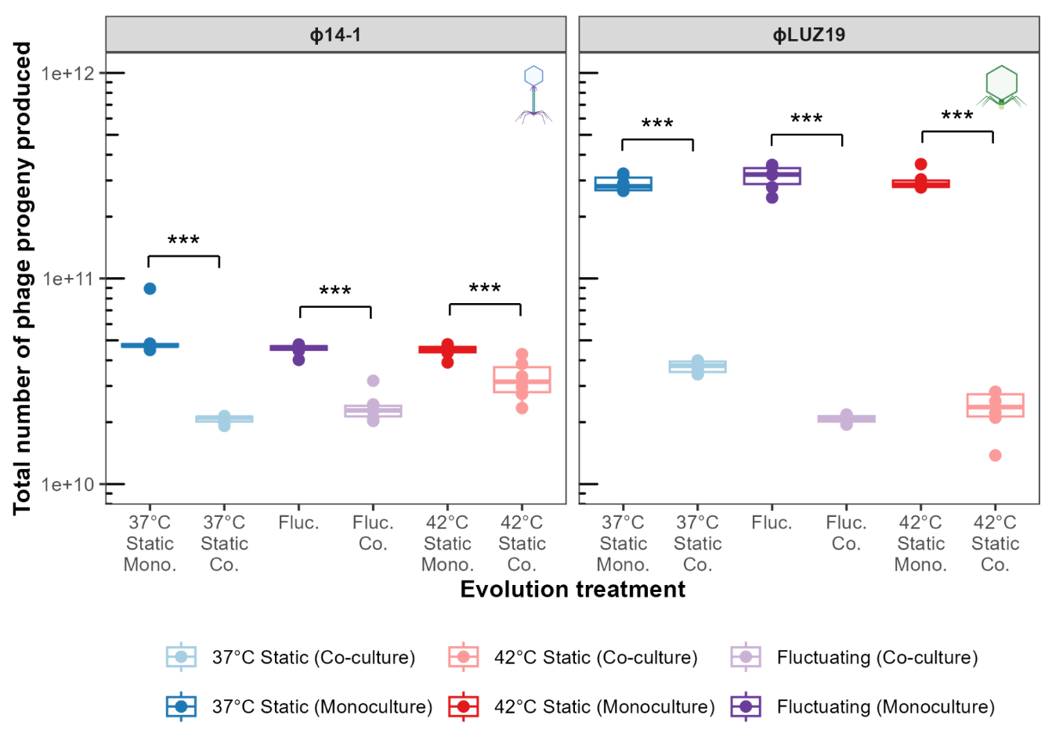
Figure S1. Per-population total phage progeny across experiment. Boxes and points show the sum total of phage progeny produced at each passage during the experiment based on data from Fig. 1A. Boxes and points are coloured by evolution treatment with monoculture in dark (37°C static in blue, 42°C static in red, and fluctuating in purple) and co-culture in light (37°C static in light blue, 42°C static in light red, and fluctuating in light purple). *** = p < 0.001. Lack of significance bar indicates non-significant differences. Six biological replicates were assayed and data points show the average of three technical replicates (batches). Technical replicates were not averaged in the statistical model but were included as a random effect. Static co-culture data was adapted from ref. [32].
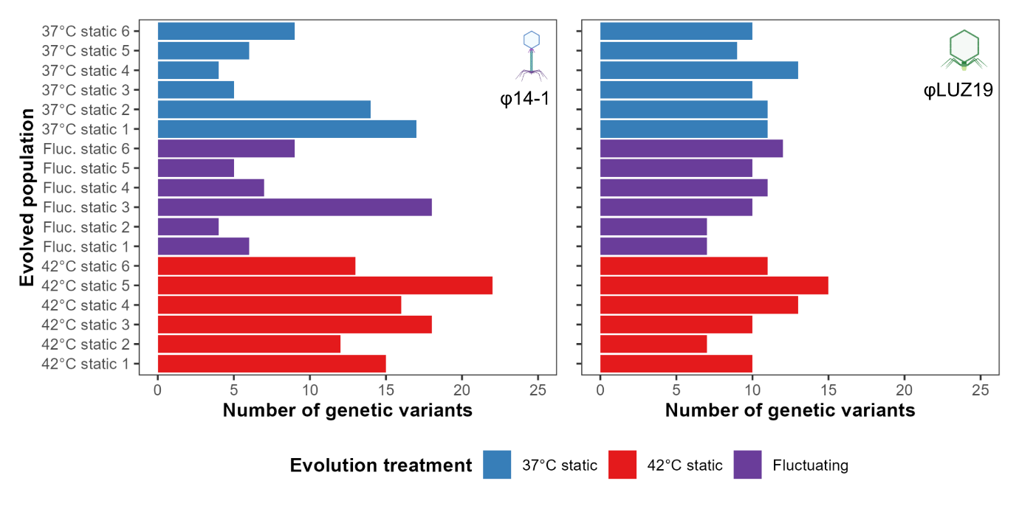
Figure S2. Number of genetic variants across evolved phage populations. Bars show the number of genetic variants for each phage population with 14-1 shown on the left and LUZ19 shown on the right. Bars are coloured by evolution treatment. Static temperature data was adapted from ref. [32].

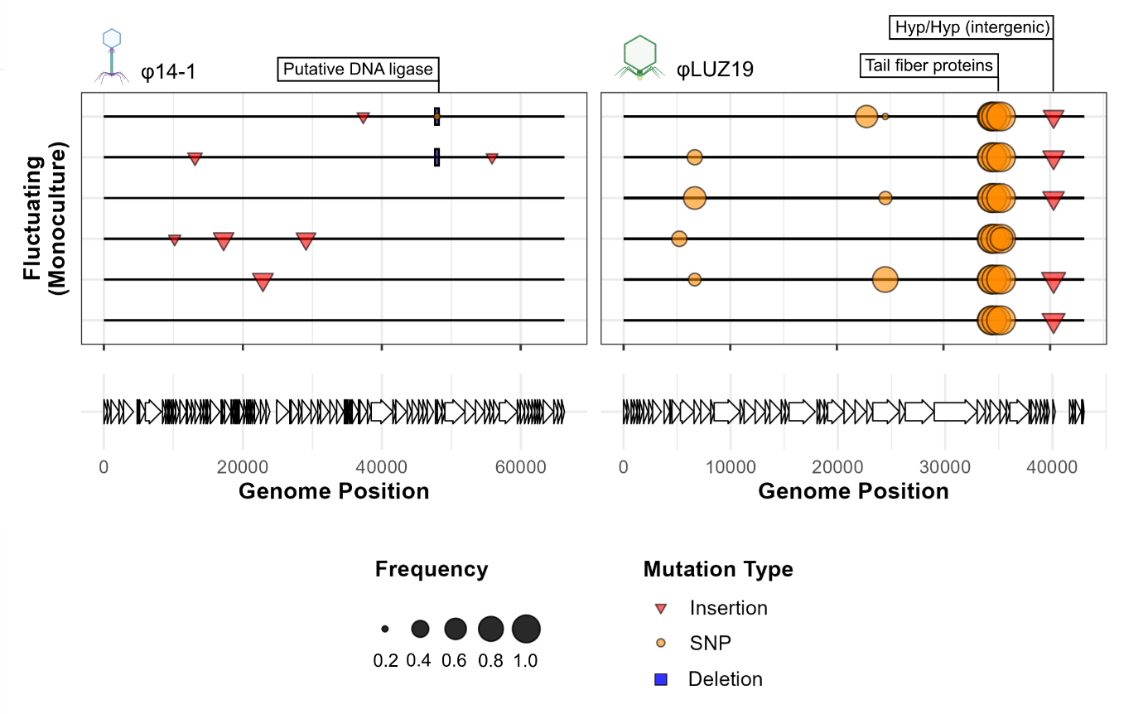
Figure S3. Fluctuating temperatures select for specialist mutations. Mutation plots show genetic variants associated with fluctuating temperatures in monoculture in phage populations. Lines represent individual biological replicates. Symbols within plots show variants across the phage genome at > 20% prevalence and which were not observed in the ancestral population. Length of deletion bars represent the size of deletion except for the φ14-1 deletion at ~48kb which is a 1bp deletion but given a fixed size for visibility. Labels show gene annotations for mutations found in 37°C and 42°C evolved populations [32]. Putative DNA ligase in φ14-1 was originally annotated a hypothetical protein but has high homology to Pseudomonas phage PhL_UNISO_PA-DSM_ph0031 DNA ligase protein.

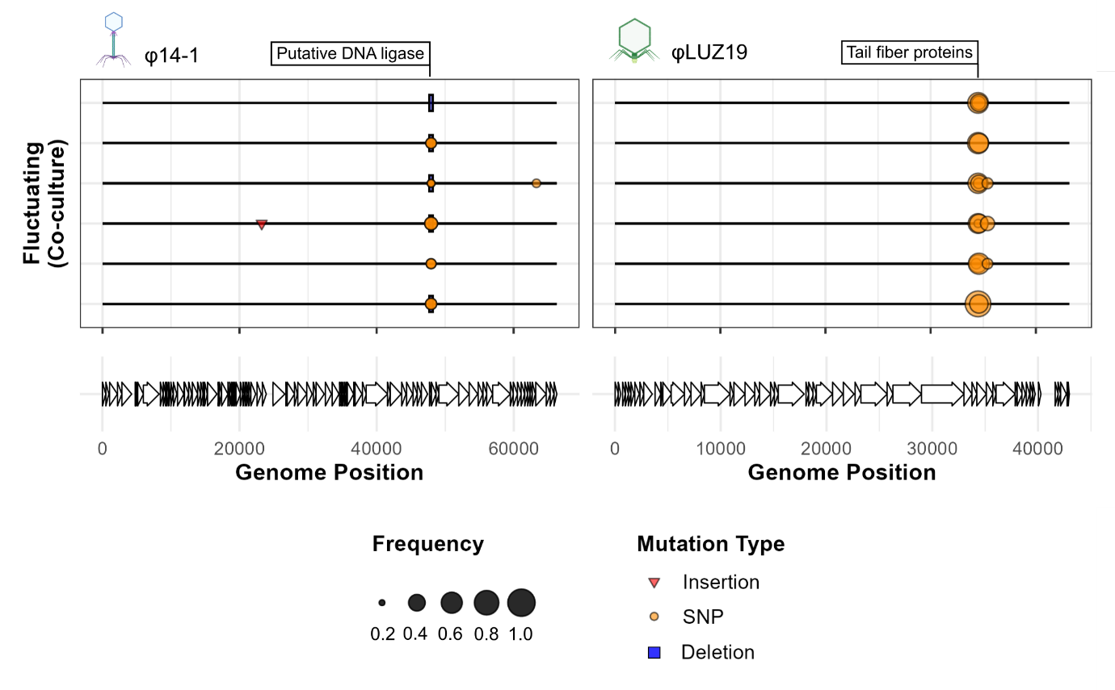
Figure S4. Competition restricts the acquisition of high frequency mutations. Mutation plots show genetic variants associated with fluctuating temperatures in co-culture in phage populations. Lines represent individual biological replicates. Symbols within plots show variants across the phage genome at > 20% prevalence and which were not observed in the ancestral population. Length of deletion bars represent the size of deletion except for the φ14-1 deletion at ~48kb which is a 1bp deletion but given a fixed size for visibility. Labels show gene annotations for mutations found in 37°C and 42°C evolved populations [32]. Putative DNA ligase in φ14-1 was originally annotated a hypothetical protein but has high homology to Pseudomonas phage PhL_UNISO_PA-DSM_ph0031 DNA ligase protein.

