- Testing Plan

  - Testing Objectives
The aim of testing was to verify that the implemented IPOS-SA subsystem behaves correctly at model, service, GUI, database, and integration level. Testing focused on confirming that core business functions such as authentication, catalogue access, order handling, payment recording, application processing, and reporting behave as expected, that invalid inputs are handled safely, and that subsystem communication follows the interface contracts defined during the high-level design stage. Since IPOS-SA communicates with the other IPOS subsystems through explicitly defined Java interfaces rather than direct database access, interface-level testing was also included as part of the testing plan.

  - Testing Strategy
A combination of unit testing, component/subsystem testing, manual GUI testing, and integration/interface testing was used. Unit testing was applied to individual model and service classes in the implemented prototype. Component and subsystem testing was used to validate complete feature flows through the GUI and database. Manual GUI testing was used to confirm that user actions triggered the expected system responses, validations, and data updates. Integration testing was planned around the subsystem interfaces defined in the Week 5 high-level design, in line with the gradual development approach in which interfaces were defined first and implementation was then built around them.

  - Unit Testing Plan
Unit testing was carried out for both model classes and service classes in the Week 12 implementation.
The following model classes were unit tested:
- Application
- InvoicePayment
- OrderConfirmation
- OrderItem
- Order
- Product
- User
These tests checked:
- Default constructor behaviour
- Parameterised constructor behaviour
- Getter and setter correctness
- Default field values
- Object state updates
- Enumeration/status assignment

The following service classes were also unit tested:
- AccountService
- ApplicationService
- OrderService

These tests checked:
- Valid and invalid authentication
- Merchant lookup and balance retrieval
- Merchant account status changes
- Application validation logic
- Catalogue retrieval
- Stock checking
- Order placement validation
- Order confirmation generation
- Order history and order status retrieval
- Exception handling for null, blank, and empty inputs

  - Component / Subsystem Testing Plan
Component and subsystems testing was used to validate complete functional flows across the implemented IPOS-SA GUI and database. The following workflows were included in the testing plan:
- Successful login using valid credentials
- Invalid login handling
- Viewing dashboard alerts and summary data
- Catalogue search and item display
- Adding a catalogue item
- Rejection of invalid catalogue input
- Removing a selected catalogue item
- Viewing and updating order status
- Viewing merchant balances
- Recording a merchant payment
- Generating management reports
- Generating debtor reminder information
- Sending reminder confirmations
- Reviewing, approving, and rejecting applications
- Viewing and managing users and merchants
These tests were intended to confirm that the GUI, service logic, and database state remained consistent throughout each feature workflow.

  - Integration Testing Plan
Integration testing was based on the interface-level communication tests defined in the Week 5 high-level design document. That document states that communication between subsystems is validated at API contract level before full business logic is complete, and identifies interface-based test cases for I_SAtoCA, I_ApplicationService, I_CAtoPU, and I_PaymentService.
For the implementation report, the integration testing plan should therefore state that the following interface behaviours were verified or prepared for verification:
I_SAtoCA
- Merchant authentication
- Order submission
- Stock checking
- Order history retrieval
- Order status retrieval
- Outstanding balance retrieval
I_ApplicationService
- Submission of valid commercial application data
- Rejection or non-approval of invalid or incomplete application data
I_CAtoPU
- Stock level retrieval
- Stock deduction
- Retrieval of stock lists
I_PaymentService
- Valid payment request handling
- Invalid amount, invalid card details, and expired payment data handling
The integration plan also included verification that invalid or missing external input was handled safely and that subsystem boundaries behaved as specified in the Week 5 interface definitions.

- Testing Results

  - Unit Testing Results
The Week 12 implementation included JUnit-based unit tests for the main model and service classes of IPOS-SA. The model tests verified correct object construction, field assignment, state updates, and default values. The service tests verified the main business logic used for authentication, application handling, merchant balance management, stock checking, and order placement.
Example unit testing results are shown below:
Test Case | Class/Method | Input | Expexted  Result | Actual  Result | Outcome
UT1 | ApplicationService.submitCommercialApplication() | valid application | application  approved | application approved | Pass
UT2 | ApplicationService.submitCommercialApplication() | null  application | rejected/  İnvalid handling | rejected returned | Pass
UT3 | AccountService.authenticateUser() | valid  username/password | user returned | user returned | Pass
UT4 | AccountService.authenticateUser() | wrong password | null returned | null returned | Pass
UT5 | AccountService.suspendMerchant() | valid merchant id | status becomes suspended | status updated | Pass
UT6 | OrderService.checkStock() | valid product id | stock quantity returned | quantity returned | Pass
UT7 | OrderService.checkStock() | invalid product id | zero/invalid  indicator | zero returned | Pass
UT8 | OrderService.placeOrder() | valid merchant and  valid item list | confirmation created | confirmation returned | Pass
UT9 | OrderService.placeOrder() | null merchant id | exception/validation error | exception thrown | Pass
UT10 | OrderService.getOrderHistory() | valid date range  with no orders | empty list | empty list returned | Pass

- ApplicationTest – Pass
- InvoicePaymentTest – Pass
- OrderConfirmationTest – Pass
- OrderItemTest – Pass
- OrderTest – Pass
- ProductTest – Pass
- UserTest – Pass
- AccountServiceTest – Pass
- ApplicationServiceTest – Pass
- OrderServiceTest – Pass

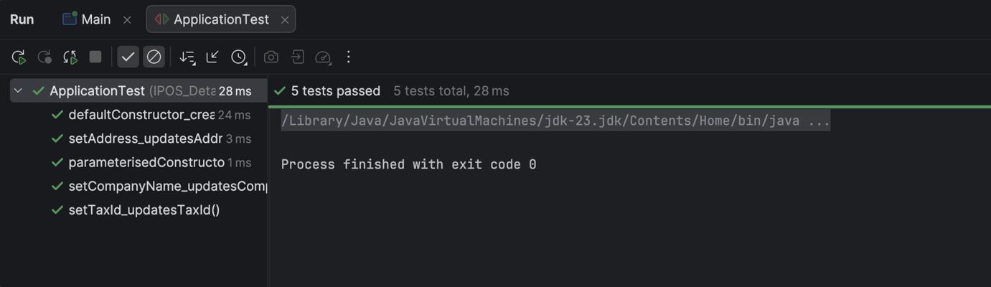
Figure 32. ApplicationTest Results
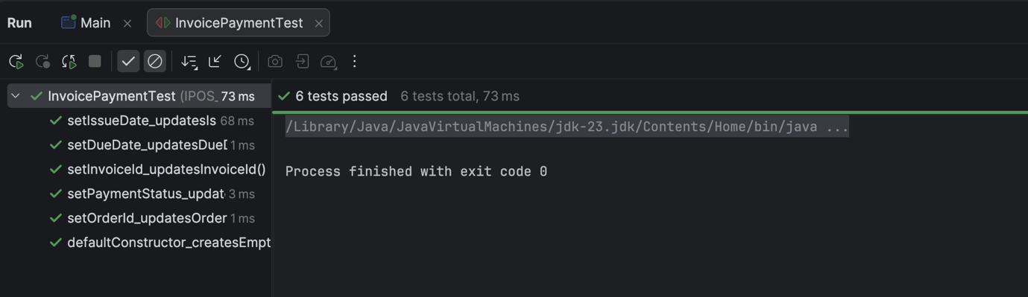
Figure 33. InvoicePaymentTest Results

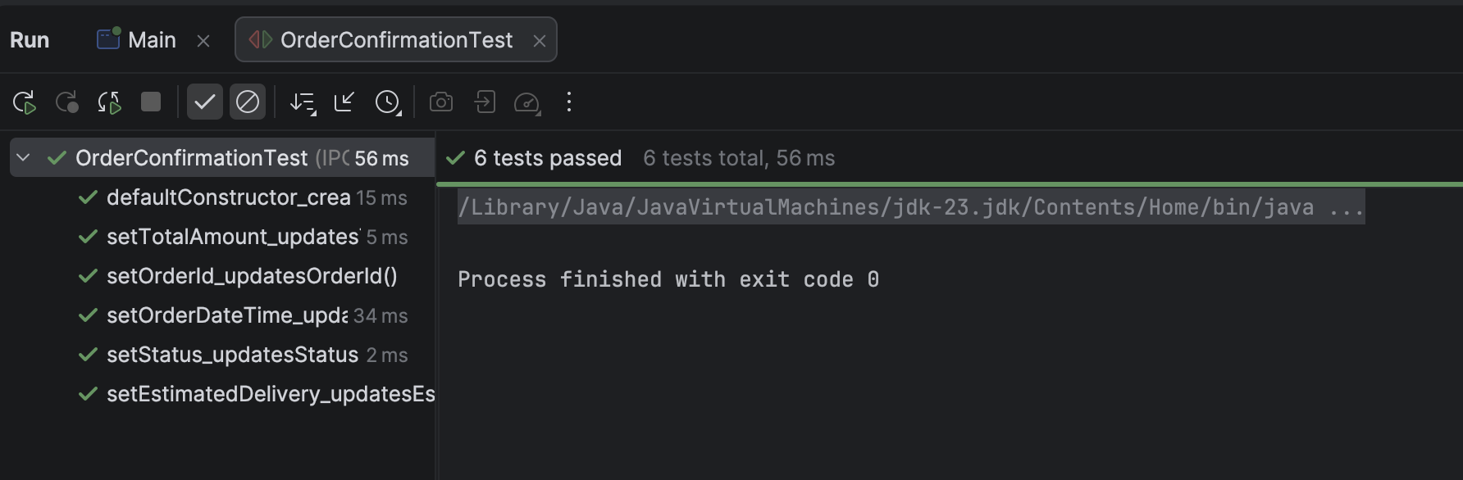
Figure 34. OrderConfirmationTest Results
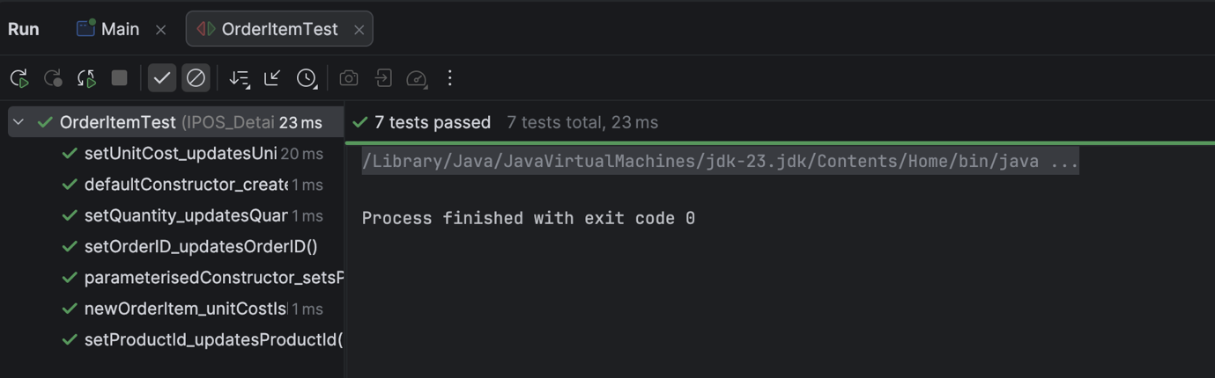
Figure 35. OrderItemTest Results
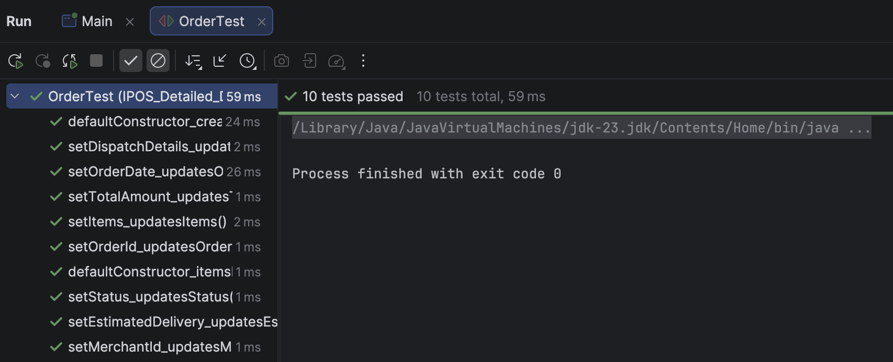
Figure 36. OrderTest Results
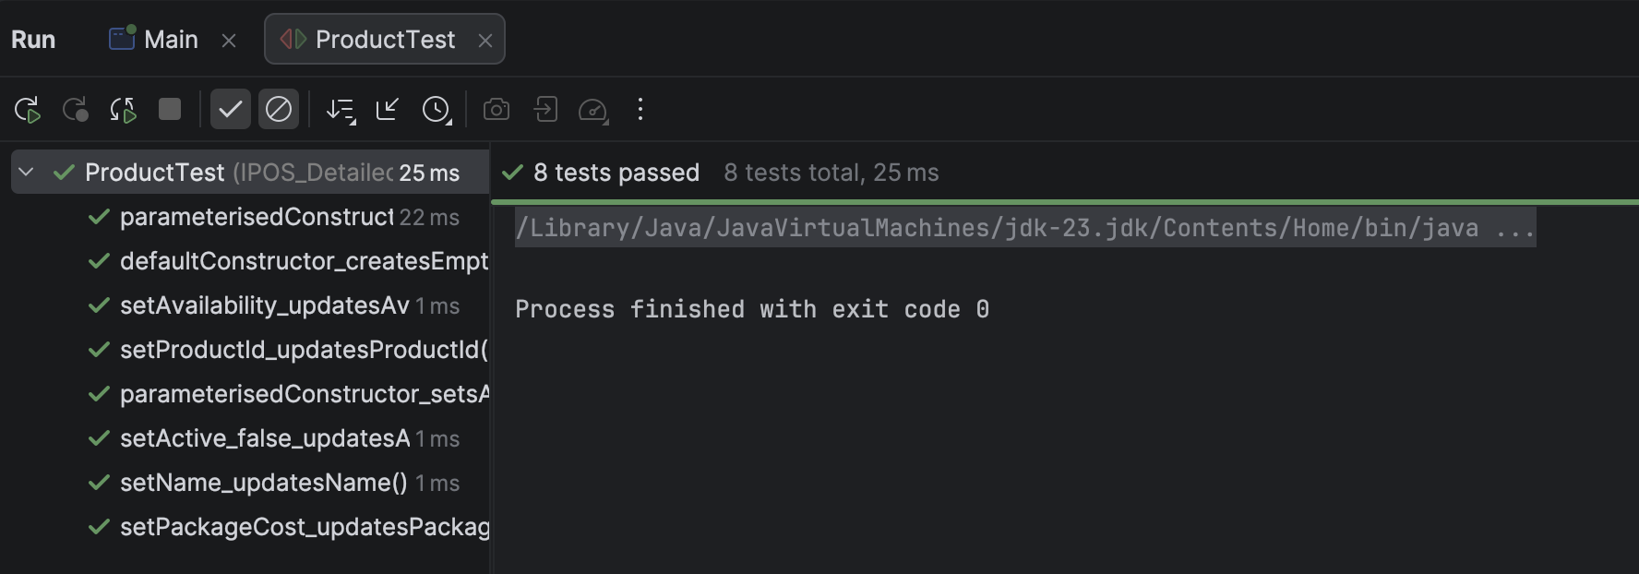
Figure 37. ProductTest Results
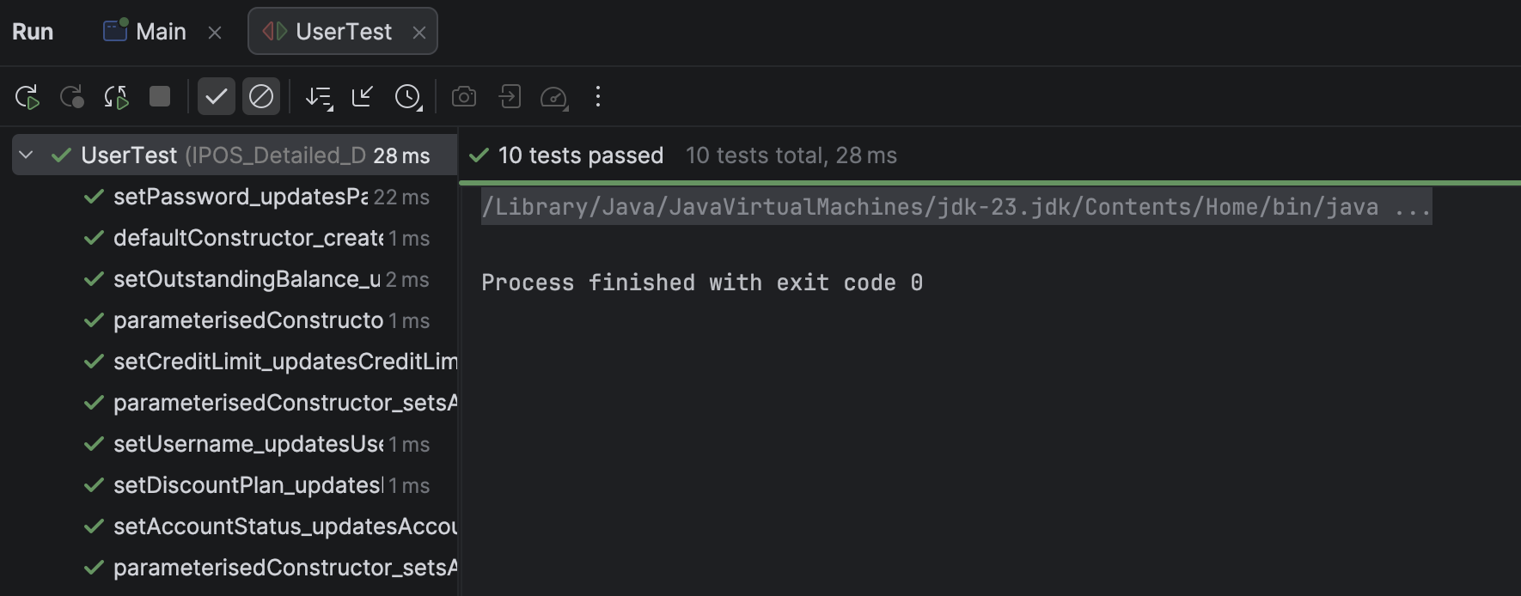
Figure 38. UserTest Results
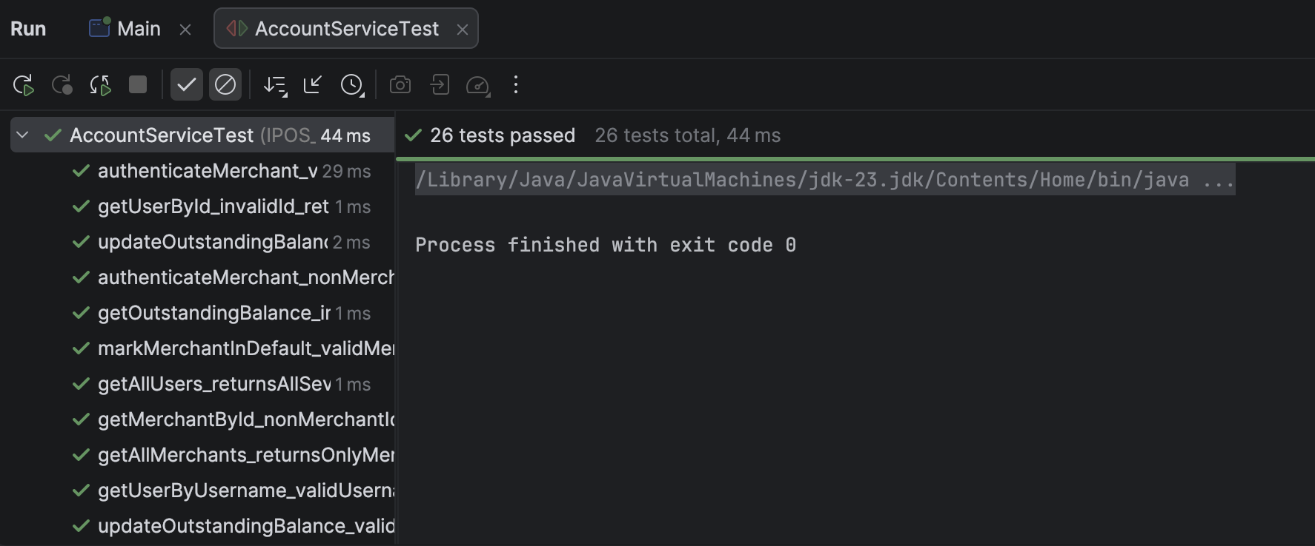
Figure 39. AccountServiceTest Results
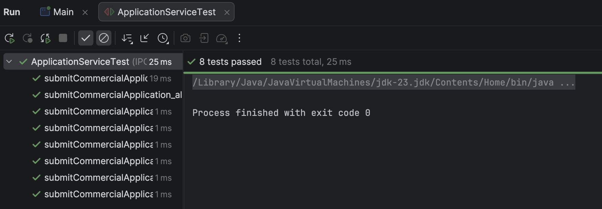
Figure 40. ApplicationServiceTest Results
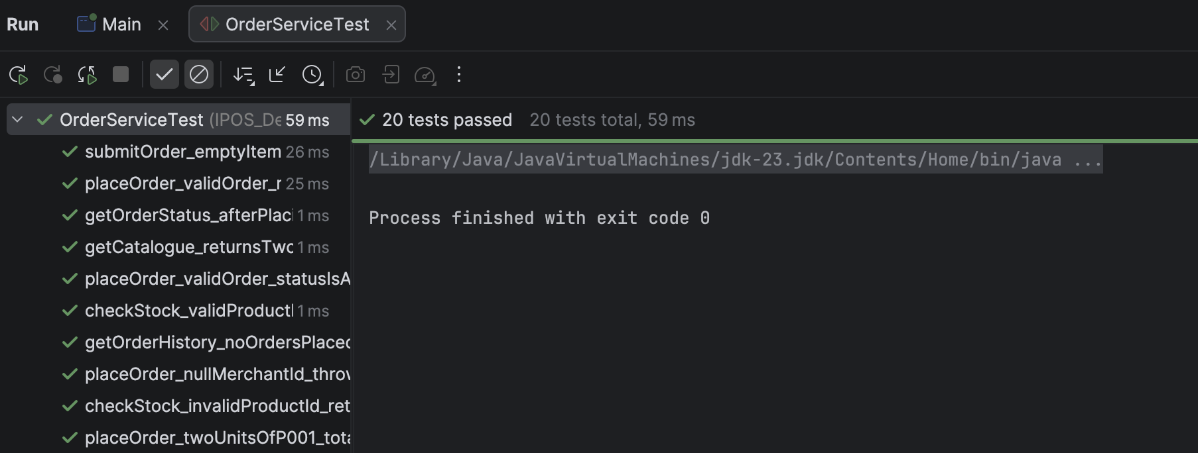
Figure 41. OrderServiceTest Results

  - Component / Subsystem Testing Results
Manuel subsystem testing was performed using the implemented GUI and database-backed workflows. These tests confirmed that the main user-facing functions of IPOS-SA behaved correctly and that updates made through the interface were reflected in the system state.
A summary of subsystem testing results is shown below.
Test Case | Feature | Expected Result | Actual Result | Outcome
ST1 | Login with  valid admin  credentials | dashboard opens | dashboard opened | Pass
ST2 | Invalid login | access denied/ validation shown | validation shown | Pass
ST3 | Add valid  catalogue item | item  stored  and displayed | item added successfully | Pass
ST4 | Add invalid catalogue item | error message shown | error dialog shown | Pass
ST5 | Remove  selected catalogue item | item removed/ deactivated | item removed after confirmation | Pass
ST6 | Select merchant in  Merchant Balance page | balance and invoice data displayed | merchant details displayed | Pass
ST7 | Record payment | payment saved  and balance updated | payment recorded | Pass
ST8 | Update order status | selected order status changed | status updated | Pass
ST9 | Generate stock/turnover/merchant reports | report displayed  in report area | report displayed | Pass
ST10 | Send debtor reminder | confirmation dialog shown and reminder logged | reminder confirmed/ logged | Pass
ST11 | Reject application | status updated  and notification shown | rejected successfully | Pass
ST12 | Approve application | status updated and notification shown | approved  successfully | Pass

  - Integration Testing Results
Integration testing was based on the Week 5 interface-level communication cases. These tests were designed to validate behaviour at subsystem boundaries and check both valid and invalid inputs for the main integration points. The design document explicitly defines interface-level cases for I_SAtoCA, I_ApplicationService, I_CAtoPU, and I_PaymentService, including authentication, order submission, stock lookup, order history retrieval, application submission, stock deduction, and payment processing behaviour.
For the implementation report, the integration results can be summarised like this:

Interface | Test Focus | Outcome
I_SAtoCA | merchant authentication with valid and invalid credentials | Pass (validated through service-level implementation tests)
I_SAtoCA | stock checking for valid and invalid item ids | Pass (verified through OrderService implementation tests)
I_SAtoCA | order submission with valid merchant and invalid cases | Pass (validated through OrderService implementation tests and GUI-based subsystem testing)
I_SAtoCA | order history and order status retrieval | Pass (verified through OrderService implementation tests)
I_ApplicationService | valid vs incomplete application submission | Pass (verified through ApplicationService implementation tests)
I_CAtoPU | stock level retrieval and stock deduction scenarios | Pass
I_PaymentService | valid and invalid payment request handling | Partial Pass

7.4 Defects found and fixes applied
- Bug: application decisions were updated in the system, but the corresponding email notification was not being sent as expected.
- Cause: the notification action was missing or not correctly invoked after the approve/reject operation.
- Fix: the approve/reject workflow was revised to trigger the notification step after the application status update.

- Conclusion
This report presented the implementation of the IPOS-SA subsystem developed by Team 46. The subsystem was successfully implemented as a Java desktop application supported by a local MySQL database, and its main software components, graphical user interface, database structure, deployment configuration, and testing activities were described in this report. The final prototype was compiled, executed, and demonstrated successfully in the intended local environment.
The implemented subsystem satisfies the main functional requirements assigned to the team. In particular, it provides working support for user authentication, catalogue and stock management, order handling, merchant balance and payment recording, application review, report generation, and user and merchant administration. Testing was carried out at unit, subsystem, and integration level, and the results showed that the core behaviours of the subsystem operated as expected within the scope of the prototype.
Overall, the final implementation demonstrates the main server-side functionality required for IPOS-SA and preserves the subsystem structure defined during the earlier design stages. It also supports interaction with the other IPOS subsystems through the planned interface-based approach, providing a suitable and functional prototype for the overall IPOS system.

