  - Database Design / Database Structure

3.3.1 Database Overview
The IPOS-SA subsystem uses a relational database to store and manage the main operational data required by the system. The database supports core functions such as user authentication, merchant account management, catalogue maintenance, order processing, payment recording, application handling, and report generation. It acts as the central data store for the server-side subsystem and ensures that the information shown in the GUI remains consistent and up to date.
The database is structured to support the main IPOS-SA workflows, including maintaining merchant records, storing product information, recording orders and invoices, tracking balances and payments, processing applications linked to IPOS-PU, and generating reports. By organising data into related tables, the subsystem can retrieve and update information efficiently across pages such as Catalogue, Orders, Applications, Reports, and User Management.
The database also supports the integration role of IPOS-SA within the wider IPOS system. It manages subsystem data independently while providing the basis for communication with other subsystems through defined interfaces, helping maintain data integrity and supporting the implemented prototype.

    - Main Database Tables
The IPOS-SA subsystem uses a relational database named ipos_sa_db to store the core operational data required by the system. The database is organised into a set of main tables that support the key functions of the subsystem, including catalogue management, user and merchant account administration, order processing, payment recording, application handling, and report generation. Together, these tables provide the structured data needed by the GUI and allow the subsystem to retrieve, update, and manage information consistently across its main features.

    - Table Relationships
The main database tables of IPOS-SA are related to support the core workflows of the subsystem. The Users table stores staff and merchant account records and is referenced by tables such as Orders and Payments through merchant-related fields. The Orders table stores the main order records, while OrderItems stores the detailed product lines for each order and links orders to catalogue products. The Catalogue table provides the product data referenced in order-processing workflows. The Invoices_Payments table stores invoice and payment-status information associated with orders, while the Payments table records merchant payments. The PU_Applications table is used separately to store application records received from IPOS-PU for review in IPOS-SA.

    - Main Tables
The main tables used in the IPOS-SA database are described below.
1. Catalogue
2. Orders
3. OrderItems
4. Payments
5. Invoices_Payments
6. PU_Applications
7. Users
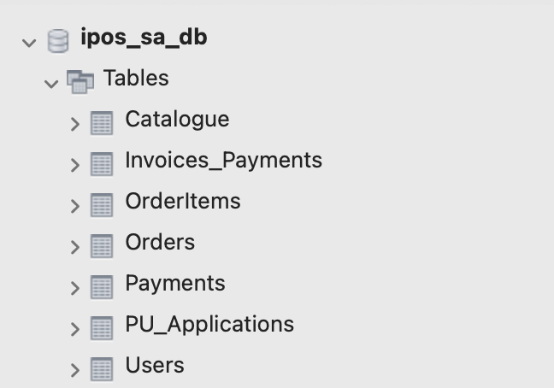
Figure 24. Main Tables in the IPOS-SA Database
Table: Catalogue
The Catalogue table stores the pharmaceutical products available within the IPOS-SA subsystem and functions as the main product repository of the server-side application. It supports several core subsystem functions, including catalogue management, stock monitoring, order-related processing, and reporting. Each record represents a single catalogue item and combines descriptive product information with operational stock data, thereby enabling the subsystem to present product details, monitor stock levels, and support related workflows across the implemented GUI.
The primary key of the table is ProductID, which uniquely identifies each product. The table contains the following attributes: ProductID, Name, Description, Category, PackageType, Unit, UnitsInPack, PackageCost, Availability, StockLimit, and IsActive. The primary key is implemented as a unique BTREE index. No foreign key constraints are defined for this table in the current schema, indicating that it serves as an independent master table for product data.
The descriptive attributes, including Name, Description, Category, PackageType, and Unit, are used to identify and classify products. The operational attributes, namely UnitsInPack, PackageCost, Availability, and StockLimit, support pricing and stock-control activities. In particular, Availability and StockLimit are used to determine low-stock conditions. For example, Ibuprofen 400mg has an availability value of 50 and a stock limit of 300, which explains its low-stock status in both the Catalogue Management interface and the Stock Turnover Report. The IsActive field is used to indicate whether a product is currently active in the catalogue, allowing records to be retained for reference without remaining operationally active.
The current dataset contains a realistic selection of pharmaceutical and related products, including Paracetamol, Aspirin, Analgin, Celebrex 100mg, Celebrex 200mg, Retin-A Tretinoin 30g, Lipitor 20mg, Claritin CR 60g, Ibuprofen 400mg, Iodine Tincture, Rhynol, Ospen, Amopen, Vitamin C, and Vitamin B12. Within the implemented prototype, this table is primarily used by the Catalogue Management page, the Add Item and item removal workflows, and the Stock Turnover Report. It therefore represents one of the core data structures of the IPOS-SA database.
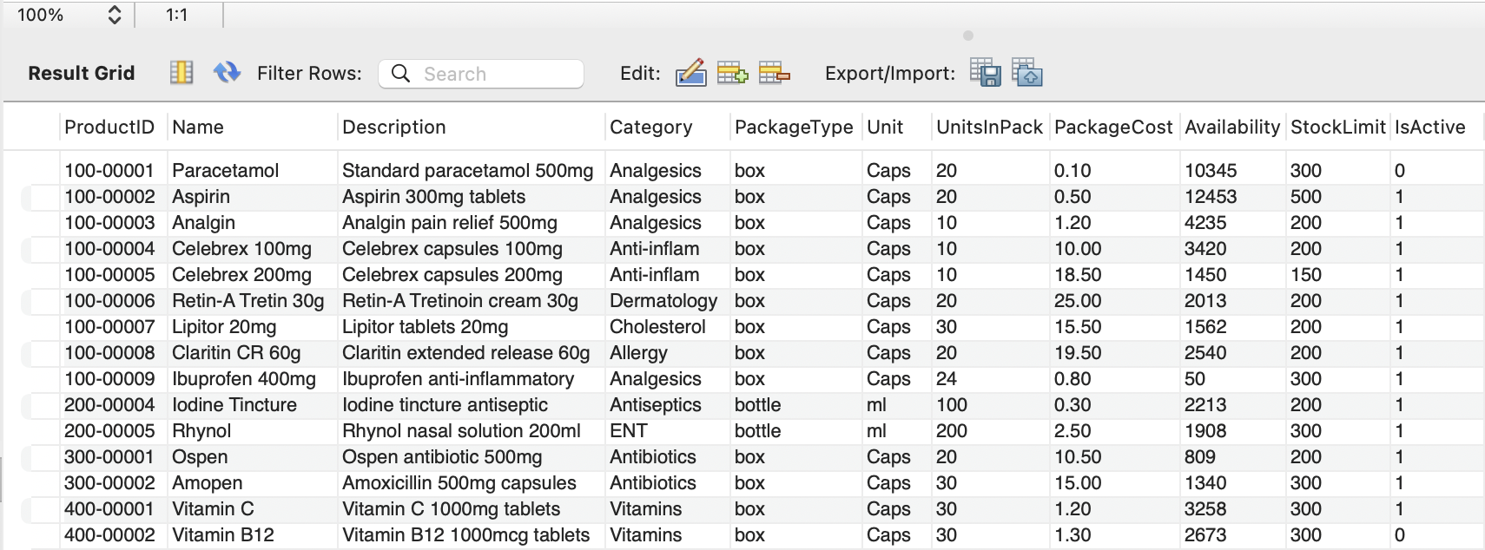
Figure 25. Catalogue Table Data

Table: Orders
The Orders table stores the main order records created within the IPOS-SA subsystem and represents the core transactional table for merchant purchases. Each record corresponds to a single order placed by a merchant and contains the main information required to identify, monitor, and manage that order throughout its lifecycle. This includes the merchant responsible for the order, the date on which it was placed, the total order value, the current processing status, and any delivery-related information. As a result, the table supports the central order-processing workflow of the subsystem.
The primary key of the table is OrderID, which uniquely identifies each order. The table contains the following main attributes: OrderID, MerchantID, OrderDate, TotalAmount, OrderStatus, EstimatedDelivery, and DispatchDetails. The schema also shows an index on MerchantID, which supports efficient retrieval of orders for a specific merchant. In addition, MerchantID is linked to the Users table through foreign key constraints, ensuring that each order is associated with a valid merchant account and helping to maintain referential integrity within the database.
The table records both financial and operational aspects of an order. OrderDate stores the date and time at which the order was created, while TotalAmount stores the total value of the order as a decimal value. OrderStatus is implemented as an enumeration and includes states such as ACCEPTED, PROCESSING, READY_TO_DISPATCH, PACKED, DISPATCHED, DELIVERED, and CANCELLED, allowing the subsystem to track the progress of each order clearly. The fields EstimatedDelivery and DispatchDetails support delivery-related information when such data is available. In the sample data, for example, orders are shown with statuses such as DELIVERED, PROCESSING, and ACCEPTED, demonstrating that the table is used to store orders at different stages of the fulfilment process.
Within the implemented GUI, the Orders table is used directly by the Orders page, where users can view order records, monitor order status, filter displayed orders, and update delivery status. It also supports invoice-related workflows and report generation by providing the main order-level data required for summaries, tracking, and financial outputs. Together with the OrderItems and Invoices_Payments tables, it forms one of the key transactional structures in the IPOS-SA database.
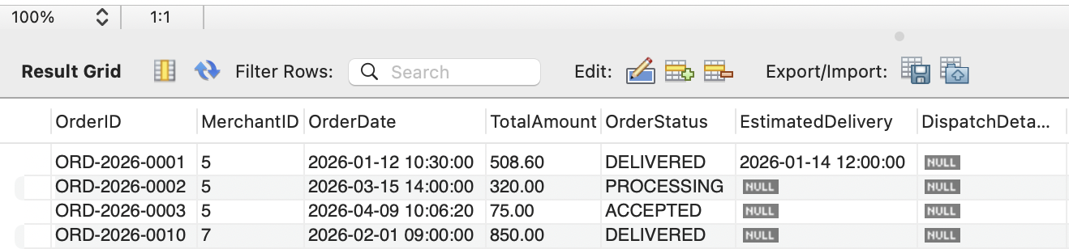
Figure 26. Orders Table Data

Table: OrderItems
The OrderItems table stores the individual line items that belong to merchant orders in the IPOS-SA subsystem. While the Orders table records the order as a whole, the OrderItems table stores the detailed contents of each order by listing the products included, the quantity requested, and the unit cost for each item. In this way, the table supports the detailed order-processing workflow of the subsystem and provides the data needed to calculate order values, generate invoices, and display order contents within the application.
The primary key of the table is OrderItemID, which uniquely identifies each order line. The table contains the following attributes: OrderItemID, OrderID, ProductID, Quantity, and UnitCost. The schema also shows indexes on OrderID and ProductID, which improve the efficiency of retrieving order items by order or by product. In addition, the table is linked through foreign key constraints to the Orders table via OrderID and to the Catalogue table via ProductID. This ensures that each order item is associated with a valid order and a valid catalogue product, thereby helping to maintain referential integrity within the database structure.
The operational fields of the table are used to represent the details of each ordered product. Quantity stores the number of units ordered, while UnitCost stores the price of the product at the time the order item is recorded. The sample data shows that a single order may contain multiple entries. For example, ORD-2026-0001 includes several products, each with its own quantity and unit cost. This confirms that the table is designed to support a one-to-many relationship between an order and its individual product items.
Within the implemented GUI, the OrderItems table is used indirectly by the Orders page and related invoice functions, where the products included in each order, their quantities, and their unit costs are retrieved as part of the order-processing workflow. It also supports report generation by providing product-level order details. As a result, this table forms an important part of the transactional data model of the IPOS-SA database.
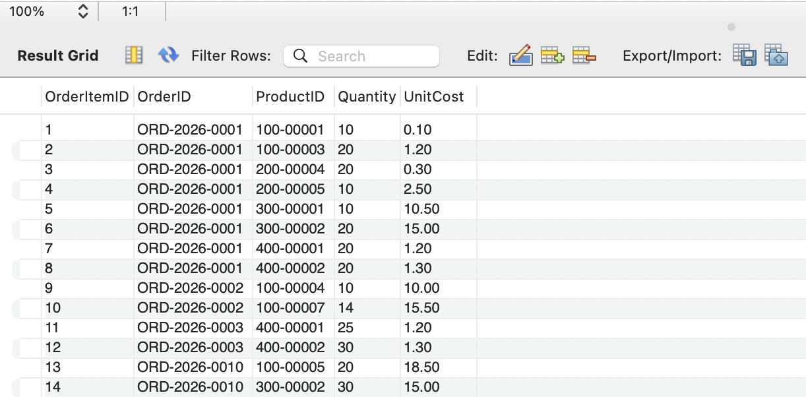
Figure 27. OrderItems Table Data

Table: Payments
The Payments table stores the payment records made by merchants in the IPOS-SA subsystem and supports the payment-tracking functions of the server-side application. Each record represents a single payment entry and contains the key information needed to record when a payment was made, which merchant made it, how much was paid, the payment method used, and the associated reference number. This allows the subsystem to maintain a history of merchant payments and support balance-related workflows within the application.
The primary key of the table is PaymentID, which uniquely identifies each payment record. The table contains the following main attributes: PaymentID, MerchantID, PaymentDate, AmountPaid, PaymentMethod, and ReferenceNumber. The schema also shows an index on MerchantID, which supports efficient retrieval of payment records for a selected merchant. In addition, MerchantID is linked to the Users table through foreign key constraints, ensuring that each payment record is associated with a valid merchant account and helping to maintain referential integrity within the database.
The table stores both financial and reference information for each payment. PaymentDate records the date and time of the payment, while AmountPaid stores the payment value as a decimal amount. PaymentMethod is implemented as an enumeration and includes values such as Bank Transfer, Credit Card, Cash, and Cheque, allowing the subsystem to classify payments according to the method used. ReferenceNumber stores an identifying payment reference, which can be used for traceability and reconciliation. In the sample data, for example, one payment record shows a Bank Transfer made by merchant 5 on 2026-01-20 11:00:00 for 508.60, with the reference BACS-20260120-001.
Within the implemented GUI, the Payments table is used by the Merchant Balance page, particularly in the Record Payment section, where authorised users can enter a payment amount, choose a payment method, provide a reference number, and store the payment in the system. It also supports balance monitoring and payment follow-up by providing the payment data required to update merchant account information. As a result, the table forms an important part of the financial data structure of the IPOS-SA database.
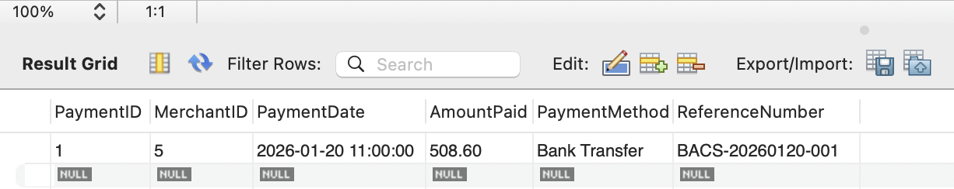
Figure 28. Payments Table Data

Table: Invoices_Payments
The Invoices_Payments table stores invoice and payment-status information associated with merchant orders in the IPOS-SA subsystem. It supports invoice tracking, payment monitoring, and balance-related workflows within the server-side application. Each record represents an invoice entry linked to an order and includes the issue date, due date, and current payment status. This allows the subsystem to keep track of whether an invoice has been paid, is still pending, or has become overdue.
The primary key of the table is InvoiceID, which uniquely identifies each invoice record. The table contains the following attributes: InvoiceID, OrderID, IssueDate, DueDate, and PaymentStatus. The schema also shows that OrderID is indexed and linked to the Orders table through foreign key constraints. This ensures that each invoice/payment record corresponds to a valid order and helps maintain referential integrity within the order and payment workflow.
The date fields, IssueDate and DueDate, are used to record when an invoice was created and when payment is expected. The PaymentStatus field is implemented as an enumeration with values such as Pending, Paid, and Overdue, allowing the system to classify the current state of each invoice clearly. In the sample data, for example, ORD-2026-0001 is marked as Paid, ORD-2026-0002 and ORD-2026-0003 are marked as Pending, and ORD-2026-0010 is marked as Overdue. This structure makes the table useful for financial monitoring and for identifying merchants with outstanding liabilities.
Within the implemented prototype, the Invoices_Payments table supports the Merchant Balance page, where invoice and payment records are displayed for a selected merchant, as well as reminder and reporting functions that depend on payment status. It therefore plays an important role in tracking outstanding balances, supporting payment follow-up, and linking order activity with invoice status information in the IPOS-SA database.
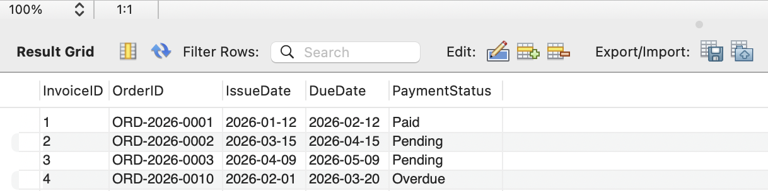
Figure 29. Invoices_Payments Table Data

Table: PU_Applications
The PU_Applications table stores the membership application records received from the IPOS-PU subsystem and made available within IPOS-SA for administrative review and decision-making. It supports the application-handling workflow of the server-side subsystem by storing the key details submitted by applicants, together with the current decision status. In this way, the table allows IPOS-SA to manage incoming applications before they are approved or rejected.
The primary key of the table is ApplicationID, which uniquely identifies each application record. The table contains the following main attributes: ApplicationID, ApplicationType, ApplicationDate, CompanyName, ApplicantName, CompanyHouseReg, Address, EmailAddress, and ApplicationStatus. The schema shows that the primary key is implemented as a visible unique BTREE index. No foreign key constraints are defined for this table in the current schema, indicating that it operates as an independent application record table within the database.
The fields of the table store both identification and review-related information. ApplicationType distinguishes between application categories such as Commercial and NonCommercial, while ApplicationDate records when the application was submitted. CompanyName, ApplicantName, CompanyHouseReg, Address, and EmailAddress store the main applicant and company details required for review. ApplicationStatus records the outcome or current state of the application. In the sample data, for example, PU-0001 is marked as Pending, PU-0002 as Rejected, and PU-0003 as Approved, showing that the table supports different stages of the application-review process.
Within the implemented GUI, the PU_Applications table is used by the Applications page, where authorised users can view submitted applications and update their status through the Approve and Reject actions. It also supports the notification workflow by providing the application details needed when decision messages are issued to applicants. As a result, this table forms the basis of the application management functionality linking IPOS-PU and IPOS-SA within the implemented prototype.
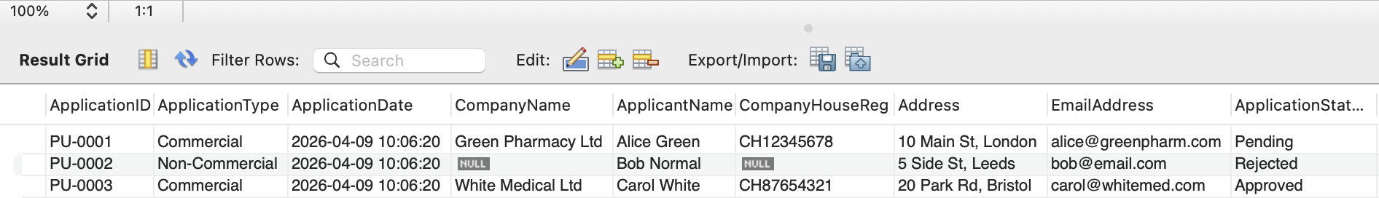
Figure 30. PU_Applications Table Data

Table: Users
The Users table stores the account records used within the IPOS-SA subsystem and serves as the main table for user and merchant account management. It supports authentication, role-based access control, and the storage of merchant account details required by the application. The table is designed to hold both internal staff accounts and merchant accounts in a single structure, allowing different user types to be managed consistently through the database and GUI.
The primary key of the table is UserID, which uniquely identifies each record. The main attributes are UserID, Username, Password, Role, AccountNo, AccountHolderName, ContactName, Address, Phone, CreditLimit, DiscountPlan, DiscountRate, AccountStatus, and OutstandingBalance. The schema also shows indexes on Username and AccountNo, which support efficient lookup of user accounts by login name or merchant account number. Although no foreign keys are defined directly on this table, it is referenced by other tables such as Orders and Payments through merchant-related fields.
The table stores both login data and account-profile information. Username, Password, and Role are used for authentication and access control, while merchant-related fields store contact, financial, and account-status information. The sample data shows that the table contains both staff accounts, such as admin, warehouse1, and accountant1, and merchant accounts such as cosymed, pharmaco, latepayer, and defaulted. Merchant records also include account numbers, discount plans, credit limits, account status, and outstanding balances.
Within the implemented GUI, the Users table is used by the Login page, the User Management page, the Merchants view, and the Add Merchant workflow. It therefore represents one of the main data structures of the IPOS-SA database, linking user access control with merchant account administration.
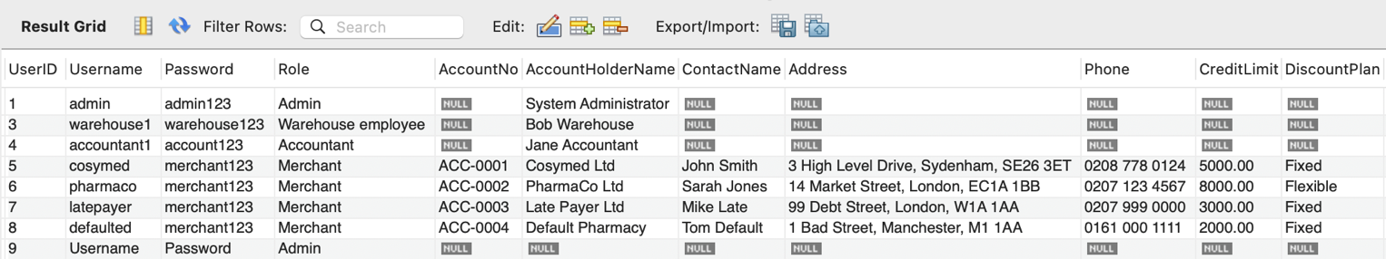
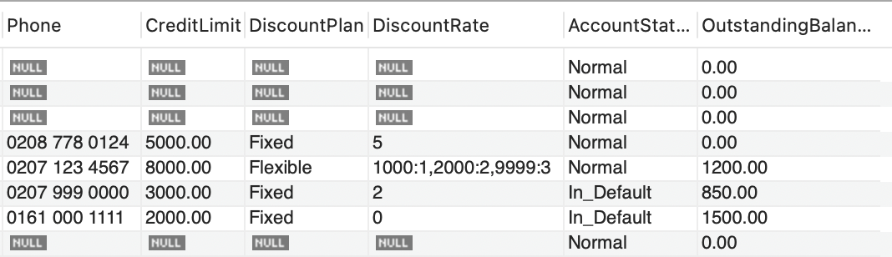
Figure 31. Users Table Data

  - Run instructions
The source code of the IPOS-SA subsystem is organised into a number of main packages, each responsible for a specific part of the implementation.

API package
The api package contains the main subsystem interfaces used for communication and service definition. These include:
- I_ApplicationService – defines application-related service behaviour
- I_EmailService – defines email or notification-related service behaviour
- I_SAtoCA – defines the main interface used for communication between IPOS-SA and other subsystem functionality, including authentication, stock checking, order submission, order status retrieval, catalogue access, and balance retrieval

Application package
The app package contains implementation-level coordination classes. In the current project structure, this includes:
- SAtoCA – application-level class linked to the subsystem communication/interface layer

DAO package
The dao package contains the database access classes responsible for persistent storage and retrieval of subsystem data. These include:
- DatabaseConnection – manages the database connection
- InvoiceDAO – handles invoice/payment-status data access
- OrderDAO – handles order data access
- PaymentDAO – handles payment record data access
- ProductDAO – handles catalogue/product data access
- UserDAO – handles user and merchant account data access

GUI package
The gui package contains the desktop user interface implementation. Based on the current structure, it includes subpackages such as:
- dashboard – dashboard-related forms and controller classes, including Dashboard, DashboardController, and addMerchantPopUp
- images – image resources used by the interface
- login – login-related GUI classes, including loginGUI and the main application entry class Main
This package provides the forms and controls used for user interaction throughout the subsystem.

Model package
The model package contains the domain classes used to represent the subsystem data. These include:
- Application
- InvoicePayment
- Order
- OrderConfirmation
- OrderItem
- Product
- User
The package also contains supporting subpackages:
- enums – enumerated types such as AccountStatus, ApprovalStatus, DiscountPlanType, OrderStatus, PaymentStatus, and UserRole
- users – specialised user-role classes such as Admin, Merchant, Accountant, SeniorAccountant, DirectorOfOperations, WarehouseEmployee, and DeliveryDepartmentEmployee

Service package
The service package contains the main business logic of the subsystem. These classes process requests from the GUI, apply subsystem rules, and interact with the DAO layer. The main service classes are:
- AccountService – handles authentication, merchant lookup, balances, and account-related logic
- AccountStatusService – handles account status behaviour
- ApplicationService – handles application submission and review logic
- OrderService – handles catalogue retrieval, stock checking, order placement, order history, and order status retrieval

Test package
The test package contains the JUnit test classes used to verify the implementation. It includes tests for both model and service classes, such as:
- ApplicationTest
- InvoicePaymentTest
- OrderConfirmationTest
- OrderItemTest
- OrderTest
- ProductTest
- UserTest
- AccountServiceTest
- ApplicationServiceTest
- OrderServiceTest
These tests support the validation of constructors, field updates, service behaviour, input validation, and core subsystem logic.

3.5 Compilation instructions
The IPOS-SA subsystem was compiled within IntelliJ IDEA as a Java desktop application. To compile the project, the following steps should be followed:
- Open the IPOS-SA project in IntelliJ IDEA.
- Ensure that a compatible Java JDK is installed and configured for the project.
- Ensure that the required project libraries are available, including the FlatLaf library used for the graphical look-and-feel.
- Ensure that the local MySQL database server is available and that the ipos_sa_db database can be accessed by the application.
- Confirm that the project database connection settings match the local MySQL configuration.
- Build the project in IntelliJ IDEA before running the application.

  - Run instructions
To run the IPOS-SA subsystem, the required local database must already be available and the application must be launched from the login entry point.
- Start the local MySQL server.
- Ensure that the ipos_sa_db database is available on the local machine.
- Open the project in IntelliJ IDEA.
- Run the class IPOS_Detailed_Design.gui.login.Main.
- The system will open at the IPOS-SA login screen.
- Log in using one of the predefined demo accounts listed below.

3.7 Test/Demo accounts
The following predefined accounts can be used to access the subsystem for demonstration and testing purposes. These accounts are based on the current contents of the Users table used by the GUI login process.
- Admin: admin / admin123
- Warehouse employee: warehouse1 / warehouse123
- Accountant: accountant1 / account123
- Merchant: cosymed / merchant123
- Merchant: pharmaco / merchant123
- Merchant: latepayer / merchant123
- Merchant: defaulted / merchant123
The login screen authenticates users against the database through the UserDAO class. For this reason, the usernames and passwords stored in the active database are the correct credentials to use for demonstration of the implemented prototype.

4. Deployment of Run-Time Software Components
4.1 Target hardware/software environment
The IPOS-SA subsystem was implemented and executed as a Java desktop GUI application. Development and testing were carried out in IntelliJ IDEA. The subsystem uses a local MySQL database, with the schema named ipos_sa_db.
4.2 Deployment configuration
The subsystem was run on a single local machine. The graphical user interface and the database both operated on the same machine during implementation and demonstration. The application accessed its runtime data through the local ipos_sa_db database connection.
4.3 External dependencies
The subsystem relies on a small set of external libraries included in the project. The main dependencies are:
- MySQL Connector/J for database connectivity
- FlatLaf for the graphical look-and-feel
- iTextPDF for PDF report generation
- JUnit libraries for automated testing support

5. Interaction with Other Subsystems
5.1 Required external functionality
The IPOS-SA subsystem required interaction with other parts of the IPOS system, particularly for application handling and subsystem-level coordination. In the implemented prototype, the Applications functionality was designed to support the review of records originating from the public-facing side of the system. In addition, the subsystem design included support for merchant authentication, stock checking, order submission, and order-status retrieval through defined interfaces.
5.2 Provided functionality to other teams
IPOS-SA provides the main server-side functionality needed by other subsystem workflows. This includes merchant authentication, catalogue retrieval, stock checking, order submission, order history and order-status retrieval, merchant balance access, and application-related processing. In the implemented codebase, these behaviours are represented mainly through the I_SAtoCA and I_ApplicationService interfaces together with the related service-layer logic.
5.3 Integration approach
Integration was implemented through a modular interface-based approach. Rather than exposing the IPOS-SA database directly to other subsystems, the required behaviour was structured through Java interfaces and supported by service and DAO classes. This approach keeps the GUI, business logic, database access, and subsystem communication separate while still reflecting the interaction model defined during the design stage.
5.4 Integration challenges
One of the main challenges was keeping shared data and expected behaviours consistent across subsystem boundaries, especially for account details, order status values, stock information, and application status. Another challenge was that the final system remained at prototype level, so not every external dependency was implemented as a full live integration. To address this, the project preserved the intended subsystem interaction structure through agreed interfaces, shared data assumptions, and service-level implementation.

