INFOPHARMA ORDERING SYSTEM

IMPLEMENTATION
REPORT

Team Project – IN2033
Team: 46
Group: 16
Subsytem: IPOS-SA
Date: 26 April 2026

- Introduction

  - Purpose of this document
This document presents the implementation of the IPOS-SA subsystem developed by Team 46 as part of the InfoPharma Ordering System (IPOS). Its purpose is to describe how the final prototype of the subsystem was implemented and how the design defined at the earlier stages of the project was translated into a working software product. The report explains the overall implementation structure of the subsystem, including the main software components, graphical user interface, database design, and testing activities carried out during development.
In addition, this document explains how the implemented prototype supports the main responsibilities of IPOS-SA, including merchant authentication, catalogue and stock management, order processing, invoice and balance handling, application review, and reporting. It also outlines how the subsystem supports communication with the other IPOS subsystems through the defined interfaces introduced in the high-level design stage.
  - Scope
This report covers the implementation of the IPOS-SA subsystem assigned to Team 46. It includes:
- the overall structure of the implemented subsystem
- the main runtime and software components used in the prototype
- the graphical user interface developed for the subsystem
- the database structures used to store and manage subsystem data
- the testing approach and testing results for the implemented prototype
- the verification of key subsystem and interface behaviours
- the final design class diagram included in the appendix
The report focuses on the implemented prototype delivered in the final stage of the project and therefore documents the practical outcome of development rather than only the earlier design intentions. Where relevant, reference is made to the interfaces and testing plans defined during the Week 5 high-level design deliverable.

1.3 Subsytem overview
The IPOS-SA subsystem is the central server-side component of the InfoPharma Ordering System. Its role is to manage the core wholesale business operations required by InfoPharma, including merchant authentication, product catalogue maintenance, stock monitoring, order handling, invoice and payment-status tracking, application review, and report generation. In the implemented prototype, the subsystem was developed as a GUI-based application supported by a relational database and a layered implementation structure consisting of model, service, database-access, and interface-related components.
The subsystem supports multiple categories of users, including administrators, operations or accounting-related staff, warehouse staff, and registered merchants, depending on the function being accessed. Through the implemented GUI, users can log in to the system, manage catalogue records, update order statuses, record merchant payments, review applications received from IPOS-PU, generate reports, and manage user and merchant accounts. The subsystem also stores its own data independently and supports communication with the other IPOS subsystems through clearly defined Java interfaces rather than direct database access, in line with the architectural approach defined in the earlier design stage.

- Overview of the Implemented Subsystem
2.1 Main functionality implemented
The implemented IPOS-SA prototype provides the main server-side functions required for the subsystem. These include user login and role-based access, dashboard monitoring, catalogue management, stock monitoring, order management, merchant balance and payment handling, application review, report generation, and user and merchant administration.
In the delivered prototype, authorised users can log into the system and access the main operational pages through the desktop GUI. The subsystem allows catalogue items to be viewed, searched, added, and removed, while also highlighting products that fall below their defined stock limit. Orders can be viewed and their delivery status can be updated, merchant balances can be monitored, payments can be recorded, and reports can be generated for turnover, stock, merchant activity, and debtor reminders. The subsystem also supports the review of applications received from IPOS-PU, including approve and reject actions with notification behaviour, and provides user and merchant management functions within the administrative interface.

2.2 Technologies used
The IPOS-SA prototype was implemented using a Java-based desktop application stack. The main technologies used in the subsystem are:
- Programming language: Java
- Development environment: IntelliJ IDEA
- Database: MySQL
- Database management tool: MySQL Workbench
- Testing framework: JUnit 5
- Version control: Git / GitHub
- Application type: Desktop GUI application
These technologies were used to support the main implementation areas of the subsystem, including the graphical interface, business logic, database access, and automated unit testing.

2.3 System architecture summary
The subsystem was implemented using a layered structure in order to separate the main responsibilities of the application. The graphical user interface handles user interaction and navigation between the main pages of the subsystem. The service layer contains the core business logic for functions such as authentication, application handling, order processing, balance management, and report-related behaviour. The model layer stores the main domain objects used throughout the subsystem, while the DAO and database-related classes handle persistent data access and communication with the MySQL database.
The implementation also includes interface-based components to support communication with other IPOS subsystems. As a result, the final prototype follows a modular structure in which the GUI, business logic, database access, and subsystem interfaces are kept separate. This makes the implementation easier to understand, test, and maintain, while also reflecting the structure defined during the earlier design stage.

- Software Compilation and Run-Time Components
3.1 Project Structure
The IPOS-SA project is organised as a structured Java desktop application with separate folders for source code, test code, documentation, libraries, and database-related materials. This organisation supports modular development and helps separate the user interface, business logic, data access, subsystem interfaces, and testing components.
The main project structure is as follows:
- /.idea – IntelliJ IDEA project configuration files
- /archive – archived project-related materials
- /database – database-related files and supporting materials
- /demo-code-submission – submission copy of the demonstration code
- /docs – project documentation files
- /javadoc – generated Java documentation
- /lib – external libraries used by the project
- /out – compiled output files generated by the IDE
- /programmers – team or development-related files
- /src – main source code of the subsystem
- /test – JUnit test classes for the implemented subsystem
- README.md – project readme file
- db.properties.example – example database configuration file
- .gitignore / .gitattributes – version-control support files
Within the src folder, the main implementation is placed under the package IPOS_Detailed_Design, which is divided into separate subpackages for interfaces, application-level integration, data access, graphical user interface, model classes, and service-layer logic. The test folder mirrors the main implementation structure and contains unit tests for model and service classes.

3.2 Forms, Controls and Dialog Boxes
The graphical user interface of the IPOS-SA subsystem was documented in an integrated way, with each screen explained together with its main controls, actions, and related message dialogs. For this reason, the forms, controls, and dialog boxes are presented together rather than as separate repeated sections. The implemented GUI includes the Login, Dashboard, Catalogue Management, Orders, Reports, Applications, and User Management screens, each supported by the relevant buttons, input fields, tables, navigation controls, and confirmation or error dialogs. Detailed descriptions and figure-based explanations of these elements are provided in the GUI implementation section of this report.
• Login form with username, password, and login action
• Dashboard with navigation controls and alerts
• Catalogue forms with search, add, and remove controls
• Orders forms with status update and merchant balance controls
• Reports forms with generation buttons and reminder dialogs
• Applications form with approve/reject actions
• User Management forms with add, edit, and remove controls

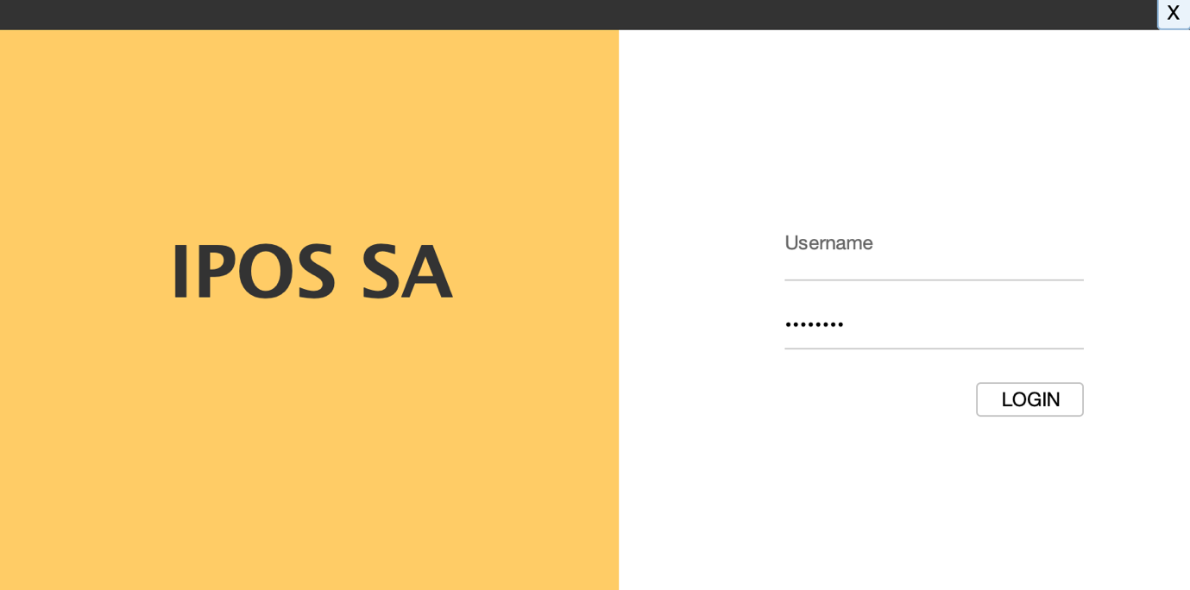

Figure 1. IPOS-SA Login Interface
The login interface is the entry point to the IPOS-SA subsystem. It allows authorised users to access the system by entering their username and password. In the example shown, the administrator account is used to log in to the system. This screen provides a simple and controlled authentication mechanism before users can access subsytem functions such as catalogue management, orders, reports, applications and user management.

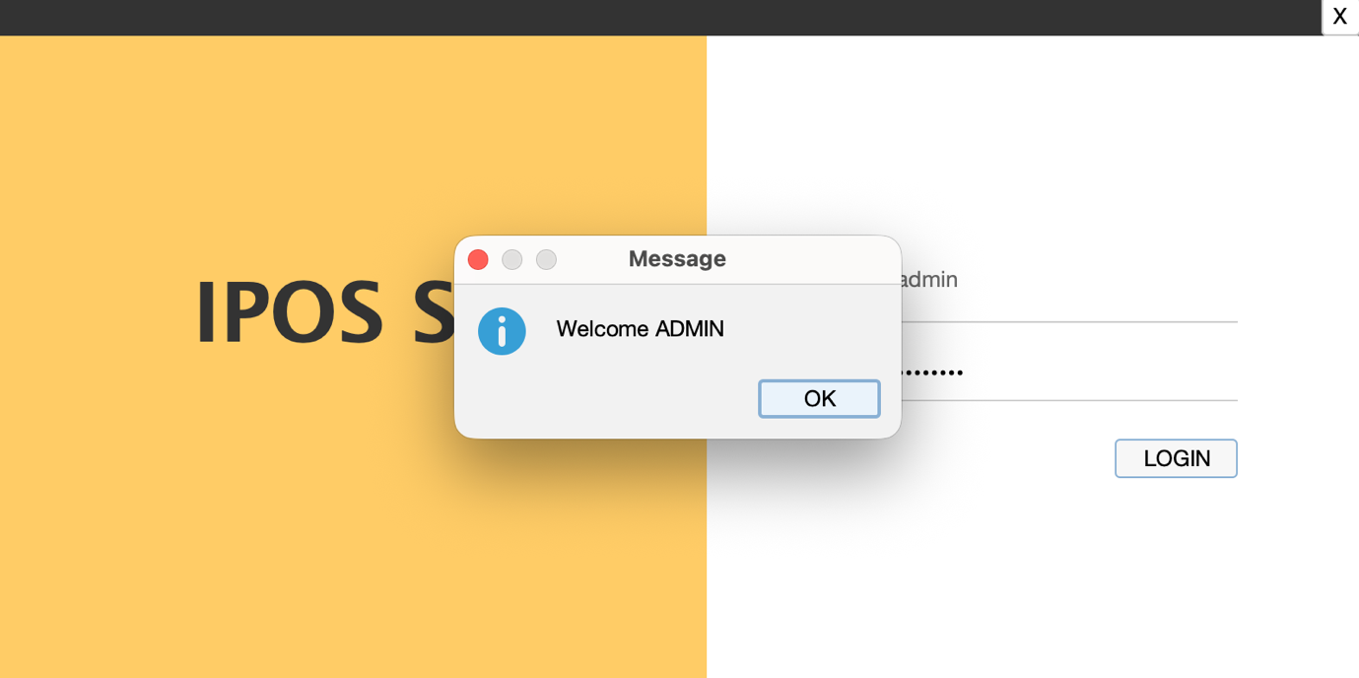

Figure 2. Successful Login Confirmation
This screen shows the confirmation message displayed after a successful login to the IPOS-SA subsystem. Once the administrator enters valid credentials, the system verifies the username and password and displays a welcome message before granting access to the main dashboard. This confirms that the authentication process has been completed successfully and that the user is authorised to access the subsytem.

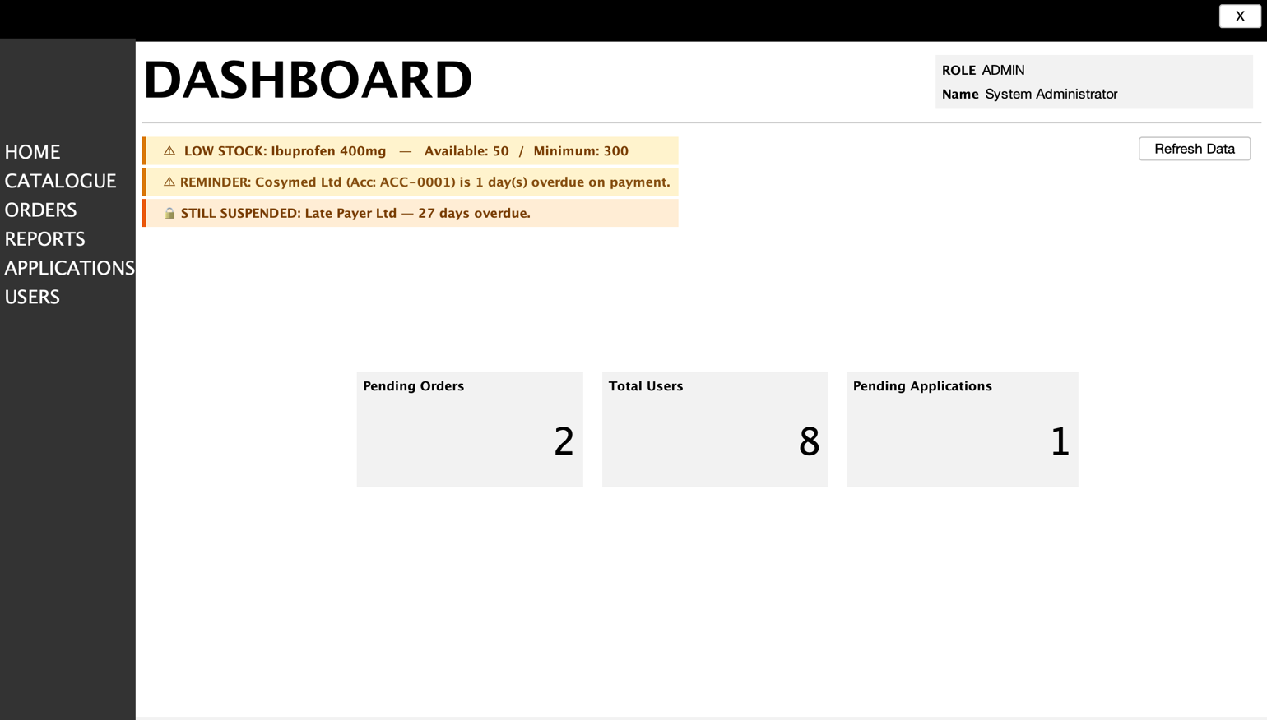

Figure 3. IPOS-SA Administrator Dashboard
This dashboard provides the main entry point for administrative users of the IPOS-SA subsytem. The left side navigation menu allows access to the main modules of the system, including Home, Catalogue, Orders, Reports, Applications and Users. The centre panel displays important operational alerts such as low-stock warnings, overdue payment reminders and suspended merchant accounts. Summary cards are also shown to provide quick overview of key system information, including pending orders, total users and pending applications. The refresh function allows the administrator to update the displayed data dynamically.

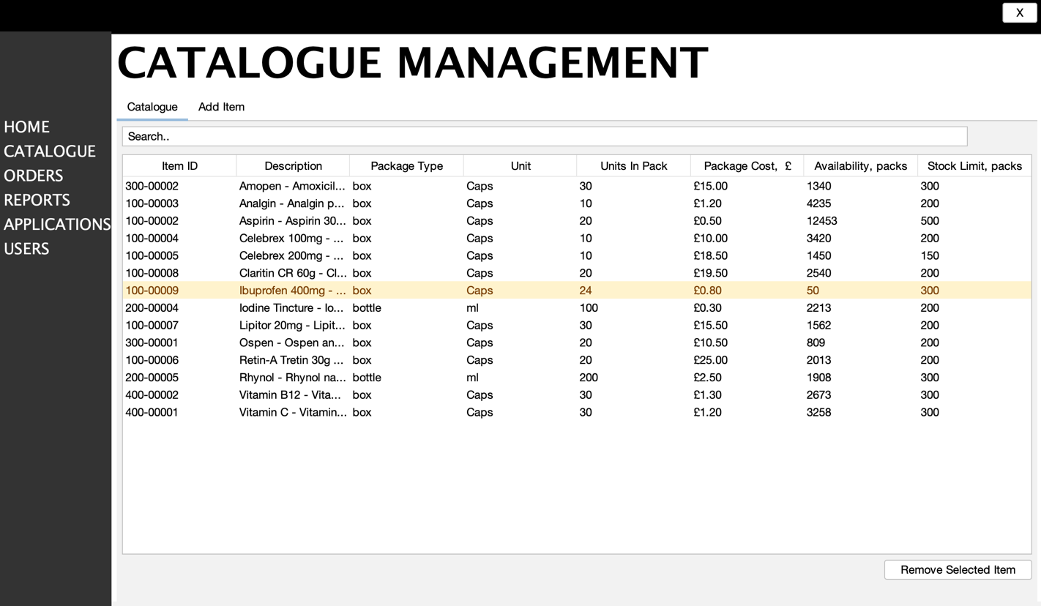

Figure 4. Catalogue Management Page
This screen shows the the Catalogue Management page of the IPOS-SA subsystem. It allows authorised users to view and manage the pharmaceutical product catalogue stored in the IPOS-SA database. The table displays key product information retrieved from the database, including item ID, description, package type, unit details, package cost, current availability and minimum stock limit. The search bar supports quick lookup of catalogue items, while the management controls allow actions such as adding or removing selected items. Items that are below their defined stock limit are highlighted in yellow to draw attention to low-stock conditions and support stock monitoring. This page supports the catalogue maintenance and stock monitoring functions required for IPOS-SA.
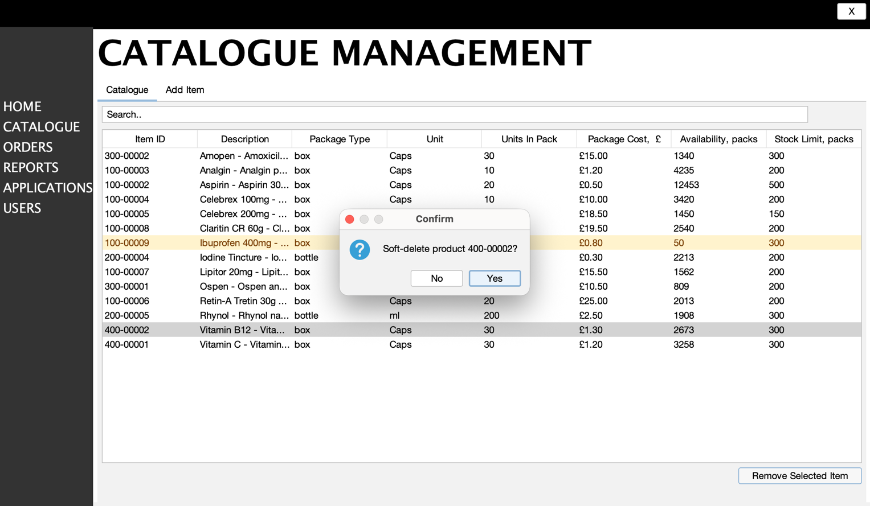

Figure 5. Item Removal Confirmation in Catalogue Management
This screen shows the confirmation dialog displayed when an authorised user selects a catalogue item and clicks Remove Selected Item in the IPOS-SA Catalogue Management page. The dialog asks the user to confirm the deletion before the selected product record is removed from the catalogue. If the user selects Yes, the item is deleted from the catalogue data; if No is selected, the operation is cancelled and no changes are made. This confirmation step helps prevent accidental deletion of catalogue records and supports safer catalogue maintenance within the IPOS-SA subsystem.
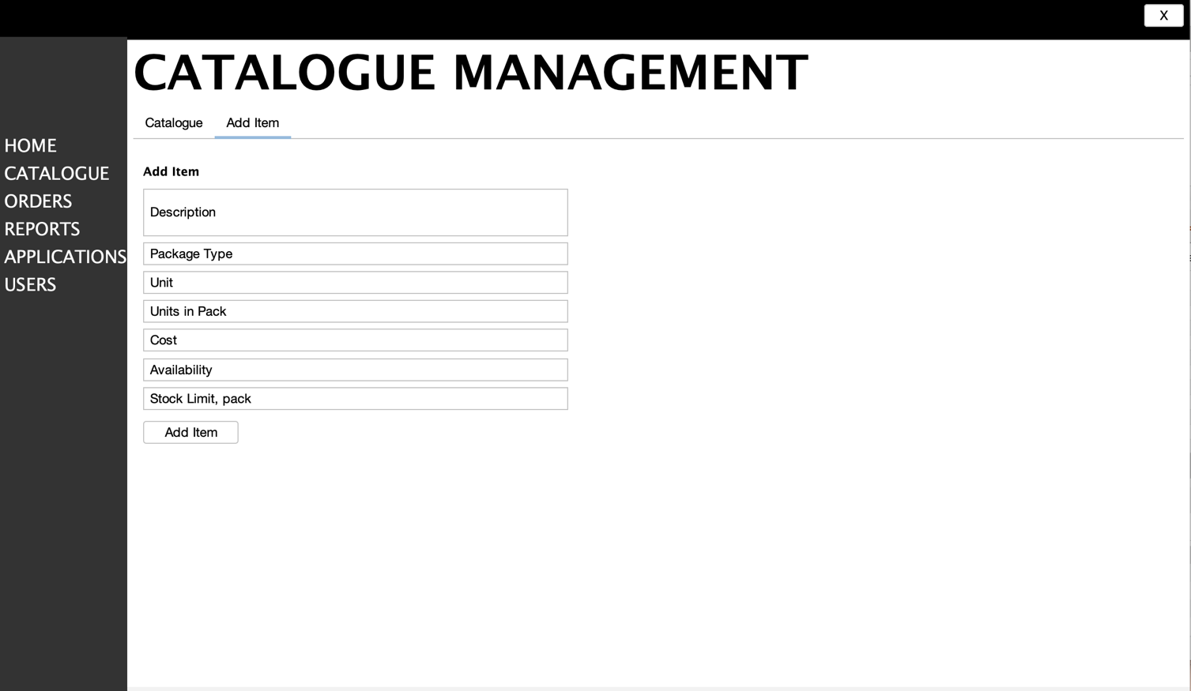

Figure 6. Add Item Page in Catalogue Management
This screen shows the Add Item page within the Catalogue Management module of the IPOS-SA subsytem. It allows authorised users to add a new pharmaceutical product to the catalogue by entering the product description, package type, unit, units per pack, cost, availability and stock limit. These values are entered through the form and, once submitted, are stored in the IPOS-SA database as a new catalogue record. This page supports the catalogue maintenance function of IPOS-SA by allowing administrators to expand the product catalogue and define the minimum stock treshold for each new item.

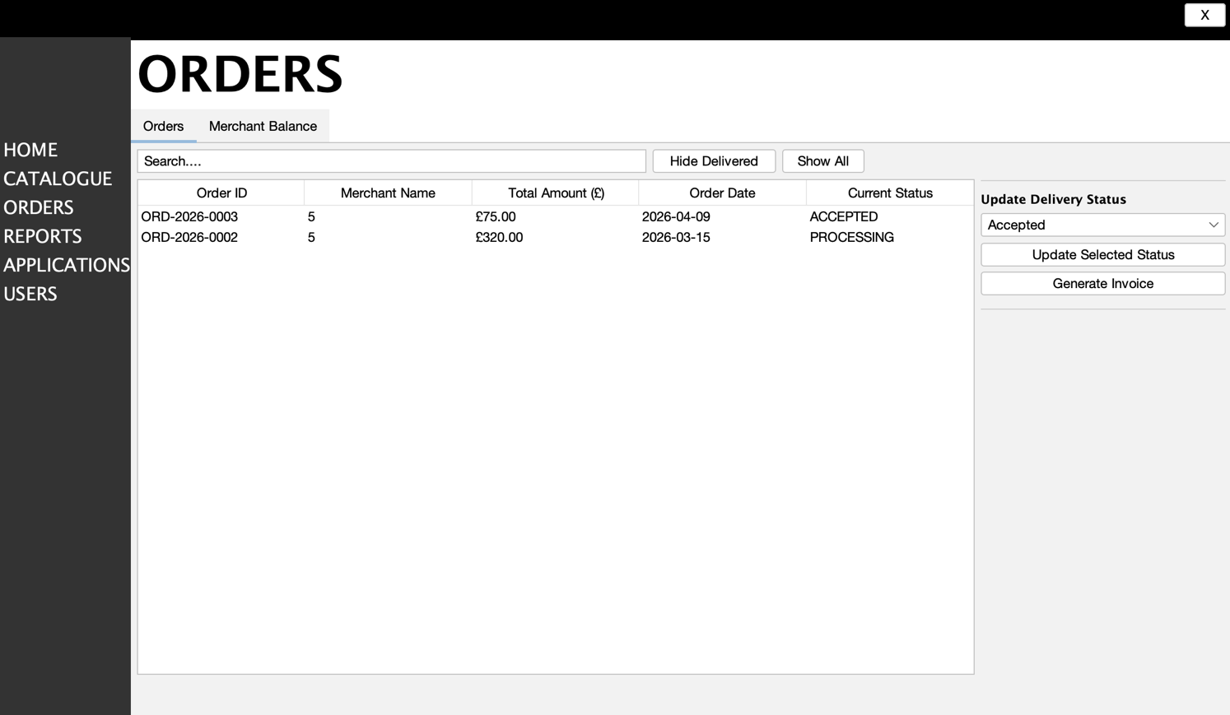

Figure 7. Orders Management Page
This screen shows the Orders page of the IPOS-SA subsytem. It allows authorised users to view and manage merchant orders stored in the IPOS-SA database. The main table displays key order information, including Order ID, Merchant Name, Total Amount, Order Date, and Current Status. The Search bar is used to quickly find specific orders, while the Hide Delivered button filters out completed deliveries and the Show All button restores the full list of orders. On the right-hand side, the Update Delivery Status drop-down menu allows the user to select a new status for the chosen order, such as Accepted, Ready to Dispatch, Dispatched, or Delivered. The Update Selected Status button applies the selected status change to the highlighted order, and the Generate Invoice button allows an invoice to be created for the selected order. This page supports the order tracking, order status management, and invoice-related functions required for IPOS-SA.

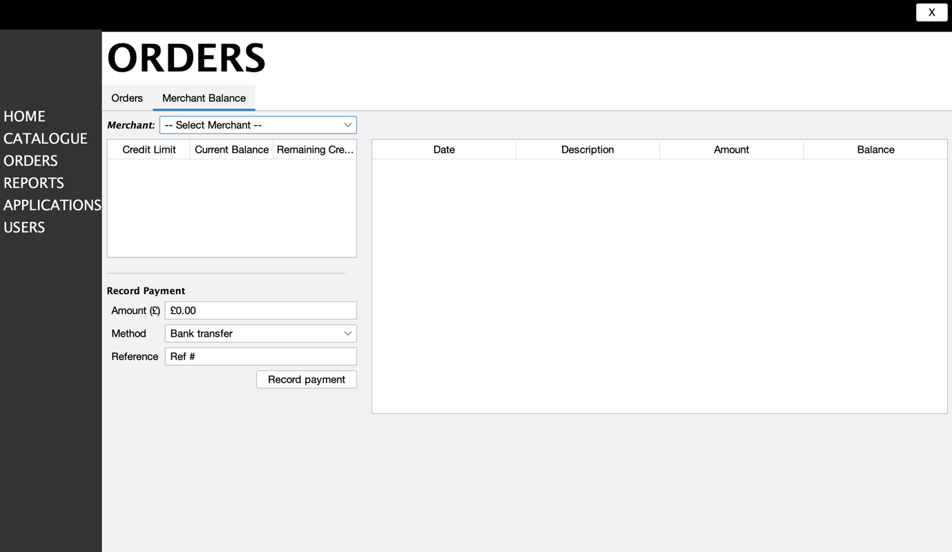

Figure 8. Merchant Balance and Payment Recording Page
This screen shows the Merchant Balance section within the Orders module of the IPOS-SA subsystem. It allows authorised users to select a merchant from the drop-down list and view account-related information stored in the IPOS-SA database. The available merchant accounts in the system include ACC-0001 – Cosymed Ltd, ACC-0002 – PharmaCo Ltd, ACC-0003 – Late Payer Ltd, ACC-0004 – Default Pharmacy. The left-hand summary area is used to display key financial details for the selected merchant, such as credit limit, current balance, and remaining credit. The table on the right is intended to show the transaction history for the selected merchant, including the date, description, amount, and resulting balance for each recorded entry.
The Merchant drop-down menu is used to choose a registered merchant account. In the Record Payment section, the user can enter a payment amount, select the payment method, such as bank transfer, credit card, debit card or cash, provide a payment reference, and then click Record payment to store the payment details in the system. This page supports merchant balance monitoring and manuel payment recording, which are required functions of IPOS-SA.

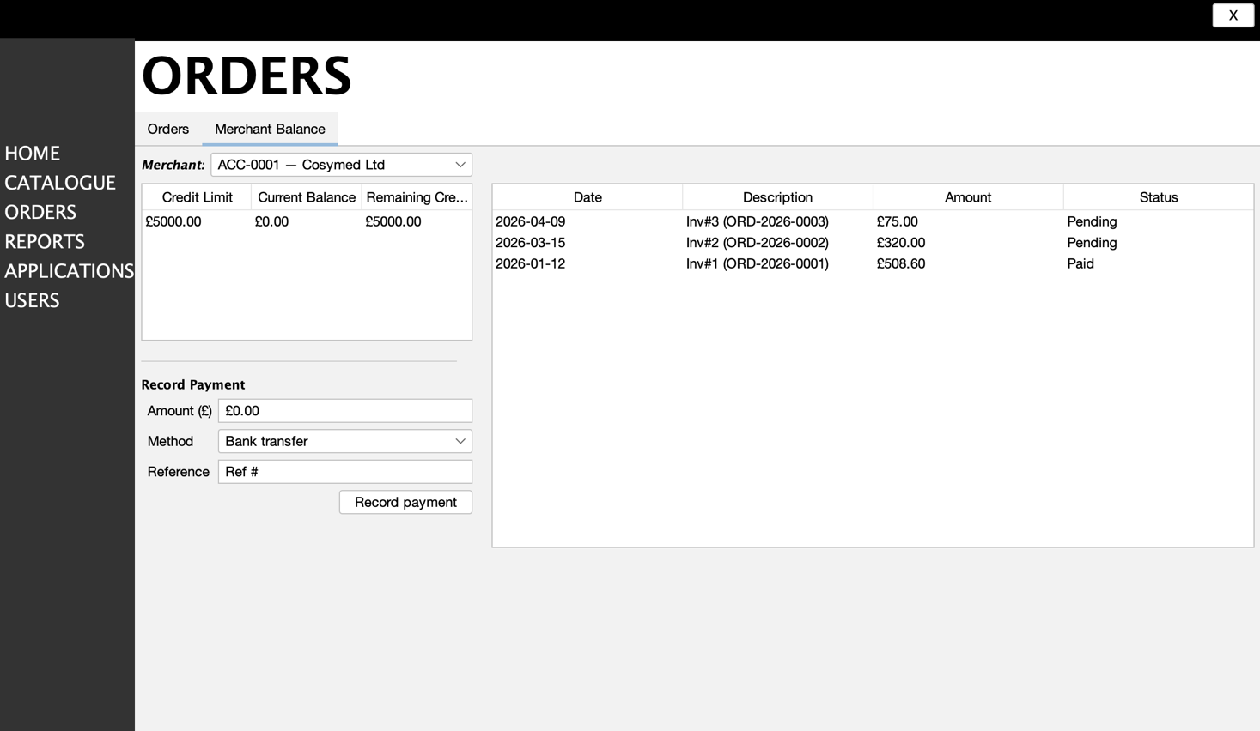

Figure 9. Selected Merchant Balance View
In this view, a merchant account has already been selected from the drop-down list. The page now displays the selected merchant’s financial details, including credit limit, current balance, and remaining credit, together with the recorded invoice history shown on the right. The transaction table lists the date, invoice description, amount, and payment status for each entry. In the example shown, ACC-0001 — Cosymed Ltd is selected, and its account records are displayed for review and payment management. The Record Payment section below can be used to enter a new payment for this merchant.

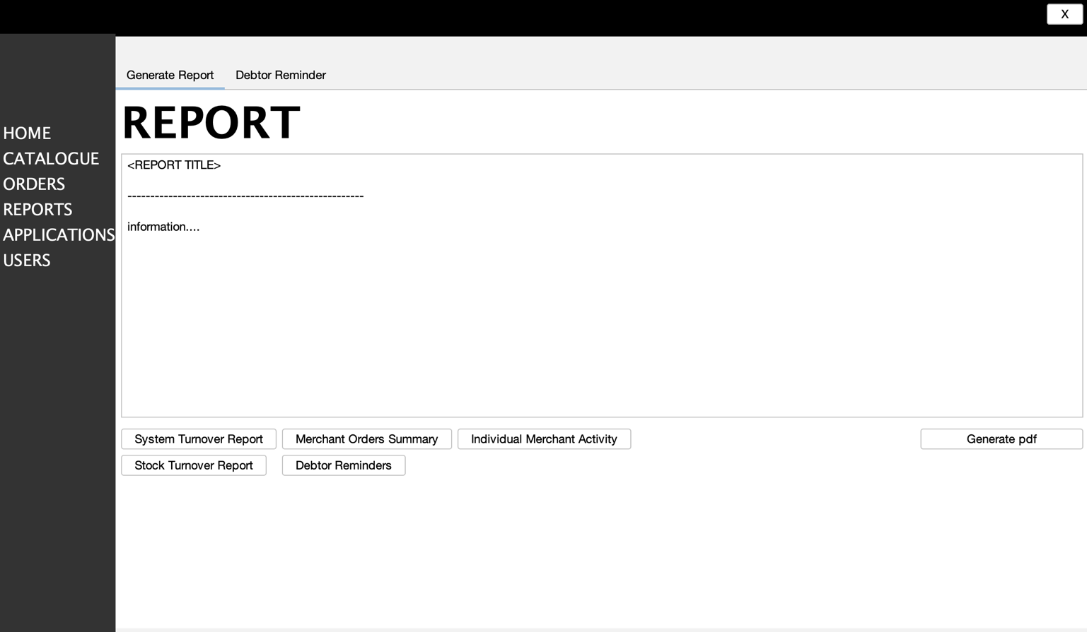

Figure 10. Reports Page
This screen shows the Report page of the IPOS-SA subsystem. It allows authorised users to generate and view management reports based on data stored in the IPOS-SA database. The large display area is used to present the selected report content, including the report title and generated information. The Generate Report tab is used to access report-generation functions, while the Debtor Reminder tab provides access to reminder-related reporting features.
At the bottom of the page, the available report buttons allow the user to generate different types of reports. The System Turnover Report button produces a report on goods sold and revenue received, the Merchant Orders Summary button generates a summary of orders for a selected merchant, the Individual Merchant Activity button shows detailed activity for a specific merchant, and the Stock Turnover Report button provides stock movement information for a selected period. The Debtor Reminders button is used to generate reminder-related output for merchants with overdue balances. The Generate pdf button allows the displayed report to be exported as a PDF document. This page supports the reporting functions required for IPOS-SA.

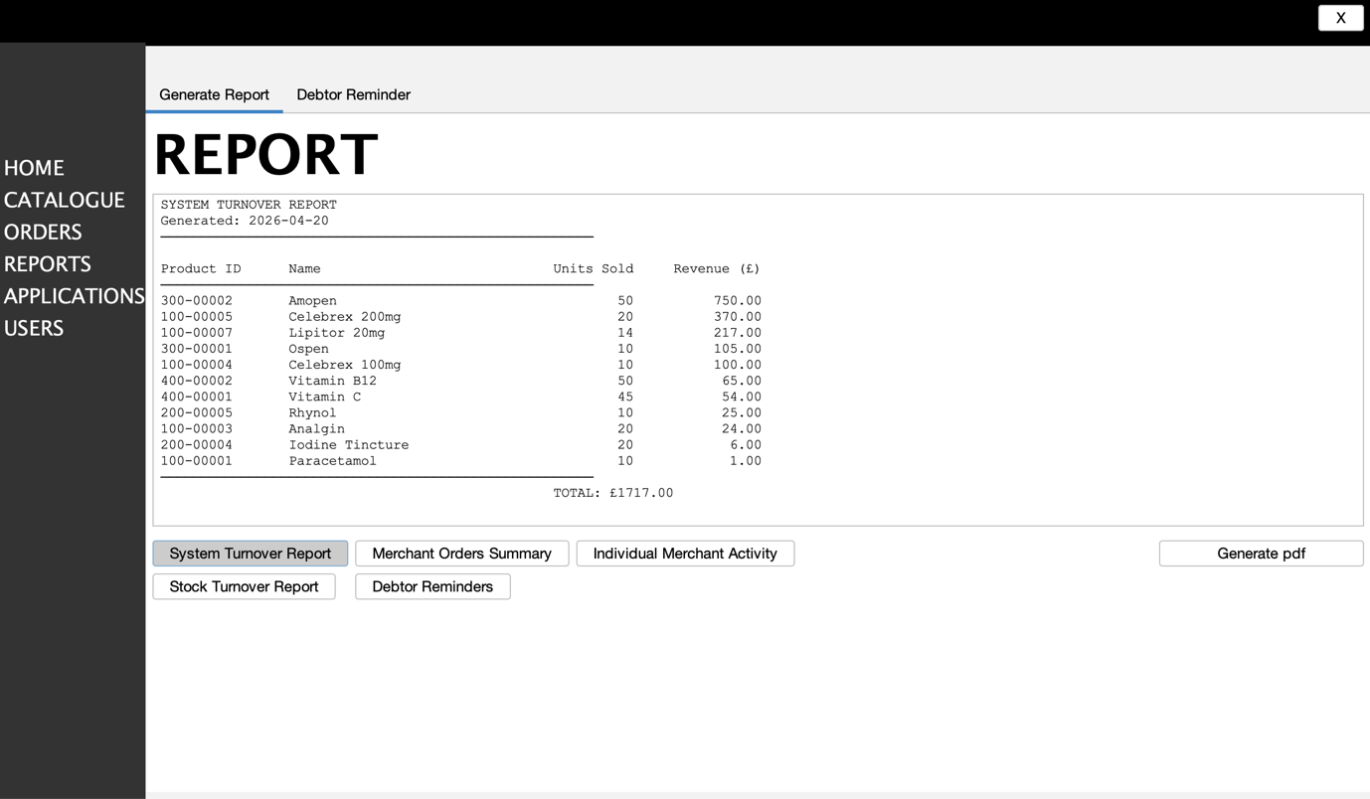

Figure 11. System Turnover Report
This screen shows the System Turnover Report generated within the Reports module of the IPOS-SA subsystem. The report presents turnover information based on data stored in the IPOS-SA database and summarises the quantities of pharmaceutical products sold together with the revenue received for each product. The displayed report includes the product ID, product name, units sold, and revenue(£), followed by a total revenue value for the selected reporting period. The System Turnover Report button is used to generate this output, and the Generate pdf button allows the displayed report to be exported as a PDF document. This screen supports the turnover reporting function required for IPOS-SA and provides management with a clear summary of sales activity.

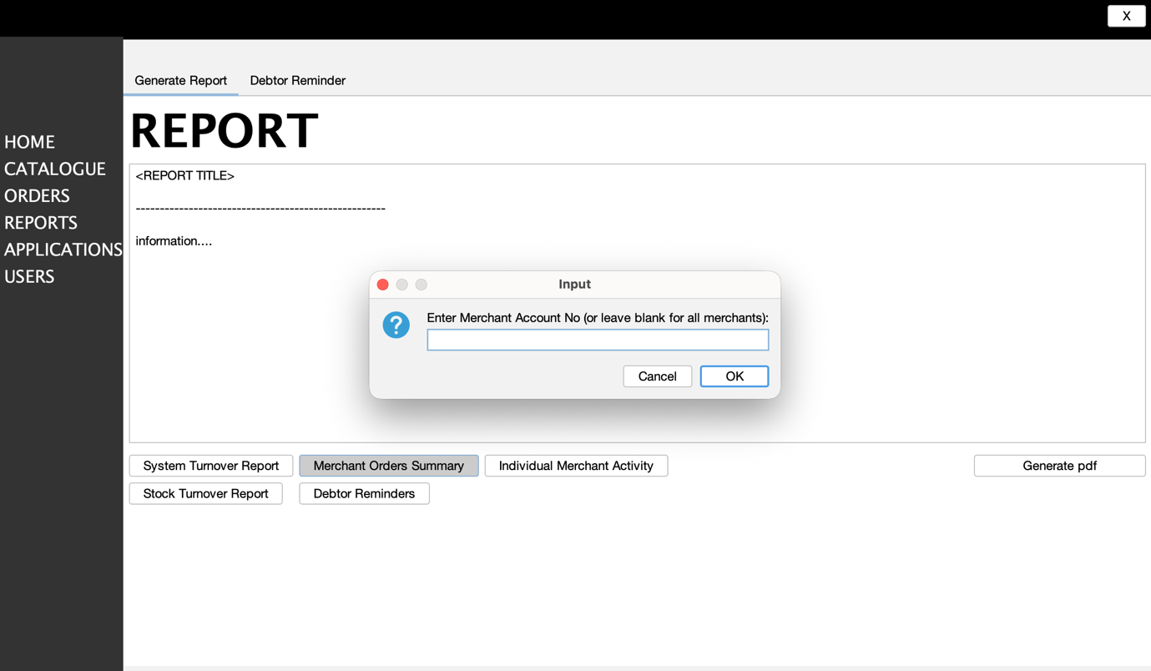
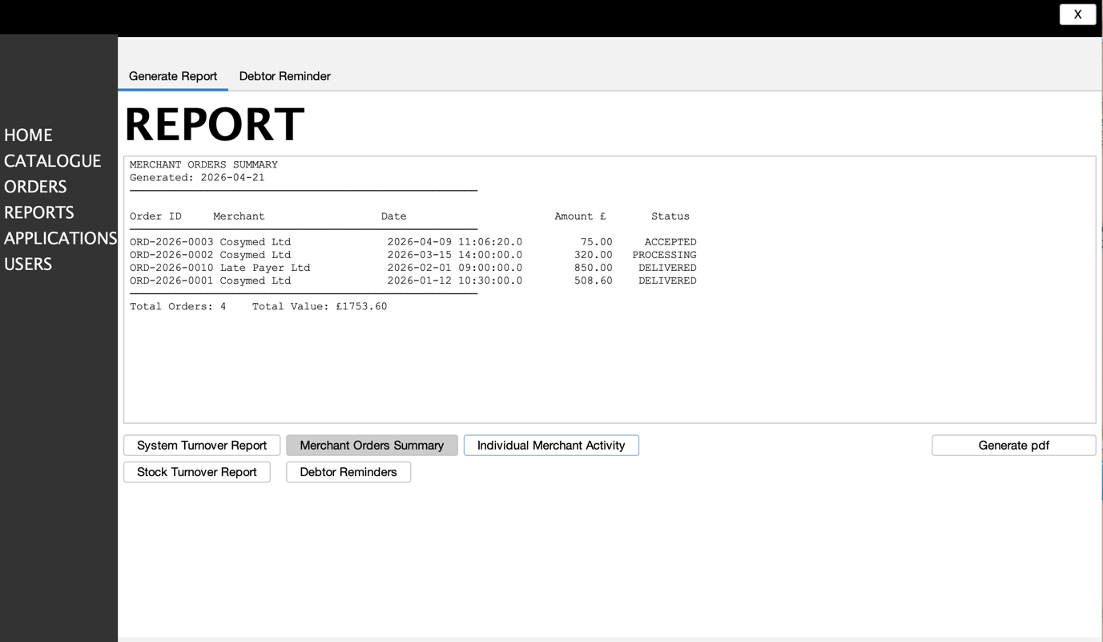

Figure 12. Merchant Orders Summary Input and Generated Report
These screens show the process of generating the Merchant Orders Summary report in the Reports module of the IPOS-SA subsystem. In the first screen, the system displays an input dialog asking the user to enter a merchant account number. This allows the report to be filtered for a specific merchant account. If the field is left blank, the system generates the report for all merchants. The OK button confirms the request and starts the report-generation process, while Cancel closes the dialog without generating the report.
In the second screen, the generated Merchant Orders Summary report is displayed in the main report area. The report presents order-related information retrieved from the IPOS-SA database, including Order ID, merchant name, date, amount (£), and current status. It also provides summary information at the bottom, including the total number of orders and the total order value. Together, these screens show how the system collects the required filter input and then produces a structured summary report for order monitoring and management purposes within IPOS-SA.

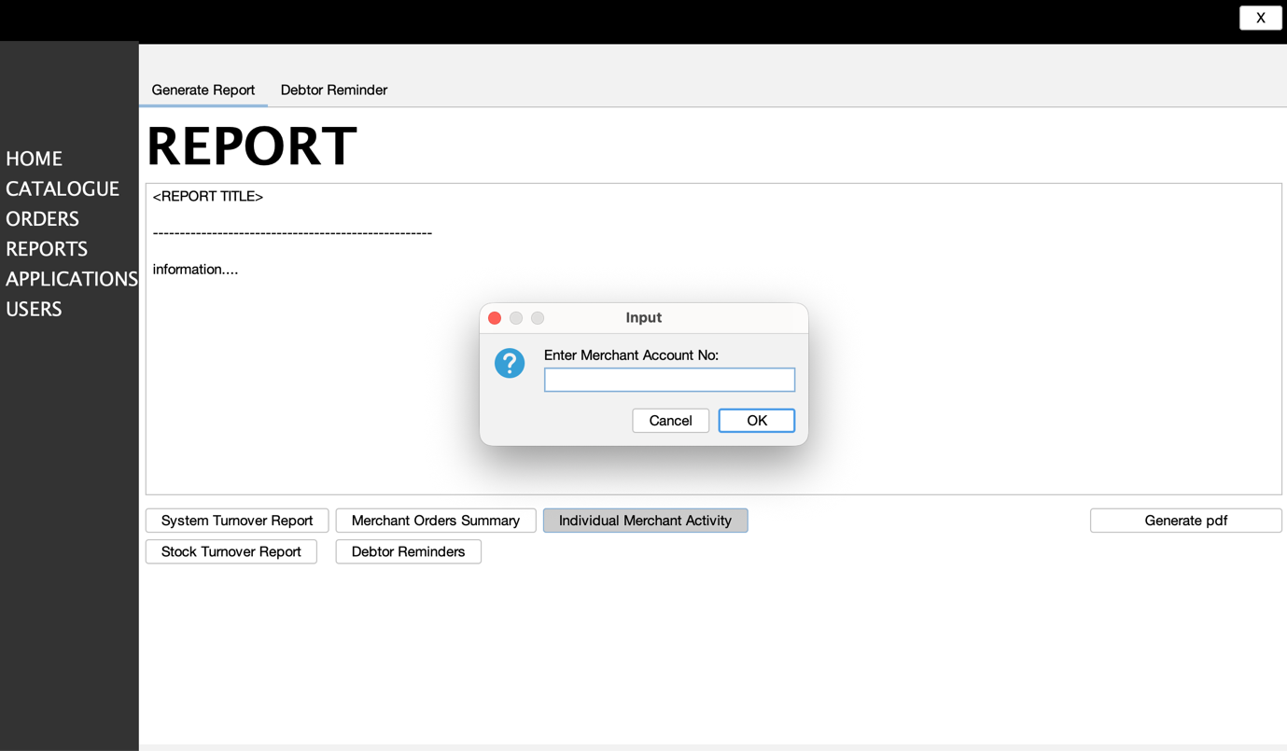

Figure 13. Merchant Orders Summary Input Dialog
This screen shows the input dialog displayed when the user selects Merchant Orders Summary in the Reports module of the IPOS-SA subsystem. The dialog asks the user to enter a merchant account number so that the report can be generated for a specific merchant. If the field is left blank, the system generates the report for all merchants. The OK button confirms the input and starts the report-generation process, while the Cancel button closes the dialog without generating any report. This dialog supports filtered report generation for merchant order summaries within IPOS-SA.

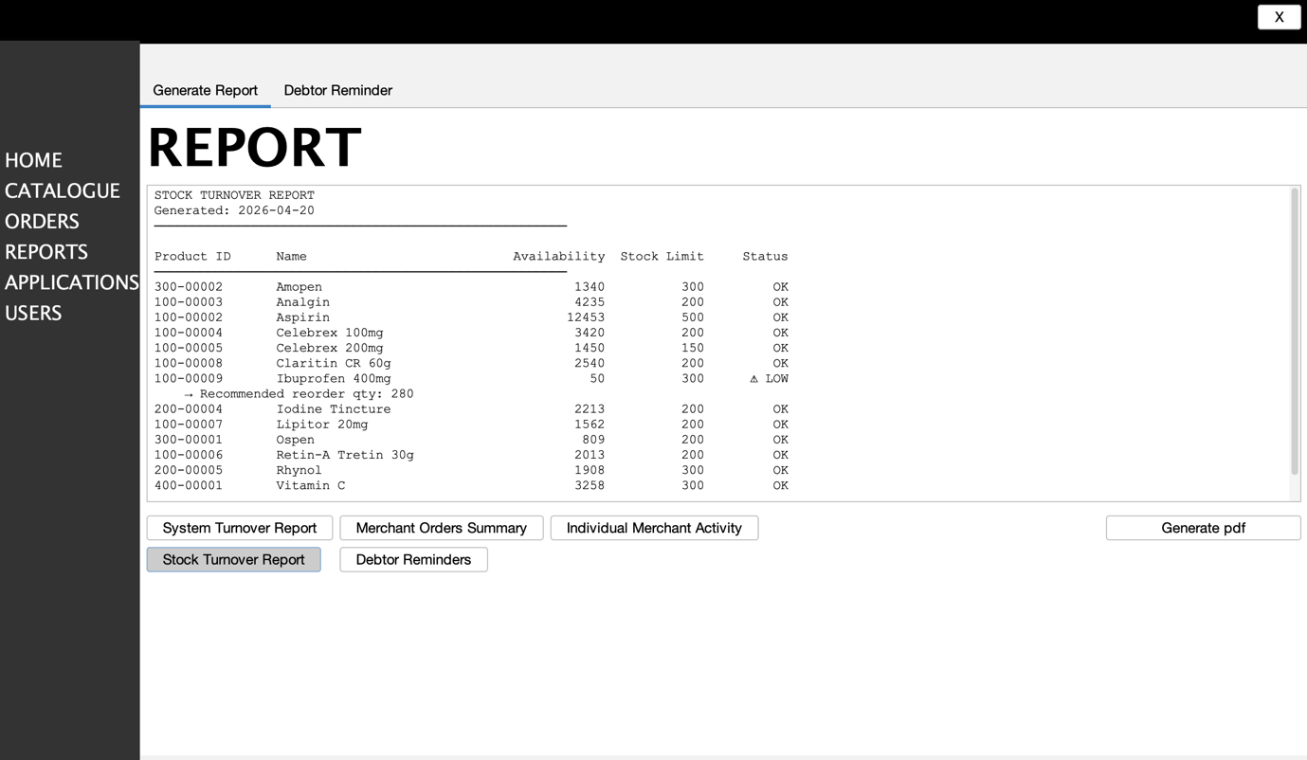
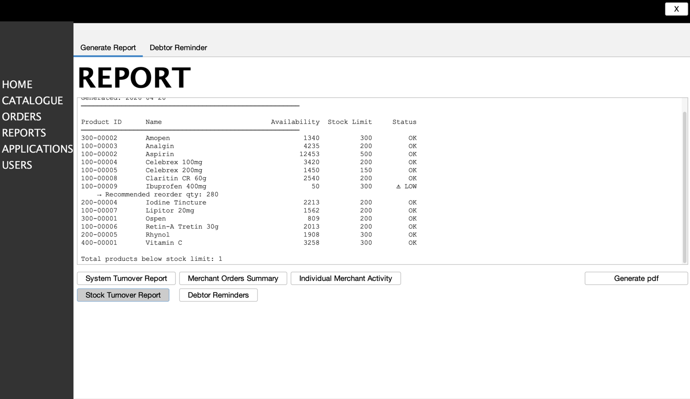

Figure 14. Stock Turnover Report
This screen shows the Stock Turnover Report generated within the Reports module of the IPOS-SA subsystem. The report is produced using data stored in the IPOS-SA database and displays stock-related information for catalogue items, including the product ID, product name, current availability, stock limit and status. Items whose availability falls below the defined stock limit are marked as LOW, allowing authorised users to identify low-stock conditions quickly. In the example shown, Ibuprofen 400mg is flagged as a low-stock item, and the report also provides a recommended reorder quantity together with a summary of the total number of products below stock limit. The Stock Turnover Report button is used to generate this report, and the Generate pdf button allows the displayed output to be exported as a PDF document. This screen supports stock monitoring and replenishment planning within the IPOS-SA subsystem.

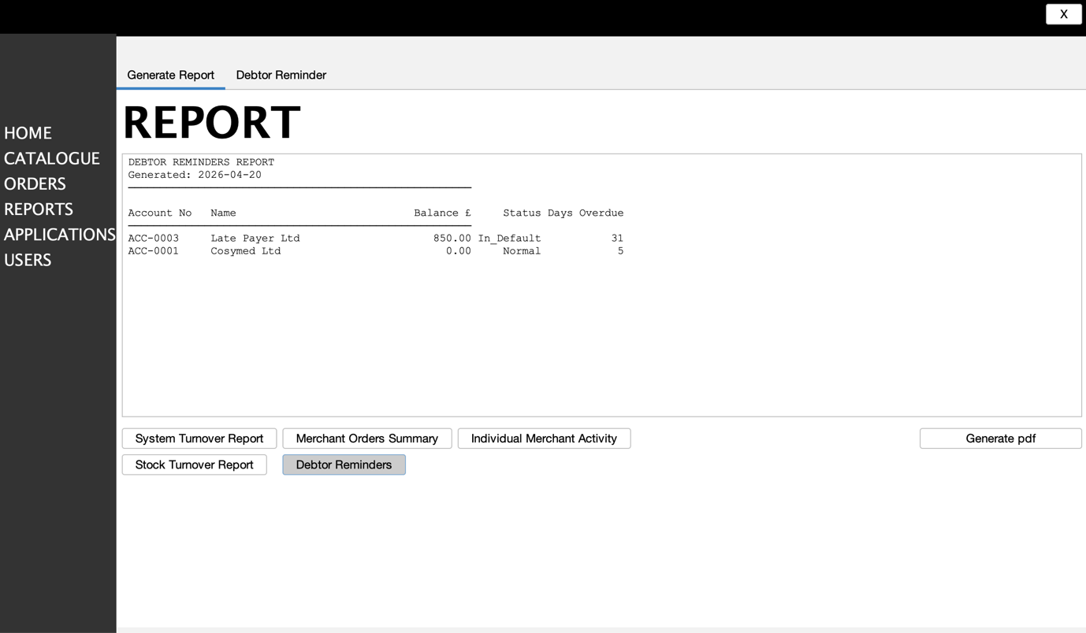

Figure 15. Debtor Reminders Report
This screen shows the Debtor Reminders Report generated within the Reports module of the IPOS-SA subsystem. The report is produced using data stored in the IPOS-SA database and lists merchant accounts together with their outstanding balance, account status, and number of days overdue. In the example shown, the report includes merchants such as Late Payer Ltd and Cosymed Ltd, allowing authorised users to identify overdue accounts and monitor debtor status. The Debtor Reminders button is used to generate this report, and the Generate pdf button allows the displayed output to be exported as a PDF document. This screen supports the overdue-payment monitoring and reminder-related reporting functions required for IPOS-SA.

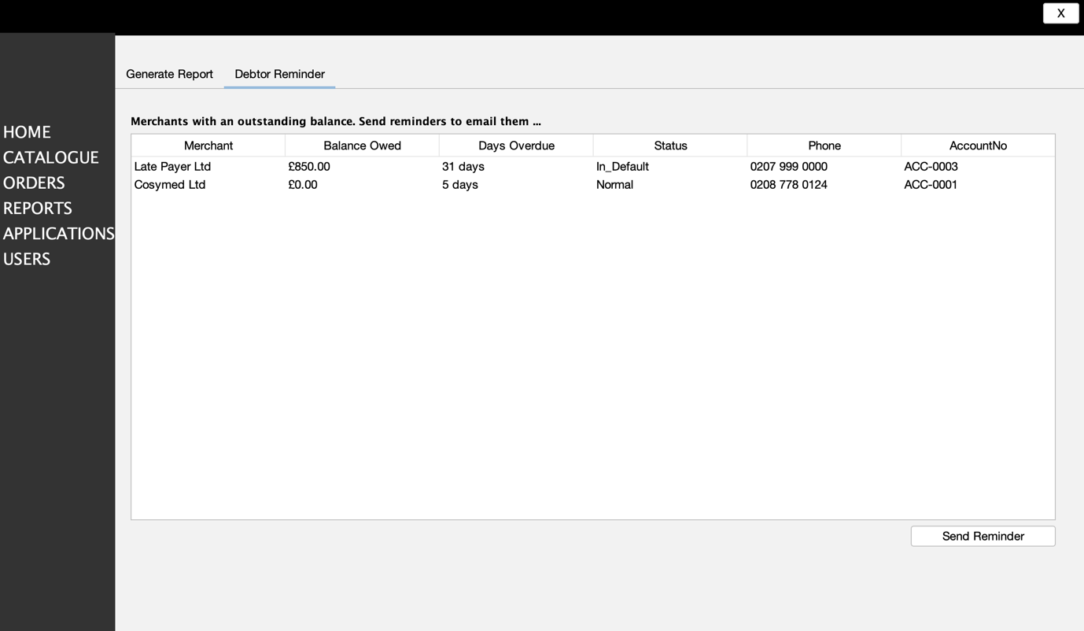

Figure 16. Debtor Reminder Page
This screen shows the Debtor Reminder page within the Reports module of the IPOS-SA subsytem. It allows authorised users to identify merchants with outstanding balances and review reminder-related information stored in the IPOS-SA database. The table displays key details for each listed merchant, including merchant name, balance owed, days overdue, account status, phone number, and account number. In the example shown, merchants such as Late Payer Ltd and Cosymed Ltd are listed with their corresponding overdue and account information. The Send Reminder button is used to send a reminder to the selected merchant, supporting follow-up communication for overdue payments. This page supports debtor monitoring and reminder management within the IPOS-SA subsystem.

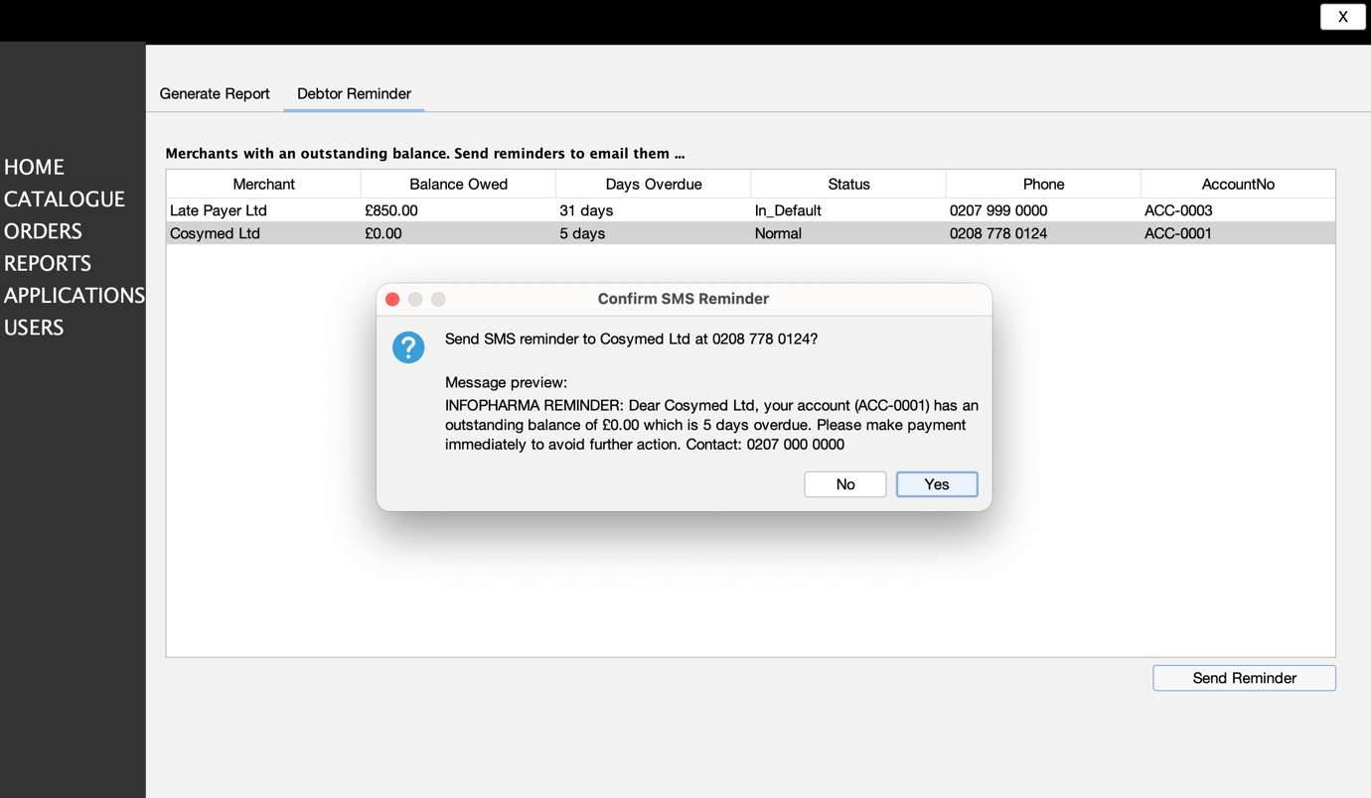
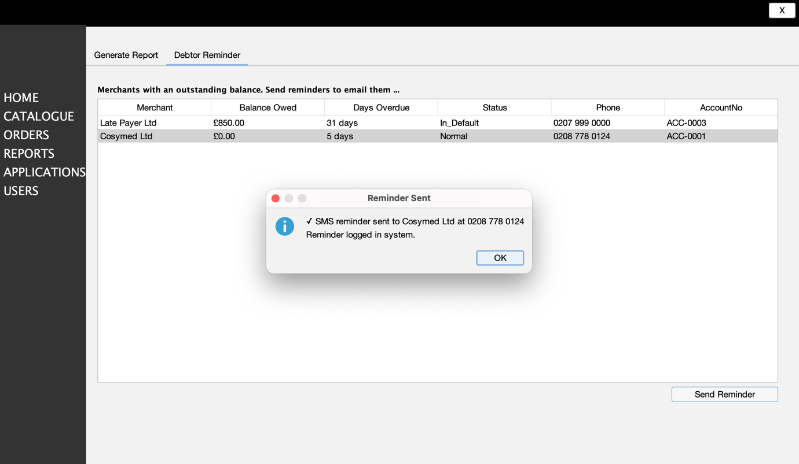

Figure 17. Reminder Confirmation and Reminder Sent Dialogs
These screens show the two message dialogs displayed after the user selects a merchant on the Debtor Reminder page and clicks Send Reminder in the IPOS-SA subsystem. In the first dialog, the system asks the user to confirm whether the SMS reminder should be sent and displays a preview of the reminder message together with the recipient’s phone number. If the user selects Yes, the system sends the reminder to the selected merchant account. If the user selects No, the action is cancelled and no reminder is sent. In the second dialog, the system confirms that the SMS reminder has been sent successfully and that the reminder has been logged in the system. Together, these dialogs support controlled reminder handling, prevent accidential sending, and provide confirmation that the follow-up action for overdue accounts has been completed successfully.

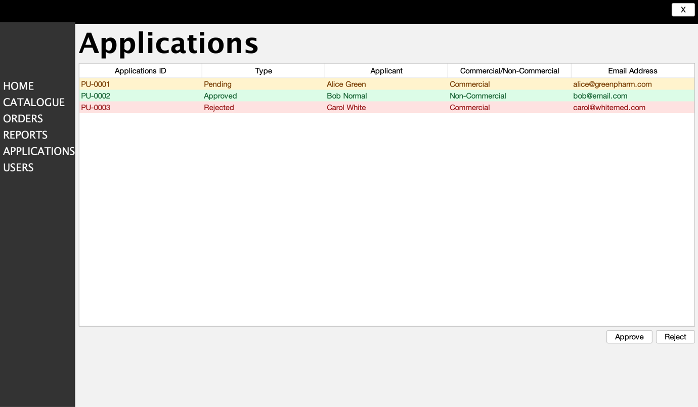

Figure 18. Applications Management Page
This screen shows the Applications page of the IPOS-SA subsystem. It allows authorised users to view and manage membership applications that are submitted through the IPOS-PU public-facing subsystem and then made available in the IPOS-SA database for review and decision-making. The table displays key application details, including the application ID, current status (type), applicant name, application type (commercial or non-commercial), and email address. In the example shown, applications are visually distinguished by status, with entries marked as Pending, Approved, or Rejected. The Approve and Reject buttons are used to update the status of the selected application. This page supports the review and decision-making process for incoming applications before access or further processing is granted within the system.

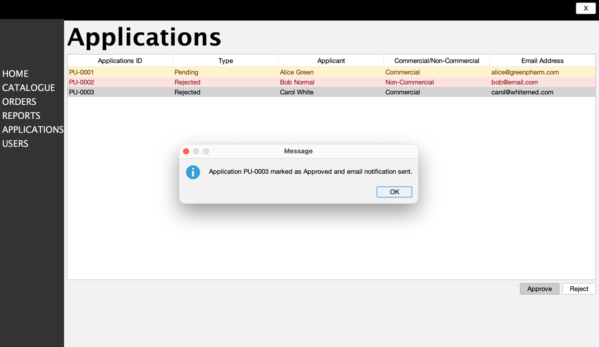
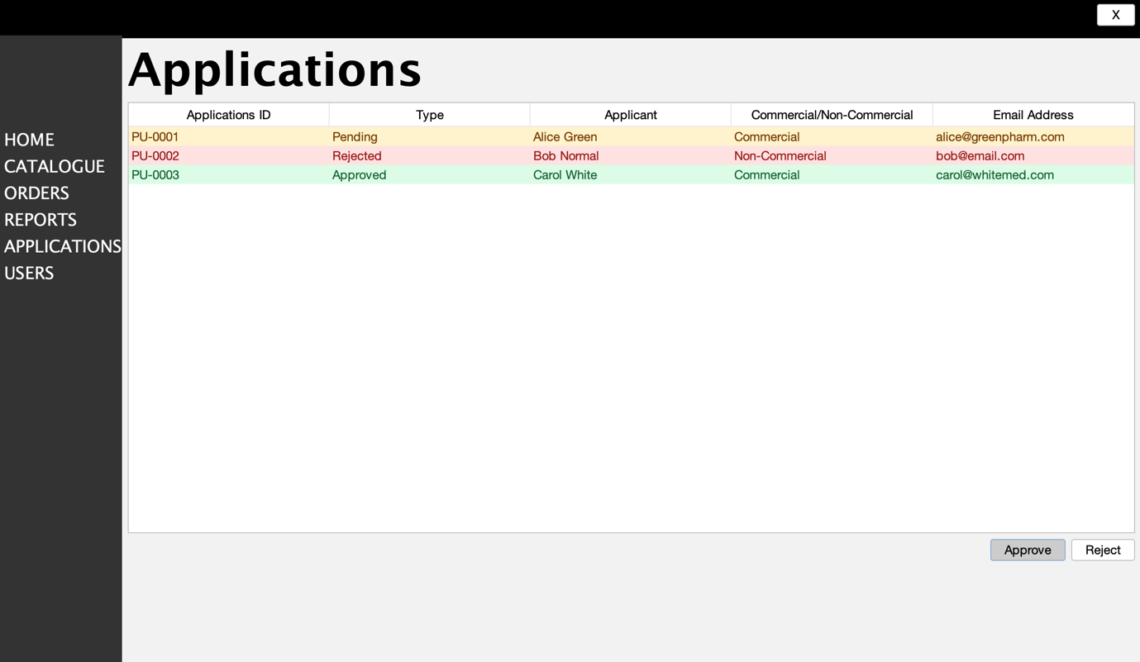

Figure 19. Approved Application Confirmation
These screens show what happens when the user selects an application on the Applications page and clicks Approve in the IPOS-SA subsystem. After the approve action is performed, the system displays a confirmation message stating that the selected application has been marked as Approved and that an email notification has been sent to the applicant. Once the user clicks OK, the application list is refreshed and the selected record appears with its updated Approved status. In the example shown, application PU-0003 changes from Rejected to Approved and is highlighted accordingly in the updated list. This confirms that the application decision has been recorded in IPOS-SA and that the applicant has been notified of the outcome. Since these applications are received from IPOS-PU and then reviewed in IPOS-SA, this page supports the approval workflow between the two subsystems.

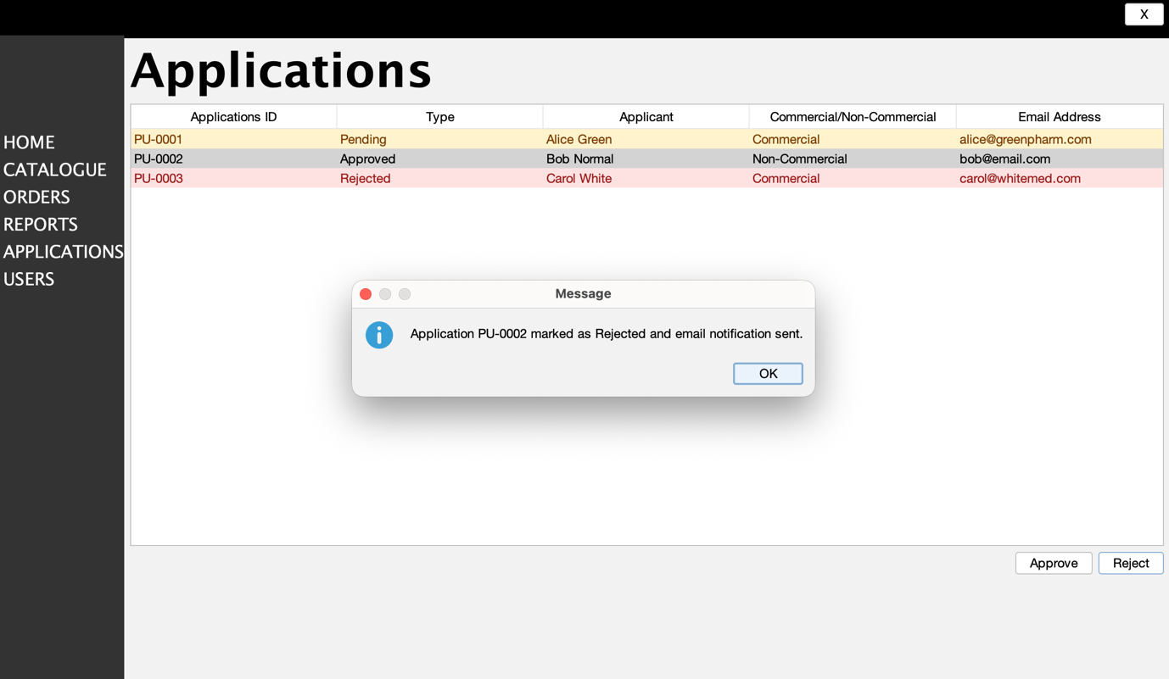
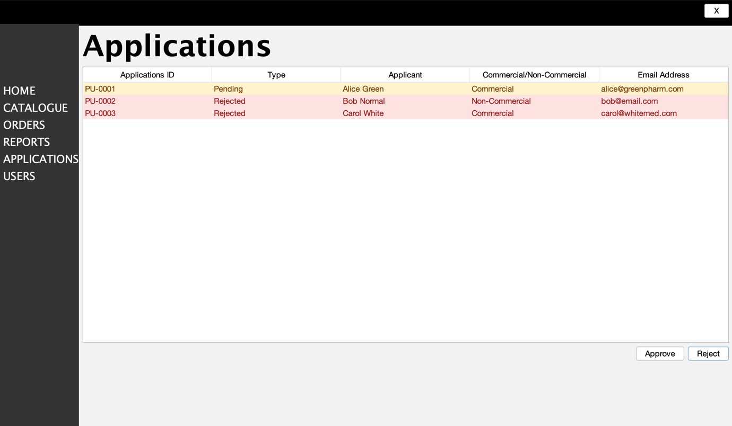

Figure 20. Rejected Application Confirmation
These screens show what happens when the user selects an application on the Applications page and clicks Reject in the IPOS-SA subsystem. After the reject action is performed, the system displays a confirmation message stating that the selected application has been marked as Rejected and that an email notification has been sent to the applicant. Once the user clicks OK, the application list is refreshed and the selected record appears with its updated Rejected status. This confirms that the application decision has been recorded in IPOS-SA and that the applicant has been notified of the outcome. Since these applications are received from IPOS-PU and then reviewed in IPOS-SA, this page supports the administrative review and rejection workflow between the two subsystems.

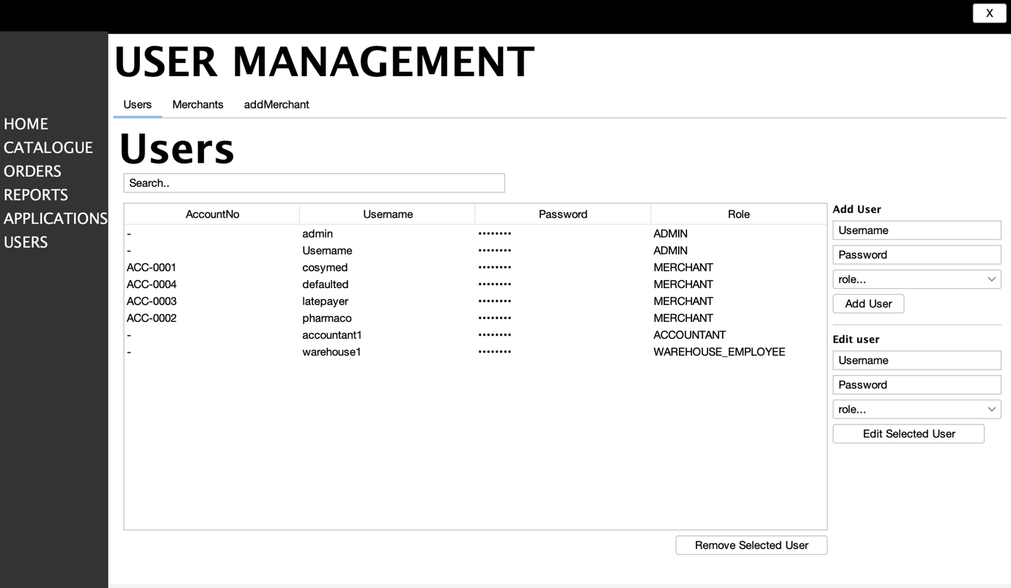

Figure 21. User Management Page
This screen shows the User Management page of the IPOS-SA subsystem. It allows authorised users to view and manage system accounts stored in the IPOS-SA database. The main table displays key account information, including the account number, username, masked password, and assigned role. The Search bar is used to quickly locate a specific account in the list. The Users, Merchants, and addMerchant tabs provide access to different account-management views and functions. On the right-hand side, the Add User section allows a new account to be created by entering a username, password, and selecting a role from the drop-down menu. In the example shown, the available roles for adding a user include admin and manager. The Add User button stores the new account in the system.
The Edit user section is used to update an existing account. The user can enter a new username, password, and choose an updated role from the drop-down list, then click the Edit Selected User to apply the changes to the highlighted record. In the example shown, the available roles for editing include admin, manager, senior accountant, accountant, warehouse employee, and delivery department employee. The Remove Selected User button deletes the highlighted account from the system. Overall, this page supports role-based user administration within the IPOS-SA subsystem.

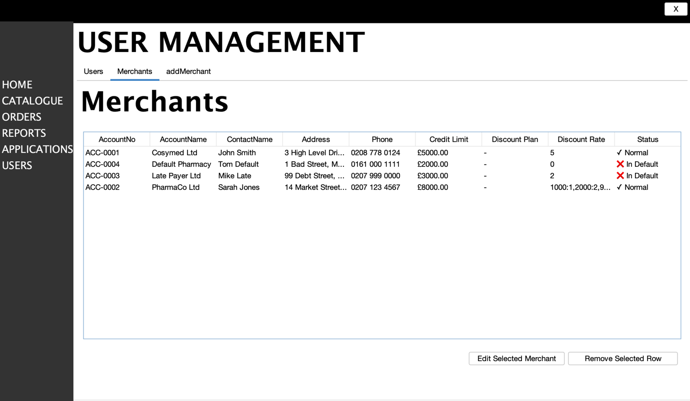

Figure 22. Merchants Management Page
This screen shows the Merchants page of the IPOS-SA subsystem, accessed through the User Management module. It is used to display and manage merchant account records held in the IPOS-SA database. The table presents detailed information for each merchant, including the merchant account number, account name, contact name, address, phone number, credit limit, discount plan, discount rate, and current account status. This allows authorised users to review both the business and financial profile of each registered merchant in a single view. The page also makes it easier to monitor account conditions such as whether a merchant is in a Normal state or marked as In Default, which is important for enforcing payment and account control rules. The Edit Selected Merchant button allows the selected merchant’s details to be modified, while Remove Selected Row removes the selected record from the list. Overall, this page supports the management of merchant accounts, including contact details, credit limits, discount configurations, and account status, which are required functions of the IPOS-SA subsystem.

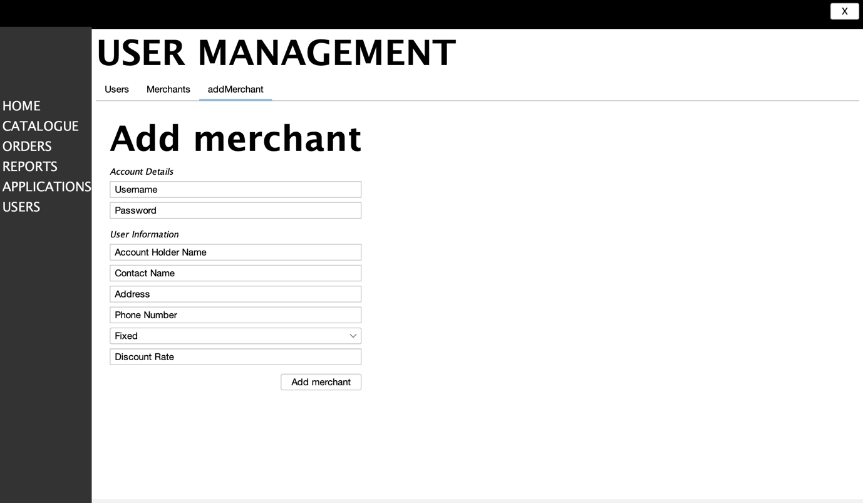

Figure 23. Add Merchant Page
This screen shows the Add Merchant page within the User Management module of the IPOS-SA subsystem. It allows authorised users to create a new merchant account by entering both account details and merchant profile information. The Account Details section is used to define the merchant’s login credentials, including username and password, while the User Information section captures the merchant’s business and contact data, such as account holder name, contact name, address, and phone number. The page also allows the user to select a discount plan type, either Fixed or Flexible, and enter the corresponding discount rate. A Fixed plan applies the same discount rate to all orders, while a Flexible plan allows the discount to vary depending on order value or agreed thresholds. Once all required fields have been completed, the Add merchant button is used to store the new merchant record in the IPOS-SA database. This page supports the creation of merchant accounts and the initial configuration of merchant information within the subsystem.

