Application Design Document

This is the application design document for ISAD251. This has been created by Samuel Jordan ID: 10611160.

This is the planning and creation of the pub application, which was made to be able to function as a fully working ordering system. The requirements of this task are as follows.

1. As a customer I wish to order a drink/snack.

2. As a customer I wish to see what I have ordered.

3. As a customer I wish to add to my current order for a drink/snack.

4. As a customer I wish to cancel my order for a drink/snack.

5. As the admin I wish to enter details of the drinks/snacks I have for sale.

6. As the admin I wish to read the details of the drinks/snacks I have for sale.

7. As the admin I wish to view a customer’s order(s).

8. As the admin I wish to edit the details of the drinks/snacks I have for sale.

9. As the admin I wish to withdraw a drink/snack from sale.

# Storyboard

Here is the storyboard for the customer

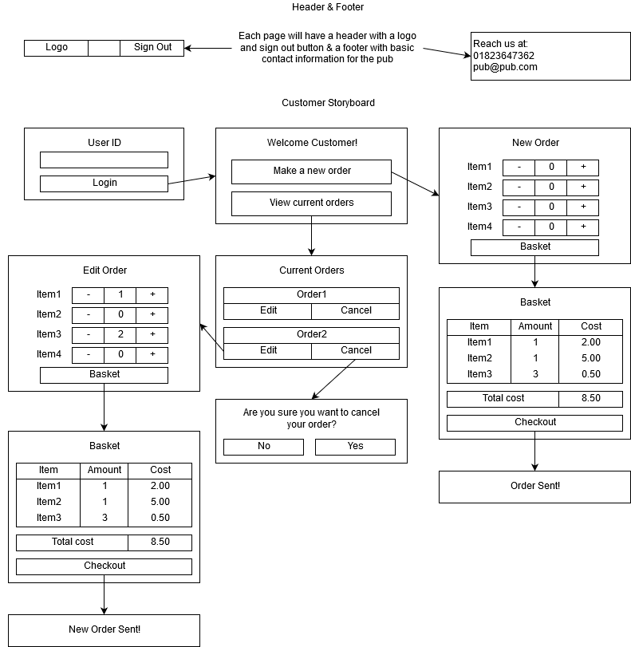

Here is the storyboard for the admin

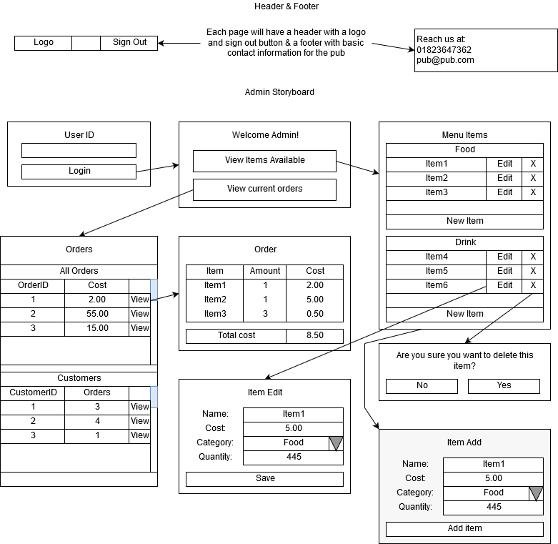

# Entity Relationship Diagram

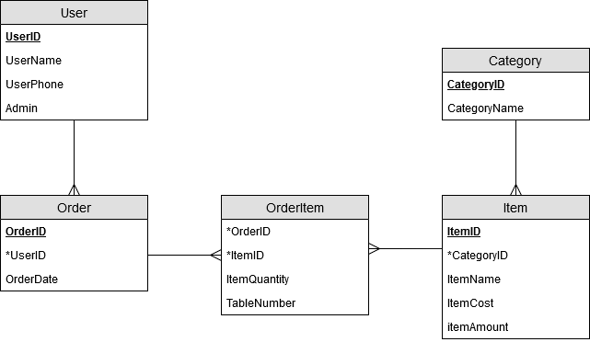

# UML

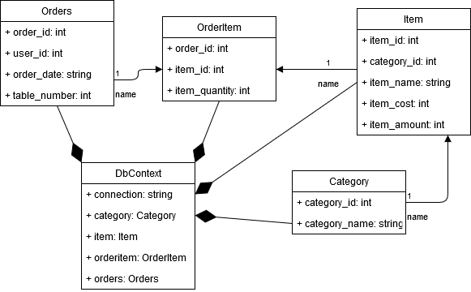

# Images Used

I used one image within my application, which I created myself within paint. This was the logo for the pub application which was placed in the header of each page.



# WAI Testing

Here are the results that i got from <https://webaccessibility.com> after i had put in the URL for the site.

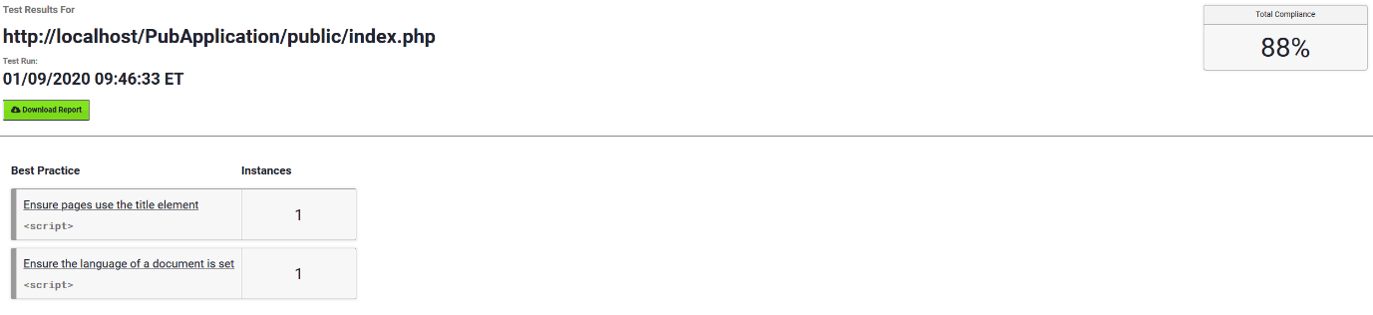

# Feedback

Here is the feedback that I got when I showed another person my application:

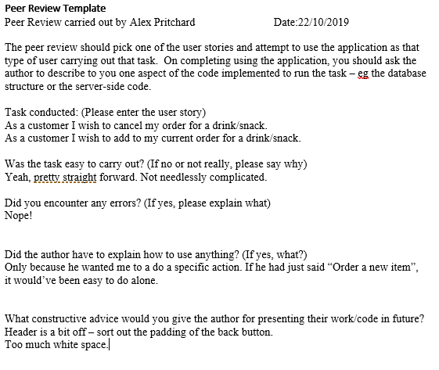

From this feedback, I changed the header, having to add a CSS file to be able to fix the problem of it not aligning properly. I also made the buttons for the main pages a bit bigger, so that there would hopefully be less white space on the page.

If I had more time there is a couple things I would do. The first I would use a template, rather than just using bootstrap, as it looks very bare, and as the feedback suggests, there is a lot of white space, so using a template would hopefully help with that. Another thing I would do is add more validation to the users inputs. I tried to use prepopulated drop down inputs wherever I could to minimize problems, but if I could have, I would like to have added more validation on the inputs.

# URLS

Hosted webpage URL: <http://web.socem.plymouth.ac.uk/ISAD251/sjordan3/pubapplication/public/login.php>

This is where the application starts and from here you can complete the specified requirements.

API Middleware URL: <http://web.socem.plymouth.ac.uk/ISAD251/sjordan3/pubapplication/src/api/orders/index.php>

Github Repository URL: <https://github.com/SamuelJordan101/ISAD251>