**Final Exam**

**Programming Fundamentals (CS-130-02)**

**Fall 2022 Total=100 points (3hr)**

**Name: Sam Kauffman**

**Question 1 to 28 multiple choices, highlight with green color also type the answer. (30 points)**

**Question 29-32 descriptive answers with examples (4*5 points)**

**Question 33-39 programming (50 points)**

1. Random generator = new Random();

**int randNum = generator.nextInt(10) + 4;**

Which of the following will be true after these lines are executed?

1. randNum will hold a number between 4 and 10 inclusive.
2. randNum will hold a number between 4 and 14 inclusive.
3. randNum will hold a number between 4 and 13 inclusive.
4. these lines will not be executed because a compiler error will result.
5. none of the above

**Answer: B**

1. **Suppose we want to write an if statement to test whether two String objects, referenced by stringOne and stringTwo, are the same. Which of the following is the correct way to achieve this?**
2. if(stringOne == stringTwo)
3. if(stringOne.equals(stringTwo))
4. if(stringOne != stringTwo)
5. if(stringOne === stringTwo)

**Answer: A**

1. **Which of the following best describes this code snippet?**

**if (count != 400)**

**System.out.println("Hello World!");**

1. If the variable count is not equal to 400, "Hello World" will be printed.
2. If the variable count is close to, but not greater than, 400, "Hello World" will be printed.
3. If the variable count is exactly equal to 399 or 401, "Hello World" will be printed.
4. If the variable count is exactly equal to 400, "Hello World" will be printed.
5. This code will not be compiled.

**Answer: A**

1. **Let a and b be valid boolean expressions. Which of the following best describes the result of the expression a || b?**
2. It will evaluate to true if a evaluates to true and b evaluates to true. It will evaluate to false otherwise.
3. It will evaluate to false if a evaluates to false and b evaluates to false. It will evaluate to true otherwise.
4. It will evaluate to true if a evaluates to false and b evaluates to false. It will evaluate to true otherwise.
5. It will evaluate to true if a evaluates to false or b evaluates to false. It will evaluate to true otherwise.

**Answer: A**

1. **Which of the following expressions best represents the condition "if the grade is between 85 and 90"?**
2. if (85 < grade || grade < 90)
3. if (85 > grade || grade < 90)
4. if (85 < grade < 90)
5. if (85 < grade && grade < 90)

**Answer: D**

1. **What is a java keyword used in switch statements that causes immediate exit or that terminates the switch statement?**

A. The case keyword.

B. The switch keyword.

C. The default keyword.

D. The break keyword

**Answer: D**

1. **Which of the following expressions correctly computes the value of the mathematical expression 5 + 27?**
2. result = 5 + 2*Math.exponent(7);
3. result = 5 + Math.pow(2, 7);
4. result = 5 + 2*exponent(7);
5. result = 5 + 2^7;

**Answer: B**

1. **In Java, array indexes always begin at ________________ .**
2. 2
3. 0
4. 1
5. -1

**Answer: B**

1. String word = "Keep Trying";

What is **word.length()?**

1. 11
2. 10
3. 12
4. 13

**Answer: A**

1. String word = "Keep Trying";

What is **word.substring(3,6)?**

1. p Try
2. ep Tr
3. p T
4. p Tr

**Answer: D**

1. **What package contains the Math class?**
2. Java.io
3. Java.util
4. Java.lang
5. Java.text

**Answer: C**

1. What is the output?

**do {**

**System.out.println("ExamDay");**

**}while (true);**

1. ExamDay ExamDay ExamDay
2. ExamDay
3. compile error
4. infinite loop ExamDay

**Answer: D**

1. What would be output by the following program segment?

**String n1 = "Monday";**

**String n2 = "Tuesday";**

**System.out.print(n1.compareTo(n2));**

1. 7
2. -7
3. 8
4. -8

**Answer: C**

1. **What package contains the Random class?**
2. Java.io
3. Java.util
4. Java.lang
5. Java.text

**Answer: B**

1. **what is the output?**

**do {**

**System.out.println("Thursday");**

**}while (false);**

1. Thursday Thursday Thursday
2. Thursday
3. compile error
4. infinite loop Thursday

**Answer: C**

1. **Which of the following lines is a properly formatted comment in Java?** 
   1. // This is a comment
   2. /* This is a comment */
   3. #This is a comment
   4. Both a and b

**Answer: D**

1. **A cast is indicated with the following syntax in Java.** 
   1. result = [int] total / count;
   2. result = (int) total / count;
   3. result = “int” total / count;
   4. result = {int} total / count;

**Answer: A**

1. **For a program to run on a computer, it must be expressed in ______________.** 
   1. an assembly language
   2. a machine language
   3. a high-level language
   4. an object-oriented language

**Answer: B**

1. **Which of the following data conversions could result in data loss?** 
   1. long to float
   2. short to long
   3. double to float
   4. int to long

**Answer: A**

1. **Which of the following is a correct declaration of enumerated type for the suits of a deck of cards?**
2. enumerated type Suit = { hearts, spades, diamonds, clubs };
3. enum Suit {hearts, spades, diamonds, clubs;}
4. enumerated type Suit = (hearts, spades, diamonds, clubs );
5. enum Suit (hearts, spades, diamonds, clubs );

**Answer: B**

1. **What is a part of a switch statement that will execute if there are no values that matched the given choices?**
   1. case
   2. break
   3. default
   4. None of the above

**Answer: C**

1. **How do you write Conditional AND operators in Java?**
2. &
3. and
4. &&
5. ||

**Answer: C**

1. **Decide if the Boolean expression evaluates to true or false. Given:**

**a = 1, b = 1, c = 3**

**a != b**

1. true
2. false

**Answer: B**

1. **You can have other if-else inside another if-else block**
2. if-else statement
3. else-if statement
4. nested if-else blocks
5. if-statement

**Answer: C**

1. **For the array:**

**int stats[4];**

**What is the range of the index?**

1. 0 to 4
2. 0 to 3
3. 1 to 4
4. 1 to 3

**Answer: B**

1. **double [] average = new double [10];**

**average[10] = 15.25;**

1. A cast is required
2. data not initialized
3. A two-dimensional array is required
4. Array Out-of-bounds error

**Answer: D**

1. **An array uses ____________ indexing to keep track of each memory allocation unit in the array.**
   1. one-based
   2. zero-based
   3. 10-based
   4. 100-based

**Answer: B**

1. **int [ ] numbers= { 1, 2, 5, 10, 15, 20, 25, 35, 45};**

If it does not have a definite answer, write down the reason.

1. **What is the value of numbers.length? _____9_____**
2. **What is the value of numbers [ 4]? ______15_____**
3. **What is the value of numbers [ 6]?**  _____25_____

…………………………………………………………………………………………….

1. **In your words explain what a Looping structure with suitable example.**

It is a loop that preforms an action over and over again as long as your condition remains true.

1. **In your own words, explain how the break and continue statement is used in control structure.**

Break is used to stop the program. Continue is used to keep the program going.

1. **In your own words, explain the difference between public and private access modifiers.**

In a public modifier you can access it anywhere. In a private, you can only access it in its own class.

1. **Explain the methods of an array list using suitable examples : addAll, contains**

Add all adds all elements to a specific list.

…………………………………………………………………………………………………………………

Programming Questions: Use Eclipse to work on the following questions. Create the class name as Question33, Question 34…**Take a snippet of the code and the output and paste it after each question**. Upload your code on a GitHub new repository called **Exam22** and add the link along with this document (**Convert it to PDF**) on Moodle.

1. **Write a while loop that prints “I love ExamDay!" 10 times. 6 points**

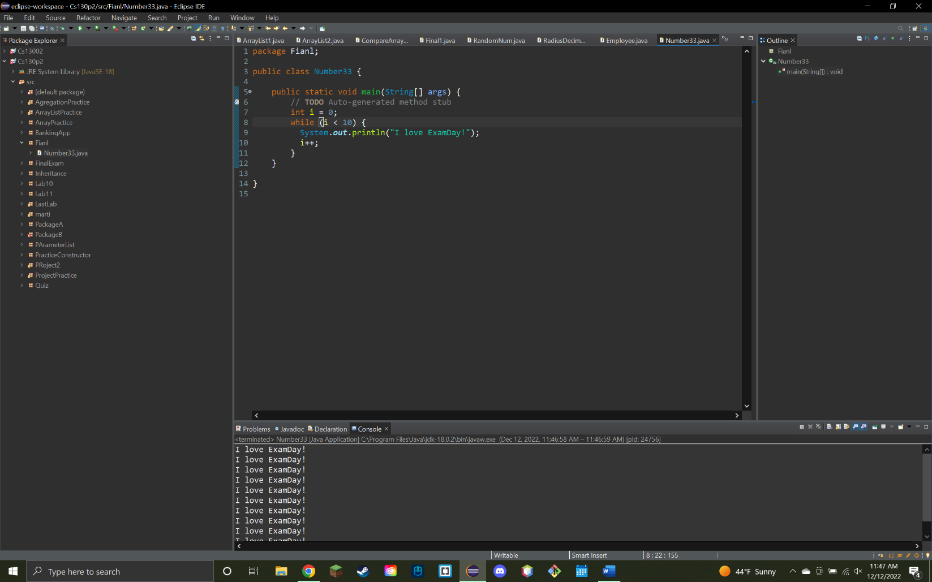

1. Write an application that will prompt the user for a double-floating point number and that prints the **square of that number**. Sample output would be:

Write down formatted output about two decimal places using **Decimal Format.**

**Enter a double-floating point number: 5.23**

**The result is : 2.2869**

**The formatted result is :2.29 6 points**

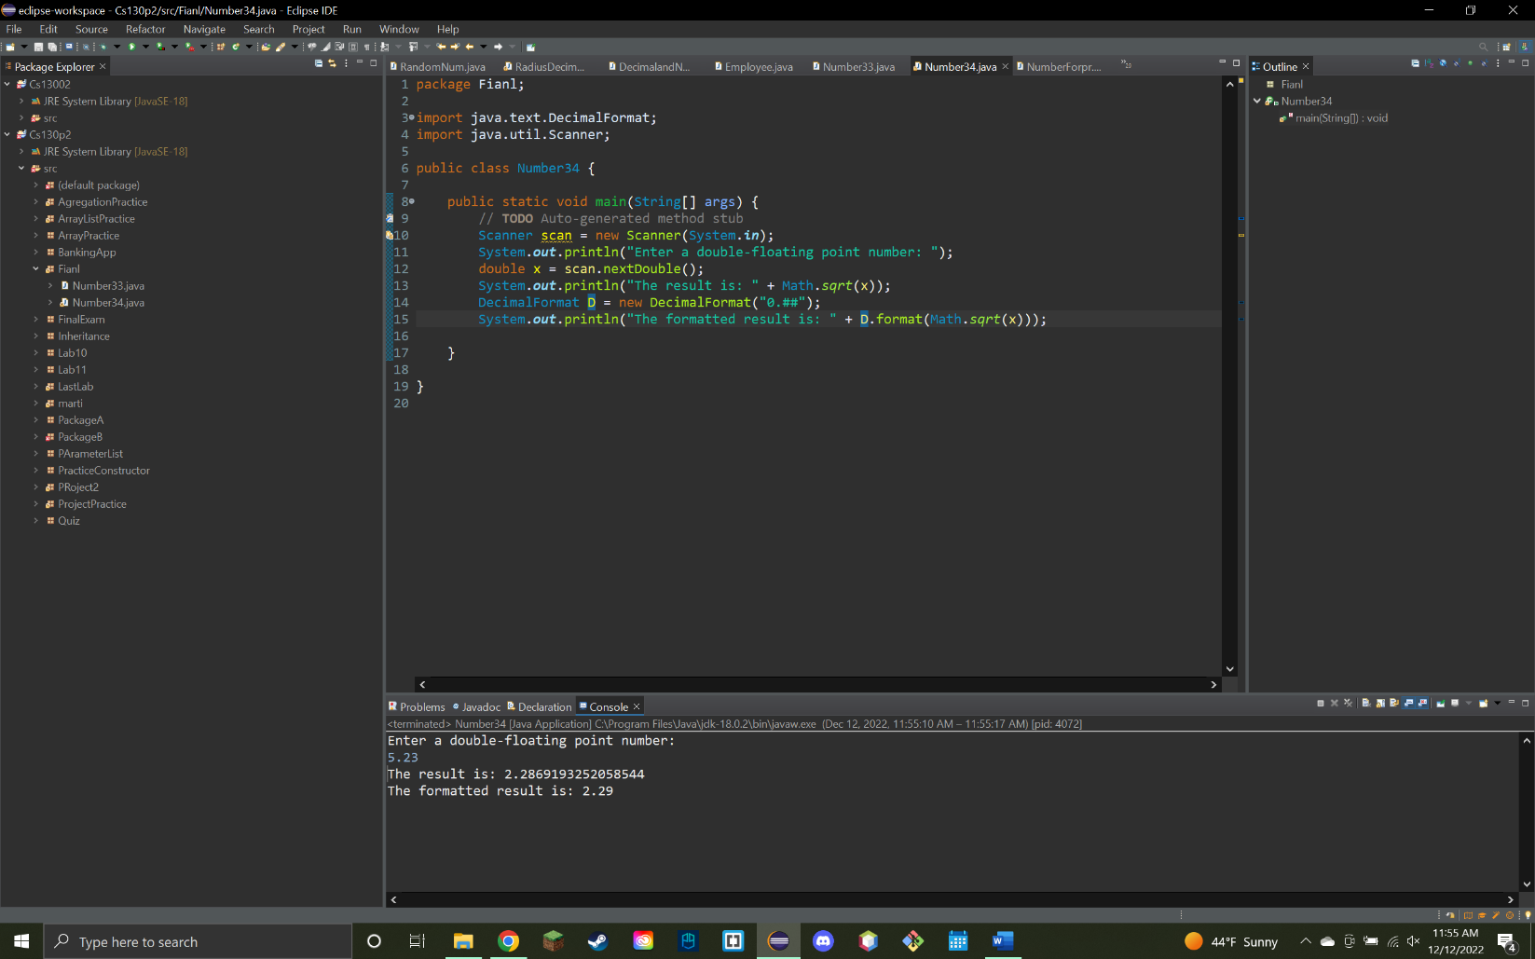

1. In the United States as of 1995, minor is generally legally defined as a person under the age of 18. Write a code to check if a student is **a minor or not**. Verify the code by two user input**. 6 points**

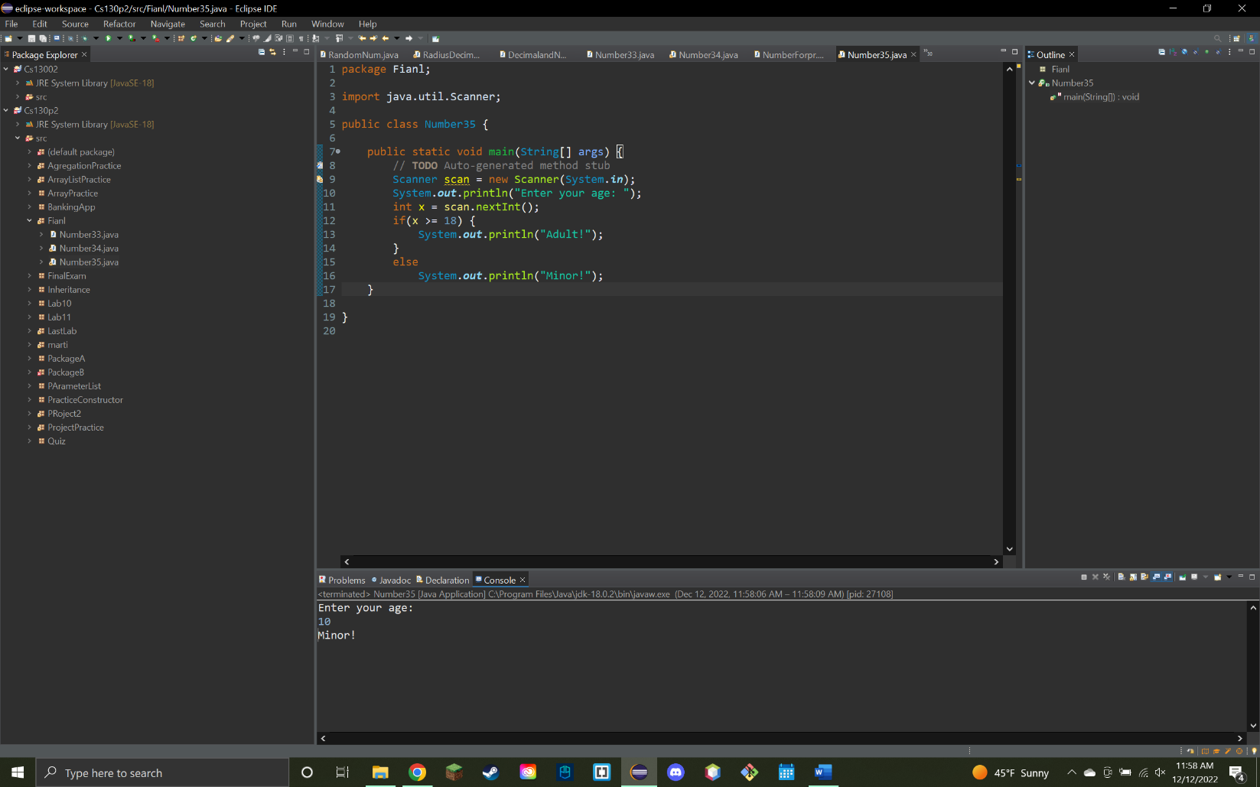

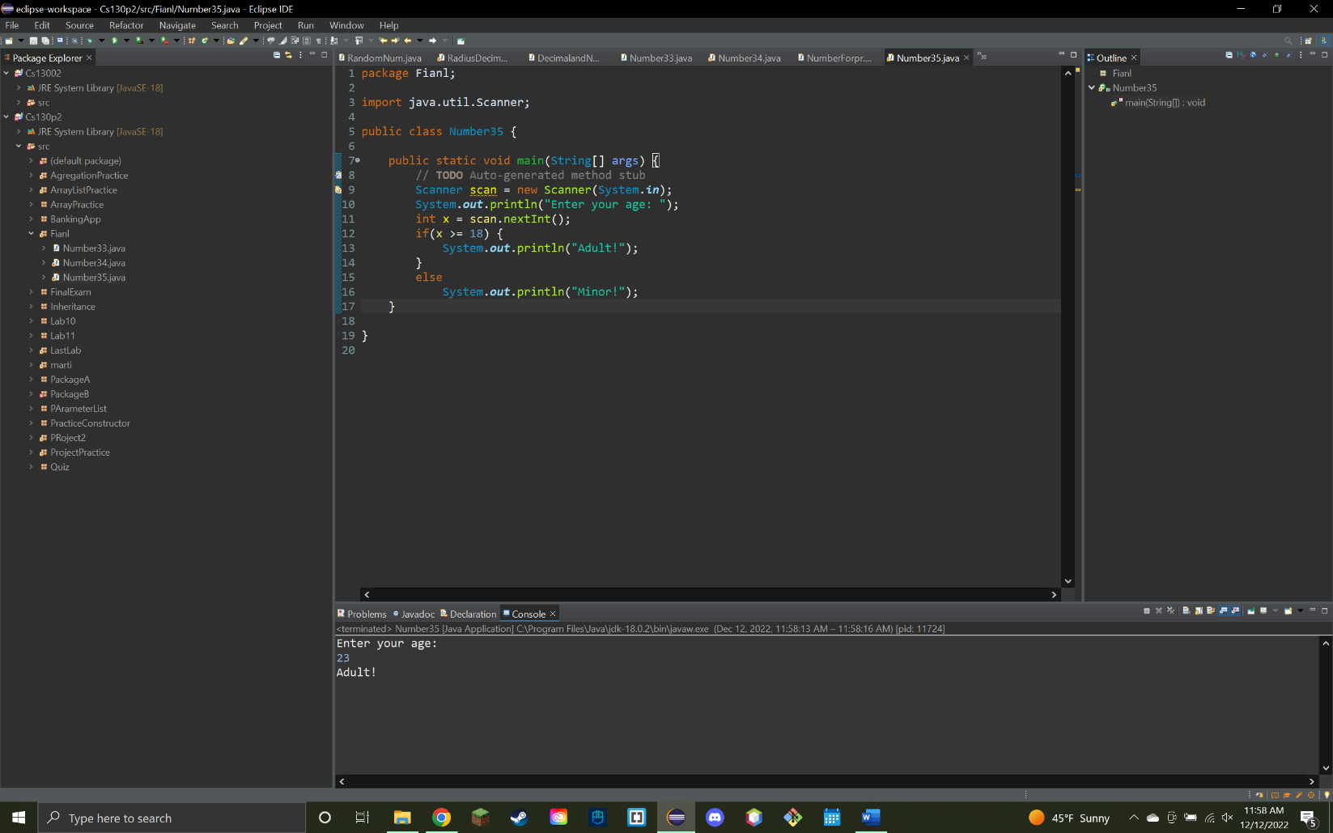

1. **Write a program that prompts the user for a workday number. Then, based on the number it classifies the working days (M-F) of a week.** The week starts on Monday. **If the day number doesn't start with any of those case numbers, then you print “Holiday”.** Below is a list of the classifications and sample run: Use Switch Case statements.

1 - Monday  
2 – Tuesday

…  
Anything else - Holiday **6 points**

1. Get an input from user and check whether the number is **odd and greater than 10**. If not, then print relevant comments. **6 points**

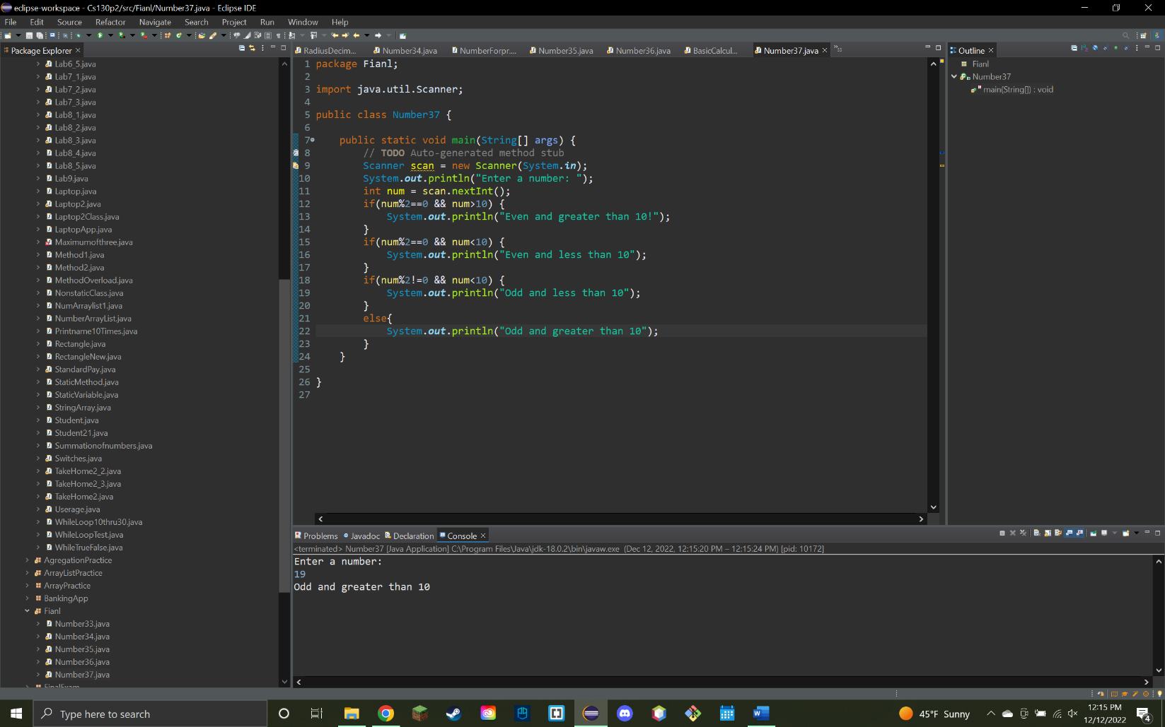

1. Create a **Integer Array List and add 10 random numbers** into it.
2. Use **random number generator** to generate those random numbers of a **range of 30.**
3. Print **each of the array list element along with its index using loop structure**. **5+5 points**

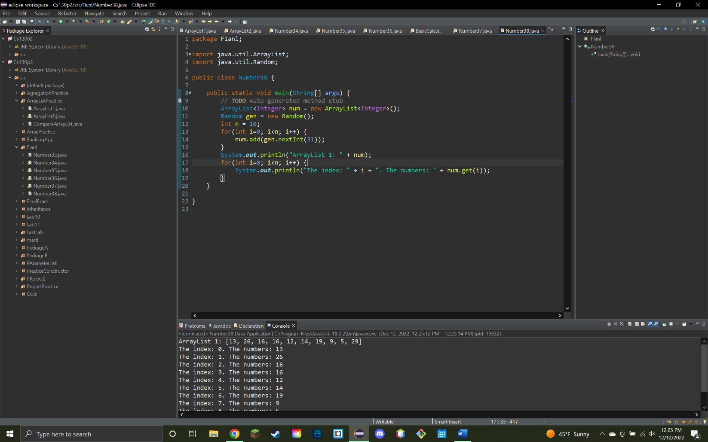

1. **Write a program to print the area and perimeter of a rectangle by creating a class named 'Rectangle'. Use a single class for this code.**
2. Create a class called Rectangle.
3. Pass two private parameters height, width
4. Create methods called areaRec(), and periRec()
5. Find the area and perimeter for height 10, width 20 **5+5 points**

