**Lab 11:**

**Programming Fundamentals CS130 Total=100**

Open Eclipse IDE and create a new class for each of the following questions: Choose class name that most appropriately defining the problem. Take a print screen of the code with console output.

1. What is Inheritance in Java? How to use Inheritance in Java? It takes information from one class to other classes.
2. What is the difference between Inheritance and Encapsulation? Inheritance is when a child class inherits from a bigger class. Encapsulation is when one class cannot have access because of private data.
3. What is Aggregation ans how it is different from from Inheritance? It is when one class has a refrence to another.
4. Implement the following UML disgram and display the student and department informations.

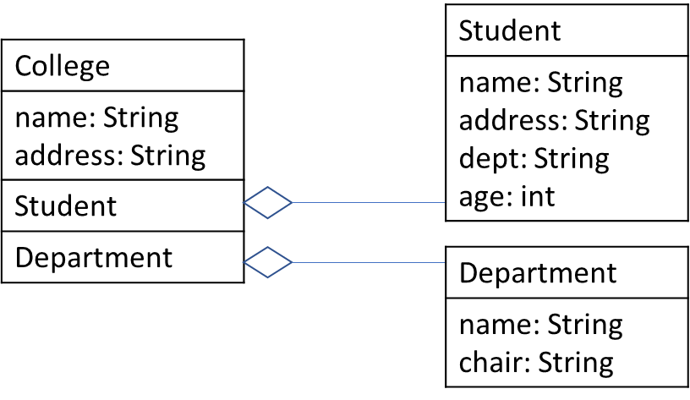

1. Implement the following UML disgram and display the Author and Book informations.

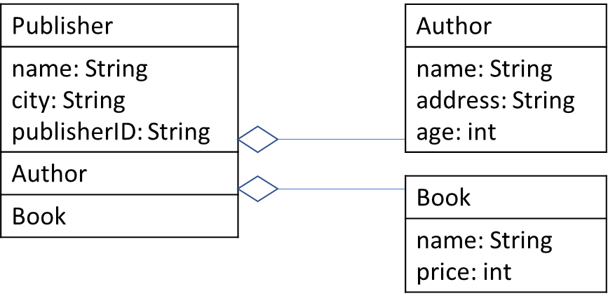

1. When classes extend the properties of each other level by level is known as multilevel inheritance. For instance, class Z extends Y and class Y extends X. Implement the multilevel inheritance and print all of the information. All of the methods are here void so it will return some meaningful information about the watch.

