**Lab 4**

**Programming Fundamentals (CS-130)**

**CS 130-02 Fall 2022 Total=100**

1. Select the best possible answer and write it down:
2. **Which assignment statement declares 32 bits?**
3. Int
4. float
5. double
6. short
7. long
8. **Which assignment statement declares 8 bits?**
   1. int
   2. float
   3. double
   4. short
   5. long
   6. Byte
9. **Which of these statements declares a constant in Java?**
   1. final
   2. const
   3. void
   4. static
10. **Which statement is correct for importing the Scanner class?**
    1. import java.util.Scanner;
    2. import java.util.scanner;
    3. import scanner;
    4. import java.lang.Scanner;
11. **Which of the following lines is a properly formatted comment in Java?**
    1. // This is a comment
    2. /* This is a comment */
    3. #This is a comment
    4. Both a and b
12. **Java is _____________________ language.**
    1. functional
    2. object-oriented
    3. scripting
13. **Which of the following is an example of an invalid assignment or declaration statement?**
    1. int age = 30;
    2. int money, dollars = 0, cents = 0;
    3. int years = 1; months = 12; days = 365;
    4. int length, meters, centimeters, millimeters;
    5. none of the above
14. **Java has two basic kinds of numeric values: _____________, which have no fractional part, and ___________________ which do.**
    1. shorts, longs
    2. doubles, floating points
    3. characters, bytes
    4. integers, floating points
    5. integers, longs
15. **A syntax error is a _____________________.**
    1. a logical error
    2. a compile-time error
    3. a run-time error
    4. a bug
    5. an exception
16. **Which of the following will is considered a logical error?**
    1. forgetting a semicolon at the end of a programming statement
    2. typing a curly bracket when you should have typed a parenthesis
    3. multiplying two numbers when you meant to add them
    4. dividing by zero
    5. misspelling an identifier
17. **The Java compiler translates Java source code into _____________ .**
    1. Java bytecode
    2. C++
    3. assembly code
    4. machine code
    5. an object-oriented language
18. **To assign a value stored in a double variable to an int variable, use**
    1. a cast operator
    2. promotion
    3. a print statements
    4. a widening conversion
    5. nothing. Java will do this automatically
19. **Which of the following data types only allows one of two possible values to be assigned?**
    1. char
    2. int
    3. boolean
    4. float
    5. long
20. **user types the number -12.6 in response to a prompt in a program.  Which Scanner class method should be used to read the user input as a numeric value?**
    1. nextInt()
    2. nextDouble()
    3. nextLine ()
    4. next()
    5. any of these methods would work
21. **Consider the following snippet of code:**

**System.out.println("30 plus 25 is " + 30 + 25);**

**What is printed by this line?**

1. plus 25 is 55
2. 30 plus 25 is 30
3. 30 plus 25 is 55
4. 30 plus 25 is 3025
5. this snippet of code will result in a compiler error

………………………………………………………………………………………………………

1. **Working with arrays at eclipse, create a new class called weight:**

0 1 2 3 4 5 6 7 8 9

**weight**

1. Print (weight of the fifth person): 67
2. Change and Print weight of the third person: 200
3. Change and Print weight of the eighth person: 120
4. Print length of array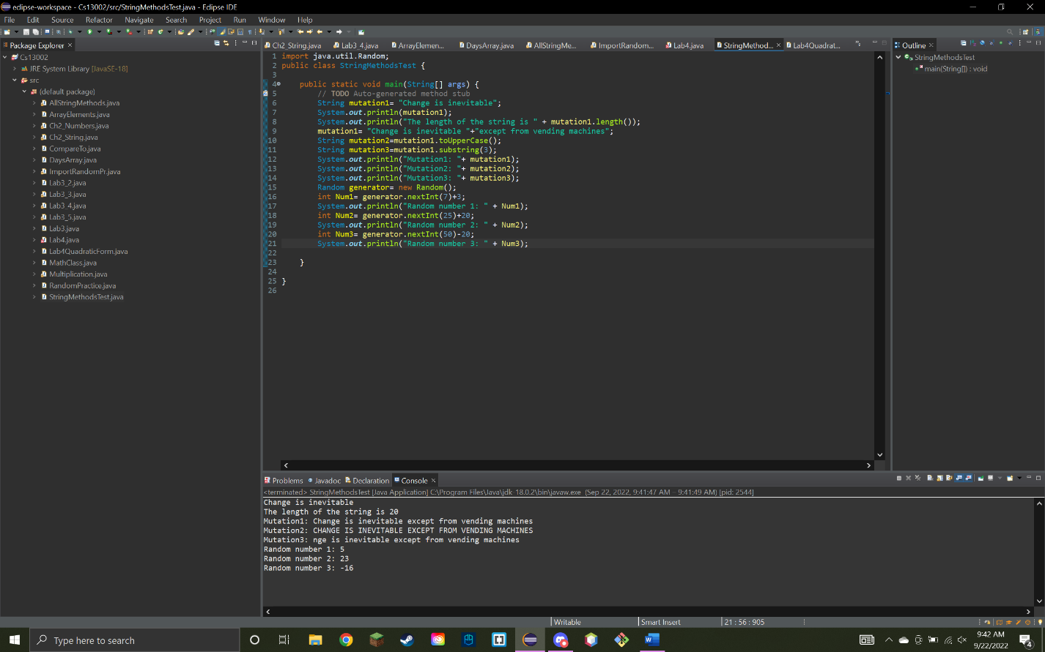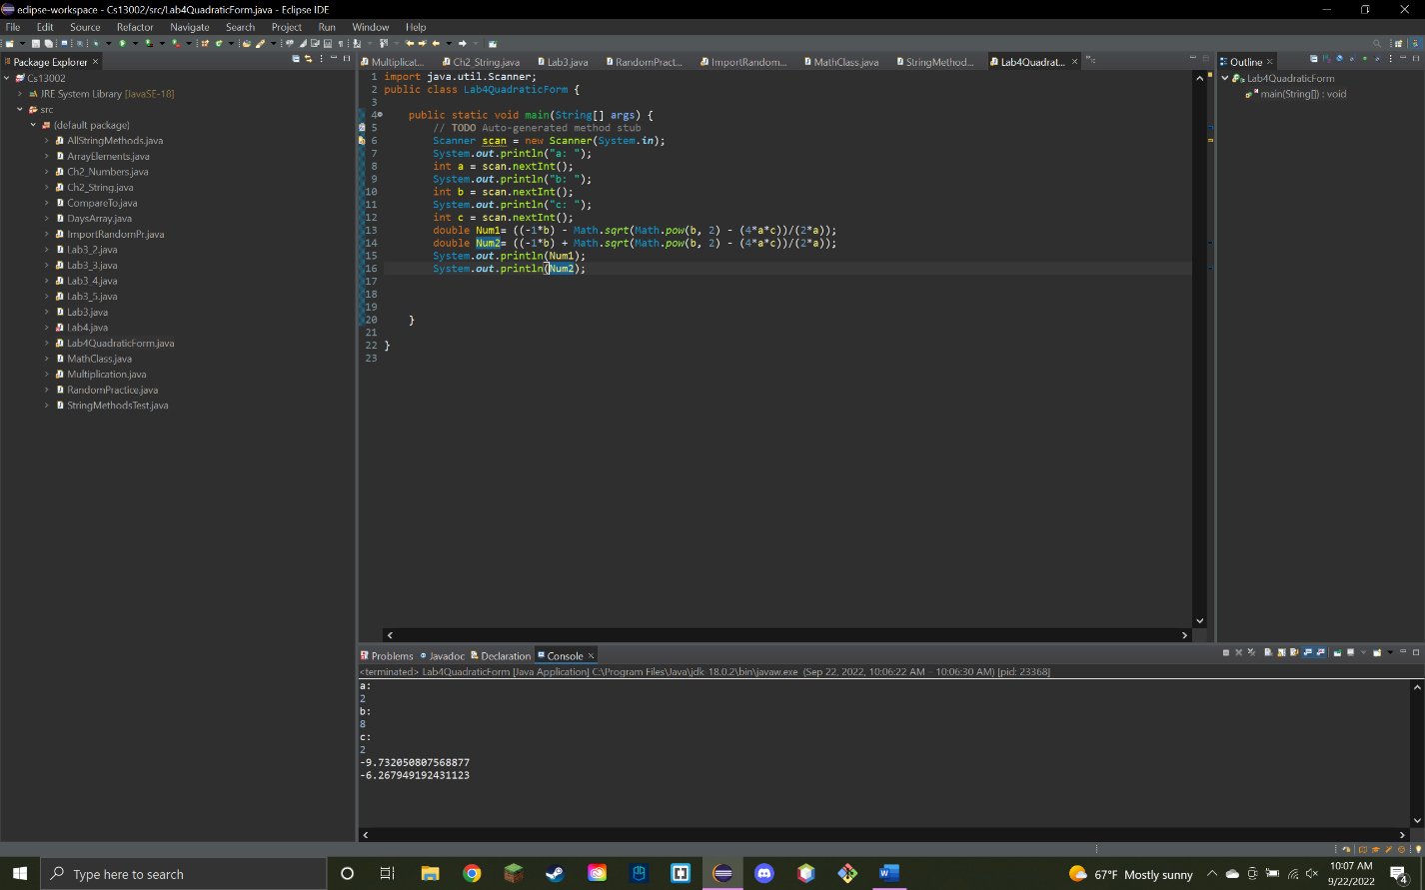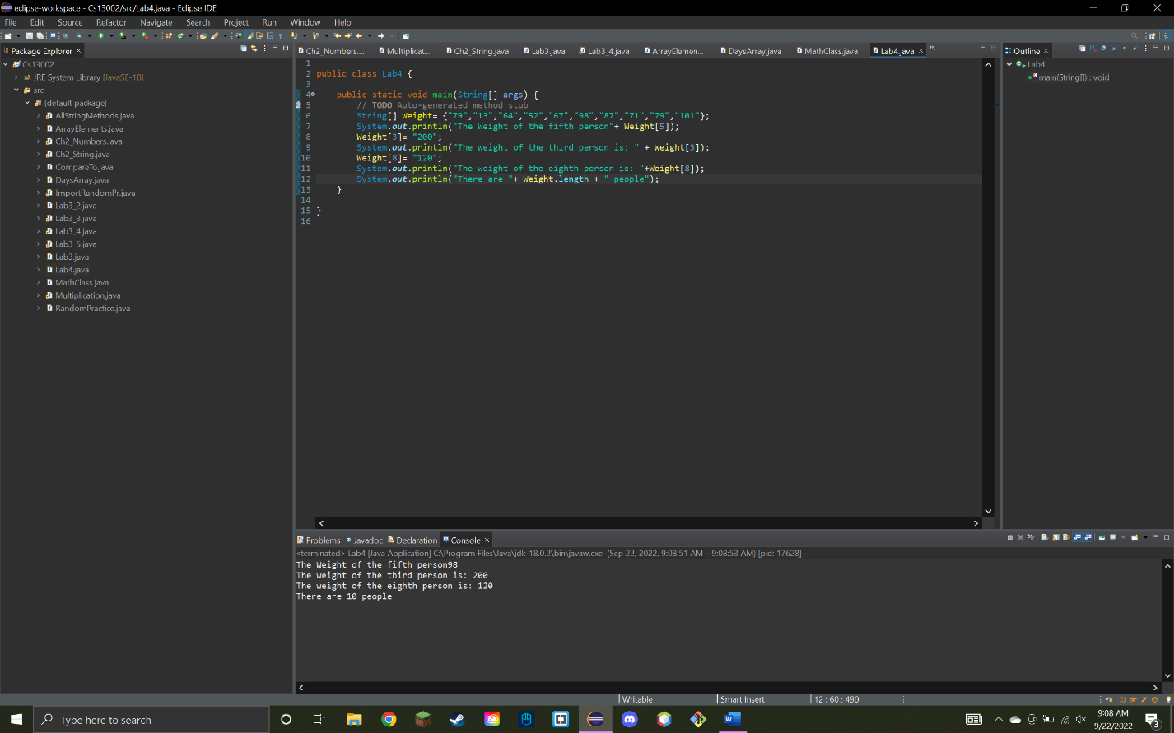
5. **Working on String Methods at Eclipse by creating a class called “StringMethodsTest”**

**String phrase = "Change is inevitable";**

**String mutation1, mutation2, mutation3;**

1. **Print** the String “phrase”
2. Find out its **length**;
3. **Concatenate** with another phase “except from vending machines” and store it to **mutation 1**;
4. **Change** mutation 1 to upper case and save it to **mutation 2;**
5. **Return** **substring** from index 3 of mutation 1 and save it to **mutation 3;**
6. **Print** length, **mutation 1-3**;
7. Generate a random number in between:
8. 3 to 10 (including)
9. 20 to 45 (excluding)
10. -20 to 30 (including)
11. The quadratic formula helps us solve any quadratic equation. First, we bring the equation to the form ax²+bx+c=0, where a, b, and c are coefficients. Then, we plug these coefficients in the formula:

You will have to find out two roots for x when, a=2, b=8, c=2 (use scanner class for a,b,c)