Take Home Questions:

CS 130 - 02

10 Points

Due : 10/10/22 by 10 am

1. **Check a number from user whether it is two digits, or three, four or five digit**

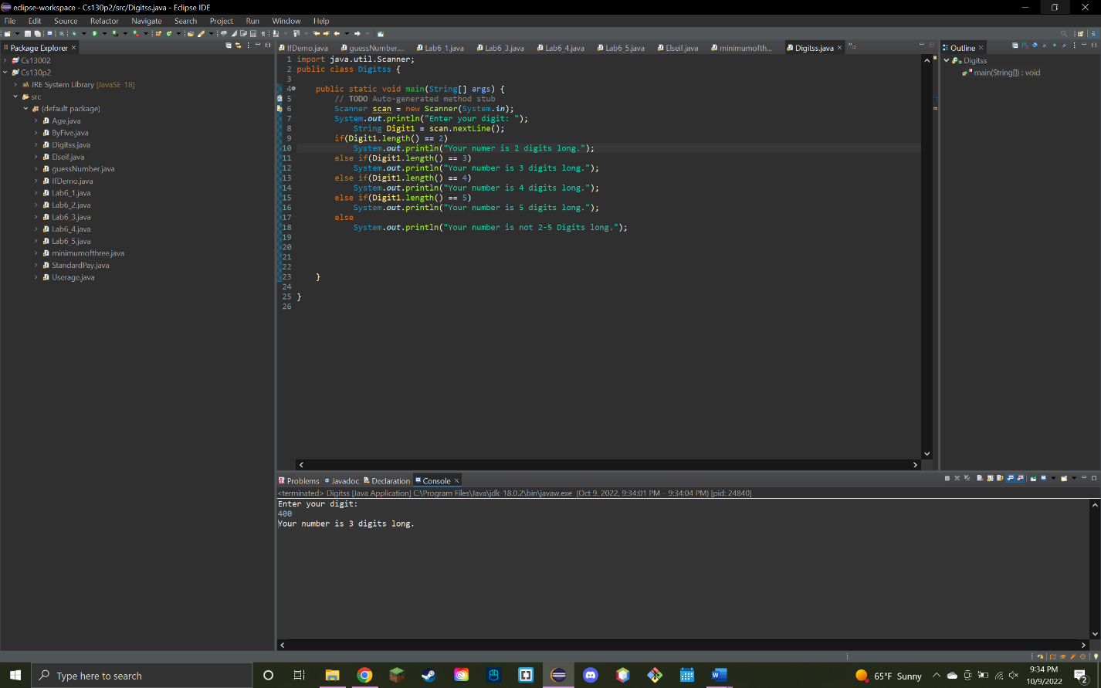

1. **Find Maximum of three number**

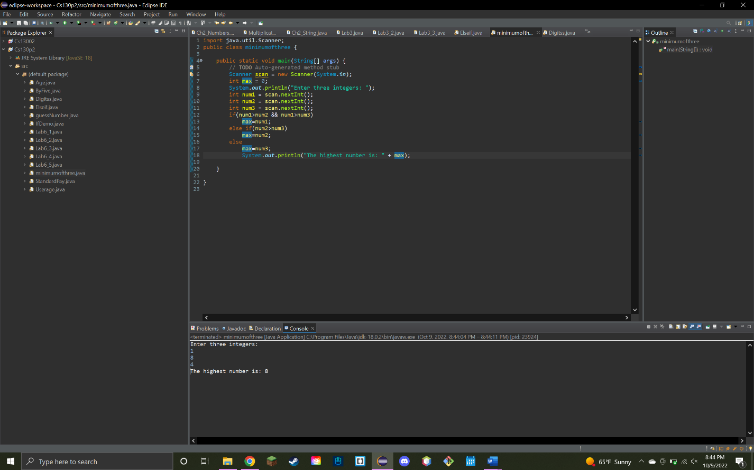

1. **Definition of Nested if and if else if ladder**

Nested if is one if statement inside another. An if else if ladder is used to figure out which if statement is correct of multiple options.