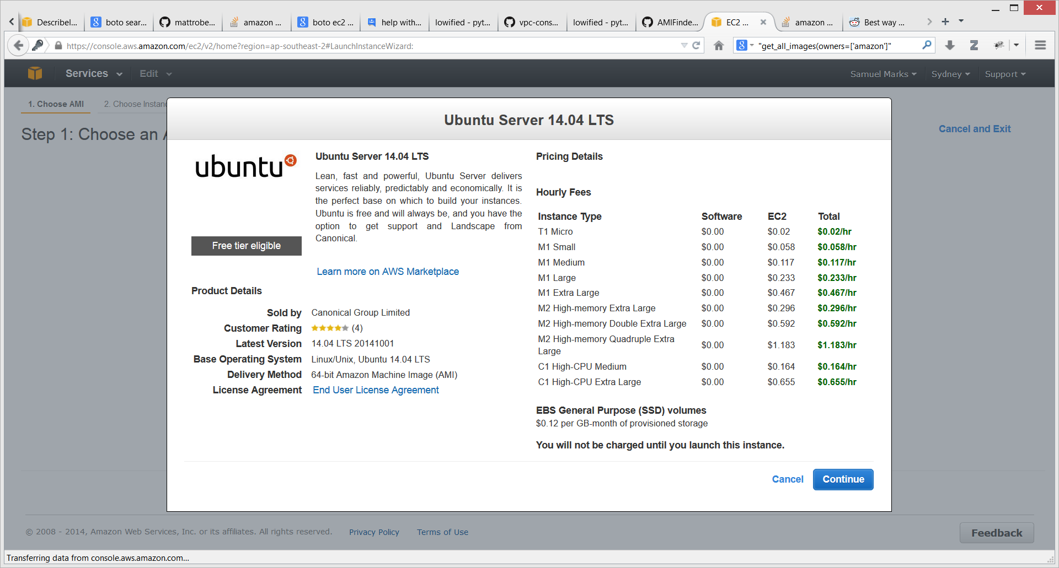
Unfortunately my search function via the Amazon SDK (boto interface) was unable to find Ubuntu instances. So I'm using the web frontend.
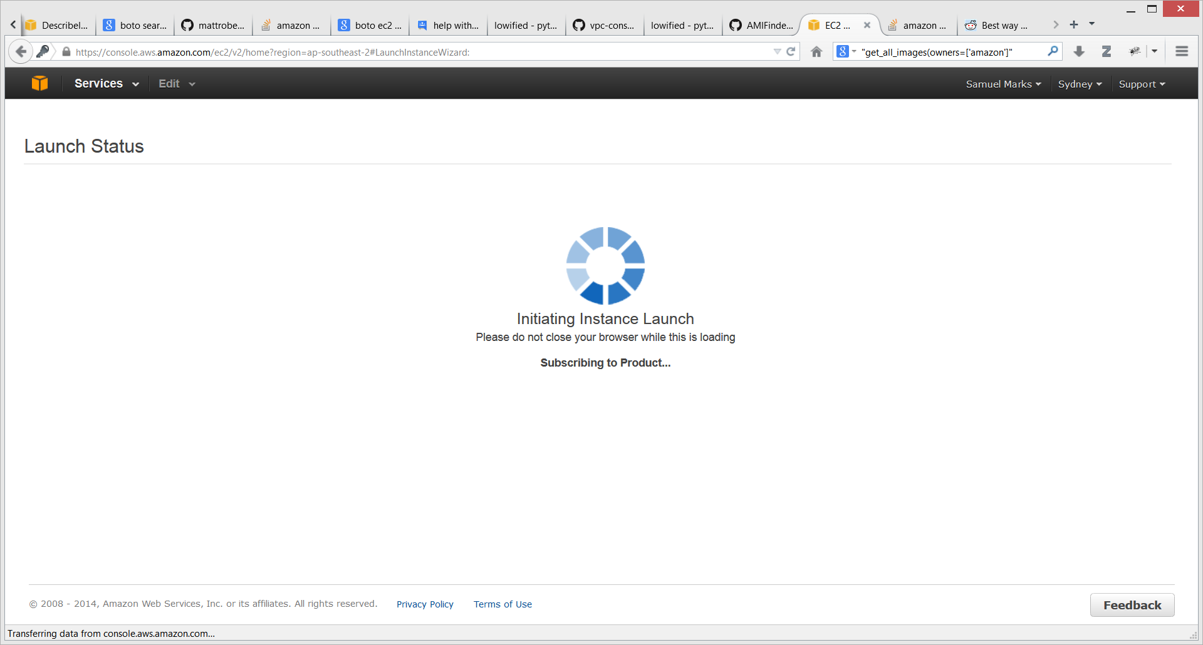
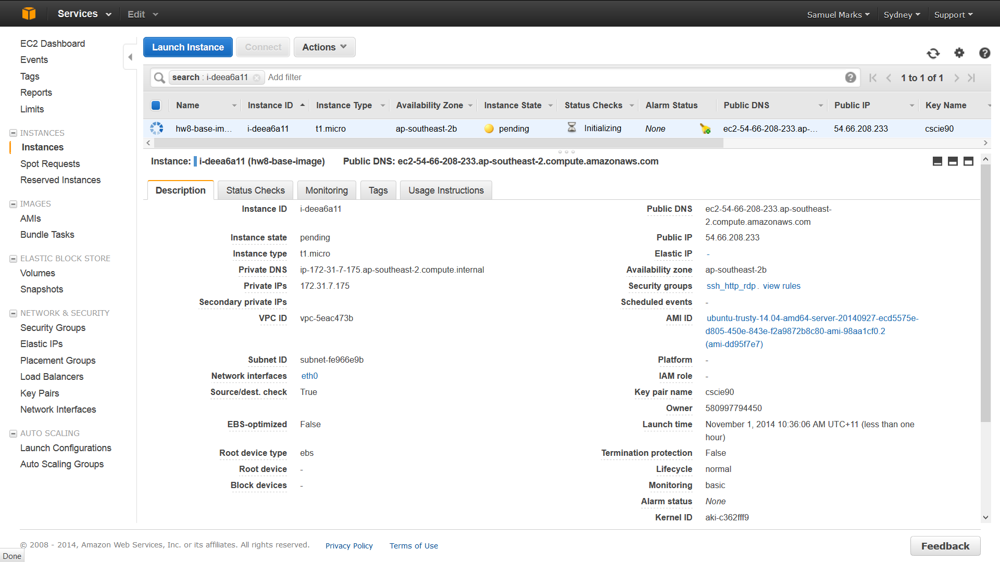

Quick note from when I was automatically adding instances, I added a few too many, so I deleted (terminated) them, but they still appeared in all my results. Here shows why: https://forums.aws.amazon.com/thread.jspa?messageID=539065

Anyway, back to the problems at hand. Here is showing that the instances I launched worked:
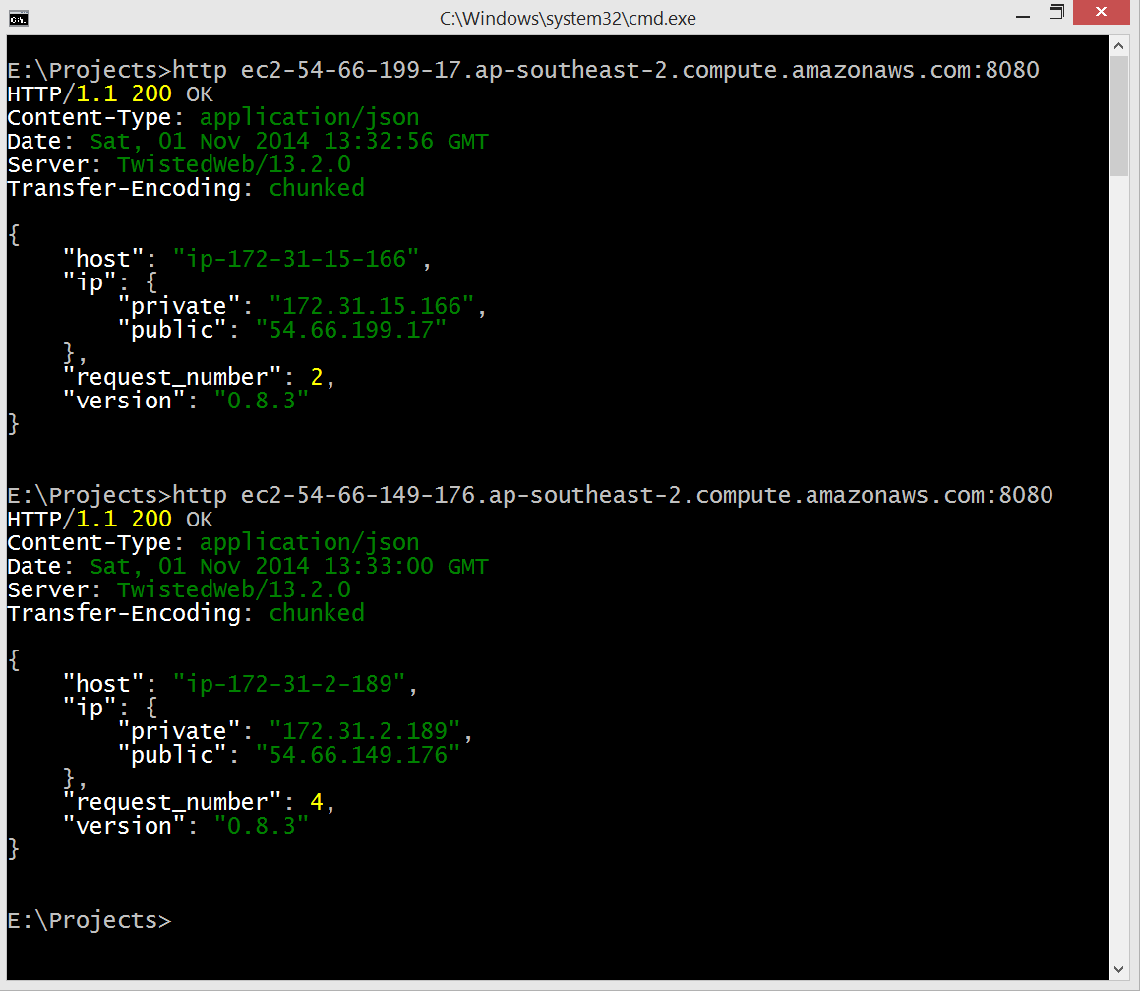

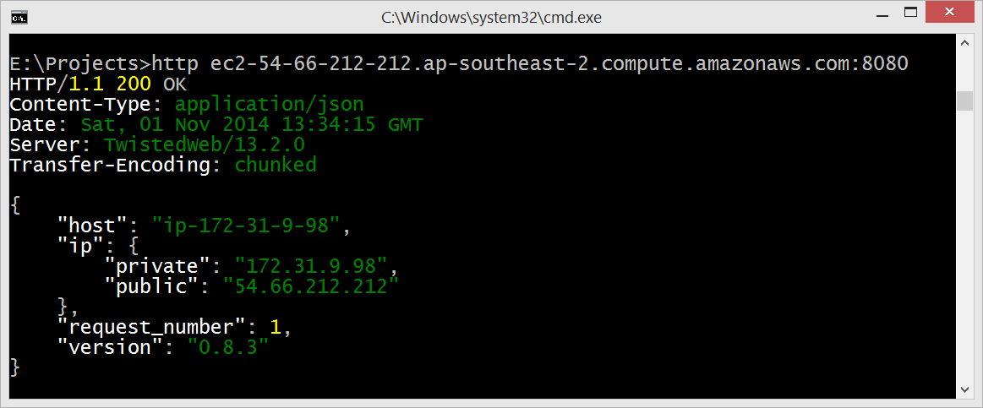
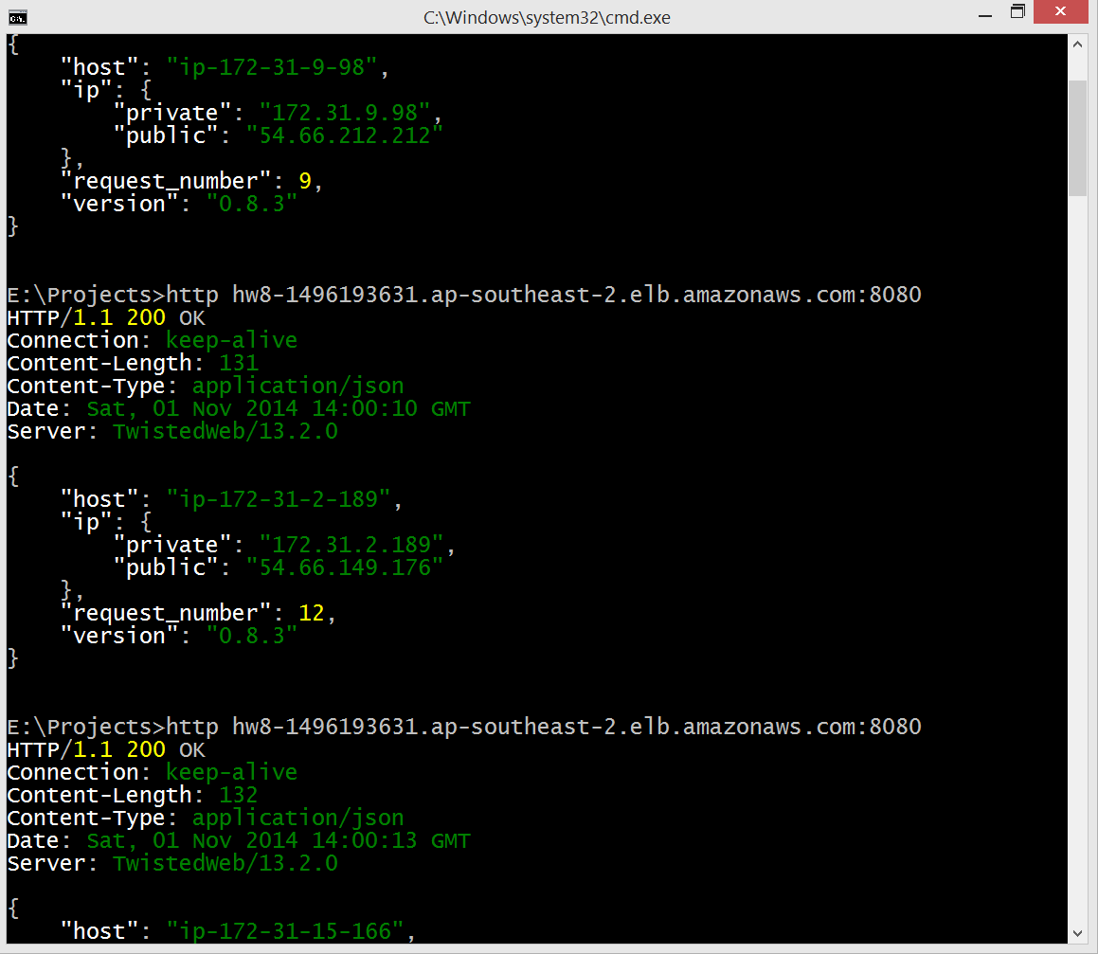
Looks pretty decently distributed. Good to see. Though it is a limited load-balancing problem, more interesting are the problems Professor Michael Mitzenmacher solved on even low values of d.

On the message queue side, I solved the problem but it has a rather massive security hole. I must distribute my public AND private keys, or at least my Amazon Access ID and Access Key. Even setting the security permissions on the queue to public (everyone*), would still add a barrier to entry, i.e.: everyone would require an Amazon account. An alternative here would be to have some sort of security proxy, with the one set of Amazon accounts used by all consumers of my API. Still, that reference abstraction is not a clean or particularly efficient solution.

